Chair Kurt Johnson called the monthly Board of Supervisors’ Meeting to order at 7:00 PM. After taking a visual note of those in attendance, Kurt announced that the following officers were present:

Roll Call:

**Supervisors**

* Kurt Johnson
* Jon Olson
* Mike Ruhland**Treasurer**
* Peter Olson**Clerk/Deputy Clerk**
* Sandra Lee Olson

Deputy Clerk Kate Laine was not in attendance.

Following the Pledge of Allegiance, Jon Olson made a motion to accept the Agenda as printed; Mike Ruhland offered a second, the motion was accepted through a unanimous vote.

Clerk Sandra Lee Olson read the minutes from May 4, 2020, Board of Supervisors’ Meeting. Mike Ruhland made a motion to accept the minutes as read. Jon Olson seconded the motion, which was accepted through a unanimous vote and placed on file with other documents from the meeting.

Peter Olson read the Treasurer’s Report into the record. Mike Ruhland made a motion to accept the report as present and subject to audit. Jon Olson seconded the motion, which was accepted through a unanimous vote, and the report was placed on file with other documents from the meeting. The Treasurer’s Report consisted of the customized first page (reproduced on page 2), Cash Control Statement (CTAS), Outstanding Checks and Deposits in Transit (CTAS), and Schedule B—Investment Activity with Accrued Interest (CTAS).

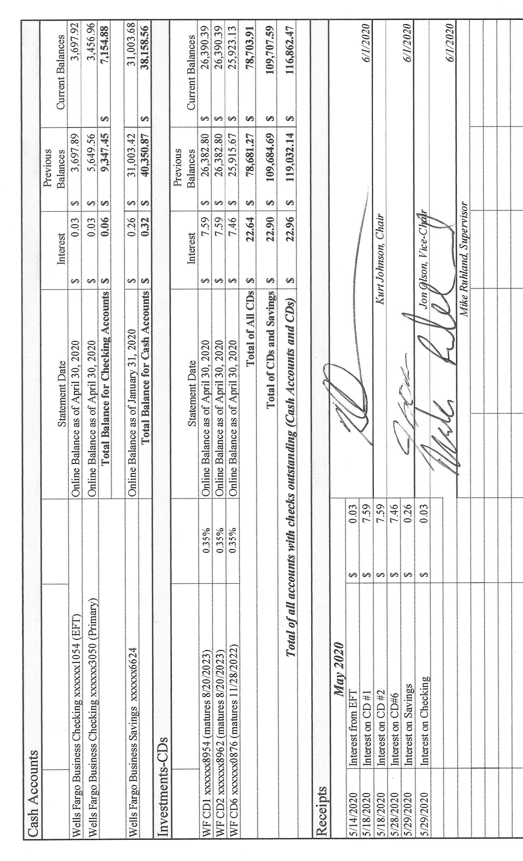

Sandra Lee Olson presented her Clerk’s Report for the period ending on June 30, 2020. Her report agreed with the Treasurers’ Report for the same period and included Cash Control Statement (CTAS)—which is reproduced below, Outstanding Checks and Deposits in Transit (CTAS), Cash Balance Statement (CTAS), and Current Investments with Accrued Interest (CTAS), and Statement of Receipts, Disbursements and Balances (Schedule 1) (CTAS). During her reading of the report, Sandra Lee asked how much the Board wanted to transfer for the monthly bills that will be paid at the meeting. Jon Olson made a motion to transfer $6,000 from Savings to Checking. Mike Ruhland seconded the motion, which was carried with a unanimous vote in favor of the transfer. Sandra Lee will transfer the amount that was approved. After the entire report was presented, Mike Ruhland made a motion to accept the Clerk’s Report, subject to audit; Jon Olson offered a second to the motion, which was accepted through a unanimous vote and placed on file with other documents from the meeting.

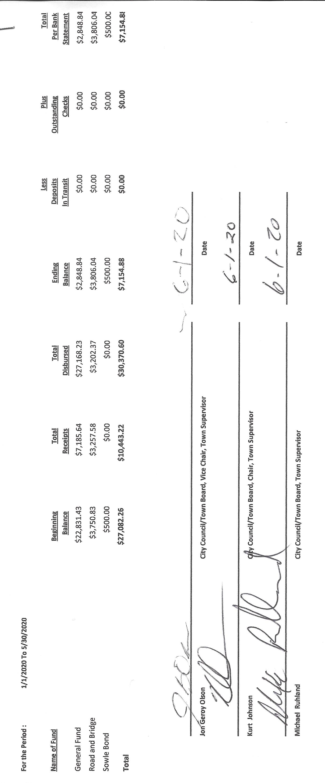

The following items of Incoming Correspondence were presented to the Board:

1. Jim Witkowski…mowing and prep at the town hall and at the cemetery ($395)
2. Jim Witkowski…certificate of insurance
3. Lake Country Power…notice that *Strictly Business* will now be emailed
4. Lake Country Power…monthly statement (Credit $130.58)
5. St. Louis County Auditor…notice of General Election on November 3, 2020
6. Rodda Grading and Excavating…grading in April ($1,211.25)
7. Arrowhead Water Conditioning…invoices 9993 and 8830 ($90.65 total)
8. Minnesota Association of Townships…membership cards for officers
9. St. Louis County/Environmental Services…flyer with dates for hazardous waste collection
10. Federated Co-ops…statement showing credit for finance charges and remaining pre-buy balance (credit of $511.50)

Emails

1. Phil Chapman…notice of training that will take place in June
2. St. Louis County…postings for hazardous waste collection (duplicate of #9 above)
3. Minnesota Weed…weed information (forwarded to Mike Ruhland)
4. Jonathan Blevins…election judge party list

Kurt Johnson read the following Payroll items into the record. Upon completion, Mike Ruhland made a motion to pay the monthly payroll as presented; Jon Olson offered a second to the motion, which was accepted through a unanimous vote and submitted to the Treasurer for payment.

* 1. Payroll $140.32
  2. Payroll $93.55
  3. Payroll $403.96
  4. Payroll $92.35
  5. Payroll $406.10
  6. Payroll $116.94

The following Claims were read into the record by Chairman Johnson. Following the reading, Mike Ruhland made a motion to pay the claims as presented. Jon Olson offered a second and the motion was approved through a unanimous vote. The claims were given to the Treasurer for payment.

4599 Public Employees Retirement Association $152.50

* 1. Peter Olson $14.95
  2. US Treasury $545.44
  3. Minnesota Revenue $47.85
  4. Sandra Lee Olson $193.62
  5. Frontier Communication $80.00
  6. Jim Witkowski $395.00
  7. Arrowhead Water Conditioning $90.65
  8. Rodda Grading & Excavating $1,211.25

The following items of Unfinished Business were discussed by the Board:

1. Cemetery
   * Kurt Johnson reported that there currently are no concerns about the cemetery. During the last month, he has received phone calls and answered questions as they were presented.
   * The Board discussed the current drought and the tendency of the grass at the cemetery to dry out during average rainfall years. Kurt will make contact with a lawn service to see options that might be available for New Independence.
2. Town Hall
   * Mike Ruhland reported that the sign has been lowered on the front of the Town Hall.
   * Jon Olson will look into getting quotes for seal coating at the Town Hall and the cemetery.
3. Township Roads
   * Road Foreman Peter Olson reported that gravel was applied to North and South Johnson and Nelson Roads
   * When peter talked with Bob Rodda, Rodda thought that Salo Road needed 15 loads of gravel. The general consensus of the Board was that it does not need that amount of gravel. Peter will check with area suppliers for quotes on gravel.
   * Peter will also check with Rick McRae for a quote on brushing.
4. Mowing Contract for Cemetery & Town Hall
   * The certificate of insurance was received for Jim Witkowski
5. Presidential Nominating Primary
   * Clerk Sandra Lee Olson reported that the request for reimbursement was submitted to the County and should be received soon. The total amount of the reimbursement was $1300+.
6. Election
   * Filing period for the upcoming election will be open in July. A notice will be sent to Voyageur and posted.

New Business

1. MAT Conference Call
   * Kurt tried to join the MAT Conference Call but was unsuccessful. The Governor was holding a news conference related to COVOD-19, but no one informed the participants thar the phone conference was cancelled.

There were no Officer Reports from June.

Having no additional business to be brought to the Board, Kurt asked for a motion for adjournment, which was offered by Mike Ruhland, seconded by Jon Olson, and accepted through a unanimous vote. Kurt declared the meeting to be adjourned at 8:00 PM

=

Minutes submitted for approval on _______________July 6, 2020_______________________

Clerk’s Signature______________________________________________________________

Chair of the Board of Supervisors’ Signature________________________________________

**UPCOMING MEETINGS**

***Board of Supervisors’ Meetings for 2020***

July 6, 2020

August 3, 2020

September 14, 2020

October 5, 2020

November 2, 2020

December 7, 2020

**2019-2020 SLCAT Calendar (meetings convene at 6:30 pm) and Related Meetings**

No meetings over the summer.