The monthly Board of Supervisors’ Meeting was called to order by its chair, Kurt Johnson. Upon calling the meeting to order, Kurt verbally noted that the following officers were present:

Supervisors
- Kurt Johnson
- Jon Olson
- Mike Ruhland
Treasurer
- Peter Olson
Clerk
- Kate Laine
- Sandra Lee Olson

He also noted that the following officer was not present.
Deputy Clerk
- Kate Laine

After the Pledge of Allegiance was completed, Mike Ruhland made a motion to accept the Agenda as presented. Jon Olson seconded the motion, which was accepted through a unanimous vote.

Clerk Sandra Lee Olson read the minutes from June 3, 2019, meeting. In her reading, she noted that on page 4 near the bottom of the page, the following change was read into the record:
- Estimate from Curt John Larson will be obtained.
Upon completion of the reading, Mike Ruhland made a motion to accept the minutes as corrected. Jon Olson seconded the motion, which carried with a unanimous vote.

Peter Olson read the Treasurer’s Report, which consisted of the first page (reproduced on the next page), Cash Control Statement (CTAS), Outstanding Checks and Deposits in Transit Report (CTAS), and Schedule B—Investment Activity (CTAS). Once Peter completed reading the Treasurer’s Report, Mike Ruhland made a motion to accept the report—subject to audit. Jon Olson made a second to the motion, which was then approved through a unanimous vote.
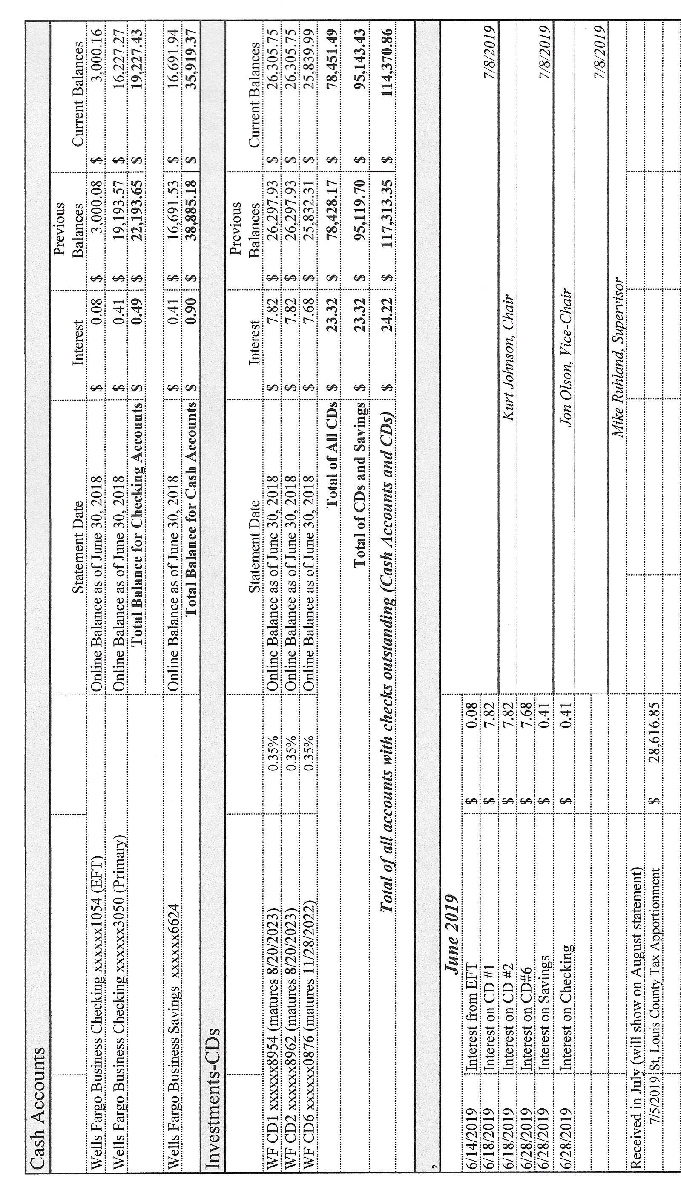

Sandra Lee Olson read the Clerk’s Report into the record. Her report consisted of the Cash Control Statement (CTAS), Cash Balance Statement (CTAS), Outstanding Checks and Deposits in Transit Report (CTAS), Current Investments (CTAS), and Statement of Receipts, Disbursements and Balances (Schedule 1) (CTAS). The first page of her report is reproduced below. Following her report, Kurt Johnson made a motion to accept the Clerk’s Report, subject to audit. Mike Ruhland offered a second to the motion, and a unanimous vote in favor of the motion followed.
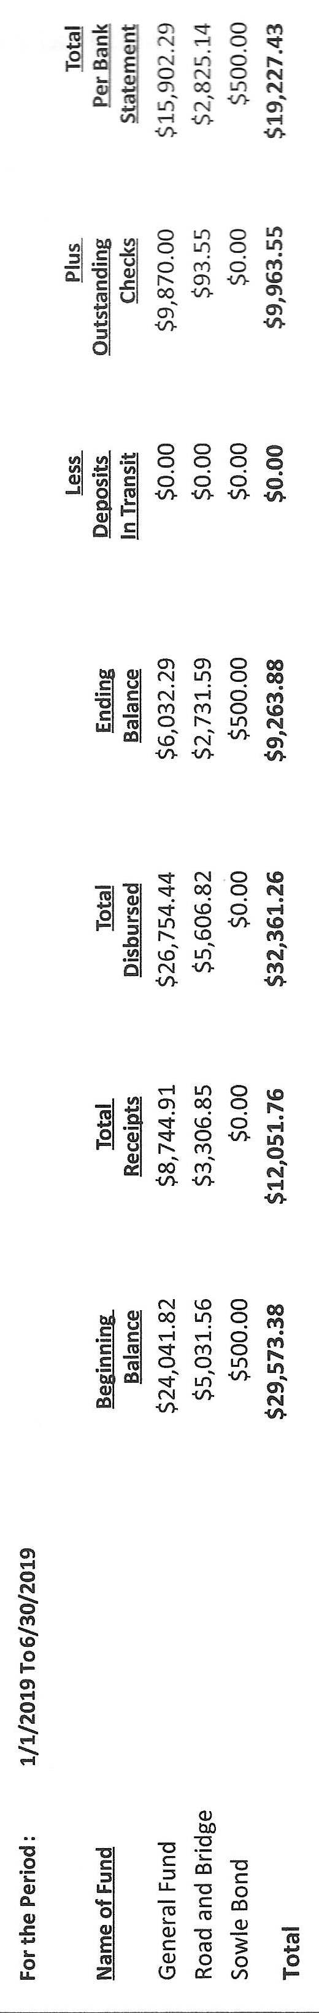
The Clerk also noted that money was transferred from EFT to Checking ($28,617.01). The total represented the May Tax Apportionment and interest received to that date.

Incoming Correspondence
- University of Minnesota…MINNESOTA LTAP: Technology Exchange
- Rodda Grading & Excavating
  - Invoice for grading ($1,237.50)
  - Letter
- St Louis County…invoice for steaming the culverts ($49.77)
- MTGF…MTGF Clippings
- Frontier Communications
  - Billing from June ($71.23 paid estimated amount of $75 in June)
  - Billing from July ($67.46)
- Federated Co-ops…summer fill program ($1.129/gallon)
- Jim Witkowski…two mowing during June—June 13 and June 25 ($375—adjusted to $370)
- Minnesota State Demographic Center…2018 Population and Household Estimates
  - April 1, 2018 population estimate is 288
  - April 1, 2019 household estimate is 121
- Minnesota Association of Townships…summer short course registration for Kate and Sandy ($100.00)
- Federated Co-ops…statement as of 5/31/2019 (credit $440.05)
- Lake Country Power…statement (credit balance of $14.98)
- Wells Fargo Bank…notification that Kate Laine was added as a signer to the New Independence Account
- Curt Larson…invoice for grading ($1,2000
- Lake Country Power…notice of capital credit allocation
  - Lake Country Power $67.45
  - Great River Energy $16.14
- Alborn Fire Department…information for cost analysis and calendar
- Alborn Fire Department…minutes from the May 29, 2019, meeting.
Emails
- St. Louis County…May Tax Apportionment ($27,590.01)
- St. Louis County Assessor’s Office…information for Board of Appeal and Equalization online training

The following Payroll items were read into the record by Kurt Johnson. Upon completion, Mike Ruhland made a motion to pay the payroll as presented. Jon Olson seconded the motion, which was accepted through a unanimous vote and submitted to the Treasurer for payment.
  - Payroll $93.55
  - Payroll $184.70
  - Payroll $93.55
  - Payroll $318.75
  - Payroll $173.15
  - Payroll $507.10
  - Payroll $163.71

The Claims were read into the record by Kurt Johnson. Jon Olson made a motion to pay the claims that had been submitted. Following a second to the motion by Mike Ruhland, the motion as accepted through a unanimous vote and submitted to the Treasurer for payment.
  - Sandra Lee Olson $43.28
  - Minnesota Revenue $120.21
  - US Treasury $686.72
  - Public Employees Retirement Association 163.50
  - Lake Country Power $300.00
  - Curtis Larson $1,200.00
  - Minnesota Association of Townships $100.00
  - Jim Witkowski $370.00
  - Frontier Communications $67.46
  - St. Louis County Public Works $49.77
  - Peter Olson $48.72
  - Rodda Grading & Excavating $1,237.50
  - Alborn Fire Department 200.00

  - The following items of

Unfinished Business were discussed by the Board of Supervisors.
- Cemetery
  - Kurt Johnson expressed concern that the road going into the cemetery needs to be sprayed. Jim Witkowski agreed to pick up chemical for the task and complete it before the next meeting. It was also noted that the area by the fence is starting to become overgrown with sumac.
- Town Hall
  - Water softener
    - Kyle from Arrowhead Water will run a gray line for the water softener. Mike Ruhland made a motion to have him complete the task; Jon Olson seconded the motion, which was accepted through a unanimous vote. Kurt will contact Arrowhead Water about the decision.
  - Chair for Deputy Clerk
    - Sandra Lee Olson did look for a chair that matches the officers’ chairs but was not able to find a match. She will continue to look.
  - Decking for the Town Hall porches
    - Mike Ruhland checked on prices for material and found material ranging from $5 to $10/sq. ft. The deck would require approximately 20 square foot. Kurt Johnson made a motion to table the project until next year. Mike Ruhland seconded the motion, which was accepted through a unanimous vote.
- Roads
  - A letter was received from Bob Rodda. In his letter, Mr. Rodda expressed concern about not receiving recent work done for New Independence. He also expressed that when he retires, he has individuals interested in purchasing his business so there will not be a gap in coverage.
  - Curt Larson did recently grade the roads upon request from the road foreman, who had been authorized by the Board of Supervisors. The Board intent is to look ahead so New Independence has a back up plan in place should it be needed.
  - After a lengthy discussion, Kurt Johnson made a motion to give Rodda first chance to complete a project. When the job is given to Mr. Rodda, the Road Foreman will specify a timeline for the project. Curt Larson will be used for spreading gravel. Mike Ruhland seconded the motion, which was accepted through a unanimous vote.
  - Road Foreman Peter Olson noted that the cost for trapping beaver would have been $1,000. Kurt Johnson interjected that Stone River was used by Schneiderman’s to get rid of seagulls. It’s possible that Stone River might be able to assist with the beaver situation.
  - Nelson Road was approved for ditching last year. As of this meeting, the project has not been completed. Peter will contact Rodda again.
- Weed Control
  - Mike Ruhland completed inspecting for weeds on Shipley, Nelson, and Stoney Brook Roads.

New Business
- Calendar
  - Each year the Board submits a list of meeting dates for the following year so the dates can be included on the Alborn Fire Department Calendar. The Board discussed various options for 2020 Board of Supervisors’ Meetings. Mike Ruhland made a motion to hold meetings on the first Monday of each month unless a change is necessary due to a conflict such a holiday. Kurt Johnson seconded the motion and the following dates were approved for 2020 meetings.
January 6, 2020
February 3, 2020
March 2, 2020
April 6, 2020
May 4, 2020
June 1, 2020
July 6, 2020
August 3, 2020
September 14, 2020
October 5, 2020
November 2, 2020
December 7, 2020

- Letter to residents
  - Community Night Out will be held on August 6 at the Alborn Community Center, 5-8 PM. Stacey Kleiner reported that hamburger and hot dogs will be served along with fruit. In addition to food, arrangements have been made for attractions including St. Louis County Rescue Squad, Sno-Devils Snowmobile Club, a bouncy house, North Memorial Helicopter, St. Louis County Sheriff and South Ridge SRO Deputy Olson, and the Meadowlands Ambulance.
  - A letter will be sent to New Independence residents to address the Community Night Out. In addition, there will be a notice about the New Independence website and request for election judges.
- Summer Fill
  - Federated Cooperative is offering a summer-fill program. New Independence will not be able to participate this year because our tank is above 80% capacity.
- LBAE online training
  - The online training is open for officers that need to be trained for the upcoming LBAE meetings. At this point, all New Independence Supervisors are trained and will not participate.

Officer Reports
MAT Specialized Training at the DECC—Sandy and Kate

Having no additional business to bring before the Board, Kurt entertained a motion for adjournment, which was offered by Mike Ruhland, seconded by Jon Olson, and accepted through a unanimous vote. Kurt declared the meeting to be adjourned at 8:21 PM.

Minutes submitted for approval on ____________August 5, 2019________________________

Clerk’s Signature_______________________________________________________________

Chair of the Board of Supervisors’ Signature_________________________________________

UPCOMING MEETINGS

Board of Supervisors’ Meetings for 2019
August 5, 2019
September 3, 2019
October 7, 2019
November 4, 2019
December 2, 2019

Board of Supervisors’ Meetings for 2020

January 6, 2020
February 3, 2020
March 2, 2020
April 6, 2020
May 4, 2020
June 1, 2020
July 6, 2020
August 3, 2020
September 14, 2020
October 5, 2020
November 2, 2020
December 7, 2020

2019 SLCAT Calendar (meetings convene at 6:30 pm) and Related Meetings
No meetings over the summer

