At 7:03 PM Kurt Johnson called the July Board of Supervisors’ Meeting to order and noted that all officers were present. The officers currently serving on the Board included:

Roll Call:

**Supervisors**

* Kurt Johnson
* Jon Olson
* Mike Ruhland**Treasurer**
* Peter Olson**Clerk/Deputy Clerk**
* Kate Laine
* Sandra Lee Olson

Following the Pledge of Allegiance, Mike Ruhland made a motion, which was seconded by Jon Olson, to accept the Agenda as printed. The motion passed by a unanimous vote

Clerk Sandra Lee Olson read the minutes from the Board of Supervisors’ Meeting which was held on June 1, 2020. Upon completion, Jon Olson made a motion to accept the minutes as read. Mike Ruhland offered a second to the motion, which was passed through a unanimous vote.

Treasurer Peter Olson read his monthly Treasurer’s Report into the record. The report included the customized first page (reproduced on page 2), Cash Control Statement (CTAS), Outstanding Checks and Deposits in Transit (CTAS), and Schedule B—Investment Activity with Accrued Interest (CTAS). After Peter had finished reading the report, Mike Ruhland made a motion to accept the report—subject to audit. Jon Olson seconded the motion, which was accepted through a unanimous vote.

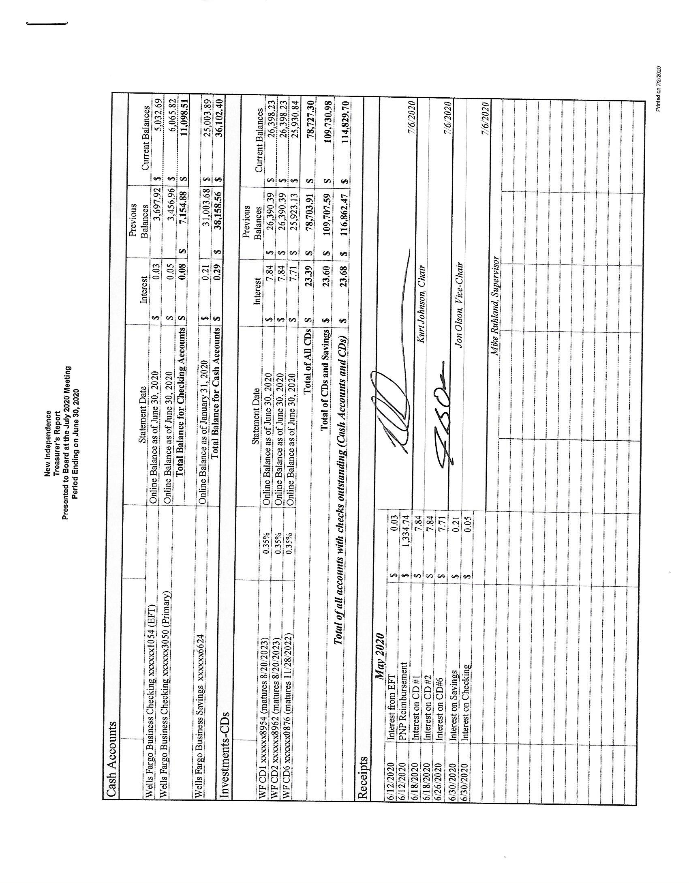

The Clerk’s Report was read into the record by the Clerk who stated that her report agreed with the Treasurer’s Report. Kurt Johnson made a motion to accept the Clerk’s Report as presented. The motion was seconded by Mike Ruhland and accepted through a unanimous vote. Sandra Lee informed the Board that the reimbursement from the Presidential Nominating Primary was received through electronic transfer. The total amount received was $1,334.74. The Clerk requested authorization to transfer funds received for Tax Apportionment from the EFT account to the Regular Checking account. Mike Ruhland made a motion to transfer $10,000 of those funds to the Regular Checking. The remaining amount of the Tax Apportionment would go into the Savings account. Jon Olson made a second to the motion, and a unanimous vote in favor of the motion followed.

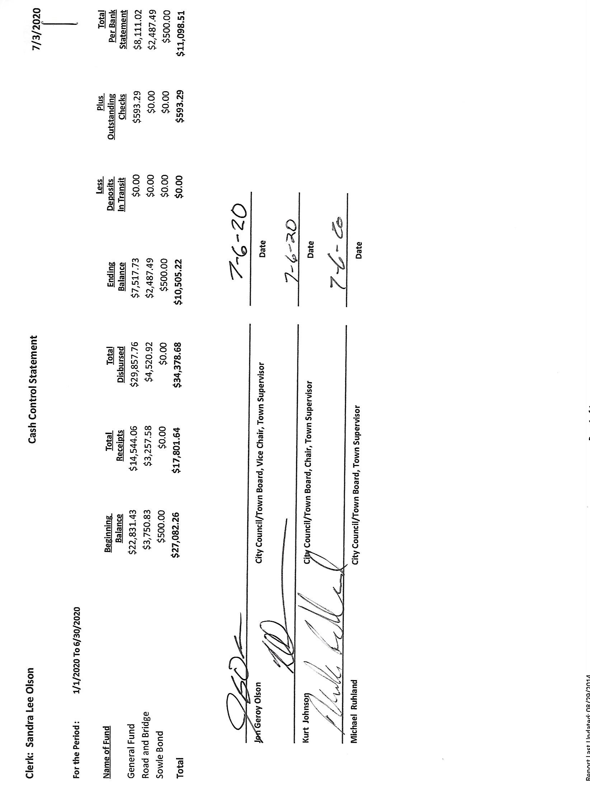

The following items of Incoming Correspondence were presented to the Board.

1. Jim Witkowski…statement for mowing at Cemetery and Town Hall (4 times, $740)
2. Lake Country Power
   * Notice of Capital Credit Allocation for 2019…$51.60
   * Monthly statement…credit of $45.79
   * Notice of Annual Meeting was held on June 26, 2020, and was closed to the public due to COVID-19.
   * Ballot for District 7—Craig Olson was due by June 25, 2020
3. Federated Co-ops, Inc
   * Monthly statement showing credit of $511.50
   * Propane summer fill special @ $1.129/gallon’
4. St. Louis County/Environmental Service…notice that the County will not increase its solid waste disposal fee at this time. It will be reviewed at its November meeting
5. Rodda Grading & Excavating…invoice dated June 23, 2020, for grading/blading and gravel ($2,542.07)
6. Minnesota State Demographic Center..2019 population and household estimates
   * Population estimate 286
   * Household estimate 120
7. Frontier Communications…monthly internet and phone service ($65.14)
8. PERA…*PERA News,* Spring 2020
9. Alborn Fire Department…information on the 2021 calendar

Emails

1. Jay Tremblay…snowplowing invoice ($80)
2. John Blevins…notice of Publication Language for Primary Election
3. Phil Chapman…update on elections, training, and pulling places
4. Local Board of Appeal and Equalization (LBAE)…notice from the St. Louis County Auditor’s Office that the online training for LBAE certification is available.
5. Gary Fredricksen…Jon received an email from Gary that the sign is down on his road. Road Foreman Peter Olson contacted St. Louis County about the sign.

The following Payroll items were read into the record by Kurt Johnson. Upon completion, Jon Olson made a motion to pay the payroll as presented. That motion was seconded by Mike Ruhland and accepted through a unanimous vote in favor of the motion.

* 1. Payroll $140.32
  2. Payroll $140.32
  3. Payroll $324.99
  4. Payroll $138.52
  5. Payroll misprinted
  6. Payroll $116.94
  7. Payroll $73.88
  8. Payroll $513.34

The following Claims were read into the record by Chair Kurt Johnson. Upon completion, Jon Olson made a motion to pay the claims as read. Mike Ruhland seconded the motion, which was then accepted through a unanimous vote. All claims were submitted to the Treasurer.

* 1. Lake Country Power $300.00
  2. PERA $168.50
  3. Jim Witkowski $740.00
  4. Rodda Grading & Excavating $2,542.07
  5. Frontier Communications misprinted
  6. Town of Alborn $9,397.00
  7. Kurt Johnson $9.20
  8. Mike Ruhland $25.30
  9. Peter Olson $35.65
  10. Frontier Communications $65.14

The following Unfinished Business was discussed by the Board:

1. Cemetery
   * Kurt told the Board that he did not check on seeding at the cemetery but will look into it for the next meeting
   * Kurt met with the Stromberg family who picked out two sites. A certificate will be sent for the plots
2. Town Hall
   * Seal coating: Jon had a quote for KTM for seal coating at the Town Hall and Cemetery. The quote for $2,250 included filling the cracks. After a discussion about the quote, the Board came to a consensus that another quote should be obtained before any action is taken on the project.
   * LP summer fill: The LP tank at the Town Hall is at 73%. Mike Ruhland made a motion to call Federated Co-ops, Inc. and take advantage of the summer fill program. Jon Olson seconded the motion and a unanimous vote in favor of the motion followed. The Clerk will contact Federated Co-ops prior to July 31 and request the fill.
   * Sandra Lee Olson told the board that the bottom board of the back ramp is loose. A brief discussion followed about replacing the ramp flooring, but no decision was made.
   * Mike Ruhland reported that blocks were placed under the water softener drain to prevent erosion.
3. Township Roads
   * Road Foreman Pete Olson reported that he talked with Gary Halvorson about the sign on South Schelin Road that was down.
   * Woods Forest Products removed trees on the right of way on Johnson Road. Before any action was taken, Peter talked with residents on the road and informed them of the project.
   * The Board discussed brushing and mowing the right of ways. Peter will contact Rick McRae for a brushing quote and possible grading projects the Township might undertake.
   * Wally Kucza talked with Mike Ruhland and Sandra Lee Olson about putting up a sign restricting parking on the road and gating where the road ends. Peter will contact him on behalf of the Board and check on signage.
4. Election
   * Clerk Sandra Lee Olson gave an update on the Primary Election and reminded the Board of dates and offices to be filled.

Township Filing dates: July 28 through August 11, 2020

Township Offices to be elected: Supervisor A, Supervisor B, and Treasurer

The Primary Election will be August 11, 2020, with polls open from 7:00 AM to 8:00 PM

* + She also notified the Board that the Township Public Accuracy Testing will be held on August 3, 2020 at 5:00 PM. The Clerk and election judges will conduct the testing.
  + Kurt Johnson made a motion to appoint Primary Election Judges that served at the last election. If any of those judges are not able to serve, the motion authorized the clerk to fill the slots according to the election guidelines. Jon Olson seconded the motion, which was subsequently accepted through a unanimous vote.

The following item of New Business were presented to the Board

1. Alborn Fire Department Calendar: Mike Ruhland made a motion to participate in the 2021 calendar by maintaining the same format as last year. The cost for the ad will be $200. Jon Olson seconded the motion, which was accepted through a unanimous vote.

Officer Reports

There were no officer reports.

Having no additional business to discuss, Kurt Johnson asked for a motion for adjournment. After a motion for adjournment by Mike Ruhland, a second offered by Jon Olson, and a unanimous vote in favor of the motion, Kurt declared the meeting to be adjourned a t8:14 PM.

=

Minutes submitted for approval on ______________August 3, 2020_____________________

Clerk’s Signature______________________________________________________________

Chair of the Board of Supervisors’ Signature_________________________________________

**UPCOMING MEETINGS**

***Board of Supervisors’ Meetings for 2020***

August 3, 2020

September 14, 2020

October 5, 2020

November 2, 2020

December 7, 2020

**2019-2020 SLCAT Calendar (meetings convene at 6:30 pm) and Related Meetings**

There are no meetings over the summer