At 7:01 PM, Chairman Kurt Johnson called the monthly Board of Supervisors’ Meeting to order. Kurt noted that the following officers were present:

**Supervisors**

* Kurt Johnson
* Mike Ruhland**Treasurer**
* Peter Olson**Clerk/Deputy Clerk**
* Kate Laine
* Sandra Lee Olson

Kurt also noted that the following officer was not in attendance:

* Jon Olson

Following the Pledge of Allegiance, Mike Ruhland made a motion to accept the Agenda as printed. The motion was seconded by Kurt Johnson and accepted through a unanimous vote.

Stacy Kleiner had intended to be at the Town Board Meeting to discuss the upcoming Community Night Out. Since she was not at the meeting, Clerk Sandra Lee Olson reminded the Town Board of the Community Night Out, which will be held on August 6 at the Alborn Community Center from 5-8 PM. Sandra Lee also stated that letters were sent out to residents on Saturday, July 20, 2019. Those letters were sent to Postal Residents at Culver, MN 55779. Alborn sent letters to Alborn and Meadowlands zip codes.

Following the reading of the minutes from the Board of Supervisors’ Meeting held on July 8, 2019, Mike Ruhland made a motion to accept the minutes as read. A second from Kurt Johnson and a unanimous vote in favor of the motion followed.

Peter Olson read the Treasurer’s Report into the record. While the first page is reproduced on the next page, other parts included in the report were Cash Control Statement (CTAS), Outstanding Checks and Deposits in Transit Report (CTAS), and Schedule 8—Investment Activity with Accrued Interest (CTAS). After Peter completed his report, Mike Ruhland made a motion to accept the report—subject to audit. A second was offered by Kurt Johnson, and a unanimous vote approving the motion followed.

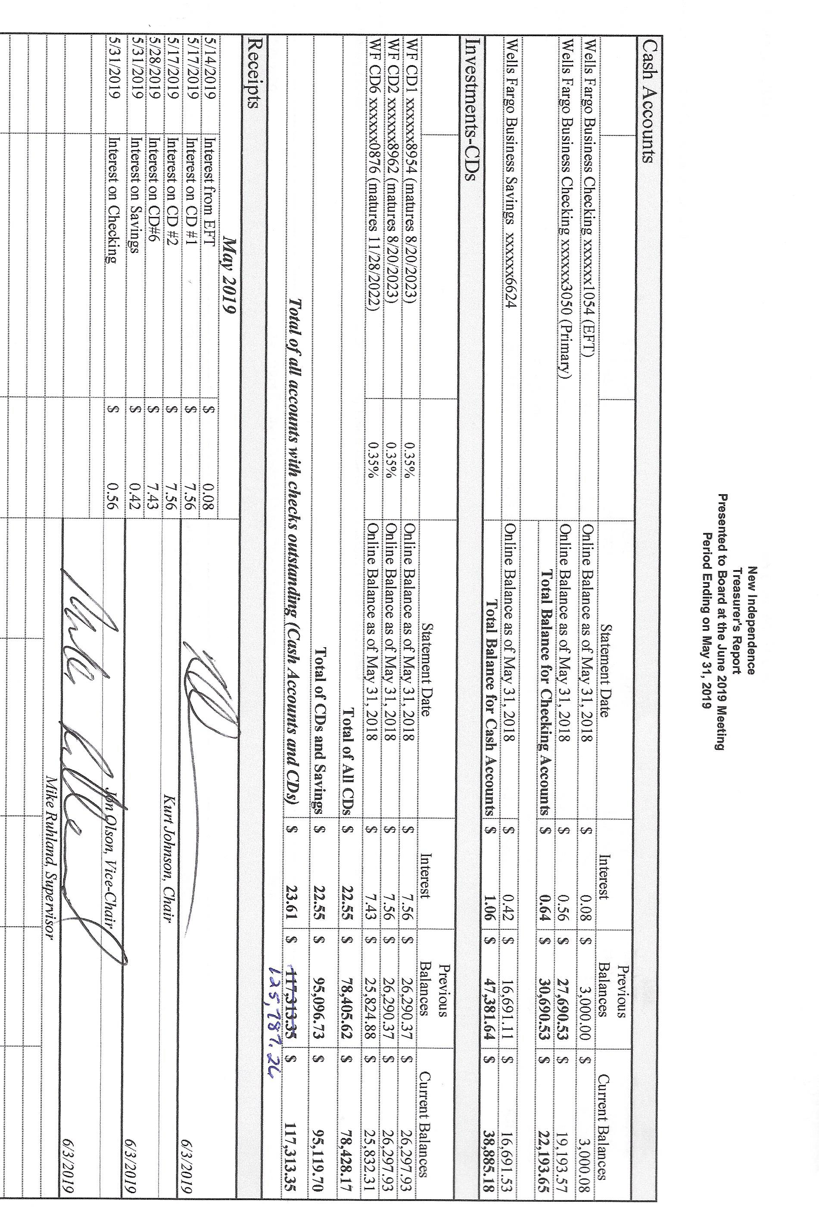

Sandra Lee Olson presented the Clerk’s Report and stated that the Treasurer’s Report and the Clerk’s Report were in complete balance. The first page, Cash Control Statement (CTAS), of her report is reproduced. Other pages included: Cash Balance Statement (CTAS), Outstanding Checks and Deposits in Transit Report (CTAS),Current Investments with Accrued Interest (CTAS), and Statement of Receipts, Disbursements and Balances (Schedule 1) (CTAS). In addition to the written report, Sandra Lee gave a breakdown of the May Tax Apportionment and discussed money received from the State. Following her report, Kurt Johnson made a motion, which was seconded by Mike Ruhland, to accept the Clerk’s Report, subject to audit. The motion was accepted through a unanimous vote.

The following items of Incoming Correspondence were presented to the Board:

1. Frontier Communications…monthly phone and internet ($75.18)
2. Jim Witkowski…mowing invoice and reimbursement for chemicals ($613.33)
3. Minnesota Department of Revenue…notice of 2020 Township Aid
4. Couri & Ruppe, P.L.L.P….notice of upcoming Township Legal Seminar
   1. Saturday, October 5, 2019 at the Cotton Town Hall from 9 AM to PM
5. Tester Niemi Post…thank you for donation toward fireworks
6. Federated Co-ops…invoice showing a credit ($316.88)
7. Minnesota Association of Townships…notice of District 10 Meeting to be held on Thursday, August 22, 2019, at Grand Lake Town Hall, with registration at 5:30 PM and meeting at 6:00 PM
8. Lake Country Power…monthly power bill showing a credit ($69.96) The payment from last month must have crossed in the mail.

Emails

1. Phil Chapman…request for election costs
2. Minnesota Department of Revenue…distribution of Minnesota Town Aid

The Payroll claims were read into the record by Kurt Johnson, who then made a motion to pay the claims. Following a second to the motion by Mike Ruhland and a unanimous vote in favor of the motion, the payroll claims were submitted to the Treasurer for payment.

* 1. Payroll $93.55
  2. Payroll $350.37
  3. Payroll $69.26
  4. Payroll $318.75
  5. Payroll $399.86
  6. Payroll $93.55

The following Claims were read into the record by Kurt Johnson. Upon completion, Mike Ruhland made a motion to pay the claims as presented. A unanimous vote in favor of the motion followed and the claims were submitted to the Treasurer for payment.

* 1. Frontier Communications $75.18
  2. Public Employees Retirement Association $125.00
  3. Peter Olson $20.88
  4. Sandra Lee Olson $341.72
  5. Jim Witkowski $603.33

Unfinished Business

1. Cemetery
   * Kurt reported that the road going into the cemetery should be sprayed to control the weeds. He also expressed concern about a couple trees and will continue to watch them until action needs to be taken. He suggested contacting Tim Anvid when the trees need to be removed. Tim has done work for the township in the past and the Board was pleased with the outcome.
2. Town Hall
   * Water softener
     + The water softener is up and running following work completed by Arrowhead Water. A discussion was held about adding a diverter onto the end of the pipe coming out of the town hall and caulking around the pipe.
   * Chair for Deputy Clerk
     + A chair still needs to be purchased for the deputy clerk. Finding one that matches the other chairs has not been successful.
3. Roads
   * Road Foreman, Peter Olson, did his monthly inspection of the roads and felt they were in good shape. North and South Schelin Roads were graded since the last meeting. As of the meeting, Rodda had not completed the ditching on Nelson Road. Peter will contact him again.
   * Kurt Johnson made a motion, which was seconded by Mike Ruhland, to have Jon Olson mow the right of ways so it is completed before Labor Day. The motion carried unanimously. Sandra Lee agreed to ask Jon to complete the project
4. Weed Control—nothing to report

The following items of New Business were discussed by the Board:

Kurt Johnson made a motion, which was seconded by Mike Ruhland, to pay any officer that attend the meetings listed as items 1 & 2 below. The motion was passed by a unanimous vote in favor of accepting the motion. Officers will receive mileage and meeting rate

1. Township Legal Seminar
   * Curri & Ruppe are offering a seminar again this year about legal issues that townships face at their Legal Seminar on October 5 at the Cotton Town Hall starting at 9 am.
2. District 10 Meeting
   * The District 10 Meeting will be held on August 22 at the Grand Lake Town Hall. Registration starts at 5:30 PM with the meeting convening at 6:00 PM.

Officer Reports

There were no officer reports this month.

At 7:38 PM, Mike Ruhland made a motion for adjournment, which was seconded by Kurt Johnson and accepted through a unanimous vote.

Minutes submitted for approval on ________________________________________________

Clerk’s Signature______________________________________________________________

Chair of the Board of Supervisors’ Signature_________________________________________

**UPCOMING MEETINGS**

***Board of Supervisors’ Meetings for 2019***

September 3, 2019

October 7, 2019

November 4, 2019

December 2, 2019

***Board of Supervisors’ Meetings for 2020***

January 6, 2020

February 3, 2020

March 2, 2020

April 6, 2020

May 4, 2020

June 1, 2020

July 6, 2020

August 3, 2020

September 14, 2020

October 5, 2020

November 2, 2020

December 7, 2020

**2019 SLCAT Calendar (meetings convene at 6:30 pm) and Related Meetings**

No meetings over the summer