At 7:03 PM, Chairman Kurt Johnson called the October Board of Supervisors’ Meeting to order and noted that all officers were present. Those officers included: Supervisor Kurt Johnson, Supervisor Jon Olson, and Supervisor Mike Ruhland, Treasurer Peter Olson, and Clerk Sandra Lee Olson.

Following the Pledge of Allegiance, Mike Ruhland made a motion to accept the Agenda as presented. Kurt Johnson seconded the motion, which passed with a unanimous vote in favor of acceptance.

Clerk Sandra Lee Olson read the minutes of the September 10, 2018, meeting. Mike Ruhland made a motion to accept the minutes as read. Kurt Johnson offered a second to the motion, which was passed by a unanimous vote in favor of acceptance.

Peter Olson read the Treasurer’s Report, which included: Treasurer’s Summary Report, Cash Control Statement (CTAS), Outstanding Checks and Deposits in Transit Report (CTAS), and Current Investments (CTAS). Mike Ruhland made a motion, which was seconded by Kurt Johnson and passed, to accept the Treasurer’s Report. While the entire package of reports is included with documents from the meeting, the first page is recreated below:

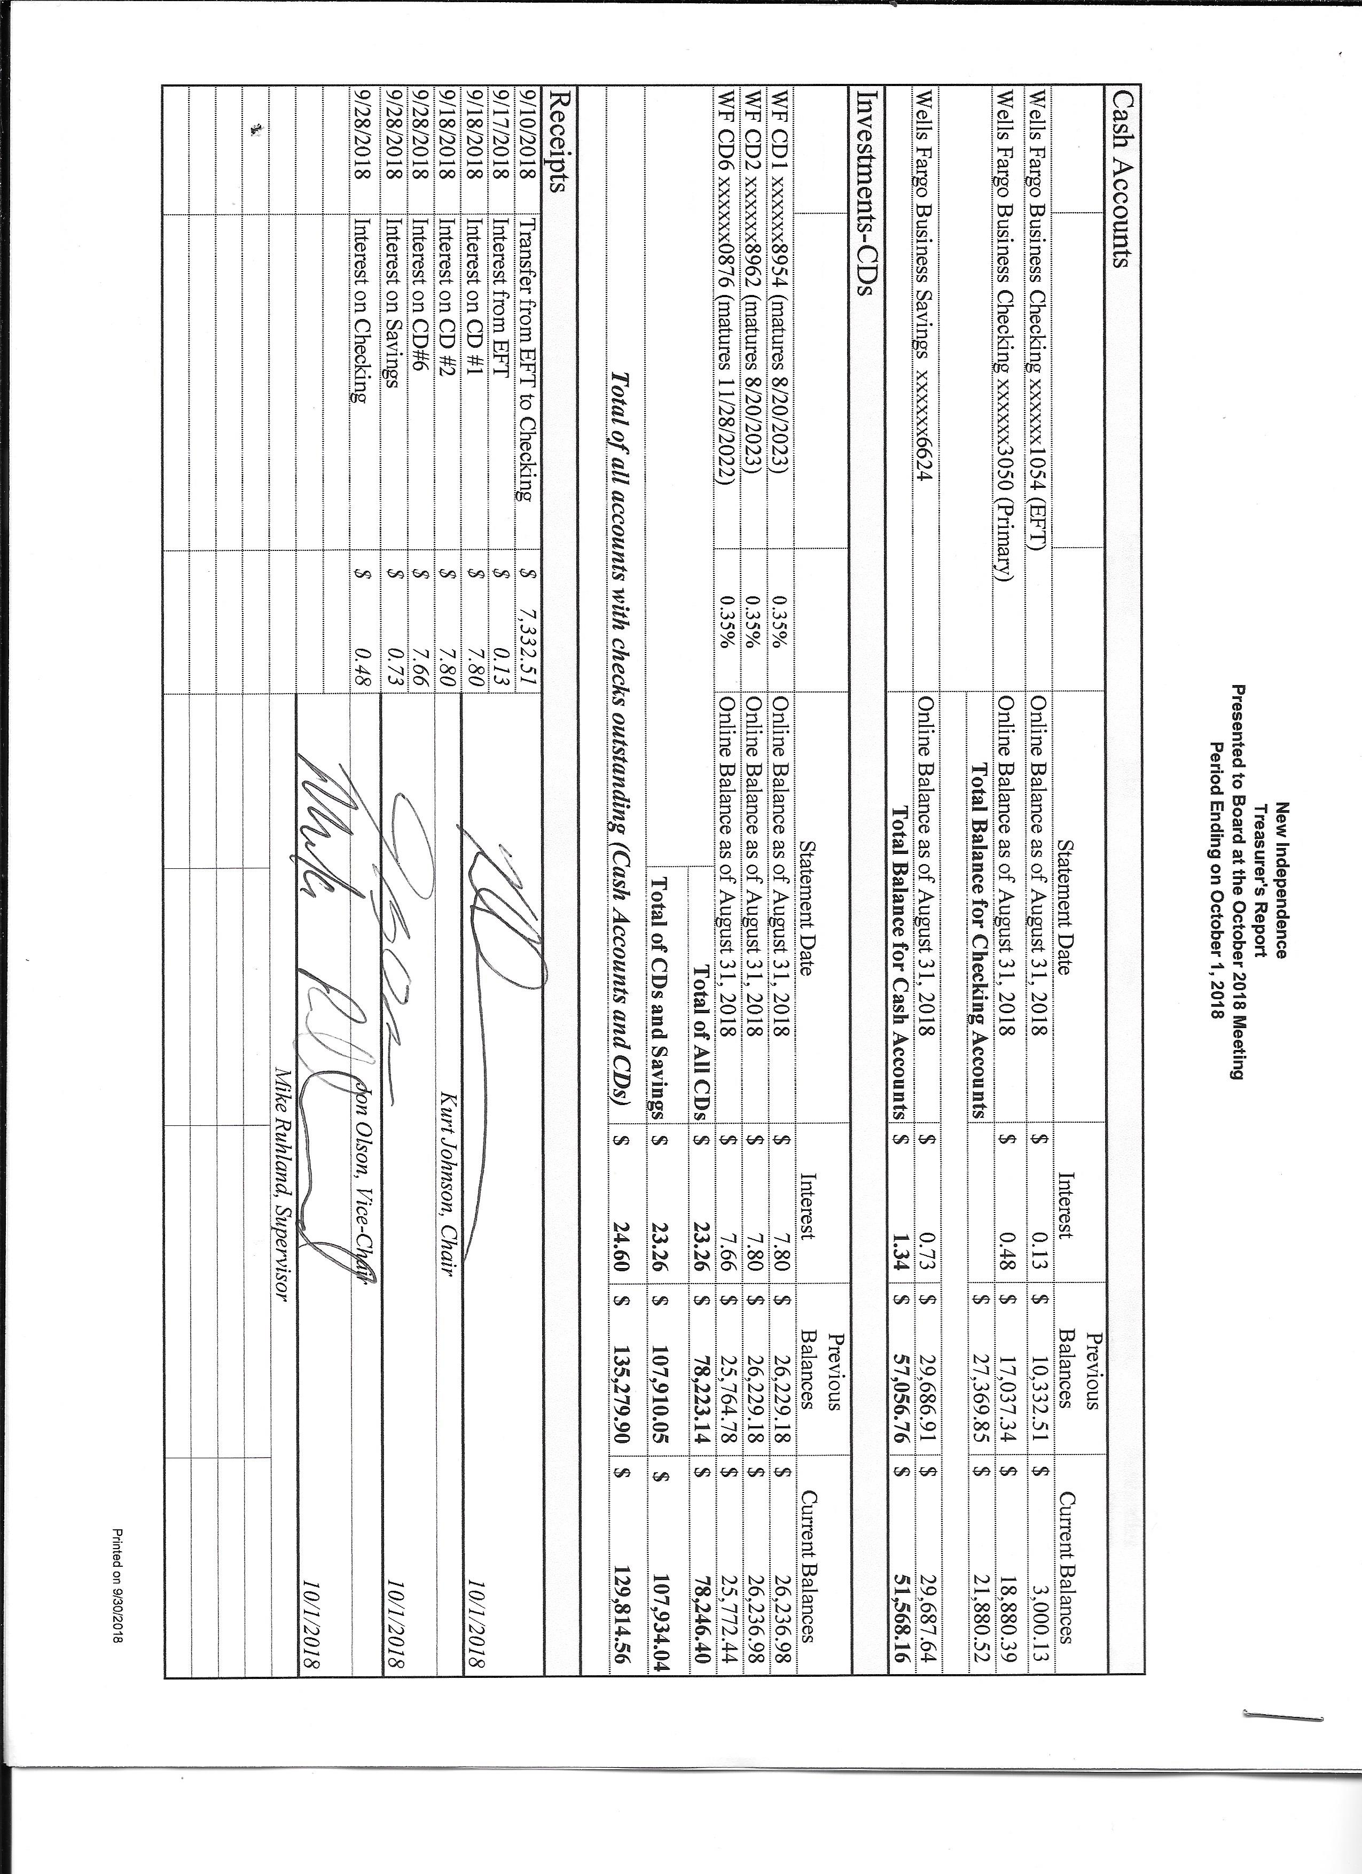

Sandra Lee Olson presented the Clerk’s Report, which included Cash Control Statement (CTAS), Cash Balance Statement (CTAS), Outstanding Checks and Deposits in Transit Report (CTAS), and Schedule B—Investment Activity (CTAS). Mike Ruhland made a motion to accept the Clerk’s Report as presented. A second to the motion was offered by Kurt Johnson, and the motion was passed with a unanimous vote in favor of acceptance.

The clerk brought up the checks that have not cleared and appear to be lost. Mike Ruhland made a motion to void the checks (#4118—Rodda; #4119—US Postal System; #4154—Jay Tremblay; and #4204—Rodda) and reissue all except the one for the US Postal System since a check was reissued earlier this year. Kurt seconded the motion, which passed unanimously.

The following items of Incoming Correspondence were presented to the Board:

1. PERA…*PERA News*
2. University of Minnesota…workshop on Minnesota’s Best Practices for Traffic Sign Maintenance and Management, October 11 in Baxter. Workshop is 8:30 AM to 3:30 PM
3. Industrial Asphalt…advertisement for paving
4. Lake Country Power…estimated meter reading and invoice showing a credit balance of $105.26
5. Public Employees Retirement Association…monthly reporting form
6. McRae Land Improvements…invoice for cutting and removing tree from turnaround on South Johnson Road
7. St. Louis County…notice of reporting money to the township for 2015 and 2016
8. St. Paul Stamp Works, Inc…information on ordering

Payroll and Claims

The following Payroll claims were submitted to the Board. Mike Ruhland made a motion to accept and pay the payroll; Jon Olson seconded the motion; and a unanimous vote in favor of acceptance followed. The following items were submitted to the Treasurer for payment.

* 1. Payroll $93.55
  2. Payroll $93.55
  3. Payroll $187.10
  4. Payroll $46.17
  5. Payroll $398.80
  6. Payroll $93.55
  7. Payroll $46.77
  8. Payroll $35.08

Claims from the following companies/individuals were read into the record by Chairman Kurt Johnson. Mike Ruhland made a motion to accept and pay the claims; Jon Olson seconded the motion; and a unanimous vote in favor of acceptance followed. The following claims were submitted to the Treasurer for payment.

* 1. Mike Ruhland $17.17
  2. Jon Olson $15.80
  3. Peter Olson $14.17
  4. Sandra Lee Olson $147.00
  5. McRae Land Improvements, LLC $200.00
  6. Lake Country Power $300.00
  7. Town of Alborn $9,670.00
  8. PERA $128.76
  9. Frontier Communication $75.00
  10. MATIT $1,669.00

Unfinished Business

1. Cemetery
   * The mowing has ended for the season, but Kurt Johnson reported that baskets still have to be removed and brush needs to be cut.
2. Town Hall
   * Mike Ruhland reported that the light bulbs were replaced, the valve for the water system was installed, and the septic was pumped. As of the meeting, no bill had been received.
   * Kurt Johnson reported that even though he did cancel the salt delivery, salt was delivered. He will call Arrowhead again about the salt delivery.
   * Options were discussed on the handling of the excess water that results from the water softener. The discussion included bringing water in to the Town Hall for drinking. Using a cistern was also discussed. Jon Olson will pick up chlorine to shock the system. Mike will check on prices for a cistern.
   * The thermostat needs to be replaced. Jon Olson will pick up another unit that can be controlled remotely.
3. Roads
   * Road Foreman’s Report
     + Peter Olson reported that the roads are in good shape going into the winter.
     + Jon Olson checked the roads after the recent storm and had concerns about the washout on South Schelin and the tree on South Johnson after the storm. Rodda was called and the issues were resolved.
4. Election
   * Bottled water will need to be picked up for the upcoming election. Sandra Lee Olson will see that is done.
   * Kurt Johnson made a motion, which was seconded by Jon Olson, to supply two pizzas for the election judges.
5. Mail-in Ballots
   * A discussion was held about switching to a mail-in ballot voting system. The Clerk will draft a letter to send to the voters and have it available for the November meeting. Sending the letter after the election would cause less confusion than if it is sent before the election. Residents will be notified that the topic will be discussed at the December monthly meeting.
6. Couri & Ruppe Legal Seminar
   * The seminar will be held on October 6. Officers wishing to attend must make their own reservation.
7. MATIT Commercial Insurance Package Renewal
   * The package was renewed because the clause involving contractors’ equipment is offered to townships at no cost.

New Business

1. St. Louis County Auditor/Treasurer
   * New Independence was notified of an error distributed in funds in 2015 and 2016. The County will adjust future distributions so townships do not have to repay if there was an overpayment. Any underpayment will be added to a future check. The chart below shows the amounts that apply to New Independence.

|  |  |  |  |
| --- | --- | --- | --- |
| CVT 475 | Over/(Under) Paid in 2015 | Over/(Under) Paid in 2016 | Over/(Under) Total Paid |
| Town of New Independence | $196.37 | ($420.61) | ($224.24) |

Officer Reports

None

Jon Olson made a motion for adjournment at 8:00 PM. The motion was seconded by Mike Ruhland and successfully accepted through a unanimous vote. Kurt Johnson declared the meeting closed at that point.

Minutes submitted for approval on _____________November 5, 2018____________________

Clerk’s Signature______________________________________________________________

Chair of the Board of Supervisors’ Signature_________________________________________

**UPCOMING MEETINGS**

***Board of Supervisors’ Meetings for 2018***

November 5

December 3

**2018 SLCAT Calendar (meetings convene at 6:30 pm) and Related Meetings**

October 6, 2018 Couri & Ruppe Legal Short Course – Cotton, 9:00 AM to 4:00 PM

Oct. 24, 2018 Cotton Township 6:30 pm

Nov. 15-17, 2018 MAT ANNUAL CONFERENCE – DULUTH DECC

Dec. 5, 2018 Cotton Township 6:30 pm