Chair Kurt Johnson called the monthly Board of Supervisors Meeting to order at 7:00 PM. Kurt noted that all officers were present for the meeting:

**Supervisors**

* Kurt Johnson
* Jon Olson
* Mike Ruhland**Treasurer**
* Peter Olson**Clerk/Deputy Clerk**
* Kate Laine
* Sandra Lee Olson

Following the Pledge of Allegiance, Jon Olson mad a motion to accept the order of the agenda as printed. Mike Ruhland seconded the motion, which was passed through a unanimous vote in favor of the motion.

Minutes from October Board of Supervisors’ Meeting were read by Clerk Sandra Lee Olson. Upon completion of the reading, Kurt Johnson made a motion to accept the minutes. A second to the motion was offered by Jon Olson, and the motion was passed through a unanimous vote from the Supervisors. The minutes were placed on file with other documents from the meeting.

After Peter Olson read the Treasurer’s Report into the record, Mike Ruhland made a motion to accept the report, subject to audit. The motion was seconded by Jon Olson, and passed through a unanimous vote in favor of accepting the report. The first page of his report is reproduced below. Other pages of his report included: Cash Control Statement (CTAS), Outstanding Checks and Deposits in Transit Report, and Schedule 8—Investment Activity CTAS). The entire report was placed on file with other documents from the meeting.

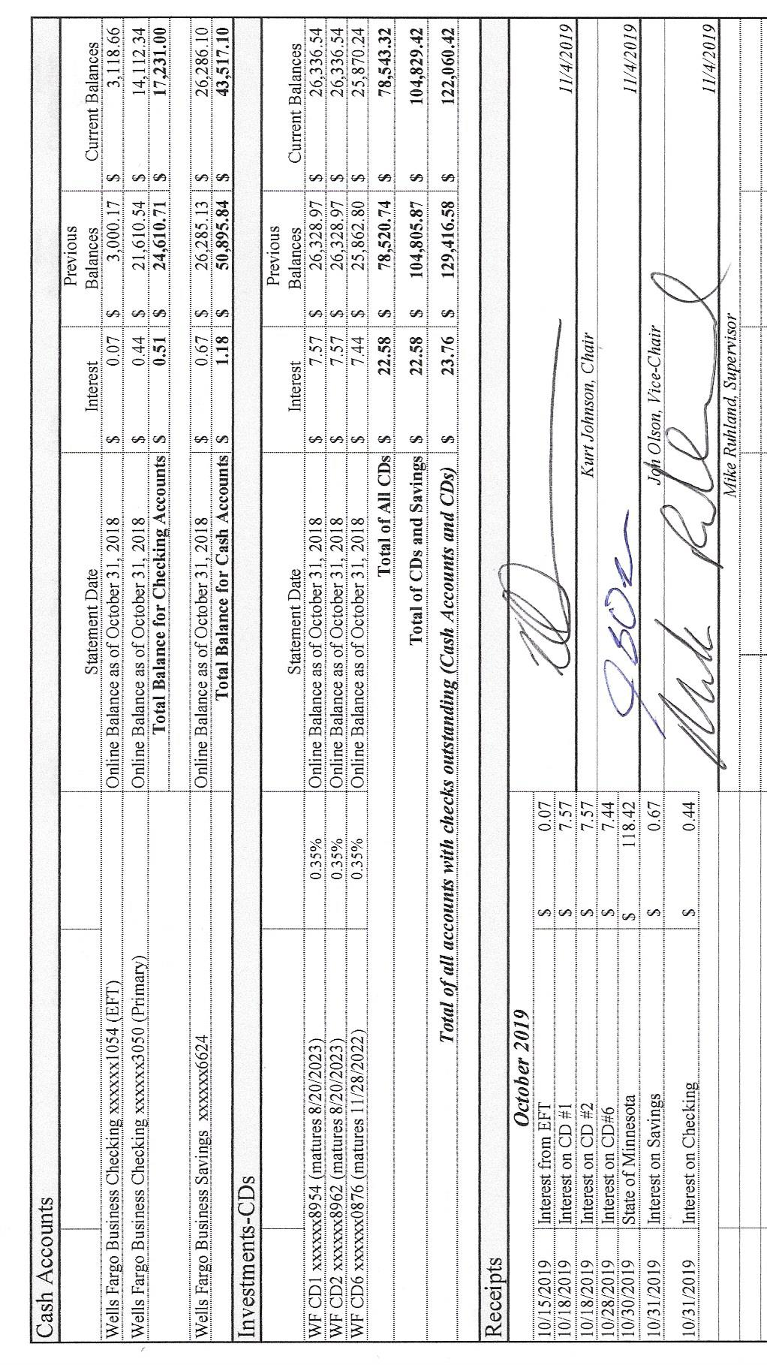

Upon completion of the reading of the Clerk’s Report by Sandra Lee Olson, Mike Ruhland made a motion to accept the report subject to audit. Jon Olson offered a second to the motion, which was subsequently accepted through a unanimous vote in favor of the motion. The first page of her report is shown below. Other pages in the report included: Outstanding Checks and Deposits in Transit Report (CTAS), Cash Balance Statement (CTAS), and Current Investments with Accrued Interest (CTAS) The entire report was placed on file with other documents from the meeting.

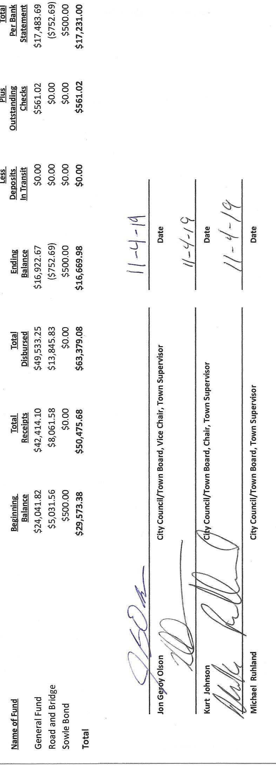

Sandra Lee questioned what the Board how much money should be transferred from the Savings to the Checking to cover the checks. Jon Olson made a motion to bring the Savings down to 20,000 by transferring money to the Checking account. This will cover any checks written until the Tax Apportionment payment is received. Mike Ruhland seconded the motion, which was passed through a unanimous vote.

The following items of Incoming Correspondence were presented to the Board.

1. Lake Country Power…credit of $109.40
2. St. Louis County/Planning and Community Development…proposed revisions to St. Louis County Zoning Ordinance 62
3. Guardian Pest Control…invoice for spraying for cluster flies ($161.08)
4. Federated Co-op, Inc

* Credit as of September 30, 2019 ($316.88)
* Propane safety information

1. Arrowhead Water Conditioning…delivery of salt on 9/11/2019 ($38.85)
2. Rodda Grading & Excavating…invoice for work completed in October 2019 ($1920.00)
3. St. Louis County Elections…certification for Sandra Lee Olson to oversee elections

Emails

1. Jay Tremblay…quote for snowplowing ($35/plowing)
2. Elections
   * Phil Chapman…official notice of 2020 Presidential Nomination Primary to be held on Tuesday, March 3, 2020
   * Phil Chapman…notice of an upcoming training for clerk or other official overseeing the election
   * Jonathan Blevins…registration for upcoming training for the 2020 Presidential Nomination Primary
     + Tuesday, December 10, 2019 at Virginia, MN, at 9:30 AM
     + Tuesday, December 10, 2019 at Virginia, MN, at 2:00 PM
     + Friday, December 13, 2019 at St, Louis County Courthouse at 10:00 AM
     + Friday, December 13, 2019 at St, Louis County Courthouse at 2:00 PM
3. Cathy Rouleau
   * Bus reservation for State Conference in Mankato
   * SLCAT meeting dates
4. State of Minnesota…notice of deposit or MV-Agriculture ($118.42)

The following Payroll claims were read into the record by Chair Kurt Johnson. Following the reading, Mike Ruhland made a motion to submit the claims to the Treasurer for payment; Jon Olson seconded the motion, and a unanimous vote in favor of the motion followed.

* 1. Payroll $163.71
  2. Payroll $228.19
  3. Payroll $93.55
  4. Payroll $318.75
  5. Payroll $46.17
  6. Payroll $399.86
  7. Payroll $187.10

The following Claims were submitted to the Treasurer for payment after they were read into the record by Chair Kurt Johnson, a motion to pay the claims by Jon Olson, a second offered by Mike Ruhland, and a unanimous vote in favor of paying the claims.

* 1. Public Employees Retirement Association $152.50
  2. Town of Alborn $115.03
  3. Alborn Fire Department Petty Cash $148.33
  4. Alborn Fire Department Relief Association $191.76
  5. Guardian Pest Solutions $161.06
  6. Frontier Communications $80.00
  7. Town of Alborn $9670.00
  8. Stacy Kleiner $23.40
  9. Peter Olson $15.08
  10. Sandra Lee Olson $16.38
  11. Lake Country Power $200.00
  12. Arrowhead Water Conditioning $38.85
  13. Rodda Grading & Excavating $1920.00

The following items were discussed by the Board as Unfinished Business:

1. Cemetery
   * Kurt reported that he remapped the cemetery
   * Snowplowing at cemetery and town hall was discussed after a quote was received by Jay Tremblay. Jay has plowed the town hall and cemetery for a number of years. In the past the township has accepted him as a contractor. When the workmen’s comp was completed last year, the secretary from MATIT suggested that the snowplowing position be listed as an employee. The discussion about the status for this position was discussed among the supervisors who decided it would be best to hire Jay Tremblay as an employee. As an employee he would have the standard deductions withheld—FICA, Medicare, and taxes. In addition, he would be covered by workmen’s comp insurance. Jon Olson made a motion to hire Jay Tremblay as an employee for the snowplowing position. Mike Ruhland seconded the motion, which was passed through a unanimous vote of approval. The clerk will contact Jay and discuss the option with him.
2. Town Hall discussions addressed the following issues:
   * Jon made arrangements for Randall Heating to be at the Town Hall on Friday to do an annual maintenance on the furnace.
   * Kurt obtained a chair for the deputy clerk.
   * Jon will pick up stakes to mark the well by the Town Hall to ensure it is visible for plowing.
3. Township Roads
   * Road foreman Peter Olson did his monthly review of the roads and reported that the roads are in good shape and ready for winter. He did not feel, however, that the culvert by Murphy’s is working properly and will need to be addressed in the spring.
4. Northern Natural Gas Pipeline
   * The clerk contacted Northern Natural Gas Pipeline and is waiting for a return call from their office.
5. Land at the forest tower
   * The clerk made a follow up contact with the State about the acre of land by the cemetery where the forest tower used to stand. In her conversation, she affirmed that the Board of Supervisors is interested in obtaining the land.
6. Tasky Follow up
   * Kurt contacted Donald Regnie about the building situation that the Taskys are facing. Basically, he was told by the county that Tasky will need to take it down or make it smaller so that the building is in compliance with building ordinances.

The following items of New Business were presented and discussed by the Board

1. Annual Conference in Mankato
   * None of the township officers are able to attend the upcoming conference in Mankato
2. Fire Contract
   * The second half of the fire contract with Alborn is due in December. In the past, the supervisors have preferred paying the assessment before the December meeting so the payment shows on the current year’s breakdown. A check was approved by the Board and will be mailed before Alborn’s December meeting.
3. St. Louis County Presidential Primary Training
   * Kurt Johnson made a motion, which was seconded by Mike Ruhland, to authorize the clerk to attend the training on December 13 in Duluth with receive meeting rate, mileage, and parking reimbursement. The motion carried through a unanimous vote in favor of the motion.

Officer Reports

1. Joint Powers…Mike Ruhland

Having no additional business to bring to the Board, Kurt asked for a motion to adjourn. Mike Ruhland offered the motion to adjourn, which was seconded by Jon Olson and passed through a unanimous vote in favor of adjournment. Kurt adjourned the meeting at 8:18 PM

Minutes submitted for approval on ____________December 2, 2019_____________________

Clerk’s Signature______________________________________________________________

Chair of the Board of Supervisors’ Signature_________________________________________

**UPCOMING MEETINGS**

***Board of Supervisors’ Meetings for 2019***

December 2, 2019

***Board of Supervisors’ Meetings for 2020***

January 6, 2020

February 3, 2020

March 2, 2020

April 6, 2020

May 4, 2020

June 1, 2020

July 6, 2020

August 3, 2020

September 14, 2020

October 5, 2020

November 2, 2020

December 7, 2020

**2019-2020 SLCAT Calendar (meetings convene at 6:30 pm) and Related Meetings**

DEC. 4, 2019 COTTON COMMUNITY CENTER 6:30 PM -

JAN. 22, 2020 COTTON COMMUNITY CENTER 6:30 PM

* POSSIBLY THE ELECTION DEPT. FOR ST. LOUIS COUNTY TO BE SURE WE HAVE ALL OUR INFORMATION, ETC. FOR THE PRESIDENTIAL NOMINATION PRIMARY

FEB. 26, 2020 COTTON COMMUNITY CENTER 6:30 PM

MAR. 25, 2020 COTTON COMMUNITY CENTER 6:30 PM

APR.  22, 2020 NEED A TOWNSHIP TO VOLUNTEER TO HOST THE APRIL MEETING.

CALL CATHY AT 290-4970

MAY 27, 2020 COTTON COMMUNITY CENTER 5:30 P.M.

* ANNUAL SLCAT ELECTION AND MEETING;