The November Board of Supervisors’ Meeting was called to order by its chair, Kurt Johnson, at 7:05 PM. Kurt noted that all officers were present. Those officers included: Supervisor Kurt Johnson, Supervisor Jon Olson, and Supervisor Mike Ruhland, Treasurer Peter Olson, and Clerk Sandra Lee Olson.

Following the Pledge of Allegiance, Mike Ruhland made a motion to accept the Agenda as presented. Jon Olson seconded the motion, which passed with a unanimous vote in favor of acceptance.

Clerk Sandra Lee Olson read the minutes of the October 1, 2018, meeting. Mike Ruhland made motion to accept the minutes as read. The motion was seconded by Jon Olson and passed through a unanimous vote in favor of the motion.

Peter Olson read the Treasurer’s Report, which included: Treasurer’s Summary Report, Cash Control Statement (CTAS), Outstanding Checks and Deposits in Transit Report (CTAS), and Schedule B—Investment Activity (CTAS). Mike Ruhland made a motion, which was seconded by Jon Olson and passed, to accept the Treasurer’s Report. While the entire package of reports is included with documents from the meeting, the first page is shown below:

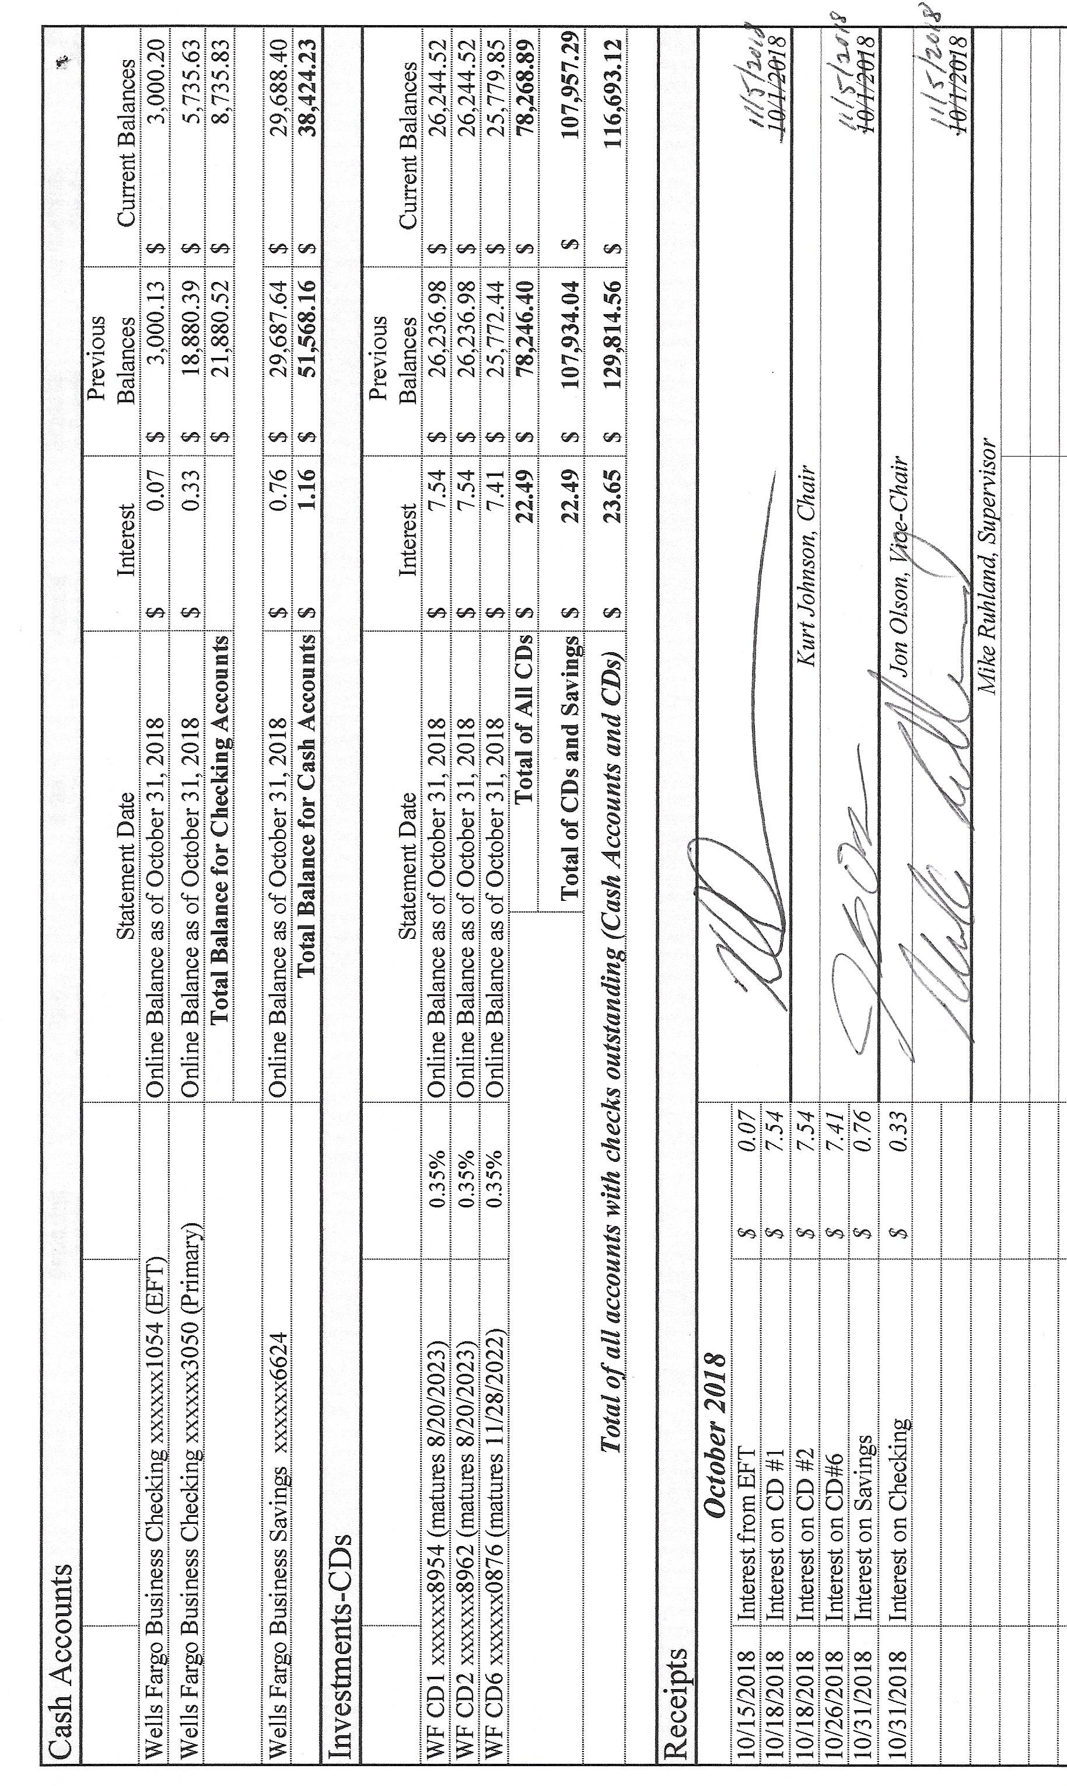

Sandra Lee Olson presented the Clerk’s Report, which included Cash Control Statement (CTAS), Cash Balance Statement (CTAS), Outstanding Checks and Deposits in Transit Report (CTAS), Current Investments (CTAS), and Cash Balance Statement (CTAS) showing balances after all checks from the November meeting clear. Mike Ruhland made a motion to accept the Clerk’s Report as presented. A second to the motion was offered by Jon Olson, and the motion was passed with a unanimous vote in favor of acceptance. The Clerk noted that $5,000 had been transferred on November 5, 2018, from Savings to Checking to cover the checks the would be issued at the November meeting.

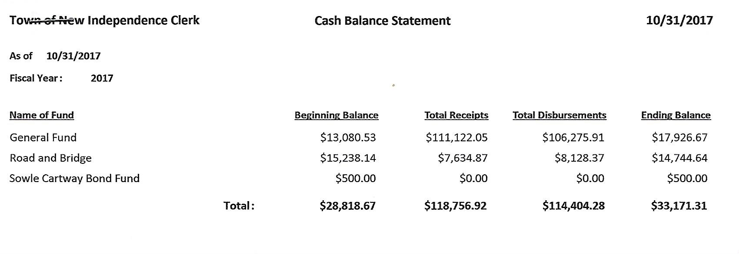

The following items of Incoming Correspondence were presented to the Board
- Brent Septic…invoice for pumping ($185)
- Minnesota Association of Townships…. request for officer information
- St. Louis County Association of Township Officers
  - Minutes of the Annual Meeting held on 5/23/18
  - Minutes of the SLCATO Meeting held on 4/25/2018
- Lake Country Power…monthly statement showing a credit ($301.20)
- PERA…monthly reporting form
- Federated Co-oops…propane safety information
- St. Louis County Auditor…certification for Sandra Lee Olson as Head Judge Training
- Rodda Grading & Excavating
  - September 26 Billing…$630.00
  - October 29 Billing…$832.50
- Lake Country Power…newsletter Strictly Business
- Arrowhead Regional Development Commission…nomination for Township Official Representative for St. Louis County ARDC Representative
- State of Minnesota…MV Credit Agricultural payment ($124.12)
- St. Louis County (SLC) Auditor…voter list
- SLC…invoice for first half of 2018-2019 snowplowing ($2,203.52) and notice that a yearly request needs to be made for services
- SLC Planning and Community Development Department…notice of meeting that was held on Thursday, October 18, 2018, at 9:00 AM
- Frontier Communication…monthly phone and internet service ($65.12)
- Jay Tremblay…snowplowing bid
- SLC…write in Summary Statements
- American Transparency…request for employee information
- SLC…notice regarding the continuation of the Comprehensive Land Use Plan public hearing
- Alborn Fire Department…minutes from the August, September, and October Fire Meetings.

Payroll and Claims
The following Payroll items were presented to the Board. Mike Ruhland made a motion to pay the payroll as submitted Jon Olson seconded the motion, which was then passed through a unanimous vote in favor of the motion. The Payroll was submitted to the Treasurer for payment.
  - Payroll $93.55
  - Payroll $116.94
  - Payroll $187.10
  - Payroll $46.17
  - Payroll $398.80
  - Payroll $93.55
  - Payroll $23.39
  - Payroll $138.52

The following Claims were read into the record by Kurt Johnson. Upon completion, Jon Olson made a motion to pay the claims as presented. A second was offered by Mike Ruhland and the motion was accepted through a unanimous vote. The claims were submitted to the Treasurer for payment.
  - Jon Olson $120.70
  - Peter Olson $14.17
  - Sandra Lee Olson $113.69
  - PERA $125.00
  - Brent’s Septic $185.00
  - Rodda Grading and Excavating $630.00
  - Rodda Grading and Excavating $832.50
  - SLC Auditor $2,203.52
  - Frontier Communication $65.12

Claims that haven’t cleared were read into the record. A motion to void and reissue these checks was offered and passed at the October meeting. Check Number 4119 to US Postal Service was already reissued, so it did not need to be included. A letter will be sent with each of the checks listed below explaining why they are being reissued.
  - Rodda Grading and Excavating (#4118) $251.00
  - Jay Tremblay (#4154) $60.00
  - Rodda Grading and Excavating (#4204) $1,665.00

Unfinished Business
- Cemetery
  - Kurt Johnson did clean up a few things at the cemetery to get it ready for the winter months.
- Town Hall
  - Supplies purchased
    - Jon Olson purchased chlorine for shocking the well, cleaning supplies and a new thermostat. Although the well has not been shocked yet, he did install the thermostat.
  - Septic
    - Jon Olson and Mike Ruhland checked the septic to determine the current level of water that is in the tank. The water softener needs to cycle frequently in order to control the iron in the water. As a result, the septic, which is a holding tank, fills up very quickly. At the last meeting, the supervisors discussed the problem and decided to look at other options. One of the options considered was a cistern system with a three-way valve that would allow multiple ways to access water flow. Mike Ruhland did research on the costs involved with installing the new system and determined that it would cost about $600 to make the change. A discussion also included options for the water softener. General consensus of the Board was to keep the water softener until a determination is made about the feasibility of the alternate system. Until a different system is installed Kurt Johnson made a motion to not use the water softener and have the holding tank pumped again before winter. Jon Olson seconded the motion, which was accepted through a unanimous vote in favor of the motion. Mike Ruhland will contact the septic pumping company and arrange for the tank to be pumped in the near future. The installation of the new system will not be started right away. Instead, the Supervisors felt that it should be carefully planned before starting the project.
  - Frontier
    - The Clerk contacted Frontier about the internet service that is supplied by them. Because the Border-to-border program was incorporated into the Town Hall, Frontier was supposed to credit townships with a free year of internet. If the internet service from Frontier were disconnected, the bill would remain almost the same due to bundling services. The Clerk did not have it disconnected.
- Roads
  - Road Foreman’s Report
    - Peter Olson reported that there is a washout on Nelson Road. Peter has contacted Rodda and left messages for him because ditching needs to be completed. Until the ditching is done, the washout will continue to be a problem.
- Election
  - AutoMark Testing was completed on November 1, 2018. Two election judges, Shirley Tremblay and Dorothy Williams, conducted the public testing with Clerk Sandra Lee Olson.
  - The General Election will be Tuesday, November 6. The constituents set the hours at the last Annual Meeting, so polls will be open from 7:00 AM until 8 PM.
  - Election judges have been lined up for the General Election and will include Joyce Greer, Stacy Kleiner, Shirley Tremblay, Dorothy Williams, and Karen Witkowski. Dorothy Williams was added as an election judge to allow Karen to start about noon. In addition, the election judges will be able to leave to vote in their own precincts and New Independence will still be adequately manned.
  - Board of Canvass will be held on November 12, 2018, at 7:00 PM. Town Board Supervisors and the Clerk will meet to certify the results and determine the successfully elected candidates for Supervisor C and Town Clerk.
  - Supper for the election judges will be pizzas obtained from the Clip Joint, as approved at a previous meeting.
- Mail-in Ballots
  - Clerk Sandra Lee Olson presented a draft of a letter that will be sent to voters. Initially, the Board was going to discuss the possibility of switching to a mail in ballot system at the December meeting, but after a lengthy discussion, Kurt Johnson made a motion to discuss the mail in ballot system at the Annual Meeting in March. Mike Ruhland seconded the motion, which was subsequently accepted through a unanimous vote. Sandra Lee will make the necessary revisions and send the letter to voters in February.

- Follow up on Zoning Issue on Highway 7
  - Mike Ruhland asked if any additional information had been obtained about the impound area that was set up on Highway 7. Kurt Johnson said he would contact the County to see what is the current status of the complaint.

New Business
- MAT Annual Conference
  - The Annual Conference will be held at the DECC on November 15-17. At this point, no officer is planning to attend.
- Nomination for Township Official Representative for St. Louis County ARDC Representative
  - The term for the current township officer that represents St. Louis County on the ARDC will soon be expiring. None of the New Independence officers were interested in serving on the committee, so no action was taken to nominate an individual.
- SLC Road Services Letter
  - The recent letter from St. Louis County stated that townships must submit a request for work that is to be completed by SLC road crews. Examples given were sanding, culvert thawing, or grading. Because New Independence has a maintenance agreement, no action was necessary.
- Snowplowing
  - Jay Tremblay submitted a quote for the 2018-2019 snowplowing at the cemetery and town hall. He will plow each location for $30/site/time when there is four or more inches of snowfall. In addition, he will plow the Town Hall before monthly meetings. Jon Olson made a motion to continue having Jay plow for the 2018-2019 winter season. Mike Ruhland seconded the motion, which was accepted through a unanimous vote. The clerk will notify Jay that he has been awarded the snowplowing contract.
- Request for Financial Information
  - New Independence has received several requests from openthebooks.com. The clerk reported that New Independence does not have to supply the information because it is not an urban township. As such, financial records are confidential,
- Land Use Plan
  - Planning and Zoning will continue to hear comments at the public hearing scheduled for November 8, 2018, in Virginia. New Independence will not be sending a representative.

Officer Reports
There were no additional officer reports to present to the Board.

Mike Ruhland made a motion for adjournment, which was seconded by Jon Olson and passed with a unanimous vote. Kurt Johnson declared the meeting to be closed at 8:37 PM.

Minutes submitted for approval on ____________December 3, 2018_____________________

Clerk’s Signature______________________________________________________________

Chair of the Board of Supervisors’ Signature________________________________________

UPCOMING MEETINGS
Board of Supervisors’ Meetings for 2018
December 3

2018 SLCAT Calendar (meetings convene at 6:30 pm) and Related Meetings
Nov. 15-17, 2018 MAT ANNUAL CONFERENCE – DULUTH DECC
Dec. 5, 2018 Cotton Township 6:30 pm

