At 7:00 PM, Chair Kurt Johnson called the December Board of Supervisors’ Meeting to order with all officers present:

Roll Call:

**Supervisors**

* Kurt Johnson
* Jon Olson
* Mike Ruhland**Treasurer**
* Peter Olson**Clerk/Deputy Clerk**
* Kate Laine
* Sandra Lee Olson

Following the Pledge of Allegiance, Mike Ruhland made a motion to accept the Agenda as printed. Kurt Johnson offered a second to the motion, which was accepted through a unanimous vote in favor of the motion.

Clerk Sandra Lee Olson read the minutes from November 4, 2019, Board of Supervisors’ Meeting into the record. Upon completion, Mike Ruhland made a motion to accept the minutes as read. Jon Olson offered a second to the motion, which accepted through a unanimous vote in favor of the motion. The minutes were placed on file with the Clerk’s records for the meeting.

The next order of business was the reading of Treasurer’s Report by Treasurer Peter Olson. While the first page of the report is reproduced, the entire report was placed on file with other documents from the meeting. The report included the customized Summary Report, Cash Control Statement (CTAS), Outstanding Checks and Deposits in Transit Report (CTAS), and Schedule—Investment Activity (CTAS). Mike Ruhland made motion to accept the report—subject to audit. Following a second from Jon Olson, the motion was accepted through a unanimous vote in favor of the motion and was placed on file with other documents from the meeting.

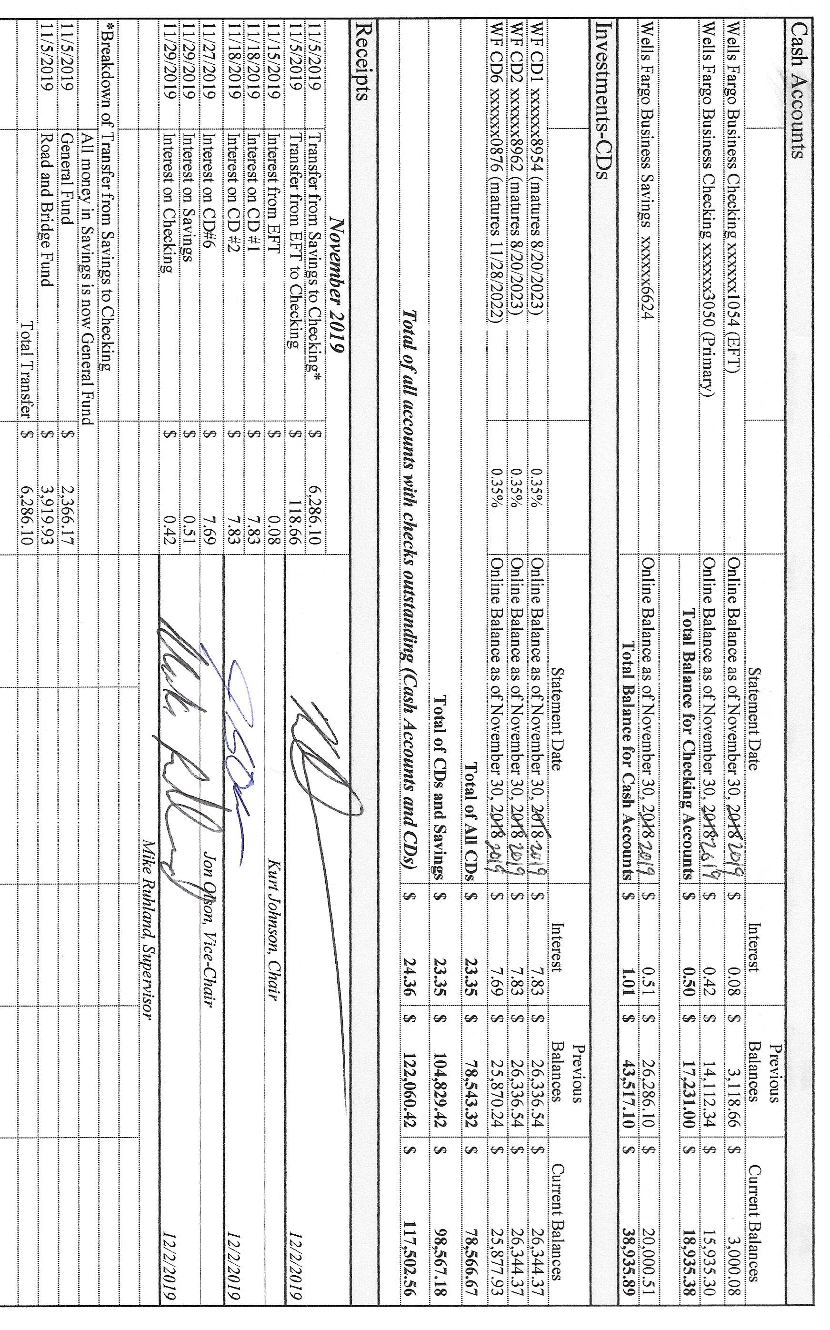

Sandra Lee Olson presented the Clerk’s Report, which include the Cash Control Statement (CTAS and reproduced below), Outstanding Checks and Deposits in Transit Report (CTAS), Cash Balance Statement (CTAS), and Current Investments with Accrued Interest (CTAS). Following her summary of the report, Mike Ruhland made a motion to accept the report—subject to audit; Jon Olson offered a second to the motion, which was accepted through a unanimous vote in favor of the motion, and the entire report was placed on file with other documents from the meeting.

The following items of Incoming Correspondence were presented to the Board:

1. Minnesota Association of Townships…request for input on possible topics for the short courses.
2. Lake Country Power…monthly power statement showing a credit of $309.40
3. Federated Co-ops…debit of $316.88 leaving a balance of unused prepaid credits of $1,316.88
4. Lake Country Power…*Strictly Business* newsletter
5. St. Louis County (SLC)/Planning and Community Development Department…notice of Planning Commission Public Hearing on Thursday, December 12 at 9:45 AM. Topic of hearing with be St. Louis County Zoning Ordinance 62 proposed Short-Term Rental standards and amendment. The meeting will be held at the SLC Public Works Building, 7823 Highway 135, Virginia, MN, in the lower-level training room
6. Minnesota Department of Revenue…New Independence qualifies for annual withholding tax returns instead of quarterly. Notice has to be given by December 5, 2019
7. Minnesota Association of Townships Agency…workers’ compensation renewal invoice ($342.00 due by January 1, 2020) and audit (due by January 31, 2020)
8. Rodda Grading & Excavating…grading invoice for $742.50.
9. Alborn Fire Department…minutes from the October 30, 2019, meeting.
10. Gary Fredrickson…notification to Supervisor Olson that the sheriff was called out about a road disturbance involving the residents on South Schelin Road

The following Payroll items were read into the record by Chair Kurt Johnson. Upon completion, Jon Olson offered a motion to pay the payroll as presented. Mike Ruhland offered a second, and the motion was accepted through a unanimous vote in favor of the motion. The payroll was submitted to the Treasurer for payment.

* 1. Payroll $93.55
  2. Payroll $228.19
  3. Payroll $93.55
  4. Payroll $318.75
  5. Payroll $46.17
  6. Payroll $399.86
  7. Payroll $93.55

The following Claims were read into the record by Kurt Johnson. Mike Ruhland made a motion to pay the claims as presented. Following a second by Jon Olson, the Board voted to accept the motion through a unanimous vote. The claims were submitted to the Treasurer for payment.

* 1. Frontier Communications $80.00
  2. Public Employees Retirement Association $135.00
  3. Peter Olson $14.17
  4. Sandra Lee Olson $71.58
  5. MN Revenue $76.79
  6. US Treasury $489.88
  7. Rodda Grading & Excavating $742.50
  8. MATIT $342.00

The following items of Unfinished Business were discussed by the Town Board.

1. Cemetery
   * Jay Tremblay had a problem with his plow and made arrangements for the Town Hall to be plowed for the meeting. He is expecting the part to arrive in the near future.
2. Town Hall
   * While the snowplowing is completed by Jay Tremblay, the snow shoveling remains a concern. The Board discussed hiring someone to shovel before meetings. Jon Olson said he would take responsibility to make certain the ramps are shoveled prior to Board meetings.
   * Mike Ruhland will pick up supplies for the Town Hall—shovels, salt, scraper, shovels, etc. He will be reimbursed for the expense.
   * Jon Olson contacted Randall Heating in Cloquet. Randall Heating replaced a part in the furnace.
3. Township Roads were inspected by Road Foreman Peter Olson, who reported the roads are in good shape going into the winter.
4. Northern Natural Gas Pipeline was contacted. The Clerk is still waiting for a return call from the company.
5. Land at the forest tower is currently being considered by the State since New Independence has shown an interest in the property. New Independence will be notified when there is a decision.

New Business

1. Presidential Nominating Primary (PNP)
   * SLCAT Meeting hopes to discuss the PNP at its December meeting. Sandra Lee Olson will attend.
   * Training in Duluth on December 13, 2019 is being offered for clerks. Sandra Lee Olson has committed to attending the training on behalf of the township.
2. As a point of information, Sandra Lee Olson reminded the Board that the January Board of Reorganization and Regular meeting will be part of the January meeting.
3. Minnesota Annual Filing of Withholding vs Quarterly is an option for New Independence. The Board said they would approve the method preferred by the clerk. Because the township currently does a quarterly report for the IRS, it will continue to do a quarterly report for the State of Minnesota. There will be no change in filing at this time.

Officer Reports

None

Because there were no additional items to be brought before the Board, Kurt Johnson asked for a motion for adjournment. Mike Ruhland offered the motion; Jon Olson offered the second; and a unanimous vote in favor of adjournment was passed. Kurt declared the meeting to be adjourned at 7:55 PM.

Minutes submitted for approval on ________________________________________________

Clerk’s Signature______________________________________________________________

Chair of the Board of Supervisors’ Signature_________________________________________

**UPCOMING MEETINGS**

***Board of Supervisors’ Meetings for 2020***

January 6, 2020

February 3, 2020

March 2, 2020

April 6, 2020

May 4, 2020

June 1, 2020

July 6, 2020

August 3, 2020

September 14, 2020

October 5, 2020

November 2, 2020

December 7, 2020

**2019-2020 SLCAT Calendar (meetings convene at 6:30 pm) and Related Meetings**

DEC. 4, 2019 COTTON COMMUNITY CENTER 6:30 PM -

JAN. 22, 2020 COTTON COMMUNITY CENTER 6:30 PM

* POSSIBLY THE ELECTION DEPT. FOR ST. LOUIS COUNTY TO BE SURE WE HAVE ALL OUR INFORMATION, ETC. FOR THE PRESIDENTIAL NOMINATION PRIMARY

FEB. 26, 2020 COTTON COMMUNITY CENTER 6:30 PM

MAR. 25, 2020 COTTON COMMUNITY CENTER 6:30 PM

APR.  22, 2020 NEED A TOWNSHIP TO VOLUNTEER TO HOST THE APRIL MEETING.

CALL CATHY AT 290-4970

MAY 27, 2020 COTTON COMMUNITY CENTER 5:30 P.M.

* ANNUAL SLCAT ELECTION AND MEETING;