Chair Kurt Johnson called the December Board of Supervisors’ Meeting to order at 7:00 PM and stated that all officers were present: Supervisors Kurt Johnson, Jon Olson, and Mike Ruhland; Treasurer Peter Olson; and Clerk Sandra Lee Olson
Roll Call

Following the Pledge of Allegiance, Jon Olson made a motion to accept the agenda. Mike Ruhland seconded the motion, which was accepted by a unanimous vote.

Clerk Sandra Lee Olson read the minutes of the November meeting. When she had completed the reading, Jon Olson made a motion to accept the minutes as read. Following a second by Mike Ruhland, the motion was accepted through a unanimous vote.

Peter Olson presented his Treasurer’s Report for the period ending on November 30,2018. His reported consisted of:
- New Independence Treasurer’s Report (shown below)
- Cash Control Statement (CTAS)
- Outstanding Checks and Deposits in Transit Report (CTAS)
- Current Investments with Accrued Interest (CTAS)

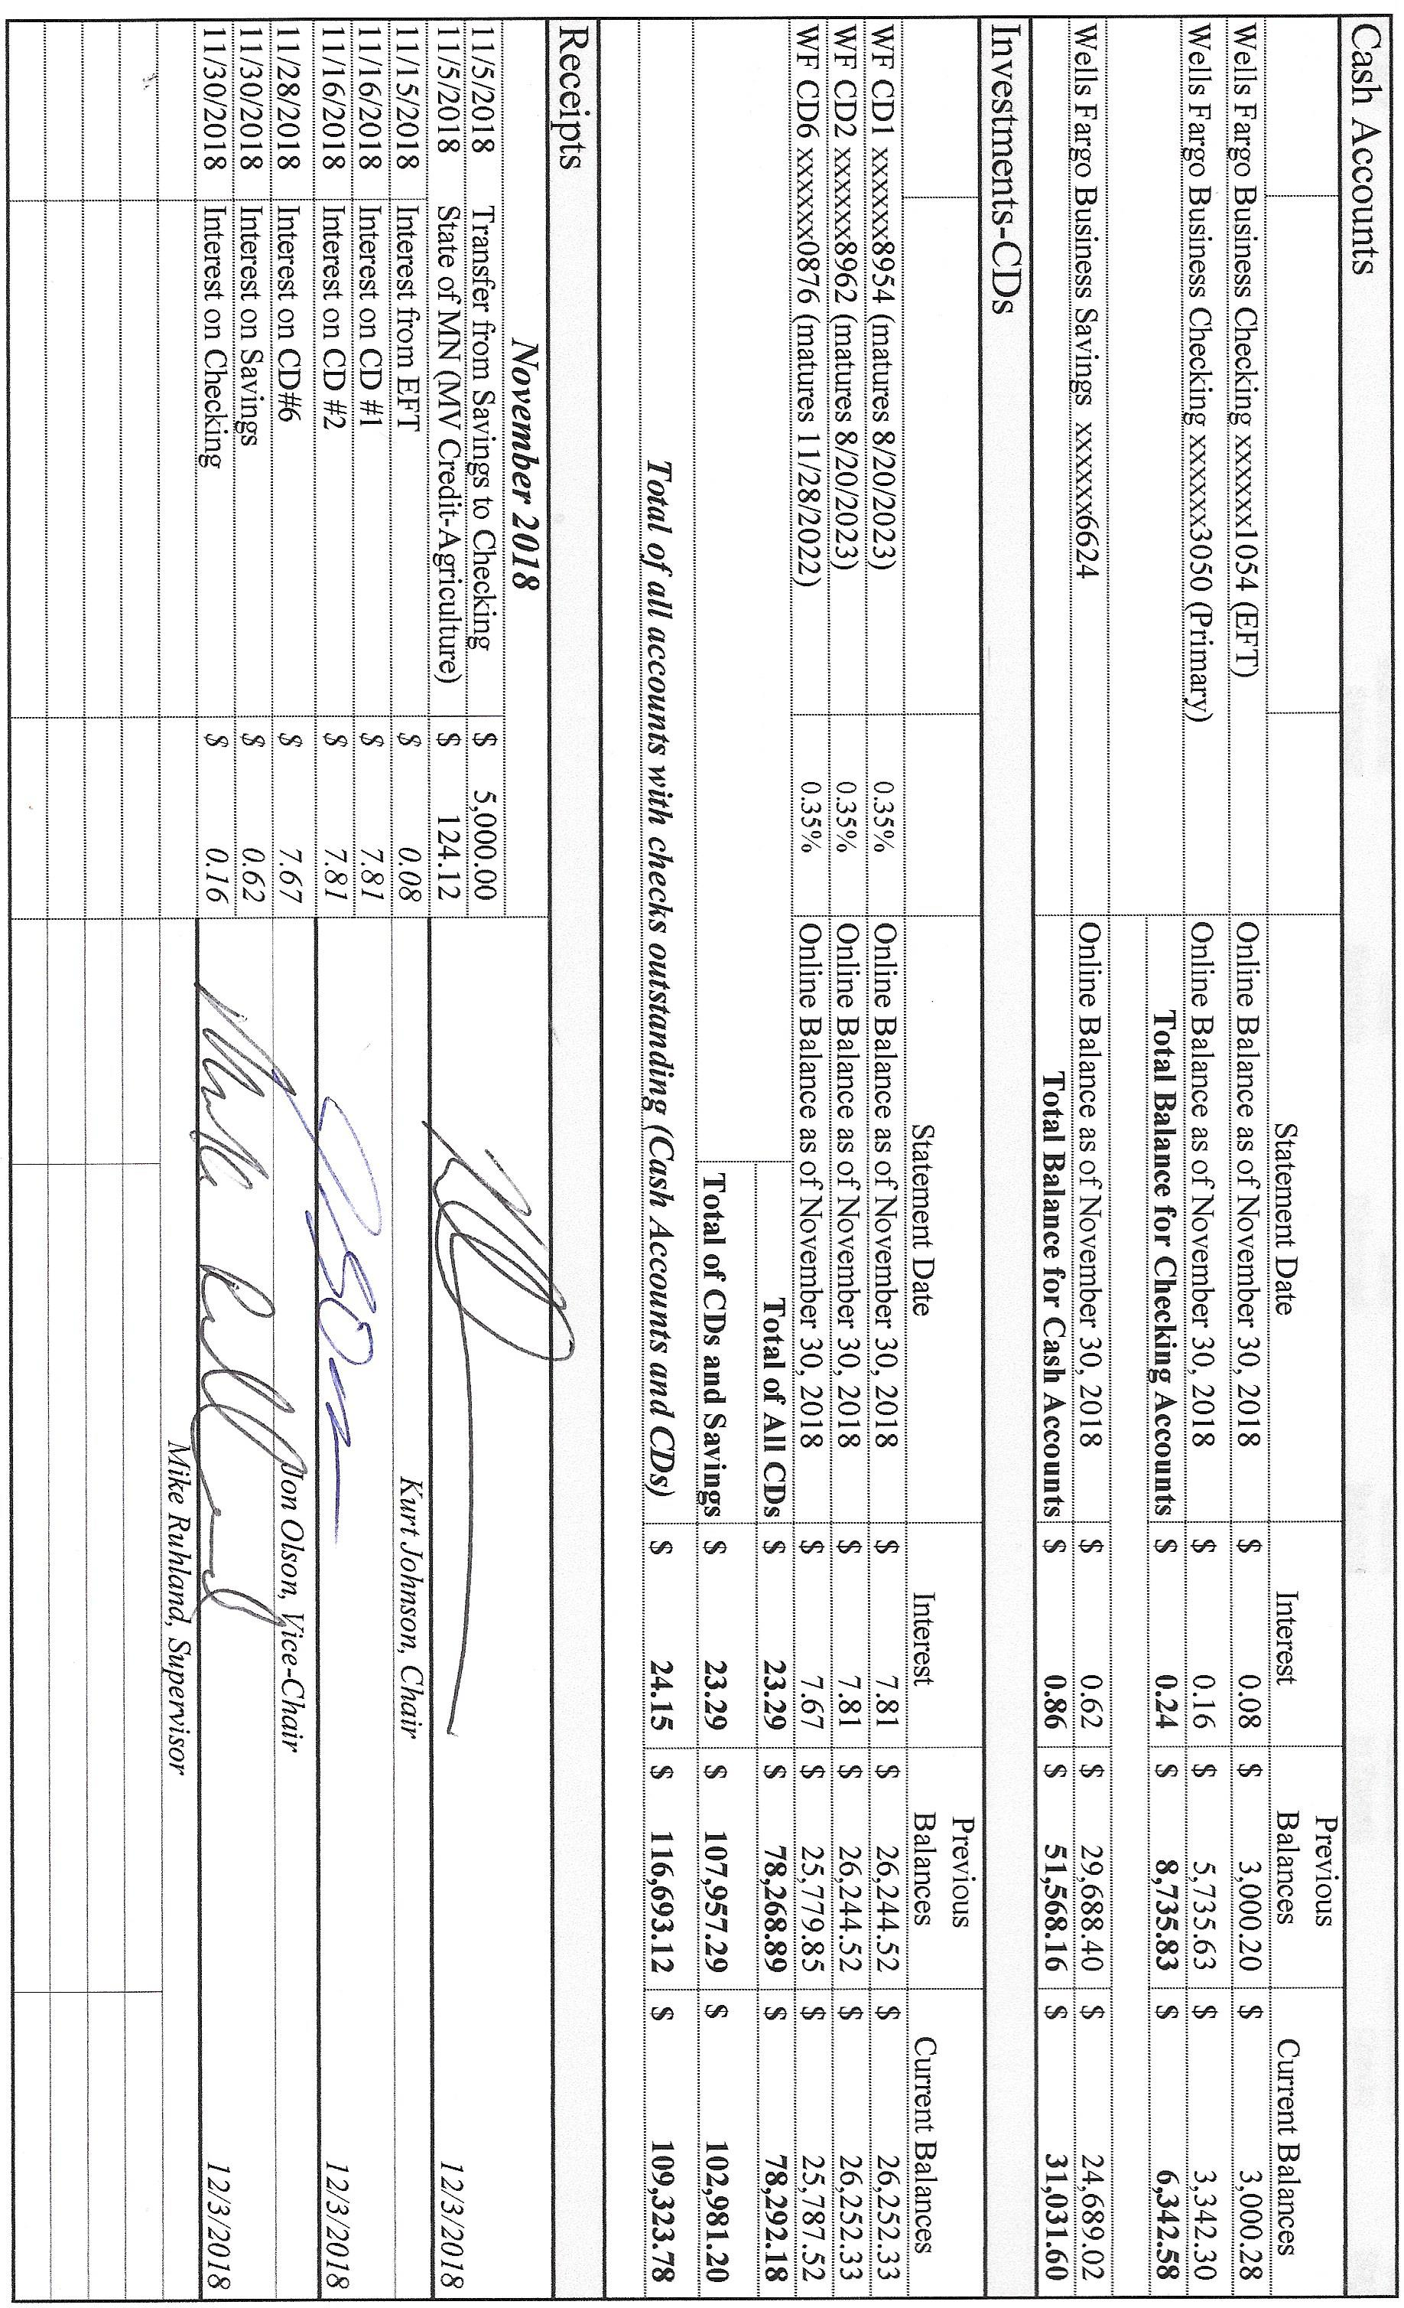

Following his report, Mike Ruhland made a motion to accept the Treasurer’s Report as presented. Kurt Johnson offered a second to the motion, which was then accepted by the Supervisors. It was placed on filed with other documents from the meeting.

Sandra Lee Olson presented her two-part report.
- The Clerk’s Financial Report consisted of:
  - Cash Control Statement (CTAS) (shown below)
  - Cash Balance Statement (CTAS)
  - Current Investments (CTAS)
  - Statement of Receipts, Disbursements and Balances (Schedule 1)

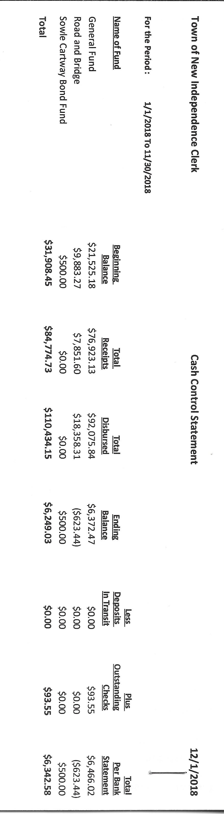
- In addition to the formal Financial Report, the clerk reported that the following transfer funds was completed:
  - Clerk’s recommendation
    - General Fund $5,000.00
    - Road and Bridge $3,000.00

Following the completion of her report, Jon Olson made a motion to accept the Clerk’s Report subject to audit. His motion was seconded by Mike Ruhland and then accepted through a unanimous vote.

The Clerk presented the following items of Incoming Correspondence to the Board:
- Brent Septic…invoice for pumping ($185.00)
- Arrowhead Water & Conditioning…invoice for salt ($47.80)
- Rodda Grading & Excavating…invoice for grading ($450.00
- Minnesota Association of Townships Agency
  - paperwork for workmen’s audit
  - Premium notice
  - Statements of Financial Position
  - Statements of Net Position
- Federated Co-ops…unused prepaid credits ($1,200.00
- St. Louis County Fair
- Rinke Noonan…information on Drainage and Water Conference, and Water Conference, February 14, 2019, St. Cloud
- Lake Country Power…monthly statement ($172.13 credit)
- PERA…monthly reporting form

Payroll and Claims
Payroll claims were read into the record by Chair Kurt Johnson. Following the reading, Kurt Johnson made a motion to pay the claims as read. Jon Olson seconded the motion, which was subsequently accepted through a unanimous vote. The payroll was submitted to the Treasurer for payment.
  - Payroll $93.55
  - Payroll $93.55
  - Payroll $187.10
  - Payroll $46.17
  - Payroll $398.80
  - Payroll $93.55
  - Payroll $92.35
  - Payroll $92.35
  - Payroll $173.15
  - Payroll $92.35

The Claims were read into the record by Kurt Johnson. A motion to pay the claims was then made by Jon Olson, seconded by Mike Ruhland, and accepted by a unanimous vote. The claims were submitted to the Treasurer for payment.
  - Karen Witkowski $180.00
  - Joyce Greer $290.84
  - Stacy Kleiner $241.49
  - Shirley A. Tremblay $247.50
  - Dorothy Williams $240.00
  - Sandra Lee Olson $35.00
  - misprinted
  - Rodda Grading and Excavating $450.00
  - Brent’s Septic Service $185.00
  - Frontier Communications $70.00
  - Arrowhead Water Services $47.80
  - PERA $120.00
  - US Treasurer $445.24
  - Minnesota Revenue $43.59
  - MATIT $355.00

Unfinished Business
- Cemetery
  - Kurt Johnson reported that there was nothing to report about the cemetery at this time.
- Town Hall
  - The flag will be flown at half-mast to honor President George H. W. Bush.
  - Water needs to be picked up for the Town Hall. Sandra Lee Olson agreed to pick it up when she goes to town.

- Roads
  - Road Foreman’s Report indicated that there are no issues with the roads at this point.

New Business
- Resolution for poll location for 2019
  - Kurt Johnson made a motion to hold all elections in 2019 at the New Independence Town Hall. Mike Ruhland seconded the motion, which was accepted by a unanimous vote. The Clerk will file the resolution with St. Louis County Elections.
- Re-organization of the Board will be held at the beginning of the January meeting and will include the Oath of Office prior to opening of the meeting.
- St. Louis County Fair donation will be addressed at the Annual Meeting, which is in keeping with previous years.
- Supplies for Accounting Records
  - Clerk Sandra Lee Olson requested money to purchase office supplies for records and the tax program. Jon Olson made a motion to approve $200 for the purchases. Mike Ruhland seconded the motion, which was passed by a unanimous vote.
- Safe
  - Sandra Lee Olson will purchase keys for the safe and copy the combination.

Officer Reports
None

Kurt Johnson asked for a motion for adjournment, because there were no additional items of business to bring before the board. Mike Ruhland offered the motion, which was seconded by Jon Olson and passed with a unanimous vote. Kurt declared the meeting adjourned at 7:56 PM

Minutes submitted for approval on ______________January 7, 2019______________________

Clerk’s Signature______________________________________________________________

Chair of the Board of Supervisors’ Signature_________________________________________

UPCOMING MEETINGS
Board of Supervisors’ Meetings for 2018
December 3

Board of Supervisors’ Meetings for 2019
January 7, 2019
February 4, 2019
March 4, 2019
April 1, 2019
May 6, 2019
June 3, 2019
July 8, 2019
August 5, 2019
September 3, 2019
October 7, 2019
November 4, 2019
December 2, 2019

2018 SLCAT Calendar (meetings convene at 6:30 pm) and Related Meetings
Dec. 5, 2018 Cotton Township 6:30 pm

