The May Board of Supervisors’ Meeting was called to order by its chair, Kurt Johnson, at 7:01 PM Kurt noted that all officers were present and included: Supervisors Kurt Johnson, Jon Olson, and Mike Ruhland; Treasurer Peter Olson; and Clerk Sandra Lee Olson

After all officers stood and recited the Pledge of Allegiance, Jon Olson made a motion to

the Agenda with the change in the order of the regular Agenda to allow Joe Tasky to speak about contaminated soils within New Independence.

Joe Tasky was not in attendance when the meeting started so Kurt noted that Joe would be allowed to address the Board when he arrived.

Minutes of the April meeting were read into the record by the Clerk. Upon completion, Mike Ruhland made a motion to accept the minutes as read. Jon Olson seconded the motion, which was then passed by a unanimous vote in favor.

Treasurer Peter Olson read his monthly Treasurer’s Report for the period ending on April 30, 2018. Kurt Johnson made a motion to accept the report; Mike Ruhland seconded the motion; and a unanimous vote in favor of the motion followed. The report was one-page summary and is shown below:

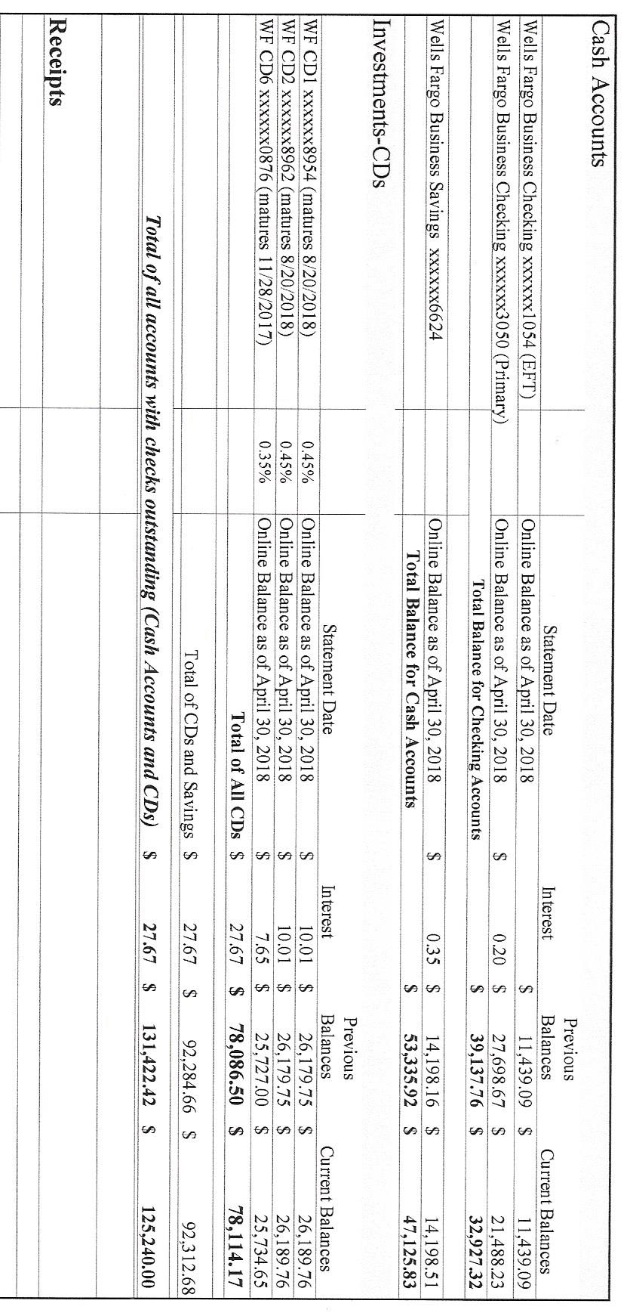

Clerk Sandra Lee Olson stated that she could not make the Clerk’s Report agree with the Treasurer’s Report so there was no written report. A discussion was held on the money in the EFT account. Kurt Johnson made a motion to transfer money to the Savings account so that only $3,000 remains in the EFT account. Mike Ruhland seconded the motion, which subsequently accepted by a unanimous vote. The Clerk will make the transfer.

The following items of Incoming Correspondence were presented to the Board:

Snail Mail

1. St. Louis County/Public Works…Invoice for 2nd half of 2017-2018 snowplowing ($1,977.51)
2. Voyageur Press…invoice for Annual Meeting Legal Ad ($74.40)
3. Public Employees Retirement Association...monthly reporting form
4. Public Employees Retirement Association...*PERA News*
5. Frontier Communications…monthly phone and internet ($59.66)
6. Federated Co-ops…apology
7. Lake Country Power…*Strictly Business*
8. Couri & Ruppi…information on Legal Seminar to be held at Cotton on October 6, 2018
9. Minnesota Association of Townships…cards for board members
10. Lake Country Power…monthly statement (credit balance of $198.41)
11. Brookston Baseball…thank you letter
12. Federated Coops…monthly invoice (credit balance of $23.53)
13. Community Education/Lenny Johnson…thank you and update
14. St. Louis County Association of Townships…minutes from 2/28 meeting and info on upcoming dinner meeting
15. Alborn Fire Department...minutes of the March 28, 2018, meeting

Emails

1. St. Louis County…2018 Notice of General Election
2. St. Louis County…AutoMark service dates
3. St. Bay High School…acknowledgment that the data was received from New Independence regarding fire protection

The following Payroll items were presented to the Board for approval. Following a motion by Jon Olson, a second by Mike Ruhland, and a unanimous vote in favor of the motion, the payroll claims were submitted to the Treasurer for payment.

* 1. Payroll $140.32
  2. Payroll $93.55
  3. Payroll $187.10
  4. Payroll $46.17
  5. Payroll $434.54
  6. Payroll $93.55

The following Claims were read into the record by the Chair. Once Kurt had finished reading the claims, he made a motion to pay the claims as read. Jon Olson seconded the motion, which was accepted by a unanimous vote.

* 1. Public Employee Retirement Association $132.00
  2. St. Louis County Auditor $1,977.51
  3. Kurt Johnson $10.90
  4. Peter Olson $13.62
  5. Sandra Lee Olson $178.33
  6. Voyageur Press $74.40
  7. Frontier Communication $59.66
  8. Tester-Niemi Post $250.00

Unfinished Business

1. Cemetery
   * Mowing contract for the cemetery and town hall was awarded to Jim Witkowski following a motion by Kurt Johnson, a second by Jon Olson, and unanimous vote in favor of acceptance. The Clerk will talk to Jim and ask him to mow before Memorial Day. A contract will be drawn up with the same amounts for mowing as last year. A certificate of insurance will also be required to complete the agreement.
2. Town Hall
   * Mowing contract was discussed and awarded with the cemetery mowing.
   * There is an issue with the septic. Mike Ruhland made a motion to pump the septic and make a determination as to the repairs needed. Jon Olson seconded the motion, and a unanimous vote in favor of acceptance followed. Mike will contact the septic pumper.
   * The Board has discussed installing a light for the flag. Kurt Johnson made a motion to authorize Mike to pick up the supplies for the project with a limit of $150 for supplies 9ropes, rigging, and sensor. Jon Olson seconded the motion and a unanimous vote in favor of the motion followed.
3. Weed Control
   * Mike Ruhland contacted Kristin Fogard about the recent workshop. Although he could not attend the meeting on short notice, Mike will continue to keep in contact with her.
4. Roads
   * + Road Foreman Peter Olson completed his monthly review of the roads and found them to be in good condition. He did note that some grading is in order once the frost is out. South Johnson currently has some frost boils.
5. Short Course
   * Sandra Lee Olson did not attend due to illness
6. St Louis County Association of Townships
   * Annual Election/Meeting, and Dinner (reservations by May 16). Jon Olson made a motion to pay meeting rate, mileage, and pay the dinner fee for anyone wishing to attend the Annual Meeting. Kurt Johnson seconded the motion, which passed with a unanimous vote in favor of the motion. Officers wishing to attend will make their own reservation.
7. Land being Donated to St. Louis County
   * Mike did talk with Jason Myer about questions that had. Jason answered what he could and told Mike that the process in still ongoing.

New Business

1. Legal Seminar
   * October 6, 2018 @ Cotton Town Hall, 9 am to 4 pm
2. LBAE
   * The Clerk reminded officers that the Local Board of Appeal and Equalization will be held on May 16, 2018, at the Town Hall from 6- PM. All officers except the treasurer are required to attend.
3. Elections
   * The AutoMark was brought in for service by the clerk.
   * There are meetings in June and July for the clerk.
4. Phone Numbers of Board Members
   * A resident recently expressed concern about trying to reach township officers. Many individuals now do not maintain land lines and instead opt to use mobile numbers. Town Board members each agreed that their numbers can be posted on the website and on the posting board. There was no motion for the action just an individual approval from each Board member. The Clerk will make the posting.
5. Soil Contamination
   * Joe Tasky was planning to attend the Board meeting but did not. Clerk Sandra Lee Olson provided the Board with a summary of Mr. Tasky’s concern which involves soil contamination from the gas pumps that used to be on the corner of Swan Lake Road and Highway 53. It is uncertain if the Minnesota Pollution Control Agency will take action or not.

Officer Reports

There were no officer reports

Mike Ruhland made a motion for adjournment. Kurt Johnson seconded the motion, which was then accepted through a unanimous vote. Kurt declared the meeting to be adjourned at 8:00 pm.

Minutes submitted for approval on ________________________________________________

Clerk’s Signature______________________________________________________________

Chair of the Board of supervisors’ Signature____-____________________________________

**UPCOMING MEETINGS**

***Board of Supervisors’ Meetings for 2018***

June 4

July 9

August 6

September 10

October 1

November 5

December 3

**2018 SLCAT Calendar (meetings convene at 6:30 pm) and Related Meetings**

May 23, 2018 ANNUAL MEETING AND ELECTION COTTON TOWNSHIP 5:30 PM

June 28, 2018 MAT Summer Specialized Training – Duluth DECC

August 2018 MAT District 10 Meeting – To be Determined

Sept. 19-20, 2018 MAT Fall L & R (Holiday Inn, St. Cloud, MN)

October, 2018 Couri & Ruppe Legal Short Course – Cotton

Oct. 24, 2018 Cotton Township 6:30 pm

Nov. 15-17, 2018 MAT ANNUAL CONFERENCE – DULUTH DECC

Dec. 5, 2018 Cotton Township 6:30 pm