The June Board of Supervisors’ Meeting was called to order by its chair, Kurt Johnson, at 7:00 PM. Kurt noted that the following officers were present: Supervisors Kurt Johnson and Mike Ruhland; Treaurer Peter Olson, and Clerk Sandra Lee Olson. Supervisor Jon Olson did not attend.

Following the Pledge of Allegiance, Kurt Johnson made a motion to amend the agenda to allow Keith Perkins to address the Board about a zoning issue at the beginning of the meeting. The rest of the agenda would remain as usual. Mike Ruhland seconded the motion, which was subsequently accepted.

Keith Perkins is a resident of New Independence that lives on Highway 7. The concern he brought to the Board was related to cars being parked at the McGraw residence. According to Mr. Perkins, cars are being stored on the site as part of an impound lot for Mac Towing with up to sixty cars being stored. There does not appear to be a variance on file for this activity. Prior to the Board meeting, Mr. Perkins did make many phone calls including township officers and St Louis County Offices. His hope is that the Town Board will be able to make contacts with appropriate officials to stop the impound lot from storing vehicles. There was a direct concern for the environment and the effect the oils and gasolines will have on the groundwater. Chair Kurt Johnson reconfirmed that zoning within New Independence is administered by St. Louis County. He went on to say that as the Chairman of the Town Board, he would make some phone calls about the situation

After the Clerk read the minutes of the May meeting, Mike Ruhland made a motion to accept the meetings as read. Kurt Johnson seconded the motion, and a unanimous vote in favor of the motion followed.

Peter Olson read the Treasurer’s Report for the period ending May 31, 2018. Upon completion of his report, Kurt Johnson made a motion to accept the report—subject to audit, Mike Ruhland offered a second to the motion, and a unanimous vote in favor of the motion followed. The second page of his report is shown below. The report also included Cash Control Statement (CTAS), Outstandiing Checks and Deposits in Transit Report (CTAS), and Current Investments (CTAS). The new format from CTAS provides for Town Board Supervisors to sign on the Cash Control Statement.

Following the reading of the Clerk’s Report, Mike Ruhland made a motion to accept the report—subject to audit. Kurt Johnson seconded the motion, which was accepted through a unanimous vote. The Clerk’s Report included the Cash Control Statement (CTAS), the Cash Balance Statement (from CTAS and shown below);Outstanding Checks and Deposits in Transit Report (CTAS), andSchedule B—Investment Activity (CTAS).

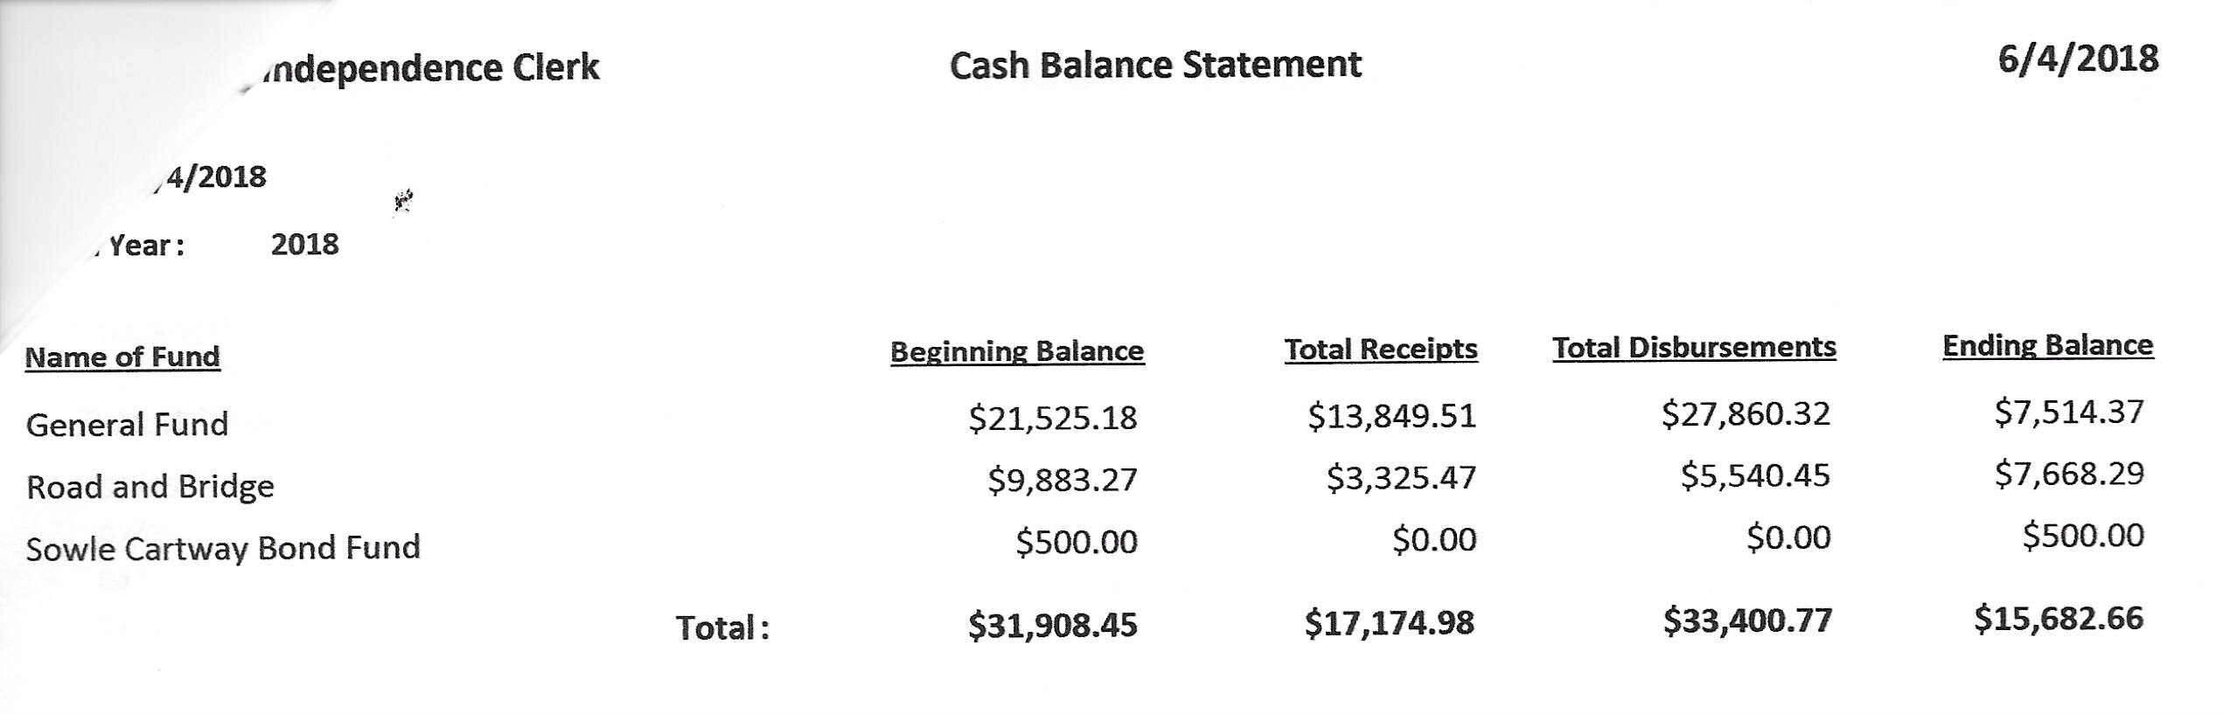
Incoming Correspondence
Snail Mail
- Lake Country Power…credit on statement ($109.23)
- Young & Associates…Certificate of Insurance for McRae
- Minnesota Association of Townships…2018 Specialized Training
- Arrowhead Water Services…invoice for salt ($43.80)
- St. Louis County Association of Townships…minutes of the May 24, 2017 meeting and Agenda for May 23, 2018
- University of Minnesota…Minnesota LTAP Technology Exchange
- Minnesota Association of Townships…Minnesota Township Insider
- Brent’s Septic Service…invoice for pumping ($175.00)
- Minnesota Benefits Association…information on insurance
- South Ridge All-Night Grad Party…thank you
- Federated Co-ops, Inc....invoice showing a prepay balance of $23.53
- Voyageur Press…invoice for LBAE publication ($67.20)
- American Family…certificate of insurance for Jim Witkowski
- PERA…monthly reporting form
- St. Louis County Planning & Development…draft goals and objectives for land use plan
- Jay Tremblay…snowplowing statement for 2017-2018 ($480)
- Alborn Fire Department…minutes of the April 25, 2018, meeting
- Jim Witkowski…mowing bill through June 5 ($438)

Emails
- St. Louis County Elections…information on training dates and reminders
- Kristin Fogard…notice of meeting and Garlic Mustard Wield Workshop/Pull Party info
- Kristin Fogard…info blast from the MDA
- St. Louis County Elections…notice regarding ballots
- St. Louis County Elections…request for ballot information for township election
- St. Louis County…calcium chloride contract

Approval of Payroll/Claims
Payroll claims were read into the record by Kurt Johnson. Upon completion Mike Ruhland made a motion to pay the payroll claims. Kurt Johnson seconded the motion, which was accepted by a unanimous vote. All payroll items were submitted to the Treasurer for payment.
  - Payroll $280.652
  - Payroll $128.63
  - Payroll $187.10
  - Payroll $46.17
  - Payroll $506.04
  - Payroll $420.97

Kurt Johnson read the following Claims into the record and made a motion to pay the claims as presented. Mike Ruhland offered the second. Following a unanimous vote in favor of the motion, the claims were submitted to the Treasurer for payment.
  - Peter Olson $14.72
  - Sandra Lee Olson $178.33
  - Voyageur Press $67.20
  - Lake Country Power $300.00
  - Town of Alborn $9,670.00
  - Brent’s Septic Service $175.00
  - Arrowhead Water Services $43.80
  - Public Employee Retirement Association $199.76
  - Voided
  - Voided
  - Minnesota Revenue $73.39
  - US Treasury $498.49
  - Mike Ruhland $260.99
  - Frontier Communication $75.00

  - The following item of

Unfinished Business were brought to the Board:
- Cemetery
  - Jim Witkowski repaired a stone at the cemetery and will be reimbursed for materials and time.
  - The Schwartz Family was notified about Xmas decorations to be removed. Mike Schwartz saw that they were removed from the cemetery
- Town Hall
  - Mike Ruhland completed installation of the lighting for the flag pole and flew the MIA/POW flag over Memorial Day. The MIA/POW flag will be flown on specific days to honor those military personnel.
  - The septic tank was pumped. It appears that it was full enough to push the pipe up. The Board discussed the situation and decided to monitor water levels. It could be necessary to pump the septic yearly or every two years to help with the water level since it is a holding tank and is not connected to a drain field.
- Weed Control
  - Mike Ruhland did not have anything to report.
- Roads
  - Road Foreman’s Report
    - Peter Olson reported that there was a cone and flag on South Schelin when he inspected the roads. All roads have been graded.
  - Vehicle parked on right of way
    - Gary Fredrickson contacted Jon Olson recently about a vehicle that parked in the road right of way. Jon did talk with Mr. Smigel about removing the vehicle as soon as possible because it is in the right of way. The vehicle was removed.
  - Calcium chloride application
    - The Board opted not to participate in the program since it has never been part of New Independence’s road program

New Business
- Zoning issue was discussed at the beginning of the meeting
- The Clerk informed the Board that she will be attending Election Training on the following dates
  - Clinton Town Hall, 12:30 pm, June 13
  - Clinton Town Hall, July
- Summer Training
  - MAT is offering specialized training on June 28 at the Duluth DECC from 1:00-5:30 pm. Preregistration is $50. Mike Ruhland made a motion to pay registration, mileage, and meeting rate for any officer attending the training. Kurt Johnson seconded the motion, which was subsequently passed by a unanimous vote. Clerk Sandra Lee Olson is the only officer able to attend the training.
- Bills presented at the meeting
  - Kurt Johnson made a motion to pay the bills that were presented at the meeting; Mike Ruhland seconded the motion; and a unanimous vote in favor of the motion was cast. Checks will be drafted for the following bills and will be distributed prior to the July meeting.
    - Jay Tremblay $480.00
    - Jim Witkowski $438.00
    - Minnesota Association of Townships $50.00

Officer Reports were given by officers that attended meetings outside of the regular Board Meeting,
- Mike Ruhland reported on the SLCAT Dinner/Election/Meeting
- Kurt Johnson reported on the Joint Powers Meeting

A motion for adjournment was made by Mike Ruhland and seconded by Kurt Johnson. Following a vote in favor of adjournment, Kurt adjourned the meeting at 9:02 PM

Minutes submitted for approval on ______July 9, 2018_________________________________

Clerk’s Signature______________________________________________________________

Chair of the Board of Supervisors’ Signature_________________________________________

UPCOMING MEETINGS
Board of Supervisors’ Meetings for 2018
July 9
August 6
September 10
October 1
November 5
December 3

2018 SLCAT Calendar (meetings convene at 6:30 pm) and Related Meetings
June 28, 2018 MAT Summer Specialized Training – Duluth DECC
August 2018 MAT District 10 Meeting – To be Determined
Sept. 19-20, 2018 MAT Fall L & R (Holiday Inn, St. Cloud, MN)
October, 2018 Couri & Ruppe Legal Short Course – Cotton
Oct. 24, 2018 Cotton Township 6:30 pm
Nov. 15-17, 2018 MAT ANNUAL CONFERENCE – DULUTH DECC
Dec. 5, 2018 Cotton Township 6:30 pm

