At 7:04 PM, Chair Kurt Johnson called the meeting to order and stated that Supervisor Kurt Johnson, Supervisor Mike Ruhland, Treasurer Peter Olson, and Clerk Sandra Lee Olson were in attendance. Supervisor Jon Olson did not attend.

Following the Pledge of Allegiance, Mike Ruhland made a motion to accept the Agenda as printed. Kurt Johnson offered second to the motion and a unanimous vote in favor of acceptance was cast.

Clerk Sandra Lee Olson read the minutes of the June Board of Supervisors’ Meeting. After she had completed the reading, Mike Ruhland offered a motion to accept the minutes as read. Kurt Johnson offered the second, and a unanimous vote in favor of the motion was cast.

Treasurer Peter Olson presented the monthly Treasurer’s Report for the period ending on June 30, 2018. The report included the Cash Control Statement (CTAS), Breakdown of Funds at Wells Fargo, Outstanding Checks and Deposits in Transit Report (CTAS), and Schedule B—Investment Activity (CTAS). The first page of his report if shown below:

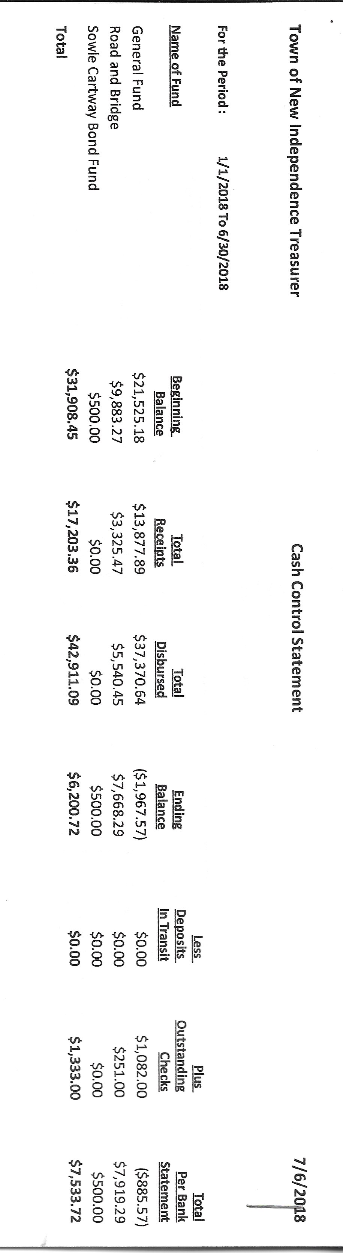

Following the Treasurer’s Report, Mike Ruhland made a motion to accept the report, subject to audit; Kurt Johnson seconded the motion, which was accepted by unanimous vote

The Clerk’s Report for the period ending on June 30, 2018, was read by Sandra Lee Olson. Her report included Cash Control Statement (CTAS), Outstanding Checks and Deposits in Transit Report, Cash Balance Statement (CTAS), Statement of Receipts, Disbursements and Balances (Schedule 1 from CTAS) (shown below), and Current Investments with Accrued Interest. Following her report Kurt Johnson made a motion to accept the report subject to audit. Mike Ruhland seconded the motion, which was subsequently passed with a unanimous vote.

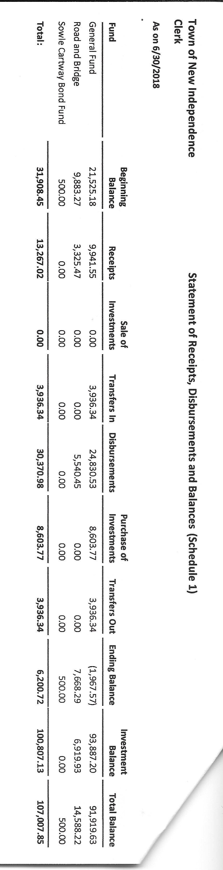

Incoming Correspondence

1. Jim Witkowski…mowing bill through July 3 ($555.00)
2. Reliable Agency, Inc … Certificate of Insurance for Rodda Grading and Excavating
3. Frontier Communications…monthly phone and Internet statement ($64.58)
4. PERA…monthly reporting form
5. Federated Co-ops
   1. Statement showing a credit from pre-buy
   2. Summer Fill Option at $1.299
6. Arrowhead Water Conditioning…invoice for salt delivery and service call ($172.75)
7. St. Louis County Auditor…invoice for AutoMark Maintenance ($180.00)
8. Rodda Grading and Excavating…grading of roads in May ($1,665.00)
9. Lake Country Power…Notice of Capital Credit Allocation for 2017
   1. Lake Country Power $68.64
   2. Great River Energy $26.90
10. Minnesota Association of Townships…registration fee for Sandra Lee Olson ($50.00 check was given at time of meeting)
11. Minnesota State Demographic Center…2017 Population and Household Estimates
    1. Population estimate 292
    2. Household estimate 123
12. Lake Country Power…monthly statement (credit of $318.83)
13. Victor Lundeen Company…invoice and statement for checks ordered ($272.84)
14. St. Louis County Elections…books for training judges
15. St. Louis County/Planning and Community Development Department…information and dates for Focus Group Meetings to discuss the St. Louis County Comprehensive Land Use Plan
    1. South County Meeting will be held on Thursday, July 19, from 4-7 pm, 911 Emergency Communications Building, 2030 North Arlington Avenue, Duluth, MN
16. Alborn Fire Department
    1. Information for purchasing calendar ad
    2. Minutes for May 30, 2018 meeting

Emails

1. St. Louis County Elections…registration for Train the Trainer on July 18 at Clinton
2. St. Louis County Auditor…May Apportionment Breakdown ($27,046.35)
3. CH—Mary Melde…Groundbreaking Ceremony for Essentia Wellness Center, July 10, 9 am
4. St. Louis County…SLC Comp Plan Process Public Workshops
5. Sarah Pierce…May Tax Apportionment Breakdown

Unfinished Business

1. Cemetery
   * Kurt reported that the Cemetery is being mowed on a regular basis and is in good condition. There is one grave site that is sinking and will be addressed by Jim Witkowski
2. Town Hall
   * Arrowhead Water
     + The water softener was not working and service was requested. The technician determined that the filter was clogged, which resulted in the unit not recycling. Kurt Johnson made a motion to purchase a new filter for the water softener and batteries for the clock. Mike Ruhland seconded the motion, which passed with a unanimous vote. Mike Ruhland will pick up a filter and batteries and install them.
     + Arrowhead Water office personnel informed Kurt that the salt is not always added when it is delivered and might need to be added by the township during the period between deliveries. The Board will monitor the situation and add as noticed.
   * Summer fill option
     + Federated Coops offers a summer fill program for LP. Kurt Johnson made a motion to take advantage of the program. Mike Ruhland made a second to the motion, which was passed through a unanimous vote. A check after the meeting indicated that the LP level was above 80% and LP will not be delivered at that level.
3. Weed Control
   * No report at this time. In the future Weed Control will be eliminated from the agenda and included as items need to be presented.
4. Roads
   * Road Foreman’s Report from Peter Olson indicated that there were no washouts after the recent storms and the roads are in good condition.
   * Kurt Johnson made a motion, which was seconded by Mike Ruhland, to post for right-of-way mowing; the motion carried with a unanimous vote.
5. Zoning issue
   * Kurt Johnson did make contacts with the County. From the discussions he learned that there is no variance for a car storage lot on file. He also learned that the situation is already in process and has entered enforcement. Kurt informed Keith Perkins of his findings.

New Business

1. Checks were reordered by the Clerk. An invoice was presented to the Board.
2. Alborn Fire Department Calendar
   * Mike Ruhland made a motion, which was seconded by Kurt Johnson to purchase an ad on the Fire Department’s Calendar for 2019. The cost is $200. The motion carried.
3. Meeting dates for calendar
   * Kurt Johnson made a motion to set the 2019 meeting dates as shown below. Mike Ruhland seconded the motion, which was passed by unanimous vote. By setting the dates at this time, the dates will be included on the Fire Department’s calendar for 2019.

January 7, 2019

February 4, 2019

March 4, 2019

April 1, 2019

May 6, 2019

June 3, 2019

July 8, 2019

August 5, 2019

September 3, 2019

October 7, 2019

November 4, 2019

December 2, 2019

1. Election Information was presented to the Board regarding the upcoming elections. The information included the following items
   * Two Officers up for election
     + Supervisor C, 4-year term, Mike Ruhland
     + Clerk, 4-year term, Sandra Lee Olson
   * Filing
     + July 31-August 14, 2018
     + $2.00 filing fee
     + Clerk’s Office needs to be open for filing on August 14 from 1-5 pm
     + Withdrawal period—August 14 through August 18 until 5 pm
   * Training the Trainer at Clinton Town Hall, July 18, is a mandatory training for the clerk.
   * Election judges
     + Mike Ruhland made a motion to appoint the following individuals to serve as election judges providing they are trained. Kurt Johnson seconded the motion, which was accepted through a unanimous vote.
       - Kate Laine
       - Julian Haines
       - Chris Boerner
       - Stacy Kleiner
       - Shirley Tremblay
       - Karen Witkowski
       - Joyce Greer
     + Training—online or by Clerk
       - $9.90/individual to be billed by the County and three-hour training compensation
       - A discussion was held about the training preferred by the Board. Kurt Johnson made a motion to train judges by the method that meets the clerk and judges needs. Mike Ruhland seconded the motion, which was accepted by a unanimous vote.
     + Compensation
       - Kurt Johnson made a motion to pay the election judges at the last rate of $15/hour. Mike Ruhland offered a second, and the motion was accepted.
       - Because the judges will be at the Town Hall from about 6 AM until all ballots are counted and reporting is completed, the Board authorized through a motion by Kurt Johnson, second by Mike Ruhland, and motion approval to order a couple pizzas from the Clip Joint for the Election Judges. The meal will be available about 5.
   * Election booth must be available that is handicap accessible—34” high. To meet this need, a table will be set up.
   * Election payments information presented at MAT Specialized Training
     + PERA/DCP cannot be deducted from wages
     + Taxes can be withheld if requested after $600 threshold is met
     + 1099s are not required for individuals under the $600 threshold
   * Election Dates
     + Primary August 14
     + General November 6
     + Board of Canvass: must be held between November 9 -November 16, 20018
   * Every December a resolution setting the polling place must be made
   * Mail-in Ballot Option for Future Elections
2. Kurt Johnson made a motion to purchase a printer for the Treasurer—not to exceed $150. Mike Ruhland seconded the motion, which was accepted through a unanimous vote.
3. Kurt Johnson made a motion to purchase New Township Manual Update from MAT ($10). Mike Ruhland seconded the motion, which was accepted through a unanimous vote. The clerk will order the manual.

Approval of Payroll/Claims

Mike Ruhland made a motion to authorize payment of the Payroll; Kurt Johnson seconded the motion, which was accepted by a unanimous vote. The following payroll claims were presented to the Treasurer for payment.

* 1. Payroll $93.55
  2. Payroll $187.10
  3. Payroll $46.17
  4. Payroll $46.17
  5. Payroll $506.04
  6. Payroll $195.35

Mike Ruhland made a motion to authorize payment of the Claims; Kurt Johnson seconded the motion, which was accepted by a unanimous vote. The following payroll claims were presented to the Treasurer for payment.

* 1. Jim Witkowski $555.00
  2. Sandra Lee Olson $227.16
  3. Peter Olson $14.17
  4. Frontier Communication $64.56
  5. Arrowhead Water Services $172.75
  6. St. Louis County Auditor $180.00
  7. Rodda Grading and Excavating $1665.00
  8. Victor Lundeen Printing $273.84
  9. Public Employee Retirement Association $199.76
  10. Alborn Fire Department $200.00

Officer Reports

Clerk Meeting for Election Laws—Sandra Lee Olson

MAT Specialized Training—Sandra Lee Olson

Mike Ruhland made a motion for adjournment; Kurt Johnson seconded the motion, which was accepted. The meeting was adjourned at 8:30 PM

Minutes submitted for approval on _______August 13, 2018___________________________

Clerk’s Signature______________________________________________________________

Chair of the Board of Supervisors’ Signature________________________________________

**UPCOMING MEETINGS**

***Board of Supervisors’ Meetings for 2018***

August 6

September 10

October 1

November 5

December 3

**2018 SLCAT Calendar (meetings convene at 6:30 pm) and Related Meetings**

August 2018 MAT District 10 Meeting – To be Determined

Sept. 19-20, 2018 MAT Fall L & R (Holiday Inn, St. Cloud, MN)

October, 2018 Couri & Ruppe Legal Short Course – Cotton

Oct. 24, 2018 Cotton Township 6:30 pm

Nov. 15-17, 2018 MAT ANNUAL CONFERENCE – DULUTH DECC

Dec. 5, 2018 Cotton Township 6:30 pm