0The August Board of Supervisors’ Meeting was called to order by its chair, Kurt Johnson, at 7:00 PM. Kurt noted that all officers were present (Supervisors: Johnson, Olson, Ruhland; Treasurer Olson; and Clerk Olson).

Following the Pledge of Allegiance, Mike Ruhland made a motion to accept the Agenda as printed. Jon Olson seconded the motion, and a unanimous vote in favor of the motion followed.

Minutes of the July meeting were read by Clerk Sandra Lee Olson. Mike Ruhland made a motion to accept the minutes as read; Jon Olson offered a second to the motion; and a unanimous vote in favor of the motion followed.

Treasurer Peter Olson presented the monthly Treasurer’s Report for the period ending on July 31, 2018. Following the reading of the report, Mike Ruhland made a motion to accept the report—subject to audit. Jon Olson seconded the motion, which was subsequently accepted through a unanimous vote. The complete report included: Cash Control (CTAS), Outstanding Checks and Deposits in Transit Report (CTAS), Schedule 8—Investment Activity (CTAS), Treasurer’s Report. While the entire report was placed on file with other documents from the meeting, the first page is reprinted below:

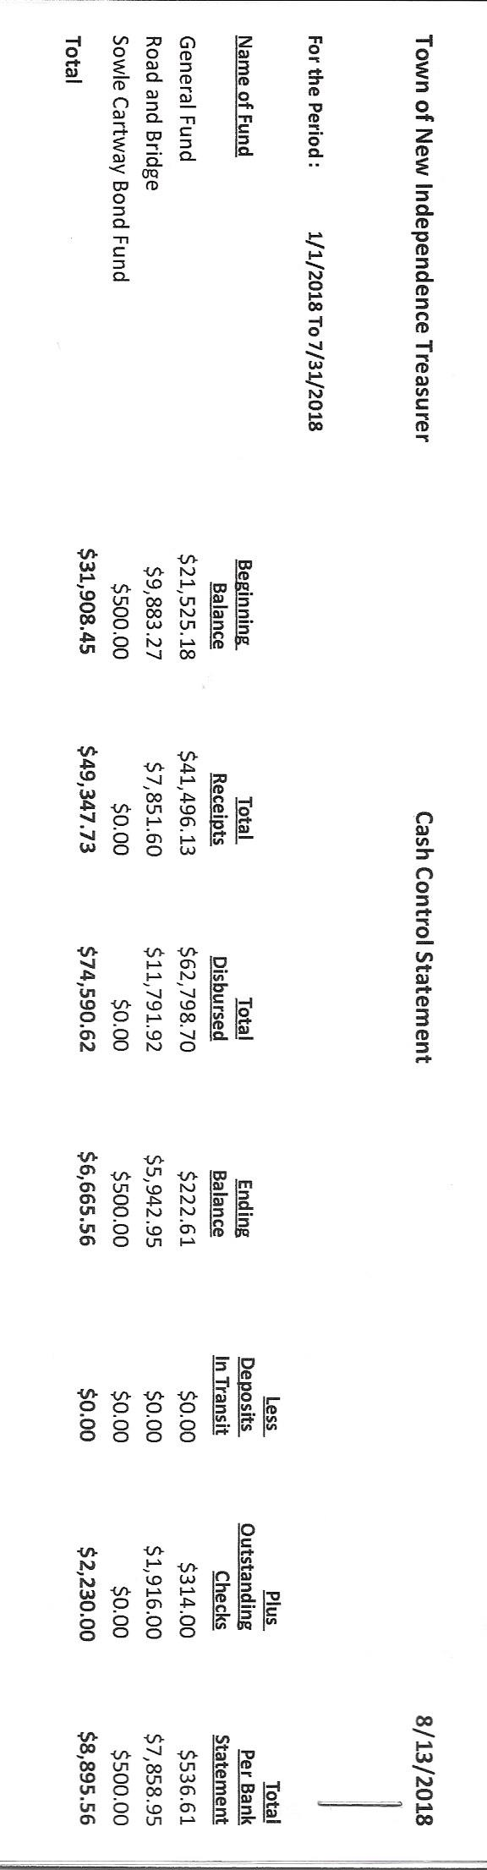

The Clerk’s Report for the month of July was presented by Clerk Sandra Lee Olson. She noted that both the Treasurer’s Report and Clerk’s Report agreed. Mike Ruhland made a motion to accept the report-subject to audit. Jon Olson offered the second to the motion, which was then accepted through a unanimous vote. Sandra Lee Olson notified that the checking account has been tied to the Savings account to prevent overdrafts. The clerk’s Report included: Cash Control Statement (CTAS), Cash Balance Statement (CTAS), Outstanding Checks and Deposits in Transit Report (CTAS), and Current Investments with Accrued Interest (CTAS). The Cash Balance Statement is shown on the next page:

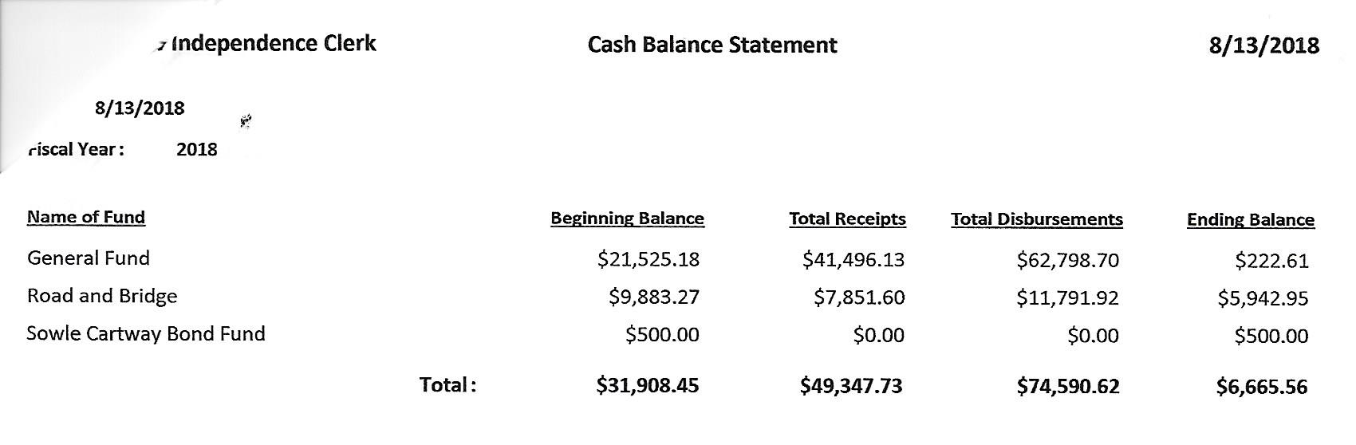

Incoming Correspondence

1. Jim Witkowski…invoice for mowing (3 times) and repairing gravesite
2. St. Louis County…first half of 2018 permits issued for New Independence

|  |  |  |  |  |
| --- | --- | --- | --- | --- |
| Permit # | Permit Type | Date Issued | Parcel ID | Structure Type |
| W-000022 | Wetland Permit | 6/25/2018 | 475-0010-03270 | Wetland—No/Loss Exemption |
| SD-000085 | Subdivision Permit | 4/24/2018 | 475-0010-04380 | Parcel Review |
| LU-001466 | Land Use Permit | 5/30/2018 | 475-0010-05070 | Accessory Structure |

1. St. Louis County…Final Tax Levy form due October 1, 2018
2. PERA…monthly reporting form
3. Federated Co-op…invoice dated 6/30/2018 ($264.80)
4. Wells Fargo…new checking account with different charges
5. Lake Country Power…monthly statement ($250.85 credit) and second notice includes a service fee of $3.97 (total $268.77)
6. Wells Fargo…notice of CD renewals (CD 1 and CD 2)
7. Minnesota Association of Townships…District 10 Meeting & Election will be held on Thursday August 30 at Grand Lake
   * 5:30 PM Registration
   * 6:00 PM Meeting
   * 6:30 PM Election
8. Rodda Grading and Excavating...invoice for grading roads ($1,552.50)
9. Lake Country Power…newsletter *Strictly Business*
10. Couri & Ruppe Law Office…info on the upcoming Legal Seminar
    * Saturday, October 6, 2018
    * Cotton Town Hall
    * 9:00 AM to 4:00 PM
11. Yellow Book…phone book
12. State of Minnesota…Town Aid $541.50
13. Frontier Communications…monthly statement ($69.56)
14. State of Minnesota…notice of Township 2019 Town Aid Notice
    * First payment for 2018 July 20, 2018
    * Second payment for 2018 December 26, 2018
15. Alborn Fire Department…minutes from the June 27, 2018 meeting

Unfinished Business

1. Cemetery
   * The grave was fixed by Jim Witkowski.
   * Branches were trimmed.
2. Town Hall
   * Water Softener Filter
     + The filter was changed, but Mike noticed there is not shut off valve for the system. Kurt Johnson made a motion, which was seconded by Jon Olson, to have Mike pick up and install a shut off valve for the water softener system so it is easier access and change the filter. The motion carried. Mike Ruhland abstained from voting on the motion.
   * Water Softener Salt
     + Jon Olson put the remaining back of salt into the water softener holding area.
     + There still is concern about the amount of salt the system is using especially since the Town Hall is used once a month. Kurt Johnson will call Arrowhead Water again and inquire about the amount of salt used and the frequency of the system.
   * Spaying for Cluster Flies
     + In the past few years, the Town Hall has been sprayed by Guardian Pest Control. The clerk did call for the same service this fall so the township would be on the service list. Kurt Johnson made a motion to have the Town Hall sprayed for flies. Jon offered a second to the motion, which passed with a unanimous vote in favor of the motion.
3. Roads
   * Road Foreman’s Report
     + Peter Olson checked the roads again during July and felt they were in good shape. In addition, Peter received a call from Steve Bosshart. Steve had noticed that the ditches had been marked by his house and was requesting the dirt be put in his yard. Peter asked the Board to reconfirm that the ditch on Nelson Road needed to be ditched since there has been a lengthy period of time since it was approved. Kurt Johnson made a motion to ditch Nelson Road as previously discussed. Mike Ruhland seconded the motion, which was accepted through a unanimous vote in favor of the motion. Peter will contact Bob Rodda about the ditching and Steve Bosshart’s request for the dirt removed from the ditches.
   * Right-of-way mowing
     + A posting was done for the right-of-way mowing of town roads. Since no quotes were received, Mike Ruhland made a motion to hire Jon Olson for the job. Kurt Johnson seconded the motion, which passed with Supervisors Johnson and Ruhland voting in favor of the motion and Supervisor Olson abstaining. Jon agreed to mow the right of ways for the same charge as last year ($675 and reimbursement for insurance.)
4. Election
   * Filing for the township election closes on August 14, 2018, at 5:00 pm. As of this meeting, Mike Ruhland has filed for Supervisor C position, and Sandra Lee Olson has filed for the Clerk’s position.
5. Mail-in Ballots
   * Information from Phil Chapman was presented to the Board regarding a mail-in ballot system for all elections. An informal discussion was held among board members with a recommendation being made to send a letter to all voters within the township to explain the option. The town board will have to pass a resolution in addition to the letter. The topic will be finalized at future meeting.
6. Printer for Treasurer
   * A printer was ordered and set up for the Treasurer to use at his home.
7. LBAE Training
   * Both Kurt Johnson and Jon Olson need to be recertified for the LBAE meeting. Online registration and coursework are available.

New Business

1. Checking account
   * Sandra Lee Olson will check with Wells Fargo about the new accounts set up and related guidelines
2. CD Renewals
   * Jon Olson made a motion to renew CD 1 and CD 2. Kurt Johnson seconded the motion, which was passed with a unanimous vote in favor of the action.
3. Couri & Ruppe Legal Seminar
   * Kurt Johnson made a motion, which was seconded by Mike Ruhland, to offer any officer attending the Legal Seminar reimbursement for mileage and the extended meeting rate. Mike Ruhland seconded the motion, which was then accepted through a unanimous vote.
4. Alborn Fire Department Breakfast on August 25
   * There will be another breakfast sponsored by the Alborn Fire Department on August 25. Last time a banner was put in the front of the New Independence Town Hall. It is anticipated that it will be put there again.
5. District 10 Meeting
   * Kurt Johnson made a motion to pay meeting rate and mileage to any officer attending the meeting at Twig on August 31, 2019. Following a second by Mike Ruhland, the motion carried with a unanimous vote.

Approval of Payroll/Claims

Payroll—Election: Jon Olson made a motion to pay the following claims related to the election. Mike Ruhland seconded the motion, which was accepted through a unanimous vote. The claims were submitted to the treasurer for payment.

* 1. Kate Laine $52.50
  2. Karen Witkowski $45.00
  3. Stacy Kleiner $52.50
  4. Joyce Greer $45.00
  5. Shirley Tremblay $45.00

Payroll: Mike Ruhland made a motion to pay payroll claims. Jon Olson seconded the motion, and a unanimous vote in favor of the motion followed. The payroll claims were submitted to the treasurer for payment.

* 1. Payroll $93.55
  2. Payroll $93.55
  3. Payroll $187.10
  4. Payroll $46.17
  5. Payroll $398.80
  6. Payroll $116.94
  7. Payroll $310.80

Claims: Jon Olson made a motion to pay claims submitted for the previous month. Mike Ruhland seconded the motion, which was accepted through a unanimous vote in favor of the motion. The claims listed below were submitted to the treasurer for payment.

* 1. Mike Ruhland $21.80
  2. Peter Olson $14.17
  3. Sandra Lee Olson $138.28
  4. PERA $122.50
  5. Jim Witkowski $580.00
  6. Federated Co-ops $268.77
  7. Rodda Grading and Excavating $1552.50
  8. Frontier Communication $69.56
  9. Mike Ruhland $34.09
  10. Clip Joint

Officer Reports

Clerk Meeting for Election Training—Sandra Lee Olson presented information from this meeting throughout the meeting.

Having no additional business to be presented to the Board, Kurt asked for a motion for adjournment, which was given by Mike Ruhland, seconded by Jon Olson, and accepted with a unanimous vote in favor. Kurt declared the meeting to be closed at 8:34 PM

Minutes submitted for approval on __________September 10, 2018_______________________

Clerk’s Signature______________________________________________________________

Chair of the Board of supervisors’ Signature_________________________________________

**UPCOMING MEETINGS**

***Board of Supervisors’ Meetings for 2018***

September 10

October 1

November 5

December 3

**2018 SLCAT Calendar (meetings convene at 6:30 pm) and Related Meetings**

August 30, 2018 MAT District 10 Meeting – Grand Lake

* + 5:30 PM Registration
  + 6:00 PM Meeting
  + 6:30 PM Election

Sept. 19-20, 2018 MAT Fall L & R (Holiday Inn, St. Cloud, MN)

October 6, 2018 Couri & Ruppe Legal Short Course – Cotton, 9:00 AM to 4:00 PM

Oct. 24, 2018 Cotton Township 6:30 pm

Nov. 15-17, 2018 MAT ANNUAL CONFERENCE – DULUTH DECC

Dec. 5, 2018 Cotton Township 6:30 pm