Chair Kurt Johnson called the September Board of Supervisors’ Meeting to order at 7:00 PM. Kurt declared that all officers were present. Those officers included: Supervisor Kurt Johnson, Supervisor Jon Olson, Supervisor Mike Ruhland, Treasurer Peter Olson, and Clerk Sandra Lee Olson. Two other individuals were in attendance.

Following the Pledge of Allegiance, Mike Ruhland made a motion to accept the Agenda as printed. Jon Olson seconded the motion, which passed by a unanimous vote.

Minutes of the August meeting were read and approved through a motion by Mike Ruhland, a second from Jon Olson, and a unanimous vote in favor of acceptance. The minutes were placed on file with other documents from the meeting.

Treasurer Peter Olson read his monthly report into the record. Kurt Johnson questioned the amounts listed for CD#1 and CD#2, which were not in agreement. The amounts listed should have been the same amounts as listed on the top portion. The first page of the report is shown below. The complete report included Treasurer’s Report Summary, Cash Control Statement (CTAS), and Current Investments with Accrued Interest (CTAS).
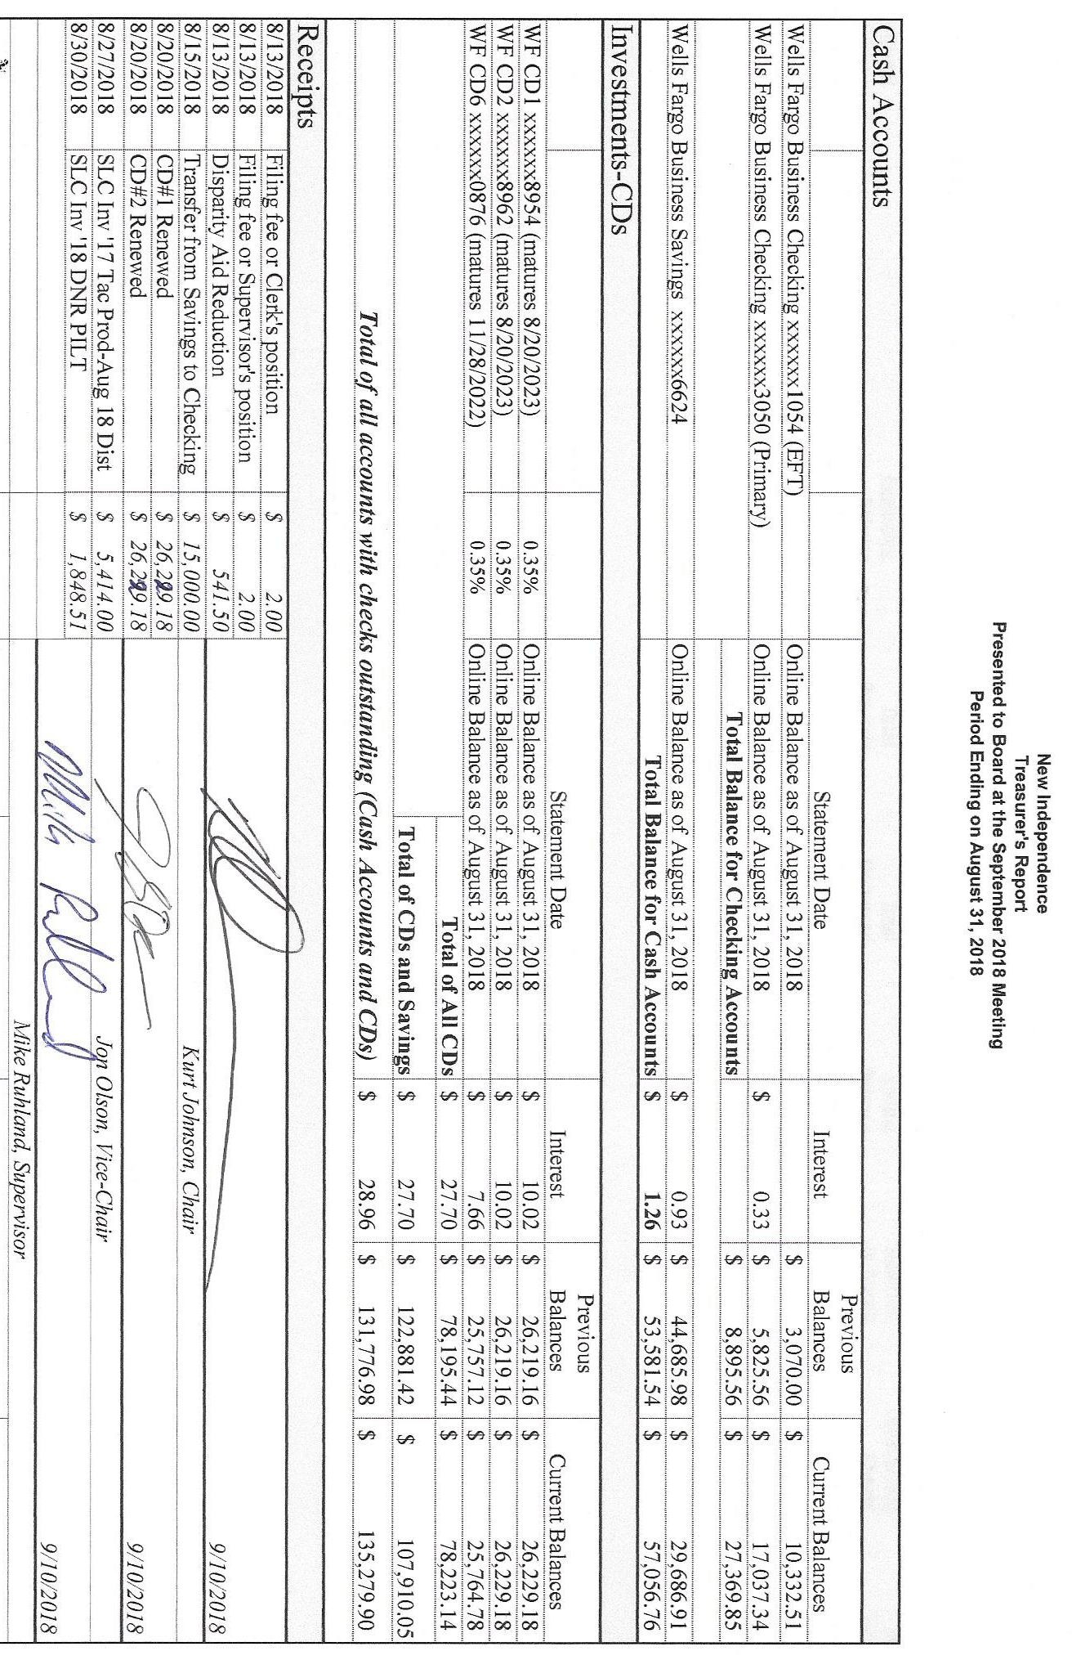

Following the presentation of the Clerk’s Report, which was read by Clerk Sandra Lee Olson, Kurt Johnson made a motion to accept the report as presented, Mike Ruhland seconded the motion, which was accepted through a unanimous vote. The first page of her report is shown below. The entire report included” Cash Control Statement (CTAS); Cash Balance Statement (CTAS); Outstanding Checks and Deposits in Transit Report (CTAS); Current Investments with Accrued Interest (CTAS); and Statement of Receipts, Disbursements and Balances (Schedule 1) (CTAS).
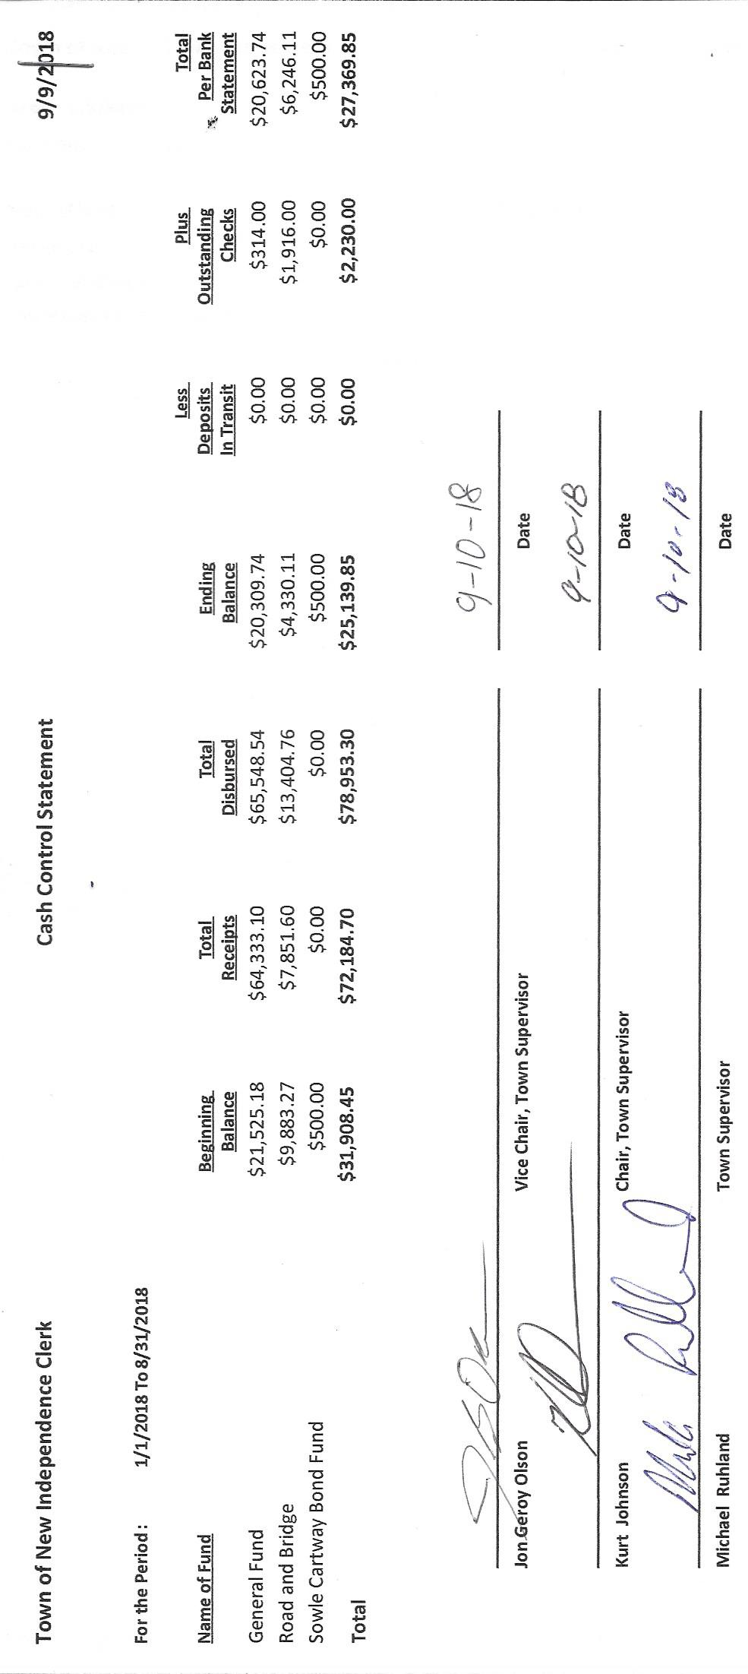

The following items of Incoming Correspondence were presented to the Board.
  - Frontier Communications…monthly phone and Internet bill ($69.56)
  - Federated Co-ops, Inc…information on pre-buy propane
  - Public Employees Retirement Association…monthly reporting form
  - Minnesota Fall Maintenance Expo...info on upcoming expo in the Cities
  - Lake Country Power…monthly power bill (credit $181.85)
  - Rinke Nooman…information on Drainage and Waters Conference
  - Thursday, February 14, 2019
  - River’s Edge Convention Center
  - St. Cloud, MN
  - Program geared to Drainage Authorities, City, Township, and County Officials, Watershed District Officials and Staff, Landowners, and Farm Operators
- State of Minnesota…Disparity Reduction Aid ($61.00)
- Jim Witkowski…mowing of cemetery and town hall ($185.00)
- Lake Country Power…information on duel fuel
- Lake Country Power…notice that meter will be changed out
- University of Minnesota…Minnesota LTAP Technology Exchange
- Minnesota Association of Township Agency…renewal of commercial insurance policy
- Alborn Fire Department…minutes for July 25, 2018, meeting
- Guardian Pest Control…invoice for recent spraying ($161.06)
- American Family…premium for certificate of insurance for brush mowing the tight of ways
- Keith Nelson…letter to voters
The following Payroll Claims related to the Primary Election were approved through a motion to approve made by Jon Olson, a second made by Mike Ruhland, and a unanimous vote in favor of approval. The claims were submitted to the Treasurer for payment.
  - Clip Joint $45.47
  - Shirley Tremblay $240.00
  - Voided
  - Stacy Kleiner $143.18
  - Joyce Greer $240.00
  - Voided
  - Karen Witkowski $210.00
  - Kate Laine $217.50

The following Payroll Claims were presented to the Board for its approval, which was completed through a motion by Jon Olson, a second made by Mike Ruhland, and a unanimous vote in favor of approval. The claims were submitted to the Treasurer for payment.
  - Payroll $93.55
  - Payroll $93.55
  - Payroll $187.10
  - Payroll $46.17
  - Payroll $398.80
  - Payroll $93.55
  - Payroll $23.90
  - Payroll $260.60

The following Claims were presented to the Board for its approval, which was completed through a motion by Mike Ruhland, Jon Olson a second made by, and a unanimous vote in favor of approval. The claims were submitted to the Treasurer for payment.
  - Sandra Lee Olson $104.10
  - Kurt Johnson $13.63
  - Peter Olson $14.17
  - Jon Olson $675.00
  - Frontier Communication $69.56
  - PERA $122.50
  - Jim Witkowski $185.00
  - US Treasury $513.45
  - Minnesota Revenue $65.14

  - The following areas and items of

Unfinished Business were discussed by the Board.
- Cemetery
  - There is brush in front of the cemetery sign. Kurt will see that it is removed.
  - There are baskets that need to be removed before fall. Kurt will deal with this.
  - Mowing is over for the season.
- Town Hall
  - Mike did work on the filter situation and noted that a valve needs to be installed for ease in changing. He will take care of the process.
  - Kurt checked with Arrowhead Water and reported that the water softener needs to recycle every 4-5 days or the iron build up is a problem. Mike will check with a septic person that he knows to see what options might be available to correct the situation with the holding tank.
  - The flag should be flown at half-staff on September 11.
- Roads
  - Road Foreman’s Report
    - The right-of-way cutting has been completed and inspected.
- Election
  - The Primary Election was held on August 14. The General Election will be held on November 6, 2018.
- Mail-in Ballots
  - A discussion was held about the mail-in ballot process. The consensus of the Board was to have the clerk develop a letter to send to voters after the General Election. This will insure that there isn’t confusion about the November election. Voters will be invited to attend the December meeting where the Board will discuss the mail-in voting option.
- Checking account
  - The recent letter indicating that fees would be applied to deposits only relates to cash deposits. It is designed to deal with large cash depositors. The township doesn’t typically deposit large cash deposits.
- CD Renewals
  - The clerk met with Wells Fargo and renewed CD#1 and CD#2 at the current rate of 0.35%.
- Couri & Ruppe Legal Seminar
  - The Legal Seminar will be conducted at Cotton on October 6. Officers interested in attending need to register for the seminar.
- St. Louis County…update on first half of 2018 permits issued for New Independence

 | Permit # | Permit Type | Date Issued | Parcel ID | Structure Type
 | LU-001466 | Land Use Permit | 5/30/2018 | 475-0010-05070 | Accessory Structure
W-000022 |  | Wetland Permit | 6/25/2018 | 475-0010-03270 | Wetland—No/Loss Exemption
SD-000085 |  | Subdivision Permit | 4/24/2018 | 475-0010-04380 | Parcel Review

LU-001466 Landowners: James and Kathryn Blom
W-000022 Landowners: James and Mindy Thurson
SD-000085Landowner: Lee Carlson

New Business
- Federated Co-ops Pre-buy Program
  - Kurt Johnson made a motion to pre-buy $1,200 worth of LP for the Town Hall. Mike Ruhland seconded the motion, which passed by a unanimous vote in favor of the purchase.

- MATIT Commercial Insurance Package Renewal
  - There was a question about the contractor equipment listed on the policy. Jon Olson made a motion to contact MATTIT and inquire about this aspect of the policy. If it is justified, the clerk will print the check for the October meeting. Mike Ruhland seconded the motion, which was accepted through a unanimous vote in favor of the action.
- Additional Checks
  - Invoices were presented as part of incoming correspondence. Because there is a time restrained on at least one of the invoices, Kurt Johnson made a motion to authorize the payment of checks to the following businesses/individual. Mike Ruhland seconded the motion. The clerk will see that the checks are disbursed in a timely manner.
- Northern Natural Gas Line
  - Shawn Sundquist talked to the Board about the gas line that runs through New Independence.
  - The Board discussed the situation and would like more information from Northern Natural Gas about the pipeline. In particular, is compensation given to owners and/or the township.
  - The clerk will make the inquiry to 1-866-865-0766 and report back to the Board.

Officer Reports
None

Because there was no additional business to be brought to the Board, the Chair asked for a motion for adjournment, which was offered by Mike Ruhland, seconded by Jon Olson, and passed by a unanimous vote. Kurt Johnson declared the meeting closed at 8:18 PM

Minutes submitted for approval on _____________October 1, 2018 _____________________

Clerk’s Signature______________________________________________________________

Chair of the Board of supervisors’ Signature_________________________________________

UPCOMING MEETINGS
Board of Supervisors’ Meetings for 2018
October 1
November 5
December 3

2018 SLCAT Calendar (meetings convene at 6:30 pm) and Related Meetings
Sept. 19-20, 2018 MAT Fall L & R (Holiday Inn, St. Cloud, MN)
October 6, 2018 Couri & Ruppe Legal Short Course – Cotton, 9:00 AM to 4:00 PM
Oct. 24, 2018 Cotton Township 6:30 pm
Nov. 15-17, 2018 MAT ANNUAL CONFERENCE – DULUTH DECC
Dec. 5, 2018 Cotton Township 6:30 pm

