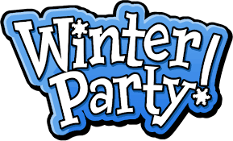
Snow Much Fun

PLATTEKILL MOUNTAIN

Thursday,

February 17
Over the years Winter Carnival has retained its warm charm and camaraderie of a OC celebration. This year will be no different! We have rented out the entire mountain for the day. Come out and join us! You do not want to miss this event.
Activities for the day include winter sports on the mountain. Private lessons will be offered by our Snowsports School, by appointment. Join our traditional hat competition. Be goofy, outrageous and creative! Participate in the mountain games and win some great prizes. Tailgating is encouraged for this event, so bring your grills, chairs, beverages and snacks.
PayPal is open for advance sign up.
LT only = $48 member LT + Bus = $60 member
LT only = $58 guest LT + Bus = $70 guest
Visit www.ocskiclub.org to sign up on PayPal. We hope you join us for a fun day on the snow at Plattekill!

