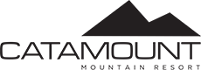

Ski Council Members

Catamount is pleased to offer special discounted lift tickets for Ski Council Members.
$30 Midweek, non-holiday
$50 Weekends, non-holiday
*Must show Ski Council card and other form of ID.

