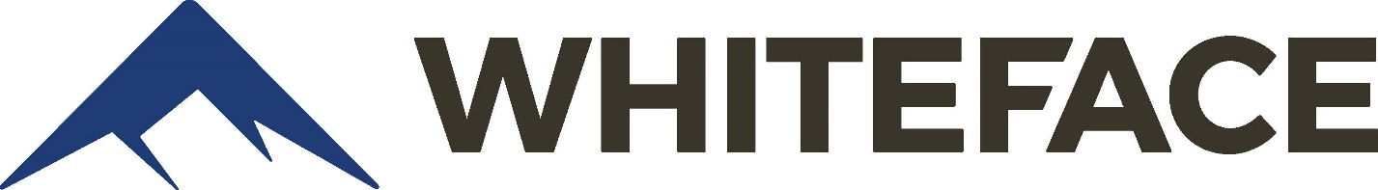

2025/26 Ski Club/Council Appreciation Days
We want to show our appreciation to all of the Ski Councils and Ski Clubs and what better way to do that than by offering a great deal on a day (or more) on the slopes!!
- February 2, 2026 (Monday) $67
- February 23, 2026 (Monday) $67
- March 6, 2026 (Friday) $67
- March 27, 2026 (Friday) $67
- April 3, 2026 (Friday) $57
- April 4, 2026 (Saturday) $57
- April 5, 2026 (Sunday) $57
Simply come to Whiteface on any of the dates listed above, show your Ski Council or Ski Club ID as well as a photo ID and get a lift ticket.
Please contact us at groups@whiteface.com or by calling 518-946-8414 with questions.

