 | Item Number | Description
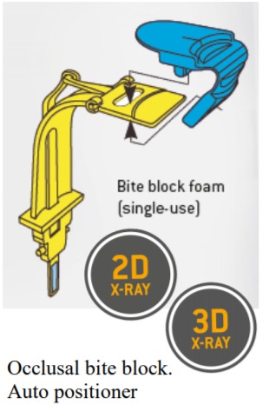 | 6211143 | - Provides electronic and visual feedback when the jaw of the patient is set in a predefined angle
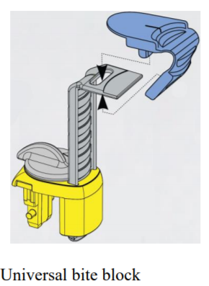 | 6094242 | - Patient can be positioned at any height -plane  - Steps are marked with colors that correspond to standard heights, yellow, blue, but also additional heights for special situations
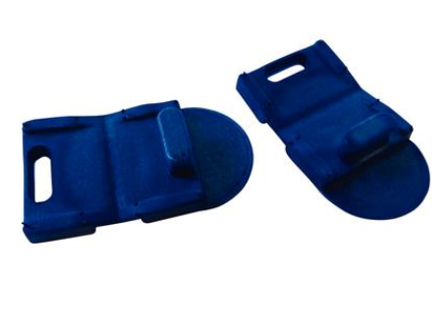  Disposable Bite Block (100) | 6141449 | - Refill pack of 100 blocks
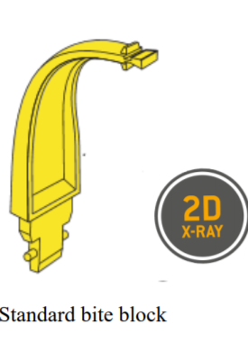 | 8921843 | - Standard positioner for all units and programs (except TMJ and sinus) that do not allow for the occlusal auto positioner  - Patient is positioned forFrankfurt Horizontal Plane (FH)

