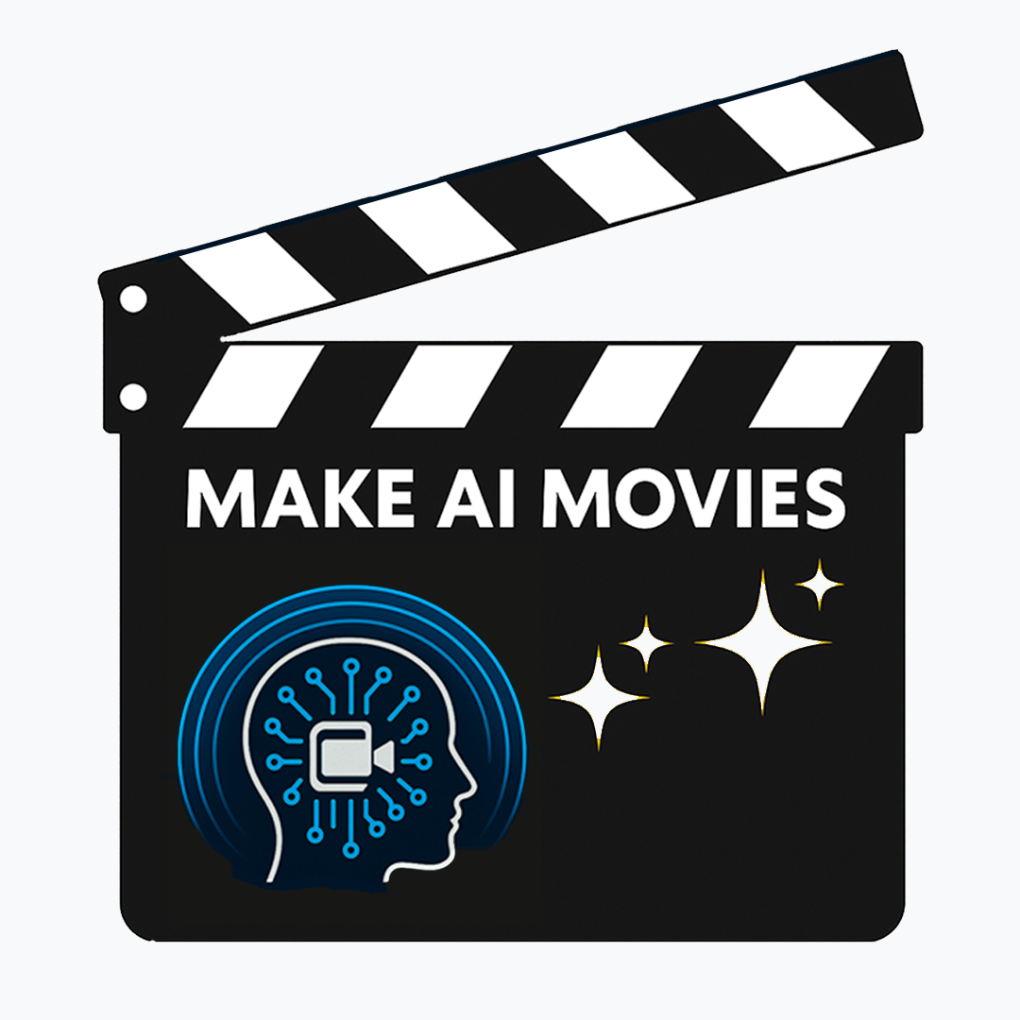
MAKE AI MOVIES
AI Filmmaking Workshops for Students
Parent/Guardian Permission & Release Form
1. PARTICIPATION CONSENT
I, ______________________ (parent/guardian),
give permission for _____________________ (student) to attend and participate in the production of an AI Movie as part of the Make AI Movies workshop program.
2. MEDIA RELEASE & PUBLICITY CONSENT
I consent to photographs and videos of my child being taken during the workshop for the promotion and publicity of Make AI Movies programs and workshops.
3. INTELLECTUAL PROPERTY RIGHTS
I understand and acknowledge that:
• The work produced by my child remains their collaborative intellectual property.
• The creative work will be shared with the school, other parents and guardians, teachers and educators, and on Make AI Movies affiliated social media channels
4. USE OF CHILD’S IMAGE OR VOICE ON AI PLATFORMS
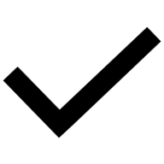
If you are happy for your child’s voice and / or image to be used in the production of the movie, please mark this box with an . If you are not, please mark with ‘X’

PARENT/GUARDIAN SIGNATURE
By signing below, I confirm that I have read, understood, and agree to all terms outlined in this permission and release form.
Parent/Guardian Full Name: ___________________________________________
Signature: ___________________________ Date: ___________________
Phone Number: _______________ Email Address: _________________________

