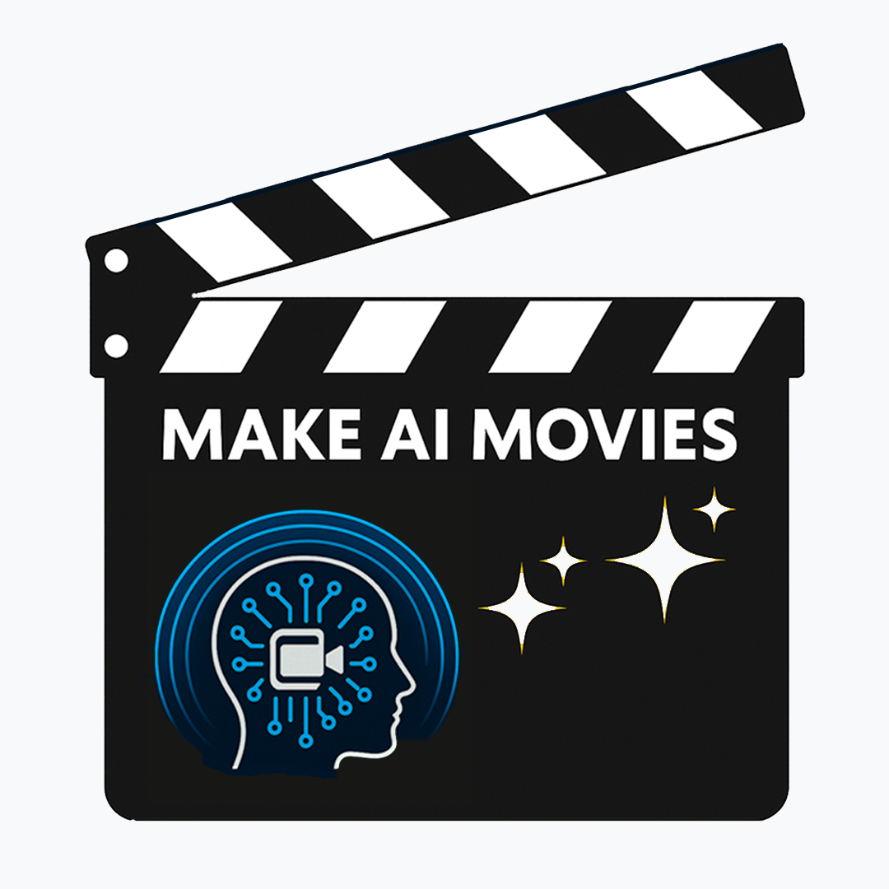
Pre-Workshop Survey for Students
(Before attending the 8-Week or School Holiday Program)
Hi movie makers! This survey will help us understand how you feel about creating stories, and making movies before the workshops start. There are no right or wrong answers, just be honest!

Section 1: About You
- What is your name? ______
- What year are you in at school? _____ and what school do you go to? _________________
- Do you like writing stories?
☐ Yes, I love it! ☐ Sometimes ☐ Not really ☐ Never tried it
- Do you like watching movies, tv and youtube videos?
☐ Yes, I love it! ☐ Sometimes ☐ Not really ☐ I don’t at all
- Have you ever wanted to make your own?
☐ Yes, I am already! ☐ Yes! but I don’t know how. ☐ I haven’t thought about it. ☐ No
- Have you ever tried to make a video?
☐ Yes, and I enjoy it! ☐ Yes! but it was too hard. ☐ No, but I want to! ☐ No, it seems too difficult
- Have you ever used AI to make pictures, videos or songs?
☐ Yes, and I enjoy it! ☐ Yes! but they didn’t turn out well. ☐ No, but I want to!
☐ No, I’ve never tried.
- How do you feel about using AI to make pictures, videos and songs right now?
☐ Excited and want to learn more! ☐ Unsure, but interested ☐ Nervous or scared
☐ No strong feelings
- How would you feel if you had to make short movie using AI right now?
☐ Excited to give it a go ☐ Not sure that it would be good ☐ Not sure that I could do it
☐ Completely impossible
- If you learned how to make a short AI movie in a group, and it turned out just OK,
would you want to try again to make another one that was even better?
☐ Yes, I want to get better at learning these skills ☐ Probably, if I enjoyed it
☐ Maybe, not if it wasn’t very good ☐ No, I just wanted to try once to see what it was like

Section 2: Your Skills
Please write a number next to each statement showing how confident you are about each one (1 = Not confident, 5 = Very confident):
Creative Thinking
- I can think of different and creative ideas for stories and characters. (1–5)
- I can try out new ideas and see what works. (1–5)
- I can adjust the rest of my ideas when I make a creative change. (1–5)
Working with Ideas
- I can explain what a story, problem or idea means. (1–5)
- I can give reasons for my ideas. (1–5)
- I can tell if my writing worked well or not. (1–5)
Reading & Writing
- I enjoy talking and listening in class discussions. (1–5)
- I understand what I read. (1–5)
Digital Production Skills
- I can use digital tools (like computers or tablets) to create and share stories. (1–5)
- I enjoy using AI to make stories, pictures, videos, or songs. (1–5)
- I regularly use AI to make stories, pictures, videos or songs. (1–5)
Working with Others
- I feel confident sharing my ideas with others. (1–5)
- I keep trying even if writing is hard. (1–5)
- I work well with classmates in group activities. (1–5)

Section 3: Your Thoughts
- What particular skills do you hope to learn in the Make AI Movies workshops?
- What kind of future opportunities do you hope will come from these workshops?

