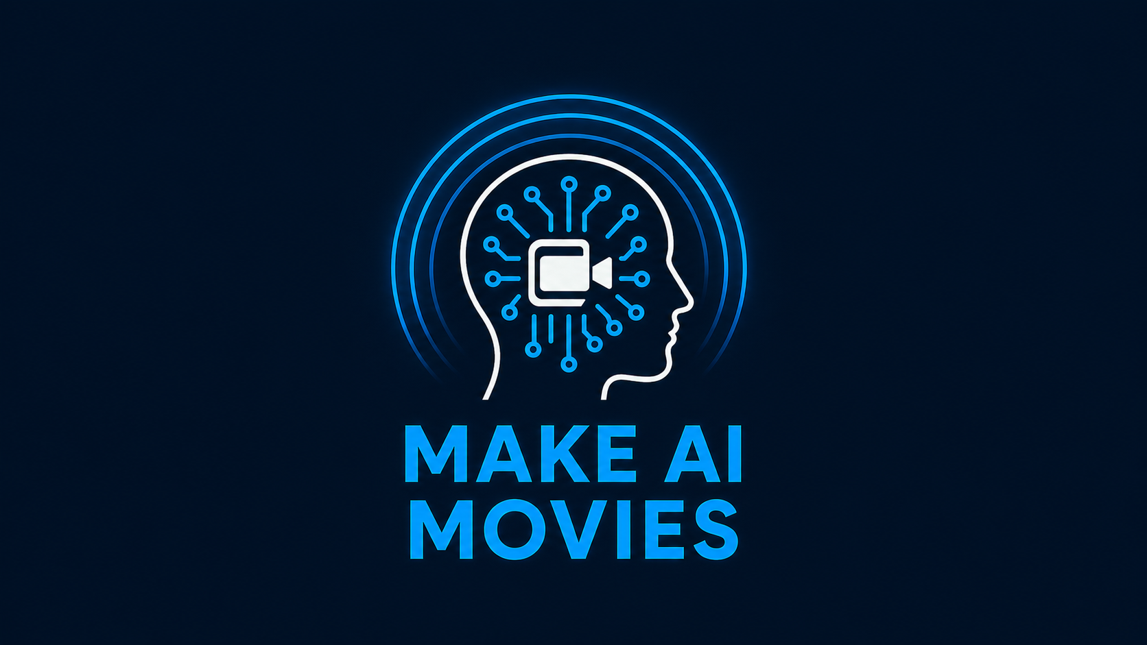

PARENT / GUARDIAN PHOTO & VIDEO CONSENT FORM
Please complete this form before your child participates in a Make AI Movies workshop.

Parent / Guardian Details
Parent/Guardian Name _________________________________________________
Child's Name _________________________________________________
Email Address _________________________________________________
Phone Number _________________________________________________
Workshop / School _________________________________________________
Date _________________________________________________

Consent
I give permission for Matthew Donaldson / Make AI Movies to photograph and/or video record my child during workshops, events and activities.
I grant Matthew Donaldson / Make AI Movies full rights to use the photographs, video recordings and any reproductions or adaptations for publicity, promotion, fundraising and educational purposes to help achieve the aims of Make AI Movies. This includes, but is not limited to, printed promotional material, websites, online advertising, social media, press releases, newsletters, posters, flyers, presentations and funding or grant applications.
Please note that no images or recordings of your child will be uploaded to AI platforms without separate and express written permission.
Photos selected for publicity will be supplied to parents at the conclusion of the workshops.

Declaration
I confirm that I am the parent/legal guardian of the child named above and that I have read and understood this consent form.
Signature: ________________________________________
Print Name: _______________________________________
Date: _____________________________________________
Privacy: You may withdraw consent at any time by contacting Make AI Movies in writing.
Withdrawal applies only to future use and cannot remove material already published.

