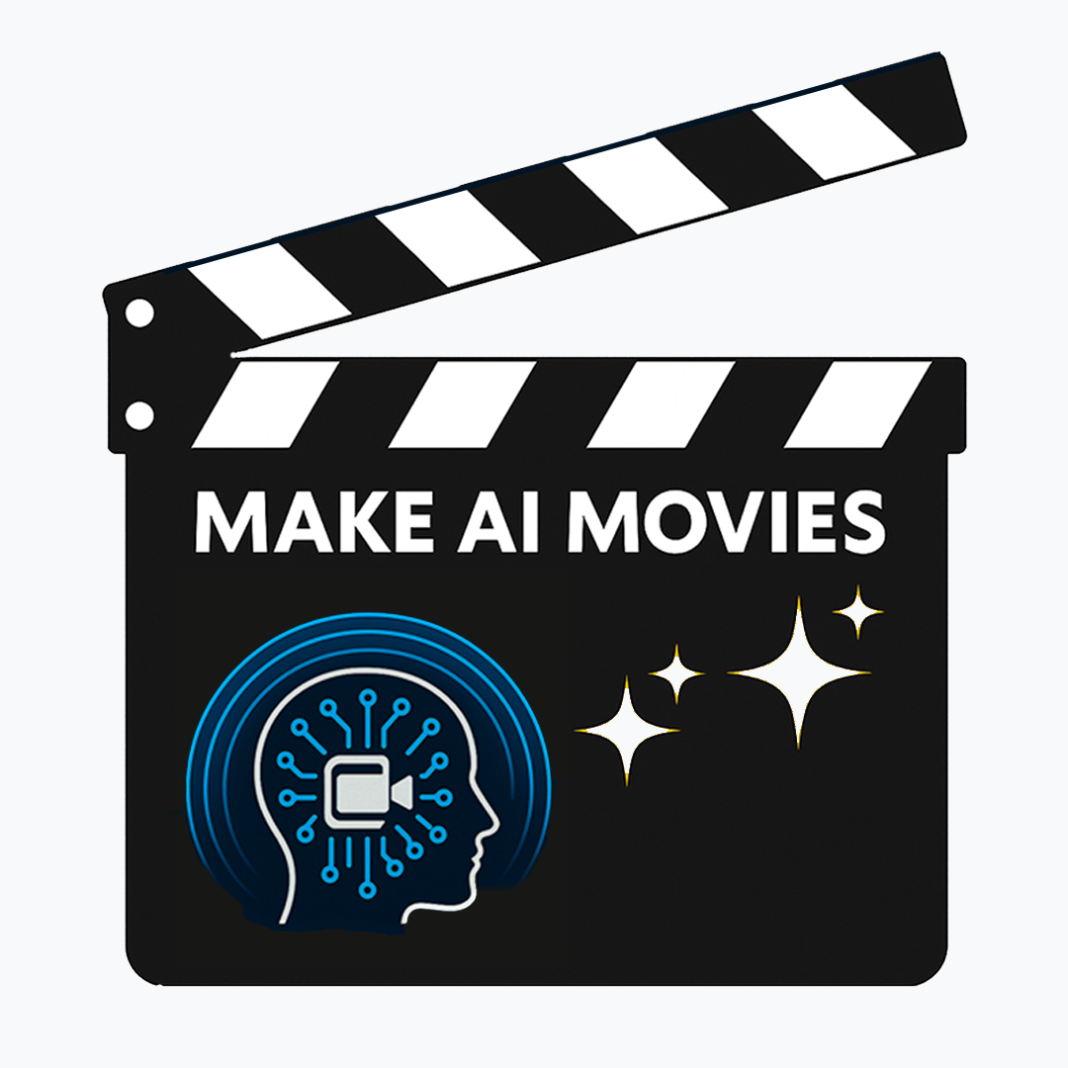
Post-Workshop Survey for Students
(AFTER attending the 8-Week or School Holiday Program)
Hi movie makers! This survey will help us understand how you feel about creating stories, and making movies now that you’ve completed the workshops.
There are no right or wrong answers, just be honest!

Section 1: About You
- What is your name? ____________________
- What year are you in at school? _____ and what school do you go to? _________________
- Did you enjoy writing the stories?
☐ Yes, I loved it! ☐ It was pretty good ☐ Not really ☐ It was boring
- Do you think you’d like to make movies, tv and youtube videos as a job?
☐ Yes, I’d love to! ☐ Could be fun ☐ Maybe ☐ No
- How do you feel after having made your own movie?
☐ Very proud! ☐ Pretty happy with it. ☐ Not that good ☐ It was hard and I didn’t like it.
- Did you learn new skills on the workshops?
☐ Yes, I learned a lot! ☐ I learned quite a bit. ☐ I already knew most things ☐ I didn’t learn anything
- Did you enjoy the workshops?
☐ Yes, I had a great time! ☐ They were good. ☐ They were OK ☐ I didn’t enjoy them
- Did you enjoy using AI to make stories, pictures, videos and songs?
☐ Yes, I enjoyed it a lot! ☐ Yes! but they didn’t turn out well. ☐ Not really
☐ Not at all.
- How do you feel about using AI to make pictures, videos and songs compared to when you started the workshop?
☐ Excited and want to make more! ☐ It might be good in future ☐ It is frustrating
☐ No strong feelings
- How would you feel if you had to make short movie using AI right now?
☐ Confident and excited to give it a go ☐ Not sure that it would be good ☐ Not sure that I could do it ☐ Completely impossible
- Would you want to have another go at making a short AI movie in a group, to use what you learned to make it even better?
☐ Yes, I want to get better at learning these skills ☐ Probably, if I enjoyed it
☐ Maybe, not if it wasn’t very good ☐ No, I just wanted to try once to see what it was like

Section 2: Your Skills
Please write a number next to each statement showing how confident you are about each one, now that you have finished the workshop. (1 = Not confident, 5 = Very confident):
Creative Thinking
- I can think of different and creative ideas for stories and characters. (1–5)
- I can try out new ideas and see what works. (1–5)
- I can adjust the rest of my ideas when I make a creative change. (1–5)
Working with Ideas
- I can explain what a story, problem or idea means. (1–5)
- I can give reasons for my ideas. (1–5)
- I can tell if my writing worked well or not. (1–5)
Reading & Writing
- I enjoy talking and listening in class discussions. (1–5)
- I understand what I read. (1–5)
Digital Production Skills
- I can use digital tools (like computers or tablets) to create and share stories. (1–5)
- I enjoy using AI to make stories, pictures, videos, or songs. (1–5)
- I want to regularly use AI to make stories, pictures, videos or songs. (1–5)
Working with Others
- I feel confident sharing my ideas with others. (1–5)
- I keep trying even if writing is hard. (1–5)
- I work well with classmates in group activities. (1–5)

Section 3: Your Thoughts
- What particular skills do you hope to learn in the Make AI Movies workshops?
- What kind of future opportunities do you hope will come from these workshops?

