**Sunshine Siamese Cattery**

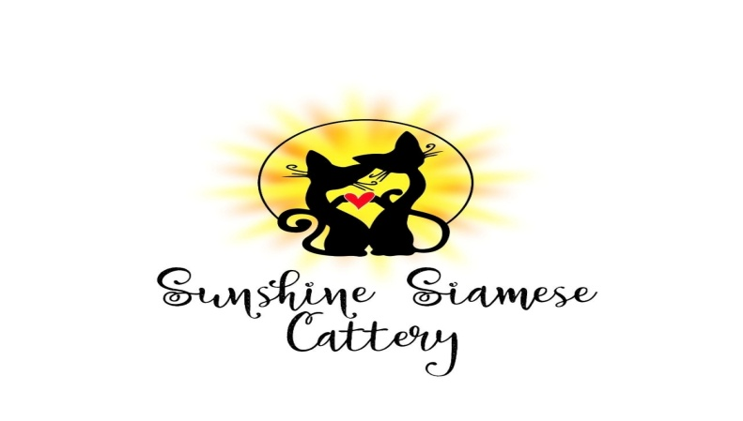

Traditional Cat Association Certified

Registered Cattery Name: Sunshine

Registration No.: 00939

The International Cat Association Certified

Registered Cattery Name: SunshineLove

Registration No.: 104042

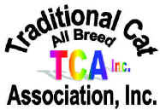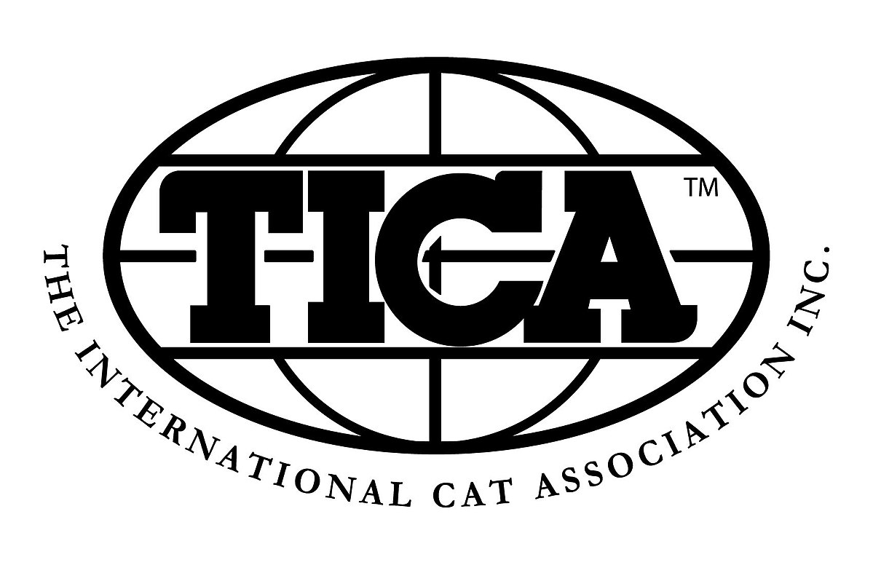

Sales Contract

Seller: Shannon “Sunshine” Dahlke Buyer:

Kitten Name (if any):

Whelping Collar Color:

Date of Birth:

Breed:

Sex:

Color:

Sire:

Registration Number:

Dam:

Registration Number:

Litter Registration Number:

Sold as: *PET (Without breeding rights)* Price of Kitten:

Seller agrees to sell to Buyer said Kitten for the price of ____

Deposit in the amount of $100.00 was made on ____. The remainder of the balance due of ____ has also been paid in full on ____ and there is ZERO owed.

Health Guarantee:

Seller is transferring this Kitten to Buyer in good faith as a healthy, loved and well cared for animal.

Kitten is guaranteed to be of sound health at the time of purchase. Buyer is encouraged to have Kitten checked by a certified veterinarian of Buyer’s own preference within a period of 72 hours after the date of transfer. If, within this 72-hour period, Kitten is deemed by Buyer’s veterinarian to be unsuitable for health reasons, this Kitten will be returned to Seller at Buyer’s expense for a full refund of the original purchase price only.

Kitten will be examined by Seller’s veterinarian prior to transferring to new owner, in addition to receiving their first set of core vaccinations and wormer. Seller guarantees Kitten to be free from Feline Leukemia virus (FeLV) and Feline Immunodeficiency virus (FIV) at the time of sale.

The Health Guarantee hereunder shall be null and void if Buyer has Kitten vaccinated with:

* FeLV or FIP vaccine;
* Rabies vaccine other than Merial Purevac;
* Rabies vaccine and/or three-way vaccine administered at the same time or before surgery.

Kitten is guaranteed against congenital defects for *one year*. Should Kitten die within that time as a direct result of a congenital defect Kitten may be replaced upon receipt (hereinafter “Date of Return”) of (a) a signed document from a licensed veterinarian stating the exact cause of death (b) an autopsy report, (c) a copy of the health and shots records for the Kitten, (d) the cause of death is a direct and proximate cause of a genetic defect, (e) Buyer provides this information within 14 days from the date of death. Replacement will be made of a kitten of comparable quality and value at the discretion of the breeder. Seller will have six months from the date of return to provide Buyer with a comparable replacement if no comparable replacement is available at the date of return. Seller reserves the right to refund Buyer’s purchase price in lieu of replacement.

*Under no circumstances will the Seller be responsible for any veterinarian costs associated with the Kitten.*

De-Clawing:

Kitten should not be surgically de-clawed no undergo a tendon-cutting procedure. If Buyer has Kitten de-clawed or has a tendon-cutting procedure the Health Guarantee hereunder shall be null and void.

Spay/Neuter:

This Kitten is intended to be a household pet and spaying and neutering is required to be done between four (4) months of age and no later than seven (7) months of age for females and (9) months of age for males. Kittens should weigh at least 3-4 pounds before having surgery. ***Buyer agrees not to allow this Kitten to produce offspring.***

Proper Care:

Buyer agrees to provide proper housing, diet, fresh water, parasite control and general health care for Kitten, including the completion of immunizations plus yearly boosters and prompt veterinary care for any illness or condition requiring medication or surgery.

Kitten is to be kept inside and should not be caged except for a short-term confinement if necessary.

Kitten should be fed a premium kitten food for the first 12 months of their lives.

Kitten has been fed/is currently eating Purina ONE Healthy Kitten dry food and Purina ONE kitten wet food, Iams kitten pate`, Blue Buffalo kitten wet food or cooked chicken twice a day.

Any changes to the Kitten’s diet should be made very slowly. It is always recommended that Kitten have access to dry food and fresh wet food two to three times a day.

***Buyer agrees to give Kitten daily LOVE and AFFECTION!***

Applicable Law:

Any dispute arising hereunder shall be governed solely by the laws of Kansas. Buyer shall be liable to Seller for any costs including court costs and attorney fees, associated with the Seller enforcing the terms of this contract.

In signing this document, Buyer acknowledges that he/she has read and understands the terms herein, and Buyer agrees to all the terms and conditions of the above sale.

Date of Sale:

**Signature of Seller:** _________________________________________

**Signature of Buyer**: _________________________________________