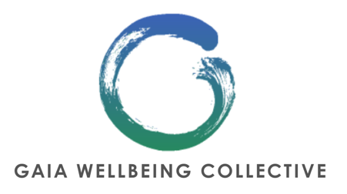

Safeguarding Policy
Gaia Wellbeing Collective – Forest School

1. Policy Statement
Gaia Wellbeing Collective (GWC) is committed to safeguarding and promoting the welfare of all participants attending our laughter sessions and workshops. We recognise our responsibility to provide a safe, inclusive, and supportive environment where participants feel respected, protected, and able to engage at their own pace.
This policy applies to our forest school project.

2. Scope
This policy applies to:
- All participants
- Facilitators, staff, and volunteers
Forest school is offered as part of our Move & Explore – Healthier Families, Connected Communities Project in conjunction with Sport England.

3. Safeguarding Principles
GWC operates in line with the following safeguarding principles:
- Safety and wellbeing come first
- Choice and consent are central
- Participation is always optional
- Boundaries are clear and maintained at all times
- All concerns are taken seriously and responded to appropriately

4. Creating a Safe Environment
To ensure participant safety, GWC commits to:
- Delivering trauma-informed, inclusive, and accessible sessions
- Clearly explaining session structure, expectations, and opt-out options
- Emphasising that all activities are voluntary and adaptable
- Encouraging and supporting self-regulation and rest where needed
- Avoiding unnecessary physical contact unless explicitly consented to
- Using inclusive, non-judgemental language at all times

5. Facilitator Responsibilities
Our forest school is delivered by a trained facilitator and community volunteers who are responsible for:
- Maintaining professional boundaries
- Monitoring group dynamics and emotional wellbeing
- Responding calmly and appropriately to distress
- Never pressuring participants to take part
- Ensuring confidentiality is respected
- Following safeguarding and escalation procedures if concerns arise
- Our facilitator and volunteers hold enhanced DBS certificates
- Facilitators are trained to industry standard and hold sufficient insurance and first aid certification

6. Managing Emotional Distress
Children are developing their ability to emotionally regulate their nervous system and can also express unexpected emotional responses. If a participant becomes distressed:
- The facilitator will respond with empathy and calm reassurance
- The participant will be given space and choice
- No personal disclosures will be encouraged
- Where appropriate, the participant may be signposted to additional support services

7. Safeguarding Concerns & Disclosure
If a participant discloses information that raises a safeguarding concern:
- The facilitator will listen without judgement
- No promises of confidentiality will be made
- Information will be shared only if there is a risk of harm
- Concerns will be recorded factually and securely
Where immediate risk is identified, emergency services will be contacted.

8. Confidentiality & Data Protection
Personal information is kept confidential and handled in line with GDPR. Information is shared only when necessary to protect safety. Group confidentiality is encouraged but cannot be guaranteed.

9. Safeguarding Lead
Name: Sally Dixey
Role: Director
Contact: gaiawellbeingcollective@gmail.com
The Safeguarding Lead is responsible for responding to concerns, maintaining records, and liaising with safeguarding services if required.

10. Review of Policy
This safeguarding policy is reviewed annually or sooner if delivery methods change, new risks are identified, or updated safeguarding guidance is issued.

11. Policy Acceptance
All facilitators volunteers for Gaia Wellbeing Collective are required to read, understand, and adhere to this policy.

