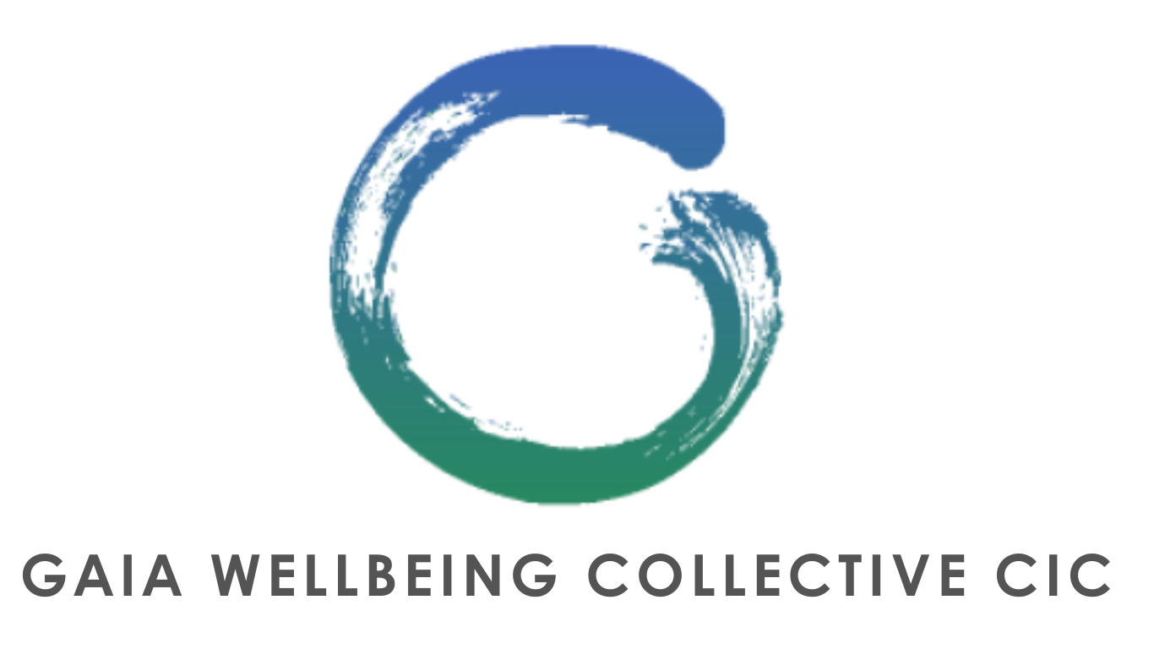

CANCELLATION POLICY

REGISTERED 15914874

Gaia Wellbeing Collective CIC. (hereinafter “**GWC**”, “**We**” or “**Us**”), is an outdoor wellbeing provider. We look to help individuals with their physical as well as mental health, which is why We offer activities such as (but not limited to): ‘Limitless’ Group classes (e.g. Bootcamps), workshops, retreats, yoga courses, mindfulness sessions (e.g. forest bathing, gong baths), knowledge sharing classes, Wild Women gatherings (female only classes designed to help females with mindfulness and reconnection) and more (together referred to as the “**Activities**”, events (e.g. GWC picnics).

Please note, We do not offer refunds, unless We are responsible for said cancellation, or unless as specifically mentioned in this cancellation policy (the “**Cancellation Policy**”). As such, please make sure that you read carefully and understand this Cancellation Policy.

1) Location: Please be aware of the location and time of your specific Activity, as We have several outdoor venues.

2) We require you to give Us notice of cancellation or of your intention not to attend the Activity **twelve (12) hours or more**, ahead of the Activity’s scheduled start time. Cancellation is done via Our website

gaiafitnesscollective.com or the Acuity app. Any cancellation made less than twelve (12) hours before the Activity’s scheduled start time will be shown as ‘Late Cancelled’ and will incur the full rate of that Activity . If you cancel an Activity more than twelve (12) hours before the Activity’s scheduled start time, you will be given credit(s) to be used within two (2) months of the credit(s) being awarded to you by GWC.

3) If you do not show up for your Activity you will be charged the full rate for that Activity without the possibility for you to gain any of the credit(s) referred to in clause 2. above and without being able to transfer your attendance to another Activity. For the sake of clarity, please note that any no-show on your part will be shown as ‘Late Cancelled’.

4) If you arrive late at an Activity, you will receive the scheduled appointment time unless other arrangements have been made directly with the trainer. Please note that in such an event, and unless otherwise agreed directly with the trainer, your Activity will finish at the original scheduled finish time.

5) Members of the monthly Gaia Limitless Classes Membership, will need to speak with a Director if more than three (3) Activities are ‘Late Cancelled’. Please refer to the T&Cs for the Limitless Class Memberships, which are incorporated by reference and form part of the T&Cs.