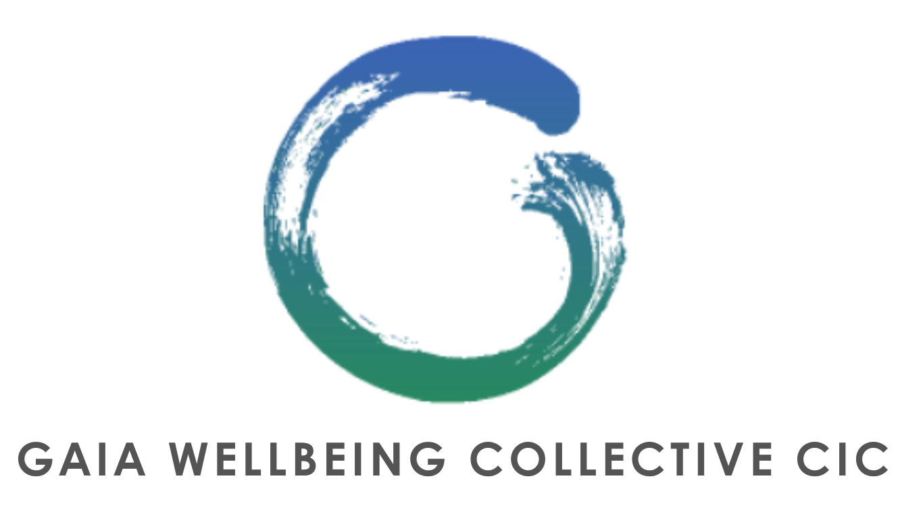

WAIVER OF LIABILITY

REGISTERED 15914874

Gaia Wellbeing Collective CIC. (hereinafter “**GWC**”, “**We**” or “**Us**”), is an outdoor wellbeing provider. We look to help individuals with their physical as well as mental health, which is why We offer activities such as (but not limited to): ‘Limitless’ Group classes (e.g. Bootcamps), workshops, retreats, yoga courses, mindfulness sessions (e.g. forest bathing, gong baths), knowledge sharing classes, Wild Women gatherings (female only classes designed to help females with mindfulness and reconnection) and more (together referred to as the “**Activities**”, events (e.g. GWC picnics).

You confirm that you have read, understood and are in agreement with the below

1) I understand that the Activities (including, if applicable, the Limitless Classes) offered by GWC constitute physical exercise and therefore will involve some level of physical exertion, which may be strenuous and may cause physical injury and/or death and that I am fully aware of the risks and hazards involved.

2) I acknowledge that advice may also be given during sessions or workshops (for example on women’s health: information on hormones or eating) including by third parties but that it is up to me to assess whether this information is right for me and how best to interpret it so that it does not cause me any harm. I hereby take full responsibility if and when I decide to follow said advice.

3) I understand that it is my responsibility to consult with a physician prior to and regarding my participation in the Activities (including, if applicable, the Limitless Classes). I represent and warrant that I am physically fit and I have no medical condition that would prevent my full participation in the aforementioned Activities.

4) When participating in the Activities (including, if applicable, the Limitless Classes) I agree to assume full responsibility for any risks, injuries or damages, known and unknown, which I might incur as a result of participating in the program.

5) I expressly acknowledge that GWC waives, to the fullest extent permitted by law, any liability with respect to any damage, physical injury or death howsoever committed (except to the extent that physical injury or death be caused by GWC’s Negligence) as a result of my participation in the Activities. I hereby expressly waive, to the fullest extent permitted by law, any claim I may have against GWC, for any personal injury, death or damages that I may sustain, as a result of participating in said Activities.

6) I acknowledge that GWC is NOT responsible for the errors, omissions, acts, or failures to act of any party or entity conducting a specific Activity on their behalf, or while utilising its facilities.

7) I, my heirs, or legal representatives forever and to the fullest extent permitted by law release, waive, discharge and covenant not to take legal action against GWC (and/or their directors, officers, employees, volunteers, representatives, and agents, and the activity holders, sponsors, and volunteers) for any damage, injury or death howsoever caused (except if physical injury or death is caused by GWC’s negligence).

8) I agree to assume all responsibility for any legal fees incurred by me however connected with my participation in any Activities.

9) I have read the above release and waiver of liability and fully understand its contents. I voluntarily agree to the terms and conditions stated above.