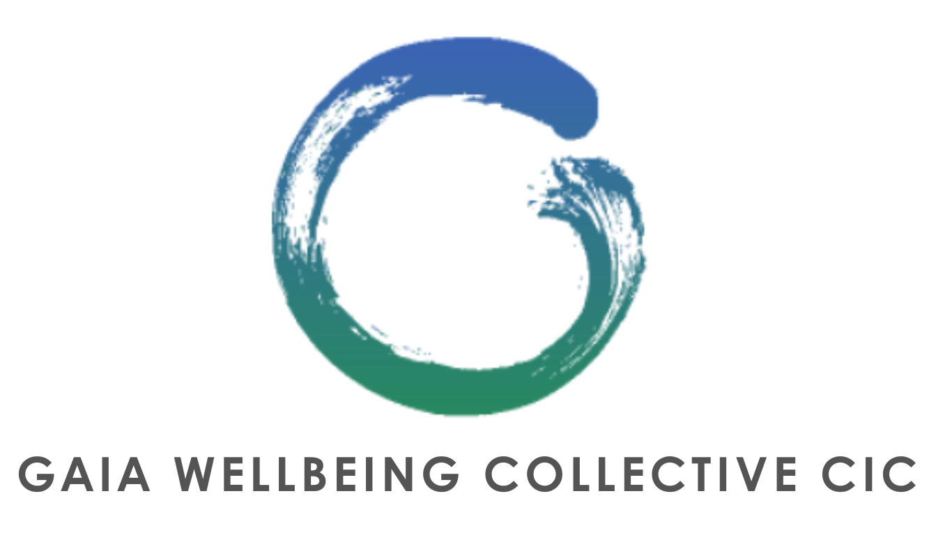

GENERAL TERMS & CONDITIONS

REGISTERED 15914874

Gaia Wellbeing Collective CIC. (hereinafter “**GWC**”, “**We**” or “**Us**”), is an outdoor wellbeing provider. We look to help individuals with their physical as well as mental health, which is why We offer activities such as (but not limited to): ‘Limitless’ Group classes (e.g. Bootcamps), workshops, retreats, yoga courses, mindfulness sessions (e.g. forest bathing, gong baths), knowledge sharing classes, Wild Women gatherings (female only classes designed to help females with mindfulness and reconnection) and more (together referred to as the “**Activities**”, events (e.g. GWC picnics).

1) Please note that these General Terms and Conditions should be read in conjunction, and agreed together, with the following documents:

• The Cancellation Policy

• The Limitless Class Membership T&Cs

• The Waiver of Liability; and

• The Privacy Policy.

Together these documents (hereinafter each separately a “**Document**”) form the **Terms and Conditions** (hereinafter the “**T&Cs**”) which govern the contractual relationship between you and Us.

In case of any discrepancy between these Documents, the General Terms and Conditions shall take precedence.

Any term defined in one Document shall have the same meaning in all the other Documents unless the context otherwise requires.

2) Rescheduling and cancellations: GWC reserves the right to reschedule the Activities if and when required. We will of course endeavour to provide you with as much notice as possible when doing so. In addition, please note, that although We will do our utmost to avoid it, We may need to cancel an Activity for example if a suitable replacement instructor cannot be found or in case of Force Majeure. In such an event, We will make every effort to give you sufficient notice. As such, we recommend that you provide Us with your electronic contact details.

3) Requirements: As Activities have limited availability, you will need to book each Activity and pay in advance for each Activity that you want to attend so that We do not over subscribe the Activity.

4) Refunds/Cancellations: We offer no refunds for cancelled Activities (unless We are responsible for said cancellation). Please see Our Cancellation Policy (which is explicitly incorporated by reference to these General Terms and Conditions and form part of the T&Cs) for more details.

5) Please note: At GWC, We endeavour to provide a peaceful and relaxing environment for all our members and/or attendees, to thrive. As such, if We reasonably believe that your behaviour is not conducive to such an environment, We reserve the right to cancel or suspend your attendance at any time.

6) For any account or billing enquiries please contact our Customer Service Team at gaiawellbeingcollective@gmail.com

7) By clicking in the box you confirm you have read these T&Cs (and specifically all the Documents) and fully understand them. You hereby signal that you agree to these T&Cs.