Sharks Cove Coalition!
is a network of community groups, neighbors, and individuals united:

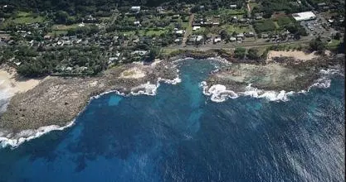

to protect and enhance the ecological integrity, natural beauty, and low-impact recreational uses of Sharks Cove, the jewel of Pūpūkea Beach Park and the Pūpūkea Marine Life Conservation District, for the benefit of local residents, visitors, and future generations.

Sharks Cove Coalition seeks to ensure that all federal, state, and county laws including the 1978 Unilateral Agreement are followed by Hanapohaku LLC, the owners developing the three contiguous B-1 “neighborhood commercial” properties on Kamehameha Highway and Pahoe Road, mauka of Sharks Cove.

The Coalition does not oppose current or future commercial uses or users on the property that fit the B-1 “neighborhood commercial” zoning, which is designed to serve the “daily retail and other business needs of the surrounding population,” so long as:

(1) proper planning and permitting processes that protect
the community and the environment are followed, starting now;

(2) adequate environmental review is completed prior to any further development to fully assess the potentially significant and cumulative impacts on the community, culture, and environment, especially Sharks Cove, the Pūpūkea Beach Park, and the Pūpūkea Marine Life Conservation District MLCD, including: litter, sanitation, surface and subsurface runoff, water or ocean contamination, traffic, pedestrian safety, noise, odors, and overuse of protected areas; and

(3) the owners engage immediately in good faith hearings, presentations, and discussions with the residents and community concerned about and affected by the present and future development.
For more information, go to: savesharkscove.org

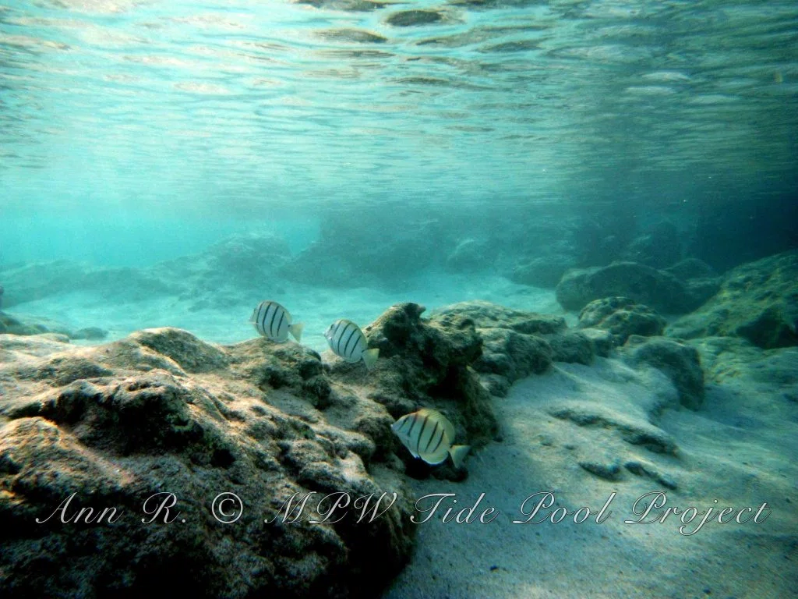
- Mālama Pūpūkea-Waimea
- Save Sunset Beach Coalition
- Friends of Sharks Cove
- Sierra Club – Oʻahu Group
- Surfrider – Oʻahu
- Defend Oʻahu Coalition
- Hawaiʻi’s Thousand Friends
- Life of the Land
- Keep the North Shore Country
- Pahoe Road Residents Hui
- Sunset Beach Community Associate
- KAHEA – The Hawaiian-Environmental Alliance

This Coalition statement was endorsed by a 10-0 vote of the North Shore Neighborhood Board
at a Special Meeting on April 6, 2016.

