**SUPPORTING DOCUMENTS FOR DECLARATION OF ORIGINAL AMERICAN STATUS**

**Prepared by:** John Doe also known as **Your Tribal Name** **Date:** 01/31/2025

### ****Statement of Authentication****

I **man/woman**, **John Doe**, also known within my tribal community as **Your Tribal Name**, submit the following supporting documents as verification of my **American Original Indigenous Status**. These documents serve as evidence of my ancestral heritage, tribal affiliation, and recognized standing within my community.

### ****Attached Documents:****

1. **Tribal Identification Card** – Verifying my membership and standing within my Indigenous Republic.
2. **Lordship Certificate** – Recognizing my title and authority within my tribal governance.
3. **Passport** – Providing government-issued identification.

These documents are submitted as part of my formal **Declaration** to affirm my sovereign identity as an **Original Indigenous Man of the Americas**.

### ****Certification Statement****

I certify that the attached documents are true and accurate copies of the originals in my possession.

**Signed:______________________________________________**  
John Doe  
Your Tribal Name   
Email: Your email

**Tribal Identification Card**



**Lordship Certificate**

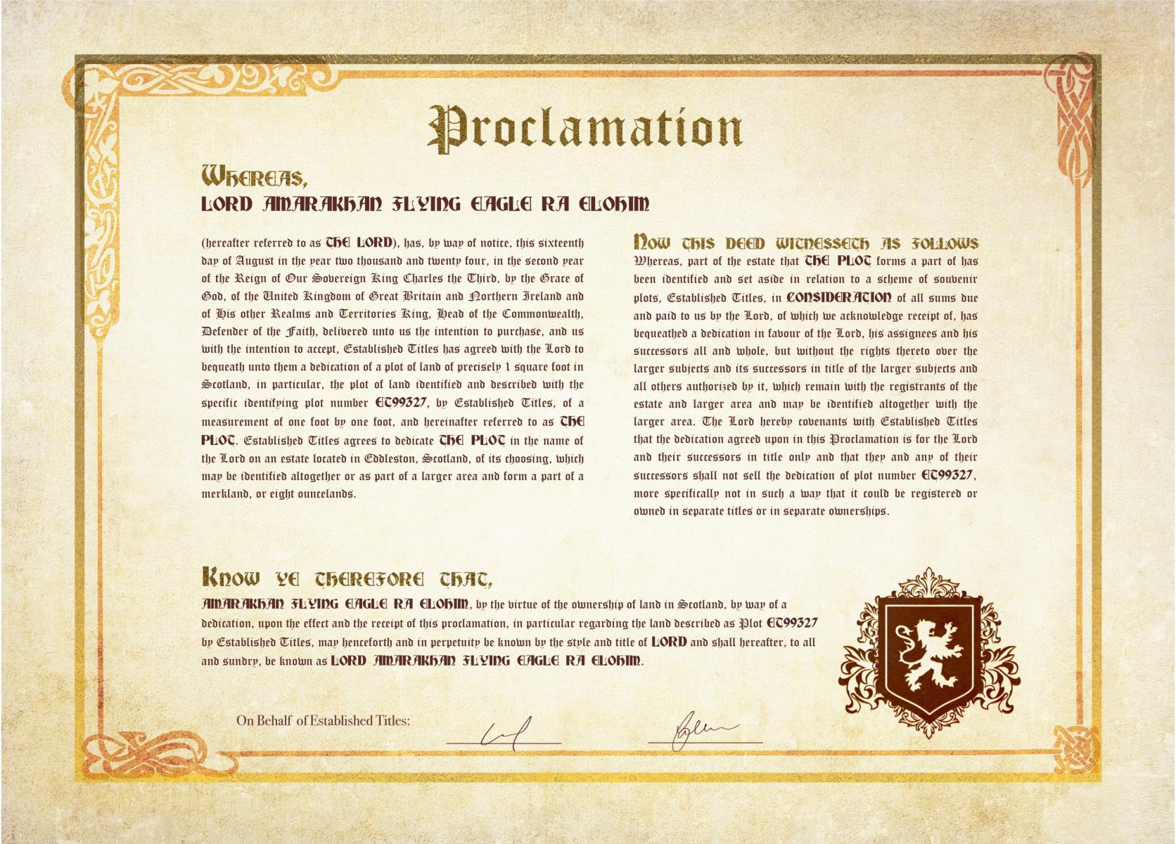

**Government Passport**

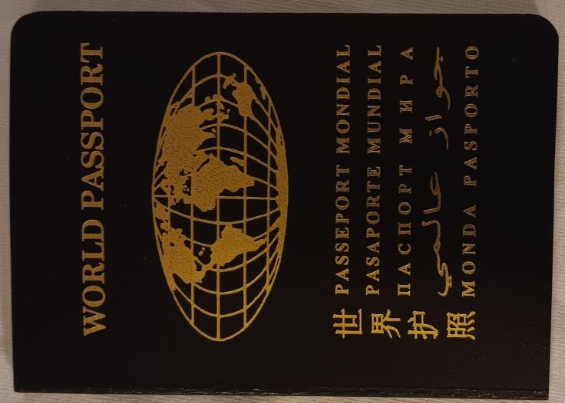Make sure to add the front page of the passport here as well.