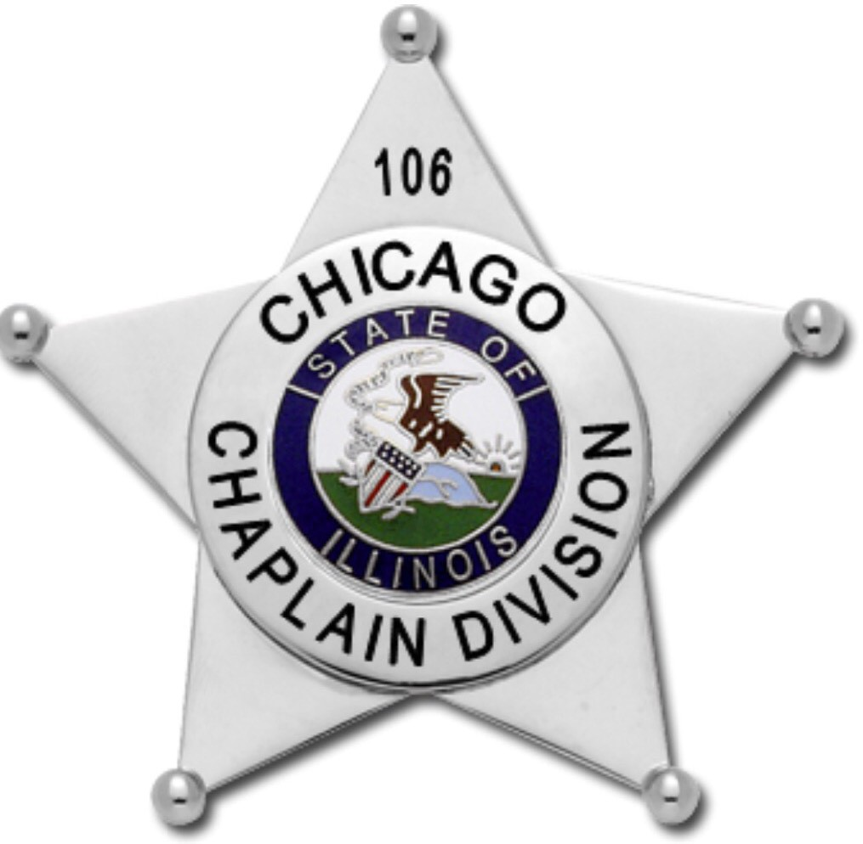Chicago Chaplain Division

[Chicagochaplaindivision@gmail.com](mailto:Chicagochaplaindivision@gmail.com) (312) 253-7479

**PERSONAL APPEARANCE AND UNIFORM REGULATIONS**

Effective Date Section Code August 22, 2020

PURPOSE:

The purpose of this order is to establish the standards of uniform dress and authorized equipment for the Chaplain of the C.C.D.

All uniform items will be issued by The Chicago Chaplain Division Manager.

ADM‐08.1

# POLICY ‐ UNIFORM REGULATIONS

1. All Chaplains are governed by this order.
2. All Chaplains while serving in an official capacity will wear one of the prescribed uniforms. Any denominational‐type modifications to the uniform (example, female skirts) must be approved on a case‐by‐case basis. Please e‐mail CCD Executive Management Team for consideration of a modification to these uniforms.
3. Uniforms, when worn, shall be neat, clean, and well pressed. Shoes, leather, and brass shall be polished.
4. It is not appropriate to attach the CCD patches to non‐approved shirts or jackets. It is also not appropriate to attempt to duplicate the CCD trademarked logos to embroider or screen non‐approved shirts. The CCD Managers include ALL approved uniform apparel. Apparel not appearing in these two places are considered not approved, and may not be worn without approval from the Board of Directors.

ADM‐08.2

# PERFORMING DUTIES OF A CHAPLAIN

CCD Chaplains are covered by the CCD insurance policy when identified as a chaplain and while performing the duties of a chaplain. In order to be considered “identified as a chaplain,” CCD Chaplains must be dressed in one of the prescribed uniforms defined below.

The only exception to this policy is when the Chaplain is dressed in another agency’s uniform (Police, Fire, EMS department uniform, Red Cross, Salvation Army, hospital or corporate attire, etc) and have permission from that agency’s director to wear an CCD badge as part of their official uniform / dress. Chaplains who wish to be covered under this section should secure the agency/corporation’s official dress policy in writing as well as record permission from the agency’s director authorizing them to wear an CCD badge.

For example:

* 1. A corporation that requires business casual attire and has given the chaplain permission to wear their CCD badge when performing the duties of a chaplain for the corporation. Wearing the full uniform would be in conflict with that agency’s dress code.

Doc 1102

* 1. A fire fighter who is also a chaplain for the fire department is allowed to wear their CCD badge with their regular fire uniform

Under unforeseen or emergent circumstances, a chaplain who is identified solely by a chaplain badge or ID card will be considered “identified as a chaplain.” While CCD recognizes that these unforeseen or emergent circumstances may arise which prevent Chaplains from changing into an official uniform before carrying out their official chaplain duties, a Chaplain who is dressed in plain clothes who does not want to wear one of the official uniforms out of personal convenience or preference, and who flashes or wears a badge on a lanyard is NOT considered to be officially identified as a chaplain.

# UNIFORM

## All uniforms will be approved by the Board of Directors and no substitutions, changes or variations may be worn unless approved prior by the Board.

Uniforms will be classified as “Tactical,” “Casual Uniform,” “Formal Class A,” & “Class B.”

**Tactical Uniform**

*Diagram 3.1 & 3.1b*

For general use. Outdoor, disaster scenes, indoor, classes, working as a chaplain.

1. Black, Navy Blue or Khaki 6 pocket BDU Pants *(Diagram 3.1)* or Black or Khaki 5‐11 Tactical Shorts. Black is preferred. *(Diagram 3.1b)*
2. CCD Tee‐shirt (short or long sleeve) (Natural, Black or Blue) (Community Service or Star Logo)
3. Black Mock Turtleneck (winter)
4. Black 1‐1/2” to 1‐3/4” trouser belt or black military tactical belt
5. Black SWAT type boots (or professional closed toe shoes/sneakers when wearing shorts *Diagram 3.1b*)
6. Black Cap with CCD logo (optional)
7. Black sweater over tee or mock turtleneck (optional)
   1. Sweaters must have CCD shoulder patches on each sleeve top 1/2 “down from shoulder seam.

# Casual Uniform

*Diagram 3.2*

For general use. A more professional uniform than the tee‐shirt uniform. Used indoors or outdoors weather permitting for classes, working as a chaplain, instructing, etc.

1. Black, Navy Blue or Khaki 6 pocket BDU Pants or Black dress slacks. Black is preferred however khaki and navy blue are acceptable
2. Polo Shirt (, Black, or Blue) (Community Service or Star Logo embroidered on the left chest)
3. Black SWAT type boots or Black Oxford style shoes
4. Black 1‐1/2” to 1‐3/4” trouser belt
5. All personnel with rank will wear metal rank on the collar of the polo
6. Name may be embroidered on the right chest of the polo in gold thread (or white thread on the black , or Blue polo).
7. Corps Chaplains may embroider the name of their Corps below their name on the right breast of the polo in gold thread (or white thread on the black polo).
8. No patches are to be attached to the polo shirts.
9. Black sweater over tee or mock turtleneck (optional)
   1. Sweaters must have CCD shoulder patches on each sleeve top ½” down from shoulder seam.

Doc 1004

**Formal Class A**

*Diagram 3.3*

For conducting or attending weddings, funerals, first responder funerals, ceremonies, photos, interaction with media etc.

1. Black or Blue button up shirt (short or long sleeved) with either the Community Service or Star logo embroidered on the left chest and CCD patches on each arm ½ inch below shoulder seam.
2. Black tie (men’s tie or women’s cross tie) is to be worn with this uniform
3. Navy blue dress slacks
4. Black Oxford style shoes
5. Black 1‐1/2” to 1‐3/4” trouser belt
6. CCD gold collar brass pins are to be worn on both sides of the shirt collar
7. All personnel with rank will wear black cloth shoulder boards on the shirt’s epaulettes with their rank
8. Navy blue dress blazer (single or double breasted) with CCD patches on each arm ½ inch below shoulder seam
9. All personnel with rank will wear metal rank on each side of the blazer’s collar
10. If the Chaplain has been issued a metal star badge, then the star badge will be worn on the left breast of the blazer, otherwise the plastic pocket badge is to be worn on the left breast pocket of the blazer or hanging from a lanyard
11. The navy blue dress hat is a standard part of this uniform. The CCD hat badge will be worn on the hat

# Class B

*Diagram 3.4, 3.4b, & 3.4c*

For professional events, working with first responders, photos, interaction with media, teaching, etc.

1. Blue or Black button up shirt (short or long sleeved) with either the Community Service or Star logo embroidered on the left chest and CCD patches on each arm ½ inch below the shoulder seam. Personnel issued a metal star badge may wear the badge on the left breast of the shirt instead of an embroidered logo.
2. Corps Chaplains with board approved Corps Branded patches will wear the patch on the right arm ½ inch below the shoulder seam. The CCD patch will be worn on the left arm ½ inch below the shoulder seam. *Diagram 3.4c*
3. All personnel with rank can either wear:
   1. Metal rank on their collars. *Diagram 3.4b* OR
   2. Rank on the shirt’s epaulettes and CCD pins on the shirt collar. *Diagram 3.4* Rank should not be worn on both the collar and epaulettes together.
4. Black, navy blue, or khaki 6 pocket BDU pants or black or khaki dress slacks. Black is preferred however khaki and navy blue are acceptable
5. Black SWAT style boots or black oxford style shoes
6. Black 1‐1/2” to 1‐3/4” trouser belt
7. Black tie (men’s or women’s cross ties) are optional with this uniform

# Wearing the Uniform

Formal Navy blue Dress Hat

1. The cap will be worn in such a manner that the lower‐most part of the cap bill will be on a line horizontal with the eyebrows.
2. All caps will be worn with the plastic grommets in place, not removed
3. The proper cap shield shall be worn on the cap at all times.

Doc 1004

1. All personnel with the rank Major and above are authorized to wear rank specific gold embroidery on the bill of the cap

Baseball Garrison Hat

1. Hat’s brim shall remain in the natural curve that it is manufactured in
2. Can be embroidered with either the Community Service or Star logo Button up Shirts
3. Shirts can be buttoned at the collar and worn with a tie, or unbuttoned at the collar without a tie. **See diagram 2:1**
4. A turtleneck can be worn under the button up shirt
5. Uniform shirts will have the pocket buttons buttoned with no bulky items contained therein. It is recommended that no pens or pencils be visibly protruding from the pocket or flap
6. No tee‐shirt sleeves will be allowed to protrude below the sleeve on the short sleeve shirt.
7. Long sleeve shirts will always be buttoned at the cuff and never rolled up at the wrist
8. Gold name plates worn on uniform shirts will be centered above the wearer’s right pocket. Any ribbons / awards will be centered above the name plate
9. Only chaplain awards will be worn on the uniform shirts. Military and public service members may not wear department awards on their chaplain uniforms
10. Only departmentally authorized tie bars or tie‐tacs are permitted (as issued by the wearer’s fire or police department). No other insignia tie bars or tie‐tacs shall be worn unless authorized by the Board. Approved tie bars or tie‐tacs will be worn at a point on the tie parallel to the bottom of the shirt pocket flap when the flap is closed
11. All personnel with rank can either wear metal rank pins on the shirt collar OR black cloth shoulder boards on the shirt’s epaulettes with their rank. Rank may not be worn in both places. If rank is worn with shoulder boards on the shirt’s epaulettes, then gold CCD collar brass pins should be worn on the shirt’s collar. All rank is worn horizontally. **See diagram 1:1** CCD. ,letter pins are worn vertically.

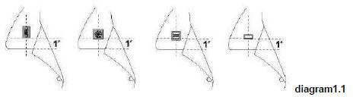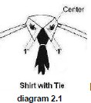

Rank

1. The designation of rank insignia shall be worn as designated on the collars of each shirt or the shoulder board on the shirt’s epitaph and also on the collar of the Formal Class A blazer. The designation of rank will be as follows:
   1. Corporal – 2 bent gold bars
   2. Sergeant – 3 bent gold bars
   3. Lieutenant – single gold bar
   4. 1st Lieutenant – single silver bar
   5. Captain – double gold bar
   6. Major – gold leaf
   7. Lt. Colonel – silver leaf

Doc 1004

Trousers

* 1. Colonel – gold eagle
  2. Brigadier General – one gold star
  3. Major General – two gold stars
     1. All trousers will be of a length that allows the cuff to touch the top of the shoes at the laces. Any lesser length will not be permitted
     2. Trousers will be clean and pressed
     3. The only trousers bloused or tucked into boots will be in the Tactical uniform.

Shoes and Socks

1. Shoes shall be a black military style boot or oxford shoe with a plain rounded toe. Shoes and boots shall be kept clean, shined, and in good repair. Black and non‐black nice‐looking sneakers / closed toe walking shoes will be permitted with the Tactical with **5.11 brand shorts** uniform only.

## Socks shall be black or dark navy in color, of sufficient height to cover the exposed leg area

Jackets, Sweaters and Coats

1. Jackets and coats shall be of the color and style approved and designated in the IFOC store and at ifoc.galls.com
2. Jackets and coats shall have the CCD patch on both arms ½ inch below the shoulder seam
3. Corps members with board approved Corps Branded patches will wear the patch on the right arm ½ inch below the shoulder seam. The CCD patch will be worn on the left arm ½ inch below the shoulder seam
4. Approved sweaters can be worn over any uniform shirt. Sweaters shall have the CCD patches attached to each arm ½ inch below the shoulder seam. As with the jackets, an approved Corps Specific branded patch can replace the CCD patch on the right shoulder.

Badges

1. The metal star badge is issued to CCD Board Members, Instructors, Regional Staff, and Corps Commanders. General personnel are issued the pocket badge in either the Community Service or Star logo.
2. Metal star badge is worn on the button up shirt or blazer or on a belt clip on the front right side of
3. the belt. It may also be worn on the left breast of the command sweater.
4. Pocket badge is worn either in the left pocket of a button up shirt or blazer, or on a lanyard. The pocket badge can also be worn in the belt like the star badge, but should be worn there with caution as they may break when sitting down if the Chaplain is not cautious

Doc 1004

Doc 1004