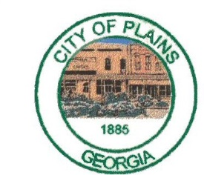
City of Plains
P.O. Box 190· 101 W. Church St. · Plains, Ga. 31780
Phone: 229-824-5445 · FAX: 229-824-5262
clerk@plainsgeorgia.org

City of Plains Notification System

The notification service is provided free to the citizens of Plains and those that receive services from Plains (for example, water service). If you have not signed up, it's not too late. Please complete the form provided below. Tum it in at City Hall (at the drop box if it's after hours) or email it to clerk@plainsgeorgia.org.
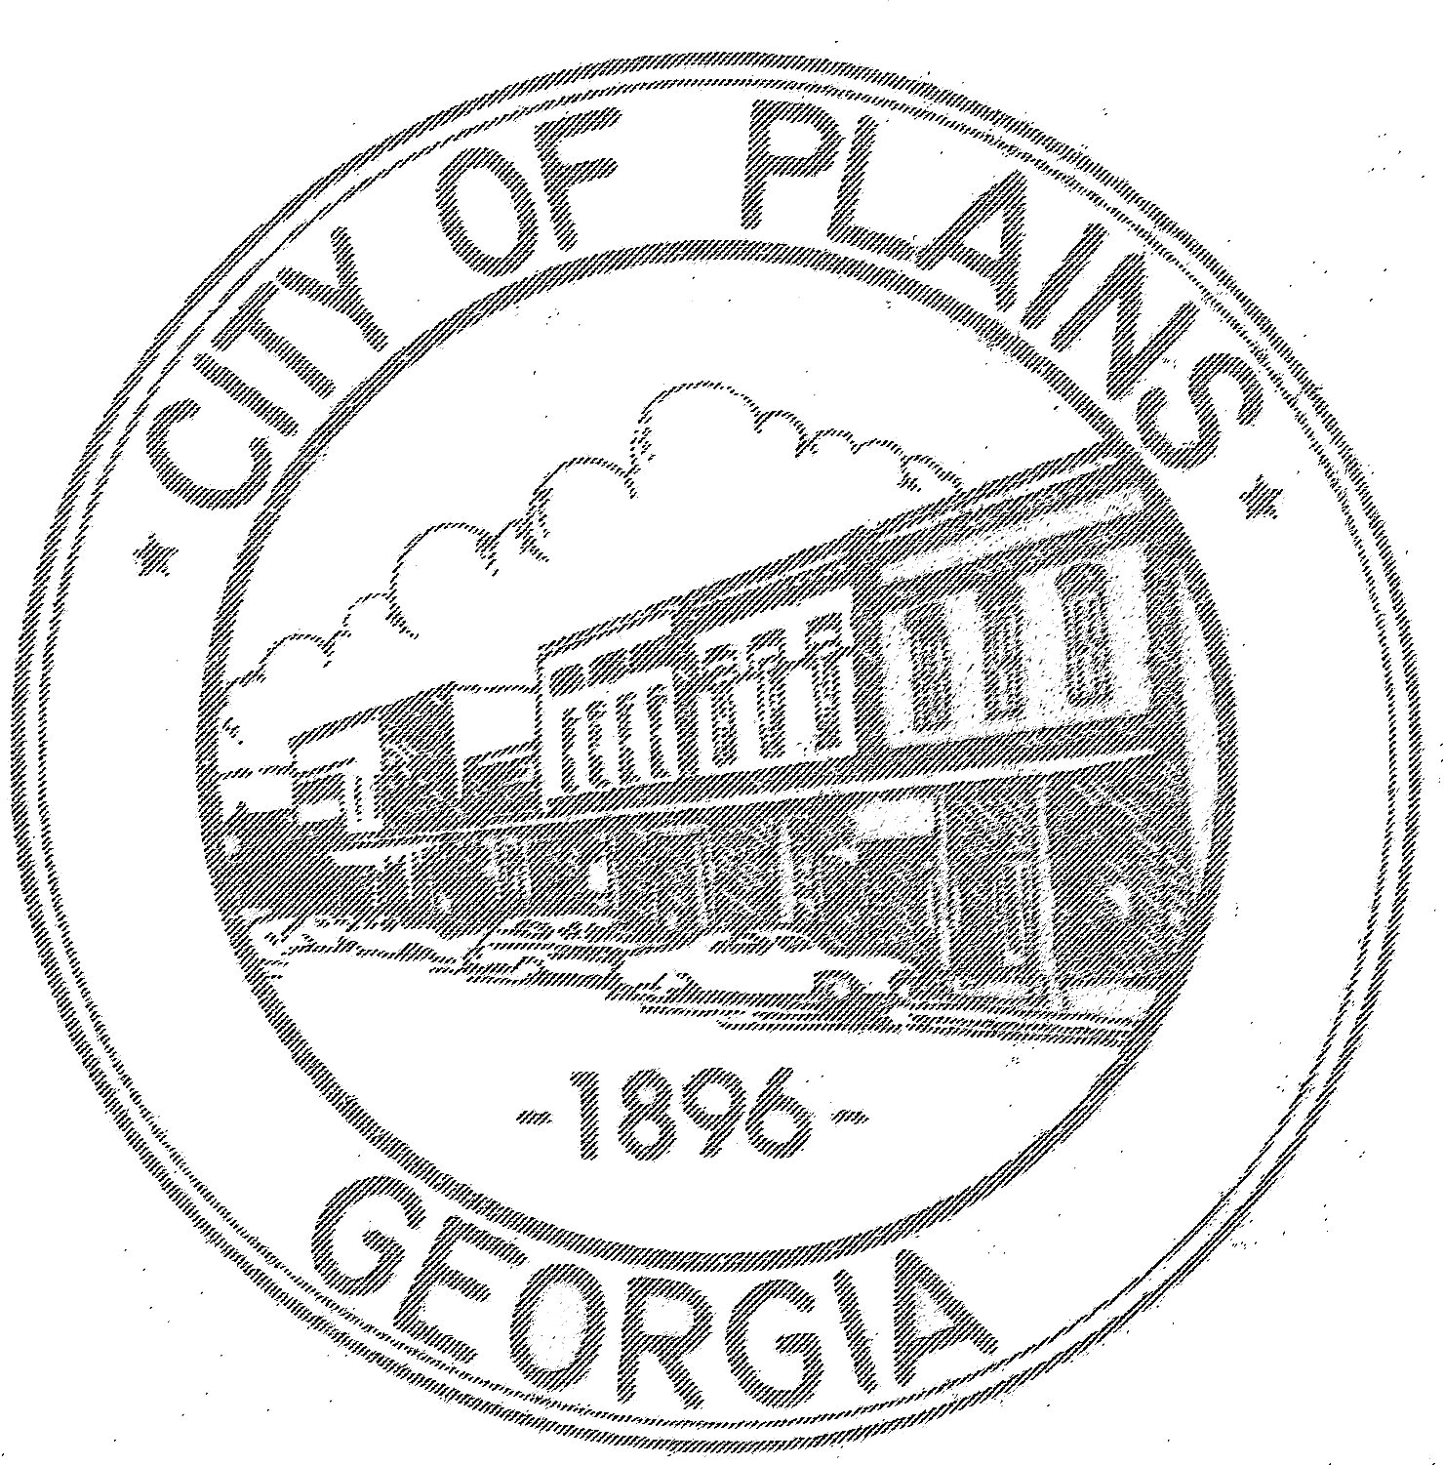

Name:__________________________________________

Address:_________________________________________

Phone Number:_____________________________________

2nd Phone Number:___________________________________

E-mail Address:_____________________________________

