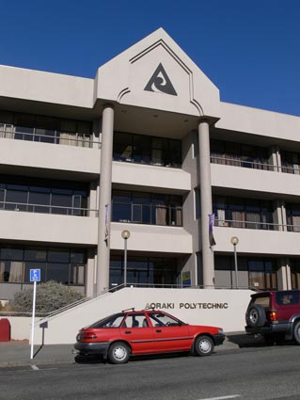
Timaru Jeanz conference theme: What editors want
The Jeanz annual conference at Aoraki Polytechnic will be held in the heart of the Mainland on December 2 and 3, with December 1 set aside for a more informal gathering to discuss unit standards and issues around their implementation. The AGM will be on the morning of December 3. The conference theme is: What editors want.
A partners programme is being developed for those who wish to use the conference as the launch for a holiday in the Mainland. Indications of interest in this to the convenor below would be appreciated.
There are flights directly into Timaru from Wellington. Alternatively, fly to Christchurch and drive (two hours).
Convenor: Peter O'Neill +64 3 6840845 peter.oneill@aoraki.ac.nz
Abstracts: Jim Tully +64 3 3642881 jim.tully@canterbury.ac.nz
Registration: Janine Burgess +64 36848240 janine.burgess@aoraki.ac.nz
Student completions discussed at JTO meeting
Concerns were raised at the April 21 JTO sector committee over the completion rate for polytechnic students on diploma programmes. The meeting also touched on J school entry criteria, the standard of students generally and the decline in the numbers seeking to study journalism.
Jeanz rep's minutes from the JTO meeting
SIT launches news website
SIT’s journalism school has launched a new website called Insitu News that includes news, features, sports, entertainment and arts sections. It also has profiles of Diploma in Journalism and Bachelor of Applied Media Arts (Journalism) students. It will be regularly updated with students' stories as they trawl the south for breaking news.
Insitu News PM
Schoeman joins South Seas
Jack Schoeman, who has been at the helm of the journalism and creative writing areas at Waiariki Institute of Technology for two years, is on the move. Jack has a new job at South Seas Film and TV School in Auckland as course director of the film and TV course (Jack's first love vocationally). Waiariki has been advertising for a replacement co-ordinator for its mass communications courses. AS
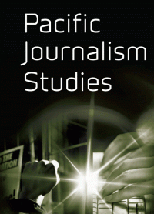
AUT seeks Pasifika journalism educator
AUT University is seeking a Pasifika journalist and educator to join its School of Communication Studies teaching staff. An advert describes the new post as a “challenging opportunity to lead, develop and teach the new Graduate Diploma in Pacific Journalism programme”. The role includes contributing to other journalism papers. Besides core journalism skills, this diploma will also offer specialist papers in Maori and Pasifika Media Industry and Reporting the Pacific Region with both Pasifika media and mainstream media internships available.
“Applicants need a thorough knowledge of reporting and production in one or more areas of the news media,” says the advert. “They are also expected to have outstanding Pacific and mainstream media experience and industry connections with strong roots and mana in the Pasifika community.” As a minimum requirement, applicants are expected to have at least five years' experience in an area of Pacific journalism and an undergraduate degree. A postgraduate qualification is preferred, but not essential. AUT advert Pacific Scoop
Whitireia running new Level 4 programme
Whitireia Journalism School has successfully initiated a Level 4 Certificate in Multimedia Journalism in 2010. This replaces a Level 3 certificate previously used to prepare students for its Level 5 Diploma in Multimedia Journalism. The new certificate was developed by programme leader Jim Tucker in recognition of the amount of preparation required to have students ready for the diploma, which has become more intensive to serve the multimedia requirements of the industry.
Required news gathering, news writing, media law, media ethics, news photography and shorthand components have been joined by an introduction to the first stages of writing for radio and electives introducing video and photo essay/slideshows for the web. There are currently 22 students completing the first certificate of the year, which is being taught by Bernie Whelan who joined Whitireia to teach the course.
Bernie has had close links with both Massey and Whitireia journalism schools in the past four years as editor of APN’s stable of community newspapers in Wellington. He was prior to that editor of the Horowhenua-Kapiti Newspapers and sports editor of the Wanganui Chronicle, where he started his career in 1979. In-between he spent 15 years in Australia, working on Perth’s Sunday Times and with Western Australian Newspapers. BW
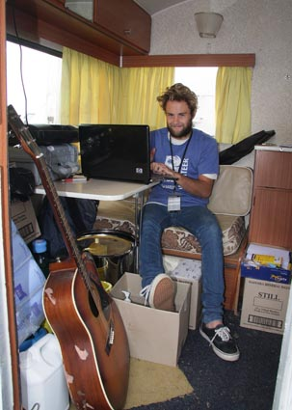
WITT students cover women's surfing festival
Witt journalism student Blanton Smith (right) posts live updates of results at the TSB Bank Women’s Surfing Festival from inside an old caravan at Back Beach, New Plymouth.
WITT journalism student and avid surfer Blanton Smith had no hesitation in putting his hand up as a media volunteer at the TSB Bank Women’s Surfing Festival held in Taranaki recently.
“It has been a real eye opener getting to work behind the scenes at a big event like this,” said the New Plymouth 23-year-old. ``The experience has been great and there are now so many opportunities that I can see my career heading after I finish the course.”
Blanton helped provide real-time web updates on the ASP Women’s Tour event via Facebook and Twitter and had several stories appear in the Taranaki Daily News during the week-long festival.
He was one of six journalism students, who along with tutor Robin Martin, gave up their Easter holidays to volunteer at the event which saw the world’s 17 best female surfers converge on Taranaki.
While many of their fellow students were enjoying a sleep-in over the break, they were up before dawn and at the Fitzroy Beach festival headquarters at 7am each day.
Their responsibilities included issuing press passes, managing the media centre and general troubleshooting for the media contingent which came from around the world. They also setup and updated the event’s Facebook page and Twitter site, and contributed photos and stories for the festival’s official website (www.nzsurffestival.co.nz). DANIEL LYNCH
World Journalism Education Congress
The Congress is scheduled for 5-7 July, 2010, at Rhodes University in Grahamstown, South Africa. It will be a highly international gathering, with simultaneous translation between English, French and Chinese. The over-arching theme is "Journalism Education in an Age of Radical Change". If you're interested in global dialogue with fellow journalism and media educators from all over the world, this is your 2010 event to attend. The gathering also takes place during the World Football Cup in South Africa, adding to the rich context of this congress. (Guy Berger)
Nominations due for Bruce Jesson Awards
The deadline for nominations for the 2010 Bruce Jesson Journalism Awards is Monday, June 30. Nominations are sought from either writers themselves (for the senior journalism award), or from heads of New Zealand journalism schools/programmes (for the emerging journalism award).
The Senior Journalism Prize offers an emolument of up to NZ$3,000 to assist writers aiming to produce the kind of critical and analytical journalism exemplified by Jesson’s work as a columnist in Metro magazine, as editor of The Republican and as the author of several influential pieces of book journalism. The prize is a self-nominatedaward dedicated to in-depth journalism projects on public issues that might not be undertaken, completed, or published without non-commercial subsidy.
The Emerging Journalism Prize recognises “outstanding recent work by New Zealand print journalism students.” It shares the senior award’s broad aim of seeking "critical, informed, analytical and creative journalism or writing which will contribute to public debate in New Zealand on an important issue or issues”.
Nominations together with appropriate supporting documentation including, for the emerging journalism award, copies of the nominated articles, should be forwarded by Monday, June 30, 2010 to Dr Joe Atkinson, Secretary of the Bruce Jesson Foundation by email j.atkinson@auckland.ac.nz, or in hard copy c/- Political Studies Department, University of Auckland, PB 92019, AUCKLAND. Nominees’ work will be assessed by members of the Jesson Foundation’s Journalism Subcommittee: Jon Stephenson (convener), Joe Atkinson, Simon Collins and David Robie.
Massey students win Emerging Journalism Prize
A three-month investigation into a potential health risk from contamination at the former Masterton gasworks has won a team of Massey University journalism students the inaugural Bruce Jesson Emerging Journalism Prize.
The six students (Amanda Fisher, Michael Hasumi-Dickison, Motoko Kakubayashi, Chloe Vaughan, Rory MacKinnon and Sarah Taane) broke the news that local residents had not been informed of toxin levels on the old gasworks site, and that the local council had failed to follow up on advice, given years earlier, to remedy the situation.
The Massey submission consisted of three stories, including the front-page lead story, in the Wairarapa Times-Age newspaper on October 26, 2009. The students’ balanced coverage, achieved under the supervision of Massey Journalism lecturer James Hollings, included a well-written human interest story told from the point of view of a nearby resident whose children regularly played on the contaminated soil, alongside extensive expert commentary about potential risks, and rebuttal from the Regional Medical Office of Health who played down the risks. Though the response of the local council was described by the paper’s editor as “muted”, the story was not subject to legal challenge and was picked up by several other newspapers.
PMC, Red Cross host war reporting seminar
The Pacific Media Centre, International Committee of the Red Cross and New Zealand Red Cross are jointly hosting twin special events on reporting wars at AUT University later this month.
They are: 4.30-6.45 pm, May 24, WA224 (AUT city conference centre): Screening of the film Balibo about the killing of six journalists in East Timor in 1975. This is followed by a Q and A session with one of the film's consultants.
7.15-9pm : Reporting Wars: The Ongoing Challenges seminar, featuring a special video message from Chris Cramer, head of multimedia news of Reuters, New York, and a panel debating cutting edge issues, including the safety and protection of journalists.
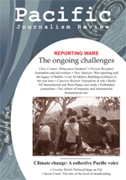
The panel will include war correspondents Cameron Bennett (TVNZ), Mike McRoberts (TV3) and independent journalist Jon Stephenson. Guest speaker will be former ABC journalist Tony Maniaty, of the Australian Centre for Independent Journalism, who was at Balibo shortly before the TV journalists were killed. He is author of the recent book Shooting Balibo and was a consultant for the making of Balibo.
The seminar will be chaired by Dr Camille Nakhid of the PMC Advisory Board. It follows up two conferences on war reporting in Sydney and Wellington sponsored by the ICRC last May. Reporting Wars flyer (PDF)
A special edition of Pacific Journalism Review will be launched at the event by Jean-Luc Metzker, head of the ICRC Delegation in the Pacific, based in Suva. The edition has been edited by professor Wendy Bacon (ACIJ), Dr David Robie (PMC) and Alan Samson (Massey).
Entry is free. Refreshments will be served between the film screening and the seminar. Book to attend with rosemarie.north@redcross.org.nz
More information: Pacific Media Centre niusblog

