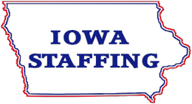
Employment Application

Iowa Staffing is an Equal Opportunity Employer and does not discriminate on the basis of race, color, creed, national origin, ancestry, religion, age, citizenship, sex, marital or veteran status, disability or handicap, sexual orientation or any other basis prohibited by applicable law. Iowa Staffing also takes affirmative action to employ, and advance in employment, qualified women, minorities and covered veterans. Iowa Staffing also makes reasonable accommodations for qualified individuals with disabilities, in accordance with the Americans With Disabilities Act and applicable state laws.

P E R S O N A L | Last Name First Name Middle Initial |  | Social Security Number  - -
 | Present Address Apt # City State Zip |  | Telephone # with Area Code  - -
 | Home Email Address |  | Alternate Phone # with Area Code  - -
Position Desired full-time Salary Desired Willing to Travel ? Yes No
part-time
Are you at least 18 years or older? Yes No If not, will you be able to obtain the necessary working papers? Yes No

Are you either a U.S. Citizen or do you currently have unrestricted authorization to work for any employer in the U.S.? Yes No

List current or most recent employer first. Please note that base salary does not include bonus, commission, benefits, overtime, or other salary incentives. Identify all periods of time during which you were employed or attending school (e.g., military service). Please account for your entire employment history (including volunteer positions). Attach additional sheets of paper, if necessary
E M P L O Y M E N T |  | Name of Employer Address |  | HIRE DATE | /
 |  |  |  | DATE LEFT | /
 |  | Your Position Description of Duties |  | STARTING BASE SALARY
 |  | Supervisor’s Name & Title Supervisor’s Telephone Number |  | CURRENT/LAST BASE SALARY
 |  | Reason for Leaving |  | OVERTIME/BONUS/COMMISSION/ETC
 |  | Name of Employer Address |  | HIRE DATE | /
 |  |  |  | DATE LEFT | /
 |  | Your Position Description of Duties |  | STARTING BASE SALARY
 |  | Supervisor’s Name & Title Supervisor’s Telephone Number |  | CURRENT/LAST BASE SALARY
 |  | Reason for Leaving |  | OVERTIME/BONUS/COMMISSION/ETC
 |  | Name of Employer Address |  | HIRE DATE | /
 |  |  |  | DATE LEFT | /
 |  | Your Position Description of Duties |  | STARTING BASE SALARY
 |  | Supervisor’s Name & Title Supervisor‘s Telephone Number |  | CURRENT/LAST BASE SALARY
 |  | Reason for Leaving |  | OVERTIME/BONUS/COMMISSION/ETC

May we contact your current Employer? Yes No If no, your current Employer will only be contacted with your consent or after you have given notice of resignation.

Referral

E D U C A T  I O N | SCHOOLS | NAME AND LOCATION | AREAS OF STUDY  Major(s) Minor(s) |  | # of Yrs.  Completed | Did You  Graduate? | Degree  Awarded
 | High School |  |  |  |  | Y / N
 | College/University |  |  |  |  | Y / N
 | Graduate, Business or Other |  |  |  |  | Y / N

Military, Professional Licenses and Designations Held or Pursuing Language Proficiencies (read/speak/write):
(specify):

WORK TYPE/WORK SHIFT AVAILABILITY:

Full Time 1st Shift Part Time 2nd Shift Seasonal 3rd Shift

SAFETY EQUIPMENT THAT YOU CAN PROVIDE:

Work Boots/Shoes Steel Toe
Hard Hat
R Safety Glasses
E Tools
L GENERAL: CLERICAL:
Assembly Machinist Administrative Assistant
E
Brake Press Mail Room Customer Service
V Carpenter Maintenance Excel
A Cleaning Machine Operator Fax
CNC Operator Mechanic Receptionist
N Concrete Mover Telemarketing
T Construction Packaging Typing WPM
Electrical Painter Word
Injection Molding Plumber
S Inventory Printer
Janitorial Quality Control
K
Labor Road Construction
I Laundry Supervisor
Landscape Welder
L
Lawn Care
L
S WAREHOUSE: HEAVY EQUIPMENT:
Computer Skills Sit Down Forklift How many years
Load/Unload Stand Up Forklift How many years Hand scanner Clamp Forklift How many years Order Selector Forklift Attachments
Receiving Crane Shipping End Loader Electric Pallet Jack Skid Loader
Manual Pallet Jack Other

Have you ever been convicted of or have you pleaded guilty to a felony or misdemeanor (exclude minor traffic offenses or convictions which have been sealed or expunged)?
No Yes – Please explain:

* A conviction record will not necessarily be a bar to employment. This information will be used only for job-related purposes and only to the extent consistent with applicable law.

Read each of the statements carefully and affirm that you understand and consent to them by signing at the bottom of the page. Please date your signature.

False Application False answers or omissions to questions or false statements or omissions made on this application, during interviews or in your resume, or in supplement thereto, including, but not limited to, with respect to duties, responsibilities, job title or salary and bonus information, may invalidate your application or, if you are hired, may be grounds for discharge from employment.

Employment is “At Will” Employment at Iowa Staffing is for an indefinite and unspecified duration. If you are hired, you may leave employment at will, and the Company may discharge you or any or all other employees at any time, without notice, and for any reason not prohibited by law. The preceding sentence may not be changed or superseded by any oral or written statement, Company manual, policy, or benefit plan, and may only be changed or superseded by: 1.) A special written agreement specifying in detail the duration and terms of your employment, which has been executed by you and an executive corporate officer of Iowa Staffing or 2.) A written, formal restatement of the employment relationship by the President of the Company. The Company disavows any oral or any other written statements to the contrary, and you should not now or in the future rely on any such statements with respect to your employment.

Handbooks, Manuals, Policies, Procedures, Benefits, Etc. The Company may, at its sole discretion, hold in abeyance or revoke, amend or modify, abridge or change any benefit, policy, procedure, practice, condition, or process affecting employees. Descriptions of these that may be contained in any handbook, manual, policy, and the like are for informational purposes and are not intended to be, nor should they be construed to constitute, an employment contract, an offer of initial or continuing employment, or a promise or a guarantee made by the Company.

Immigration Reform and Control Act (IRCA) This federal law prohibits the employment of unauthorized aliens and further requires that, if you are hired, Iowa Staffing verify your identity and your authority to work in the United States on a Form I-9, even if you are a U.S. citizen. This must be done within three days from when you begin employment. You are responsible for obtaining and providing the documentation required to perform the verification. Failure to provide required information will result in termination of employment. [Information concerning the verification procedure and requirements is available upon request.]

Medical/Substance Abuse Testing In applying for and during employment, you agree to voluntarily participate and cooperate, if so requested by the Company and as not prohibited by applicable law, in 1.) blood, urine, or other forms of testing to determine the presence of controlled drugs, illegal substances, or alcohol, and 2.) post-offer medical physical examinations. Such tests or examinations will be performed by the Company, and you hereby authorize them to release the results of these tests or exams to Iowa Staffing.

Applicant Acknowledgement

Signature of Applicant Date

Authorization I voluntarily give Iowa Staffing or its authorized agent the right to make any investigation of my background deemed necessary by them including, but not limited to, my present and former employment, my educational background, and my personal or professional references; and I hereby authorize those persons or institutions contacted by Iowa Staffing or its agents to provide the information requested, including the reasons for termination of my employment, work performance, and other information pertinent to my qualifications for employment. Any offer of employment is contingent upon the successful completion of the Company’s total pre-employment screening process.

Applicant’s Signature | Date

The information provided by the Krist Insurance Services – HR Consulting is an opinion and while we endeavor to keep the information up-to-date and correct, we make no representations or warranties of any kind, express or implied, about the completeness, accuracy, reliability, suitability or availability with respect to the information. Any reliance you place on such information is therefore strictly at your own risk.

The legal information provided is, at best, of a general nature and cannot substitute for the advice of a licensed professional, i.e., by a competent authority with specialized knowledge who can apply it to your particular circumstances. Please contact a local bar association, law society or similar association, including your benefit advisor.

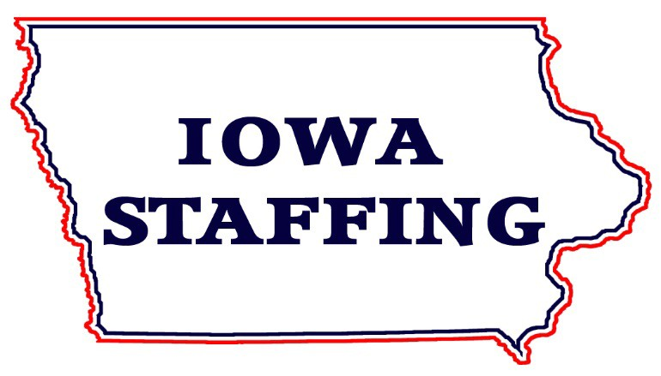
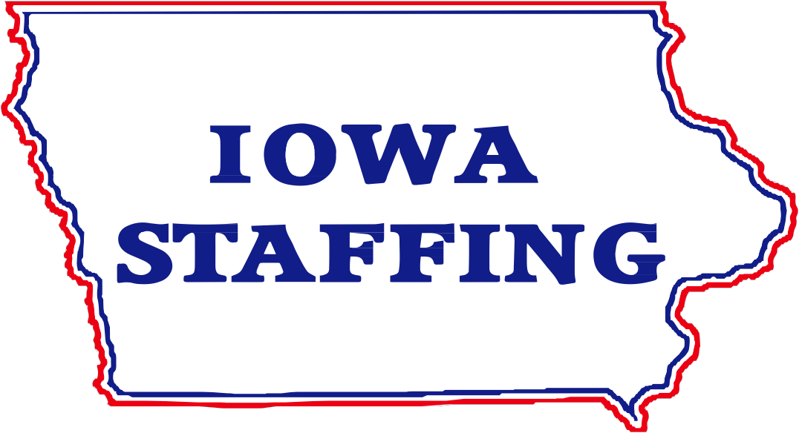

2150 Hubbell Ave.
Des Moines, IA
50317
Ph. 515-465-1930
Fax 515-276-3125

717 N. 18th St. St 4. Centerville, IA 52544
Ph. 641-569-7900
Fax 515-276-3125

SAFETY IS EVERYONES BUSINESS.

Welcome to Iowa Staffing.
We specialize in contract to hire opportunities along with short and long term positions. We are happy to have you as a candidate and we will do our best to match your skills to upcoming positions with our clients.

All Iowa Staffing employees will be assigned to a safe working environment.

Remember Safety is Everyone s Full Time Job.

