September 25, 2020  
Austin, Texas

**Note to Activity and Resident Program Directors**:

Below is a list of flyers that describe remote educational entertainment programs I offer via Zoom. I have been developing and delivering these programs “live,” in-person, to retirement, assisted living, and independent living facilities around the Austin, Texas, area for over 30 years – so long that I am now becoming one of them! As a former science and history teacher, I strive to create and present programs that stimulate thinking and promote memories.

For example, recently, at the beginning of a remote Zoom presentation of the *Evolving Electric Grid* program to residents at Brookdale Westlake Senior Living here in Austin, a resident shared a story describing her memories of being a young girl coming home after school and being ‘asked by her mother to start the Delco generator to create electricity for the home.’ Throughout the presentation, this resident and others offered similar memories from their youth in small towns about experiences with limited or no electricity. They also were aware of current events, offering observations and asking questions about how solar energy and electric vehicles work in relation to the grid. The session was very relaxed and enjoyable for all participants.

As a longtime volunteer to the elderly, starting as a boy in the 1960s mowing lawns, raking leaves, and shoveling snow for elderly neighbors in my suburban Virginia hometown, I value senior friendship and listening to the accumulated wisdom they like to share from years of living in a challenging world. Later in my life, what started as a personal volunteer program in the 1980s to provide slide show entertainment to elderly facilities and neighborhood community members grew into a small thriving business venture in which facilities insisted on compensating me for my entertainment services.

Today, in the age of CoVid, unable to provide live, in-person shows, I have transferred these shows to online presentations. Some facilities prefer that I pre-record a program and post it on You Tube, which the activity director will then share with their residents at an appropriate time. Either format works well for me. Activity directors find remote programming fits well with into their daily activity schedules. Most directors are tech savvy, but, when needed, I work with them to arrange the technical setup of a Zoom presentation, which is fairly doable for most facilities. Some use iPads and TVs, others email the Zoom link to residents who access the program from their laptops.

As stated on the flyers, the usual fee per show is $85. That rate is reduced for multiple show bookings. However, I understand that some facilities have little or no budget for entertainment. In these cases, time permitting, I am willing to waive the program fee. Please feel free to contact me to discuss.

Thank you for your time in reading this introduction. Keep up the good work in these challenging times. With many facilities and residents still in quarantine mode, I know you’re acutely aware that it’s important to keep connections and minds engaged and active.

Sincerely,

Michael G. Albrecht  
[mike@virtualvideoshows.com](mailto:mike@virtualvideoshows.com)  
[www.virtualvideoshows.com](http://www.virtualvideoshows.com)  
512-497-2803

**Tour of the Universe Series**

**Astronomy Slide Presentations**

**Parts 1 & Part 2**



**Color images of galaxies, stars, planets, moons, and comets   
 the world’s major terrestrial and space-based telescopes**

**Presented by**

**Michael G. Albrecht**

**Science, Nature, History and Travel Photographer  
Amateur Astronomer**

**Projector and large screen provided when in-person**

**Lively, generation-relevant, mentally-stimulating presentation**

**$85 per show (approx. 1 hour) – In-person or remote Zoom online**

**Reduced rates for multiple bookings – 12 programs available**

**512-497-2803**[**mike@virtualvideoshows.com**](mailto:mike@virtualvideoshows.com)

**Fall 2020**

**Einstein’s Theories of   
Special and General Relativity**

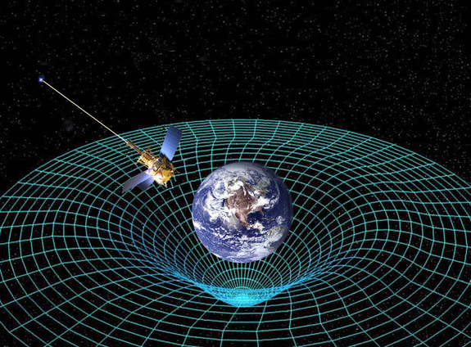

**Hear the exciting historical background leading to Einstein’s great insight into the nature of time, space and gravity**

**Presentation by**

**Michael G. Albrecht**

**Science, Nature, History and Travel Photographer  
Amateur Astronomer**

**Projector and large screen provided when in-person**

**Lively, generation-relevant, mentally-stimulating presentation**

**$85 per show (approx. 1 hour) – In-person or remote Zoom online**

**Reduced rates for multiple bookings – 12 programs available**

**512-497-2803**[**mike@virtualvideoshows.com**](mailto:mike@virtualvideoshows.com)

**Fall 2020**

**U.S. – Russian Space Race: Competition and Cooperation (1940s to present)**

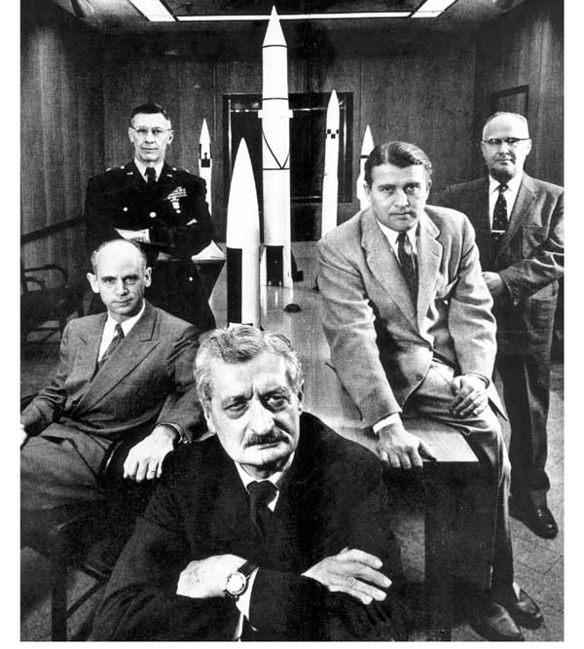

**Presentation by**

**Michael G. Albrecht**

**Science, Nature, History and Travel Photographer  
Amateur Astronomer**

**Projector and large screen provided when in-person**

**Lively, generation-relevant, mentally-stimulating presentation**

**$85 per show (approx. 1 hour) – In-person or remote Zoom online**

**Reduced rates for multiple bookings – 12 programs available**

**512-497-2803**[**mike@virtualvideoshows.com**](mailto:mike@virtualvideoshows.com)

**Fall 2020**

**Evolution of the Electric Grid**

**History of electricity from Ben Franklin to Edison to Tesla, from the 19th Century to Present - the power that enabled modern civilization brought forth during resident’s lives**

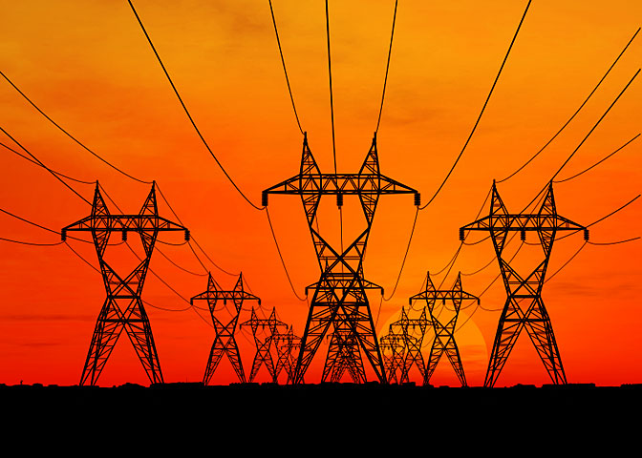

**Presentation by**

**Michael G. Albrecht**

**Science, Nature, History and Travel Photographer  
Amateur Astronomer**

**Projector and large screen provided when in-person**

**Lively, generation-relevant, mentally-stimulating presentation**

**$85 per show (approx. 1 hour) – In-person or remote Zoom online**

**Reduced rates for multiple bookings – 12 programs available**

**512-497-2803**[**mike@virtualvideoshows.com**](mailto:mike@virtualvideoshows.com)

**Fall 2020**

**Come Tour the Grand Canyon**

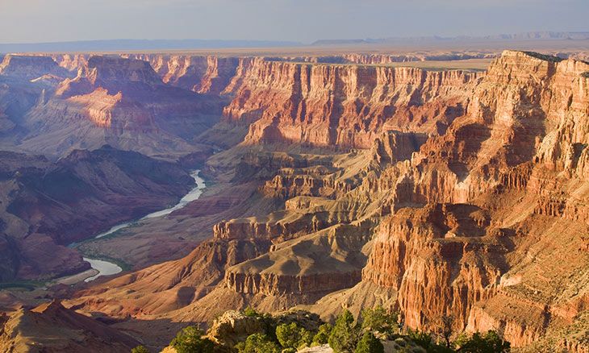

**View the Great, Timeless Geologic Wonder of the World from the   
Air, the Rim, and Interior**

**Photos and presentation by**

**Michael G. Albrecht**

**Science, Nature, History and Travel Photographer  
Amateur Astronomer**

**Projector and large screen provided when in-person**

**Lively, generation-relevant, mentally-stimulating presentation**

**$85 per show (approx. 1 hour) – In-person or remote Zoom online**

**Reduced rates for multiple bookings – 12 programs available**

**512-497-2803**[**mike@virtualvideoshows.com**](mailto:mike@virtualvideoshows.com)

**Fall 2020**

**Texas Hill Country   
Spring Wildflower Tour**



**Photos and presentation by**

**Michael G. Albrecht**

**Science, Nature, History and Travel Photographer  
Amateur Astronomer**

**Projector and large screen provided when in-person**

**Lively, generation-relevant, mentally-stimulating presentation**

**$85 per show (approx. 1 hour) – In-person or remote Zoom online**

**Reduced rates for multiple bookings – 12 programs available**

**512-497-2803**[**mike@virtualvideoshows.com**](mailto:mike@virtualvideoshows.com)

**Fall 2020**

**Druids, Celts, and Romans**

**Who were the Druids? How were they related to the Celts?   
Why did the Romans go all the way to Anglesey Island, Wales, to subdue them?**

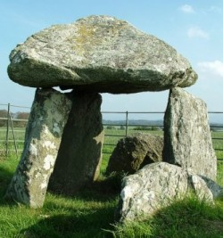

**Come explore this fascinating ancient history**

**Photos and presentation by**

**Michael G. Albrecht**

**Science, Nature, History and Travel Photographer  
Amateur Astronomer**

**Projector and large screen provided when in-person**

**Lively, generation-relevant, mentally-stimulating presentation**

**$85 per show (approx. 1 hour) – In-person or remote Zoom online**

**Reduced rates for multiple bookings – 12 programs available**

**512-497-2803**[**mike@virtualvideoshows.com**](mailto:mike@virtualvideoshows.com)

**Fall 2020**

**Magnificent Costa Rica**

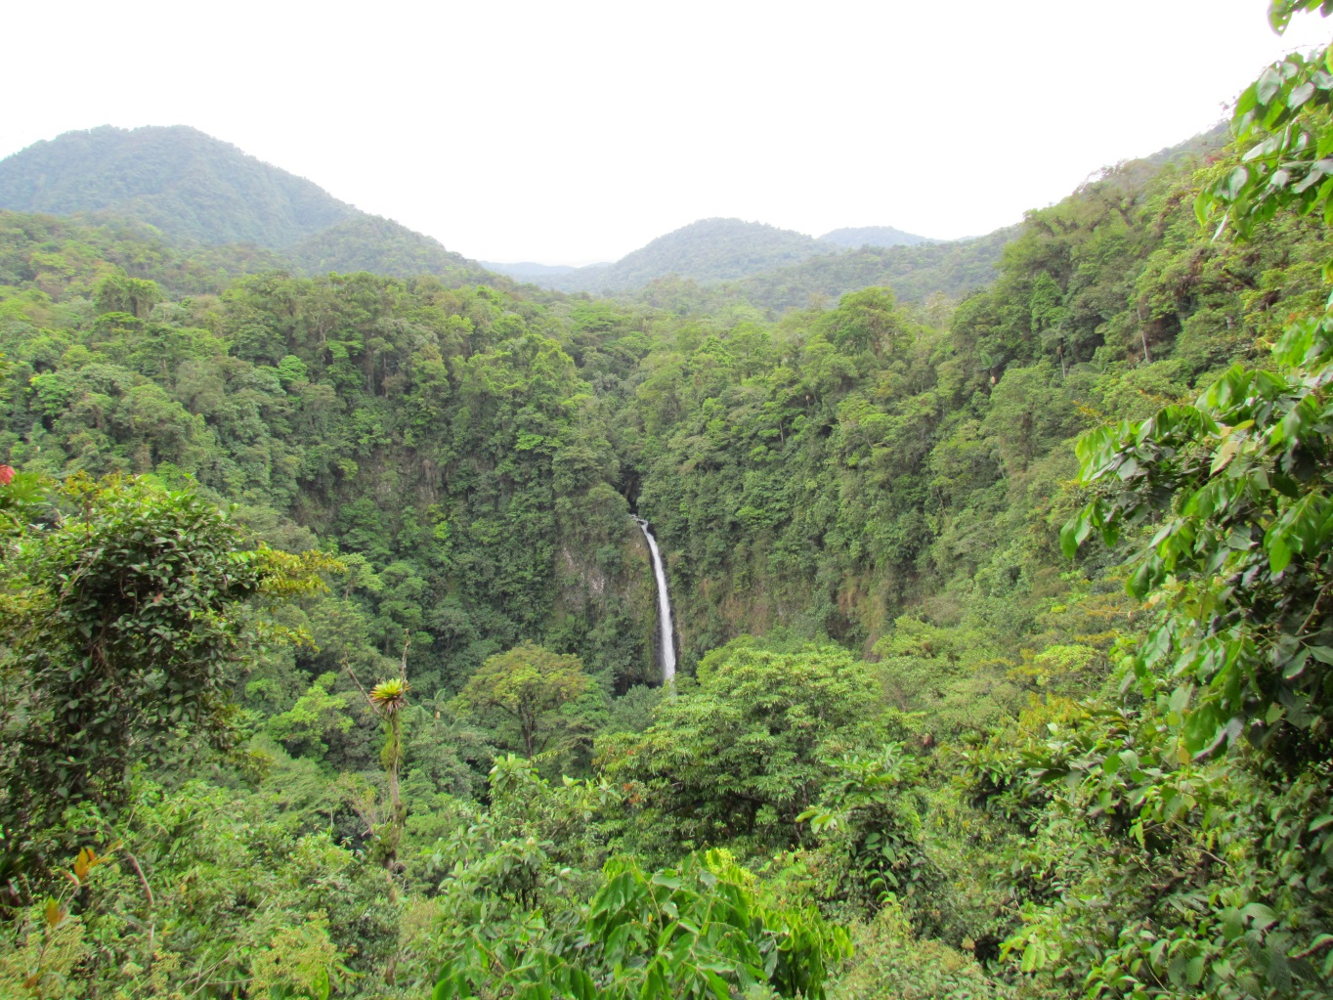

**View the wonders of this spectacular Central American country**

**Photos and presentation by**

**Michael G. Albrecht**

**Science, Nature, History and Travel Photographer  
Amateur Astronomer**

**Projector and large screen provided when in-person**

**Lively, generation-relevant, mentally-stimulating presentation**

**$85 per show (approx. 1 hour) – In-person or remote Zoom online**

**Reduced rates for multiple bookings – 12 programs available**

**512-497-2803**[**mike@virtualvideoshows.com**](mailto:mike@virtualvideoshows.com)

**Fall 2020**

**Climate Change Explored**

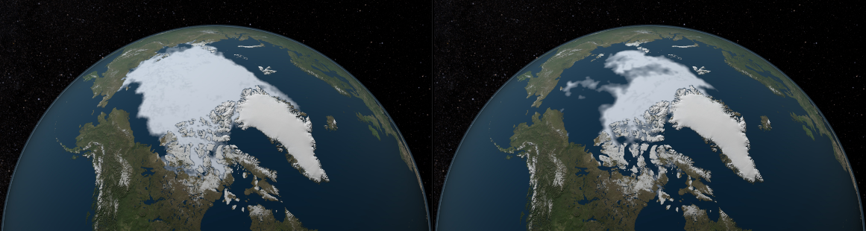



**View NASA Satellite Photo-documentation of Climate Change in progress**

**Presentation by**

**Michael G. Albrecht**

**Science, Nature, History and Travel Photographer  
Amateur Astronomer**

**Projector and large screen provided when in-person**

**Lively, generation-relevant, mentally-stimulating presentation**

**$85 per show (approx. 1 hour) – In-person or remote Zoom online**

**Reduced rates for multiple bookings – 12 programs available**

**512-497-2803**[**mike@virtualvideoshows.com**](mailto:mike@virtualvideoshows.com)

**Fall 2020**

**Big Bend National Park - Texas**

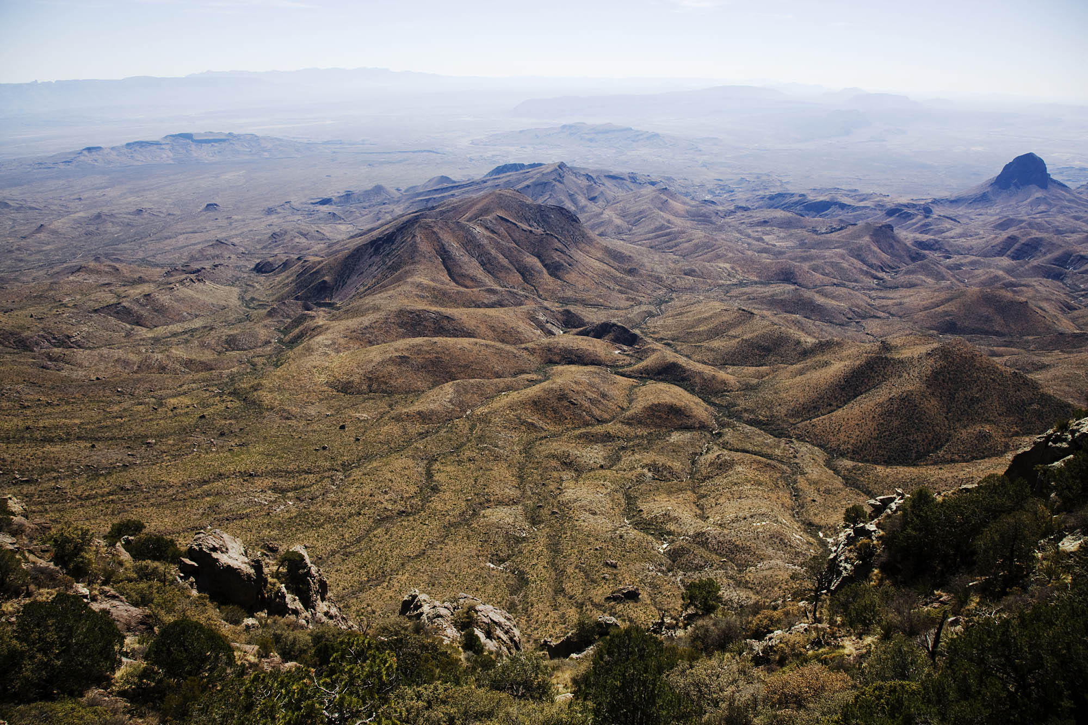

**View the vast rugged Chihuahuan Desert Region of   
Remote Southwest Texas**

**Photos and presentation by**

**Michael G. Albrecht**

**Science, Nature, History and Travel Photographer  
Amateur Astronomer**

**Projector and large screen provided when in-person**

**Lively, generation-relevant, mentally-stimulating presentation**

**$85 per show (approx. 1 hour) – In-person or remote Zoom online**

**Reduced rates for multiple bookings – 12 programs available**

**512-497-2803**[**mike@virtualvideoshows.com**](mailto:mike@virtualvideoshows.com)

**Fall 2020**

**A Rugged New England Winter**

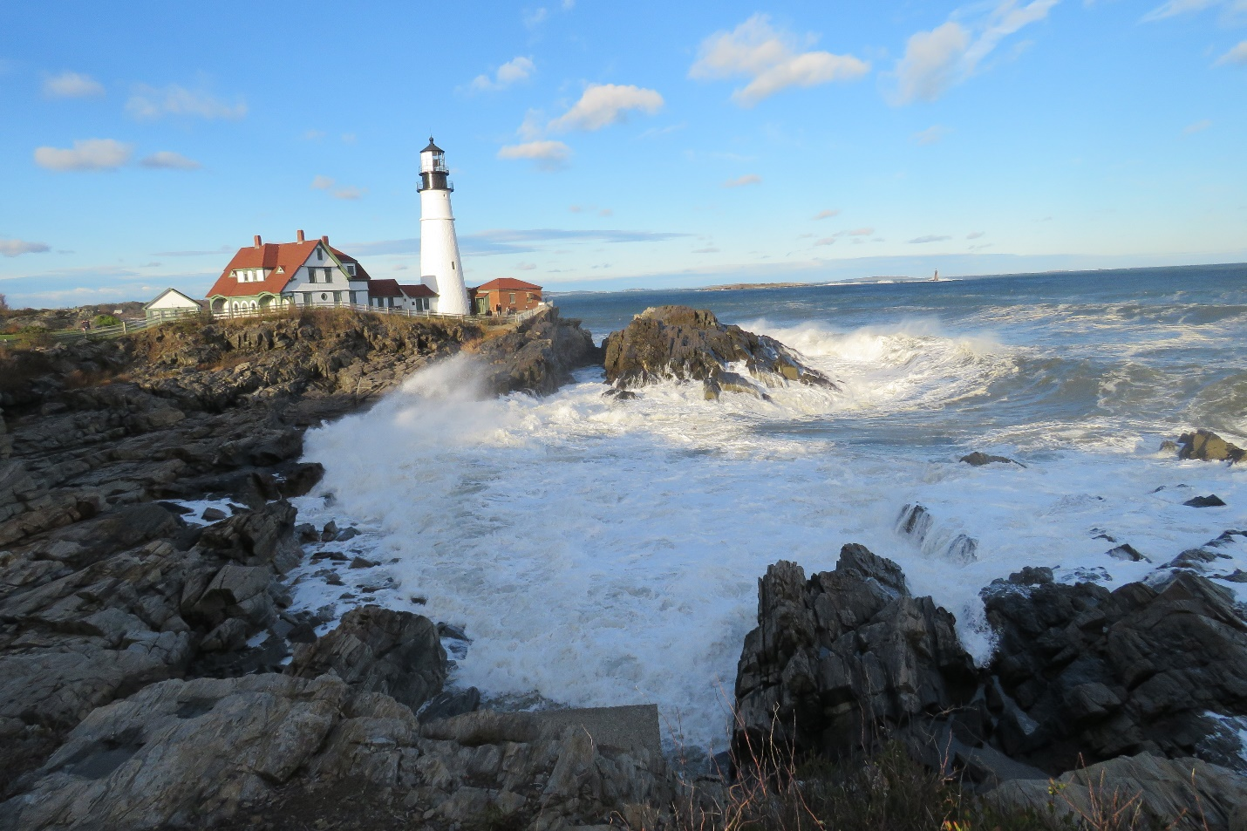

**Photos of the rocky Maine Coastline, New Hampshire’s sublime   
White Mountains, and energetic Boston**

**by**

**Michael G. Albrecht**

**Science, Nature, History and Travel Photographer  
Amateur Astronomer**

**Projector and large screen provided when in-person**

**Lively, generation-relevant, mentally-stimulating presentation**

**$85 per show (approx. 1 hour) – In-person or remote Zoom online**

**Reduced rates for multiple bookings – 12 programs available**

**512-497-2803**[**mike@virtualvideoshows.com**](mailto:mike@virtualvideoshows.com)

**Fall 2020**