Name:________________________________________ Date: _______________ Account #________________

DOB: ____/____/_____

Complaints

1. Please describe your primary symptom/complaint: _____________________________________________
2. Did your symptoms start because of an accident or specific injury? (Circle) No Yes
3. When did you symptoms begin (date): ________________________________________
4. Please describe how you were injured or what caused your symptoms: _____________________________

_______________________________________________________________________________________

1. Do you have secondary complaints? :(Circle) □ No □ Yes (If yes, describe)________________________
2. Please rate your symptom severity on a scale of 0-10 (where 0 is no pain and 10 is worst pain ever). You should rate it as if feels at this time. List the area of your complaint and the pain rating at this moment.

Complaint:___________-____/10 Complaint:___________-____/10 Complaint:___________-____/10

Complaint:___________-____/10 Complaint:___________-____/10 Complaint:___________-____/10

1. How frequent is your pain/symptoms present during the day? (constant-present 76-100% of the time), (Frequent-present 51-75% of the time), (occasional 26-50% of the time), (intermittent-present 0-25% of the time). Check appropriate box.

Area: ________________________ □ Constant □ Frequent □ Occasional □ Intermittent

Area: ________________________ □ Constant □ Frequent □ Occasional □ Intermittent

Area: ________________________ □ Constant □ Frequent □ Occasional □ Intermittent

Area: ________________________ □ Constant □ Frequent □ Occasional □ Intermittent

1. What time of day are your symptoms most intense? □ Morning □ Afternoon □ Evenings
2. Do your symptoms radiate into your arms or legs? □ No □ Yes If yes, where?_______________________

Please use the symbols below to draw on the body where you feel your symptoms.

**A=Ache B=Burning N=Numbness T=Tingle P= Pins/Needles O=Other ___________**

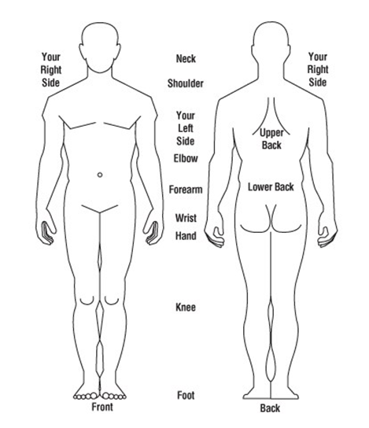

Fairfield Spine and Rehab Center, LLC, 2217 W. Fair Ave., Lancaster, OH 43130 , (740) 654-3375

Name:______________________________________ Date: __________________Account#_______________

DOB: ______/______/______

1. Please describe all positions or activities that increase your symptoms: _________________________________

___________________________________________________________________________________________

1. Please describe all positions or activities that decrease your symptoms: _________________________________

___________________________________________________________________________________________

1. Please list (or provide a copy to front desk) of all medications, vitamins, supplements, herbs etc. that you are taking for your complaints: ___________________________________________________________________________________________
2. Please mark all treatments you have tried at home for your complaints:

□ Ice □ Heat □ Pain patches □ Ointments □ Stretches □ Exercises □ Other____________________

1. Please list all providers (doctor, physical therapists, massage therapist etc.) you have seen for this problem; how many times seen and their treatment. If no one else seen for this problem, check mark this box □ No one seen

***Health care provider(s)*  *Times seen/Date last seen*  *Treatment (s)***

____________________ _____________________ ____________________

____________________ _____________________ ____________________

____________________ _____________________ ____________________

____________________ _____________________ ____________________

____________________ _____________________ ____________________

1. Please list all diagnostic tests you have had performed for this problem (x-rays, lab, CT Scans etc.) or □ No tests

***Test performed* *Where*  *Date***

____________________ _____________________ ____________________

____________________ _____________________ ____________________

____________________ _____________________ ____________________

____________________ _____________________ ____________________

____________________ _____________________ ____________________

Patient SignatureX ___________________________________________ DateX__________________

**Doctor Section Only:**

**Fairfield Spine and Rehab Center LLC. 2217 West Fair Ave. Lancaster, Ohio 43130**