

Welcome To KOTM

Senior Camp

Kids on the Move

2019

Summer Camp Registration Package

McClellan Community Child

Operated at Highview Public School

240 McClellan Way, Aurora

(905)841-1672 or (905)841-1638

**\*KIDS ON THE MOVE**\*

Recent Photograph

A camp sponsored by McClellan Community Child Care, Inc. (905) 841-1638

**Child’s Full Name: _________________________Date of Birth: ________________________**

**Home Address: ____________________________**

**Mother’s Name:** ________________________ **Father’s Name**: __________________________

**Mother’s Home #:**( )___________________ **Father’s Home #:**( )_____________________

**Mother’s Work #**:( ) **Father’s Work #**:( )______________________

**Mother’s Cell #:**( )_____________________**Father’s Cell #:**( )_______________________

**Mother’s Work Place**:(Company and Address) **Father’s Work Place:** (Company and Address)

**Company name ___________________ __________________________________**

**Address__________________________ ___________________________________**

**Town, Postal code__________________ ___________________________________**

Doctors Name:______________________ Telephone #:( ) ________________________

Address: __________________________ Town:_________________ Postal Code:________

**Emergency Contact :** Name:_________________ Address: _____________________________

Home #:( ) ________________Work #:( )____________________Cell #: ( )__________

**Person’s Authorized to Pick Up Child (other than Parents):**

**1. _______________________ 2.________________________ 3._______________________**

**History of Medical Conditions**: **Allergies:**

_____________________________________ ______________________________________

_____________________________________ ______________________________________

**Anaphylactic Protocol**: We require two epipens to be on site. The children who carry their epipens on their person will be required to hand off their epipens to the camp leaders during outings involving water. Medical Care Plans must be completed and submitted prior to attending camp.

**Copy of Immunization Record Included: Yes**

**Medications Taken (Name, Dose, Time of Day)** ________________________________________________________________________

(please note that all medications must be given to the camp leaders. We require scheduled medication records for the dispensing of any drugs. Please ask a staff member for a form. All medications incl. epipens require a medication form)

Any other Pertinent Health Information:_______________________________________

In the event of a medical emergency, every effort will be made to notify the parents or the contact person. If required in the judgment of the camp staff, the child will be transported by ambulance to the nearest hospital. A staff member will immediately follow to the hospital.

It is the parent’s responsibility to inform the supervisor in writing of any changes in their child’s health or personal information. . I also give the above named permission to attend and participate in all on and off site excursions, activities and alternate excursions due to inclement weather. I give permission for my child to be photographed for the purpose of publicity and program

I, _________________________certify that my child __________________________is in good health, and able to participate fully in the * **KIDS ON THE MOVE**\* Program.

Parent/Guardian Signature__________________________ Date: _____________________

E mail _________________________________________

KOTM AT A GLANCE

Welcome to Kids on the Move Summer Camp. We look forward to a fun filled summer loaded with interactive games, sports, crafts, and outings.

Hours of Operation: 7am-6pm (late fees apply after 6:00 pm- $1.00 per minute/child)

Food and Snacks-

* All campers must bring a lunch daily that is fish and nut/ peanut free
* Am breakfast is served from 7:45-8:30
* Afternoon snack is provided for on-site days. We encourage children to bring extra snacks on trip days.
* Allergy alert *no fish/shellfish, no sesame seed, and no peanuts/tree nuts*

Label- label all of our child’s belongings

Items to bring daily- hat, sunscreen, refillable water bottle, lunch with cold pack, footwear suitable for physical activity (no flip flops please), spare set of clothing, and towel for Friday

Trip Items- Camp t-shirt, towel, bathing suit, lunch, extra snacks, comfy shoes, hat, and sunscreen . Please do not send money.

Medication- *McClellan administers-prescribed medication-it must be in the original container and a medication form must be completed. Medication must be given to the camp leader upon arrival- Items such as a lactose intolerance tablets, antihistamines must be individually labelled with date, child’s name, expiry, administration instructions (a medication form must be completed by a physician)

Mosquito Repellent- Some families may choose to use repellent. We ask that application of any mosquito repellents be done so at home prior to arrival. Certain types have a longer efficacy, to ensure protection for most of the campers’ day.

Field Trips-

* Arrive on time so that you don’t miss out, at least 15 minutes before departure, (trips may be changed due to extenuating circumstances- such as weather). Assume all trips depart at 9am sharp. There will be no reminder phone calls and the bus will not stop to pick your child up on from the route.
* You may contact the centre for alternate trip details. The alternate trip is at the camps discretion and is usually booked for the same day. The substitute outing will likely be confirmed after 9am. Your patience is greatly appreciated.
* Should you child be absent due to illness, choice, or suspension there will be no reimbursements or credits for the missed day and no alternate child care will be provided.

Electronics/Toys from Home- These items from home are not permitted and are only welcome if posted by the program.

Sick/Missed Days- Please call (905)841-1672/(905)841-1638, no payment adjustments will be made if your child is sick or away

End of the day Departure- Parents are required to pick up their children from our program (unless otherwise specified in writing).

CODE OF CONDUCT- Every person has the right to be treated with respect in a safe environment. Every person has the right to have their property treated with respect and to accept consequences for his/her own behavior.

*Kids on the Move*

A camp sponsored by McClellan Community Child Care Inc, (905)841-1638

Current Health/Medical Conditions (please list all pertinent information related to your child’s health i.e. seizures, disorders, diseases, allergies, dietary restrictions, asthma, etc)

________________________________________________________________________________________________________________________________________________________________________________ ________________________________________________________________________________________

Medications taken (name, dose, time of day, storage, instructions)

Please fill out required medications form provided by the Centre if we are to administer any prescription medication. Please note non-prescription medication requires a medical form to be completed and signed by a physician.

________________________________________________________________________________________________________________________________________________________________________________________________________________________________________________________________________

Any other pertinent health information (if any information should change, it is the parents or guardians responsibility to immediately inform the staff)

________________________________________________________________________________________________________________________________________________________________________________________________________________________________________________________________________

□ Copy of Immunization Record or Statement of Conscience or Religious Belief affidavit.

In the event of a medical emergency, every effort will be made to notify the parents or the contact person. If required in the judgment of the camp staff, the child will be transported by ambulance to the nearest hospital. The staff member will ride with the child or immediately follow the child to the hospital. In the case that the parent remains inaccessible all medical attention and decisions are the responsibility of the medical care professionals.

I, _____________________ certify that my child_______________________ is in good health, and able to

participate fully in the Kids on the Move program.

____________________________________ ______________________________

Parents/Guardian Signature Date

____________________________________ ______________________________

Supervisor signature Date

McClellan Community Child Care Inc.

Discipline and Excursion Policy

Due to the nature of this camp, it is important to set guidelines regarding unacceptable behaviours and their consequences both on and off –site.

The following behaviours are viewed as unacceptable:

*Fighting

*Hurting another child

*Defiance or disrespect of camp leader’s authority

*Abusive and repeated foul language and/or gestures

*Spitting

*Unsafe conduct causing or potentially causing harm to self or others

*Poor sportsmanship that results in demeaning belittling or insulting others

*Defying off site safety rules and group leader direction*Breaking bus safety rules, property damage

*Placing oneself in an unattended situation including not following the group from one environment to the next

*Socially inappropriate behaviours

*Unsafe behaviour while on an out trip will result in a suspension on the following out trip

1. First offence-parent will be informed verbally and in writing including a description of the disciplinary action taken unless unsafe behaviour is during an outing then the consequence is loss of the following outing without alternate care.
2. Second offence-will result in parent notification (2nd disciplinary document) and the removal of a privilege, such as not attending the next scheduled trip day. An outlined behaviour improvement plan will be implemented in collaboration with the parent/guardian.
3. Third offence-will result in a 1 day non-refundable suspension from the program. Any child suspended from the program will have their behaviour monitored. If undesired behavior continues the Board will review the situation and reserves the right to withdraw service.
4. Children may need to enter a discipline contract to assist in behaviour awareness and approaches to change the unacceptable behaviour
5. This is to acknowledge that I am fully aware of and understand the School Age Disciplinary Policy. I hereby agree to comply with all regulations in this policy and those subsequently added for which I received notification of.

_____________________________ _____________________________

Child’s Name Parent/Guardian Signature

_____________________________ _____________________________

Date Date

***Kids on the Move***

A camp sponsored by McClellan Community Child Care Inc. (905)841-1638

Please return this complete application, immunization record, and updated photo of your child, along with post-dated cheques made payable to McClellan Community Child Care to:

Light of Christ Child Care Highview Child Care

290 McClellan Way 240 McClellan Way

Aurora, Ontario Aurora, Ontario

Summer Camp Payment Policy and Registration 2019

Fees are due as follows: On the first business day of the month for the number of weeks that you wish to enroll your child.

Please make all cheques payable to McClellan Community Child Care Inc.

Camp operates from Tuesday July 2nd to Friday August 30th, 2019.

Two week notice is required to transfer or cancel weeks. A $100.00 cancellation fee applies. Transfers may only be made if we are able to accommodate. A $50.00 administration fee applies to all each change.

Please return your completed packages by April 19th, 2019 (spaces are limited).

Weekly fee: $268.80 for a 5 day week, and $228.80 for statutory holiday, 4 day week. There is a fee of $15.50 for a camp T-shirt (all campers must wear a KOTM t-shirt on all off-site trips).

If your child is unable to attend any of the offsite trips for any reason it becomes the parent or guardians responsibility to find alternative care for his or her child, outside of the child care.

**I have registered my son/daughter____________________ for *Kids on the Move* camp (McClellan Community Child Care Inc.) located at Highview Public school. I give permission for my child to attend the scheduled outings including the alternative trips.**

Post-dated camp cheques are dated for the 1st of each month and made payable to **McClellan Community Child Care Inc.**

T-shirt order *Reminder-children must wear their camp t-shirt to attend on trip days.

**Youth extra small (5-7),Youth small (6-8), Youth medium(10-12), Youth large (14-16) Youth XL (16-18)**

**Cost: $15.50 per t-shirt # of shirts________= $_______________(please provide a separate cheque)**

______________________________ __________________________________ Parent/signature Date

______________________________ __________________________________

Camp Supervisor Date

*Please remove the camp calendars from package prior to submission for easy reference.

**Senior Camp 2019-Weekly Registration**

**July Registration**

**I have chosen the following :**

**July 2nd – 5th**

**Silly Safari –This week we will be making plaster molds, water bottle boats and exploring the sounds of Africa. On Thursday July 4th our safari trip will be to Elmvale Zoo.**

**_____$228.80**

**July 8th – 12th**

**Super Super Hero- This week is filled with superhero challenges. On Thursday July 11th we will be having a splashing time at Cedar Park Resort where we will be riding the tube slides and swimming. _____$268.80**

**July 15th – 19th**

**Excellent Explorers. This week we are exploring a butterfly transformation in our butterfly habitat. We will be experimenting all week through and making a “walk in” teepee by the woodlot. On Thursday July 18th get ready to jump around at Air Riderz.**

**_____$268.80**

**July 22nd – 26th**

**Knights and Dragons- We will be kings, queens and knights this week, creating jewel crafts and participating in a Kings Court competition. On Thursday July 25th we will be cheering for our favourite knight at Medieval Times**

**_____$268.80**

**July 29th – August 2nd**

**Home on the Ranch- This is a fun week filled with an array of activities from planting, to cooking to a Western music Freeze Dance challenge. Off we go to Rounds Ranch on Thursday August 1st.**

**_____ $268.80**

July Payment: $______________ Cheque #________________



**Senior Camp 2019 - Weekly Registration**

**August Registration**

**I have chosen the following:**

**August 6th – 9th**

**Tropical Escape- We will be having a fun week with everything from sandcastle competitions and smoothies to sand art. On Thursday August 8th  we will be heading off to Barrie Beach**

**_____$228.80**

**August 12th- 16th**

**Under the Sea- This week we are coconut bowling, making cool food concoctions and participating in team fun. Get ready for water fun on Thursday August 15th as we go to Kids Town Water Park.**

**_____$268.80**

**August 19th -23rd**

**Backyard Party-. This week we will compete in replays, enjoy team games and sports and create some awesome crafts. Off we go to Wet n Wild on Thursday August 22nd where we will be enjoying the lazy river and water slides.**

**_____$268.80**

**August 26th- 30th**

**Luv 2 Learn- Come and experiment with us, as will end the summer with tons of science fun. On Thursday August 29th we will be heading to Luv 2 Play.**

**_____$268.80**

August Payment: $_____________ Cheque #: ________________

**AIR RIDERZ**

Page 1 of 2

**RELEASE OF LIABILITY, ASSUMPTION OF RISK AND INDEMNITY AGREEMENT**

**I understand that this document affects my legal rights and the legal rights of the minors, and that by signing below I acknowledge that I have read and understood the disclosure of risks, voluntarily accept those risks, and agree to be bound by all terms and conditions of this agreement. PLEASE READ CAREFULLY!**

In consideration of the services provided by Air Riderz Inc. ("the Park") and of the permission granted by the Park to use the Park's property, facilities, and services and to participate in trampoline games and activities (including but not limited to trampoline related activities such as dodgeball, basketball, gymnastics, and similar activities), climbing activities, jumping and sliding activities on inflatable and other equipment, and other exercise and amusement activities at the Park, including but not limited to foam pit, rock climbing, aerial training, fitness classes (the "Activities"), I, on behalf of myself and on behalf of my child or children and any other minors within my care as listed below ("Minors"), irrevocably agree to the following terms and conditions:

**1. General Release and Waiver of Liability.** I, for myself and on behalf of the Minors as well as my spouse, children, wards, heirs, assigns, personal representatives and next of kin (the "Releasing Parties"), voluntarily release and forever discharge and agree not to sue the Park or its agents, shareholders, employees, representatives, managers, owners, officers, directors, principals, volunteers, participants, insurers, facility operators, visitors, lessors, predecessors, affiliates, relater parties, controlled or subsidiary organizations, successors, assigns, equipment suppliers and manufacturers, trainers, intellectual property holders, or any other persons or entities acting in any capacity on the Park's behalf (hereinafter collectively referred to as the "Protected Parties") from liability for any and all claims, demands, suits, losses, personal injuries (including death), debts, proceedings, costs, expenses, damages, property damage and loss, settlement amounts and liabilities, judgments, actions or causes of actions, whatsoever or howsoever, including and any and all costs and expenses in connection therewith, including legal fees and costs of investigation (collectively the “Claims”) connected with or arising from my or the Minors' participation in the

Activities or use of the Park facilities, including DUE TO ANY CAUSE WHATSOEVER, INCLUDING NEGLIGENCE, OMMISSIONS, BREACH OF CONTRACT, OR BREACH OF ANY STATUTORY OR OTHER DUTY OF CARE, INCLUDING ANY DUTY OF CARE OWED UNDER THE OCCUPIERS’ LIABILITY ACT, R.S.O. 1990, c. O. 2 ON THE PART OF THE PARK AND FURTHER INCLUDING THE FAILURE ON THE PART OF THE PARK TO SAFEGUARD OR PROTECT ME OR THE MINORS FROM THE RISKS, DANGERS AND HAZARDS OF THE ACTIVITIES.

I understand that this release of liability will prevent any of the Releasing Parties, including me and the Minors, from bringing any lawsuit or making any claim for personal injury, damages or death connected with participating in the Activities or using the facilities.

**2. Acknowledgement of Risks.** I understand that my participation and the participation of the Minors in the Activities involves known and unanticipated risks that could result in physical or emotional injury, paralysis, death, or damage to me, to the Minors, or to third parties. Such risks (the "Risks") include, but not limited to:

* the risks inherent in the Activities, including but not limited to slipping and falling, collisions with fixed objects and/or other participants, falling off equipment, unexpected failure of equipment, over---exertion, double bouncing, failed attempted jumps and stunts, and sustaining lacerations or contracting any illnesses from contact with equipment and/or flooring surfaces in the Park;

* the negligent acts or omissions of the Protected Parties, or their agents or employees; * defects in the Park facilities;

* improper or inadequate instruction or supervision regarding the Activities or use of the Park facilities;

* the behavior of other participants in the Activities; * accidents or incidents in the Park facilities; and

* first aid, emergency treatment or services rendered or failed to be rendered by the Protected Parties or their agents or employees.

Possible injuries include, but are not limited to, bruises, sprains, scrapes, contusions, lacerations, broken bones, eye injuries, torn ligaments, joint injuries, weakening of growth plates, stunted growth following fractures, internal injuries, brain injuries and concussions, permanent disabilities, broken back, broken neck, paralysis, heart attack, and death.

I understand and acknowledge that the above lists are not complete or exhaustive, and that other known or unanticipated risks may also result in injury, death, illness or damage to me, to the Minors or to our property.

I understand and acknowledge that it is the Park's policy that its Participants follow all rules and safety guidelines, including safety video provided by the Park on its website www.airriderz.com. I HAVE WATCHED THE AIR RIDERZ SAFETY VIDEO AND FULLY UNDERSTAND ITS CONTENT. FOR ANY INDIVIDUAL THAT I AM THE PARENT OR LEGAL GUARDIAN OF AND FOR WHOM I HAVE COMPLETED A WAIVER FOR, I CONFIRM THAT I HAVE VIEWED THE VIDEO WITH THEM AND/OR EXPLAINED THE CONTENT REGARDING THE RULES, REGULATIONS AND POTENTIAL RISKS OUTLINED WITHIN THE SAFETY VIDEO.

**3. Assumption of Risks.** After being fully informed of the above risks, I, on my own behalf and, to the fullest extent allowed by law, on behalf of all Releasing Parties and the Minors, expressly agree and promise to accept and assume all known and unanticipated risks associated with participation in the Activities and use of the Park's facilities, including the Risks listed above, and I voluntarily elect to participate and to allow the Minors to participate in the Activities and use the Park's facilities.

I agree that there are certain risks inherent in the Activities that cannot be avoided or eliminated, and that by signing this form I am giving up my right and the right of the Minors to recover from the Protected Parties in a lawsuit or other proceeding for any damages, including personal injury or death to me or the Minors, that results from such risks, including the Claims. I understand that I have the right to refuse to sign this form, and the Park has the right to refuse to let me or the Minors participate if I do not sign this form.

**4. Indemnification Agreement.** I hereby agree to hold harmless, discharge, indemnify and defend the Protected Parties from and against any and all Claims, (including claims brought by any of the Releasing Parties or Minors), arising out of or connected with my or the Minors' participation in the Activities or use of the Park's facilities, regardless of whether the Claims are the result of the negligent acts or omissions of myself, the Minors, the Protected Parties, or third parties, including other participants in the Activities. Such indemnity obligation shall include, but not be limited to, any Claim, action or proceeding that alleges that I or the Minors negligently or intentionally caused any injury, death or damage to other participants in the Activities or other third parties at the Park.

**5. Release of Rights to Audio, Video and Photographic Images.** I hereby grant the Park on behalf of myself and the Minors the irrevocable right and permission to photograph and/or record me or the Minors in connection with the Activities and the Park and to use the resulting photographic images, audio or video for all purposes, including advertising and promotional purposes, in any manner and in any media now or hereafter known, in perpetuity throughout the world, without restriction as to alteration, and without any reimbursement of any kind due to me or the Minors. On my behalf and on behalf of the Minors, I waive any right to inspect or approve the use of any such photographic image, audio or video. I agree that the Park will be the exclusive owner of all rights, including but not limited to the copyrights, in and to the photographic images, audio and video and the results and proceeds of my participation hereunder.

**6. Certifications.** In order to assist the Park in effectively providing for the safety of me and the Minors, I certify that:

* I have no knowledge of any health problems that would cause participation in the Activities to negatively impact my health or the health of the Minors

* I and the Minors possess a sufficient level of physical fitness and skill to safely participate in the Activities, and neither I nor the Minors have any pre---existing physical or medical conditions that might be impacted or worsened by use of the Park, including pregnancy, orthopedic problems, including back problems, heart problems, or breathing problems

* I will not use or allow the Minors to use the Park while any of us are under the influence of any drugs, alcohol or medications that may impair our physical activities or judgment

Page 2 of 2 * I agree to follow (and cause the Minors to follow) all safety rules of the Park and to alert the Park staff to any rules violations or dangerous behavior of other participants

* I understand that my failure or refusal to abide by the safety rules of the Park or by instructions and directions of Park staff can lead to the immediate revocation of my right to use the

Park, without any right to refund of any payments made

* I will notify Park staff before I or the Minors participate in Activities if any of us have been diagnosed with behavior disorders or are taking any behavior modification medications * I will inform Park staff immediately if I or the Minors feel any unusual discomfort while participating in the Activities and will immediately stop (or cause the Minors to stop) participation in the Activities

* I am aware that Park staff may need to end my or the Minors' participation in the Activities if my or the Minors' actions present a danger to myself or others

* I authorize the Park staff to administer emergency first aid and CPR to myself and to the Minors when deemed necessary by the Park staff

* I authorize the Park staff to secure emergency medical care or transportation if deemed necessary by Park staff, and I agree to assume all costs of emergency medical care of transportation; if any

* I acknowledge that the Park encourages each participant to obtain medical clearance prior to participating in the Activities

**7. Term of Agreement.** I understand that this agreement shall continue in effect and will be in full force and legal effect each and every time I or the Minors visit the Park, whether at the current location or any other location or facility. I agree that the Park may require me to sign a new agreement at any time as a requirement for my participation or the participation of the Minors in the Activities.

**8. Legal Fees.** I promise to indemnify the Park for any legal fees and costs incurred by the Park to enforce this agreement, including costs associated with any collection efforts. If Park obtains a judgment against me pursuant to this agreement, prejudgment and post---judgment interest shall accrue thereon as allowed by applicable law.

**9. Governing Law; Venue; Dispute Resolution.** This agreement shall be governed by and interpreted in accordance with the laws of the Province of Ontario. I agree and acknowledge that any claim or dispute arising from or related to this agreement or the relationship of the parties in any respect thereto shall first be submitted to mediation, and that engaging in such mediation is a condition precedent to bringing any claim against the Park arising from or related to this agreement. If settlement is not reached within sixty (60) days after delivery of a written demand for mediation, such claim or dispute shall be submitted to and be settled by final and binding arbitration within one year of the date of this agreement and will be determined by binding arbitration before one arbitrator to be administered pursuant to the Arbitration Act (Ontario). I further agree that the arbitration will take place solely in the Province of Ontario and that the substantive law of Ontario shall apply. If, despite the representations made in this agreement, I or anyone on behalf of myself and/or my child/ward file or otherwise initiate a lawsuit, in addition to my agreement to defend and indemnify the Protected Parties, I agree: (I) that any litigation involving the parties to this agreement shall be brought solely within the Province of Ontario and shall be governed by the laws of Ontario, and (ii) to pay Protected Parties within 60 days of initiating or filing a lawsuit against Protected Parties liquidated damages in the amount of $5000 plus 12% interest per annum if payment is not made on time.

**10. Entire Agreement; Severability.** I understand that this is the entire agreement between the undersigned and the Park, and that it cannot be modified or changed in any way by the representations or statements of the Park or its employees or agents or by the undersigned. This agreement supersedes any and all previous oral or written promises or agreements.

I understand and agree that this agreement is intended to be as broad and inclusive as permitted by the laws of the Province of Ontario and that if any portion thereof is held invalid, void or unenforceable, it is agreed that the remainder of the agreement will remain in effect and will continue in full legal force and effect.

**11. Effect of Agreement.** I have read the above and fully understand the terms of this agreement and I have either consulted a lawyer regarding the agreement or have elected not to do so. I am aware that by signing this agreement, I am giving up rights that I may have to bring a legal action or assert a claim against the Protected Parties on the basis of their negligent acts or omissions. I understand that by signing this agreement I may be found by a court of law to have forever waived my rights and the rights of the Releasing Parties and the Minors to maintain any action against the Protected Parties on the basis of any claim from which I have released the Protected Parties. I am giving up these important legal rights voluntarily, freely, under no threat of duress, without inducement, promise or guarantee being communicated to me. I have had reasonable and sufficient opportunity to read and understand this entire agreement. I unconditionally agree to the full terms, statements, warranties, notices, representations, waivers and releases contained in this agreement on behalf of myself, the Releasing Parties and the Minors listed below.

|  |
| --- |
| certify that I am the parent, legal guardian or authorized agent of the Minors listed below and that I have authority to sign this agreement on their behalf. I also certify that the information provided below for each Minor participant is true and correct. I acknowledge that the Park staff may require me to present a picture I.D. to verify my identity. **CHILD’S INFORMATION**  **NAME OF CHILD # 1 DATE OF BIRTH ____/_____/______ RELATION______________________**  (MM/DD/YYYY)  **NAME OF CHILD # 2 DATE OF BIRTH ____/_____/______ RELATION______________________**  (MM/DD/YYYY) |
| **PARENT or LEGAL GUARDIAN’S INFORMATION**  * THIS SECTION IS REQUIRED FOR ALL PARTICIPANTS  In consideration of the minor(s) detailed above. I voluntarily agree that all terms and conditions set forth herein shall equally apply to such minor(s) as if the minor was eighteen years old or older.  **Full Name: _______________________________________________________________________ Date of Birth: ____/____/_______**  (MM/DD/YYYY)  **Signature ______________________________________________________________________ Today’s Date ____/_____/______**  (MM/DD/YYYY)  **Email: _________________________________________________**_ **____________ Address: _________________________________________________** |
| **EMERGENY CONTACT**  **NAME: ____________________________________________________________________**  **Phone#__________________________________Relation____________________________** |

**AIR RIDERZ**

Page 1 of 2

**RELEASE OF LIABILITY, ASSUMPTION OF RISK AND INDEMNITY AGREEMENT**

**I understand that this document affects my legal rights and the legal rights of the minors, and that by signing below I acknowledge that I have read and understood the disclosure of risks, voluntarily accept those risks, and agree to be bound by all terms and conditions of this agreement. PLEASE READ CAREFULLY!**

In consideration of the services provided by Air Riderz Inc. ("the Park") and of the permission granted by the Park to use the Park's property, facilities, and services and to participate in trampoline games and activities (including but not limited to trampoline related activities such as dodgeball, basketball, gymnastics, and similar activities), climbing activities, jumping and sliding activities on inflatable and other equipment, and other exercise and amusement activities at the Park, including but not limited to foam pit, rock climbing, aerial training, fitness classes (the "Activities"), I, on behalf of myself and on behalf of my child or children and any other minors within my care as listed below ("Minors"), irrevocably agree to the following terms and conditions:

**1. General Release and Waiver of Liability.** I, for myself and on behalf of the Minors as well as my spouse, children, wards, heirs, assigns, personal representatives and next of kin (the "Releasing Parties"), voluntarily release and forever discharge and agree not to sue the Park or its agents, shareholders, employees, representatives, managers, owners, officers, directors, principals, volunteers, participants, insurers, facility operators, visitors, lessors, predecessors, affiliates, relater parties, controlled or subsidiary organizations, successors, assigns, equipment suppliers and manufacturers, trainers, intellectual property holders, or any other persons or entities acting in any capacity on the Park's behalf (hereinafter collectively referred to as the "Protected Parties") from liability for any and all claims, demands, suits, losses, personal injuries (including death), debts, proceedings, costs, expenses, damages, property damage and loss, settlement amounts and liabilities, judgments, actions or causes of actions, whatsoever or howsoever, including and any and all costs and expenses in connection therewith, including legal fees and costs of investigation (collectively the “Claims”) connected with or arising from my or the Minors' participation in the

Activities or use of the Park facilities, including DUE TO ANY CAUSE WHATSOEVER, INCLUDING NEGLIGENCE, OMMISSIONS, BREACH OF CONTRACT, OR BREACH OF ANY STATUTORY OR OTHER DUTY OF CARE, INCLUDING ANY DUTY OF CARE OWED UNDER THE OCCUPIERS’ LIABILITY ACT, R.S.O. 1990, c. O. 2 ON THE PART OF THE PARK AND FURTHER INCLUDING THE FAILURE ON THE PART OF THE PARK TO SAFEGUARD OR PROTECT ME OR THE MINORS FROM THE RISKS, DANGERS AND HAZARDS OF THE ACTIVITIES.

I understand that this release of liability will prevent any of the Releasing Parties, including me and the Minors, from bringing any lawsuit or making any claim for personal injury, damages or death connected with participating in the Activities or using the facilities.

**2. Acknowledgement of Risks.** I understand that my participation and the participation of the Minors in the Activities involves known and unanticipated risks that could result in physical or emotional injury, paralysis, death, or damage to me, to the Minors, or to third parties. Such risks (the "Risks") include, but not limited to:

* the risks inherent in the Activities, including but not limited to slipping and falling, collisions with fixed objects and/or other participants, falling off equipment, unexpected failure of equipment, over---exertion, double bouncing, failed attempted jumps and stunts, and sustaining lacerations or contracting any illnesses from contact with equipment and/or flooring surfaces in the Park;

* the negligent acts or omissions of the Protected Parties, or their agents or employees; * defects in the Park facilities;

* improper or inadequate instruction or supervision regarding the Activities or use of the Park facilities;

* the behavior of other participants in the Activities; * accidents or incidents in the Park facilities; and

* first aid, emergency treatment or services rendered or failed to be rendered by the Protected Parties or their agents or employees.

Possible injuries include, but are not limited to, bruises, sprains, scrapes, contusions, lacerations, broken bones, eye injuries, torn ligaments, joint injuries, weakening of growth plates, stunted growth following fractures, internal injuries, brain injuries and concussions, permanent disabilities, broken back, broken neck, paralysis, heart attack, and death.

I understand and acknowledge that the above lists are not complete or exhaustive, and that other known or unanticipated risks may also result in injury, death, illness or damage to me, to the Minors or to our property.

I understand and acknowledge that it is the Park's policy that its Participants follow all rules and safety guidelines, including safety video provided by the Park on its website www.airriderz.com. I HAVE WATCHED THE AIR RIDERZ SAFETY VIDEO AND FULLY UNDERSTAND ITS CONTENT. FOR ANY INDIVIDUAL THAT I AM THE PARENT OR LEGAL GUARDIAN OF AND FOR WHOM I HAVE COMPLETED A WAIVER FOR, I CONFIRM THAT I HAVE VIEWED THE VIDEO WITH THEM AND/OR EXPLAINED THE CONTENT REGARDING THE RULES, REGULATIONS AND POTENTIAL RISKS OUTLINED WITHIN THE SAFETY VIDEO.

**3. Assumption of Risks.** After being fully informed of the above risks, I, on my own behalf and, to the fullest extent allowed by law, on behalf of all Releasing Parties and the Minors, expressly agree and promise to accept and assume all known and unanticipated risks associated with participation in the Activities and use of the Park's facilities, including the Risks listed above, and I voluntarily elect to participate and to allow the Minors to participate in the Activities and use the Park's facilities.

I agree that there are certain risks inherent in the Activities that cannot be avoided or eliminated, and that by signing this form I am giving up my right and the right of the Minors to recover from the Protected Parties in a lawsuit or other proceeding for any damages, including personal injury or death to me or the Minors, that results from such risks, including the Claims. I understand that I have the right to refuse to sign this form, and the Park has the right to refuse to let me or the Minors participate if I do not sign this form.

**4. Indemnification Agreement.** I hereby agree to hold harmless, discharge, indemnify and defend the Protected Parties from and against any and all Claims, (including claims brought by any of the Releasing Parties or Minors), arising out of or connected with my or the Minors' participation in the Activities or use of the Park's facilities, regardless of whether the Claims are the result of the negligent acts or omissions of myself, the Minors, the Protected Parties, or third parties, including other participants in the Activities. Such indemnity obligation shall include, but not be limited to, any Claim, action or proceeding that alleges that I or the Minors negligently or intentionally caused any injury, death or damage to other participants in the Activities or other third parties at the Park.

**5. Release of Rights to Audio, Video and Photographic Images.** I hereby grant the Park on behalf of myself and the Minors the irrevocable right and permission to photograph and/or record me or the Minors in connection with the Activities and the Park and to use the resulting photographic images, audio or video for all purposes, including advertising and promotional purposes, in any manner and in any media now or hereafter known, in perpetuity throughout the world, without restriction as to alteration, and without any reimbursement of any kind due to me or the Minors. On my behalf and on behalf of the Minors, I waive any right to inspect or approve the use of any such photographic image, audio or video. I agree that the Park will be the exclusive owner of all rights, including but not limited to the copyrights, in and to the photographic images, audio and video and the results and proceeds of my participation hereunder.

**6. Certifications.** In order to assist the Park in effectively providing for the safety of me and the Minors, I certify that:

* I have no knowledge of any health problems that would cause participation in the Activities to negatively impact my health or the health of the Minors

* I and the Minors possess a sufficient level of physical fitness and skill to safely participate in the Activities, and neither I nor the Minors have any pre---existing physical or medical conditions that might be impacted or worsened by use of the Park, including pregnancy, orthopedic problems, including back problems, heart problems, or breathing problems

* I will not use or allow the Minors to use the Park while any of us are under the influence of any drugs, alcohol or medications that may impair our physical activities or judgment

Page 2 of 2 * I agree to follow (and cause the Minors to follow) all safety rules of the Park and to alert the Park staff to any rules violations or dangerous behavior of other participants

* I understand that my failure or refusal to abide by the safety rules of the Park or by instructions and directions of Park staff can lead to the immediate revocation of my right to use the

Park, without any right to refund of any payments made

* I will notify Park staff before I or the Minors participate in Activities if any of us have been diagnosed with behavior disorders or are taking any behavior modification medications * I will inform Park staff immediately if I or the Minors feel any unusual discomfort while participating in the Activities and will immediately stop (or cause the Minors to stop) participation in the Activities

* I am aware that Park staff may need to end my or the Minors' participation in the Activities if my or the Minors' actions present a danger to myself or others

* I authorize the Park staff to administer emergency first aid and CPR to myself and to the Minors when deemed necessary by the Park staff

* I authorize the Park staff to secure emergency medical care or transportation if deemed necessary by Park staff, and I agree to assume all costs of emergency medical care of transportation; if any

* I acknowledge that the Park encourages each participant to obtain medical clearance prior to participating in the Activities

**7. Term of Agreement.** I understand that this agreement shall continue in effect and will be in full force and legal effect each and every time I or the Minors visit the Park, whether at the current location or any other location or facility. I agree that the Park may require me to sign a new agreement at any time as a requirement for my participation or the participation of the Minors in the Activities.

**8. Legal Fees.** I promise to indemnify the Park for any legal fees and costs incurred by the Park to enforce this agreement, including costs associated with any collection efforts. If Park obtains a judgment against me pursuant to this agreement, prejudgment and post---judgment interest shall accrue thereon as allowed by applicable law.

**9. Governing Law; Venue; Dispute Resolution.** This agreement shall be governed by and interpreted in accordance with the laws of the Province of Ontario. I agree and acknowledge that any claim or dispute arising from or related to this agreement or the relationship of the parties in any respect thereto shall first be submitted to mediation, and that engaging in such mediation is a condition precedent to bringing any claim against the Park arising from or related to this agreement. If settlement is not reached within sixty (60) days after delivery of a written demand for mediation, such claim or dispute shall be submitted to and be settled by final and binding arbitration within one year of the date of this agreement and will be determined by binding arbitration before one arbitrator to be administered pursuant to the Arbitration Act (Ontario). I further agree that the arbitration will take place solely in the Province of Ontario and that the substantive law of Ontario shall apply. If, despite the representations made in this agreement, I or anyone on behalf of myself and/or my child/ward file or otherwise initiate a lawsuit, in addition to my agreement to defend and indemnify the Protected Parties, I agree: (I) that any litigation involving the parties to this agreement shall be brought solely within the Province of Ontario and shall be governed by the laws of Ontario, and (ii) to pay Protected Parties within 60 days of initiating or filing a lawsuit against Protected Parties liquidated damages in the amount of $5000 plus 12% interest per annum if payment is not made on time.

**10. Entire Agreement; Severability.** I understand that this is the entire agreement between the undersigned and the Park, and that it cannot be modified or changed in any way by the representations or statements of the Park or its employees or agents or by the undersigned. This agreement supersedes any and all previous oral or written promises or agreements.

I understand and agree that this agreement is intended to be as broad and inclusive as permitted by the laws of the Province of Ontario and that if any portion thereof is held invalid, void or unenforceable, it is agreed that the remainder of the agreement will remain in effect and will continue in full legal force and effect.

**11. Effect of Agreement.** I have read the above and fully understand the terms of this agreement and I have either consulted a lawyer regarding the agreement or have elected not to do so. I am aware that by signing this agreement, I am giving up rights that I may have to bring a legal action or assert a claim against the Protected Parties on the basis of their negligent acts or omissions. I understand that by signing this agreement I may be found by a court of law to have forever waived my rights and the rights of the Releasing Parties and the Minors to maintain any action against the Protected Parties on the basis of any claim from which I have released the Protected Parties. I am giving up these important legal rights voluntarily, freely, under no threat of duress, without inducement, promise or guarantee being communicated to me. I have had reasonable and sufficient opportunity to read and understand this entire agreement. I unconditionally agree to the full terms, statements, warranties, notices, representations, waivers and releases contained in this agreement on behalf of myself, the Releasing Parties and the Minors listed below.

|  |
| --- |
| certify that I am the parent, legal guardian or authorized agent of the Minors listed below and that I have authority to sign this agreement on their behalf. I also certify that the information provided below for each Minor participant is true and correct. I acknowledge that the Park staff may require me to present a picture I.D. to verify my identity. **CHILD’S INFORMATION**  **NAME OF CHILD # 1 DATE OF BIRTH ____/_____/______ RELATION______________________**  (MM/DD/YYYY)  **NAME OF CHILD # 2 DATE OF BIRTH ____/_____/______ RELATION______________________**  (MM/DD/YYYY) |
| **PARENT or LEGAL GUARDIAN’S INFORMATION**  * THIS SECTION IS REQUIRED FOR ALL PARTICIPANTS  In consideration of the minor(s) detailed above. I voluntarily agree that all terms and conditions set forth herein shall equally apply to such minor(s) as if the minor was eighteen years old or older.  **Full Name: _______________________________________________________________________ Date of Birth: ____/____/_______**  (MM/DD/YYYY)  **Signature ______________________________________________________________________ Today’s Date ____/_____/______**  (MM/DD/YYYY)  **Email: _________________________________________________**_ **____________ Address: _________________________________________________** |
| **EMERGENY CONTACT**  **NAME: ____________________________________________________________________**  **Phone#__________________________________Relation____________________________** |

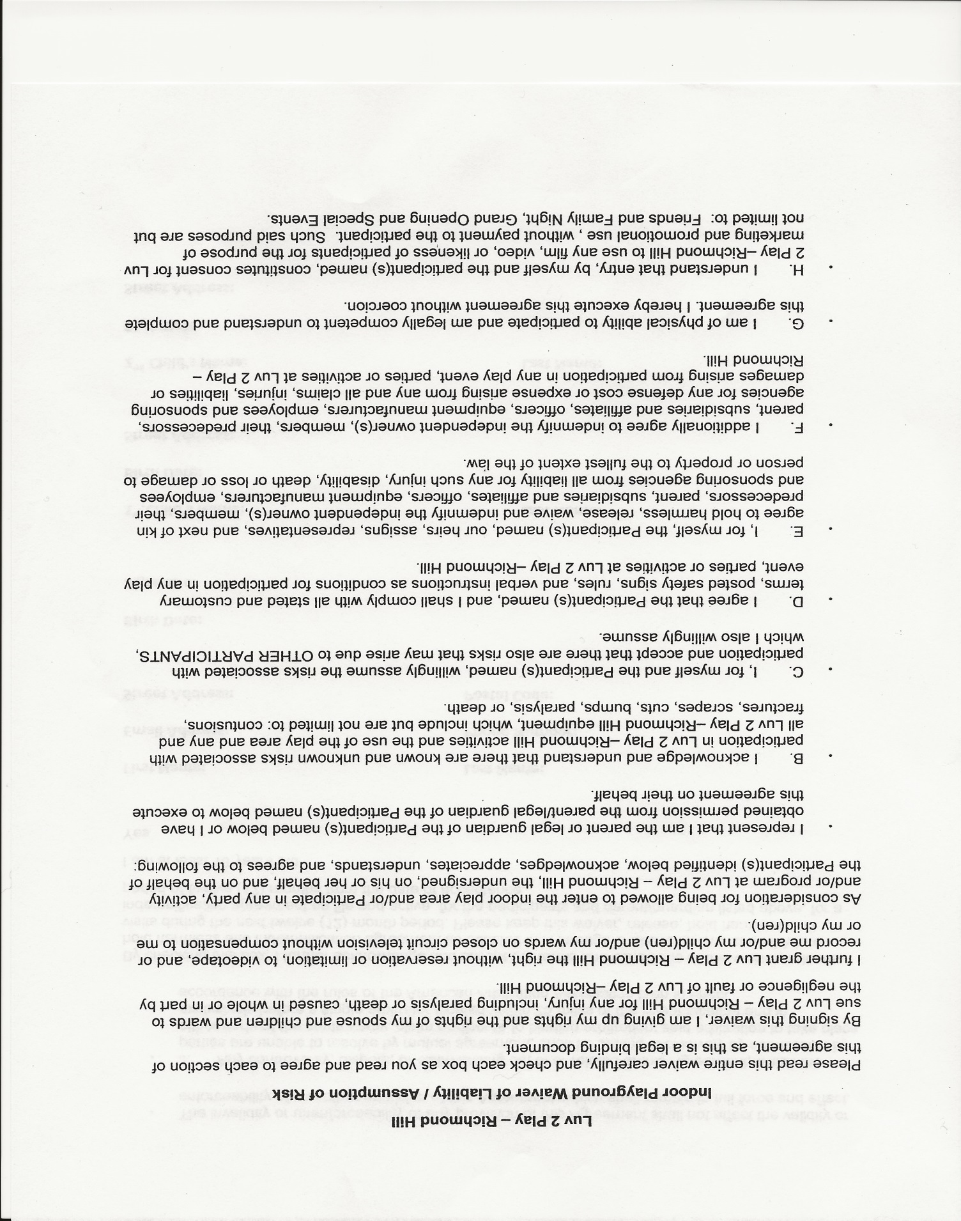

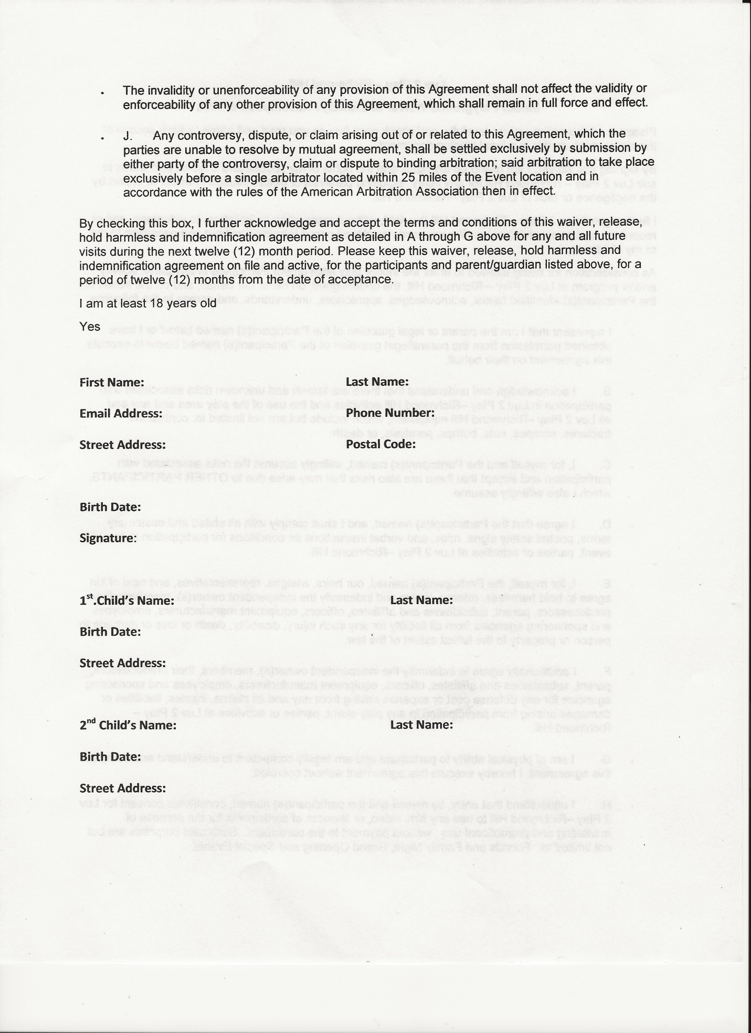

**Camp Checklist:**

**Medical History Form completed (unless currently enrolled)**

**Emergency/Registration Form completed (including current photo)**

**July registration completed (including post-dated payment)**

**August registration completed (including post-dated payment)**

**Summer Camp Payment Policy**

**Discipline Policy Review and Sign-off**

**T-shirt order completed (separate cheque)**

**Calendars removed from package prior to returning registration**

**Medication forms and medications if applicable**

**(medical care plans for anaphylactic allergies plus medication form)**

 **Waivers for Air Riderz and Luv 2 Play**

