Kim Obele 8-24-2021
Westside District Ranger-
4350 Cliffs Drive
Pocatello, Idaho 83204
Kim.obele@usda.gov

RE: Comments from Watershed Guardians, Scoping Document, South Fork Mink, Dam Analogues and Post Structures comments

Contents
Summary 3
About Watershed Guardians 3
Idaho Department of Fish and Game’s Role 5
USFS Westside District’s Opportunity 8

Table of Figure
Figure 1: Historical trends of beaver activity on the South Fork of Mink Creek, Caribou-Targhee NF, Westside Ranger District, 2012-2021. 4

Summary Points

- Watershed Guardians has historical data on beaver population trends in the Mink Creek Basin.
- Beaver populations have been in decline on the South Fork Mink Creek since 2017 and were extirpated on the West Fork Mink Creek in 2017.
- The beaver restoration project from IDFG, makes no clear aims to protect or enhance beaver population in the Mink Creek basin.
- There are no provisions for long-term maintenance of the man-made dams described in this proposal.
- Previous work done by Watershed Guardians’ staff and volunteers including beaver activity censuses (BeaverCount) and stream gauge monitoring network (MARS) is not considered and may be compromised by this project.
- The West Fork of Mink Creek is closed to trapping, the South Fork is not.
- We support construction of man-made dams on the West Fork to the extent that they coincide with beaver introduction. Beaver relocation appears as a possibility on the West Fork of Mink yet not a specific component.
- We support projects that specifically improve the opportunities for beaver. This project does not appear to do so.
- Due to the significance of this Federal project, and the fact that new dams are to be constructed, not maintained, an Environmental Assessment is required.
- As written, we do not support this proposal. We would be honored to meet with the principals of this proposal to develop it further.

About Watershed Guardians
Watershed Guardians is a 501(c)(3) non-profit whose mission is to “Preserve, protect and maintain the Portneuf River Watershed, one beaver at a time.” As the Mink Creek is a tributary to the Portneuf, it falls within our geographical scope.

Since 2012, volunteers from the community and elsewhere have tabulated beaver populations in the Mink Creek basin . We have trained over 235 volunteers to identify active beaver colonies, censused 299 miles of streams and logged 2,767 volunteer hours with the specific intent of understanding the health and population trends of the local beaver colonies, especially in the Mink Creek.

We appreciate Idaho Department of Fish and Game’s (IDFG’s) desire to restore the stream bank on the South and West Forks of Mink Creek. The conditions of this stream that formerly supported multiple species, included the oft-cited Yellowstone cutthroat trout indicate a willingness to address concerns related to stream degradation. We think that beavers might be the right tool for the job.

Over the past 9 years, we have submitted comments and testified at bi-annual season setting comments calling on IDFG to limit beaver trapping in the Mink Creek basin. With populations nearly extinct on the West Fork and approaching lower levels on the South Fork, we asked for reduction in the allowable take to be reduced. The West and East Forks were closed after the populations were essentially exterminated after 2017. We requested that IDFG monitor and track nuisance trapping in the basin in 2014 and in 2016, IDFG developed a system that tracked permits and requests for nuisance beaver trapping. Nonetheless, nuisance trapping continued in the Mink Creek Watershed basin, specifically at Cherry Springs.

Vandalism has also been reported as well as reports of shooting at dusk, carcasses on the creek bank and decreases in population with no beaver trapped under a controlled hunt. These and other instances known to IDFG indicate that some out-of-season, non-regulated beaver takes are occurring. We have been forwarding these reports to conservation officers as they occur. Yet beaver activity continues to decline.

After 9 consecutive years of monitoring, the population on the South Fork Mink continues to decline. Our data show that the populations on the South Fork have declined from 70 active dams to 6, or 95% under IDFG’s previous management approach. In short, the populations have cratered.
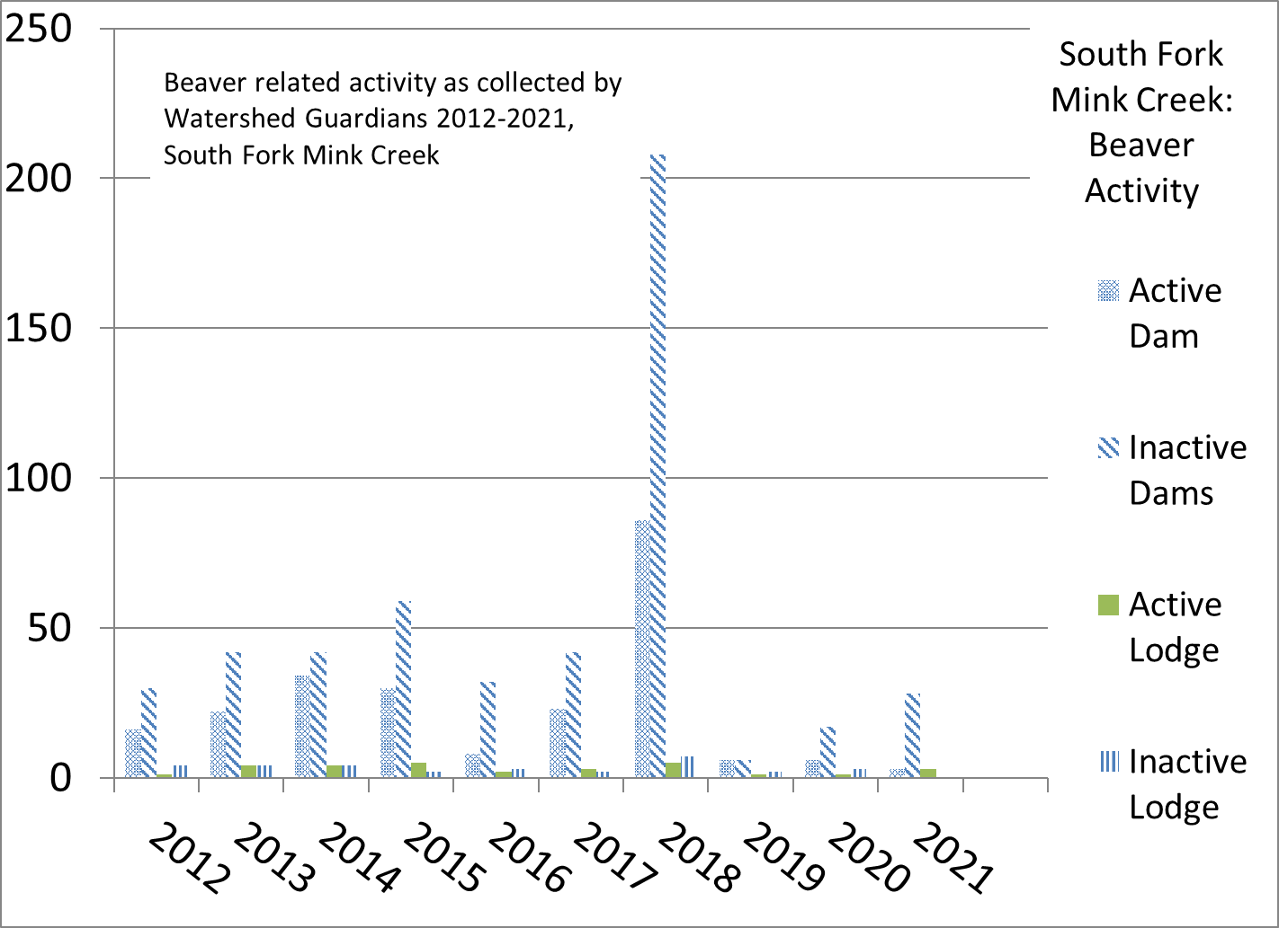
Figure 1: Historical trends of beaver activity on the South Fork of Mink Creek, Caribou-Targhee NF, Westside Ranger District, 2012-2021.
These drastic declines were attributed to everything from “disease” to “lack of forage”, to “predation”. We do know that IDFG has the authority to limit the number of beaver legally taken in these drainages. We see limiting legal beaver trapping as a first step towards proving (or disproving) that illegal, disease or predation or over-harvesting is occurring within the controlled zones on Mink Creek. With this proposal, IDFG is proposing another approach.

Idaho Department of Fish and Game’s Role
This “beaver restoration” proposal consists of constructing 55 artificial beaver dams and imbedded logs to restore the stream. On the West Fork, a similar approach will occur with ~35 artificial dams. We cannot support the South Fork proposal until the root cause of the decline in population is addressed. We DO SUPPORT the proposal on the West Fork because this stream is CLOSED to beaver trapping provided that concerns listed later in our comments are addressed.

As shown in Figure 1, the beaver activity on the South Fork in 2017 was extensive. The number of active dams was actually greater than the number of dam analogues proposed in IDFG’s proposal. We obtained the IDWR-ACOE joint permit application document which describes the projects in more detail. Because the Joint Permit is a federal action and because the scoping document is a federal document, we request that these two documents be read as two parts of the same project. References to the Joint Permit are included throughout these comments.

Restoration is “the process of assisting the recovery of an ecosystem that has been degraded, damaged, or destroyed. Ecological restoration focuses on reestablishing the composition, structure, pattern, and ecological processes necessary to facilitate terrestrial and aquatic ecosystems sustainability, resilience, and health under current and future conditions. Functional restoration focuses on the underlying processes that may be degraded, regardless of the structural condition of the ecosystem.” If we consider that constructing ponded habitat will increase fish and other critical habitat, but no additional controls will be placed on the taking of beaver in this drainage, why would we expect that a series of artificial dams would restore the beaver population. There is no evidence to suggest that beaver will be “restored” by this proposal without a decrease in legal takes and greater investigation and enforcement for illegal takes. Simply calling something a beaver restoration project does not make it so.

We consider something that increases the population to a sustainable level a restoration project. This project proports to do so and according to the 404 permit application, the IDFG “hopes” that the beaver will move in to the artificial beaver dams identified in this project. There is evidence that beaver will relocate into an area where BDAs are constructed, but to our knowledge, no person, agency or group has demonstrated a stream-wide or basin-wide or sub-basin wide impact on beaver population through construction of BDAs and certainly not in streams that remain open to trapping.

The Idaho Department of Fish and Game is the management agency responsible for setting the trapping season, enforcing anti-poaching laws and, limiting and tracking nuisance or depredation trapping. These factors impact the beaver population on the South Fork, and the IDFG has ample authority to control and increase beaver population through their season and take limit rules.
------
Beaver Dam Analogues by any other name, are check dams. As such, they are regulated by the Idaho Department of Water Resources (IDWR). These dams are temporary. They require a significant input in resources and man-power to construct. Peeled post cores pounded into the stream substrate, and willows harvested and woven into the posts. After a few seasons or even one season with heavy runoff, these are often breached, never to be rebuilt. Some effects may be observed with valley bottom widening or increased sinuosity, but even these features erode away after a few years without yearly maintenance. In contrast, beaver on on-site 24/7 to complete maintenance with no external costs.

How will these analogues be maintained? Who will maintain them? How will beaver population be measured? For example, if we measure active dams, and 1 beaver moves into a reach with analogues, how will we know? Historically, we have measured the number of ponds in a reach. If the number of ponds decrease or increase how can we attribute these changes to beaver? Our work to assess beaver activity is a community-wide effort that has been on-going for nearly a decade. Information from those censuses has doubtlessly contributed to the need to “restore” beaver to this basin, but now, possibly, that effort will be difficult at best, useless at worst. This proposal does not acknowledge that work and may create a fur desert in the area, once the analogues fall into disrepair.

Watershed Guardians is about the long-term view. We received a permit from the Westside Ranger District’s Lori Bell to construct stream gauges at various locations. Working with undergraduate students from the MILES undergraduate research program, we calibrated several of these and our volunteer network has been monitoring these gauges for stream flow since 2017. Some of these may be flooded and become useless in this project. This year, volunteers have spent nearly 100 hours maintaining these gauges this year. We request that the USFS honor the efforts by so many volunteers and we ask that these gauges not be disturbed or damaged by this or any such proposal.

IDFG mentioned in their IDWR permit application that they would like to relocate nuisance beaver into the West Fork. This is fantastic! Creating ponded habitat prior to relocating beaver is a critical first step. However, it is not clear that this is a specific objective. In previous discussions, this was deemed impractical. This proposal would be great opportunity to address relocation challenges and we would support it where it is specifically included in the proposal. Considerations such as relocation protocol, animal welfare, monitoring, funding for trail relocation (if needed), volunteer labor and supplies and addressing flow concerns from downstream users is critical for successful re-locations. Addressing minute relocation details in this proposal may not be appropriate, but replacing a “possible beaver relocation” with a “will relocate” outlining a second phase with animal welfare concerns addressed is necessary.

We appreciate that IDFG wants to do a project and that this project ostensibly has something to do with beaver. We and our volunteers also understand that each of the objectives listed in this proposal; enhancing native cutthroat fisheries, improving bank stability, increasing riparian acreage, boosting waterfowl and upland game habitat and boosting big game opportunities can be accomplished by beaver. This proposal dances around beavers’ ability to restore and in so doing is throwing out the baby with the bathwater.

USFS Westside District’s Opportunity
While we understand that the IDFG has the primary management authority for managing beaver populations, the USFS has several roles related to any proposal or project that seeks to improve conditions on the forest and maintain its Multiple Use mandate. However, some beaver-related impacts are less bureaucratic and more mundane. One of these is floodplain development. Increasing ponded area such as included in this proposal, increases the likelihood that structures, campsites, roads and permittee structures will be affected. Keeping such development to a minimum will help reduce conflicts and the need to remedy low-flow pernicious flooding caused by beaver to a minimum.

That said, the historical USFS practice with beaver-caused flooding was to call in the Wildlife Services and their contractors to exterminate several colonies at once. In one case an employee was “asked” to get a trapping permit so that the beaver could be taken out “off-hours”. We hope that this practice has discontinued. Alternatives to mitigating low-flow flooding abound and the technologies have matured from home-made gadgets to state-of-the art, certified flow control devices. While it is true that some seasoned hydrologists are unfamiliar with their use and application, their use is well-proven and developed. Over 100 such devices have been installed on public and private land in Washington and Oregon. Supporting the construction, application and use of bona fide flow control devices will bring well deserved accolades from the nature-loving public, including grazing permittees.

There is no apparent long-term maintenance proposed for the analogues in either South or West Fork of Mink Creek. Maintenance of any impoundment structure is critical not only to secure the investment of public funds, but also to ensure that there are no significant damages to property or human life. We cannot support a project anywhere within the basin without a well-thought-out maintenance program described. How can this be accomplished? We think beaver can handle the job. However, to do that, some administrative protection for beaver is required. We support all projects where this protection is forthcoming.

Finally, we disagree that this project falls below the requirement for an environmental assessment. While 36CFR §220 indicates that a Categorical Exclusion is appropriate for maintenance of existing structures in the stream, Section 220 doesn’t include constructing new, in-stream structures. Because this proposal includes constructing new structures (i.e., dams) and because this proposal will have a significant impact on the environment, we are requesting that an environmental assessment (EA) be completed on this project.

Watershed Guardians, Inc.

Signed:

Tina Chopko ____________________________ Date_______________________

Patty Healy ____________________________ Date_______________________

Sarah Jackson ____________________________ Date_______________________

Tim Norton ____________________________ Date_______________________

Collin Petrun ____________________________ Date_______________________

Mitch Popa ____________________________ Date_______________________

Daria Van Dolsen____________________________ Date_______________________

Mike Settell ____________________________ Date_______________________

Vicki Allen ____________________________ Date_______________________

Idaho Department of Water Resources/Army Corps of Engineers (IDWR/ACOE) permit application 29-20174.

