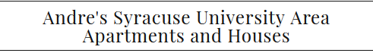

www.SU-Area.com
Andre El-Amir
4457 Wining Creek Rd
Manlius, NY 13104
315-857-4269

Landlord Permission Form
TENANT PERMISSION for LANDLORD TO RELEASE INFORMATION

I Tenant/Resident Name: Currently residing at

Street Address: Unit #:

City: State: Zip: do hereby give my current Landlord/Owner/management Company doing business as_______________________________ to release information to Andre El-Amir VIA phone call, text or email regarding my tenancy including information related to Rent Payment timeliness/ Living habits and or complaints by other tenants or neighbors.

Current Landlord Name: ________

Current Landlord Telephone #:

Tenant Signature: _______________________________________

Date: _______________________________________

