Behavioral Science and Public Policy Challenge | Research Document

Brief from BEPP

Client: Kisha Davis Petties, Bureau of Partnerships and Collaboration, Division of Early Childhood, Illinois Department of Human Services (IDHS)

Research Question:
As of school year 2014-2015, the statutory age for mandated school entry is six years old. As a result, children who do not attend kindergarten may not be fully assessed for academic readiness and achievement until third grade or two years after mandated school entry. Third grade is high stakes since it is the first grade-level benchmark in school accountability. Furthermore, if performance is anything short of "meeting expectations," improvement may be a longer road to travel since the sensitive period for development has just closed, says Carisa Hurley, ISBE. In 2019 SB2075 was introduced, calling for Illinois congress to amend the School Code, lowering the compulsory school age from 6 to 5 years of age beginning with the 2020-2021 school year. Unfortunately, the Bill was not passed.

Solution Sought:
As Kindergarten is not mandatory, how do we incentivize private providers and parents to ensure that the children are kindergarten ready. Think of short-term, medium-term and long-term solutions across
the spectrum of behavioral and administrative solutions. In your solution, clearly explain your theory of
change, with clearly defined measures of success and ways to measure success. The best solutions should
be time and resource efficient and implementation friendly yet meeting the defined KPIs of success.

By the endline of Kindergarten they should be ready

Resources:
• Presentation Slides from the Launch event and Policy Memo (Access Here)
• Recording of the Launch Session including QnA (Access Here)
• Data Sources: a) Excelerate Illinois b) INCCRRA c) KIDS Data ISBE d) KIDS Report, ISBE (KIDS: Kindergarten Individual Development Survey)

Our Understanding
The client (The state) is looking for incentive programs (short, medium) or policy level (long) solutions to ensure children have a Kindergarten level of readiness measured using the 4 domains of the KIDS report through formal schooling or informal learning at home/community provided through parents or private players. As Harris, we need to include evidence of the intervention success and also deliver a program evaluation method and metrics to showcase efficacy.

- 85% of the brain development happens by 6 years of age; important to ensure school readiness
- The only testing happens at 8 (Grade 3) - to see out any imbalances in their cognitive levels and provide adequate support causing developmental challenges later in life.

Research Areas:

- Kindergarten Landscape
- Why are Kindergartens important?
Advocates say that gains made in prekindergarten continue throughout grade school and into adulthood, with more children staying in school, out of jail, and earning more during their lifetimes than their peers who did not attend prekindergarten. This contributes to family stability, less crime, and greater upward mobility, all of which benefit society.
The first three years of a child’s life are the most active period for establishing the brain's architecture. In fact, more than 1 million new neural connections form every second. Moreover, cardiovascular disease, diabetes and depression—three of the most common and costly conditions that account for more than $600 billion in health care expenditures in the U.S. annually—are associated with adverse early childhood experiences.

- Who are the key stakeholders?
- Awareness, Access and Appeal of pre-school or play school.
- What do the educators think?
- Are parents aware of the benefits of Kindergarten? What will their children be competing with?

- Learning Quality Landscape
- According to the 2022-2023 KIDS data (36% kids do not meet any of the 3 domains, 30% meets all 3 domains, 17% meets 2 domains, 17% meets 1 domain
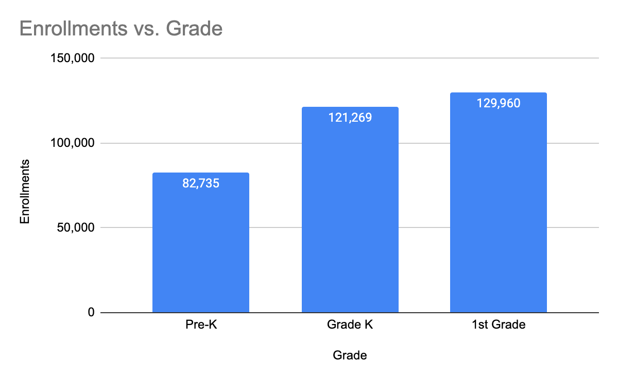
- Kindergarten readiness: measured in the first 40 days of kindergarten instruction for 87% students enrolled in Grade K. Three key development areas (Appendix 6.1):
  - Social and Emotional Development - curiosity, self-regulation, social interactions
  - Math skills - classification, quantity, math operations, shapes
  - Language and Literacy development - communication, conversation, comprehension, vocabularyState of KG readiness:

- MATH is consistently the area in which the fewest students have been rated ready, indicating a need to offer greater support for both early childhood educators and families on supporting students' development of early math skills.

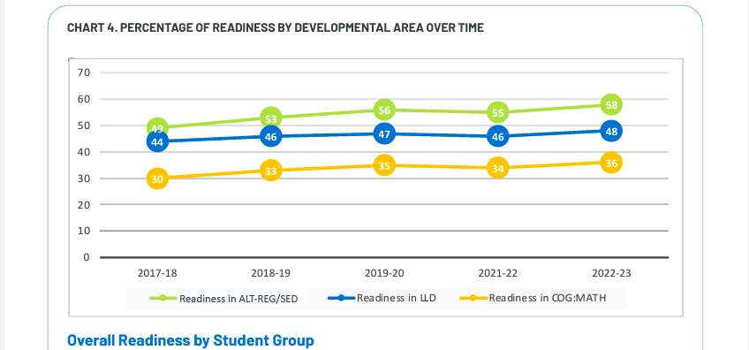

Racial disparity in kindergarten readiness

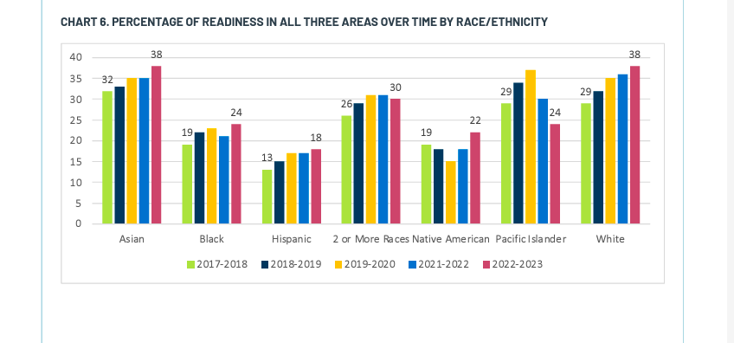
- Groups categorized as EL, IEP, FRPL most in need for interventions
  - EL: (English Learner): This refers to students who are in the process of acquiring English language skills. They are often provided with specialized instruction to improve their proficiency in English.
  - IEP (Individualized Education Program): An IEP is a plan developed for public school children who need special education. It's tailored to the individual student's needs and may include special instruction, accommodations, or other support.
  - FRPL (Free and Reduced Price Lunch): This refers to students who are eligible for free or reduced-price meals at school, typically based on family income. This is often used as an indicator of economic need or disadvantage.

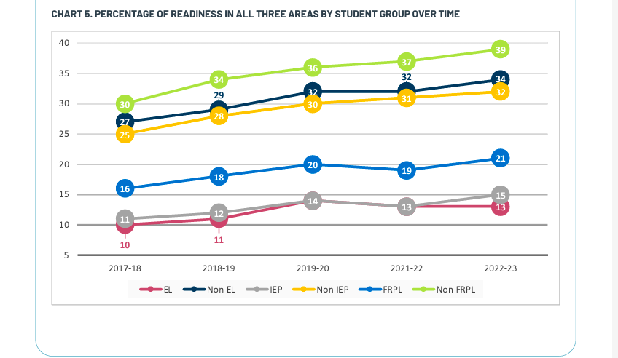

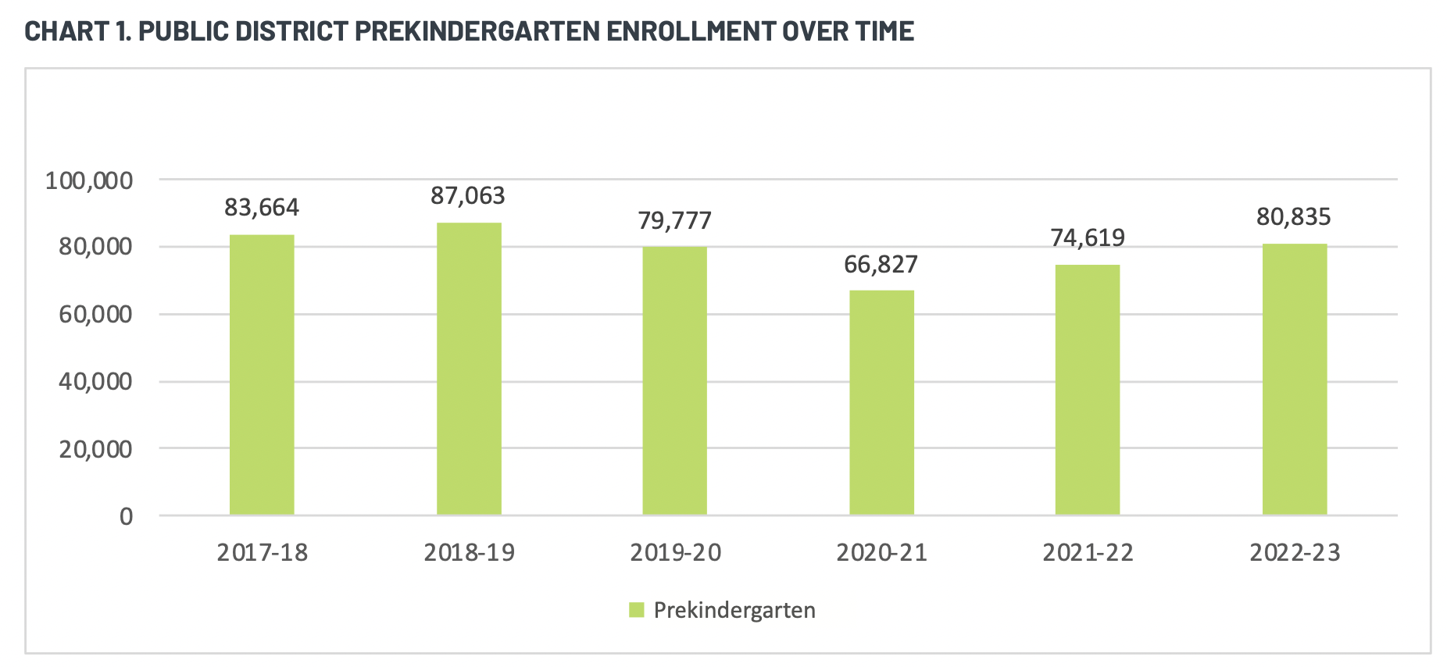
- In pre-school, children’s developmental goals are mainly in three domains: Socio-emotional learning (Curiosity and Initiative in Learning, Self-Control of Feelings and Behavior, Engagement and Persistence), Language and literacy development (Relationships and social interactions with family and peers, Use of Language, Reciprocal Communication and Conversation, Comprehension of Age-Appropriate Text, Phonological Awareness, Letter and Word Knowledge), and Math (Classification, Number Sense of Quantity, Number Sense of Math Operations, Shapes).
- Kids who showcase expected skills and behaviors in 2, 1, or none of the 14 measures above, will need additional support.
- Additionally, there are domains like Language Development, Physical Development, etc. Recommended practice is for teachers to complete the survey two or three times a year.
- The lead convening advocacy groups in Illinois are Start Early and Illinois Action for Children. IAFC and Start Early work in partnership and coalition with many organizations, including the Quality Alliance, a decades-old coalition of more than 40 early childhood organizations, the We, The Village coalition of over 90 organizations which launched the Right To Care campaign, and Raising Illinois, a coalition of more than one hundred organizations focused on investment and policy change in the prenatal and first three years of life.
- Tool for reading level readiness in the first grade

- What kind of statistics of children who do not go to kindergarten?
- There is an established free option for Kindergarten, why are people not using this?
  - Application process is too complicated
  - It is too far, not accessible, other students are not going from the neighborhood
  - Don’t have time to drop to school, No childcare and security of little kids
  - Ariel: Reasons why these kids who don’t come to the school - economically disadvantaged, their families don’t have enough money to build those skills, give people who lack money more money to give those skills for the first day of school - focus on many studies across policy conversations. Doing this is super important especially if the basic material needs are met. There is no proof of this happening in the US - there is no proof that the basic material needs meeting leads to better schooling outcomes.
- Do homes have features to help with this learning?
- Absenteeism from pre-school - in the city of chicago - lots of kids were enrolled in the pre-school but their kids missed half the day of school
- How do parents interact with their children at home?
  - Reading story books, outings outside the house, places of learning parks, museums etc, asking open ended questions,
  - Poor parents don’t do a lot of math or discipline their children in a specific way.
  - Vocabulary skills - Having access to reading materials is not a problem for low income families - they already have books, very few households have no books.
  - Change parents’ opinions about the importance of reading? That’s not true either. Parents believe strongly in the value of reading. I like reading. But I don't have time to read.
  - Low income families may not be home at kids’ bedtime. Most of the reading in economically advantaged families happens within 8 mins.
- No mandatory assessment when you enter 1st grade | How do we know a child is ready for kindergarten?

- Kindergarten Policy Landscape
- Kindergarten attendance is optional in Illinois. (School Code 105 ILCS 5/26-1)
- Only 150 of Illinois’ 852 school districts do not already have a full-day program. Schools with an existing full-day kindergarten will not be affected, and they can still offer a half-day option if they choose to.
- Having a public option for full-day education and child care for children as young as 4 would allow many parents to return to work, which benefits working families and the economy.

- Requirements:
  - To begin kindergarten in Illinois, a child should be 5 years old on or before Sept. 1 of the kindergarten year and live within the boundaries of the school district.
  - Up-to-date Immunization Record in compliance with IL Dept. of Public Health.Most children entering kindergarten will need a DPT, Polio, MMR, and Varicella immunization. Due October 15, 2022.
  - The State of Illinois requires all incoming kindergarten students to have a current Illinois physical exam and up to date immunizations, vision exam and dental exam for entrance into kindergarten. *Failure to comply with the State of Illinois regulations will result in exclusion from school beginning October 15, 2022.
- Why was the bill brought into focus? Why is the mandated year of testing not moved to an early age?
- Illinois Gov. J.B. Pritzker has signed a new law paving the way for full-day kindergarten throughout the state in coming years. Under provisions of the bill, full-day kindergarten will need to be offered by school districts by the 2027-28 school year, though some schools could qualify for an extension of that date.
- Potential Concerns with full day kindergarten.
  - Identify potential cost savings: Savings may include lower transportation bills, as districts no longer require separate busing for kindergarteners. New Mexico, for example, has saved approximately $5.5 million per year in reduced labor, maintenance, and fuel costs. As teachers are able to spend more time with their students, they are able to detect learning and developmental needs earlier and recommend prevention services. States have projected savings in state childcare subsidies as well,17 although funds from such subsidies cannot be simply transferred to finance full-day kindergarten because these two types of programs operate in different policy arenas and
  - under separate funding streams.
  - Use pilot programs. Successful pilot programs can address concerns about unique policy contexts or demographics.
  - Develop a comprehensive strategic plan for early care and education, birth to age 8. Instead of addressing infant and toddler care, universal preschool, kindergarten, and primary grade supports as separate initiatives, policymakers should address them as parts of the same whole.

- Birth to third grade alignment

- Chicago: Income and Education Relationship
- Low income families may be tired, distracted, busy, having inertia due to the cognitive load in the environment. How would you reduce the friction of making things happen?
- How would you develop that habit? Remember you told me you loved reading, send this in the text message - inspire the parents to tell them how good it feels to read to the kids.
- What is the impact of a parent's education level on child skills?

- Best Practices in other US States
- Bridge to Kindergarten Summer Program
The first study goal was to examine the effects of adding a self-regulation intervention to the B2K program on children’s self-regulation, math, and literacy. The second study goal was to compare changes in self-regulation, math, and literacy during the kindergarten transition period for children attending the B2K program with the intervention to expected development. Results from a randomized trial indicated that children who participated in the B2K program that included the self-regulation intervention experienced more gains in self-regulation relative to children who participated in the B2K program alone. There were no significant effects on math or literacy at the end of the program. However, when examining change during the kindergarten transition period, participation in the B2K program with the self-regulation intervention was associated with improved growth in self-regulation, math, and literacy into the fall of kindergarten compared to expected development.
The purpose of the B2K program is to help children develop early academic skills, as well as positive relationships with adults in school settings and strong social-emotional behaviors (e.g., lining up, raising a hand before talking, waiting for a turn).
During B2K, children are exposed to a variety of learning experiences (e.g., large group, small group, and read a-louds) with open-ended exploration of materials that support literacy, math, and social-emotional development. This program also encourages family engagement in school. The ultimate goal of B2K is to facilitate a positive transition to kindergarten for a population of children at higher risk for school difficulties. Children attend B2K for four hours per day, five days a week for three weeks in July prior to starting kindergarten in September. Starting in 2014, the RLPL intervention was fully integrated into the B2K curriculum for approximately 20–30 min each day during the three-week program.
- Financial Incentives for Promoting Participation in a School-Based Parenting Program in Low-Income Communities
We examined the extent to which the financial incentives delivered via bank debit cards ($15 for attending weekly group sessions, $5 for completing weekly practice assignments) motivated parents to enroll in the program and were associated with higher attendance and practice completion but poorer participation quality in group sessions, and how parents used the extra cash. Over 3 years, 67.4% (n = 372) of eligible families enrolled in a parenting program called the Chicago Parent Program. Most parents were African American (68%) or Latinx (24%); 67% reported annual household incomes < $20,000.
Another paper by Leviitt on financial incentives: https://www.nber.org/papers/w21477
- Home visit causal analysis (working paper)
- Engaging Parents with Preschools: Evidence from a Field Experiment
Parental engagement with schools is an important part of child development. Yet, parent engagement with preschools tends to be low. To increase parental attendance at school-sponsored family-engagement events, we conducted a 4-month RCT with 319 parents across six preschools in Chicago. We designed an intervention using a combination of financial incentives and two tools from behavioral economics: loss-framing and reminder messages. The treatment parents were given a $25 per event incentive to attend 8 events sponsored by their preschools, as well as weekly text message reminders about the events. The financial incentive was framed using loss aversion: parents were initially given $200 in a virtual account, and lost $25 for each missed event. We find that this intervention did not increase the fraction of parents that attended at least one event. implying that there was no extensive margin treatment effect. The intervention did lead to a modest increase in the attendance rate among parents who attend at least one event.
- Investing in Early Childhood Development in Preschool and at Home
We conclude that existing research on early childhood education falls short of sufficiently answering fundamental questions about what works for whom and why.
- Best Practices Global
- Parents’ Beliefs About Their Children’s Academic Ability: Implications for Educational Investments
Schools worldwide distribute information to parents about their children’s academic performance. Do frictions prevent parents, particularly low-income parents, from accessing this information to make decisions? A field experiment in Malawi shows that, at baseline, parents’ beliefs about their children’s academic performance are often inaccurate. Providing parents with clear, digestible performance information causes them to update their beliefs and adjust their investments: they increase the school enrollment of their higher-performing children, decrease the enrollment of lower-performing children, and choose educational inputs that are more closely matched to their children’s academic level. Heterogeneity analysis suggests information frictions are worse among the poor.

- Eurokids/Anganwadi

- Private market for Early Childhood
- Who are the current private providers? What challenges do they face?
- Why is there not enough traction in the preschool private industry?
- Are we pushing them to build more alternate learning products or provide more Kindergartens?
- https://www.raisingillinois.org/wp-content/uploads/2023/12/Raising-Illinois-FY-2024-Priorities-FINAL-12-4-23.pdf
- Primary and Secondary User Journey | Touchpoints
- Primary - (Child 4-5YO): Home [Parents, Radio/TV/Youtube, Siblings], Daycare [Care-Takers, Activities, Peers, Vaccinations], Co-curricular classes [Classmates, Activities], Community Parks/Centres [Neighborhood, Activities]
- Secondary(Parents): Home [Media], Community [Parks, Events], Work, School [If sibling is in school], Shopping [Stores], Hospitals

