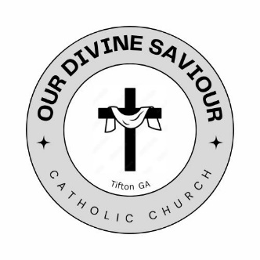

**Form for New Membership**

Name _____________________________________________________________

Household Members and Ages _________________________________________

___________________________________________________________________

Address ____________________________________________________________

Previous Church, City, State ____________________________________________

Employment ________________________________________________________

Phone Number ______-______-____________

email Address _______________________________________________________

Any Needed Sacraments for Family? _____________________________________

___________________________________________________________________

What Would You Like to See from Your New Church? _______________________

___________________________________________________________________

___________________________________________________________________

___________________________________________________________________

Are You Interested in Any of the Following?

Music Ministry Eucharistic Minister Lector Council of Catholic Women

Knights of Columbus Altar Server Sacristan Youth Ministry CCD Teacher

Other ________________________________