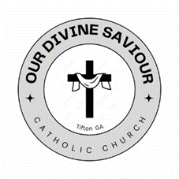

**Godparent Requirements**

Godparents must be practicing Catholics in good standing who have been confirmed and are at least 16 years of age. If married, the sponsor must be in a valid marriage. Married according to the laws and regulations of the Catholic Church, which means the were married by a Catholic priest or obtained an official permission for getting married outside the Catholic Church. If single, the sponsor may not be cohabitating with someone without the benefit of marriage. The sponsor may not be the mother or father of the person to be baptized.

**Responsibilities of the Godparent**

The godparent’s role is to assist the person in Christian initiation. In case of infant baptism, the role is, together with the parents, to present the child for baptism and to help the person to live a Christian life befitting the baptized. A godparent’s responsibilities extend far beyond standing with the family at church. A godparent is expected to be a spiritual guide for the child. Whether the child is a blood relative or the child of a close friend, the expectation is that every effort will be made to get to know your godchild well and help the parents by sharing your faith with the child in every way possible, from the day of the baptismal ceremony to all the days beyond.

**Our Divine Saviour Requirements**

We require selected Godparents to attend a Baptism Preparation Class either at Our Divine Saviour or their home parish. Also, a Godparent Verification Form of Eligibility must be filled out. This form is available on the *Parish Forms* page.

