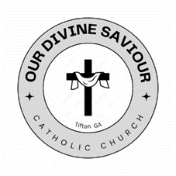
Sponsor Form for Infant Baptism
Congratulations!
You have been selected as the sponsor of_____________________________________. (Name of child to be baptized) Accompanying this child on his or her journey of faith is an important part of being a sponsor. As the sponsor, you have a vital responsibility to help the baptized child live a Christian life in accordance with baptism and to faithfully carry out the responsibilities that come with it.
Sponsor Information (Please Print)
Name _____________________________________________________________________________________
I am a member of _______________________________________________________________________Parish
As one willing to be a BAPTISM SPONSOR I affirm that: (Please check the boxes that are appropriate)
- I have received the sacraments of Baptism, Confirmation, and Eucharist in the Roman Catholic Church
- I am sixteen years of age.
- I participate regularly in Sunday Mass as a practicing Roman Catholic.
- I actively strive to live out my commitment to Christ and the communal life of the Church through my loving response to those with whom I encounter daily.
- I fulfill my obligations to my parish to the best of my ability in support of the Gospel message.
With my signature, I certify that I meet the criteria for a sponsor as outlined above.
Prospective sponsor signature_________________________________ Date ________________

For the priest or parish staff at the parish of which you are a member.
(This must be completed before sending the form back)
I verify that this person is a registered member of our parish and is in good standing.
Signature: ________________________________________________________
Parish: ___________________________________________________________
Date: ___________________________________
Parish Seal

