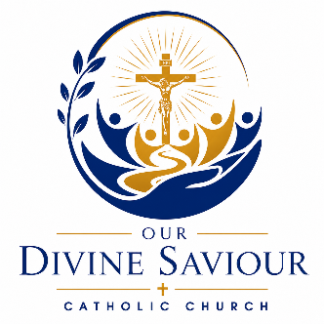
Form for New Membership
Name _____________________________________________________________
Household Members and Ages _________________________________________
___________________________________________________________________
Address ____________________________________________________________
Previous Church, City, State ____________________________________________
Employment ________________________________________________________
Phone Number ______-______-____________
email Address _______________________________________________________
Any Needed Sacraments for Family? _____________________________________
___________________________________________________________________
What Would You Like to See from Your New Church? _______________________
___________________________________________________________________
___________________________________________________________________
___________________________________________________________________
Are You Interested in Any of the Following?
Music Ministry Eucharistic Minister Lector Council of Catholic Women
Knights of Columbus Altar Server Sacristan Youth Ministry CCD Teacher
Other ________________________________

