Fortune
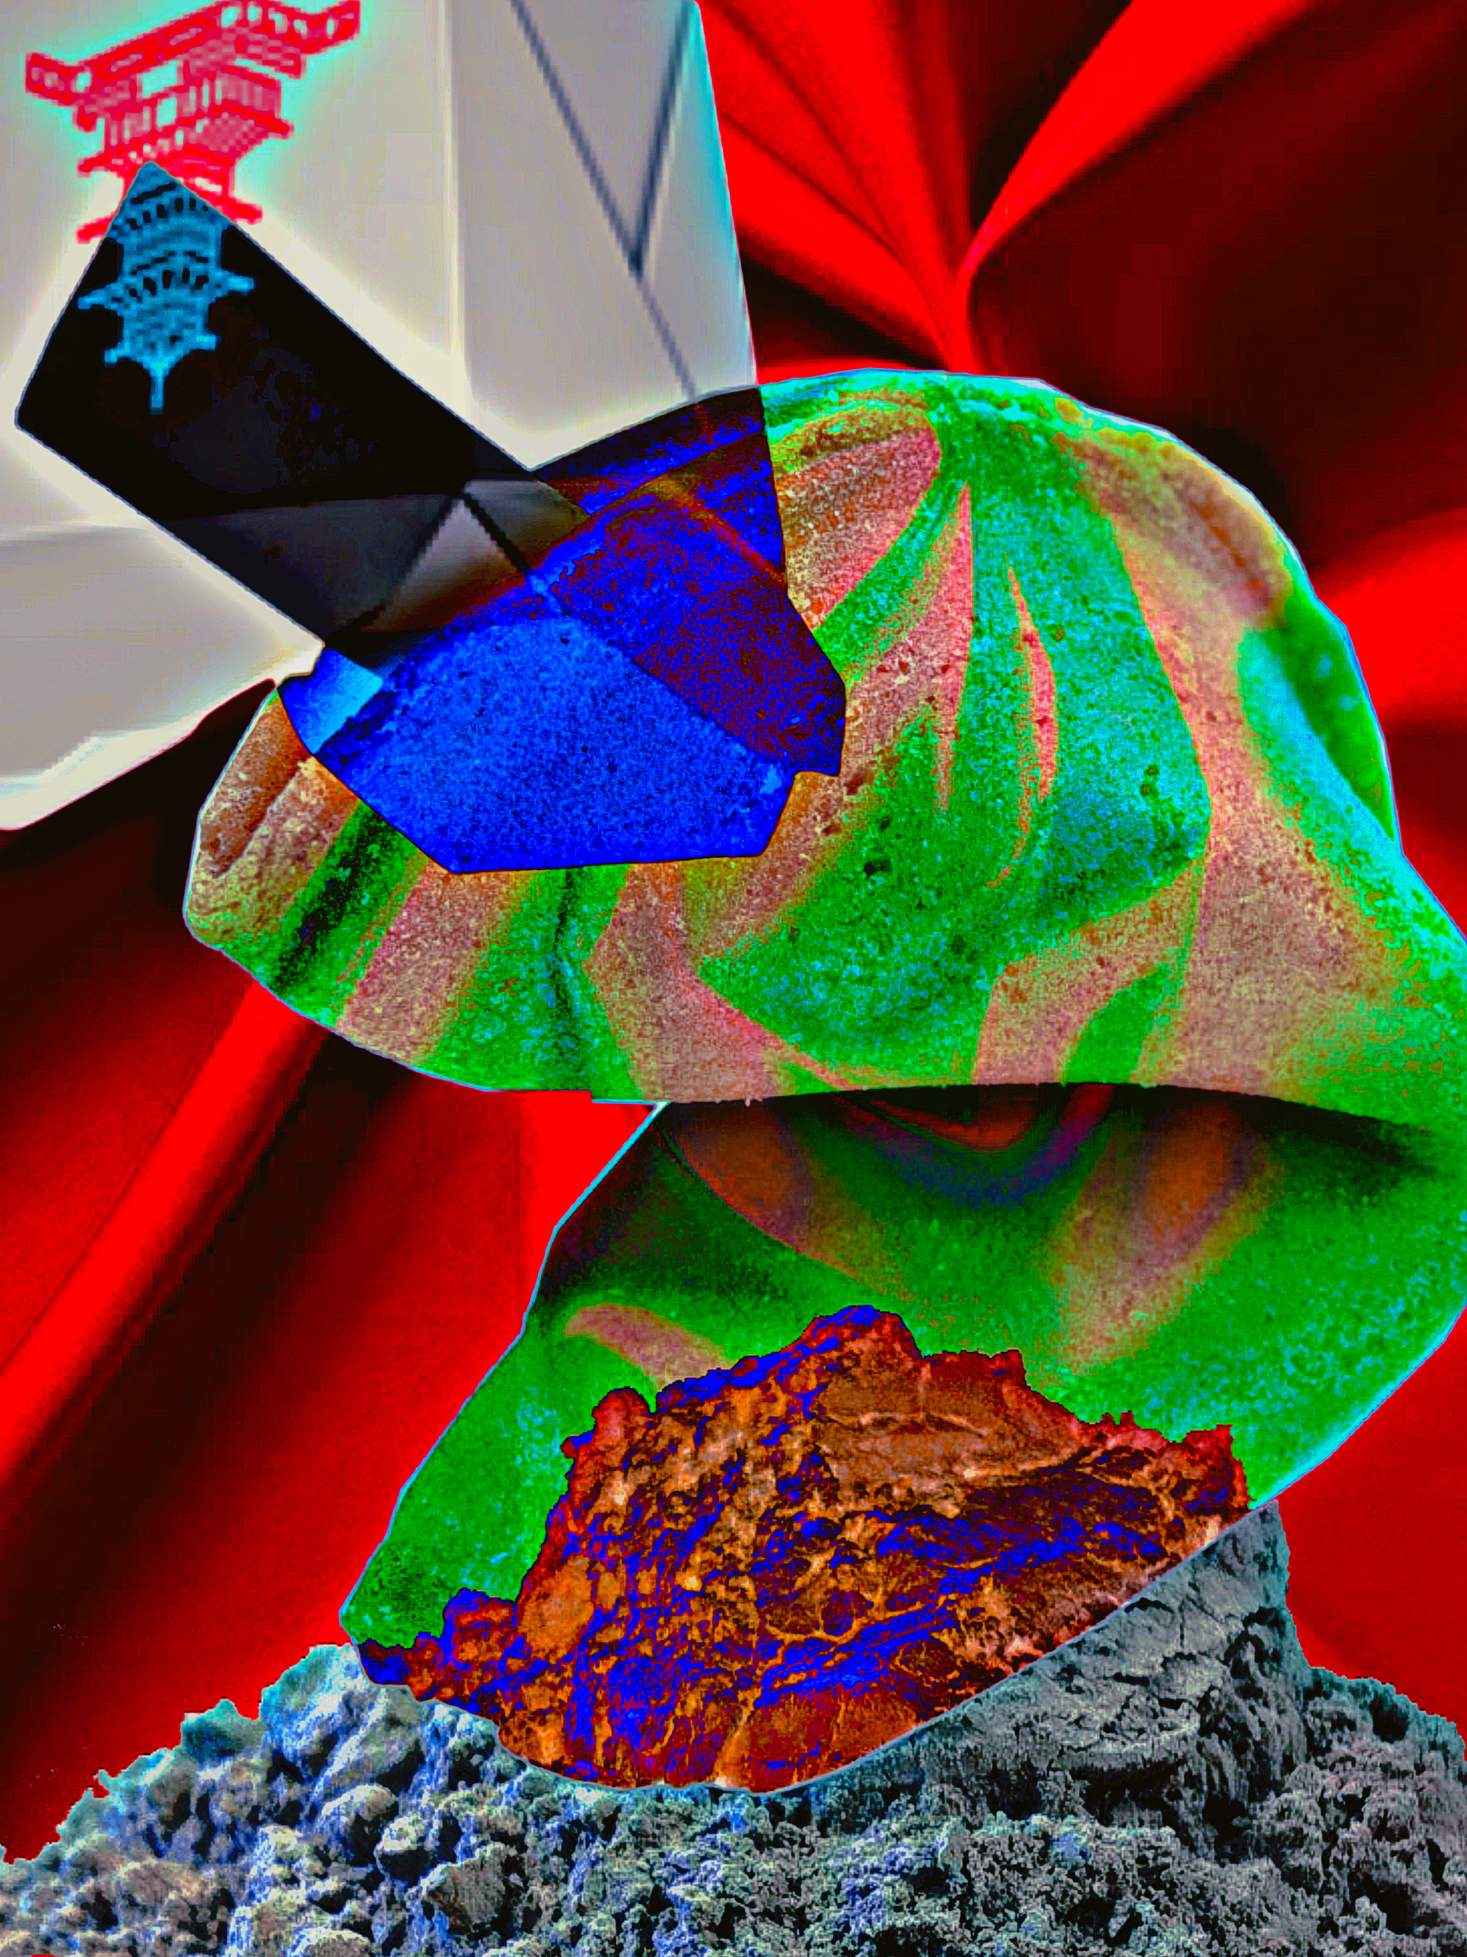

Fortune
To serenity.
If you would like to view or submit art or music inspired by this story or what inspires you, please submit to www.nancyreaume.com.

To view the Spotify playlist inspired by this story, search for ‘Fortune’ or use the following URL: https://open.spotify.com/playlist/5UARU9Cc71FjmlcCrmBsoC?si=yUkBLWTkTc2Px-woft2P0w
Part One: Tar, Pit, Trap
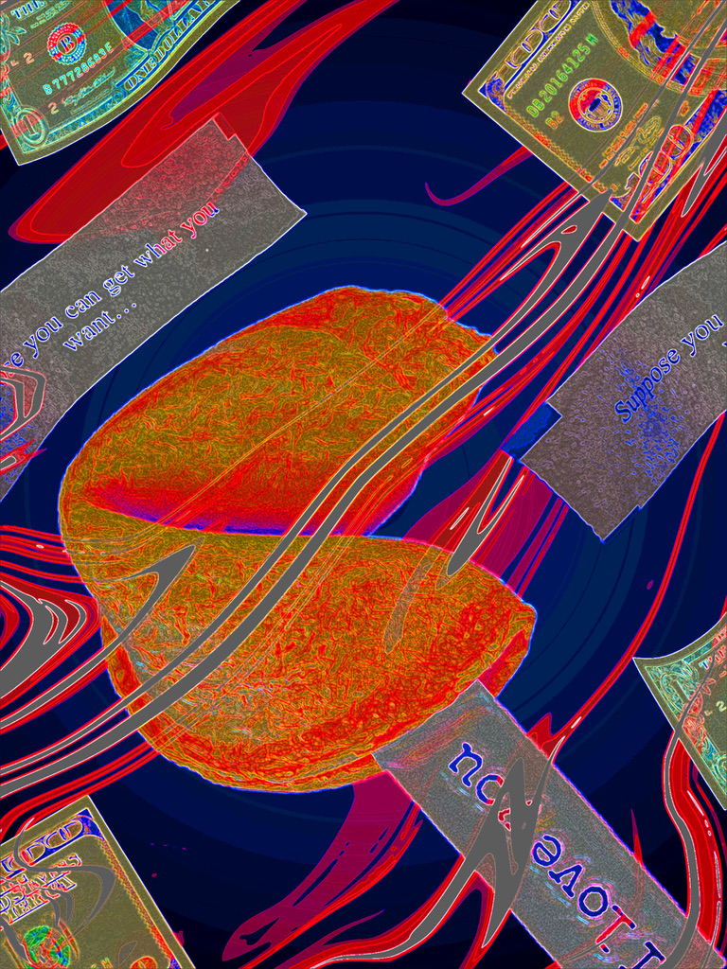
Since the accident, my mind has been convoluted, and my memory has been shrouded in mystery; most of my issues are related to a mysterious man named Kurt, whom my mind flashes back to like memories, to which existence, in reality, is the question, as no one in my life acknowledges he ever was.
My doctor proposed that my mind was tricking itself into believing these memories were my own when, in fact, they were fabricated filler stories created by a creative mind trying to make sense of it all and not feel so alone. I disagreed because my memories had an attachment to them that was far too great to believe they were just filler stories. I was confident that I could tell the difference.
Even after leaving the hospital, my mind tortured me with him, and I missed him so much that I couldn’t function. Hope is the umbilical noose you feel compelled to climb regardless of the outcome.
As my life failed to move forward, I decided to try to numb the pain with alcohol. So, I walked to the only bar within walking distance; this establishment is where people came to drown their sorrows around others, not with them, and I appreciated this. Yet, what made this bar exceptional was the Chinese restaurant next door. The first time I ate there, my fortune cookie said, “What you seek, you may find, but only if you don’t forget what you sought.” I’ve always been more than a tiny bit superstitious, so I took it as a sign.
My life continued as such, so I relied on those fortune cookies for encouragement and guidance, and they became as addictive as the alcohol to me: the alcohol was to numb the absence of hope, while the fortunes were there to remind me that things could change for the better, while in a hopeless situation. Since I am not a rich girl, I tried to purchase just the cookies, but they refused as it “wasn’t on the menu but a gift for ordering something that was.” I tried to cut down on the booze to leave more money, but I couldn’t because the idea of hope couldn’t overpower actual hopelessness, so it seemed they would both need to remain.
Ultimately, my budget allowed for a weekly message, and not once did I receive a generic message like “a penny saved is a penny earned.” I kept them all: “You must let go of much but never let go of love,” “You can replace much but never your soulmate,” and “The one you seek, you have never replaced, and the person you seek finds you irreplaceable.” Those fortunes never let me down; they always said what I wanted to hear: someone will love you as much as you love them, you are important, and you aren’t one of many but one and only.
Eventually, I explained the supernatural messages to one of my few friends, who was concerned enough to phone my mother. My mother then insisted that I go with her to the hospital, where the doctor asked why no one knew Kurt, and there was no evidence of him if he was more than an illusion or mirage. The doctor added that it isn’t healthy to wager or plan their lives by their fortunes, as they are meant to clarify feelings within reality. I agreed to stop obsessing over a phantom so my life could move forward and avoid such trips.
When I got home, there was a stack of mail, and on top was a flyer advertisement for “Play it again, Kurt,” one of the longest-standing stores in our town that sold used records, tapes, and CDs. I inspected it closer and noticed the flyer was advertising Fate’s album, “Out of Ashes”; the cover was of a man and woman, constructed of ashes, holding hands. While admiring the art, I was blasted into a memory where a song was playing, and Kurt, the only thing in focus, said, “Oh shit! It’s our song!” Then he kissed me. Unfortunately, as soon as it came, the memory floats away; I try to will it back, but I can’t control it; it is a tip-of-your-tongue recollection that I can’t recall. I sit there still. I can’t let go.
Eventually, I decided to go to the record store and then to the Chinese restaurant. But then I felt so fatigued that I lay there, thought, and hurt deeply. Some say it’s a self-pity pit, and that makes it seem like a choice to be attached to hell and detachment from all the better things in life, which is untrue; it’s not a pity pit, a but tar pit trap because just like being stuck in tar, my inability to move hasn’t anything to do with my will—wanting to do something and being able to can be so much further than you expect. I fell asleep to visions of tar pouring over me, and struggling did not make me freer but more tired. In my sleep, I stayed encapsulated in tar and experienced sleep paralysis for an excruciating amount of time before I heard Kurt scream, “Baby, remember; you got to remember! It’s the only way we can be together.”
I wanted to yell, “All I fucking want to do is remember!” But the tar filled my throat; I woke up screaming.
After I calmed myself, his words replayed in my head, and they seemed to be riddles disguised as statements. But pulling for memories after they played out was like grasping for the ghost of a memory, so faded and disconnected it almost isn’t. Then, my sadness started to drown me; my desire for something out of reach was suffocating. These are precursors to my true darkness, which invites you in to stay, and knowing how badly I wanted to stay, I figured I'd best move. So I grabbed my things and walked to the record store.
On that walk, I saw an incredible number of inanimate objects in the shape of a heart: a stone, dried grass, litter on the side of the road, potholes, etc.
When I got to the record store, I inhaled the smell of age, like my grandparents’ basement, which I found comforting. I was greeted by a lady with a hat resembling something a trendy pilgrim would wear; she asked what I was looking for, and I said the “Fate” CD. She explained they didn’t have a CD but a vinyl, so I explained that I didn’t have the equipment.
She smiled and said, “That’s too bad. That’s the best way to enjoy music.”
My look of despair must have pulled on her heartstrings because she said, “Well, how about I let you listen to the vinyl in the basement, and I can order you a CD?”
I agreed and gave her my information. Then she led me to the basement, which I erroneously assumed had a customer area, as I realized it was a storage area next to the employee break room that had no carpeting, just this reddish-orange shag rug that appeared to have been hot glued to the cement and never washed.
She invited me to sit down, but seeing my hesitation, said, “Oh, right? That carpet is disgusting. Let me get you a seat.”
She hauled over a restaurant booth-style seat, which was red, pleather-backed, and much cleaner, which I gratefully accepted. Then, she gave me a quick tutorial and started the record. As the record began to play, she disappeared.
I enjoyed the music, especially that they had a male and a female vocalist who had whole songs to themselves, but weaved in duets, two complete people joined together. The first songs were fiery, and you could hear the metaphors and allusions to the strongest emotions, especially passion. Then it calmed down into acoustic and a cappella songs that dealt with different struggles, especially those between two lovers, and as they progressed, you could feel that the fire had burned everything to ash.
My favorite song was about the two coming together to make a kingdom of cinder because it is impossible to reverse fire damage, but regardless of circumstance, it was still them, and love is the only thing that could transform the reality of ashes into a fantasy of love. The last thing I remember was Kurt saying, “Oh shit, it’s our song.”
I woke up in bed and couldn’t believe it. I did not remember walking home. This terrified me. But then I reassured myself that I must have had the most realistic dream. But after I got out of bed, this was dispelled because I felt the paper in my pocket, and it was the pink slip for the “Fate” CD. It was signed by the woman who assisted me with a strange message at the bottom: “I can never repay your kindness, but kindness is always repaid. The CD is my treat.”
I thought, “What act of kindness did I do Blacked out. Losing time like that is not a good thing, but I was scared of doctors because I didn’t want to be in the hospital anymore. Eventually, I decided to go to the doctor and made an appointment for the next day.
The next day, I took the bus, and the ride was a nightmare. These two menacing men kept staring at me the whole ride, and I became scared enough to get off the bus several stops early.
As I walked, I passed lilacs, and it triggered a flashback of Kurt bringing me the flowers and saying, “Here, these are for you; I know they are your favorites. I have an extraordinary surprise for you tonight. And we’re going to eat at your favorite…”
The memory faded, and I found myself in the doctor's office. I did not remember finishing my walk, so it was good that I was there. I must have been talking during my absence because he looked at me as if waiting for a response. When I didn’t know what to say, he said, “Are you doing ok?”
I said, “Ummm.”
He smiled and said, “You were talking about your fiancé, Kurt. How long have you been together?”
I stammered, “My fiancée? Umm… together? Hmm.” Then I started crying.
The doctor knelt and said, “It’s ok. You’ve been through a lot. The brain is unique and mysterious, but I know you will sort this out with time.”
It was so beautiful and reassuring. I said, “Thank you, Doctor.” Then I walked home because the bus ride unsettled me. During this walk, I noticed money was littered along the street. I tried grabbing some floating fortune, but the wind was too fast. Further down the road, the money had been attached to the ground by some sticky red substance, which was concerning. I figured I’d call and report it when I got home.
When I got home, I was too tired and decided against calling about the money; I figured they had received tons of calls by now. So I put on some music and willed my mind to help me.
After falling asleep, I dreamed of the men on the bus. Kurt was also there; he looked terrified and was crying. Why would I scare him? What is going on?
Then everything was black, but I was aware, and it stayed that way until I woke, which felt like being buried alive. I woke up sweating and petrified. I wished my sanity or insanity would finally win, so I wasn’t in the giant tug-of-war between them.
Then the phone rang, and the lady from “Play it Again Kurt” said the CD I ordered would arrive the next day. I was happy to hear this and then got in the shower. After I showered, I decided to get Chinese food because I needed some comfort food.
On my walk to receive my fortune, I noticed most of the fortune was still attached to the ground, except the attached substance’s color had browned. It brought some strong emotions, oddly tied to nothing; I felt sadness and thought, “Money is so beautiful until it is bloodied.”
I was glad when I reached the restaurant because I needed to disconnect from my thoughts.

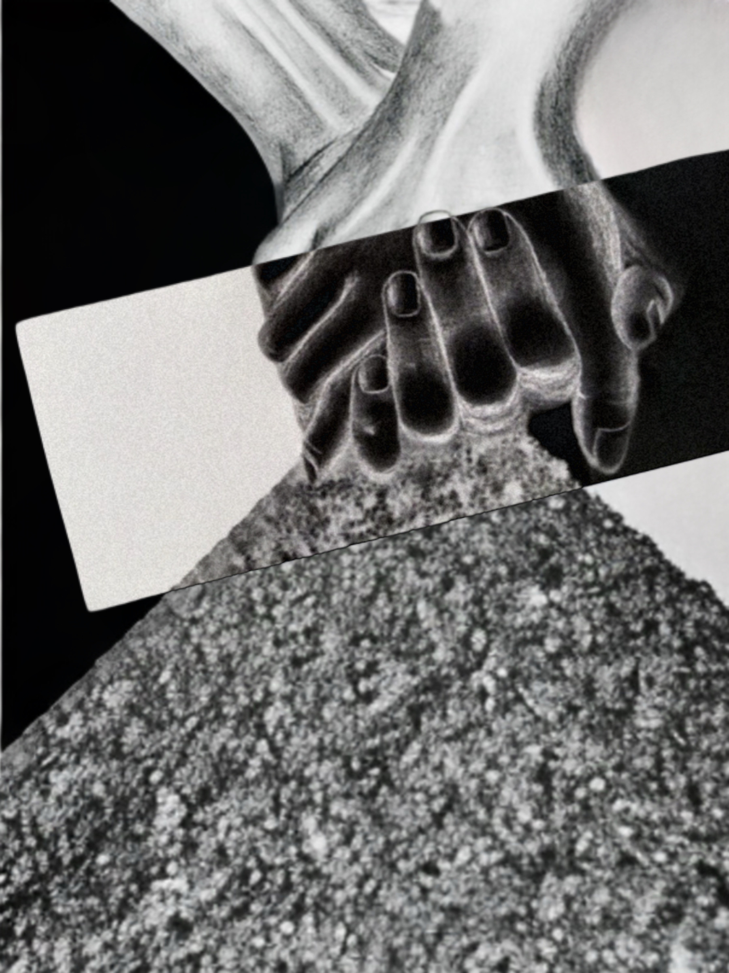
Part Two: Recovered Fortune

Once I arrived, I gave the restaurant server my name for my order, and then he profusely thanked me throughout the process, which was so overboard that I felt uneasy.
I decided to ride the bus home and was relieved when I was alone. However, right when I relaxed, the menacing men got on the bus. The smaller of the two men sat down, but the larger man with a gold dollar sign belt buckle approached me like he was about to attack me. I was scared and frozen. Then everything went black.
I woke up on my couch with evidence that I had eaten the Chinese food without recollection. I noticed the fortune sitting on the table and picked it up; it said, “I love you.”
I needed the message badly.
“I love you.”
There is no I love you without two people, and it is only two people. I fantasized about my life if love were more tangible than a phantom or hope; it is a lovely picture.
As I sat there, my telephone rang. I answered, and the record store reminded me that the “Fate” CD was ready.
I rode the bus without incident but felt anxious the whole time. When I got to the store, the employee who helped me differed from the lady who placed the order. She thanked me with a visible vulnerability that was beyond bizarre. I felt concerned that even the simple things in my life had become outlandish and uncomfortable.
I got on a different bus than usual, which was extra footwork, but avoiding those men made it worthwhile. The ride was peaceful until the men entered the bus three stops before my own. As they walk towards me, I hear people screaming, and it goes black.
I wake up in bed with the “Fate” CD playing. It was on the first song, and I had no recollection of getting there.
I daydreamed while listening to the songs; when “Ashes-2-Ashes” played, I was transported to sitting at the Chinese restaurant with Kurt. Kurt smiled, gave me a silver heart-shaped tin, and said, “This is for you.” I open the tin, and inside is a ring.
Kurt says, “It’s ok to let go; I will catch you.” I tried to hold on, but then opened my eyes.
I sat and cried, wondering, “Was I once that happy, about to watch my dreams come true?” And then “Tar Pit Trap” repeated in my head.
I go to shower and realize I have nothing to wash my hair or body with, so I head to the basement, where I keep backups, and reach for the bin on the top shelf. I am short, so I’m on my toes and inching the bin towards me when the movement knocks something onto my twinkle-toe.
I pick up the object and recognize the metal heart-shaped tin from my delusion or dream. I set it down and wonder.
That’s all I could do for the next week, and nothing else happened. By the time my weekly Chinese food run came up, I needed it. A whole week of thinking of all that could’ve been was torture.
I walked to the Chinese food restaurant and lived my life as I wanted: marriage, then milestones together. My fantasy became a limb on my walk home, and all possibilities branched from there. To live so many lives but never be disconnected from Kurt was a pleasurable journey; our appearance, occupation, and personalities were altered, but never our love, as every version of ourselves loved each other.
When I got home, I read my fortune: “Kurt loves Netty.” I fell to my knees. It was unreal.
Then, I watched the words come off the paper and duplicate until the words circled me like a very slow tornado: “I love you. I love you. I love you. I love you. I love you. I love you. I love you.” Then, the words multiply even faster without delay until I cannot see through them; I am entombed in blackness. That is when the screaming started.
As the screaming stops, the blackness transitions into Kurt and me sitting at the Chinese restaurant. I have the ruby and emerald engagement ring on, and the heart-shaped metal tin is on the table. I was so happy to be with him.
He takes my hand and expresses his excitement about marrying me. I feel so much love for him, and I try to say so, but I cannot make a sound.
Seconds later, the two men from the bus angrily enter the restaurant. At this time, I left my body, so I was watching my body outside itself. I noticed immediately that the men had guns as they demanded that everyone get on the ground so they could zip-tie us, including the children.
Kurt was telling me, “We have to fight this or not make it out,” but was interrupted by gunshots as the men shot people at random to display the price of disobedience.
Kurt and I looked at each other; our closeness was apparent in the quickness with which we understood each other. So, we stood up together and went to take down the first guy so we would have the gun.
Then, we both successfully pushed the gunman to the floor. I grabbed the gun, stood up, and pointed it at the man who was standing while Kurt tried to keep the flailing man pinned to the floor. I told the gunman to drop his gun, or I would shoot him. Which made the standing gunman laugh, then shoot Kurt and then me; the distraction was enough to allow some people to escape.
The men assessed the situation and realized that so much had gone wrong with this plan that the risk of staying now was too high, so they ran off.
I could tell Kurt was gone.
As my life blackened, I noticed my fortune floating in our blood; it read, “Today, you will discover the meaning of life.”
The darkness stayed for an uncomfortable time, but then life started again and went in reverse. Suddenly, I remembered the missing memories and experienced them all coming together.
Kurt says, “I will love you even if your possessions, beauty, wealth, health, sanity, happiness, and peace are incinerated.”
I could recall all of the laughter and tears of our love story.
Then, I returned to the Chinese restaurant but lived my life instead of viewing it.
Kurt hands me a heart-shaped metal tin. I take out the ring and pull him into me. I’ve lived two realities, with and without him, so I don’t want to let go.
We stay momentarily, and then he takes my hand and pulls me from our living scene, and we watch ourselves and the enfolding scene. We see the attempted robbery and the carnage that ensued, but time continues instead of reversing.
I watch as I am loaded onto the ambulance while Kurt and the other victims are removed in body bags.
Then, a burst of light blinds me, and surprisingly, when my vision returned, people unzipped themselves from their bags and approached us. I immediately recognized the record store clerks and the Chinese restaurant server, but now, I remember them being shot before us. They all expressed gratitude that we allowed people they loved to escape the fate they suffered.
Then, Kurt and I are at the hospital where my body lies. Kurt says, “You’re stuck, baby. You’ve trapped yourself in there.”
Then, sunflowers flooded the hospital until they pushed it out of frame, leaving Kurt and me holding hands in a sea of flowers.
Kurt says, “I missed you.” Kurt had lived in two worlds, with and without me, and would never let me go; instead, he pushed the flowers aside to reveal an opening, and we stepped through the flowers into another place.
In this other place, I watch my life continue with Kurt in fast motion. It is as beautiful as I knew it would be. Then it all goes black.
Then Kurt and I are in the hospital bed together again, and I hear the sound of my flat line. As the noise begs for attention, the room fills with water, and fish swim by me; I worry that I am drowning, then realize I don’t need to breathe, so I stop.
Once I stop, the water escapes like an aquarium whose transparent walls have collapsed from the weight and pulls me along until I end up back in the field of sunflowers, where I see Kurt waiting for me. I run to him.
After I died, my mother was despondent until she cleaned my room and found a heart-shaped tin that held collected fortunes, which she pulled out one by one: “Mothers are lions,” “This is not the end,” “I'm happy now,” and “I will see you soon.”

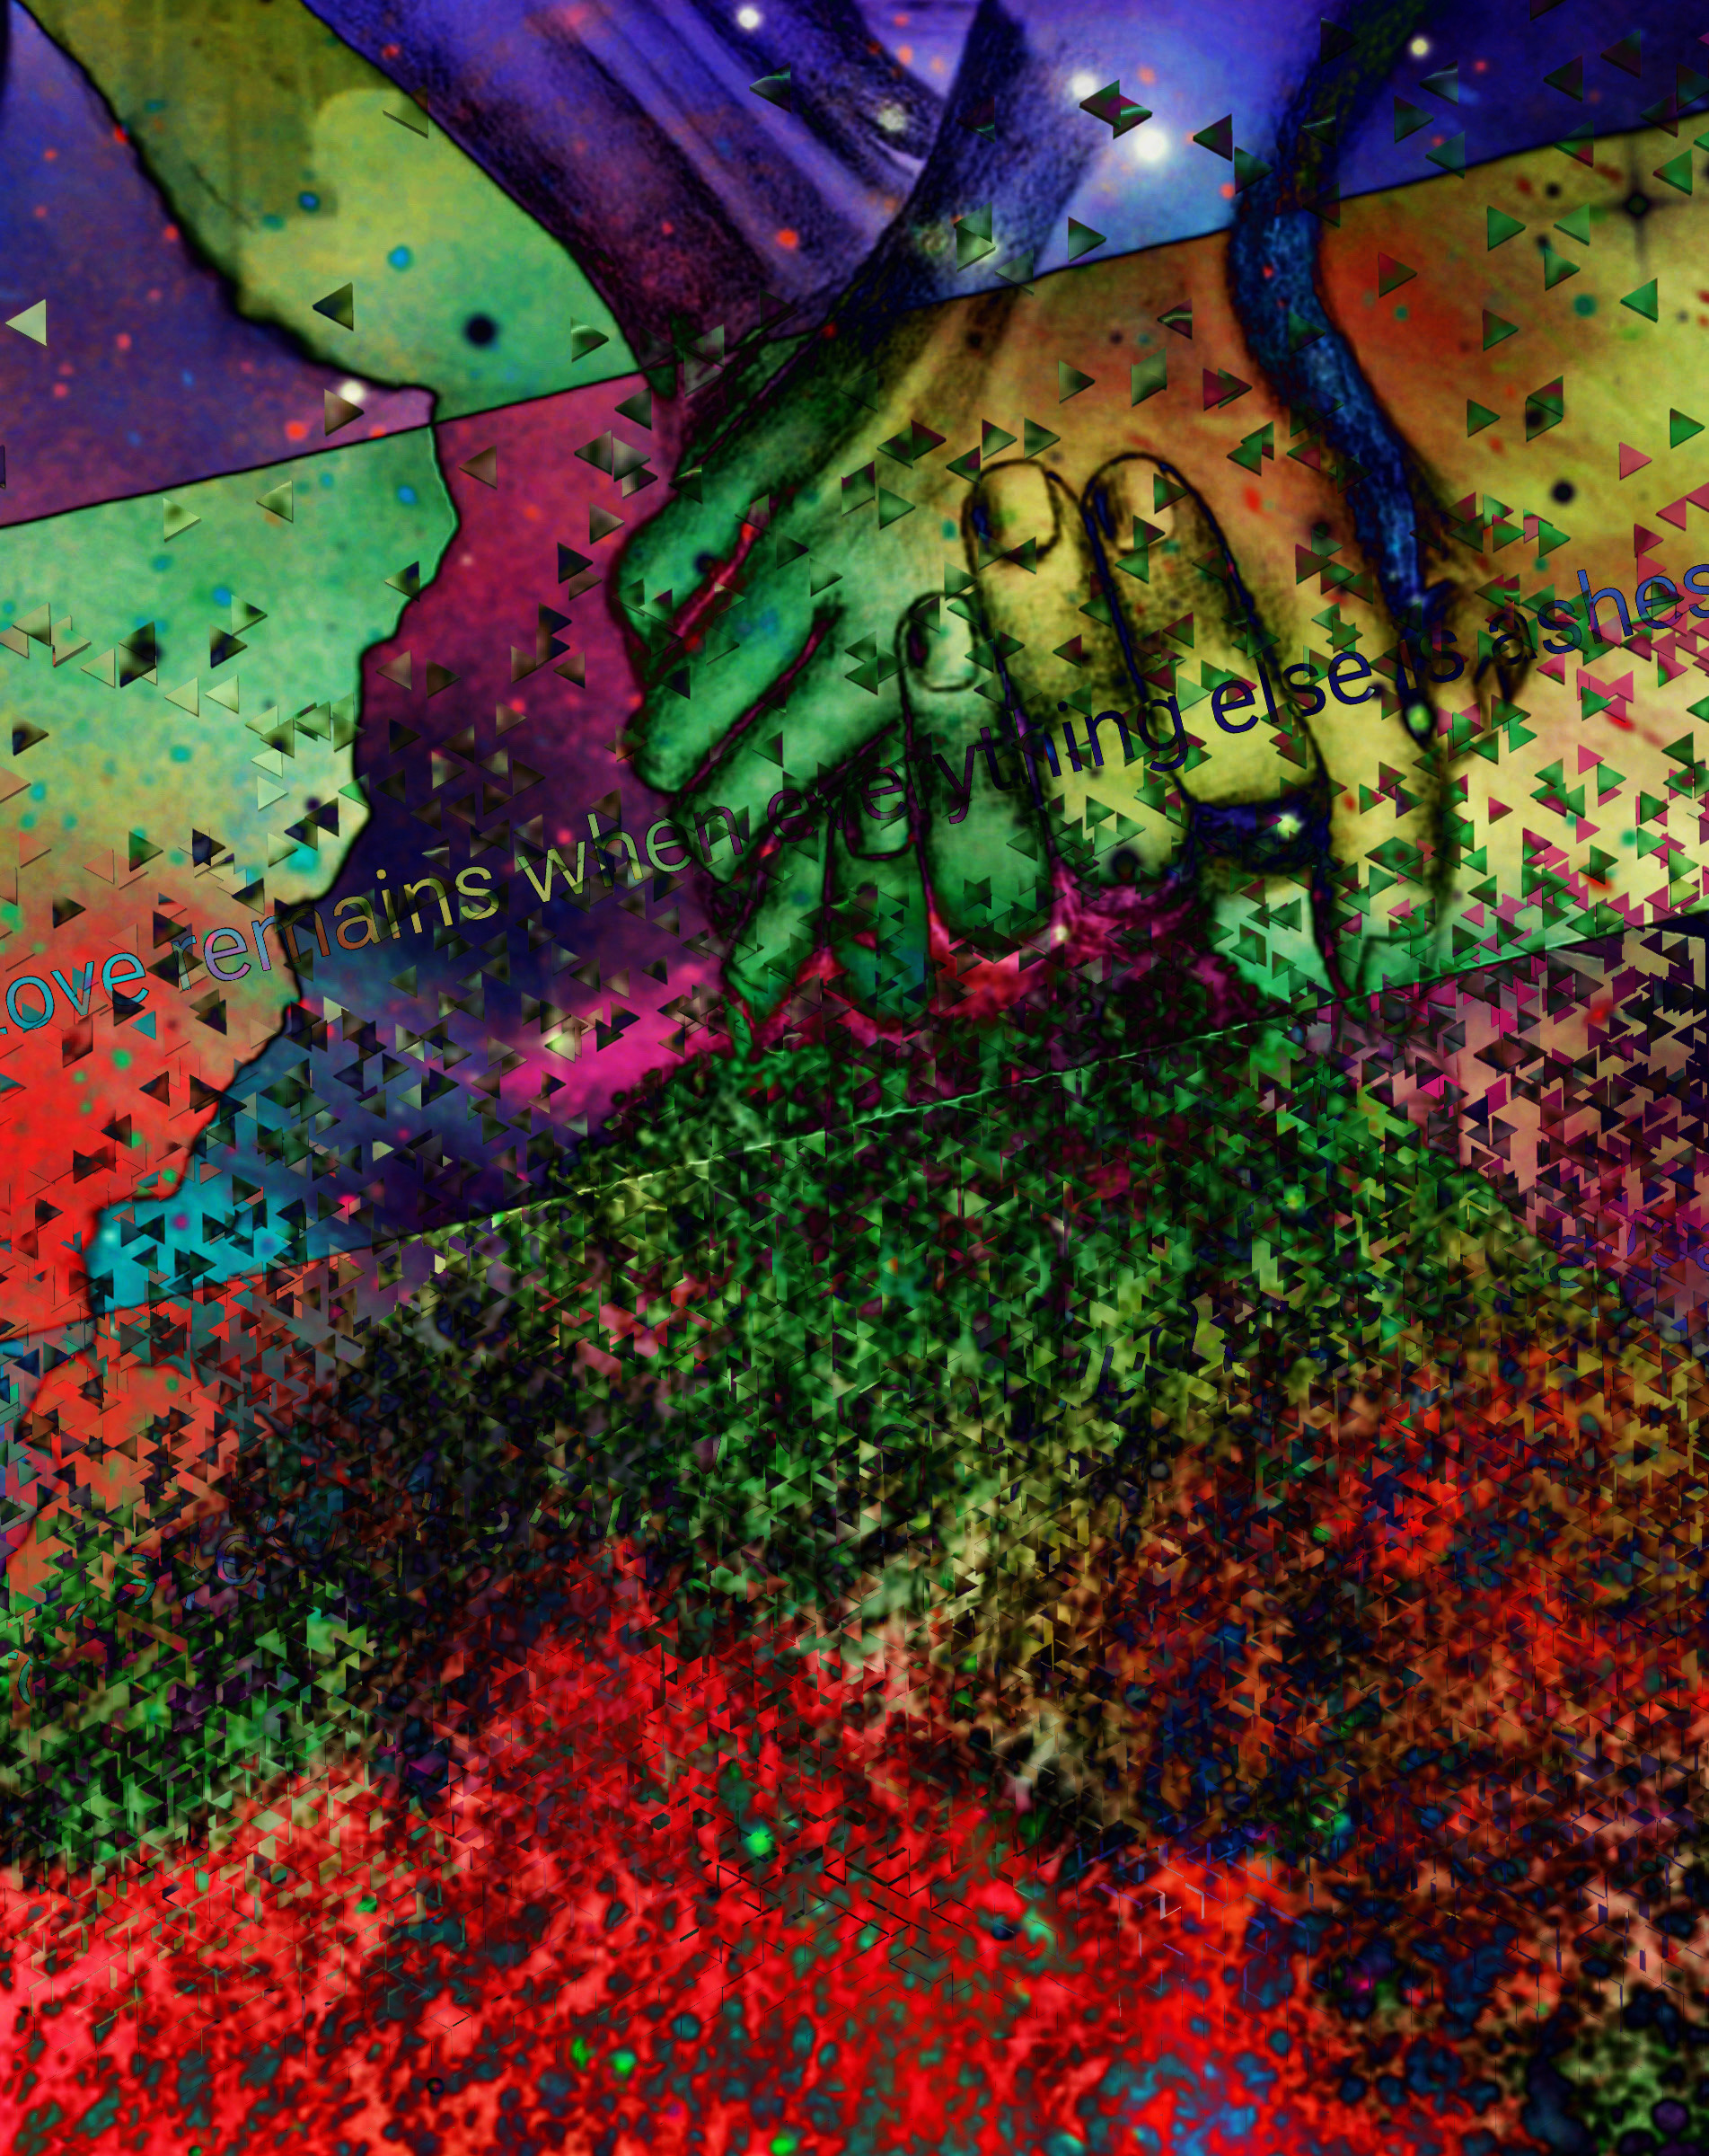
Fortune

