
The Woods
The Woods
I dedicate this story to my dearest friend Jerry, who can reframe any situation as a better one, and whose view of the world reflects these masterful edits.

To view the Spotify playlist that helped keep the book flowing, please visit Spotify and search for ‘The Woods,’ or visit https://open.spotify.com/playlist/5epGjlnTUAjqMDHwUXQyJx
Part One: Flash Bulb
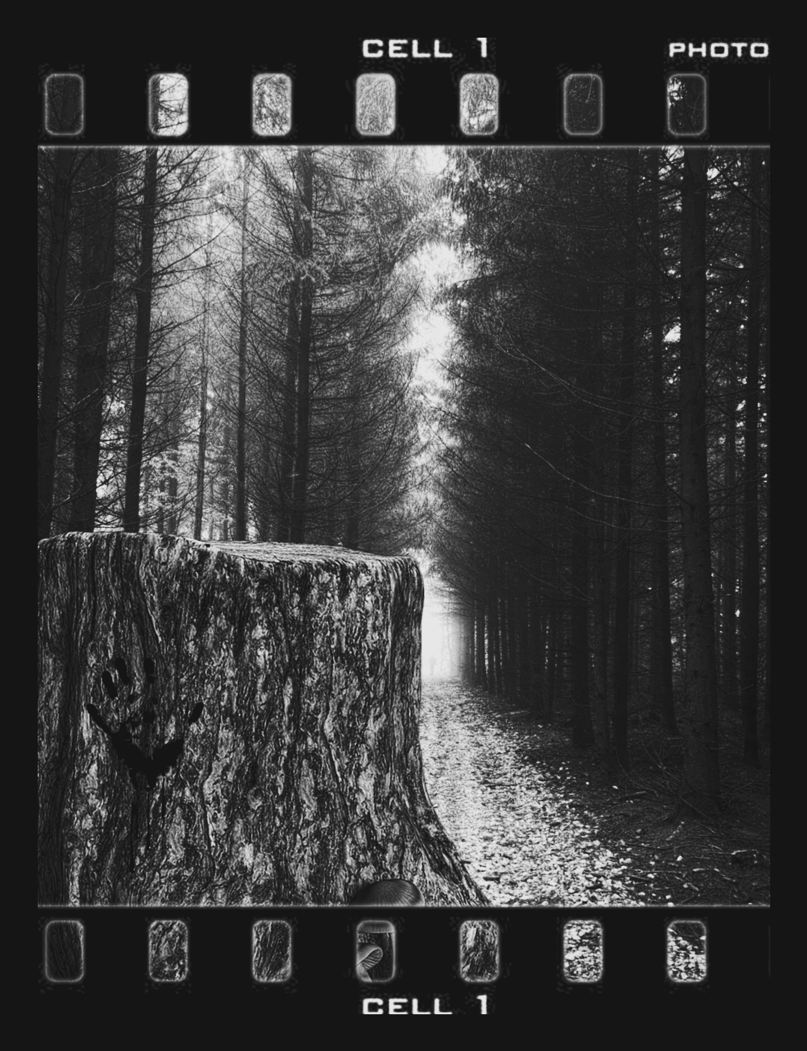
When I was a little boy, I became profoundly afraid of tight spaces because of a recurring nightmare that I still have. In the nightmare, I’m in a sealed, clear coffin while my funeral procession is happening. I can see everything, so I am screaming and hitting the coffin, but none of the anguished mourners acknowledge me. Even as they individually visit the casket and are right next to me, they don’t see that I am alive.
When it is my mother’s turn to say “goodbye,” she presses her whole body on the coffin and wails, “No. No. No, Jerry, you can’t be gone. I didn’t get to say ‘goodbye.’” Her face, in perfect view, is one of pain, twisted and contorted. I want to comfort her, so I yell at the top of my lungs until I am shaking and exhausted, “Mom, look at me! I’m not dead; I’m alive. Mom, please!”
It always ends the same way: the group styled solely in black, all pull down matching intricate veils, so I can no longer see their faces; then they all hold large black candles and slowly drip the wax over my transparent hell tomb. I continue to scream that I’m alive and not to bury me, and hope that this is the time they see or hear me, yet they never do, so I get encapsulated in black wax and lowered; that’s when I used to panic. Now, I panic at the beginning and never stop. I suppose when you know what’s coming next, it’s a different fear than the unknown.
Eventually, I had to consult a therapist because I stopped sleeping to avoid being buried alive. My therapist said that when we sleep, our minds try to sort through all the data we unintentionally collected as we live our lives; sometimes you deal with things, but sometimes you intentionally or unintentionally place something on hold because you cannot deal with it right then, and it stays as a problem waiting for some resolution. She asked me if there was anything in my life that I had put on hold to deal with later, related to feeling trapped.
Even though it’s so simple, I suppose I never thought of that explanation because I only considered it to be a physical fear of tight spaces; however, there were many times when I did feel a metaphorical suffocation. I believe my father is the root of this.
When I was young, my father became obsessed with photography. He photographed and edited everything, but always with his own artistic flair. My brother, Harry, always said he turned everything creepy; I would agree. There was something about it, from the staging and shooting to the development and final edits, that collaboratively made this happen. Instead of a Midas, he had a gothic touch.
One of Dad's favorite subjects was stumps of very large trees, like redwoods; he said he loved that something that massive was taken down, but would always leave a reminder of its existence with roots so entangled that it’s simpler to leave the ghost. I don’t believe that he was relating to the tree or inspired by it, but instead wanted to take one down, and then be reminded and haunted by it.
Helping my father on one of those stump shoots, he told me that he once discovered a skeleton of a female in one of the stumps on our land. He said the few belongings that remained after her flesh and muscles had long decayed indicated she was a spy during the war, when the military owned this land. He said that he never reported this to anyone because he had a few illegal operations active off the farm.
I never knew what to believe from my father because he was a natural storyteller; photographers usually are, since it’s the verbal medium of the visual that they have mastered, skillfully capturing sentiment and story without words. He could place a perfect photograph in your mind with his detailed descriptions and expertly selected words; although, in addition, he often added, embellished, and outright lied in the process. I think he figured that sometimes stories need a little finesse to take something from a factual event to a legendary or memorable one; truth be damned! Comparing my father’s stories to the facts served as my only way to understand how his brain worked. I wanted to decode this man so badly because I didn’t understand him, and with him already being so detached, I didn’t feel bonded to him. These days, he was nothing more than an odd character who sometimes stopped by the old farmhouse that my mother inherited, which the family has owned for generations, including the large forest area. So I would always enjoy the story and get the facts later, because while my father’s stories lacked a trunk and beyond, they usually were a stump with roots.
This particular story was too interesting not to follow up immediately, so I made a special trip to ask my grandmother if she knew anything about it. My brothers and I had often used her to fact-check our dad’s stories slyly. We would eat dinner with her, which always had the smell, taste, and texture of raw earth, and ask her gems, such as, “Did dad really absorb his twin sister in the womb, so now he is also his sister?” She would say, “No, but his sister was stillborn when he was six, but is an angel watching over him now.” Or, “Was Dad ever abducted by a clown from the traveling carnival?” She answered, “No, but he did once disappear at a birthday party where a clown was performing. They found him quickly, having put a hand in each birthday cupcake.” Even though my father was the editor, by some magic, his final edit became the absolute truth to him, with the undistorted, original photograph discarded and now forgotten.
Sadly, other than asking Grandmother about Dad’s stories, my brothers and I didn’t come around much because of what we considered her imposing her rigid and boring lifestyle on our visits. Our grandmother was a super fan of the Victorian era, especially Queen Victoria, but she went so over the top with it that it felt like we were in a museum or historical reenactment with strict rules we must follow. When we were young, we used to love the outdated lifestyle and uncomfortable clothing, seeing it as an adventure while playing dress-up; yet, as we got older, we lost the wonder and were just irritated by the inconvenience of it all.
After sitting down, and saying our prayer for the meal, I asked my grandmother about the skeleton spy in the tree stump that dad found, and was expecting to hear that he found the family dog dead of natural causes in a field, so when my grandmother said, “Yes, but found isn’t the right word since he placed her in that stump to begin with. She is still in that tree; no one has ever found her. Those woods behind your home are full of spirits, you know? Where is your grandfather, by the way? His food is getting cold.”
My grandfather had been dead long before I was born. I wondered how many meals she had made for a ghost and how much longer she would be able to, and then I was consumed by what she just said to me. My grandmother was an honest woman who never lied for my father’s sake; yet she was having issues with her memory, so I decided to check the woods for myself, but I would have to wait for the morning, as it was dark.
When I got home, I couldn’t wait to speak with my younger brother Harry, who is part of the five brothers my mother hoped to start a family band with. We were Harry, Jerry, Larry, Perry, and Terry, and our band was the “Anonymous Astronauts.” Our mother had our band theme as outer space, and she made us costumes with leftovers from the craft store she worked at, expertly sewing them, creating pieces that appear whole and seamless. The sets were very silly because we were not very focused, but she made it fun.
Our mother was never a very flashy person; she grew up on our family farm, where they had two television channels, both of which constantly played television programs that starred families in a band, which she marveled at how much happier life was than the hell she lived in, which she would hardly speak of later in life. However, I’ve heard that it was a home where the children were frequently beaten and starved. So she escaped into those shows and became fixated on the idea that if you had a family band, then your life would be safe and humorous. When she turned this dream into a reality, no matter the lack of success, she had a great sense of achievement. So, despite her marriage being awful, she seemed happy for a while; however, there was a letter that ultimately proved otherwise, and she was gone like the wind.
The day our mother left, we all had a particularly lovely day; then later, she left a note in her bubbly, beautiful cursive, which said she wanted to start her life over because she was not all that happy with her life here, and she had met a man she loved, whom she was leaving us for. It was a sucker punch; we never saw it coming because she seemed to love us genuinely, believing the care and love she provided was too overwhelming and constant to have been faked. She would do loving things, like if we had a scratch, come over and do a little cute dance, give it a kiss, and say, “The fairy has healed you!” How could we still cry when the healing fairy has danced for us? She was there for everything we did and always cheered the loudest. I try to remember the good about my mother because there was so much good. Still, after she left, it was hard not to blame myself, and my brothers felt the same. This deep insecurity and confusion materialized negatively for all five of us over the years.
Since I was the second-to-last child and Harry was the youngest, he and I were always very close. Harry has only a few fleeting memories of our mother; he was very young when she left, and so had the least amount of time with her, and relatively, he was the least affected later on. However, her absence was evident in some of his choices, like marrying when he was sixteen to a woman who was forty, matronly, and kind. The brothers all shamefully bet against their relationship, and figured he would cut her loose after he matured further, but he never did. They were a team that loved deeply and fostered children. I was nineteen when I moved in with Harry and his wife, Marnie, who became a cherished friend to me. She really helped me through my mother leaving us, and our father leaving soon after, with hardly any communication.
When Harry arrived home, I approached him, but he spoke before I had the chance, saying, “I had to pick Dad up from the police station and take him to rehab; he was disheveled and incoherent. He will probably be out tomorrow and repeat this all over.”
I then said, “Speaking of Dad, he told me he found a woman spy’s skeleton in the tree. Naturally, I wanted to get the real story to compare it to, so I went over to Grandma’s house, and surprisingly, she confirmed this, but said Dad is the one who put the woman in the tree. Although she was also looking for Grandpa and preparing meals for him.”
Harry replied, “That man is just so out there; he probably found a dead raccoon in a rotted-out tree or something. It sounds like we might need to make arrangements for Grandma, though.”
Even at seventeen, my brother was more mature than my father, and I was glad to have his support whenever dealing with the many family issues that always seemed to fall in my lap. So I chalked it up to another of Dad’s stories that grandmother couldn’t dispel because her own grip on reality was slipping; still, I planned on checking out our woods just out of curiosity.
So the next day, I checked the woods, and I found a few hollowed-out trees where you could hide something; however, there was nothing in them except the last one, which had a barrette with hair in it as though ripped out. I knew immediately this was my brother playing a joke on me, because even though it wasn’t much in his character, Dad hiding a woman in a tree was probably too tempting to pass up. Yet, I wasn’t going to give him the satisfaction, so I didn’t speak of it again.
Unfortunately, from then on, in my nightmares, I was no longer in a glass coffin; instead, I was gagged and placed in the tree stump, but now there was no one viewing me; instead, I was alone, which made it much worse than my previous recurring nightmare, where at least people were around. It reminded me of an adage about trees related to whether the knowledge of something happening makes it real or if the act itself does. I could only scream on the inside until I woke up screaming out loud. I was then prescribed heavy sedatives that made me so tired that I don’t know that I ever dreamed; I went into a deep blackness instead, although the few times I forgot to take the medication, I would be trapped in that tree, so it wasn’t flat tired being changed, but rather a spare. Then, I went about my life, which never felt like fully living; sometimes, I wondered if parts of me were buried as I had been in my dreams. I felt unseen like a ghost most of the time.
If my mother’s leaving and dad’s absence were my first suffocations, then my eldest brother, Larry, dying by suicide was my next major one. He left a note that described a tortured person who wanted badly to be freed but never could find peace, which we already knew but could not fix.
Since Larry Jr., who insisted we not add the junior to his name which attached him to our father Larry Sr., was the oldest, he often had to play dad since our mother watched her dreams of a beautiful partnership transformed into a solo fight attached to a man with a deep-seated pain that was soothed by hurting those who loved him the most, while being mysterious and almost nonexistent. It was Larry who showed up at our events, helped with our bills, read us stories, and gave us moral guidance; yet, he didn’t resent the role of father, but instead, relished it. Supporting five children wouldn’t have been possible without my brother Larry. I know Mom felt bad to lean on her child, but I also know she had to. They were exceptionally close because of the bond and dependence.
Larry had always been so happy when our mother was around, but when she left, Larry was critically hurt, and he couldn’t seem to get past it. He didn’t understand how she could leave us for her lover and never return, while leaving him with everything, and so he became more of a shell of himself; underneath, only intense anguish and loss. Most times, his eyes were somewhat red and wet, and he looked as if he could cry at any time, although he tried not to in front of us. However, Larry did his best to continue fathering us because even after we told our dad that Mom had left with only a note, he didn’t offer support to Larry in caring for us.
Luckily, some months after our mother left, Larry met Mary Margaret, whom he fell in love with and became obsessed with, and we were all relieved because he seemed so happy again. Larry suffocated her; yet it was not a problem at first because she loved the attention and feeling like someone’s everything; however, later, the novelty wore off when the behaviors increasingly became more restricting and cumbersome, like him watching her from his car, when she did anything where he was omitted, even family events, and later trying hard to get her to stop talking to anyone without him around and not to attend anything without him. If she disobeyed, he would guilt her or be angry with her. Exhausted, she ended the relationship when he couldn’t accept the terms of a healthy one.
Larry was responsible for the death of that love, but was absolutely devastated. My brother Perry, who was closest to Larry, tried to comfort him, but was vocal about not understanding why Larry loved her but couldn’t agree to her reasonable requests, which would keep her. Perry felt like Larry was doing it to himself and should stop, if it were only that simple. Later, we came to understand it was a compulsion so ingrained in him that he felt powerless to it; control to someone who has lost it became an addiction.
Larry mourned the end of that relationship for months, and it was pitch black; fortunately, dawn came again with a new love interest, Margaret, who bore such a strikingly similar appearance to Mary Margaret that the younger brothers used to call her that accidentally; luckily, she thought it was our nickname for her, a nod to her devotion to God, instead of the eerie resemblance to his never spoken of past relationship.
After he met Margaret, we were all so relieved again because we had been so afraid for him. We also had faith in the relationship because he selected a better fit for himself this time with the pious, rosary-carrying Margaret. After all, her life was already so self-restricted that it wouldn’t be such a point of contention, unlike Mary Margaret, who had a large social circle and an active social life and fought hard to maintain those. Larry even became religious, joining Margaret in church because this was one thing she would not go without, and even though Larry went out of obsession, he found peace in it and enjoyed it.
Soon, Larry and Margaret were inseparable and spent all their time at the farmhouse. We all loved her because she would bring us cookies, spend time with us, and mother us, even though she was younger herself, so we became incredibly attached to her. Seeing how good she was for his brothers in addition to himself, Larry wanted her to live with us, but she wouldn’t without being married, so they decided to get married at 21 and 22 years old; at this time Perry was 20, Terry was 18, Harry was 13, and I was 14; however, Perry was absent as he had moved out to join the Navy.
For Margaret and Larry’s wedding, we didn’t have much money, so we boys each got what we could: wildflowers, scraps of fabric, bottles, etc, and we threw a backyard wedding that may not have been posh unless you’re looking at authenticity and purity, then it was extravagant. It’s hard for me to look back at that time knowing how it all ended because those early days were exactly what love should be: they respected each other, they selflessly used much of their time on us boys, and they had stars in their eyes for each other; it was beautiful. It then became a crowded but happy home.
Unfortunately, where we thought that the person he chose was the answer to Larry’s extreme abandonment issues, we had misunderstood his illness, which stood independent of anything, much less the person he decided to marry. Sadly, we watched things change when, after two years of marriage, the younger boys became more independent, and Margaret craved change, so she attempted to broaden her life, which Larry detested. As she tried to gain a little independence, he was there as a shadow waiting to tear her apart. He loved her so much that it was hard to see him be so cruel to her for no reason. Eventually, his verbal insults and coldness became too much, and Margaret left. From then on, I often heard that guttural cry that I remember hearing after Mom left, coming from Larry’s room. He was writhing in the pain he created.
Unfortunately, after Margaret left, Larry started to stalk her. It was terrifying to her, but she hoped that he would lose interest and gain acceptance, which he never did, as things only escalated until Perry was home on leave, and he ran into Margaret, who told him what was going on, begging him to help her. Perry thought she was over exaggerating, but decided to tail Larry and found that Larry was indeed stalking and menacing her.
Perry confronted Larry at home after witnessing him try to coax Margaret’s dog into his car from her backyard, which was beyond disturbing. It was a loud argument between two young men capable of explosive anger, yet never directed at each other, just at the situation. I was awoken out of a sound sleep to hear Perry screaming at the top of his lungs, “Brother, you are crossing the line, and she is going to call the cops. You are supposed to be caring for the family. Do you want those boys to be taken?” Larry screamed back, saying it was none of his business.
Eventually, it came to blows until Perry skillfully put the larger Larry in a military hold. Larry fought to free himself and couldn’t until he wore himself out entirely and started to sob, which caused Perry to start crying and let him up. Perry said, “Listen, man, relationships end. You learn from those, and you grow, and the next somebody will be right there before you know it. You shouldn’t need to scare someone into loving you. If you keep this up, then you will lose our family. I promise there’s someone out there for you. I love you, man.” This allowed Larry to calm down, and he seemed to accept the soundness of his brother’s loving advice.
From then on, the rest of Perry’s visit was amazing. Perry was the fun brother; he was overly jovial and made us laugh all the time. He had saved money during his training, which he couldn’t spend, so he got us all new clothes and tons of canned food; he spent every dollar he had on us and continued to send money home. It seemed the slack of our father had again been passed to the next in line.
For a time after Perry left, Larry was back on track; he even wrote Margaret a nice apology note that spoke of our mother and the impact of her leaving, which he had never openly discussed with anyone before; she was so moved that she agreed to be friends with him again. However, this decision proved to be the wrong one, as he resumed his demanding and controlling behavior, even when they were not in a relationship, and as a result, she pulled away again. So the stalking and cycle started again, but more intensely, fueled by Larry, who was given some hope with the acceptance of the friendship.
Then, some months after the start of the failed friendship, Margaret’s mother showed up at our door crying, unable to get police assistance since, at the time, stalking was not illegal. She had seen the good in Larry many times before, so she believed he would respond to the heartfelt plea, begging him to stop, expressing the distress that Margaret was under. However, Harry, Terry, and I watched as Larry shut the door in this crying woman’s face. Larry’s transformation was a slow burn to becoming a raging forest fire, so no one understood how dangerous it was until it was too late for evacuation; still, this moment was a defining one for me. I knew the somewhat obsessive and slightly combative Larry, who also possessed many other positive attributes; yet, lately, I didn’t at all recognize this entirely cold, heartless, out-of-touch man, not mixed with anything else, anymore.
About a month after Margaret’s mother’s visit, Harry and I ran into Margaret at the nickel and dime store, and she was as unrecognizable as Larry; she was no longer sweet and friendly but jumpy and paranoid with the familiar red, teary eyes. I remember feeling sadness, which turned to fear, as I felt a premonition based on reality that something bad was headed our way. I looked over at Harry, and his look of concern was confirmation.
Not long after that encounter, Harry was at baseball practice, so I was watching television while Terry, the third eldest son, and Larry, who was acting significantly more disturbed, visited with Terry’s door closed, when we heard a knock on the door. I answered the door to find police officers in full tactical gear swarming our farmhouse. I was immediately removed from the home, as I heard police screaming commands and a loud bang as Larry was shot after pointing his gun at the police, while Terry looked on.
Shortly after being placed in the back of a police car, I noticed Terry being carried out with specks of red all over him; he was as white as a ghost, and his expression was stuck in terror.
We found out later that Larry had shot Margaret, unable to deal with another loss, especially from the person he considered to be his soul mate. We understood Larry too late, and then we understood him well enough to carry some darker things with us permanently.

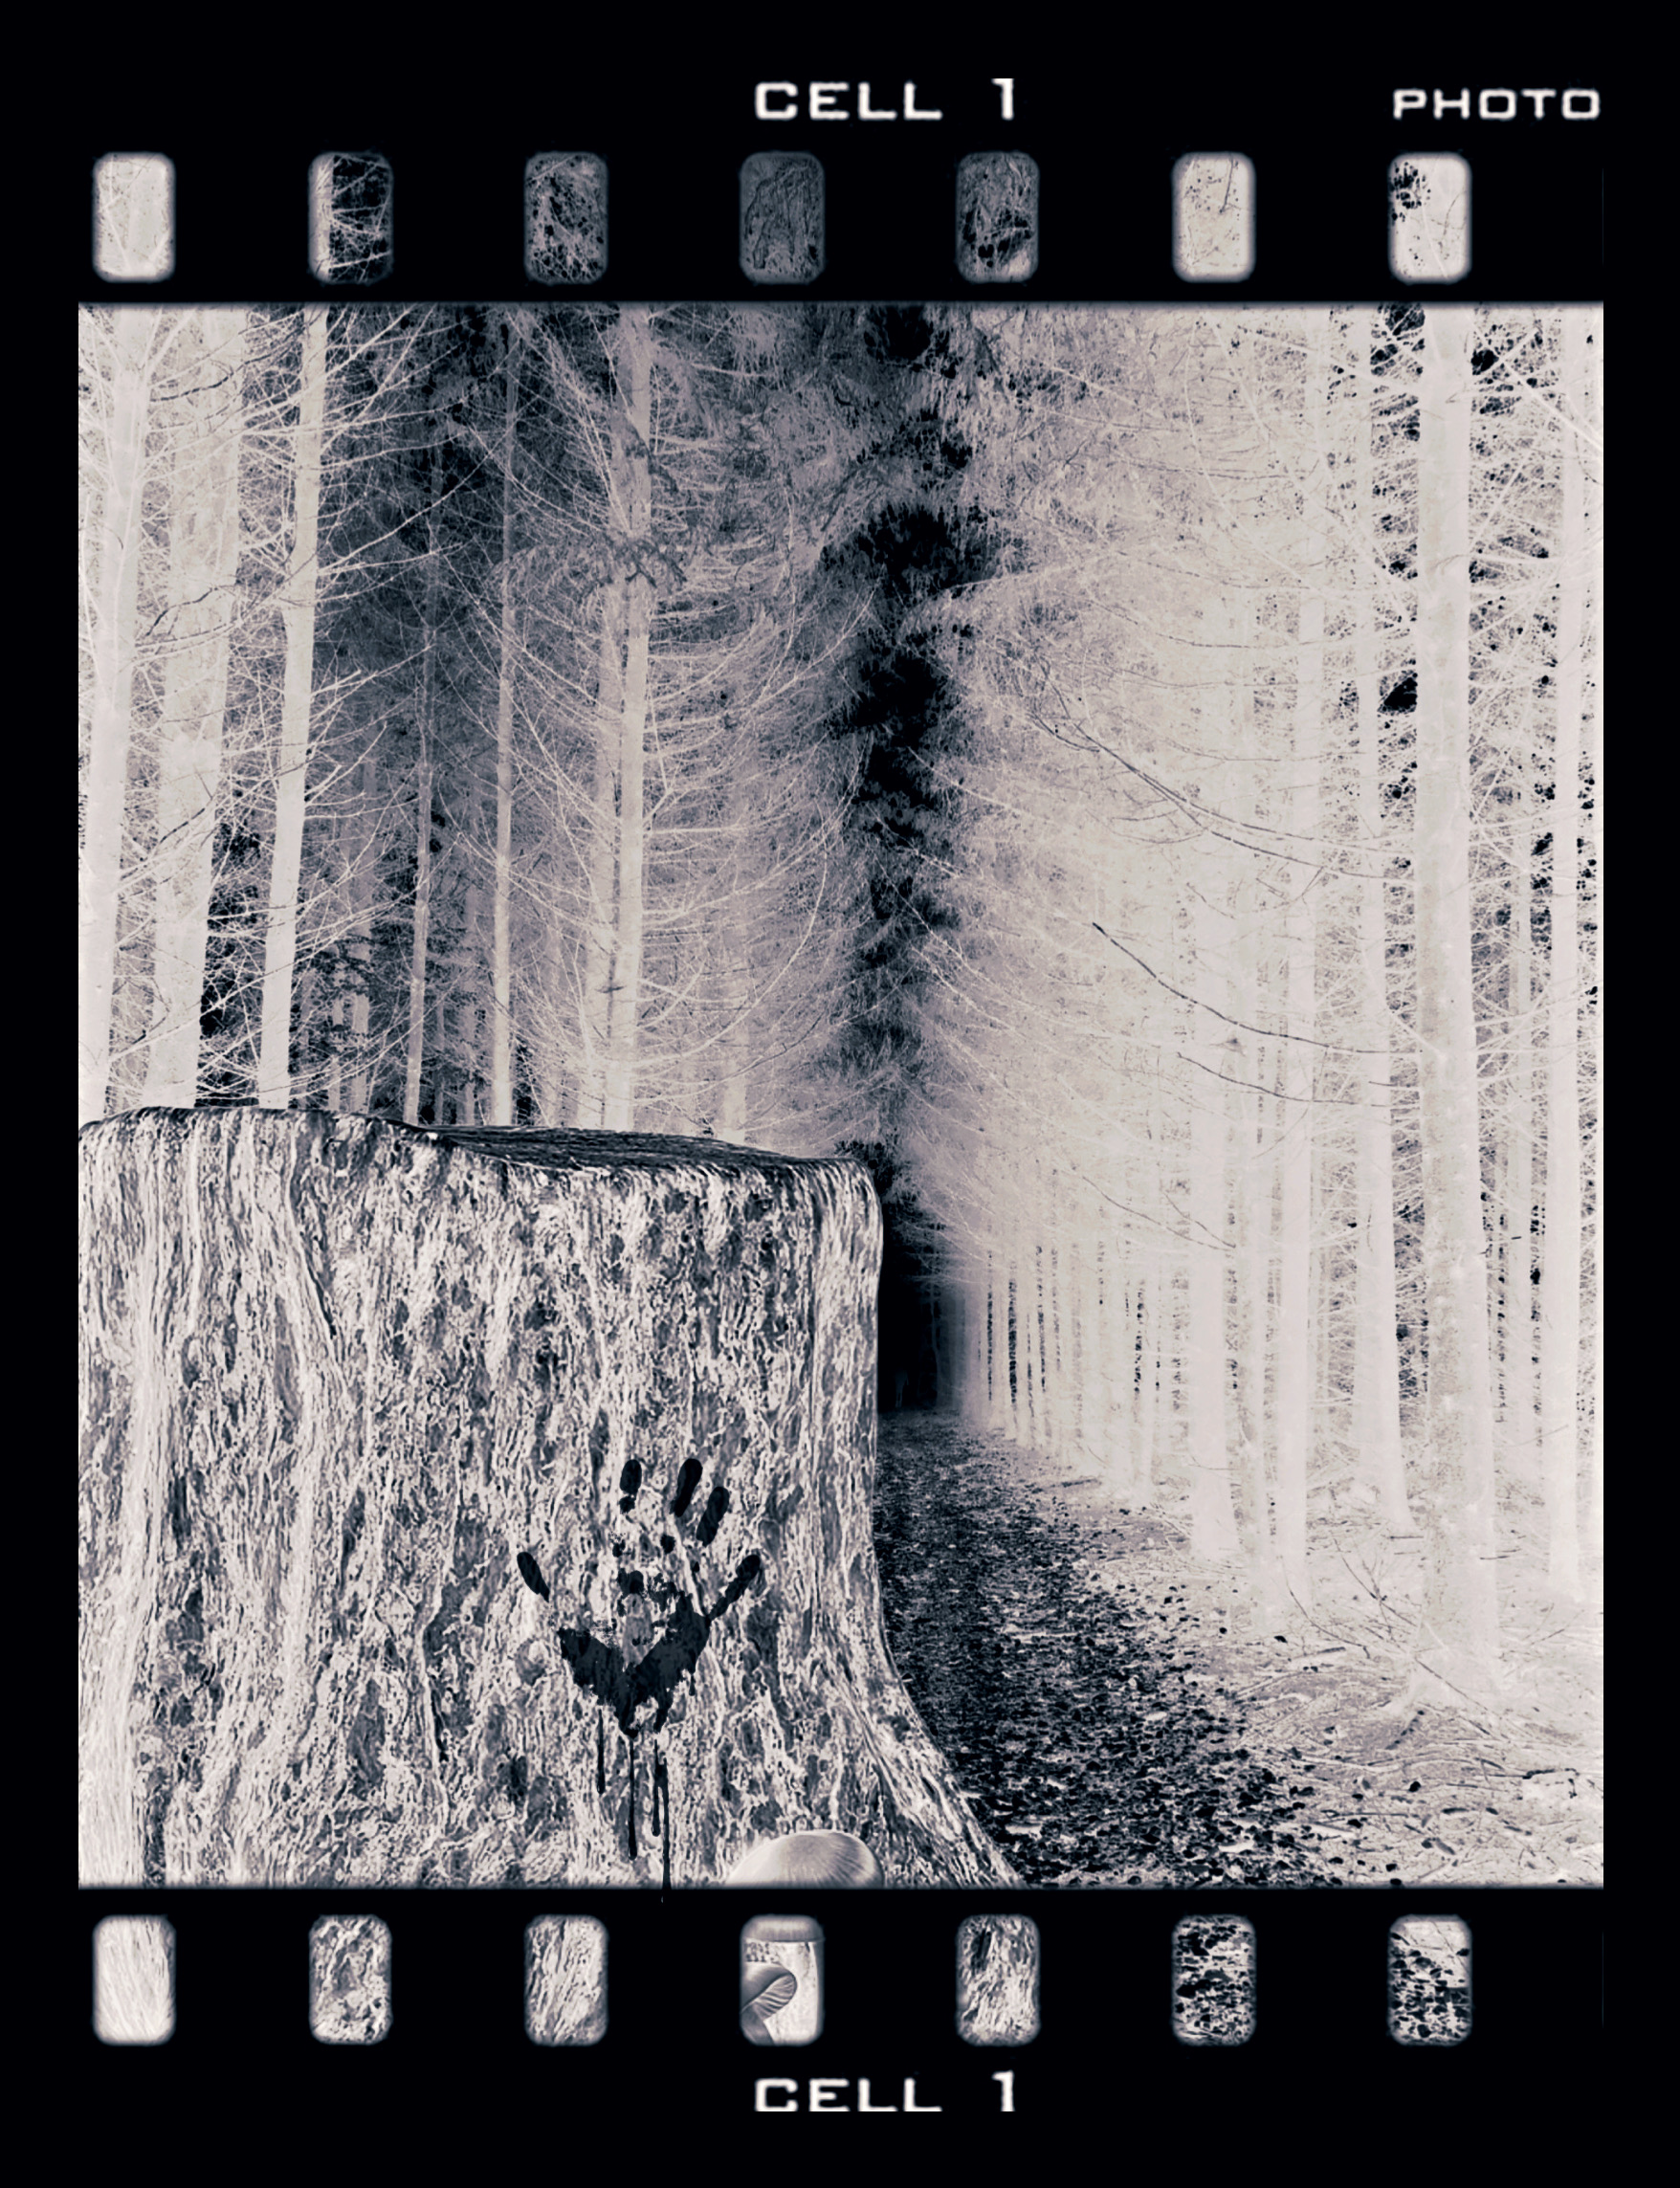
Part Two: Dark Room
When Larry died, I was 17, Harry was 16, Terry was almost 19, and Perry was 23. Terry tried to take over since Larry was gone and Perry was away with the Navy, but he couldn’t get past what he saw; even the terror frozen on his face lessened, but never went away.
Growing up, I idolized Terry and wanted to be most like him. Terry was extremely handsome and the only one of the five brothers in the disbanded band to have any musical talent; we all believed he absorbed all the brothers’ musical powers because the rest of us had no talent, while he was natural at any instrument he tried and had a silky smooth baritone. When he started working on music solo, we thought he could have made it as a musician. So, Terry was a heartthrob by his teens, and he never had fewer than four girlfriends at any time, whom we secretly, jokingly called by the day of the week the woman was scheduled for.
However, after witnessing Larry end his life, he was unrecognizable, as he stopped caring for himself properly, and worse, it became clear he had a stress disorder, which made him irritable, irrational, and erratic. Sadly, he reminded me of Margaret when we had run into her before she was later shot dead by Larry. This sad decline continued until one day, Terry asked Harry where we put Dad’s shotgun, and so we called and got him help. At this time, I was 18 and the only one still at home while attempting to finish high school, Larry was dead, Harry was married, Perry was in the navy, and Terry was in the hospital.
When Dad realized it was just me, he would stop by the house more because I was the only child who “didn’t guilt-trip him” into responsibility or express bitterness that he would never accept any for his children’s sake. My mantra with him is, “I know I can’t change him, so why bother?” Thus, I am known as the sensible and forgiving brother, which is not what I would have chosen initially among the many talents and positive attributes of each brother; yet, I felt differently once I found tremendous value in it later in life.
By the time Terry had been in the hospital for a month, I saw my father at least three times a week, instead of his regular three times a year. I enjoyed it for what it was, which was tall tales, insane rants, grand schemes, and, as of late, tons of booze, which I loved because he would uncharacteristically share when he was sauced. Yet, sadly, months later, when Terry was able to come home, my dad disappeared, worried he might have some burden placed on him by his mentally ill son. The only thing you could depend on Larry, Sr. for was not to be; he always left when even his children could inconvenience his life.
After Terry came back home, he didn’t seem much better than before we brought him to the hospital; he remained shell-shocked and angry. Still, I always brought out the best in him by meeting him where he was, because I wanted to be there for him regardless of the hardship to myself. Unfortunately, after some time, Terry started sleepwalking. I would hear him banging around and find him walking around with a knife in his hand. It became too much for me to care for him safely, so Harry and his wife, Marnie, then had him move in so they could take shifts and offer more support. Unfortunately, Terry, out of his mind, attacked Marnie that first night, so we were at our wits’ end. We were contemplating returning him to the hospital, but a chance encounter changed that.
Luckily, the day after the incident, Harry, Terry, and I went to the store where we ran into Mary Margaret, Larry’s first girlfriend. You could tell that Terry felt comfortable and had a deep connection with her because his animation and enthusiasm were just as they had been before Larry died. This made sense, given our frequent interactions with her, as Larry had insisted she never leave his side, which meant always being at our home. Secretly, Mary Margaret, who was closer in age to Terry than Larry, always thought Terry was attractive and loved his music; if Larry hadn’t been so jealous, she would have expressed herself as a fan. Although back then the attraction and admiration wouldn’t have been returned by the then handsome and flighty Terry because Mary Margaret was plain and conservative, and he loved options. However, now he saw beauty on better terms, which captures the whole of the person, and she was the most gorgeous woman he had ever seen; he had been blind, but now he could see.
Mary Margaret and Terry spoke for nearly an hour while Harry and I shopped. Terry enjoyed the light in his pitch black so much that he wanted to keep in contact and asked her for her number. She looked ashamed as she stated she was couch surfing, so she didn’t have a regular number to give. Terry thought this was unnecessary, given that we had a decent-sized farmhouse with just me living in it, so he looked at me, seeking approval for her to stay with us, even though he was older than I. I liked Mary Margaret and appreciated the motherly way she had with us when we were younger, and I was so happy to see Terry excited about something, so I smiled and nodded in approval.
It ended up being a blessing and an answered prayer because Mary Margaret was exceptional at calming Terry down, and he was doing immensely better; plus, she liked caring for him, and that showed. In turn, Terry loved her enormously because she weathered the many storms his brain conjured up and kept him anchored, and so, his biggest fan had several songs written about her, and he only had eyes for her. After the birth of their son, Eric, the terrified, disturbed man had been entirely replaced by a stronger, more stable one. Terry ended up being more genuinely happy than he could have been as the older version of himself, since he had depth of character that he never had before, and chose a woman with the same. He appreciated the sun extremely, knowing that many storms had preceded it and might come at any time.
Mary Margaret and Terry would never divorce. Their three sons formed a band with the talent to support it, so they became successful. My mother would have eventually seen her vision realized if she had only stayed.
Unfortunately, we didn’t see Perry after Larry died until he came back home after leaving the Navy years later. Larry and Perry were as close as Harry and I in age and spirit so we all, Perry included, were happy when we erroneously thought that he was the one brother who overcame the curse, not realizing that the pain was there, increasing without being dealt with, and waiting for its moment to come out as an explosion rather than seeping out slowly. Sadly, once he came home and no longer had the rigid walls of the military and so many choices, he began to unravel. He became addicted to danger and the extreme side of pleasure, which made him feel alive. Within a few months of returning, Perry had three automobile accidents and one criminal charge for soliciting sex from an uncover cop who looked strangely like our brother Larry.
Soon after his arrest, Perry turned our family home into a place where you could lose yourself, and all those who were there were clearly lost. Once, I walked in on him and two other males in the throes of passion, among enough empty liquor bottles to believe we had started a recycling business. It is a vision I don’t think I could forget, even though I wish I could, mostly because something about it secretly turned me on, which felt excessively not right.
During this time, my father, who loves a good time, came around the family home more. I was surprised to catch him there every time I stopped by because Perry is the last person that I ever expected to be the apple of my father’s eye, mainly because the old Perry used to loathe my father, and never held his tongue with his feelings or asking for accountability like supporting his family; yet, they seemed to get along now famously, encouraging each other to act foolishly and up the ante on whatever that was.
After trashing the home that our mother and many generations of her family called home, more arrests, and blowing all of his savings, Perry found out that his liver was failing, so he had a choice to make, and he chose to get sober. Once he got treatment, he got the help he needed to deal with his pain, and everything else seemed to improve for him. He even reconnected with a formerly wayward man, Stan, from the house party days, who was also in recovery, and they fell in love. The two renovated the farmhouse to incredible glory.
My father, missing his addictions being paid for by Perry and the companionship in his madness, kept hoping that Perry would relapse, but that wasn’t happening, so, realizing the party was over, he stole some valuables and then left without a word.
After Perry was stable in his recovery, I had more time to reflect, and I realized that, for better or worse, every other brother’s life had moved, whereas mine felt stagnant and stationary. That may be because I felt like I couldn’t have a life because I was the family’s “doctor on call” and had to stay sober, within reach, and ready. So, I didn’t have much to show for myself; I had no career, partner, or accomplishments outside of being a rock for my family. Don’t get me wrong, I love my family, and they were always so grateful I was there, but I wanted to be more than just a chapter in other people’s stories; instead, I wanted to have a book of my own and for it to include success and love, and not to be turbulent.
Unfortunately, while I was contemplating how to move my life forward, Perry lost his job and several friends to war, so Perry fell off. Perry’s partner, Stan, who was also in recovery, struggled because he loved Perry but felt drawn back into a world he never wanted to return to, so he eventually left. After Stan left, I moved in to watch over my brother; I was the keeper of them after all. I met him where he was and hoped he would get it out of his system and then get help like last time.
Soon after Perry relapsed, my dad started coming around. I would usually stay in my room because the two were unpredictable and loud. Although one night the two wore me down with the promise that they would go to bed after I had a few beers, so I was coaxed into hanging out with them. Luckily, the two had only been drinking beer they stole at the grocery store, unable to purchase liquor, so they were less obnoxious, and I actually enjoyed spending time with them. Perry reshared plenty of hilarious stories from his time in the service, and then Dad started to share his tall tales. Having not many interesting or funny stories myself, I retold the spy skeleton in the tree to Perry. My brother started laughing, thinking of the many doctored versions of the truth that my dad had told over the years. However, our dad, now obnoxiously drunk, was not laughing but indignant, slurring his words, saying, “That was no spy, that was your mother.”
Neither of us thought that was funny or believed it, so we called him a liar. Then, our father, being the uncouth man who lacked tact, said, “I can show you assholes.” We both knew this was my father’s sick sense of humor and that whatever joke it may be would likely piss Perry off enough to strangle him, but our curiosity got the better of us.
So we grabbed flashlights and headed into the woods, where Dad led us right to the tree stump that I had found the barrette with attached hair, some time ago, so I knew there was no body. Still, Perry and I couldn’t resist looking in and were both pissed that our father brought us out in the freezing cold to play a prank on us, as there was nothing in that tree stump.
After calling him a liar and laughing at him in unison, Dad got angry, jumped in, and started removing packed moss, debris, and natural materials; then, a few feet of unpacked materials later, he pulled out another barrette that matched the one I found, and then one bone after another, until he finally removed a human skull. Perry immediately recognized the barrette that I was too young to remember as our mother’s.
There are three responses to any stressful situation: fight, flight, or freeze. I always froze, while Perry always fought. So, I was frozen while I watched Perry, pumped up with rage, grab our father and beat his head into that old stump until he was no longer alive. It was so shocking and over so quickly that I couldn’t believe it. I’ve always accepted my father as a restless drifter who never would meet my expectations, so I never had any for him, and so I was never disappointed; yet, I felt that change when I realized that he had killed our mother, which caused a ripple through our family that cost us so much.
While Perry was crying over our father, I rewrote the five brothers and our mother’s lives if he hadn’t killed her. It was beautiful picture: Larry Jr and his wife Margaret were both alive and well, Perry had an interior design business with Stan having never known addiction, Harry had more of a childhood and a broader life, Terry wasn’t haunted by watching his brother die, and I had the life I wanted, freed from the responsibility of being an anchor to the chaos and storms around me. Although beautiful, it would ultimately turn into a devastating photograph, because it was so wonderful and the way it should have gone, but didn’t. I stayed in my perfectly edited shot until I realized the reality that it was time to be that anchor again, so I pulled Perry up, and I held him as he shook and cried. I said, “I love you, brother. It is going to be OK.” As I held him, I could feel how gutted he was, which made me start crying because I didn’t want Perry to hurt like that, and I was worried that he was likely to go to prison, because he was high, and there was illegal stuff all around the farm and in the house. I then thought about how much of all of our lives were stolen because of our father, and how no one should lose anything else to that man, and said, “Why don’t we get Mom and bury him in that tree?”
Perry was shocked because I was the never-defective moral compass to the family, until he realized exactly how I felt. He agreed to the plan, grateful I had made the decision easy. He helped me into the stump, and I handed the rest of our mother to him, then buried our dad in the way he had her so many years ago, and then we took our mother’s skeleton home.
That night, Perry and I couldn’t sleep; having our mother’s skeleton on the kitchen table added an element of horror on top of the many horrors of the night that could best any bogeyman. Perry eventually came into my room and said, “Jerry, what am I going to do?”
I said, “You’re going to check into a rehab and one day be happy again. It is what mother would have wanted; I know you know that.” He nodded, then went to pack.
The next morning, I checked him into rehabilitation; then I buried our mother on the other side of the woods. I figured it would do no good for Harry and Terry to know Mom was dead or about what happened to Dad, which would mean keeping big secrets at risk to their families.
After I buried our mother, I would visit her daily, and after some time, these beautiful Columbines, which rarely ever grew here, completely covered her grave. I took it as a sign that she was at peace and still showing her love.
Later, when Perry got out of the rehab facility, I reiterated to him that Mom would insist that he live a life that would make her proud and not dwell on things he couldn’t change. He took this to heart, rejoining the Navy and straightening out his life. Stan later joined him in California, and after that reunion, they never parted again. I know that Perry dealt with a lot, but he found ways to go on still, and his love for Stan was solid after feeling what it was like to lose him.
After Perry left, I stayed alone in the farmhouse, wanting to be close to Mom and enjoying true solitude for the first time, while thinking about my life. I hardly saw the family except for the holidays, which I knew our mother would love. Perry and Stan would be the cooks and entertainers, Terry and his family would bring the fun and songs, Harry and his family would buy the food, and I would be the scheduler and always at the ready to combat any calamity that came. Larry Jr. was always missed, but our father and mother’s absence was no surprise.
Later, I met a sweet girl, Lea, who was a bit of a disaster. She was a siren who sang so sweetly until we were in a perfect storm, and I would have to keep us steady. I believe I sought her for that reason, because for so long, my purpose was to keep things steady, so later, when I didn’t have to, I lost my purpose, and in a way craved the chaos, and perhaps the gratefulness and attention of those I stabilized. I fell in love easily with her, and surprisingly stayed in love even realizing that I would never be navigating calm waters, but instead often rafting like a maniac. I’m not sure that the people I loved wanted that for me, but they also didn’t live in denial-filled love and saw that the good times were perfect and sunny enough to accept the storms, so they held their tongues.
We got married soon after we met in the woods behind our home. Just before I was to be staged at the altar, my nephews brought over a bouquet of columbines they said came from “the lady in the woods.” I asked them to describe the woman, and the description matched my mother. I never saw her ghost nor believed in them outside of metaphors and memories, but chose to find meaning because I needed it.
After I was in place, I looked around at the remaining brothers, all happily there for me. The sentiment moved me that while it is impossible to exorcise our bad experiences from our minds, we had all detached more from the different and similar horrors we endured, and with support, we never had more than we could handle, and eventually found some measure of happiness.
When my wife and I had our first child, I understood my mother so much better, which further separated me from my father, which cleared up any lingering conflicting feelings about him being in that tree stump.
Many years later, when I was advanced in age and Lea had already passed away, my health declined enough that I needed care. When I moved into a care facility, one of my great-nephews and my grandson moved in, and in their spare time, would explore the seemingly endless woods. They eventually found my father in the tree stump, but I wasn’t privy to the news for my protection; I am not sure I would have remembered anyway. The only other person who knew the secret, Perry, wouldn’t be talking because he died a few years back, right after Terry. Harry, the only other living brother, knew nothing and was caring for his wife, who was terminally ill.
Immediately, the authorities took control of the land as a giant crime scene and then began the tedious search of the large area. During the search, they unearthed Mother, three other women, and a small boy. The cops got a mystery they couldn’t solve; the one woman was an exceptionally friendly friend of my father’s, who appeared in several of my father’s photographs, and the child appeared to be hers. My father and mother were dead, but at much different times and killed differently. The other two women were never identified, and my father and mother were just children when the women were killed. It was clear that the woods around us held secrets for many people ready to be unearthed, and even still, it is a mystery.
My mother’s family, believing she had left, buried her, not even knowing until then that she had died 60 years ago. My father was cremated, so my great-nephew and grandson, who were inseparable, scattered his ashes in all of the places he loved to photograph; they only knew this man from the picture we painted for them, which was edited.
In the end, we tried to all move past the imperfections in ourselves and our lives, with the woods always as the backdrop, and if we didn’t like the picture, then altering it would help.

The Woods

