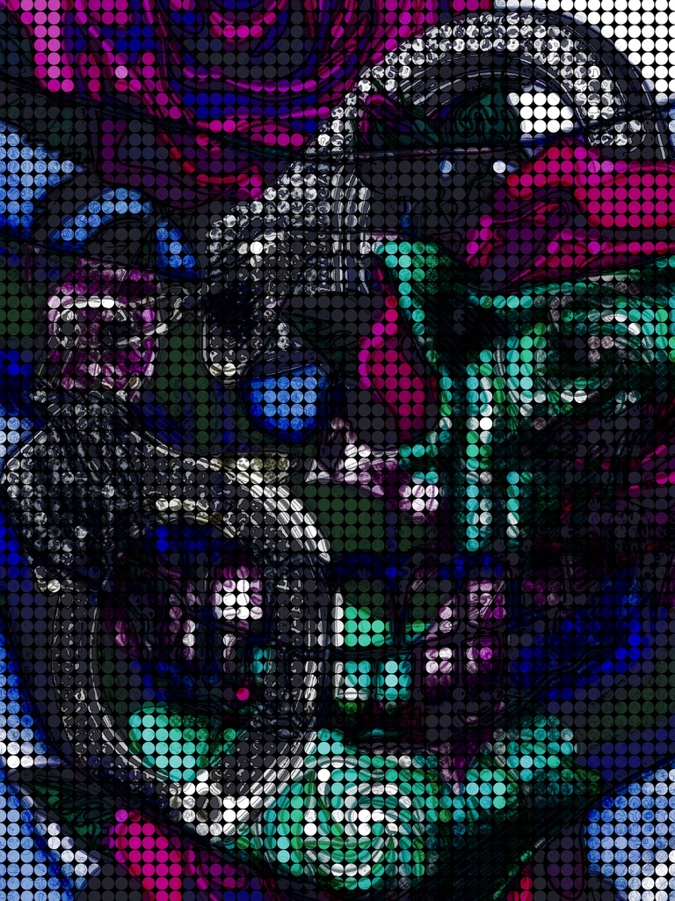
Roulette

Roulette

For Kevin, my Doctor Frankenstein, my inspiration, and most of all my heart; For Tasha, who stuck by me in the worst of times.
Part One: Crapshoot 4
Part Two: Double Down 11
Part Three: Poker Face 19
Part Four: Ante 27
Part Five: En Prison 32
Part Six: Alternative Lines 39
Part Seven: Buying In 47
Part Nine: Big Blind 53
Part Ten: Double or Nothing 58
Part Eleven: Risk of Ruin 64
Part Twelve: Bet Max 68
Part Thirteen: Face Cards 78
Part Fourteen: Backdoor 87
Part Fifteen: Blinds 95
Part Sixteen: Calling 100
Part Seventeen: High Rollers 104
Part Eighteen: Limit 114
Part Nineteen: The Whale 118

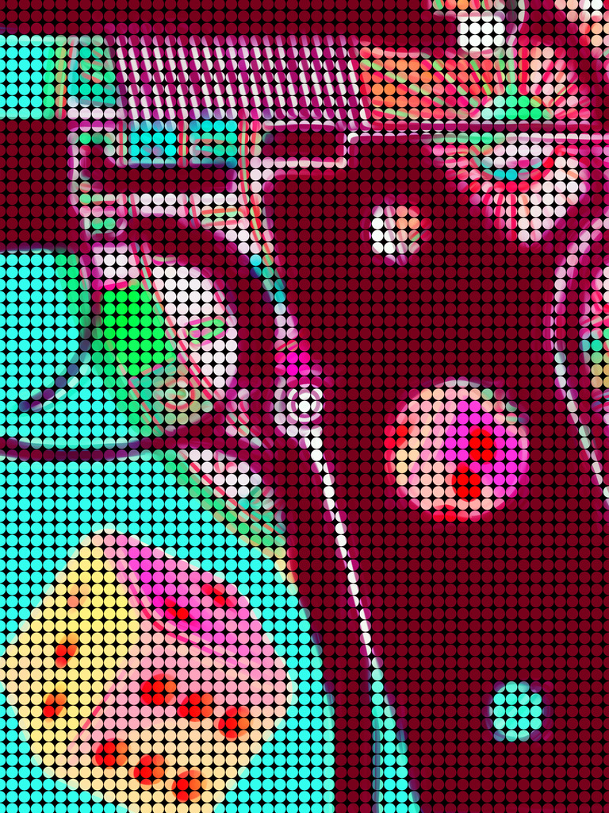
Part One: Crapshoot

The man passes the gun and says, “Go,”so I grab the gun and place it to my head, and in my hesitation, I think of what got me here; over-simplified, the answer would be love, but that is so incomplete; to understand it, you must know the journey, because it was a series of many steps of love and hate that led me to where I am now, and the first step in my journey here started with the death of my father.
My father was a gambler, so to avoid letting it affect their four daughters, our mother silently, selflessly sacrificed so much; it didn’t take long for her to exhaust her friends and family’s charity and loans, which led most of them to avoid her so they wouldn’t feel uncomfortable when they declined to be tapped for more or angry at not being paid back. Money has power, like nothing else.
When our mother could “borrow” no more, she pawned everything she had, piece by piece, including cherished possessions from her late mother, for pennies on the dollar; she would then cry alone after each sacrifice. She could never understand why her husband could put her in many hard positions while his life changed none; he ate like a king and slept like a baby, while our mother clipped coupons with calloused fingers late at night and worried about everything. We never knew anything was wrong with her during those hard times because she hid it so well, until the month before she killed our father, when, in hindsight, it is clear there was an issue; looking back, I remember my mother’s eyes were constantly wet, raw, and red, and she was quick-tempered and jumpy. What we didn’t know was that she had received a foreclosure notice posted on our front door, and, heartbreakingly, realized that the money she had given our father for so long had gone to the casinos instead of our shelter. When our mother confronted our father, he made light of it, saying he would stay with his mother while the rest of us could stay at a shelter; he called it an adventure. To this, my mother threw his possessions on the lawn and then turned on the sprinklers. My sisters and I didn’t know what to think because our mother had never behaved like this in front of us, and we were so young; I, Lola, was the oldest at 11, Keri was 7, Surbhi was 4, and Lexus was 9 months.
Our father, feeling indignant over our mother’s “temper tantrum” and her daring to question him, decided to “teach her a lesson” by taking his possessions and our only vehicle for days while he went on a bender. So, when mom went to work nights, she had to walk miles to and from her waitressing job.
To make matters worse, on the ninth day that our father was gone, our mother received a phone call from a lady who introduced herself as Cherish and she said, “I wanted to see if it was true,” to which my mother was confused until Cherish continued, “I wanted to see if my fiancé Terry already had a wife like my cousin said. Are you his wife?” My mother dropped the phone and then disappeared into her bedroom.
When our father returned home a day later, he walked in with a smirk, expecting a heartfelt apology, certain his absence had been a real loss to a woman who had long grown used to being alone. He never realized that she didn’t love him anymore; every year after the first year they were together was miserable for her, only bearable because of her daughters. For our sake, she accepted his abuse, so we weren’t exposed to fighting, and he took full advantage of that, enabling a horrible man to remain unscathed. Unfortunately, all the terrible emotions and feelings she had pushed down came out at once, so instead of a slow leak, it was an eruption.
Our mother screamed at him, “You motherfucker. You piece of shit. You pig. Who is Cherish?” And then, “We are going to lose the house because you are the center of the universe and we are all here to serve you, so you have no inconvenience or consequences.”
Our father should have felt bad and begged for forgiveness —anything to avoid pushing a volatile situation —but he has never apologized in his life, something he proudly proclaimed, and he wasn’t going to start then; plus, he was perplexed and angred by his wife’s newfound wrathful voice, and he felt she should have known there are punishments for trying to prevent him from doing whatever he wishes, whenever he wishes, and trying to give him consequence —forget that he has children.
Enraged, my father added fuel to the fire, saying, “Oh yeah, I know Cherish, that’s my fiancé, who I’m moving in with next week; we used the money you have been giving me for this house payment for the down payment on our place.” Then he approached our speechless mother, poked her chest, and screamed, “You are a tired, worn-out, old hag who let yourself go. Why would I stay with you?”
Hearing the screaming, two of my sisters joined the three of us in the kitchen; at this point, our mother’s complexion was bright red, and she pulled at her hair, screaming at him, “I look tired because I work doubles, and also do all the housework, laundry, cooking, and childcare. I never had a partner in any of it.” Then she started crying angry tears and shook, as she waited, again, cyclically, for him to say or do something to make it better; he had never before, but she believed the severity of this fight would bring about a change. Unfortunately, she would be waiting forever, cyclically, for him to be something he wasn’t.
Hearing this, our father’s face relaxed, and he looked like he were thoughtfully mulling it over, as if she had struck a chord that might motivate him to get the help he needed and be accountable. For those moments, even though our mother was distraught, she felt hopium; all she wanted was for him to stop being so cruel, and to contribute and be a faithful partner, the way she was always to him. She could forgive him if he did the right things, so we could have a fresh start and stay together as a family.
He then approached our mother like he was going to hug her, but instead pushed her to the ground. There had been no epiphany; it was another one of his sick games. He then kicked her several times when she was on the floor.
After the assault, our mother stayed on the ground while we were all crying hysterically, and our father was laughing. It was then that my mother realized her patience, encouragement, and hope would change nothing about him, so she left the room.
Our father was still laughing when my mother shot him in the back of the head, with three of their daughters, gazing on. As his body went limp, his neck made impact with the table, contorting it into an obscene and unsettling position. He landed right beside us, so we started screaming; it was this nightmare image that I believe is the driving force for the demons that would be unleashed different ways from then on for us girls. For years after, I would be going about my life when, unprovoked, this scene would replay, but additionally, my father would speak after the fall and always say cryptic things; it was a terror that never lost its edge, and an image that cannot be easily erased, nor its accompaning curse.
Our mother then stood shocked; even though she had gone all the way to the bedroom, retrieved the weapon, loaded it, came back into the kitchen, aimed, and shot the gun; she felt as if something had possessed her, and she was not directly involved in the act itself, only to fully return with bloody hands and a dead husband. I believe that is true: she was possessed by several terrible emotions that had been repressed for years by a man whom she sacrificed endlessly for, only to be continuously destroyed by him; the volume and strength of accumulated heartache and anger had exploded, and she did something she would have never done had this imperfect mixture not become caustic; she had been pushed far beyond her limit, and there were consequences; still, she was neither satisfied nor justified; she was mortified.
After a few moments, our mother dropped to her knees and cried, realizing that the possessed moment would have serious repercussions. She immediately wished she had just let him go and figured out how to survive as she always had; then she could have kept her girls and freedom, but now she would lose everything over a few moments of insanity.
An hour later, my sisters and I were still frozen when our mother suddenly stopped crying, rose, and asked if we wanted pizza for dinner. I was the only one old enough to grasp the gravity of the situation, so I asked her whether we should call for help first. She calmly replied, “Why, honey?” I said that our father was hurt, and the hospital could help with that.
My mother looked at me and said, “Don’t be silly; your father is just resting. Go take your sisters and bathe them, and I will order pizza.” I remember feeling so relieved that our father was ok and did as I was instructed.
Our mother then, out of our sight, dragged our father to the bedroom, all while speaking to him as if he were really just a passed-out drunk husband who she had to drag to bed. We lived with his dead body and the horrible smell until they came to evict us, which was a great surprise to the collection industry, which had seen it all. It was clear that our mother didn’t accept that he was dead, and so she was stunned when they arrested her; she continued telling the police to talk to her husband because he would tell them that he was sleeping. The police officer looked at the dead man, now home to maggots, and said, “Yeah, lady… the forever sleep.” Then, social services arrived and took her four daughters.
During the investigation, the investigators sympathized with how far she was pushed and how much she would lose, so those mitigating factors and being believably deluded ensured she was deemed not sane enough for trial; so she was sent to a mental institution.
When our mother was sent away, her daughters were then split up; the baby, Lexus, 9 months old, went to a later disgraced preacher and his broken, self-medicating wife; they left New York for their home in California as soon as the ink was dry on the adoption papers. Keri, 7, went to our frazzled, maternal, widowed grandmother. Surbhi, 4, went to our bitter, resentful paternal grandparents. I, Lola, 11, was placed in foster care.
When our mother first went to the mental institution, we were notified that she was allowed weekly visits. However, Lexus was in California, and our paternal grandparents weren't going to bring Surbhi because they blamed our mother for their son’s demise, so it was just Keri and me, which was a silver lining because it deeply bonded Keri and me, which was something our other sisters never got to have.
From the day we were split up, all four sisters came to have drastically different lives with one commonality: our vice of “gambling” in various ways; it’s possible we were more like our father than we could accept, or, more likely, the high-intensity lives we had lived almost made us crave chaos and become subservient to our destructive vices. It was a high we needed to feel alive.

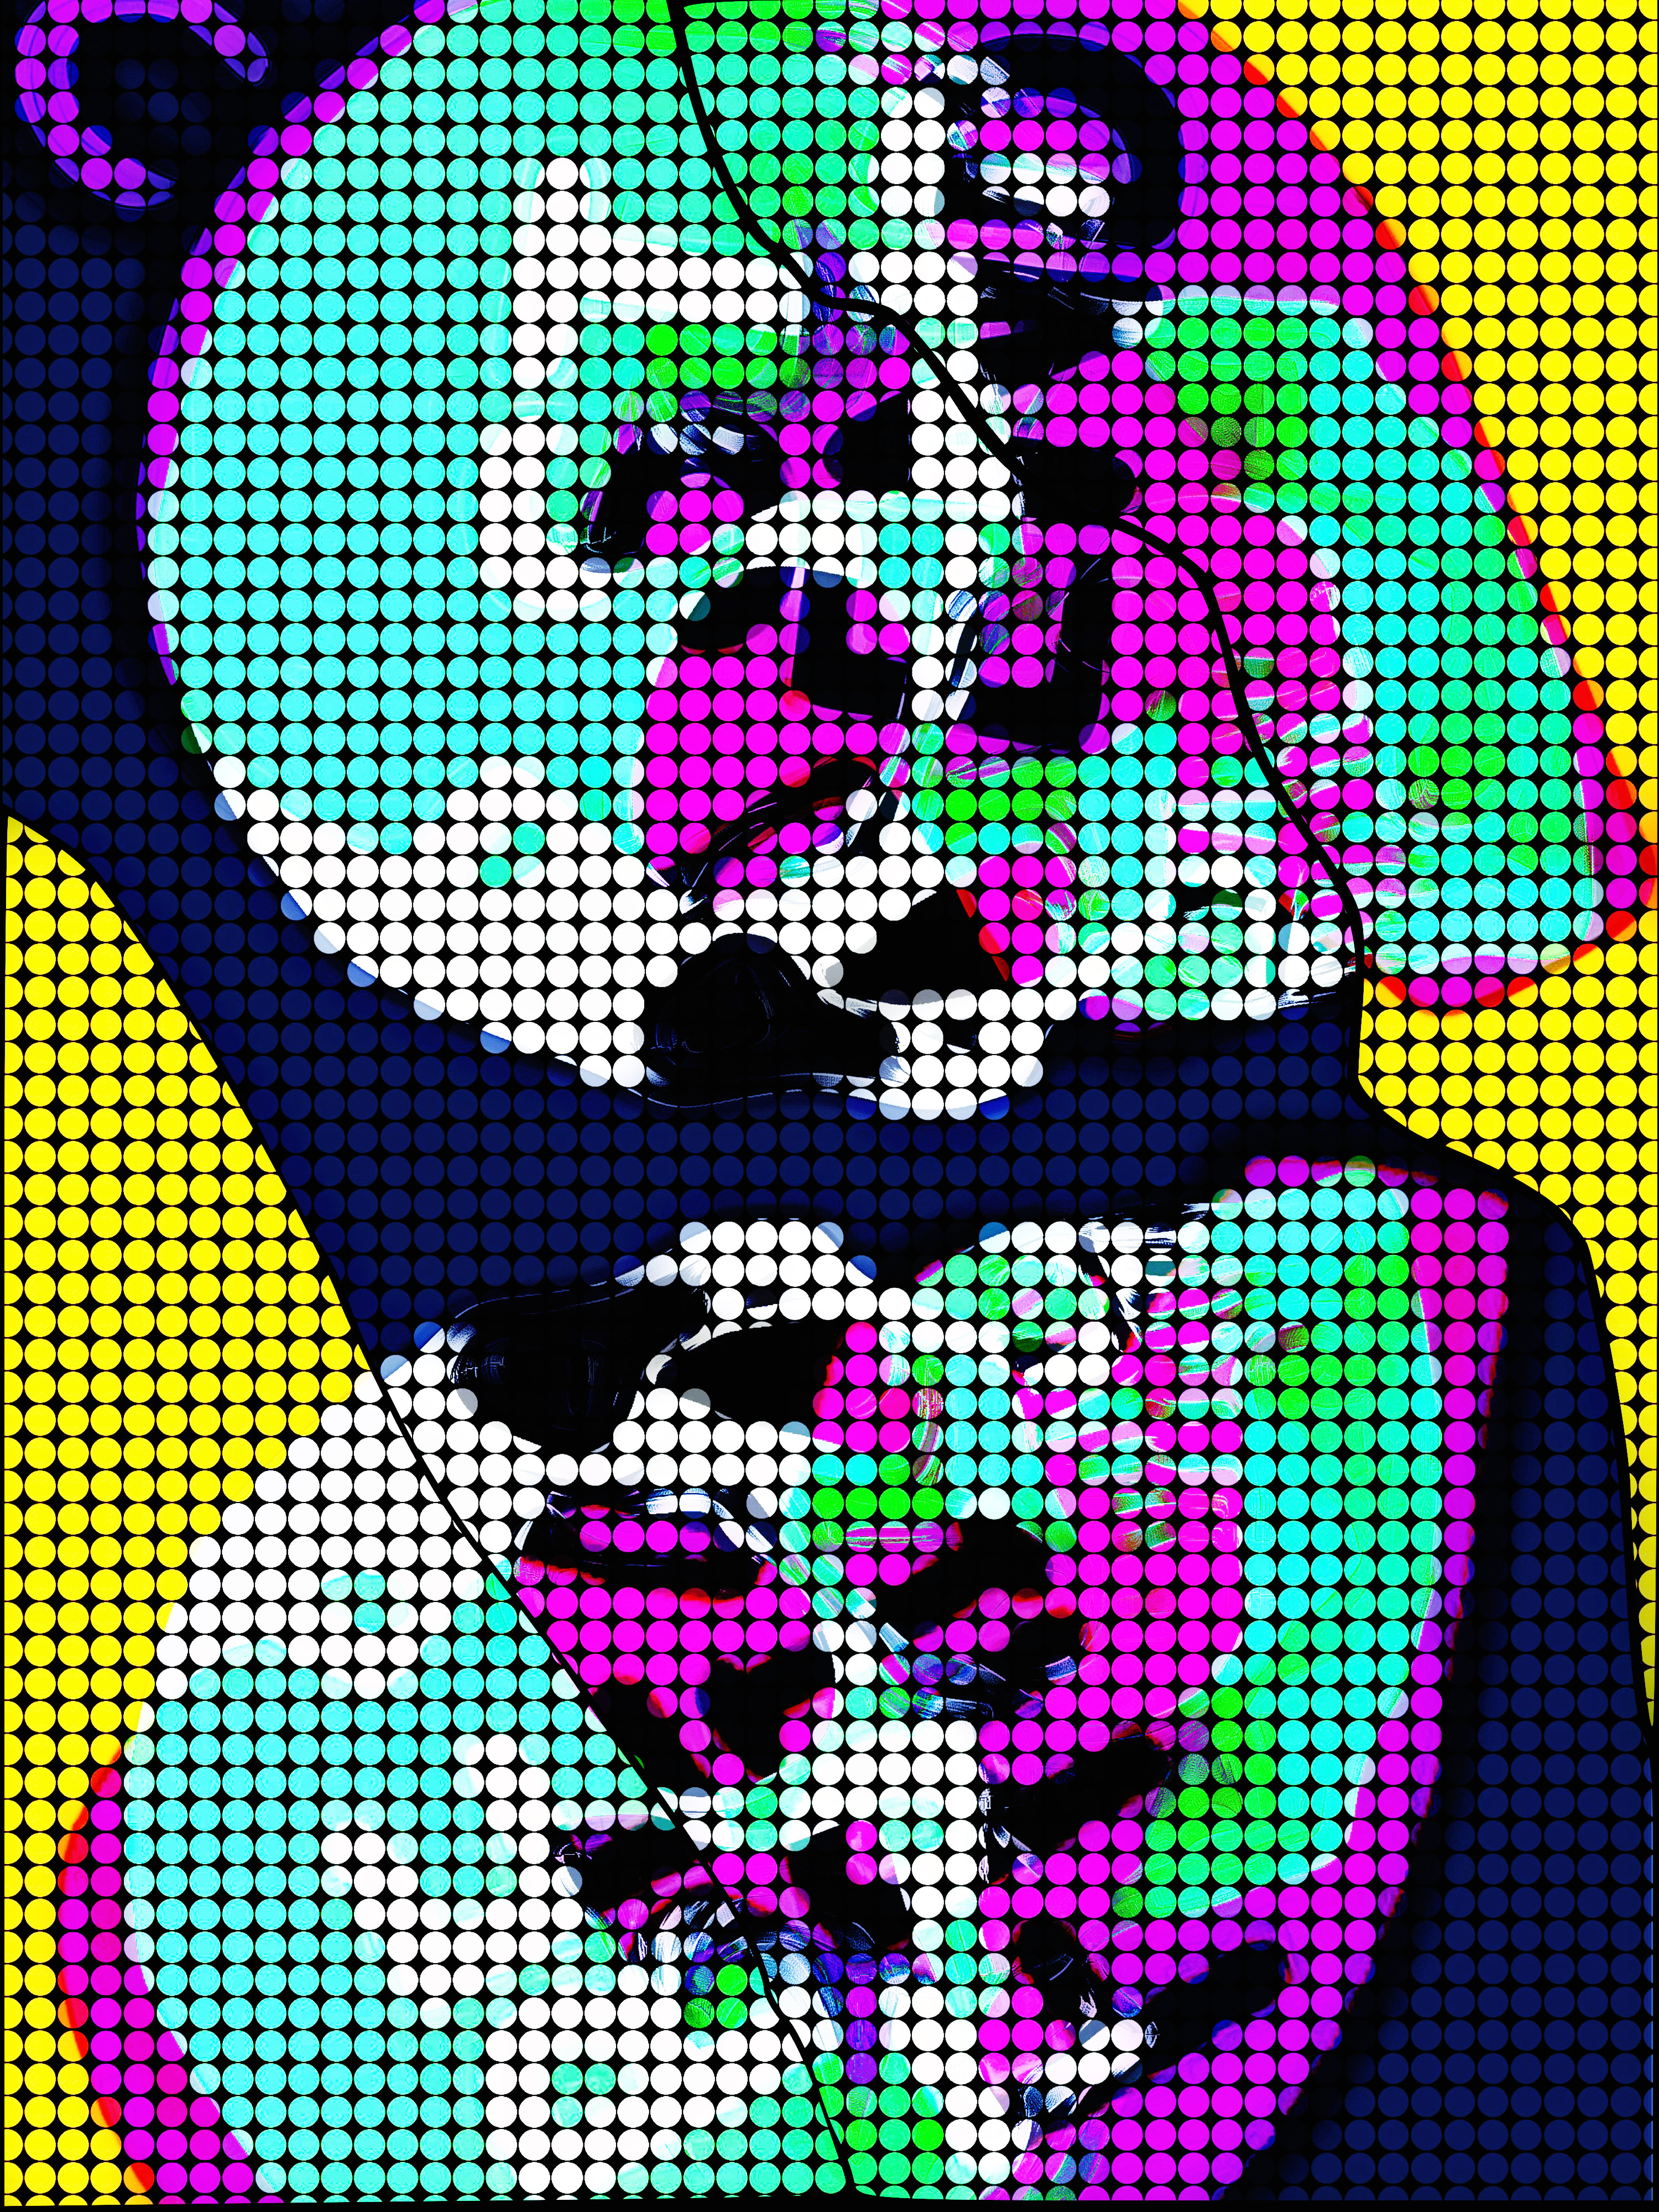
Part Two: Double Down

When I was first put in foster care, I thought it was only a matter of time until a family member or my mother would be well enough to retrieve me. That first month, I stayed optimistic, and at least I got to see Keri once a week for our three-hour visit with our mother; during these visits, we were allowed to be physically with our mother, but she wasn’t interested in that, as our mother was somewhere else, and the more we tried to pull her back, the more irritated she became with us, and she could be so mean in her frustration, which she had never been before, so we just colored next to our non-present mother and talked to each other. Keri was always the jokester of the clan and kept me smiling, so it could have felt a lot worse.
It was a month after that when my solid faith in being with my family again soon was shaken, which made me terribly depressed; the group home was run like a sterile prison, and there was no affection or love, which my mother had given so freely, and I had grown accusMarked to and dependent on. To make matters worse, when the other children found out who my mother was, they teased me mercilessly. I would cry myself to sleep every night; the saying should be “sticks and stones will break your bones, but words will find a way to end you.” I honestly was too young to understand suicide, but I did not want to exist anymore, independent of understanding how that is accomplished. It was a difficult situation, but I always prayed while I cried. When I finally felt I had no hope left, I met Natasha Shreder, who was 15, and the unexpected answer to my prayers.
Natasha had been in and out of various systems since her youth, and as a result, she possessed the keenness of an FBI profiler, combined with the knowledge of a Savvy con artist many years older. Surprisingly, when Natasha arrived at the group home, she came straight to me. I couldn’t understand why, so I almost flinched, expecting an impending punch or punchline; instead, she met my awkwardness with a smile and asked me if I had a smoke. I said, “Like from a birthday candle?” She laughed, thinking I was joking; then said, “No, from like a cigarette.” She had me lost again; I wasn’t sure of what a cigarette was because my overprotective mother made sure I was never anywhere where I could learn about cigarettes, so I said, “I don’t know.”
Natasha said not to worry, as she had hidden some, and then grabbed my hand and dragged me into shenanigans, reminding me of Keri, which made me hurt deeply because I missed all my sisters, especially Keri, whose opposite personality complemented and gave life to my reserved, quiet one.
Once we reached the treasure’s location, Natasha asked me to keep an eye out while she popped out of the air vent and reached inside, pulling out a sack of items. She then pulled me into the utility shed and had me watch over her while she inventoried her bag of goodies, which I hoped included candy, since I always had a sweet tooth and we weren’t allowed sweets here. I was jolted when she said, “Shit, no lighter.”
I replied, “To create the smoke with?” Which is when she realized that I wasn’t sarcastic or a comedian, but that for most of my life, I had been sheltered from the very real world she had always lived in. She could have teased or left me, but instead she decided to accept me as I was, because the only good thing Natasha’s monster of a stepfather ever taught her was that networking is just like its namesake, so the broader and tighter the net, the larger the catch, which means more of much, so she never turned anyone away who wanted to surround her. She found that connection is a currency, and it is also a lifeforce.
After a moment, Natasha told me to “stay here,” then ran inside; when she returned, she had a tampon, and two paper clips which she was straightening; then she said to look out for her while she “popped the outside socket.” What she did terrified my inner safety officer, who was waiting to come out with a list of safety hazards in my assessment, ranked by severity. I didn’t say anything, though, because I wanted to pretend to be cool like she was. She then ran back to the shed with the burning tampon and used it to light her “birthday candle”; she inhaled deeply and let the smoke deliberately escape from her lips, causing it to move and dance. Then she handed me the cigarette, and I copied her, taking a deep drag. Unfortunately, I was shocked that the smoke was actual smoke; she was smoking smoke. I thought that was odd, as I had never looked at a campfire and felt the urge to inhale or ingest from it for fun. After that deep drag, I felt lightheaded and coughed violently, as I handed the cigarette back to her. She smiled, took it, and never offered it back to me.
That week, I was Natasha’s shadow, but she never seemed to mind, and it wasn’t long before her mother started signing us both out on pass; during the drives, Natasha was distant, and her mother seemed like she wanted to challenge or question more, but was reticent because of the cruelty Natasha frequently endured at the hands of her stepfather; still, you could tell they loved each other, but sometimes circumstances don’t yield perfection, so we have to play the cards we’re dealt, and their “tell” was that they hadn’t folded; they found a way to make it work, and so they stayed close without being close.
Natasha and I always left as soon as we reached the house and then rode various forms of transportation around New York, collecting money. I had never traveled using public transportation because, while we were not rich, my mother was overprotective; she always sensed that horrors awaited us, which was correct; yet, ironically, all the excessive preventative measures didn’t change the outcome, but instead they limited our lives.
After some collections, I asked Natasha if she was selling Girl Scout cookies, and she said, “Something like that,” which made me so excited, because my mother would give us a sweet each day and tell us she loved us, and I missed that so much. I missed my mother, who was otherworldly strong, like Natasha, who also found it a curse as much as a gift, because needing excessive strength all the time without reprieve had devastating personal consequences for both.
After we finished for the day, we raced home so her mom could take us back. It was a delightful day and a much-needed distraction from the constant fear and trauma. When we got back to the group home, I saw that my social worker, May, who I came to think of as another mother, had left me a little gift: a Princess Press, which presses colored, plastic beads that were placed into pattern mold metal trays into a design, that creates a cool piece of art, it is like Creepy Crawlers and Light-Bright had a baby, and delightful. I was so grateful; it was my only toy, and I missed my toys.
I asked Natasha if she wanted to “do a press,” and I could tell she was about to say, “No; that is for children,” but then she considered that my father was dead, my mother was in the hospital, and I was separated from my sisters, and instead said, “Fuck Yeah!” It was something she taught me that I still apply to my life: that if we choose to be “too good” or “too cool” for something, then we miss out on so much of life. She was eternally making lemonade in an unusual way that would stop traffic and leave an impression.
Then, Natasha and I pressed some patterns; she made the bold decision to use the blank molds to make her own designs, and the results were incredible. Her art was roses with thorns; she was never willing to remove for fear of harming the rose. No, you would need to accept the reality of the balance in her world and art.
Later, we hung the presses in our common area, and the children and staff would take time gazing upon Natasha’s pieces as if in an art gallery; she then had everyone pleading with her to take special orders, and the entrepreneurial empress obliged, which gave her an outlet that was much healthier than the other way she was making money, as a runner for the Northern Ghosts, information I was not privy to at the time. The Northern Ghosts is an all-male, with one exception, motorcycle gang, from which she was making a substantial amount of money because she was 15 in legal age and 40 in street smart age; thus, she never encountered any resistance or had any incidents with her deliveries and collections, making her exceptionally valuable to them. Still, she relished the youth and self-esteem that art gave her, which no one else ever did, and so she told her gang that her temporary home was run like a prison, and she didn’t want to bring any heat by getting in trouble there, and from then on, we would go on passes and enjoy our time together, and I became attached to her. During our days in the sun, she told me that she had a brother who lived with their dad in Arizona, and she missed him terribly, but she insisted that he stay away to keep him from her stepfather, who was abusive in every form; yet, she said she was figuring out of how to safely reunite them; one thought she had was getting her GED and then moving to Arizona to attend art school, now that she had discovered a natural talent that she loved and gave her purpose, which she could refine and make marketable.
After four months at the group home, Natasha suggested we visit my mother on a pass, since they had stopped taking me for quite some time due to a staffing issue that never seemed to be resolved, and she knew I would be too afraid to navigate alone. The day of our pass, we arrived at the hospital, and found my mother, whom I introduced Natasha to, but she wasn’t responsive. Since my mother was mute, I looked around her room and noticed a box containing various items that people had left for her; many were drawings by Keri, who, even at her age, had the same natural artistic ability as Natasha. I was happy to see Keri’s artwork, but it also made me miss her horribly. Putting this all together, Natasha suggested I leave a note for Keri, and she could reply.
While I diligently worked on the letter, Natasha pulled out the Princess Press, which I was unaware she had packed in her backpack. She explained the process to my mother and demonstrated it using the baby possum mold and colored beads. When the possum was pulled out of the press, she showed it to my mother, who smiled as it cooled. I had not seen my mother smile in a very long time; when she brightened, even fleetingly, she was a warm explosion of color.
Even more shocking, just as I finished my letter, miraculously, my mother spoke, asking Natasha to press her a heart. Natasha said she didn’t have enough supplies with her this time, but she would bring them on the next visit. My mother nodded, then lay on the bed and fell asleep almost instantly. It was then time to go, so as we left, I said, “Goodbye, Mom; I love you,” but there was no response.
That night, Natasha and I pressed a piece for my mother and Keri; it was a beautiful work of art, enhanced by expertly placed high and low lights. As the artwork cooled, I realized that where I had previously felt unlucky, cursed even, my luck had changed.
From then on, Natasha faithfully accompanied me to visit my mother once a week; there, I would read and reply to Keri’s notes and look at the art Keri left behind, while Natasha would create art with my mother. When Natasha left Keri a Princess Press for Christmas, Keri would try to recreate the patterns Natasha had made with Mom, and after a bit of trial and error, she got pretty good for her age.

Part Three: Poker Face

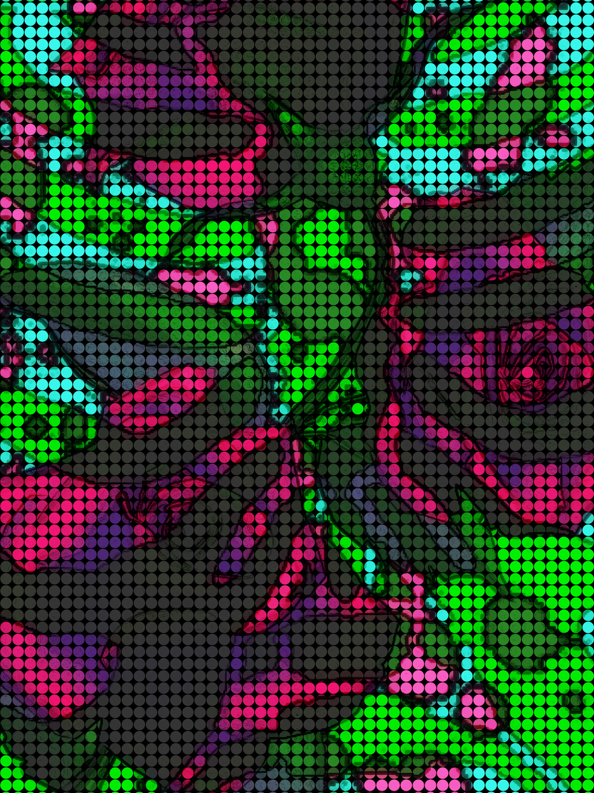
At the one-year mark of our first meeting, Natasha’s stepfather finally won his petition to get her back home, and she was devastated. I asked her why, if he hated her so much, would he work so hard to get her back, and she said, “He hates himself, so he doesn’t like anyone. He especially hates me being out of his control because he loves to hurt me.” I didn’t pry further because she seemed very upset.
After Natasha left, I felt I had lost everything all over again. While she was around, she protected me, but with her gone, the kids teased me and asked me things like whether my mom gets her dates at graveyards or if I’ve seen my father’s brain. It made me want to die. I cried all the time.
Then I went to visit my mother, who was disappointed that her companion wasn’t going to create art with her in the safe place Natasha had built for her. I wasn’t jealous because I felt the same way.
It was three hard months before Natasha came back, and I was so glad; with hr return, the feelings I had for her were magnified because, in losing her, I saw my life without her, and it was different as can be; I lost my protection, but more, I lost my purpose.
Unfortunately, when she returned, she was drastically different, and it was clear she had been greatly affected by something, but she wouldn’t talk about it; still, it was clear that she had
lost the small joy she had built up by her admired talents and diminished responsibilities and hardships, which resumed with a vengeance after she went home. After she returned, I could barely get her to do the things she had loved, like going to the arcade or out for a day in the park, and she certainly would not use the Princess Press, even when the price offered to her was high. What I did not know was that Natasha had now fully immersed herself in gang life, carrying the culmination and magnitude of the hurt she had endured while endlessly trying to prove herself as tough, so it seemed pointless and childish to her hardened personality. I didn’t press the issue because what good could come from it? Instead, I accepted her unconditionally, because she had loved me that way first, which taught me how.
After some months, Natasha’s stepfather was able to get her back home, but at least this time, when she said “goodbye,” I knew it was really “see you soon,” because she was not going to stay with her stepdad, and would run the streets until her luck ran out, and they would bring her back, and it would repeat until she was an adult. So, I figured I could bide my time until my sun returned.
Unfortunately, without Natasha’s mother signing us out on a pass, I was unable to see my mother, because staffing never improved; this is a place that decent people could only stay in for so long before the sadness and grueling work schedule became too much, and they would leave; none of the children even bothered to learn the names. After months of Natasha’s absence, I began to lose faith, became withdrawn, and cried myself to sleep; it was then that I learned that temporary and permanent pain are so different, and this realization dropped my faux armor, and I started getting impaled by all of the repressed hurt and feeling abandoned. I do not like to think about this time, and I do not know how I survived it.
It was over a year after Natasha left, and I had not seen or heard from her, when I found out that my mother had killed herself. I was 13 and didn’t understand mental health at that time, and so I felt enormous anger and loss of the innocence that I previously clung to with much strength; I went from sweet and mild to angry and reactive. I didn’t know how much pain without assistance that one should be able to take, and I didn’t recognize myself after the change.
Then, three months into this dark period, I was asleep when I was jolted by a hand covering my mouth, and I was panicked until my eyes adjusted and I immediately recognized Natasha’s beautiful, distinguished eyes peeking out from a black bandana with a ghoul’s face painted on it. She smiled as she watched my spectrum of incredible silent expressions, then grabbed my hand and led me outside to a cherry-red BMW. I asked who was here to pick us up, and she said she was, so I asked, “Who was driving?” And she repeated the answer, then got into the driver’s seat. As my jaw lay on the floorboard, Natasha drove us along, and we talked; she told me she heard my mom had passed and was really sorry, and she wanted to tell me so in person.
While she drove, I expressed my hatred for everything and that I wanted to join her on the streets. I was surprised when this made her cry so hard that she pulled us over to a scenic spot and asked me if I loved her. I said, “The very definition,” so she then asked me to promise her something, and I agreed without information or hesitation; then, she asked me to promise that I would not live a life of crime, which is romanticized but, in reality, was constant violence, loss, and uncertainty, and to return to the sweet and optimistic girl she adored.
It was a heavy promise because it would be infinitely hard work, but I loved her enough to do what made her happy, so I agreed. In this act, I saw a glimmer of who she used to be as she hugged me, feeling relieved. Then we got into the car and drove home in silence, both thinking about the heaviness of our lives and fantasizing about the life we wished for. Natasha changed my life dramatically that day, as I decided then that I would become a police officer to resist temptations; from then on, I kept my eye on this goal, which would later fully blossom from that one seed.
Luckily, after that night, the tides started clearly turning for me, which crescendoed when six months after my mother’s death, I found out that my social worker, May, resigned so she could adopt me. I loved May because she often gave me gifts, like the Princess Press, and extra attention, like sneaking me into the mall or movies, which made me feel special and loved.
Unfortunately, while the adoption process was ongoing, time drug painfully on, unlike before with no possible end in sight, and I felt constantly worried that my hopes would be shattered when the application was denied, which was a real possibility because she was currently unemployed and single; that anxiety was entirely consuming, and I became inpatient with everything because what was once a far-off wish, was now a real possibility, and I wanted it to come through fast because I was a nervous wreck, and needed relief.
Luckily, when May got a new job, the application was updated, and this changed things considerably. It was not long after that that I found out the application had been approved and that I would be entering my new life. Then, May signed the final papers and drove me to our home. I could not believe I had beaten the odds; I never thought I would get out before I turned 18, and it was hardening and changing me more as time passed; I knew there would be nothing left of me if I remained, so leaving was a dream come true.
When we arrived home, I was beyond exhausted; I looked for my room but was surprised when she motioned me to the one-bedroom and bed, which she said we would share. I didn’t share a bed with either parent at any age, but I thought I only knew my own experience, so I figured this could be normal, and what I was used to was the antithesis, so who knows? Surprisingly, it was actually nice at first; she and I would watch the older classic Hollywood movies she favored and eat junk food in our matching nighties until we passed out, like an endless sleepover; sadly, things changed when three months later, she gave me “special expensive juice,” which made me feel very happy, like my problems floated away; then she put on some sticky-sweet, melodic music with a lady singing in French, which touched my soul, and we danced around the room, as life spun to the music. Initially, it was a beautiful blend of shades of happiness and colors; I’d never felt this high. Then she drew me in and kissed me.
I didn’t know what grooming was at the time, what was happening, or what to do, so I froze while she pulled off her nightgown and then mine. She fondled my breasts and directed mine to hers, and then she kissed me with her tongue in my mouth. After, she pulled me to the bed and kissed my whole body, and my first orgasm was from a rape.
Once the initial shock wore off, I excused it as not being anything wrong or serious, because I lived through things like watching my mother shoot my father, my mother’s suicide, and being separated from my sisters. I had no clue what normal was.
The next morning, May told me that this “special relationship” needed to stay between us, because if I told, then “they” would split us up and send me back to the group home, which had become more violent; then, she sent me off with a box of chocolates and a kiss.
I ate the chocolates on my walk to school, hoping to conjure up a sweet memory of my mother, but, now dead, she appeared as a ghoul with her eyes and mouth stitched closed, attempting to scream. I dropped the chocolates on the ground, and immediately, crows grabbed them up like performing a magic act, and they disappeared instantly.
The sexual abuse added to such a jumbled soup of confusion for me because it’s so complicated that my feelings weren’t black and white due to the complexities, but whether abuse is acceptable or not certainly is. After our first sexual encounter, May treated me like I was her adult girlfriend, albeit a secret one. It took me many years to believe I wasn’t in a relationship because a child and an adult cannot be in one, but that is how twisted it makes your mind.
Unfortunately, the more developed I became, the more aroused and intense she became, and my not showing resistance made her bolder in being who she really was. One night when I was still fourteen, she asked me if I had ever heard of the Nazis, and I said I had not. She told me how it is best to leave only Aryans and cleanse everyone else, because it would be purer. She then told me that she believed that she was the reincarnation of Irma Grese, an infamous Nazi, who is known for her dalliances with both men and women, and her love for torture; Grese was hanged for her crimes, and will remain one of the most hated women who have disgraced the earth. That night, our relationship drastically changed because she hadn’t seemed like a deadly predator until then, so I didn’t realize I was bloody in the tank with a shark until I was within mouth range. I didn’t understand the pleasure that she took in hurting my body, but once we crossed that line, there was no going back; from then on, I was there to please as a submissive, but it was not consensual or wanted like the BDSM that I enjoyed later on, where you communicate, and “stop” means just that.
It was on my fifteenth birthday that I had a good chunk of my nipple ripped off, and I contemplated suicide. I wasn’t happy, especially since, in addition to the pain she inflicted, she made me go to these Nazi meetings, and the things I heard were painful, and you lose parts of yourself being shredded up by hate; then, May would feed off of these meetings, believing that they had invited Irma to fiercely possess her, and the sex would be exceptionally degrading and painful. I didn’t want to live like that.
Fortunately, that day I felt certain that Natasha and I had a divine connection, because when all hope was lost, I heard a knock at the door. I didn’t answer at first, as I wasn’t allowed, but then I heard Natasha screaming my name, saying she knew I was in here, so I quickly invited her in. There is nothing in the world like the person you love the most being there when you need them the most, without ever expecting it.
Once inside, she was noticeably shocked seeing the collar I was wearing and the wounds all over my body. She asked if my adopted father did that to me, and I said, “I do not have a father; it was May who did this to me.”
She was so concerned for me that she didn’t mention that her stepfather had hit her brother, who had been visiting, hard enough that he broke his neck and would require care for the rest of his days. Her mother was besought with guilt, and if she were ever part of a parent prior, she was worse than no parent after. At least her stepfather had been arrested.
Natasha, now legally an adult, had continued running drugs and money for the Northern Ghosts; it was a life lived hard on both sides of the coin; she loved and was loved so deeply, and she had hurt and was hurt so deeply. Her glass was never empty or full, but rather, never permanently fixed, because to her the state of everything was temporary, so the present’s proof meant nothing because of how quickly it can change, and so she became transfixed on controlling the future, and less and less present in the present, until it vanished, and all that remained was a painful past with the additional weight of trying to control an uncertain future. I wish I had known what she was going through; instead, she held me and told me she would help me get out of the situation.

Part Four: Ante

Shortly after Natasha left, the police raided our house and took May’s computer and cellphone; they had received a tip about child exploitation and would find an extensive collection of child pornography. So, I ended up back at the group home, where I first met May, while she awaited trial. Unfortunately, even though I was the victim of abuse, I was teased mercilessly, and I dreaded testifying. Strangely, I felt a great amount of guilt, as if I had been the reason for May’s life imploding, rather than her actions, in addition to loneliness, which I felt without the relationship I had become accustomed to. I would often think so much of the trial and the future that I could not eat or feel happy.
Although I found out soon enough that there would be no trial, after May killed herself in jail two months after her arrest, I didn’t feel freed by this, as everyone seemed to imply or expect, but rather much more enslaved, because as much as I knew I wasn’t responsible, I still felt the weight of the guilt as if I was. So I found myself back in the darkest and deepest of places, which never seemed to turn over to light.
Luckily, the light came when the Californian preacher and his wife, who had adopted Lexus, recognized my leaked name in a national newspaper story and offered to adopt me, believing this would be great PR to display their virtue. I was very excited about the prospect of being in a family, seeing Lexus, and enjoying warm weather, but I was also sad because it meant I would be far from Natasha; before I left, I tried to find her, but she had moved, so I did not get to say “goodbye,” which the thought of often made me cry.
When my new family arrived to pick me up, Lexus did not recognize me because she was 9 months old when I last saw her, and now she was in kindergarten. I requested that my new parents allow us to visit with Keri and Surbhi before we left, but they said it was not possible as they were on a tight schedule that seemed plenty loose.
Sadly, my fantasies of my new life were quickly dispelled, when I realized what a drastic change it was, because while I was treated like an adult with May with no responsibilities, now I had a rigorous schedule of chores, church, and providing childcare while being treated like a child without freedom, and while I imagined my reunion with Lexus would allow us to build the closeness I had with Keri, I was sorely mistaken; Lexus wasn’t like us, she was mean-spirited, quick-tempered, and entitled, but it didn’t take me long to understand she was a product of her environment: Liz’s, purse was a haven for assorted pill bottles which allowed her to be somewhere else to escape the pain inflicted by our adopted father, Larry, who was a secretive man, that was hardly around, but when he was, he made sure we all felt less than.
While I was trying to adjust, Natasha was across the country, watching her remnants be shattered into fine dust when her brother died from complications from the beating that he received from his stepfather. Natasha, by this point, was fully hardened by the men she shadowed and aspired to be like, but this was her Achilles heel, and the pain was amplified. Sadly, her stepfather never faced more than the initial child abuse charges he pleaded to, even after Markmy died, because her mother refused to cooperate, saying it was a misunderstanding, and there were no other witnesses to testify; even worse, later, when her stepfather went before the parole board, Markmy’s death wasn’t mentioned, and her mother, taken in with her husband’s prison love letters that expressed repentance and a passionate desire to renew their romance, was there with pleas and promises that were enough to allow him to get out of prison. Unfortunately, yet expectantly, it did not take long for reality to remove the rose tint, and the same brutal and selfish man was revealed. Still, her mother stayed because she hoped he would go back to being the man he only pretended to be, yet again.
When Natasha came home for one of her now extremely infrequent visits, seeing the man whom she expected to be serving life for murder was such an unimaginable shock for her that she didn’t move, thinking she had taken too much of any of the substances that she regularly took, which allowed the man, who was not a figment of her imagination, a necessary head start; by the time she grabbed the knife, he was locked in his car and raced off.
Natasha was then left with her mother and her rage, which was an aMarkic bomb. As soon as she saw her mother, she pushed her, and yelled so many of the worst things that rush out in the worst of scenarios, and then did not see her until her mother was on her deathbed some years later, when Natasha realized anger has too high a price that collects after it is too late; if she could have gone back to change that moment with her current wisdom, she would have for any price.
After this encounter, Natasha requested a hit on her stepfather which was sent to the top of her gang; she knew that she was too close to get away with murder, so she figured a contract was the best way to go, and three days later, a price was offered to her: she would need to perform an execution when the order was given without hesitation or question, a life for a life with an interest charge of pledging her life to the gang without option to ever leave alive; blinded by rage, she accepted without truly understanding the astronomical price, and that day, a semi hit her stepfather, unfortunately for him, it was fatal; then, the fire of vengeance and wrath burned everything to ash, and she felt the stillness and finality, which was magnified by the gravity of her oath that would alter the future in which she previously had considerable control, but now had lost entirely; she felt cemented in a coffin, alive.

Part Five: En Prison
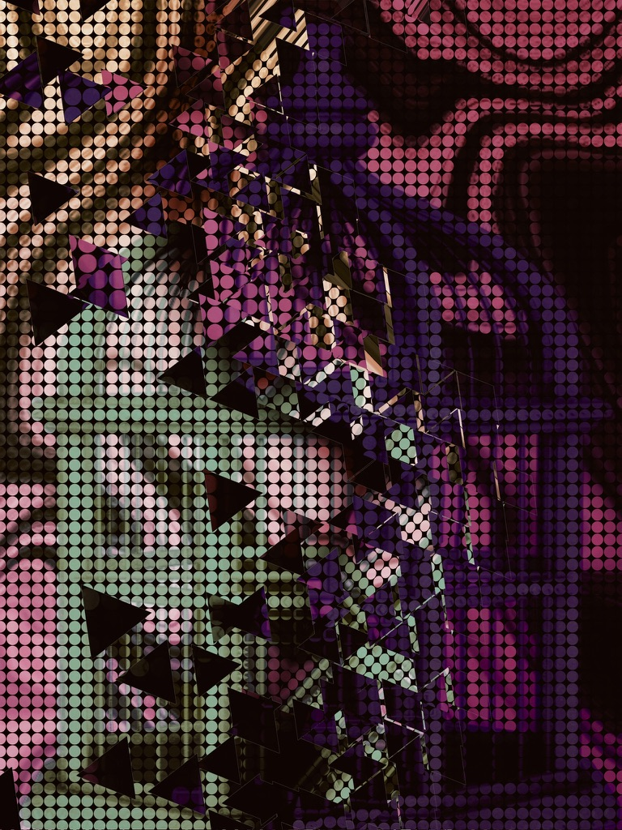
Unfortunately, in the West, I realized that my situation was no better than in the East, so my hopes that geography would allow me to outrun the pain that held me back were now heartbreakingly expunged. Most of my time was spent watching my sister, Lexus, who was conditioned to be an asshole, and disturbingly, reminded me of our biological father’s actions and appearance, which I saw in none of my other sisters, or myself; to have to see and feel him was haunting and I felt afraid, which angered me; this was all while also ensuring our adopted mother did not aspirate when she passed out; I started to resent them all and lose myself.
Then, over a year after I arrived, our adopted mother, Liz, received a phone call, which caused her to scream and drop the phone. On that call, she was informed that a story was about to break about her husband, Larry, the preacher, using church funds to film and produce gay pornography; however, she refused to believe this and stood by her man all the way up until Larry filed for divorce, and then married Steve, a younger man, who lacked common sense and self-restraint; the newly weds easily gained custody of Lexus, given Liz’s inability to show up to court or pass a drug test, which left me to care for the mess of a woman at the height of her addiction and pain, who never made it easy, being as emotionally draining as she was.
Many times, after my adopted mother became my ward, I thought of leaving, but I gained valuable growth in sticking with it, as time allowed a change of heart which afforded me the ability to see the raw, hurt, and rejected woman she was, and my heart filled with compassion for her; Liz had innumerable flaws upfront, if you looked for nothing else, but when I looked for the good, I found it, and grew to love her as she was. I was so glad I had the change of heart because after my eighteenth birthday, we found out the years of substance abuse had taken their toll on Liz, and vital organs were shutting down; we knew that death was imminent, so she mourned the life she wished she had, while I watched the stages of grief on a stage.
After Liz passed on, I felt lost, sad, but most of all, fatigued; all I wanted was some time to catch my breath. How many tragedies in a row can you expect to take without needing a break? I felt certain I had reached my limitation because my mind and body were now in muscle failure, fried and shutting down.
Luckily, my wish for a break was granted when I found out that Liz had set up a trust for me to use for college, which I started immediately. I also began trying to contact Surbhi and Keri, but to no avail. Unfortunately, I had to push that aside due to my schedule; yet I knew that when there was a pause, I could resume. Then everything improved greatly for me. I loved studying criminal justice, and I believed that my life experiences would make me a good law enforcement officer while helping me keep my promise to Natasha.
Unfortunately, across the country, Natasha was not faring as well, because after she had her stepfather killed, the debt she owed often pushed past her limitations, which caused her to vacillate between unnatural numbness and a pain so unbearable that it had to be numbed by substances. The life expectancy of a gangster is so short because if you are lucky enough that someone doesn’t get you, you will get yourself.
Eventually, Natasha’s luck ran out, and she faced prison time for the first time. Still, no matter what deal was offered to her, she would not talk, so she received a seven-year sentence, and she was devastated; at this time, she was twenty-two, which is exceptionally young to spend nearly a decade behind bars. Natasha, however, is adaptable, enterprising, and well-respected, so her time went as well as it could have; she earned her associate’s degree in art and had plenty of money from taking specialty art orders while networking and learning more about life.
Sadly, four years into Natasha’s sentence, Keri, who was now eighteen, joined her; Natasha recognized her name and then confirmed it with her unmistakable gray eyes, they like looking into my own, and her heart dropped.
I had not spoken to Keri in many years, and her conviction for solicitation made it clear a lot had happened since. What I had not been privy to was that our mother lied and manipulated Keri into sneaking razor blades into the hospital, which is how Mom killed herself some years ago. Keri was the one who discovered our mother in a pool of blood; so, along with guilt, she was haunted by another horrible sight to add to many.
After that, Keri was inconsolable and became unrecognizable; she seemed to continue to steadily slide into hell from then on; yet, now she had a guardian angel in Natasha, who introduced herself and then treated her like family, and Keri hadn’t had that in so long, so she clung to it like a child to a mother, and her attachment to me gave her proxy to family which was comfort in a horrible place. Natasha soon convinced Keri to get her GED and persuaded her to make the same promise I had: leave her demons at the prison gate and then move forward on the path to success.
Before long, Natasha pulled some strings to become cellmates with Keri, and the two were inseparable. Their talent and love of art only strengthened their connection, and before long, both women were the best versions of themselves. The year they spent together was one of the happiest of Keri’s life. Previously, the only support system Keri had was our maternal grandmother, who looked like Mrs. Claus with white hair that she styled in a perm so tight her coils could spring anything on impact never to be seen again, with a sturdy figure, and permanently rosy cheeks; in better times, she also shared the same positive spirit, but the loss of her daughter changed things so much for the worse that she wasn’t herself at all after, and while our grandmother never directly said she blamed Keri for the death of her only child, her actions screamed it from the rooftops; for many years, Keri could never be good enough at anything, even when she was, and she was disciplined in a way that was disproportionate or senseless; it may not have been conscious, but it was abuse nonetheless. Keri felt she had no choice but to clam up and try her best to protect what remained of her light, which caused the withdrawn Keri to be as different a woman as our turned abusive grandmother. The degree to which and what we change is related to the amount of pain or pleasure presented, and this was full-throttle bad for both.
However, as Keri got older, naturally, she grew physically stronger and would fight back, so our grandmother had her taken to a center for troubled children a few times, but even when she had the option to re-home Keri, due to the escalation, she oddly wouldn’t hear of it; it was like our grandmother couldn’t let go of the part of Keri that was her daughter, her flesh; yet she couldn’t let go of her misplaced blame and rage either. Later, when the state insisted that Keri be taken from the home, she fought to keep her; so Keri stayed with a strict warning to our grandmother that there would be no more chances; if our grandmother could not live without Keri, she would need to find a way to live with her, and the solution for our grandmother then became alcohol.
At first, when our grandmother was just a sloppy drunk, which Keri enjoyed because of the reprieve, since our grandmother was too drunk to stand most of the time and slept the rest, so there were no longer confrontations, chores, or strict rules for Keri, who took full advantage of the freedom; it was every preteen and later teenager’s dream: no school or bedtime, easy access to alcohol, and the ability to come and go like an adult; still, in the end, it was no substitute for love and care, because while her friends had to go to school, they also had the important things Keri lacked, and she wished she could trade places with them, so much of paradise in perception.
It wasn’t long before Keri had become dependent on drugs, and then she started sex work to pay for them. Our grandmother’s house then became a center for lost souls, until a passed-out “party guest’s” cigarette set the whole house on fire, and he didn’t bother to grab our grandmother, as he exited to avoid blame, and as a result, our grandmother, who often prayed for death, had her prayers answered in the most horrific way. Keri had been gone at the time of the fire and came home to find that she no longer had a home or a grandmother.
After the fire, Keri would at times feel happy that her grandmother, who was abusive and miserable, was dead, but then feel so sad, because she had hoped that one day, they could love one another again, and now she knew that day would never come; plus, having nowhere to stay left her much more vulnerable. Keri would then live her days as a transient who was no stranger to being locked up.Yet, the day Keri was released from prison this time, she was a changed woman because of Natasha, who had given her so much hope for the future, and she knew she would have family when Natasha got out and helped her locate me.
Keri had a three mile walk into town and it was so cold, but she her dreams kept her warm; until she saw an abusive ex following her in his car, he must have figured out when she would be getting out. Keri didn’t want to speak with him because he had already caused so much chaos so she started walking faster, only to have to match the pace but with aggression; so when another truck pulled up and a man asked he if she wanted a ride, she thought it was a godsend, and gratefully got in and out of the cold. That would be the last time Keri was ever seen alive.

Part Six: Alternative Lines


I had no idea that Keri was missing, as I continued my education in law enforcement. I still lived near Lexus in California, but after the phone call where she spewed misdirected hatred and refused to come to Liz’s funeral, I didn’t know if I would ever speak with her again. I didn’t ever see her again, and found out years later through searching Facebook that she had died in an automobile accident when she was nineteen, which also took the life of the preacher, which made me full of sadness to think of the dream we all lost.
After I graduated with my law enforcement degree, I couldn’t wait to leave the area, because for some time I felt haunted by Liz’s sorrow, not a sorrowful, ghost haunting, but a personification, and so I felt a gloom, and her words would creep into my ears… You know, he was supposed to be straight! He was supposed to be with me forever! I was not supposed to die without a lover… Marriage is forever… How could he… he… he… and then her tears would accompany the words, and it was enough to move me to comfort her and weep, wherever we were, so I looked so crazy; I usually composed myself and left, never to return. Luckily, those pleading cry-screams stopped when the memories faded with distance, and the triggers were removed; I never looked back, knowing what I would find in the rearview.
Unfortunately, I hadn’t had a plan when I left, because it was more an act of self-preservation, but now I needed a plan, and Natasha kept coming to mind; sadly, I hadn’t had much time to think of her because being haunted while taking classes and working, left room for nothing else, especially happier things, but the more I wondered where to go, the more I felt I knew; so, I ended up back in my hometown and found work as a prison guard, where I felt concrete confirmation when I ran into Natasha, who was finishing up her sentence. I felt so sad to see her there, especially being her guard; we couldn’t speak openly, but right after she was released, she showed up at my house with a bottle of whiskey. I missed her so much that I never wanted to let go of her. I treasured this time because there was no better word to describe it.
After some time in the true joy of an impactful reunion, her face turned somber, and then she explained that Keri had spent time with her, but she would let Keri tell me the rest. I was shocked by this information because I had no idea about Keri’s life at all, and I would not have even considered it. But more than anything, I felt guilt that I hadn’t tried harder to find her, or worse, thought much of her because I was surviving my own life.
I started to cry, but Natasha told me that I shouldn’t waste my energy or send it into the world; instead, we could find her together and all be a family.
From then on, Natasha and I kept getting together and trying to find Keri, but eventually it seemed there was nothing more to do than wait on the work we had put out; it was hard not to have answers, but Natasha’s overcoming spirit meant joy could be present when there should have been none; she was a magic woman. During those times of waiting, Natasha and I got out and did shit like two usual people would, never betraying the trauma we endured or showing the effects of the hardships, and that gave me enough to carry on. Over time, I moved into police work from the prison, and she respected that; we adopted a don’t-ask, don’t-tell policy for matters beyond our friendship.
Not long after I made the switch, I was put on the violent crimes unit, which was being bolstered to investigate a series of armed bank robberies, which had already resulted in one death, and people were terrified. The team was reviewing the latest footage when I immediately recognized that one of the robbers was Natasha, with her ethereal eyes, impeccably made up, peeking out from her signature terrifying ghoul mask; so, I had been told against my will, and now I knew, and so what now? I always strove to do the right thing, but I didn’t know what exactly that meant now. It was a struggle because the one person I connected with was the very person at the center of the dilemma. I couldn’t help but be affected by that information, yet at the same time, my love for her was so enormous that I knew I could weather this storm. Unfortunately, one day I noticed blood on her sneakers, and I felt I had no choice but to tell her I couldn’t continue to see her, and she understood. It was one of the most complicated and painful decisions of my life, but my promise to her was my reason. Still, no matter what, I could never bring myself to turn her in.
After Natasha was gone, I became very depressed; I relied on her company and infectious happiness more than I could express, and the depth and clarity of our relationship was irreplaceable. I did my duty, but joy left me when she did. I often wondered if the price of right was worth the lack of life I felt.
Surprisingly, a year later, the task force had to be diverted from the robberies, which had waned, to a serial killer task force due to the recent discovery of a mass grave; it took us weeks to get all the bones out of the area where humans were dumped like trash. I had previously felt like, given the amount of violence I had experienced in my years, that I was reasonably well-adjusted: I took the good with the bad, and I didn’t allow ghosts to permanently squat in my mind, but this was a straw that broke my back, because each day brought some new horror, and then all these ghosts now had claim to prospect.
I would often spend days watching many womens’ bone fragments be sorted, as best could be done, because the victims’ parts had been mixed up in a way that would only allow them to be mostly separated, preventing the individual remains to returning to entirely whole. At night, I would have nightmares of these women looking like Picasso artworks, with mixed-up parts, which was garish, and I would wake up screaming.
Then one day, I was extremely tired, having stopped sleeping at night, but was jolted awake when a call came in saying that a new grave sight was found, but this time the victims’ bodies were not decomposed into skeletons, so I watched as they brought in four bodies, and one of them was Natasha’s.
I woke up screaming; I had fallen asleep and was on duty. Since this was a repeat offense, I knew I had to sleep at home or lose my job, but none of the sleep medication worked for me; either I was so groggy I was ineffective on the job, or I just felt really sleepy, wishing I were asleep.
I was doing the violent head jerk during a presentation when a fellow investigator, Mark, asked if I wasn’t getting any sleep or playing chicken with the desk. I laughed, and he offered some tips after class; he explained that he used to never sleep because of what he saw on the job during the day, but now he has studied herbs and created a tincture that, when taken after a nighttime jog, lets him sleep like a baby. He brought his tincture to work the next day; it smelled like sweaty feet, but the gesture made me feel really special. I hadn’t ever been attracted to a man until that moment, because my only sexual experience had been with a woman possessed by a nazi ghost, and so I suppose I had only considered that to be normal, or assumed that any attraction would be homosexual, but more than anything, my life had been so crazy and I had been so driven, that love wasn’t anything I sought; yet, after that day, we were inseparable. It was against all odds that I found happiness, and that gratefulness gave me light again.
Mark reminded me so much of the cowboys in the movies that my mother so loved; her obsession was evident in the fact that she would never allow us much exposure to anything not Christian media, much less violence, but she would not sacrifice her treasured cowboy shows, as she cared for us alone; while her girls enjoyed the allowance in disbelief and marveled at the value for this reason; the need for escape overpowered her strong will to overprotect in this instance. I have strong memories of looking into her watching eyes and seeing stars, which always turned to sadness, as she seemed to process, in a loop or in tandem, that while cowboys do exist, there was likely not one waiting to save her; then ironically and unfortunately, she ultimately ended up in a duel with destiny nonetheless, sans a cowboy. I don’t much believe in heaven, but I sometimes like to watch nonfiction westerns about pioneers that my mother pined over, and in my mind, I transpose her face onto the love interest of the brave, and figure it is the same as a laboratory-made aquamarine, to match Mark’s eyes, perfect and piercing. If Helen of Troy could launch a thousand ships, then Mark of the Department could raise the dead.
Unfortunately, I kept much from Mark as I was getting to know him, or I had to make some things up to avoid seeming suspicious. I didn’t know what to do, seeing as my father was a horrible man who is dead, and my mother was the reason neither is alive, and my other sisters have varied issues, such as Keri’s rap sheet. Add that to the fact that my only real friend is one of the bank robbers involved in homicides, and I was once the sex slave of a dominatrix who scarred my body and soul. These were just a few of my most serious things, and I didn’t see how he could love me with them all, so I thought Is editing cheating? Is editing omitting? Maybe I can leak things and test the waters? Does the past matter when the future is all that really does?
What I kept going back to was that I believe in taking accountability for your past, and a part of that is being honest about it, but I had no control over any of it, and so to accept the consequence of being passed over or judged because of circumstances and people outside of my control seemed like nonsense. So, I could never bring myself to be honest about any of it for fear of losing him, for not feeling attached to those things, and mostly because I was creating a new life, so why in this new life should any of that old taint or destroy it?
Then one day, my evasion was no longer effective, and he asked me about my parents; so, I told him that my mother had married a Korean man after my father died of heart failure, and they moved to North Korea, which I regretted immediately, as it sounded like the lie it was. I was not concerned for long because it seemed so outrageous that he could only accept it as truth. I told him that I had only one sister who traveled a lot, but I hadn’t seen her in a while and was concerned, and that I had only one friend, who is a global banker.
Mark, in turn, told me that his parents both taught law at universities after prestigious careers in the field; they wanted him to follow in their footsteps, like his three brothers, but he felt called to law enforcement. That caused some friction at first, but eventually they came around. Which set him to talking about everything, and I was so glad because then I wouldn’t have to divulge as much and therefore keep track of fewer mistruths or outright lies. As he talked, his life was so picture-perfect that I felt I was right to remove the display of the juxtaposition of our lives by showing the contrast; maintaining the purity could do no harm.
I also found that with Mark, I could easily conceal my potential sexual and intimacy issues, because he was conservative in his pursuit of physical intimacy, perhaps because he was shy or was worried that, since we were coworkers, he foolishly figured that crossing the line would negatively change things for both of us, when in reality we both had been mature enough to weather much worse.
I really fell hard in love with Mark, very fast; life had been so horrible that the way he made me feel became my drug. I became consumed with him, and the joy he brought into my life turned into a nuclear landscape; I felt life sprout, impossibly, all around me; impossibly, green burst from the radioactive red soil.
I will never forget the day Mark told me he loved me for the first time, because it was the day the Northern Ghosts killed a woman and a child in an armed robbery of a gas station.

Part Seven: Buying In
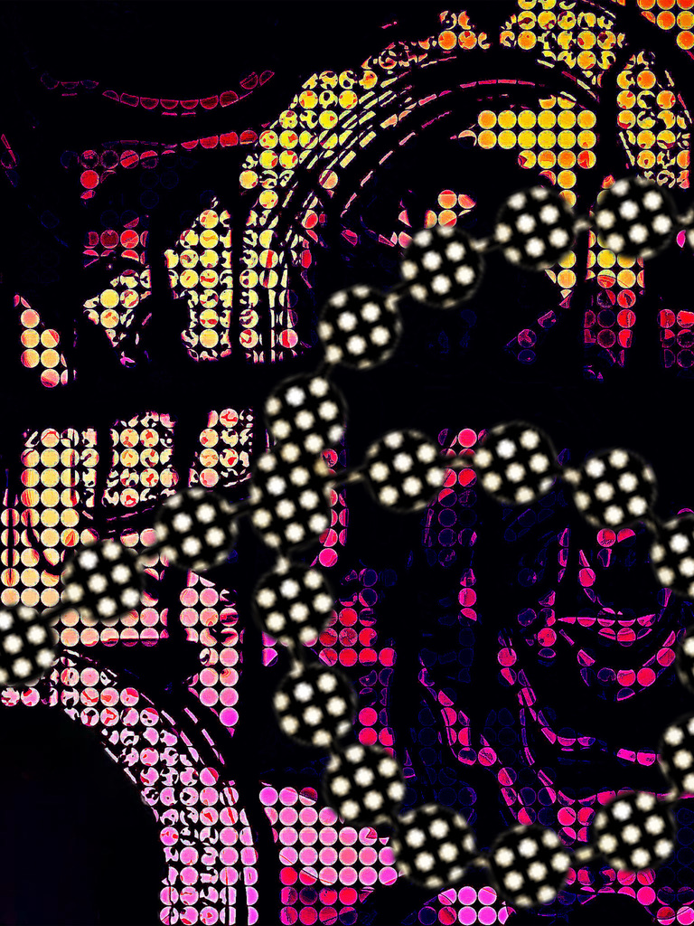
As Natasha witnessed a woman and child being shot, she was as shocked as anyone, even though the crew was armed, because as the bags were being filled with cash, the people were scared but compliant, so there was no reason for anyone to get hurt. It was now evident that this crew no longer used violence only as an end but also as a means; she thought that using violence when not necessary was senseless, which seemed hypocritical at first, but seeing the escalation, it didn’t seem so; every crew has a code, usually, and that is usually to never harm a woman or child; when evil knows no restraint, then everyone else will end up in them. Seeing the little boy, clearly dead, Natasha got sick in the bank, leaving significant evidence that could later reveal her identity, which she had never done before. Those moments would forever replay in slow motion for her… the shots… the screams… her heart dropping… and then, realizing that the penny she thought she was in for was now tons.
That night, she found out she was pregnant, so she was not just sick over the dead child, but also from the one growing inside of her. To see a child die while carrying a child who will live felt like a curse, not a blessing, to her. She decided that she must get an abortion because she thought that whatever good could come of all of this?
However, when Natasha went to the doctor, she found out that she was too far along to abort the baby, which was surprising, given the inconspicuousness of it all. Luckily, the pregnancy forced her to step back from the grind that she had been thrown into, which removed her from witnessing more of the horrors that a life of crime exposes you to.
Initially, she didn’t want to tell the baby’s father, Raul, because they were not in a relationship, she didn’t know him very well, and she didn’t think that he would want a child, but he ran into her by chance, and the pregnancy and the timing were too much for him to ignore. She was surprised when he said he had been trying to find her, missed her, and would love to be part of her life. Still, she didn’t trust anyone, and she remained hard to get, but it was impossible not to fall in love with Raul; watching him sing Spanish songs to their unborn child or showing up with pickles and punch was too much warmth not to affect her frozen heart, and before long, she was well along in her pregnancy and entirely in love.
Before the baby was born, the two went to the courthouse and were married. Natasha wore a purple velvet dress by Betsey Johnson that complemented her dimensional, orchid-colored hair and sculpted body. That night, they stayed in the most expensive hotel and enjoyed their short honeymoon.
For so long, Natasha’s life was dark, as if light would never enter, but then she found light even in hopeless circumstances.
My life had also brought me much joy; Mark and I had a strong bond, and it felt so good that he was so accessible to me, but I found intimacy to be much more challenging than I expected, and it felt like something was missing; although, it was a feeling that I could never rationalize with proof.
It wasn’t long before the department pulled Mark into heading our task force that paralleled working to solve the string of deadly robberies and an unrelated serial killer. I loved his attention all day and into the night. I had felt alone for so long, then presto, I am never alone… it was beautiful, and I felt like I was living in Shakira’s Empire.
Then, in record speed, Mark asked me to marry him because of his faith and a mutual desire to be together physically, spatially, and spiritually. I thought it was fast, but then, I thought, the sooner the better, as I was a woman with plenty enough to make lesser men run, or less informed ones, rather. I still knew what omission was by definition, and yet, when my actions screamed it.
When the marriage was looming, I knew my time to tell him without him feeling misled or worse, betrayed, was closing, and I kept thinking You have to clear some things up… You need to add some information, but then I thought, would it be so bad to give myself the life that I wanted? So I decided to allow myself the happiness that had eluded me for so long.
Our wedding was bittersweet for me; I had no one in attendance, but Mark’s family was super Christian, innumerable, and overly welcoming. I liked the feeling of a ferrel cat being domesticated; it was the yellow brick road filled with flying gorillas and sleepy poppies, on my way to normal.
That night with Mark, I wasn’t really sure what to do, considering my only previous lover was a child predator who loved torture; when added to the importance of sex when you love the person you are making love to, it felt like my mind was overwritten; I worried so much about what I should do, because I didn’t know which I had learned was normal, so I sort of just laid there and looked at with Star Wars poster on his ceiling. I felt like a limp fish, coming to Darth Vader. That first time, he was just as nervous, so he didn’t notice my shut-in.
Then, one night, he asked me what all I got in a bag of goodies I had been gifted at my bachelorette party, which was made up of fellow female officers that Mark, I think, talked into showing up for me. I got: a pair of lavender Pumas that Vicky, our “spit fire” dispatcher, who wore her hair short and spikey, in a way that wind couldn’t move, had Beadazzled to read “Bride Biatch,” those were my favorite, a couple of dozen different variations of Cheetah Print lingerie, a dildo which was called the “Rauunchy Rainbow” due to its fun color, Chocolate lube which tasted like French fries and chalk, and of course, fuzzy handcuffs.
As I was riffling through everything, Mark asked me if I wanted to try any of the stuff out, which surprised me because, from our few sexual experiences at this point, sex toys were not something I thought was on the table. I had to say that I felt a strong stir of excitement within me, because this sex was what I was most familiar with; it was visceral and required confidence.
I knew exactly what I wanted, which, on my “pleasure days,” May would oblige, but with Mark, I felt limited in knowing what I could ask for without at least judgment or worse, so I figured to just let him take the lead, and I asked him what he would like to play with.
I thought he would ask that I wear the lingerie, but was surprised when he asked to put the handcuffs on me, which I declined, because while I wanted to please him, that is what pleased May, and never pleased me. So, instead, he asked me if I wanted to put the handcuffs on him. I should have kept on script, but instead I said, “Yes.”
As I watched the first card blow off, I realized that what I had tried to manifest into stone, was a structure that was apparently card-thin and dependent on miracle conditions to exist for even short periods of time. One card is a definite sign of things to come, and yet, as the ship started to go down, I realized love is the only thing that will have a treaured ship’s captain turn down a lifeboat to his doom while screaming, “but this is my lifes work!” “Who am I without the Siren?” While the siren screams, trying to will her company back to her, “Who am I without my Captain?” Alone or wishing to be near him. Death on the rocks or life alone on the rocks; it seems neither shall get their dream for more than moments before disaster, but neither would have given up the pursuit, even knowing the outcome: love.
So, I put the handcuffs on Mark; he was completely under my control, and I loved it. I clawed and ravaged him. My tale was now my tell, as he saw the feeling of sex that he hadn’t seen before with me.
I felt completely free until he asked that I not act so much like a prostitute. The timing and seething tone made me realize that, for as much as I had been hiding, I really didn’t know the man I had married, sexually or habitually. In shame, I took the cuffs off of him, and he turned over and then fell asleep, while I wept.
Things just kept getting worse after we got married and I felt like I couldn’t do much right or understand him; then one day, I found some evidence that he had taken home, which he wasn’t supposed to, but sometimes, it needs to be done, and that is when I saw Keri’s key chain charm that she made with her Princess Press, which was of Snoopy and Charlie Brown, with her initials in the heart between them. When Mark came home, I asked him about it, and he said it was found on one of the victims of the serial killer.
I said, “That was my sister’s.”
He said, “But… Your sister is alive.”
I said, “I lied,” just before I had a heart attack and lost consciousness.

Part Nine: Big Blind
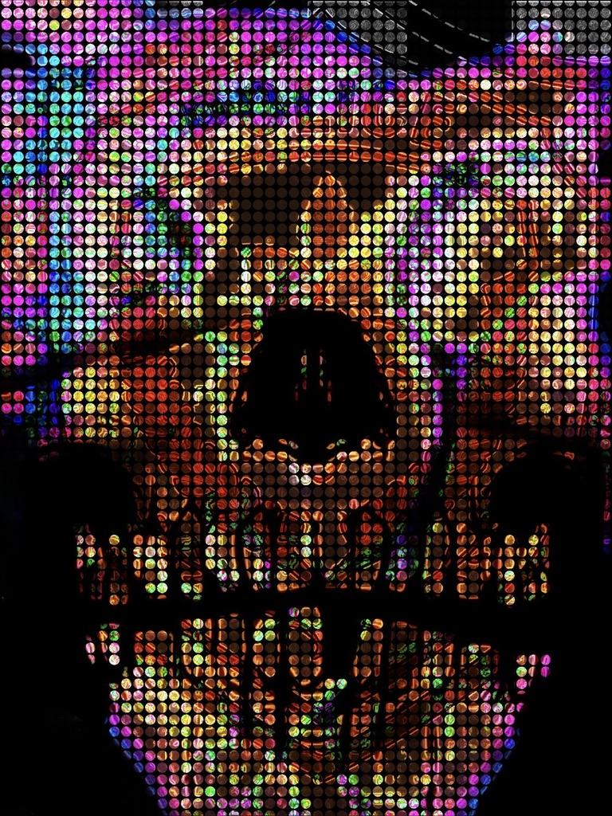
Two weeks later, I woke up in the hospital; I had two flower arrangements from the police department and the FBI, one set of divorce papers, and no husband; apparently, my soon-to-be ex-husband asked to be relocated to a place far away from me for a fresh start, once he found out who I was and how many lies I told, he felt betrayed, and he knew he wasn’t going to stay or want me to know his location. I felt an emptiness, but not a loss; the shock was more in the abruptness of it all.
Once they realized I was awake, the nurse signaled, and a familiar face from the FBI stepped into the room: Kevon, one of the FBI agents on the task force we worked on together; he wore a dusty shade of lavender shirt and a well-tailored suit, and he was carrying an iPad.
Once inside, Kevon noticed the divorce papers on my table, which were no surprise to him, having been tipped off about Keri by Mark, who had explained how he had been buried under the lies, after the avalanche, and that he would be leaving me, coma or not, so in case I didn’t make it, he wanted the task force to know about Keri.
Through investigating Keri’s murder, the task force learned so much about me intimately, things I wouldn’t have shared with my coworkers, and not telling my husband the reason for my divorce. It was strange to know my life had been given the FBI investigative treatment, which means they not only knew about my twisted origin story and family, but also about May, in great detail. The amount of sex and violence that surrounded me, how could that not affect their perceptions of me, or forever have me feel like I was missing some top layer of clothing, like in a dream where you are suddenly naked at work, and wake up panicked? I hate the feeling.
Bravely, Kevon chose to acknowledge the elephant on my table and said he was sorry to hear that Mark and I were divorcing, as our relationship, had once been the only silver lining of this whole brutal task force: an investigator and federal agent fell in love while tracking a serial killer, and got married; it was the stuff of romances, and the reminder of cards raining down, losing structure entirely.
It was horrible to have to answer those questions about Keri because they applied to me, and I wanted so badly to run from the truth and the pain; I couldn’t bring myself to shed the sole thread that kept me attached to being a success story: once upon a time, I made it off the crazy train and found success and love. I had escaped and hid for so long, and now I was uncovered. Seeing my reservation and evation, Kevon reminded me that women were being preyed upon, and the answers they sought could be discovered using the victimology. I knew then that I would have to answer the questions.
“When was the last time I saw Keri?” he asked. I cried, and he backed off and went more neutral. I provide him with her birth date and place.
He asks me to write down any information about Keri’s friends and family. I cry as I write down what remains of my family: Surbhi and the paternal grandparents who adopted her, Lexus, and also the maternal grandmother, who I would find was deceased. I was sadly not much of Keri’s life, but she was a loner like me and probably shared a sole best friend of Natasha, who I couldn’t write down because she was a criminal; the thought of her being caged felt like a waste of such a Lite-Brite of wonderful, if only those bright things weren’t battleships.
With the list quite small and including no friends, I had to explain how we had been split up, and tomorrow was something I was going to get around to, when time hadn’t suffered a mortal death; before then, it feels endless. I loved Keri more than I could ever put into words, and I wished I had more time with her. This all made me so upset I started to sob and shake, until the nurse came in and gave me some drugs in my IV, and then I felt myself become warm, and a peace tried to enter the war; then, I didn’t feel happier, but calmer, which was so necessary, because he then said he had to ask me about the “Nympho Nazi” stuff, which I couldn’t understand; I could only understand it if it wasn’t a serial killer and they were looking into it as revenge for May’s suicide or related motive, but that was clearly not the case. Seeing my hesitation, Kevon leaned in and said that whatever I told him wouldn’t leave this room or go into print, he would download it into his information bank, and no one beyond him would need to access that. He was so professional and calm, and as sedatives took me on a smoother ride, his voice hummed; even as I felt the dragger of his questions, I gained the kind of detachment I desired, answering my coworkers’ questions in my hospital gown about things that go beyond comprehension.
He stayed there for hours, and when he could think of no more questions, he still lingered; I thought perhaps this was so awkward for him that he wanted to ensure that he wouldn’t need to come back for follow-ups, but then he didn’t have the look in his eyes of someone trying to recall or think of something, but instead, like he was studying me; then I fell asleep.
As soon as I woke up, I was told I was being discharged; it all felt so lightning-fast, especially compared to two solid, dormant weeks; it was like bam, Keri and my constant companion and husband were gone, and Natasha was too flaming hot to touch, no matter how bad I knew she would want to be here for me, because any encounter risked both of our freedoms.
On my Taxi home from the hospital, I was anticipating that Mark would have emptied our house, since almost everything we had was his, and all of our wedding gifts were from his associations, but when I arrived home, I found something worse than anticipated: he left everything; like he didn’t want a trace of my energy possibly clinging to anything that could be transferred to his new life. I couldn’t blame him, because I would soon find the traces of him were haunting me, and all I wanted to do was not feel his presence. I missed him, but I guess I didn’t know him, so instead I missed the fantasy and the transformative power love had on my life.
I got rid of everything, not having enough money to replace it, so I existed in emptiness. Then I realized I desperately wanted the things back that he never returned for, so I bought what was left at the thrift store, and then I spun out of control.

Part Ten: Double or Nothing

In my emptiness, and on leave to grieve Keri, I realized that I didn’t feel much of anything, not that I wasn’t sad, but more that I was too sad, too many times, and my mind went into a survival mode. When this seemed endless, I thought, “When was the last time you felt anything?” and then Mark, in handcuffs, came to mind. I thought maybe I could fuck the pain away, but I also knew that my fetish came with a hefty chance of rejection. That is when I decided to post an ad in the next town’s fetish magazine. I posted: w/f Dom, looking for an inexperienced male submissive for biweekly meetups, and I provided a post office box for reply.
That day, the DNA they collected at the hospital for comparison to Keri confirmed what I had known in my heart, but now, the chance that she was still alive was none, and I again couldn’t feel anything but made of stone.
Later that day, they called me into a meeting where they said that I could work on the murders related to the robberies with the task force that would be split, but I would be removed from the serial killer task force, due to a conflict of interest. I hadn’t considered this, and it was devastating because I would lose considerable control over the investigation, which was giving me a focal point in my chaos.
That night, I checked my PO box, and I had a reply from a man who stated he was very new to BDSM and lived a perfect 60 miles from me; he suggested that we meet up at the cabin lodging at a ranch that catered to swingers, and so the rooms had alterations that could only be found at their lodging. I wrote him back and accepted his proposal for anonymous sex in the cabin. I rushed with a thrill of gambling with my mind and safety; I felt something, I felt alive. I wondered if this was what my father felt when the house took our house? I hear his spirit say, See your just like me, and with a jolt, his twisted, dead body laughs menacingly.
Surprisingly, during that week at work, while catching up on the mountain of evidence related to the endless crime spree of the Northern Ghosts, I did not see Natasha in any of the new evidence, which made me happy to think she got out, but then after a second, I thought Or she’s dead… Which is more likely with gangsters? Still, I couldn’t accept it, and so I powerfully manifested that she found someone who loved her and they had a family and lived the prairie life that she strangely often expressed as her retirement dream; maybe, a necessary amount of calm to combat the terrors of a life lived in survival mode in a vacuum of violence and loss? Denial is a mirage when the desert is the reality. I couldn’t control any of it, and that yearning for control made me consistently think of my nipples, clamped tightly… I pull his collar and give the order… he puts my nipple in his mouth…
It was easy to replay the things I wanted to do because they had been done to me against my will with May, but now I would be powerful like May, and see that experience from a different vantage point, and I would let myself think of nothing else.
That Friday night, I made the trek up to check the lodge out, and it was super nice, like a fancy Skee Resort; there was a main cabin for everyone and then many cabins scattered through a large piece of land, which had plenty of privacy, but everywhere outside, there were cameras that were monitored by security. It was enough to decide to meet up with “Dark Horse” the following night.
That night, I masturbated repeatedly to the thoughts of control and sex with a man I had never met, who therefore appeared in a mask; a man in a mask between my thighs, or tied up, his anonymous backside exposed, a fly in my web; I fell asleep to thoughts of a dance for two as I spun my sticky web.
The next day, I showed up early at the reserved room and placed the handcuffs and riding crop on the bed, and then got into my lingerie, which was black lace and see-through; then I hid personal safety devices everywhere.
When everything was set, I still had an hour, and then I had nothing to preoccupy my thoughts, and so my thoughts said, There is a serial killer out there…remember? Your sister is dead. Leave now! Get out! But I was already addicted to the escape this provided my life, and it did make me feel better, perhaps this is the logic of someone hanging onto addiction, but also, it really did make me feel better, and I kept thinking: You need to feel better… To feel alive… You should risk it. It was an endless tug of war before I decided I would leave; maybe, just thinking of the sex would be enough, for longer… But just then as I started to packup, there was a knock at the door, and then I had a choice: I could hide, and then run when he went to the main lodge, or I could answer the door.
When I answered the door, almost nude, I was shocked to recognize the shadowy equine to be Kevon, and so I slammed the door shut; then reality was too much, so everything was frozen, while I thought, This was not among the risks I considered. So, I just sat there and willed reality to be changed, and I tapped my feet together toping this was a strange sex dream and I would wake up soon; yet, reality came crashing in when he started to talk to me through the door, “Lola, it’s OK, I am also here, you know; if I was going to expose you, I’d be exposing me; I wouldn’t anyway. Don’t be embarrassed, please open the door.”
It reminded me of one of my favorite music videos, where a man sings to be let in to a woman in a less than perfect state, and it made me smile, and then I felt like this is a gift from God, and an in to have control with Keri’s case.
After a moment, I opened the door, and then I put my hands over my face in embarrassment and refused to take them off; so he said, “Fancy meeting you here.”
With hands still over my face, I said, “No! It is many things, but fancy isn’t among them.”
Kevon said that it was ok, since we were on different task forces, we could have a sexual relationship, and that he was new to opening his sexual horizons, and so I shouldn’t be nervous, there was no comparison. I don’t know if it was my extreme need to get lost, his making it easy to say yes, or the intensity of being nearly naked with his body pressed into preppy attire, so close to me.
So, I said, “Take off your shirt,” and he did. Then I told him to remove everything but to put his briefs in his mouth and lie on the bed. Then I handcuffed him and asked him if I could enter him from behind; his eyebrows said “surprised,” but he spat out the boxers and said, “You may,” and so I put the boxers back in his mouth, and then I straddled him and kissed the back of his neck, shoulders, back, and butt; when I bit his butt hard he didn’t flinch, and then I kissed his balls, and the back of his shaft, then down his legs; then I grabbed the dildo, and attached it to myself and lubricated, then I put my mechanical extension into him, and since it does the work of pumping, I kissed him everywhere I could reach.
After some play time in silence, I take the gag out of his mouth; I wanted to hear him. I could tell he was surprised by how good it felt, and I loved that he was completely in the moment and how vocal he was once he was permitted to speak; he was free from judgment or shame, which circled back to his argument of entry: maybe it was easy not to feel judged when the other person has a mechanical penis strapped on, and you know their dark life story.
As we got lost in pleasure, I realized the relief it gave me from the constant chaos around me; I took the handcuffs off him and placed his hands above his head, then I removed myself and flipped him over and pulled him so he is missionary on his back, and I kissed him passionately. His tongue was so forceful in my mouth, and I loved the way it felt so intentional and made me incredibly turned on. When I grabbed him again, he was moaning so loud, and with my tongue in his mouth, he climaxed.
Then, I put myself on his mouth, and he ate out, soaking himself in his cum; I climaxed loudly. I was so quick with the actual sex act, but the long foreplay made it impossible to wait any longer.
Having finished, I was planning on getting out of there quickly because I felt it would be awkward once the passion wasn’t there to fill the void in my mind; as I jumped up and went to quickly grab my things, he pulled me to him and kissed me; I wasn’t expecting that, but instead that he would join me in the mad dash to avoid the strangeness I assumed would follow the encounter. Having not considered this, I didn’t know what to do, so I kissed him, and that felt right.
Later, he asked me if this fetish had anything to do with May, since I disclosed that to him at the hospital. I was surprised he would speak of something like that, but then I thought how nice it was to trust someone to speak about it, even if the ask was a bit invasive.
After a second, I said, “Not exactly,” and in turn, I asked him, “Have you been responding and posting ads with the fetish place long?”
He smiled and held my hand as he said, “This was his first and last time.”
Then, I felt the manna of a man fall from the heavens over me.

Part Eleven: Risk of Ruin
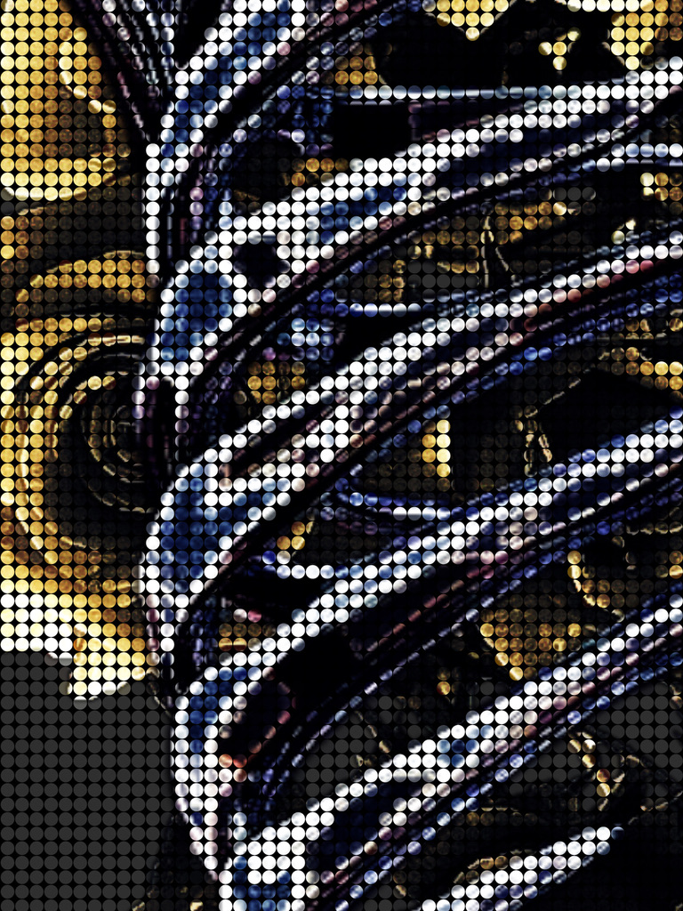
I got word that my divorce had been finalized at a speed that screamed strings had been pulled tightly. I couldn’t imagine Mark’s accurate ability to not be attached to me, in a way I couldn’t understand, because May would often enter my thoughts; I could never villainize her entirely; my feelings for her on any day was a deck of cards: one would reveal the Queen of Hearts, and I would remember the long talks in bed, and how smart she was; then, the King of Spades, and I would remember her racist rants and her torturing me. She made me feel so special and mature; she made me feel so used and damaged; it will always be a mixed deck.
After Kevon and I shared that night, I was nervous about returning to work; shame is sometimes not immediate, and I worried that he would have regrets, that I would remind him of them, and that it would make things awkward. But at work, he approached me immediately and started to talk to me without the hint of strangeness, which put me so at ease. He asked me if I wanted to try the coffee from his office, and motioned for me to follow him. Once in his office, he shut the door, had two mugs of coffee on the table, and kissed me hard. He didn’t play games or give me a chance to be concerned; he was just there, which was wonderful.
In the days that followed, I felt so alive again, like flowers lit up brightly, blooming and opening everywhere. There was no shortage of things that we tried, and I loved the mix of love and lust. I fell in love so quickly. My gamble on living had paid off, and now resurrected, I found that everything was heightened by it.
Kevon kept me updated on the serial killer case, risking his job, and bonding me deeply to him. I shared with him my thoughts, as I would have had I been able to work the case, and he would make my silent voice speak by his magic.
There is something about the law of attraction…
There is something about fools rushing in…
He was my perfect match. If I had known limited love before, I now knew true unconditional love. Soon, I had many firsts sexually and emotionally. I felt entranced by him. I thought, isn’t there something they say about charmers? Isn’t there something they say about things being too good to be true? But then I thought, but don’t they say something about striking gold or dreams coming true?
As time passed, he suggested that we get married, but I said I couldn’t after how quickly my previous marriage ended; undeterred, he said that it ended because Mark didn’t know everything, and Mark told him everything, with me filling in the gaps; he accepted those parts of me and loved me. I said, “I haven’t even seen your house, or know much about you.”
He said, “What does a house say about love?” I clarified, “I mean your space says so much about the person who lives within it, and I haven’t seen that expression; there’s more to know; nt the actual structure.”
Kevon said that his place was a mess, but we would get our own place, and to just let him clean the house while moving; so, I accepted this, and later in the week I made plans with him upstate, and said I would have to meet him there; while he was waiting for me, an hour away, I was claiming car trouble and breaking into his house; so, I couldn’t lie to myself anylonger and say Natasha is an outlier in who I am and my behavior; yet, after Mark, I felt like another heartbreak would be the death of me, but losing Kevon would be like then becoming a ghost and silently watching as time moves forward.
Unfortunately, I was astonished at what I found; his house was his real office, and it was a museum to the serial killer case, and included much more than he shared with anyone, and so much of the information he gathered he held close to the vest. Why? Why would you not disclose this to the rest of the team? Crime-solving is collaboration, so why not share everything?
Then, I walked into the kitchen and found it was a room dedicated to Keri and my family. Like a mad scientist, he tried to decipher us, and therefore see more of a picture which would remain in his private collection. That’s when a cardboard box with my name on it caught my eye; when I opened it, it was filled with private eye-style photographs of surveillance and other information related to me. Worse, he had a photo of me setting up the PO BOX, that I got to post the ad, which never made it out of the post office because he intercepted it, and it was also in the box.
Still worse, the deeper I dug, the longer I saw I was being surveilled, and astongingly before Keri was found to be the victim. If he didn’t know Keri was the victim, then why follow me before? I could not come up with any good reason. But, I didn’t think he could be the killer, because it was obvious he was trying to solve the crime, not intentionally memorialize it.
I left there, and I did not answer Kevon’s calls. I lay in bed, and I cried. It was the end of a dream.


Part Twelve: Bet Max
Natasha had so enjoyed the life, that once she accepted the life of a gangster, she thought would never be possible. Even though she cared for her little brother and me, she never saw herself as motherly, and so was shocked when she realized that she was always a natural. If Natasha could have frozen any moment in time, it would hands down have been the time before she was called back to the contract she had agreed.
When Natasha was called back, she was a much different person, in every way. She loved Raul, and so she ended her affair with her boss, Adam, because while she never attached much to sex, she was now in love. Unfortunately, this would cause her own first card fly when that rejection turned into a vendetta.
Some weeks later, her bill came due, and she got the name of the life she would have to take in exchange for the one the gangsters took on her behalf years ago: Raul Gonzales, her husband. She was told that he was stealing drugs from the gang they both called family, except he was a soldier and she was a captain. She knew this wasn’t true because she knew Raul; he was like most of the soldiers - he was exploited and wanted to belong, and, aside from his profession, was an honest man. Immediately, she knew that Adam must have had a hand in the Uriah Plot that she now found herself in. She told the other bosses that Raul was her husband, the father of her child, and she was not going to execute him. “Ok, then, you must pay with your life. Would you like us to grab some pills?” One of the bosses said, with perfect seriousness.
Natasha was desparate as she said, “May I have 24 hours to think about this?” She needed time to, but not enough to give them the impression she was going to run. It was nothing that anyone else would be granted, but she had endeared herself to these men in which she had been around since she was a teenager, like an effective novelty, and they were hoping she would see that there are other fish in the sea, and could get over one that would sleep with them, and so the consensus was that she would not be leave, because they would find her no matter where she ran, and there are things worse than falling on the sword, like unimaginable torture that never ends; so, once again in battle she demonstrated her greatest power: connection, and was granted the hours to choose whose life to take.
Then Natasha raced home and grabbed her son and Raul; then she looked me up and broke into my house; I found her there with her son. She told me what was going on and that if she didn’t kill Raul, they would massacre her family, just to stand firm in the example of what happens with disobedience. I was shocked. She told me her son’s name was Matthew, but to give him a new one.
It was most incredible and I didn’t know what to do, but then I felt like I wanted a reason to pick up and leave, ala Mark, and I couldn’t decline someone who I loved and was such a part of who I am; so, I told her that I would guard her son, as if he were my own, and we would hide; after I told her I loved her and she kissed my cheek.
Sadly, in a rush, she told me she loved me and then hugged her son and told him we would meet here in exactly one year at the same time, and by then, they would have enough set up to safely retrieve their son. Then presto, like the magic that seemed to compose her, she was gone.
After she left, I thought about how ten minutes ago, I hadn’t so much as a house plant; now I had Matthew, or rather, I thought, I need to rename him; I thought: Zillah, Zero, David, Solomon; I decided Zillah Solomon, and then in an instant, I became a guardian. I then grabbed anything important and packed up the truck, and we headed to somewhere warmer. I left a notice at my job that stated the family tragedy as a reason to quietly leave and try to guard a tiny child that was being hunted. I loved Natasha, but the further south I drove, the more questions I had do baby’s eat beef jerk? Do they like Mountain Dew? What do babies eat? Then, deeper, A year; that’s a long time. What are you going to do for money and child care?
Then, hearing the baby cry, I pulled over into a rest area and reached into one of the diaper bags, when I noticed it was full of cash, enough to keep the baby and me on the move, which took considerable burden off and offered more options to us; I figured that we would get an RV and see America; no address, less risk. It would be a year-long road trip with a baby that I found myself unprepared.
After we purchased the RV, we headed to Florida first, where we parked up in a catalog-ready RV Park, which was mostly retired seniors, but they were a little bit different, and I realized the catalog was actually a decoration to add reality for when the nukes were dropped; however, luckily, right when I thought about leaving, I met Delliah, who was a part-time insurance salesperson and part-time tarot card reader—a business, like others in the RV Park, was run from her mobile home; I loved the neon lights that declared her a psychic and open for business in passionate purple and raspberry-pink.
Having Delliah introduce me around, was like being vouched for so slowly people warmed to me, and I found that the RV park was not a sketchy or scary place, but a community where good people enjoyed the beneifits of fringe living, and who were largely left alone due to the road leading here, which was expansive, treacherous in neglect, and often flooded, beyond drivability, and of course, a study found there are more alligators on this road per year than people. People love that they know their neighbor, and there are rarely strangers, because this isn’t a place you “pass through,” or mistakenly wind up in, because there are many signs that tell the grave tale of the only road to an RV park that is the road’s only destination.
I learned so much from Delliah, and she was so patient when trying to explain how to care for a baby, and she never asked questions about our backstory. She loved that little boy; it was beautiful. Delliah also taugh me so much about Tarot, and even trained me to take clients, so I was able to hone a gift she manifested in me with her encouragement. During the day, she would teach me the intricacies of her field: many pieces of the universe, endless knowledge—the more information was all for the better translation for the universe. I had never thirsted for knowledge in the way that I did, trying to forget Kevon. I initially didn’t completely buy in until I did it long enough, and I was convinced that there was something a little magical about it; what that magic was, I couldn’t say, but it was there.
While baby Zillah and I were settled and secure, Natasha and Raul were on the run. This was not a situation you could talk your way out of; gangsters will always follow through with a threat because of the desire to never show weakness; that means being tortured to death. She could not believe she had ever loved anyone, knowing the risks, but then again, love is magic; so, Natasha, Raul, and a diaper bag full of cash headed to Canada, where they reached a remote hunting lodge area that her stepfather owned, and his estate had never sold; maybe, for the same reason Mark left everything behind for me. The cabin had two bedrooms, a small kitchen, and a dining room, and a stream ran right behind their house, so even while she was panicked, it would often lull her to sleep. It would have been picture perfect if the reality of the circumstances didn’t encapsulate it in darkness; still, Natasha loved Raul, and that held enough power to get them through this blackout storm.
Once in Canada, Natasha and Raul immediately got jobs on the surrounding farms, which paid under the table, with the crop usually being cannabis. With the money they saved, they had plans to purchase land farther up north and become self-sufficient in the wilderness, and then they would be ready for their son when they came to retrieve him.
In the beginning, Natasha was very sad, but she hid this from Raul, because he seemed to feed off her energy and match it, and she only wanted to see him happy. She trusted that her boy was safe with me, which eventually allowed her fake joy to turn into something less than happy but completely genuine, and, for the circumstances, this felt like a glass half full, and none of that was denial or substances. Luckily, the intense and time-consuming distraction of learning how to be fully self-sustaining also helped make it survivable for them; she would push fears aside by envisioning a postcard of her family on the prairie from the future to the present; like, Hang on because this too shall pass, and then… presto, it is a reality, the kind that can be sent as postcards to another time.
Unfortunately, the fear that Natasha regularly faced with herculean effort was a well-founded one, and one day she came home to a man with a gun pointed at her, another man with a gun pointed at Raul, and then another armed man at the ready. She was surprised when the men removed their masks, and one of them was George, who stood at the top of the pyramid, which seemed out of place at an execution.
Raul knew that if they didn’t fight, they would die; gangsters would take prisoners only for ransom, so he started being extremely animalistic and violent; he was shot swiftly, and Natasha started to scream, and the man asked George which of them should kill her.
There was something extraterrestrial in Natasha’s eyes; the colors looked like Earth viewed from space, and while she was tough and would not flinch, in moments such as these, she did not have the bandwidth to conceal nuance; her vulnerability came through, and added depth to them, which made them celestial. There is good in the worst of us and bad in the best; no matter where you find yourself on the scale that weighs your heart, we are all human. Looking into Natasha’s eyes sparked the memory of when she first joined the gang in her teens, trying to become one of them; George was mid-level in the gang at the time and was present for this initial introduction; the soldiers laughed hysterically until she ran down their operation to them: choke points, losses, and improvements, and how a Trojan horse, like a pretty teen girl, could expand their operation. This stopped the laughter and captured the attention of George, who was thirty years Natasha’s senior, and an intelligent and enterprising man. She reminded him so much of himself.
George grew up as the only brother to nine sisters in a very poor family. His father died in a freight accident when he was nine; his mother was a fragile woman who hadn’t planned on ten children, much less alone. George started running the streets to provide for his mother and sisters, and his natural drive and need for money proved valuable as he began earning, which made an impression on those he was also pulling in green for.
George was one of the few people who could live in two worlds and keep them exceptionally compartmentalized, so separate that if anyone from either world had been told of the other, they would have been in disbelief. His sisters, even his older ones, knew him as a surrogate dad who put food on the table; his mother knew him as a savior; his gang associates knew him to be cunning, charming, and effective; his adversaries knew him to be cutthroat and without mercy. He did things in his life he was proud of; his sisters all became successful women because he made sure they had what they needed, and later, as the money rolled in, much past that. He did things that gave him nightmares, and accepted violence as part of the job. It was a fragile balance.
Since the order came in to kill Natasha, George had been in a dark abyss, knowing that if he was half evil and half good, this would irreversibly push him past the point of no return. George had killed in service to the gang, but never a woman, not even as a witness. The best part of himself was his care for his sisters, and now his blackened conscience would negate that all.
Still, there was nothing he could do to prevent it, because there were men above him who came to a consensus, and if he pleaded against this order, he would not change their minds, but rouse suspicions, which would likely mean he would also meet her end, but also too may his sisters and mother; gansters know that the real pressure comes from one’s love of others over themselves, and so love can be leveraged in the wrong hands.
So, George went through the motions of looking for her without actually doing so and figured that he could at least give her a head start, and he knew her to be resourceful, and after time and lost resources, the search would be abandoned, with new and therefore more pressing problems pushing her father away into safety. Unfortunately, this didn’t buy him nearly as much time as he thought, before they added two relentless and ruthless men to join him. He knew then that this was about more than her leaving the gang; this was clearly personal, and then he put the pieces together.
When they did finally locate Natasha, he felt this horrible, terrified feeling, in which the ride to her was filled with cold sweat, and feeling like he was going to faint; still, there was no other option.
Until those eyes…
They unlocked a hidden door, and he saw only one option, and while not a long-term one, it would still buy more time. So, George said that he should be the one to do it, and asked the gangster to his right to borrow his gun; he then pointed the gun at Natasha, changed position, and shot the armed gangster and then the unarmed one.
Natasha was shocked as she was just staring down a gun barrel, facing certain death, but now, she was covered in the men who were trying to kill her blood. She ran up to George, and she hugged him, and he said, “You need to leave the country. I am going to say that Raul shot these two, and I shot you and Raul. I have someone at the morgue who can get me a body, and the grunts that come to clean up this mess will never notice that one of the bodies is not the correct one, but you can never return to the United States; you can use my sister Amy’s passport and stay with her twin in Switzerland. In the meantime, you will need to stay in my secret panic room in the basement until we can get you on a plane. Come with me now.”
Natasha, still in disbelief, got into the trunk of his car, and they headed for his large estate, where he had a secret basement that was a smart investment for someone who lived in a world where violence was par for the course.
The whole ride to George’s place was terrifying for a woman who had just witnessed the murder of her husband and two other men, and the space left no light in; it was pitch black. It just all replayed in her head without anything to draw away from it. She came so close to having what she would never have pursued, but ended up finding true happiness in the life that happened by chance, and now she had bet everything and lost it all. She cried the whole ride, but her son gave her reason to reach the next point so she could see him again.

Part Thirteen: Face Cards


Every day with baby Zillah brought joy to my life; he reminded me so much of his mother, and I missed her. It was so hard to think that one day, I wouldn’t see him every day. It felt like I kept losing everybody, and it felt inevitable.
For a few months, I tried to process everything because I thought that maybe whatever dark force kept peace and people from my life for long would then be exorcised. My life then became a routine: I would see Delliah for a few hours a day, work as a Tarot Medium while Delliah watched Zillah for a few hours, then spend time with Zillah, and at night, I acknowledged the many ghosts that always surround me.
First, Dad.
He appears with poker chips as eyes, and his mouth is an ATM that spits out cash endlessly evading him, as he wretched the painful vomitus and devastation at the loss of the spew. I tried to speak to him, but it was never any use. So instead, I imagined his life as I wanted it. I transformed his horrific childhood into a wonderful one, and he became well-adjusted. So, when he met my mother, he appreciated her, remained faithful, and became the father we always wished for.
Next, mom.
She always wears a light blue and white paisley sundress, the same one that she wore at her wedding and was later buried in, unable to separate herself from the man she wanted so badly to love her. It would be beautiful if it weren’t covered in the blood she was soaked in. She cries silently. I transformed her marriage into one of fidelity and true joy, allowing her to be the mother she wanted to be.
Then, Keri.
I remember Keri in two separate versions: one was the sarcastic, hilarious, artistic, talented, and self-assured girl who was my best friend; the other was someone who had been molded by time, pain, regret, loss, and guilt, reformed into someone who seemed nothing like the first. Keri and I have always had a deep bond, from the day she was born. As the oldest child of an absent father and an exhausted mother, I took on many of the child-rearing responsibilities, but it never felt that way; it felt like having live baby dolls who loved me back. I loved all of my sisters, but Keri was the yin to my yang, which meant that when we were together, we were a perfect balance, in a way that two similar pieces never could be, no matter how comfortable.
I felt so guilty. I felt so much regret.
I see Keri as a hyperactive child that matures at hyper speed into a woman with track marks on her arms and a haunted look in her eyes, and then she decays at the same speed into the bones, which then fall into the mass grave, which they had been found.
For so long, these are the ghosts that followed me around, and at night I openly entertained them, in the hopes that I could find a way to set them free from my mind. Being free sounded like heaven.
Then one day, Deliah asked me if I had ever had any spiritual work done on me. I said I had not, so she asked if I felt I might have negative energy stuck to me like tar, to which I said, “I suppose I do.” She then set a date, arranged for her sister to watch Zillah, and prepared for my “spiritual cleansing.” On that date, she asked me to wear white and said to expect to get wet; I almost reconsidered until I remembered my desperate need for liberation.
When the time came, she had spent much effort transforming her bathroom into an enchanted place, and her walk-in tub was also surrounded by candles.
She asked me to stand in the tub, which came to the level of my breasts. She then asked me to drink a psychedelic tea, which I turned down, until she said it was part of the process; so, again, my desperation won out, and I agreed; she then told me to drink the first third of the tea, which tasted of earth, rose, and honey.
She then turned off the lights, which enhanced the beauty of the many red candles dripping white wax, slowly running down the length of the cylinders.
“This room is now a place where you can meet what troubles you and let it go,” “close your eyes,” Deliah said.
I closed my eyes, and in the blackness, my ignited imagination, fueled by drugs, transported me to my family, many years ago, and we were all at the kitchen table, my dad was even there; it was one of only a few happy memories when my dad was still sometimes around, and things hadn’t escalated into contention and later acrimony between my parents, which lingered sticky in the air and attached itself like hard to remove, negative tar to more than just them.
I looked around the table, and everyone was having pancakes, laughing, and smiling, as Keri did her best impressions with precision.
Then the table started spinning; at first, it was slow, like a merry-go-round, which was fun, until it sped up, and it became clear we were sitting on a roulette wheel, whose speed began to make me so sick; with the distorted faces of the other spinning family members, adding to the nausea, it came with a vengeance. Just when I thought that this could not get worse, a ball came spinning in, threatening to clobber us. It seemed to go on forever, until the smell of herbs and oils brought me back into the tub, where Deliah asked me to finish the tea if I wanted to continue. I didn’t want to, but I needed to, so I drank the rest of the tea.
Then, she asked me to dunk myself into the water and stay under as long as I could handle. When I dunked under, I went down several feet into what was transformed into a vast ocean-like body, which was filled with dice, so many that I had to keep pushing them aside to get closer to the surface; as I got closer to the surface, the thought of more light and the ability to breathe were intoxicating, but I never made it, because all of the dice and I were sucked up into some sort of filtration system; as I was pulled through, the dice impaled me, until I finally came up and was with my father at the running tracks near our house; he smiled and said, “I’m glad you arrived; I know the ride is jarring.”
While I never completely blamed my father for the way things turned out, because his death took away a lot of that anger, I was upset, and that was something I carried with me; yet, he looked so happy and was so warm that it was disarming. He asked me to run with him, and as I did, he told me that he loved me and not to waste my life with games. I was surprised because I had never heard anything even remotely like this from him; then he said, “I hope you can forgive me.”
In that moment, I knew that I did, and I said so. He smiled, and then each of us was sucked up into separate roulette balls, headed in different directions.
I then ended up among many bingo balls, and when I was selected, I emerged in the tea house that my mother used to take me to when she still had luster; she smiled and said she loved me, and that I should always value myself, and that I should never stay where I don’t feel precious in value. I agreed, and she smiled. She then asked for my forgiveness.
I had forgiven my mother a long time ago because I had so many precious moments with her, and her value could never decrease, even tarnished and broken; still, I hadn’t realized until then how much I felt stuck in the pain of the experiences that came after her decision. I had to let that go.
I told my mother that I forgave and loved her, and then poker chips fell from above, and on impact, turned liquid; as the room filled with liquid, we each grabbed onto a bingo ball, and as we drifted in the water, we were separated further into what became an expansive ocean.
When I finally landed in an area of green, I was relieved, until I saw a pool cue coming towards me, and realized that I appeared to be in a crystal pool ball now. As the cue took effect, I shot into the air and ended up back in my childhood living room, where Keri was so young. I watched as she and a younger me performed the play The Problem with Being a Possum. As we danced around and sang together, I cried at the sight. She then stopped and told the younger me that she loved me and that I should never lose the magic of childhood. Past and present me both nodded in agreement.
Then she pulled a blanket over her and, like a magician, when she removed it, it was Keri, at the age when she died, but instead, she was healthy and radiant. She smiled at me, told me she loved me, and asked me to promise to live my life for both of us and not to live in darkness. I told her I loved her and agreed, as many cards were swept in and floated about us without gravity or destination. We both grabbed onto one heading in different directions, and I screamed in agony and desperation because the reason Keri is my strongest ghost is my incredible attachment to her and my unwillingness to let go of her, even her spirit.
When my card landed, I was back with Kevon; he was smiling at me in a sly way. There were so many undesirable things about me, and he never made me feel that way. He made me feel everything. I was able to let go of much of the shame about my life and sexual desires, which allowed me to feel a connection with him that I had never had before and had a hard time believing I could again. Seeing his face again so tangibly, after so long, felt like a sucker punch. I loved him. It hurt.
While frozen between my pride and pleasure, I felt I couldn’t breathe. I had never been suffocated before, and it panicked me. Kevon tells me, “I love you; wake up!”
I awake on the bathroom floor, and Deliah is giving me CPR while crying. She is so relieved to see me cough up water and then look at her.
She told me that I didn’t come up after much time, so she tried to pull me out, but I kept fighting her, like someone alert and actively drowning, not incapacitated. She tried fighting with me, but she was overcome, and then she was being drowned with me, until both of our weight pushed the door open, and we ended up together on the floor, along with a flood.
She kept apologizing because she had never had anything like that happen, and she was so scared that she was going to lose me. I hugged her, and we both cried. Then, she handed me a robe because I had forgotten to wear a bra under my white linens, and we cleaned up the water, both still shaken.
As I mopped up the water, I realized I had never been baptized, and while Deliah was no priest, still, she reminded me a lot of the namesake wilderness mind and man, and I felt a change within me.
Once everything was cleaned up, Deliah and I were both still wet and exhausted. She asked me if I wanted to order a pizza and watch a movie, offering that her sister could keep Zillah until the next day.
I wanted to decline, especially because I hadn’t been away from Zillah since I became his guardian, but then I just felt that caring for a baby would be too much in my condition, and I trusted Deliah, so I agreed.
We then inhaled the pizza and started a movie, but twenty minutes in, Deliah said she was tired and showed me to the guest room, which also had a TV. The room was as eccentric and esoteric as the decorator, and I found myself looking at everything: moon guides, lover’s stones, candles, tarot cards, and everything else you would imagine.
Then, Kevon’s eyes pop up out of the wall, ocean blue, which completes the siren’s call. It makes me cry as I am compelled to move into the ocean of his eyes, which say, “I miss you.”
The feeling of loss made me choke on water, and so I couldn’t say it back, even if I was willing to. His eyes say, “ That’s ok,” and then he comes diving in, nude, in his Iris sea, and we wade in the water, but the tides turn quickly, and then we are separated, but I am able to say, “I miss you, too,” before the violent waves tear us apart.
I woke up to an EMT giving me CPR while Deliah cried, and repeated the same thing she said to me earlier, and I realized that I was in that white dress without undergarments, soaking wet. I looked around at the seven people around me, then down at my chest, and then ran into the shower, and said I was going to just die of shame in the shower, and to pray for me on their way out. They chuckled, and then Deliah saw them out and when she came back, she sat awhile, as I took a hot shower; the warm water came pouring down on me, and it felt like revival to the cold renewel water I so recently almost drowned.

Part Fourteen: Backdoor


The “panic room” was one of the many precautions that showed how George was able to survive in the unpredictable and violent underworld for many years longer than most.
After George closed the garage door, he led Natasha from the trunk of his car and into the house, where he pulled her towards the broom closet at the back of the house; then, he pushed the flooring down and to the left and then moved it to the right and pulled up, which caused the startling sound of the hydraulic locking system letting out pressure; he said, “This is the only entry into the secret basement.” Natasha then realized the “panic room” was actually a full floor of an expansive house, that the blueprint wouldn’t betray, and the odd point of entry would ensure. The basement’s existence and extent were familiar to her: a life opulent enough to fulfill a third-grade dream of having a secret “Bat Cave,” mixed with the bitterness of the irony that this cave existed to avoid the violence that comes with the life of a gangster, which is one of isolation. It is why Natasha and George got along in a way that only kindred spirits can; the two were perfect pendulums that swung in sync, as one might experience only once in a lifetime.
Once unlocked and the floor pulled up, it revealed stairs leading to bulletproof, soundproof housing stocked with supplies to last 5 years. George said he would try to visit her as much as he could, but that he would be disinfecting and re-infecting the crime scene and dealing with the backlash of losing two particularly brutal assets to the company. When George said this, Natasha was worried, because she didn’t know what she would do alone, especially without her son, for long periods of time.
In those coming weeks, waiting for George’s sister to return to obtain her passport, Natasha would find pain equally as much time, which was torment. But then one day, she knew holding onto Raul’s ghost was disintegrating her mind, which she needed to get her son back, and so she made a choice and kissed Raul’s ghost’s cold lips goodbye; he understood because that is why he loved her after all, she was a mountain lion mother, so without protest he withdrew into somewhere else.
Once things slowed down after the massacre, George spent considerable time with Natasha, which caused him to realize the enormity of the sacrifice of not having his own family; he saw his sisters’ children with plenty of caution and preparation, so, with a busy life, it never hurt to go without, but now that he found himself falling in love with Natasha, he couldn’t help but want those things all for himself. She made him feel that he had wasted much of his life, but also that he still had life left to live, and he was the happiest he had ever been, just the two of them in their secret hideout.
Then, three months into Natasha’s stay, she kissed George, and he was surprised; he never thought she would reciprocate his feelings. It was unfortunate that this was the night he would disclose that he had the passport and that she would leave tomorrow, which he could have withheld, but he didn’t.
Natasha said, “What if I just stayed?”
George said, “That’s not going to work because when you’re seen alive as a dead person, that puts your life, my life, and by extension, my family, at risk.”
Natasha clarified, “No, I mean, what if I stayed in the basement bunker? Then, I can meet my son at the agreed time and place, in so many months, and then leave,” she then grabbed his hand and told him that she loved him, and that she wasn’t ready to part.
George was surprised because the wild woman he had known some years back was so much different than the woman in front of him today, but more than anything, he was relieved; George and Natasha loved each other in the way that can only be achieved sequestered; they were trauma-bonded in a foxhole, but then love transformed it into a cocoon. Perhaps, the two should have considered more closely the later ramifications of growing even closer when Natasha and Matthew, nee Zillah, would need to leave in a year, and he would not be able to see her, maybe forever, due to the risk, but the truth is they probably did, but their love was a magic salve that is set by a clock; up until the 11th hour, or month rather, it felt like there wasn’t a clock or anything to do but enjoy being with someone whose soul was intertwined with your own.
Natasha had a mantra that she used to proclaim so loudly that those words played in the head of everyone who knew her when they thought of her: “I’ll take my high-highs with my low-lows,” meaning that she could never lead a “middle-of-the-road” type of life; she had always enjoyed danger and pushing limits, likely in rebellion to an abusive step-father; it may be a self-fulfilling curse, because her life could be best described as a roller coaster, saga, or an odyssey, which turned full Greek tragedy at some point, especially when you consider that once she became a mother and fell in love, all she wanted was to be in the middle of the road with her family, out of anger, by her side.
Then, ten months into the year that Natasha had planned to meet with me, George announced that he had managed to obtain a passport for her son, which had seemed impossible because children are checked more carefully against the adult companion’s passport. Still, his love was personified in the “miracles” he conjured for her benefit, and the fact that he made it seem like it was all taken care of, while losing sleep at night knowing that he may not be able to make something like traveling with her son internationally possible, but there was something in the way that Natasha never had the type of care he gave her or expected it, that fueled his desire to give her another life, even knowing that he may never be a part of it. When love is selfless, then it is timeless and ageless, and it is rare; if Natasha never had enough of what one should have, George made up for all of that by miles.
When Natasha saw that the surname matched the one he got from his sister, she said, “Your sister was willing to do this? I thought you said that you were not going to ask her to bring her children into this?”
George had sacrificed so much for those he loved, so he knew his sister would help, but he didn’t want to risk anyone else’s life, and he wanted so badly not to inform or involve his family in his other life, so he tried to find another way to get a passport, but with the surnames needing to match, it was like finding a needle in a haystack, and as the grains of sand in the hour glass became so few that he hardly slept, he knew that there was no other way, and so he asked his sister, in the process, explaining what he had carefully concealed for so long. His sister Esther and her twin Hester had been given so much by their brother that, while they could have cut ties over the risk or given him trouble at the worst time, they just helped him and started working on fortifying the Switzerland estate and rehearsing the cover stories. It was hard to accept a life that now included an incredible amount of risk, but his sisters had benefited from the life he had provided, which had created hearts good enough to want to protect a woman and child who were hunted by monsters and who could be helped by no one else.
On the flight home to Natasha, those passports caused a clock to ceaselessly audibly tick inside his head, realizing that 60 days was all they had left. There is always more time until there isn’t, but there is much to be lost in worrying about losing something; all he could think of was how much she had enhanced his life in ways that he knew would be missed in a way that would feel like an entire loss of color in his life, and what could replace that or stop that pain? George cried more on that long flight than he had in his entire life, just thinking of having to say “goodbye” to the only woman he had ever deeply loved.
George said, “It is ok; she wants you two to be safe. Both sisters will be there with their families and will help you both adapt,” which set off an endlessly ticking clock in Natasha’s head; she had been so excited to see her son and being in love that she hadn’t really let it sink in that her new life would be sans George; the magic protection from reality was then broken.
From then on, it was quite sad for both of them, but they put on a brave face for each other; even so, it was hard for either of them not to cry at any moment. If we spend our whole lives hoping for a tiny amount of love, what happens if we find the most powerful kind and can’t hang on?
If love is a bridge, then their walk together was a true transformation, but sadly, at the end of that bridge, they knew only one of them would cross. It was a soulmate match, enhanced by nesting, only to be reduced to screaming or silence, and left in constant discord. Those two months were in bitter contrast to the many before them, and both seemed set to sabotage whatever time they did have rather than treasure it, but what can be done when it is the subconscious mind running the show?
Then, the week before Natasha was to pick up her son and head to Europe, George decided he would forever regret it if he didn’t give them the kind of warm goodbye that was true to his feelings and not his fears, which had kept them both at a considerable distance, especially in contrast to the previous melding into each other. Natasha was receptive, and so glad that he had swallowed his pride, and somehow the pair did the impossible, and that magic salve gave them such a beautiful last week together. The two were good and bad in perfect proportions solo, but together they brought out the best in each other and canceled out the bad; nothing transforms like love, nothing comes close.
The night Natasha was meant to retrieve her son and head to Switzerland, George remained stoic so she could be strong for her son. George loved her so much and wanted more than anything to go with her, but that would put everyone at risk.
Natasha had the same strategy and had been trying to avoid thinking of leaving George to stay strong for her son, and had also been drinking to numb herself. Raul had been a light in so much dark and had given her a family she never would have pursued, and she would always have love for him, but George was the love of her life, and she knew that she would never meet someone like him again, and so would likely not love again; there’s something about taking consolation after experiencing the supernatural that would lose its appeal completely. So, then the two star-crossed lovers were huddled together under the cover of night, waiting for me to hand over Zillah, and then, dreadfully watching their love story end.
Sadly, I never showed up, so they were forced to wait until the sun began to light the area; George wanted to protest leaving before they were detected, but he loved her and knew her child was everything to her, so they remained.
It was in those early hours that fate would again deal Natasha the hardest hand of her life, because it was while walking back to the car to return home to try to locate me that Natasha met with the eyes of the man who tried to have her killed to save his hurt ego, who was driving to a meeting. The mobster naturally did a double-take and then stopped the car entirely, believing he was now being haunted; he was quite frightened until he saw George and put it together: the huntsman had saved his target.
When George noticed the stopped car and who was in it, he nearly fainted, because this was a man who had called for the torture of men that left an impression on foe as well as friend, and Adam was not one to let go of a vendetta.
George screamed, “Natasha, get into the car now,” and the two jumped into George’s car with a monster in pursuit.

Part Fifteen: Blinds
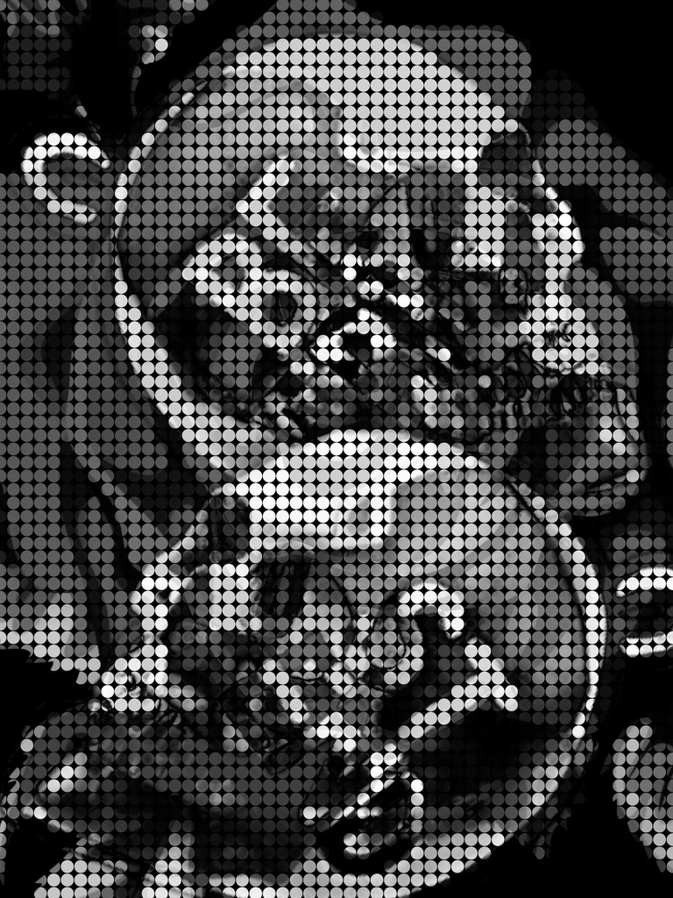
It could have been the powers of manifestation over anything supernatural that Deliah had aided me in, but after that, I felt so much lighter and less haunted; then I enjoyed a couple of months of true joy; still, I knew my time with Zillah would be coming to an end, and I knew I was going to miss him. As he grew, he reminded me so much of the Cheshire Cat, and was entertaining and always up for entertaining; he had so much personality even at that young an age. I saw so much of Natasha in him, and it made me miss the only intimate friend I had ever had; yet it gave me a part of her that eased that pain. I would have never spoken or wished for the mantra of Natasha’s youth about taking life’s low lows if it meant there would always be the highest heights, but nonetheless, I ended up living that life, seldom finding myself in the middle of the road, which I had always wanted to be. Entering the gambler’s life by choice is so much different than being forced into the stakes; I would have easily forgone life’s highest moments if it meant I could avoid its lowest; yet, here I was in one of the highs, believing that I had beaten the odds, or the curse, and that the water washed away whatever held me back or whatever ghosts clung tightly, and I would never see another low-low again.
Sadly, it was a month after my cleansing when that theory would be proven false with devastating force, when, out of boredom, I picked up Deliah’s paper, while I waited for her and Zillah to return from the park; in that paper were the details of a gang-related slaying on the East Coast, which left four dead. I dropped my coffee when I noticed among the slain were Natasha and Raul. The mug broke and shattered everywhere while splashing scolding coffee all over my body. All I could do was scream, “No,” then I felt anger for the first time at a God whose love so recently felt like it had saved me; I couldn’t help but think, you can take something or someone, but not everything and everyone; you cannot survive like that. Worse, I was not that far from meeting up with her and reuniting her with her son; it would have been a life on the run, but a life nonetheless, and so I was devastated.
Now, I had Zillah and a promise to protect him no matter what, which was a huge task before the 1-year commitment turned to 17 more years. I didn’t know what I was going to do, but I did know I would never break the promise I’d made to a woman I owed my life to. I felt many times so depressed that I wondered if I would be able to continue, and I often thought about not, but out of some sense of duty, I kept with it, even though I was a zombie; keeping my promise kept me safe in a way I was never able to do for her, which was one of the greatest regrets of my life.
My new state of mind must have been apparent because Deliah commented on it, and I said that I had lost someone very important, which she understood better than anyone, having lost her partner of decades, and felt the constant pain from the loss; unwilling to want to find love in this life, and then Deliah had lost her only daughter to breast cancer, and had no grandchildren, so Zillah gave her a joy that nothing else could and she loved him as if he were family, so she offered to watch Zillah for some time while I cleared my head, and I gratefully accepted.
During this time, I drank, smoked pot, ate, thought, and repeated; it was a bodiless wake with fully embodied pain. I felt as though I could figure out how to proceed or have the emotional strength to do so; I had been in such deep pain that it did not lessen with time, and so I wondered if there was anything that could help lessen it, and what I kept going back to was seeing Natasha one last time, even in the morgue; I knew that her body would be evidence and likely for a while, once they realized that those slain gangsters were involved in a series of armed robberies and murders; thinking of this, I knew one person who would have access to her body… Kevon, yet I anguished over swallowing my pride and calling him; I would have been happy to forget a time when I almost had my dreams come true and avoid dredging up the pain we caused each other in the end, and if it were anyone but Natasha, I would have stayed away, but instead, I decided to call him, under the guise of having left my only family photo album, where the members now were in real life either dead or detached, in this photo, all were still alive and in times worth taking photographs.
After much internal struggle, I called him, not expecting him to pick up on the second ring. I froze and hung up the phone. Then, I jumped when my phone rang. It figures that the F.B.I agent who was overly curious about everything couldn’t let a hang-up slide. I didn’t answer it. I wasn’t sure what I would need to feel ready for this mandatory task, or was it like having a tooth pulled, one more day of preparing would lead to one more, and be ceaseless. I am a pretty fearless person, so this fear made me realize how much I still loved him; then I realized that I don’t think I ever stopped, but self-preservation kept me from fully feeling it. I asked Natasha in our youth what would make her love a boy, and thinking of my own answers at the time, which were pleasurable over practical, I was surprised when she said, “The only way I could ever love anyone would be if they truly understood me entirely, and wanted to stay.” I believe Natasha, to avoid being hurt, tried to self-sabotage, believing there was no one who could love her fully, and not realizing that, many years later, as a young woman, she would find her soulmate; that stuck with me, and while there were plenty of pleasures with Kevon, the brunt of the magic was being known and still loved, which is why whatever he was doing in his museum of tragedy, with plenty of exhibits that included me, was all the more confusing.
Thinking of him made me cry, and then the phone kept ringing. Only Kevon would take a hangup and likely misdial into a marathon of rings. I took the phone off the hook.
I was unsure what to do. I hadn’t prayed much in my life, but I prayed for strength and guidance because I felt I needed assistance. The aspect I hadn’t considered when praying in such general terms was that not only if but how that prayer is answered is not within your control.

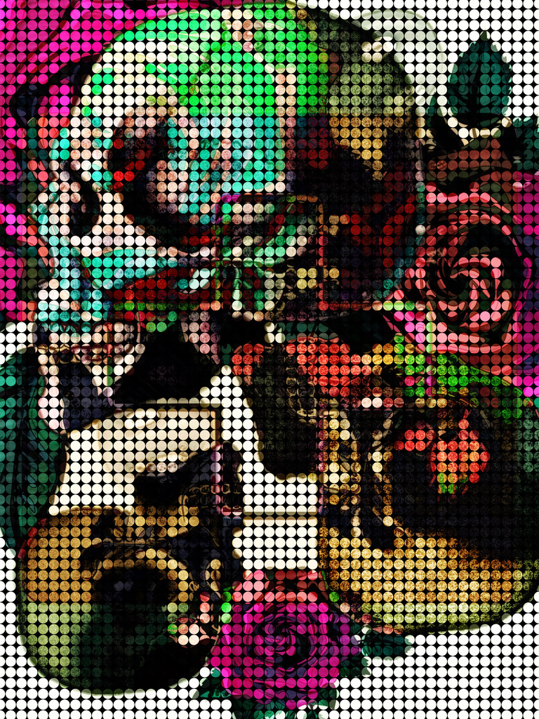
Part Sixteen: Calling

George’s sacrifice for Natasha, including murder, staging a crime scene, faking Natasha’s death, and harboring his target, who, if he were found out, would mean he would be tortured to the death he would pray to come once it started, had been for naught. It was devastating.
George knew that he would never be able to stay with Natasha and his sisters, because of the risk to all of them, but part of him had hoped that he might one day retire there; now, he had a reason to go into hiding with her because neither were safe, but he knew that she would never leave without her son, and if she didn’t leave, death was the best case scenerio; he never wanted to part from her, but his love for her was what let her reach safety, so he said, “Natasha, you have to go as planned without your son, and I will go into hiding while trying to find where your son is. Staying here is the only thing that will guarantee tragedy, but at least we have a chance if you go.”
There is nothing in the world that Natasha wanted more than to stay until she found her son, but she knew that George was right, and she couldn’t be walking around regularly in the daylight, seeing as she was certifiably dead. She also knew that George loved her in a way that was so encompassing and deep, and he would stop at nothing to see her happy, so he gave her some hope.
George got Natasha to the airport while keeping a calm that was the opposite of his internal hurricane; after he dropped her off, he knew that he could never go back home, as he was now a hunted man. His first stop was to abandon his car at the airport and take a taxi to a sketchy car lot, where he purchased a used car with cash, and then headed to South Carolina, where he had a small property under an assumed name, for this very reason. The first night he was there it rained nonstop and then didn’t stop for days, and those days were so lonely; he knew he would miss Natasha, but when someone is a constant in your life, then individual happiness becomes completely intertwined, so they couldn’t experience it independently of each other; they never saw codependent as an issue, but instead a wonderful state of finally being fully accepted and together: the wish both had secretly wished for their whole lives which were lived paralleled only to later intersect with great force.
Unfortunately, George began to lose his mind in that desolate, isolated property, but more than anything, he was haunted by happiness almost attained; is it better to have loved and lost? The pain made him almost wish he had never had it, but then there was something she gave to him during their time together, which reawakened him and gave him his first dose of absolute love, which had opened things in him, and so he could never wish he had never fallen in love, even knowing the outcome.
Natasha found herself in another parallel with George, as she shared the identity with George’s sister and stayed in the secure compound George had purchased for his family, located in a remote part of Switzerland. Natasha was concerned that his sisters would hate her for risking them all, and what revelations George had to make to make that possible, but that was not the case; both Hester and Esther were more than willing to protect a fellow woman, as they would want done for themselves, which made Natasha continuously think about how the ugly things George did gave his family a chance to be beautiful people; life is so odd when looked at in black and white, but once you add depth and color, it changes the whole scene.
Initially, Natasha declined the many gracious personal invitations from George’s sisters because, while she was not one to lie in sorrow, she never had the luxury; she was in deep emotional pain and worry, and she could not bring herself to do anything but be miserable. Still, eventually, Natasha managed to pull herself out of it and started planning to get a property ready so that George and her son could join them. She also started learning the language and worked full-time on a farm, where she made organic beauty products and saved all her money. She told herself to focus on manifesting the life she wanted instead of worrying about the life she no longer had or had control over, which took discipline, lucikly while she was in the process of hoping, she finally opened herself up to the twins, who lived on the compound in which Natasha also stayed, all in separate houses with the twins living with their families. During this time, Natasha reluctantly joined the twins’ church as something to do and to be supportive; at first, it was strange for the former gangster to be there, and she worried she would be judged and rejected, but then she found this was exactly the place where she wouldn’t be, and she found true meaning and acceptance there and went all in. Natasha was baptized outside in a group ceremony, and she told herself that when she came up out of the water, she would be new, and that her tears would add to the cleansing water as she was reborn.
Natasha has many tattoos, but her most intricate is a butterfly, which was a metaphor for her: ever-transforming, surprising, beautiful, and regal; this day, it was a personification of the soul.

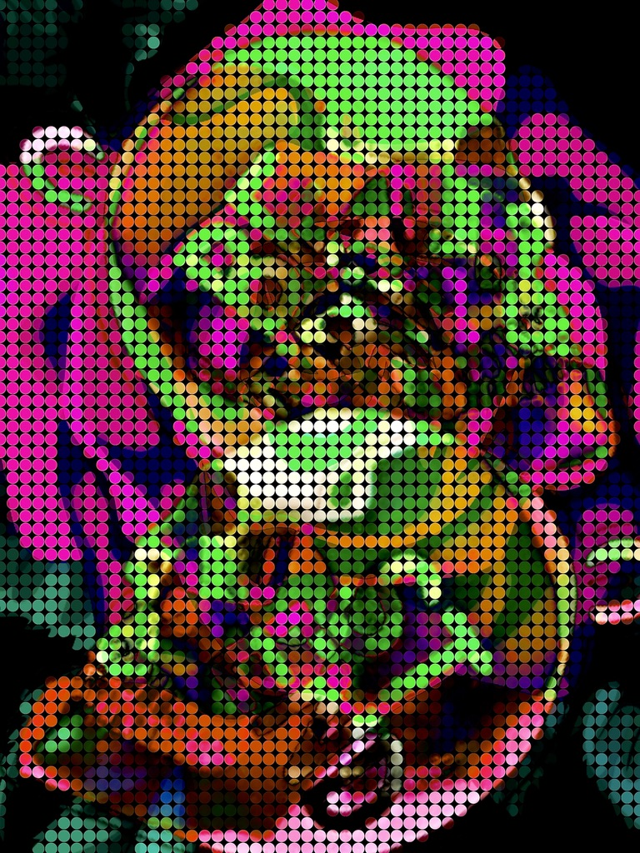
Part Seventeen: High Rollers
I had underestimated my former lover being a detective; his job was always his passion, and so my phone rang regularly while Kevon showed that even a likely wrong number would need to be investigated to the hilt. I wanted so bad to answer because I knew I would never be OK if I didn’t see Natasha before they buried her, but the pain of actually speaking to him was too much, and so I couldn’t physically bring myself to; ultimately, I decided that I would probably not be able to, and at that time, the phone calls stopped, which was oddly depressing, considering I was the one who let the phone ring without answering.
Then, baby Zillah needed to come back into my care because Deliah was having surgery on her hip, and while I didn’t feel ready, more time wouldn’t change that, and once the little guy was back in my care, I realized that he needed me because his parents were dead; I figured the best way that I could honor Natasha was to care for him, so I decided I would let go of my obsession to bid farewell to her earthly body.
It was minutes after I had fully accepted that I would never see her again, but that I would see her daily in Zillah, when the doorbell rang. I was expecting Deliah’s sister, who was picking up some meals I had premade for her for the week, so I yelled, “Come on in.” My back was turned when I heard the footsteps come in, so when I turned around, I dropped the casserole, as the face staring back at me was Kevon’s; he said, “Damn, baby, you should have stayed in police work. I had a hard time tracking the phone number to this address and you.”
I was dumbfounded and soaked in cheese, mushrooms, and breadcrumbs; I didn’t know what to say at first, but then the words just came; there was always an ease to us, so I said, “My God! You flew here because someone hung up on you? Are you a psychopath? Did your museum lose its appeal?”
He smiled at me, and it seemed that I never infuriated him in the way I did everyone else, which was as attractive as it was surprising; he said, “I am not a psychopath! I wouldn’t travel all this way for a hang-up call, but since you left, I will check into calls that come in, which could be you, and eventually it was. What museum?”
This was the most beautiful thing said to me, and yet I remembered all I knew about him, and that diverted genuine romance into a jab when I said: “You have all that stuff with my family and the serial killer investigation going on in your house, but worse was seeing the surveillance of me before Keri was even disclosed as a victim or my sister.”
He said, “This is why you ran? Oh my God…” He dropped his head and shook it side to side, and said, “Baby, I wasn’t surveilling you, well, not exactly… we were surveilling your ex-husband, because there was a tip that your sister had been seen with an officer who fit his description, but once we found out she was your sister, it made sense, and so we moved on; I mean the higher ups wanted to not waste time, and so I stopped investigating him, but yes I fell in love with you while investigating you, because it was not a concious decision but instead a natural and magical connection that was formed until you shredded my heart.”
I was shocked and said, “Mark never met Keri. I met Mark after Keri was gone. He just felt connected to her, though; he even took her keychain home, just trying to solve her case. You have the dates confused.”
He said, “What keychain? That was never in evidence. Are you certain it was hers, and you never had possession of it?”
I said, “I am certain it was hers. It should be logged into evidence.”
Kevon realized that falling in love with me had allowed him to ignore his strong sense that something was wrong about Mark; now the flood of mental evidence he subconsciously suppressed came rushing like a tidal wave, and he knew that a likely serial killer was roaming around.
The recognition in Kevon’s eyes sparked something in me, and so I got slapped as the wave hit me; there were so many things that fit.
Kevon said, “Shit, baby; I’ve got to go.” The fact that he still called me baby, even after I left him, and he didn’t know if I was in a relationship, was so entrancing and confident; that is, until I realized that Mark had likely killed my sister before he knew me. I wondered when he knew I was her sister, or if this was one of those eerie moments in life where lightning strikes twice in the same place. As the shock set in Kevon said, “I have got to go; I will come back for you. Don’t tell anyone you are here or leave.”
I said, “Actually, please don’t tell anyone I am here, I am hiding out here.”
He raised an eyebrow, stepped forward, kissed my forehead, and left to catch a serial killer; during the ride, the horrors of the investigation came in to haunt him; those girls all had so much potential, and now they were pieces and memories.
The ensuing investigation was as covert as they come, as they were investigating one of their own; my sworn statement about Mark’s possession of Keri’s Princess Press keychain was enough for them to search Mark’s home while they called him out of town to help with a bogus investigation. What they uncovered was expertly hidden and enough to arrest Mark for multiple murders.
Surprisingly, Mark confessed right away, saying he had been feeling haunted by the women, especially Keri; he immediately pleaded guilty to try to appease the ghosts, but asked for the death penalty, which the judge denied as he figured prolonging the haunting seemed fitting.
During the investigation and sentencing, Kevon was extremely busy and concerned with protecting me, so we couldn’t speak, and I missed him. I still wanted to see Natasha’s body, but that place was too hot to even think it possible; the only comfort I drew was knowing Natasha would want Keri’s killer in jail over feeling her best friend’s tears fall upon her.
It was a month after Mark’s sentencing that I couldn’t help but feel that Kevon had cold feet or moved on, because he never tried to contact me, even when things should have cooled considerably. I felt rejected and started breaking down in tears at random, and everything started to remind me of him or sound like his tone. The sadness on top of everything was unbearable, but then it seemed that any time the sadness drowned me, Zillah picked up the pace of being adorable, and it always let some sun break through the darkest of storms.
Then one day, I noticed this black SUV was constantly creeping around our trailer park, and I started to think the worst. I was very scared, and so the seeds of fear of staying here were sown; I wanted to stay because Deliah meant so much to me; she was this esoteric, motherly figure who loved Zillah as much as I did. I never thought I would be close to someone again, and it was tragic that now I was, only to know I have to say goodbye.
All of this fear also made me realize that I was hoping that Kevon would come back for me like he promised before he left, and even though it seemed like it was a game to pay me back for ghosting him first, it was everything to me, and I didn’t want to let it go, regardless of the contrary evidence.
Deliah was almost fully recovered from her surgery when I told her that I would need to move on with Zillah to Canada because a family member needed assistance. She told me to just go and come back, and she would watch my place, but I declined. She then began to cry because she had grown attached to Zillah and me; we were her family, we filled her life with joy, and she was sad knowing how much different life would be when we were gone. I hugged her and told her that we would visit.
Then Zillah and I moved on to Canada, and the whole drive, I cried because I felt so foolish for falling in love and trusting; once there, I found us a small, remote house, with the closest store a general store two hours south; the post office wouldn’t even deliver, so PO Boxes were required. I spent my time learning about how to homeschool Zillah and working on ways to be even more self-sufficient. We weren’t there, but a few weeks later, when I heard a knock on the door, which terrified me, as there are no deliveries or neighbors, so fearing that we had been found, I grabbed Zillah and ran out the back, and smacked right into Kevon; of course, he rang the front doorbell and then ran to the back, correctly predicting my moves.
He smiled at me, and I started to cry, so he held me and told me he was sorry, but he needed to make sure everything was set without exposing my location. I understood this. He had a duty that saved lives and got my sister justice, but I also felt so abandoned by him; yet, he had a way of disarming me because his care felt so genuine. Baby Zillah, in my arms between us, started swatting at Kevon’s new addition beard, making us both laugh. I pulled away and signaled for Kevon to follow me inside, and I put Zillah down for a nap; then, he and I snuggled up on the bed, unable to speak because the emotion was too strong and the floodgates were barely kept at bay. He felt so good and smelled even better. I loved him.
After an hour, Kevon pulled something from his pocket, got down on one knee, and said, “Will you marry me?” “I have it arranged so we can go now to the embassy and then on a honeymoon. I brought your friend; she can watch your son. I will adopt him.”
At first, this made me realize how little he knew about me, since Zillah was not my son, until I realized he was my son, and that this man, without question, included my son, which made me feel so much love for him; although I would have some explaining to do and wasn’t sure how to, I somehow felt safe to do so. Natasha’s voice played in my mind: “If someone ever knew me and loved me, then, yes, I would believe in soulmates.”
I knew Natasha thought it was impossible, and I found it by some miracle, so I felt I would be doing him an injustice by not entirely embracing it; I pulled him in and kissed him; then, forgetting to say “Yes” with actual words, I said it, and he hugged me and kissed me.
After some time, we walked to meet Deliah’s car, where Kevon stepped away for a moment while I handed over Zillah’s possessions, and Deliah said, “He’s a keeper. Thoughtful; smart; handsome; with eyes as glorious as oceans.”
I raised my eyebrow and then smiled. It was beautiful to see my friend so happy for me, and it meant a lot that she loved Kevon. Then I said goodbye with no sorrow, knowing I would see her again so soon.
Then Kevon and I traveled to and married at the embassy in Switzerland, where we also honeymooned. The night before we married, my conscience required I be honest with the man I loved more than all the hate combined, so I filled in a lot of the information I had withheld, including Natasha, which meant I admitted committing felonies and dereliction of a duty in not reporting and stopping her, and that Zillah was her child, and his father was one of the other gangsters killed along with her. All the time leading up to this, and especially on the plane and train, I agonized over this moment based on the high odds he would walk away over getting involved with someone he knew to be a magnet for disasters, who also had committed crimes, and had a family history that rivaled the House of Manson.
Expecting the worse, I flinched until he smiled and said, “Family is where your heart is; your heart is inside of your chest which is caged; your chest makes a melody, which makes my heart sing;” this was a perfect response because it was our inside joke; I am so socially awkward, so if I ever got nervous, he would recite off-the-cuff, over-the-top romantic poems, which made others withdraw and made me laugh. I loved him for not making me need to go further into the dark waters that had a way of always pulling me under, and for making me feel so accepted.
Then he kissed me sweetly, but after a moment said, “Hey! Wait…”
I was startled as he continued, “Natasha could not have robbed the bank because we ran the prints from the Jane Doe from the shootout, and it did not hit for any crimes at all, not so much as a traffic ticket.”
I didn’t question our good luck because it meant I hadn’t been tied to the woman in the robberies, and therefore, Kevon had no dilemma.
Then, while drinking at our hotel bar after we got married, I saw Natasha’s doppelganger delivering vegetables to our fancy hotel bar near the embassy. I took this as a sign that this was meant to be, but then, I kept looking at this woman and thinking, what are the odds that someone looks almost identical to you? This was not just close, it was absolute.
I didn’t want to be creepy to this local woman, so I approached slowly like a cat and realized how I increased my creepiness exponentially with this approach, and then it seemed like I was going to pounce on this woman because I overcorrected; expectantly, this startled the woman, who fell into the vegetable cart upon seeing me.
As I helped the woman up, I realized it was Natasha’s ghost, and I realized I had finally snapped and gone fully mad; it made sense based on the accumulation, and so while I was devastated, I thought how being married for a day before I went to the hospital, likely forever, was more than I had expected.
My dramatic, silent reverie was broken when the woman started laughing and said, “Lola, stop staring at me like a fool and help me out of this cart of vegetables, which are now useless due to my bum and beaver being rubbed on all of the produce.”
I was just thinking that death did not diminish her sense of humor when she pulled on my arm and lifted herself up in the process. Once face-to-face, she said, “What are the chances?” Then hugged me and we both cried.
After some time, I said, “I thought you were dead,” and then, “How the hell are you alive? My God! Only you.”
Natasha smiled and said, “I need to fill you in, but first, where is my son?”
I told Natasha that he was safe, but we should speak in private, so she gave me an address and left to finish her work.
Right after she left, Kevon came over and said, “Wow, there is no way I could get a phone number after ramming into someone like a bull.”
I smiled and said, “No, I actually know her from the states and we are going to have dinner tonight,” and he echoed Natasha, saying, “What are the chances?” Then Kevin and I walked through the hotel’s botanical gardens, and those words kept playing in my head on repeat, what are the chances? My mother, eventhough she became unraveled later, had always been firm in her religious beliefs against odds, whereas I had usually adopted my father’s ideas that said there wasn’t a god, only yourself with luck and skill, so I never had much faith in anything outside of myself, but this moment in time changed things for me; sometimes a sign is all faith needs to be ignited, and I got a bright neon, leopard, and vanilla scented sign, so this was my revival.

Part Eighteen: Limit

When we returned to the hotel room, I showered with Kevon, our first shower as a married couple. After I had dressed, I called for a cab, and Kevon said he wanted to join me, but I explained I needed privacy to clear the air with this person, so he called me a cab and provided the address from the slip of paper that I handed him.
The cab ride was long, and during it, I wondered if maybe life does try, by law of its own goodness, to balance things out; for so long I had felt like tragedy followed me, but now I felt like I was seeing dreams like marriage or dining with ghosts come true, and it made everything sweeter, but sometimes the memories made it sadder. It reminded me of Natasha always saying, “You want this layered, fragrant, romantic rose, then you must refrain from shaving off the thorns.” My life turned out to be a bed of roses, just the natural kind with thorns, and that bothered my none. It was a serendipitous thought because not long after having it, we arrived at a compound-like place with large gardens, gardening structures, and many rose bushes.
I knocked on the door, and Natasha answered; she was cooking and asked me to call her Mia, and I said I would only call her “The Possum” based on her performance art of death. She smiled and drew me into the kitchen, which looked like something a professional chef would cook in; seeing my astonishment, Natasha said, “Oh… It’s a lot, right? But I figured if this is my next act, I should pursue something I love, and self-reliance is it.”
I could tell she was so worried about her son, so I filled her in on Zillah; she loved his name so much she wanted to keep it. I then went into my own saga, which included a serial killer, a guardian, and true love. Natasha cried at the news that Keri’s killer was behind bars and expressed happiness in my own. She then told a tale that rivaled and resembled my own epic journey to this point, which included murder, false death, and true love. I offered my condolences to Raul and expressed joy that she had found George; she immediately started crying, saying she had no idea where he was.
Then she pulled it together because the cooking timers were going off, and she resumed preparing our feast, with me helping. We were hustling around so much that we didn’t notice that someone had come in the door, so I didn’t see it coming when I went to use the restroom, and someone grabbed me and put a gun to my head, and then pulled me back to the kitchen, where Natasha dropped a knife on her foot, which began to bleed everywhere. It was clear she knew this man.
Natasha was fearless, so seeing her shake as she spoke only terrified me more. I said, “Who is this man, Natasha?”
Ever Natasha, she said, “A loser whom I turned down and seems to have come back to prove why,” which naturally got the party started, as he ran towards her to hit her, but slipped on her blood, falling hard into her, ultimately landing on top of her, pinning her to the ground. I went to grab the gun, but also slipped on the blood, which made the whole floor a slip and slide, and the amount immediately made me concerned that any further loss of blood would mean her second death; can you imagine if someone shot Lazarus as he sprang out of the pits of death?
The blood wrestling then ensued, and we looked like we were in a slasher movie, only to be interrupted by someone clearing their throat. I thought, Kevon does that when he’s nervous, only to turn and see it was Kevon; he said, “You look like ‘Carrie,’” “You did not tell me to dress for this volume of blood,” “Who is this asshole with a gun?”
Natasha answered, “This is the top boss responsible for a crime network that includes those murders and armed robberies, and that quadruple shooting. I could tell you more, but I like you, and want you to be able to sleep again.”
The gangster took advantage of the distraction and shot me, and as I fell to the ground, Kevon shot him.
Then, Kevon and Natasha knelt beside me, and I told them I loved them the last time before it went black.

Part Nineteen: The Whale

I am in Las Vegas, walking around, when I see Keri, so I chase her through the bright lights and sounds into a newly built hotel, which has dancing water to beautiful music, where she slips through the VIP entrance, which I was also not able to gain access, on account of not being on a list or a VIP. I look back and see the line and the wait looks like hours, so I keep telling the doorman that I need to get past him, because I see someone who I believed was dead and is clearly alive, and I am her sister. The man laughs and says, “That is original.” He lets me in.
The club is packed, and the music is so loud it is vibrating the floor; everywhere, people glitter, and most seem to be with someone or are trying to be, because there are very few stags or strays. I push through the crowd looking for Keri, and on the way, I get pulled in to dance with people. As I get past a few, a new group would pull me into dance, until I get corralled into the bathroom, where several people are snorting different varieties of colored powders. Once, a woman dressed like a pop star in pink pleather hands me a straw and says, “Looks like you need this.” I say, “No, thank you. I need to find my sister.”
The pleathered diva says, “I will help you if you relax; take this pill.” I don’t want a pill, but I want help, so I took it.
After I took the pill, she grabbed my hand, and as we went around the massive establishment, I found that I was attached to the queen, who insisted upon holding court while we looked for Keri, which was slower than when it was me as a small clam being pulled with the currents, unable to make progress.
Then I look up at the balcony and notice Keri, who sees me and takes off again. I go after her while my new best friend was attached to my arm and did not let go, even in pursuit. As we ran, the club dropped chips, balloons, and confetti on the crowd, and everyone went nuts.
I checked every inch of the club, and I couldn’t find her. I didn’t know why she was running. I decided she was likely at the casino, so I ventured out.
As I walk past a table, a man puts down four queens, and the people go crazy as the casino staff fills bags to the brim with chips, which attracts a large group of adoring women, who leave when his luck changes not much later in the night. Life is broken down into our lucky and unlucky times because we only remember impactful moments rather than the routine, and so you always know if you’re in the unlucky that the lucky could be around the corner, which gives you hope, and it gives you the wisdom to enjoy any luck before it changes.
As I continue, a woman with Natasha’s esoteric eyes is arguing with her partner, saying that she wants to gamble the last they have left, saying, “You cannot win big without risk.”
My attention is distracted as a man who has just lost flips the table, sending cards and everything else flying, which started a fight. The instigator threw a glass with the strength of a warrior and the skill of a toddler, so it hit me, and then things went dark.
I woke up in the hospital, where I looked over and saw a cot where Keri was sleeping. I went to jump out of the hospital bed but found myself unable to move or speak; it was terrifying. After too many minutes, my heart rate from my internal panic set off the machines’ alarms, and the staff came running in to stabilize me, which was done in a matter of minutes. The main nurse said my doctor would be in soon, but I needed to stay calm. Keri stood up and said she would keep me calm until the doctor returned.
I could not believe it, even with having a best friend fake her own death, so I started to sob, eventually getting enough composure to speak, “Keri, damn it! We thought you were dead. I missed you so much.”
Keri crawled into the hospital bed with me, like when we were small, and said, “You know I love you, Lola. I missed you, too. Tell me you love me.”
I said, “Keri, you know I love you. You are my everything. I missed you so damn much,” then we embraced and cried for some time.
After, I said, “How did you do it? I mean… how did you fake your death? Whose bones do the police have?”
Keri pulled me in tight, and she said, “I didn’t fake it; I am dead. I love you.” I couldn’t move as Keri got up and walked out, turning just before completely exiting and saying, “Promise me you will live for both of us.” Then time sped up fast backward, and I watched Keri progressively transform from a young lady into her five-year-old self.
I said, “I don’t want to live without you,” and Keri stopped and said, “Sissy, you have to wake up and live. That is what mom and I want.”
The last thing I said to her was, “I am awake,” and then I awoke in a hospital bed. I had been in a coma after being shot. The alarms sounded like many slot machines cashing out. I was surviving with machine assistance, which was terrifying to wake up attached, and so I was panicking, and as the hospital staff rushed to my room, I saw a bunch of clothes on a small chair move, and then a man pushed the clothes that he had been buried in off, and that man was none other than Kevon; he looked so happy to see me awake, it made my heart glow in a time of fear and darkness.
I did not remember being shot or almost dying, and I hadn’t realized that I had been in a coma for four months, which I later found out that Kevon had held vigil for all of those days, working from the hospital.
After the hospital staff got me set up for being among the independently living, Kevon explained it all to me, which made me cry because I knew that meant Natasha would be in jail, because Kevon had his ethics and job. He said, “Don’t cry, baby. They didn’t kill you. You are going to be ok, I will make it so.”
I kept crying; in between sobs, I said, “I am… not…worried…about me… Natasha is… in prison and… being linked to me… put her there…” He said, “Was I unaware of your psychic abilities?”
This was so strange that I stopped crying and said, “What the fuck, Kevon?” Thinking he was joking or being strange.
He said, “Darling, I mean… how could you tell the fate of your friend when you were in a near-death slumber?”
I said, “I didn’t mean I saw it, but I knew you knew who she was, so I knew you’d have to turn her in. I do agree with ‘do the crime, do the time,’ but I also love her with all my fucking heart. That is my family. She is my only friend. I knew her story. I love her. So I can understand it and hate it at the same time.”
He said, “You are right about being ethical,” but I’d better get someone to explain this to you that isn’t me; okay? I will get them now.”
That is when I knew she was dead for the second and final time; Fuck! People, as a rule, should only be allowed to fully die once, because it is hell that I barely survived to go through it again as a much older, harder, and damaged woman.
I started crying and shaking, and screaming like a madwoman, “Mother fucking hell. Is it not enough; is it never enough?” My performance was over the top, so the nurse gave me a dirty look and put a finger to her lips, and “shushed” me.
As the nurse moved on, seeing I was behaving appropriately, I noticed the person who was coming to talk to me, and then I knew I was in another dream within a dream, and I thought, don’t you dare invest in this coma fever dream, just go with it, no matter how crazy.
So as she entered the room, I said, “No, ma’am, I’m not going to Charles Dickens’ this shit to realize you are dead and I am in a coma.”
Natasha turned to Kevon and said, “I think she must have brain damage.” Then she came up to me and hugged me tightly. I said, “Ghost lady, I know this is a dream, but I can’t breathe.”
That is when she realized that I didn’t trust anything anymore, which happens when people come back from the dead so much, and sometimes it is not a dream or a coma. So, she just stayed with me forever watching TV because I said, “I am not investing, so let’s watch this crime show.”
We watched all the crime shows with Kevon and Natasha being as patient as possible; they figured adjusting is never the wrong thing. Once they gave me valium, I was rushed with inner peace, and they thought being spoken to as if they were ghosts due to disappear at any moment brought comedy and lightness where it seemed impossible it should be.
Three full days later, I came around to believing they could be real and would speak seriously with them. That is when they explained that he didn’t turn Natasha in because he thought she would help pull me through, so against his moral code, he harbored a fugative to help save his wife, and he knew she wouldn’t run if my life was in the balance; he knew of our relationship so well that he had trust in it; still he had her sequestered to the hospital where she was his ward; with much worse things out there, and her love for me, Natasha more than complied.
At the hospital, both were distraught, and while waiting and praying, they got to know each other, which is the enemy of hate: humanization. It was easy to love Natasha, and over time, he saw that this woman lived a life filled with near complete pain and loss, and had metamorphosed when she became a mother and later fell in love. Kevon came to see through plenty of his own experience that beauty can bloom from gutter situations, plenty. Eventually, he asked her if there was anything she could give him to get the scent off everything enough to allow her to remain dead; Natasha was shocked by this offer from someone who seemed wholesome and rule-obeying. There was information that she would never give because she was from a gang that was oftentimes like family to her, and she knew how shit ripples; yet, there was one person she could give that would stop the buck: Adam, the spurned gangster who was responsible for much evil, and only sitting in jail for attempted murder of me.
The Big Boss Takedown yielded plenty, so Kevon left the soldiers of that trade alone, which he secretly had done as a favor to Natasha, who became like family to him, so she didn’t have moments of guilt over the ripples of her deal. If life is about balance, perhaps for all the good she had done and bad she had suffered, luck finally shone down on her, and she experienced her lottery win. Additionally, once he trusted her, he got her into witness protection, found George, and reunited them, allowing George to join her, who never hesitated, leaving everything behind, including his sisters; he loved Natasha, and he knew his sisters would want him to finally have a family of his own. So George died, and Gary was reborn into witness protection.
After the trial, Natasha was reunited with Zillah, who joined them in witness protection, and they will all get the life they may not have initially deserved, but then, after everything, they more than earned a second chance. I get to see her twice a year, the perks of being the wife of a successful F.B.I agent.
Later, I joined the F.B.I. and worked as my Kevon’s partner—just two Type As, who are overly snoopy about everything, bring their work home, and never let anything go; we won several awards and became a sort of comical pair to an agency privy to our antics. We heard that we were made for each other, especially when our OCD would cause people to need to take frequent breaks, while he and I out-organized and overthought each other—it is always a draw.
Natasha and George later had two daughters together, Zera and Zella, whom Zillah adored, as did I; after trying for years, I saw a doctor who gave me the bad news that the possessed woman who abused me had left me scarred and unable to conceive; part of me felt so much sadness that, of no fault of my own, I could never have children with this wonderful man, but then I realized that I never in a million years saw being in love in the cards for me, yet I won the jackpot when I found not only love but the soulmate kind. So, we changed our perspective and goals, and we started rescuing animals; eventually, when we retired, we had a whole sanctuary, where another couple joined after their three children had all left for college; we often shared meals, walks, and adventures, and of course, we were always busting out the Princess Press.
The end kiom
