Counting Backward


To be allowed to have a past and the gift to be able to move forward.
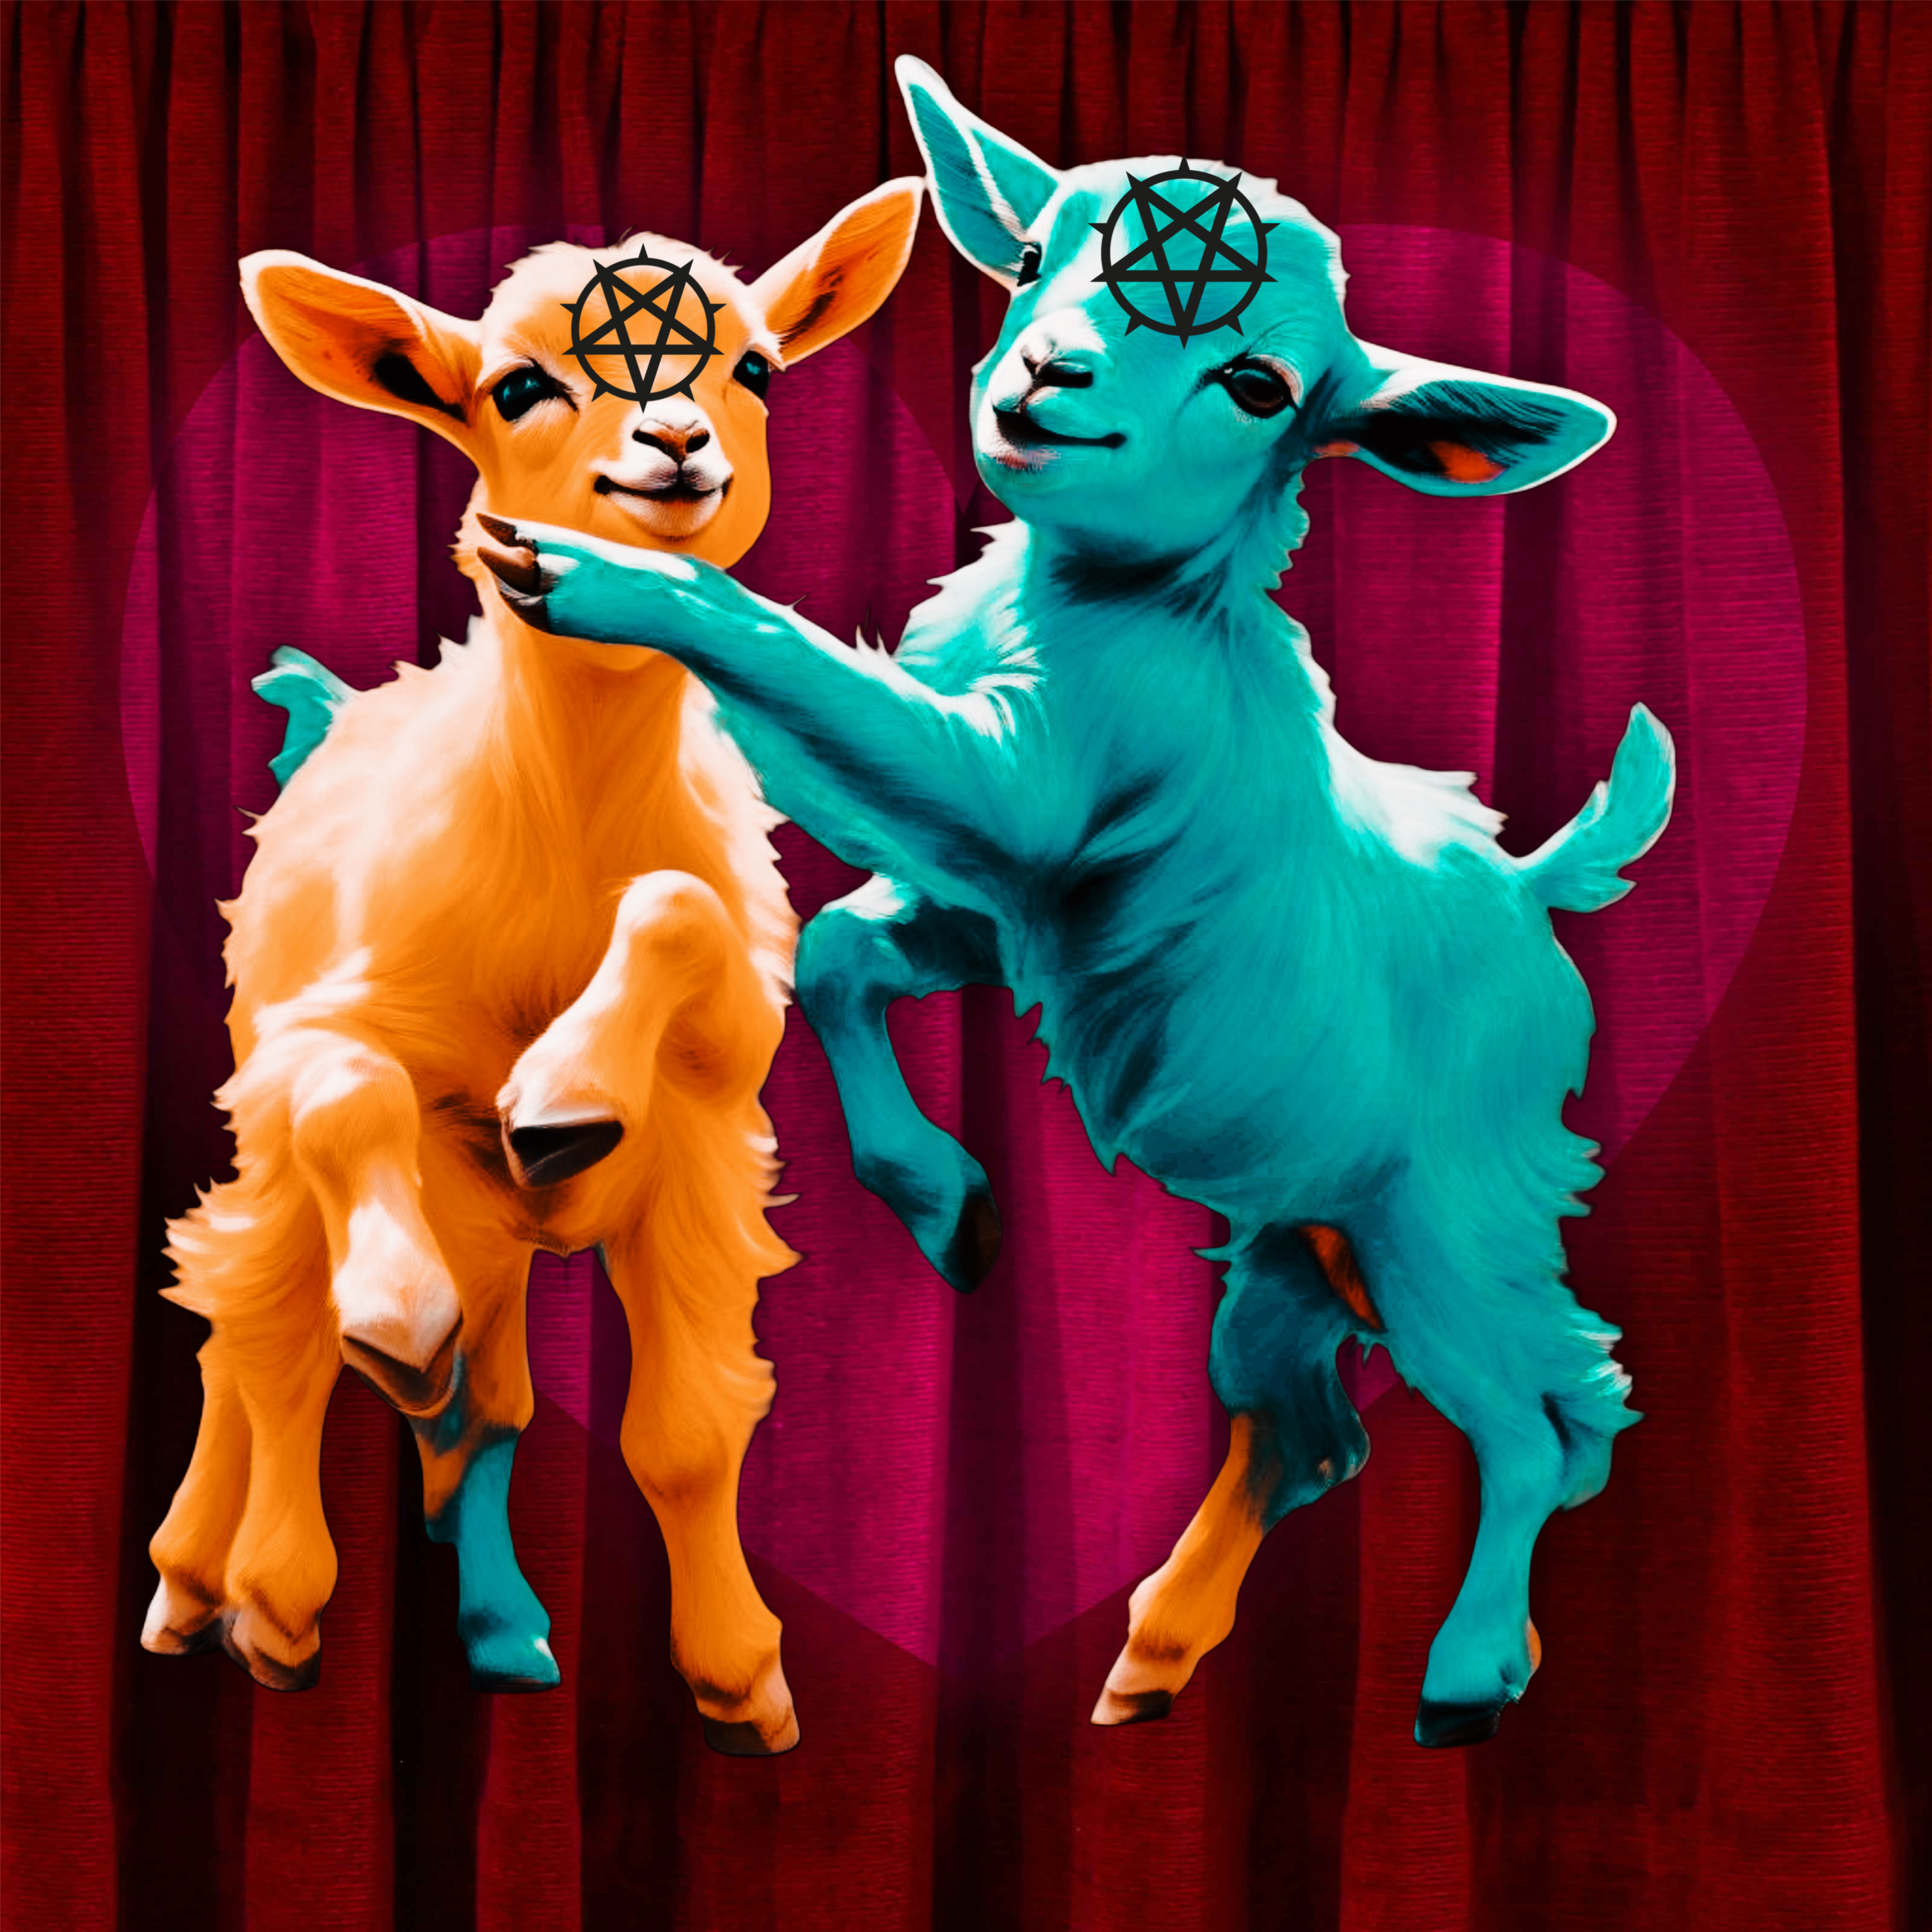
10
I have this recurring nightmare in which I am tangled up and can't move; I cannot wake myself up, so I remain until I finally wake up, gasping for air. My life feels like that nightmare, and maybe that’s why I am having the nightmare. It is easy to unintentionally take for granted the impact of movement; when I stopped moving in meaningful ways, my life lost meaning and transformed into listlessness.
Wanting to get better, I tried many treatments over the past five years, from holistic to heavy medications, but nothing worked. That is, until I saw a doctor who recommended hypnosis. My doctor said that sometimes we need help figuring out what we need to heal ourselves, and hypnosis can aid that. I decided to try it out of curiosity and liked that it almost seemed like witchcraft.
I’m on a velvet couch, and the hypnotist explains that he uses numbers to help the mind organize the healing process; he says the conscious mind commutes this system to the subconscious, which can sort everything without your active mind while on autopilot.
I acknowledge that I understand the instructions; he has me close my eyes and says, “I want you to think of your fears, and I am going to count down from ten.”
He says the word “ten,” and I am gone. I am in another place and now surrounded by multiple-colored Satanic baby goats (MSBGs) with black pentagrams on their foreheads; they dance around and, in song form, list my fears to me, including worries I hadn't thought of yet.
Then the MSBG, covered in glitter, asks me, “If I heard the baaaaad news.”
I answer, “More than likely.”
The little goat, “baas,” expressing displeasure, looks at me like I was intentionally being difficult and then says, “Have you accepted Satan as your lord and slaver? Baa”
I say, “That sounds like a lot of work to accept anyone as anything. Wouldn’t you say?”
He looks at me, wonders if I am worth the trouble, and then assesses that I am not. So the tiny glittering MSBG walks away, but he doesn’t get far before the other MSBGs telepathically chop his head clean off; it is jarring. I am only briefly concerned because the headless MSBG immediately smiles in delight.
Then, the other MSBSs telepathically cut each other’s heads off, and seconds later, all the goats are headless, and their heads manically bounce around, giggling.
The hypnotist says, “Samantha? Hey. Hey. Hey. Samatha?”
I am pulled from that place that feels like sleep but is much too vivid and detailed to be a dream.
After I adjust, he asks me, “Do you feel your mind has begun sorting things out?”
I say, “It must be.”
This satisfies him, so I will see him next week and leave the office.


9
After I arrive at my appointment, I lie on the velvet couch, and the hypnotist says, “I want you to walk yourself back through where you are now and discover what brought you to this point; think of all the events, big and small.”
I think about my life like a plot outline, and the hypnotist counts down after some time. The last thing I remember is hearing “nine.”
I am confused when transported to absolute darkness, especially considering my flashy experience last week. However, I am not confused for long because a spotlight shines bright, exposing a stage, and a bright green MSBG walks into the light, wearing a snazzy top hat and a fancy shirt. He is singing Elvis’s “I Can’t Help Baaing in Love with You.” And it isn’t long before a whole chorus line of MSBGs appears in showgirl garb and dances around him. The colors pop in the light against the black, and the showmanship is top-notch.
Then, my name was lit up in a Vegas-style sign behind them, and I enjoyed the show; it was a reprieve.
Unfortunately, not long after, the bright green MSBG starts to behead the chorus line telepathically while they all laugh.
I wonder if I should be worried about my safety with these creatures: fancy emo or killer emu? Somehow, they seemed only baaed in a “Hot Topic” way, so I calmed my mind.
Shortly after, my hypnotist calls me back, saying, “An emu like the animal?”
I start to adjust and say, “Come again?”
He says, “You were saying something about an emo or emu, maybe both, while away. Are you thinking of these or experiencing them?”
I say, “Oh…Yes… Both. See you next week.”
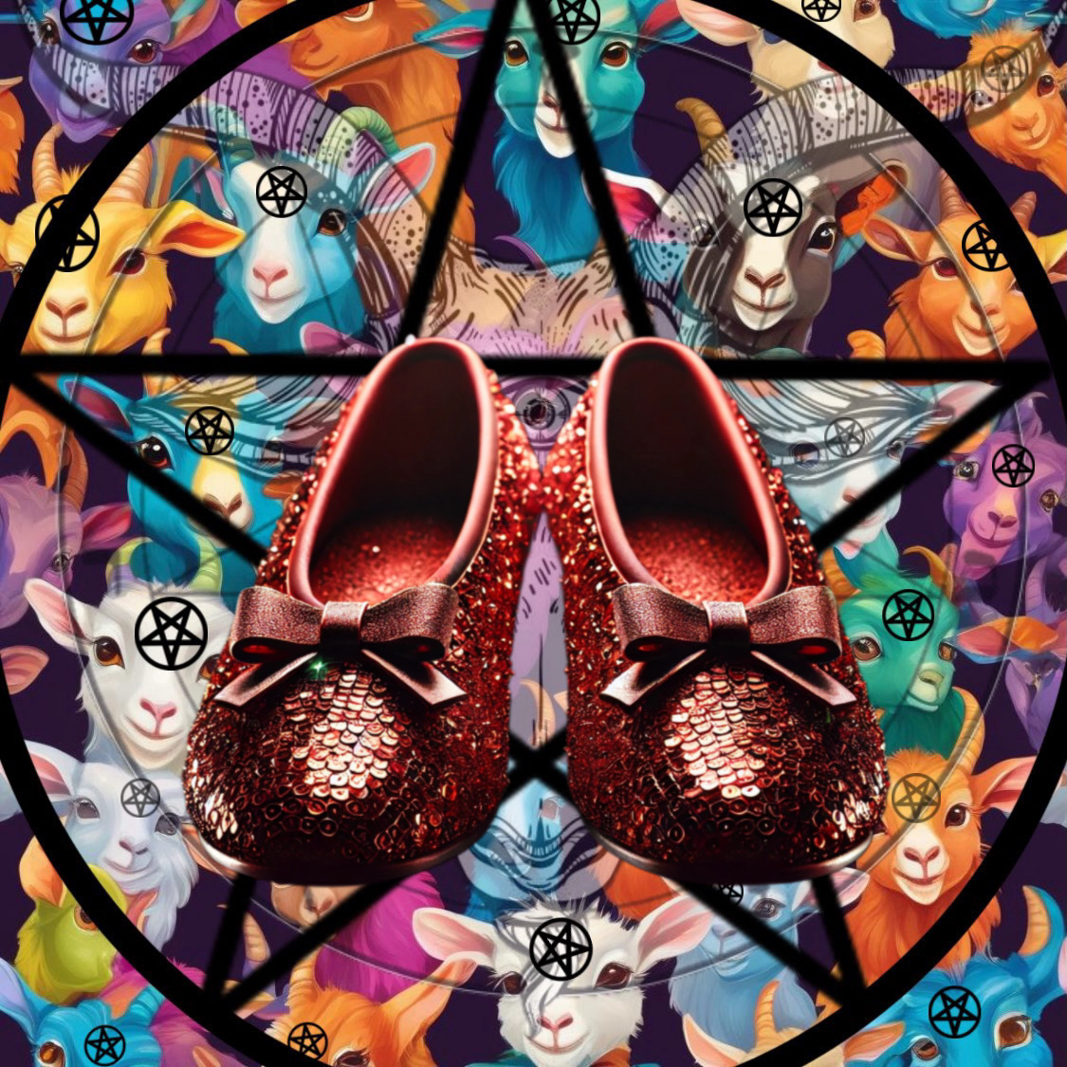
8
I arrive at my appointment early, lie on the couch, and get down to business. The hypnotist says, “So the system should be starting to unwind itself to before the trauma that led to you seeking treatment. The hope is that you feel more like you did before you experienced the trauma. Please think about the wounds that have changed you.”
I think about my wounds, and a voice in my head says, “This room is where time bounces; you believe each time that time will go forward and are constantly shocked when it comes back to repeat, unendingly.”
The hypnotist announces the countdown; I make it to “eight.”
Then, I am transported elsewhere, where ruby slippers engage in a legless dance around me; they tap, tap, tap until a giant mouth swallows us. It is dark, and it doesn’t take long for me to wish for some light. Although I roam around for some time, I never bump into anything.
Just as panic sets in, the MSBGs come marching in with tiny lanterns as a haunting piano piece plays; they take their seats and play various instruments. The chords feel like a light massage to the brain, and their tone sends messages to me. This was quite a sight, but the MSBG's love for fire overpowers their will to execute their much-practiced moment, and they start to break the lanterns; they laugh as the climate becomes hotter. I am concerned; they are elated, which trumps my desire not to be ablaze.
When the heat becomes unbearable, we are swallowed and submerged in a glowing green goo that illuminates the MSBGs and me as we float along.
After a little while, a Broadway-style sign of a gold number eight is in front of us, but we are pulled slowly away, and then it disappears, or I do.
My hypnotist wakes me up and asks me if I am feeling better; I reply that I am not feeling worse.
I leave the office and notice a trail of gumballs, which I decide to follow out of curiosity. Who would waste gumballs? The trail goes forever, and then I hear these crackling noises, and I realize the gumballs are eggs, and out came MSBGs; they are so tiny, awfully adorable, and equally fussy. Their crying sounded just like a baby, and they all started in.
“Wake up,” my hypnotist urges. He appears upset that I can’t be roused, while I am upset that I thought I was awake when I wasn't.
Most of the time, the hypnotist is exhausted with me, but he can tell the truth in the things I say, and he figures it better to have a sound mind and only visit with a madman than to be one.

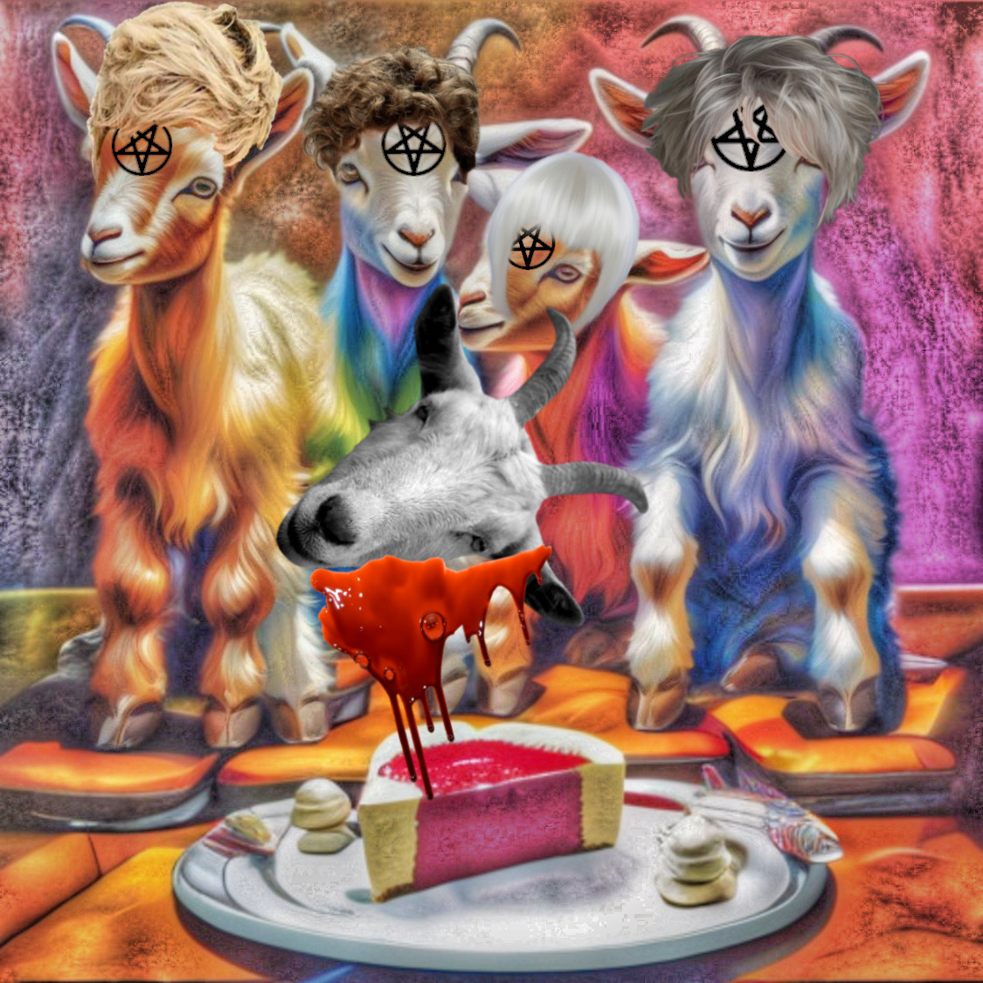
7
I walk into my appointment, and I lie on the couch. The hypnotist said, “Think about what happiness means to you and how you can obtain it.”
Then he counts down, and I make it to “seven.”
I am transported to the studio audience for “The Goaten Girls,” which starred four MSBGs. Baalanch had a predicament about loving two men: Satan and a man named Tom. Satan has the power of a god and infamy, while Tom is a farm boy who is well-endowed and isn’t constantly distracted by human domination. The thespian MSBGs all ate a bloody cheesecake while mulling this over. It was pretty cute until the MSBGs working the set got restless and started destroying everything, like Rockstars on Angel Dust.
I hear My Love say, “Do you love me?”
I look around and realize the voice is in my head, so I think, More than anything.
It makes me sad when I realize my only hope for him to be in my life is to descend into madness. Welcome to my circus. Bears…lions…tigers!
Tigers! That thought manifests a tiger in the middle of the madness as the cute satanic baby goats dance around him. I am afraid, but I realize this tiger is different… not young and agile but mature and battle-worn, which is wisdom. The MSBGs seem upset that the tiger is not trying to attack them, as they thought he would, which was no fun, so they all hold up wall mirrors and circle him; in his reflection, he sees himself not as he is, the result of years of shock collars and chains which have taken their toll, but who he used to be: strong and young; this seems to build his self-esteem.
I catch myself in the magic mirrors and notice no pain etched on my face and my beautiful smile; My Love loved my smile. I forgot what it was like to look lovely or happy, as much as I forgot what it is to feel that way. Once My Love was gone, I avoided looking in the mirror because each time I did, I would see myself expire and then decompose until I became a rose bush; my roses always grew in a familiar symbol, accompanied by eerie sounds. I know perspective is a lengthy topic, so I avoid that internal conversation daily.
Then, I felt exhausted and couldn’t remember the last time I slept, even though I slept so frequently.
The hypnotist's words come through, “Who are you?” “Who are you now?” As my appearance returns to the truth.
Then I hear, “Samantha,” I suppose that is simple enough; my name repeats louder and louder until I am back in the hypnotist’s office; he asks me if I am getting answers, and I say, “Sure,” as I figure I am, they are just unintelligible.
I push back the show curtain and leave the office. I can tell it rained, but it is sunny again. I catch my reflection in a perfect puddle, and the tired tiger’s face is transposed on my own.


6
After I lay down on the couch, the hypnotist asks me to ask myself, “What is the brokenness causing the dysfunction?”
He counts down, and when I hear “six,” I am transported to a breathtaking landscape; I walk along and deeply think; my thoughts are juxtaposed with the serene scenery.
Then it starts raining, and everything runs together, and I realize that I am not in the landscape but a painting of one.
Before long, parts of me have mixed into the painting, leaving me a suggestion of my former self; I’m mostly gone, but so is everything else.
I hear My Love say, “Will you always love me?”
I am about to answer the question that everyone knows the answer to when the MSBGs appear in the painting, and we start to swirl; as we do, the MSBG’s many colors turn us into cotton candy; we smell like cotton candy.
Then I hear the hypnotist loudly say, “Return, Samantha. Samantha…Samantha.”
I open my eyes.
He is shocked at how hard it is to rouse me and says, “I hope you are feeling better after these sessions.”
I say, “I’m sure,” as I wasn't sure I was better, but after a while, that matters less.
I leave the office, and the wind is unbearably fast, turning everyday items into instruments, and it is a symphony.
On the corner, cotton candy is sold, making me feel dizzy.
I continued to hear music where there was none the rest of the week, which at first made it hard to concentrate and then made it easier not to worry about concentration.
I dreamed of My Love for the first time in a long time; we were at a carnival, and the man running the show was Salvador Dali’s doppelgänger but a hundred times his size; he directed the affair like the Statue of Liberty directs New York, frozen in time and so large we could see him from everywhere. His likeness to the artist makes me think of clocks, and I envision time being frozen when I lost My Love; it never really restarted meaningfully for me again.
Then my timekeeping visions started melting until they were a soup of black and gold with baby blue numbers floating about: a 3, 5, 8, and 6 floated by, then a 6, 1,7, 8, and 5. I grabbed the second set of numbers and placed them in my purse, but the first set disappeared as though made out of fragile tissue or dissolved in acid. When the first set of numbers disappeared, I dug in my purse to see if I could switch the numbers; I screamed to the larger-than-life man, “Sir! Please change my numbers,” but realized the master had become made of wood, similar to the copper statue.
My hypnotist appeared in my dream and asked what numbers I wanted to trade. “Phone numbers?” I say, “Nothing as practical,” then wake up and head to his office.

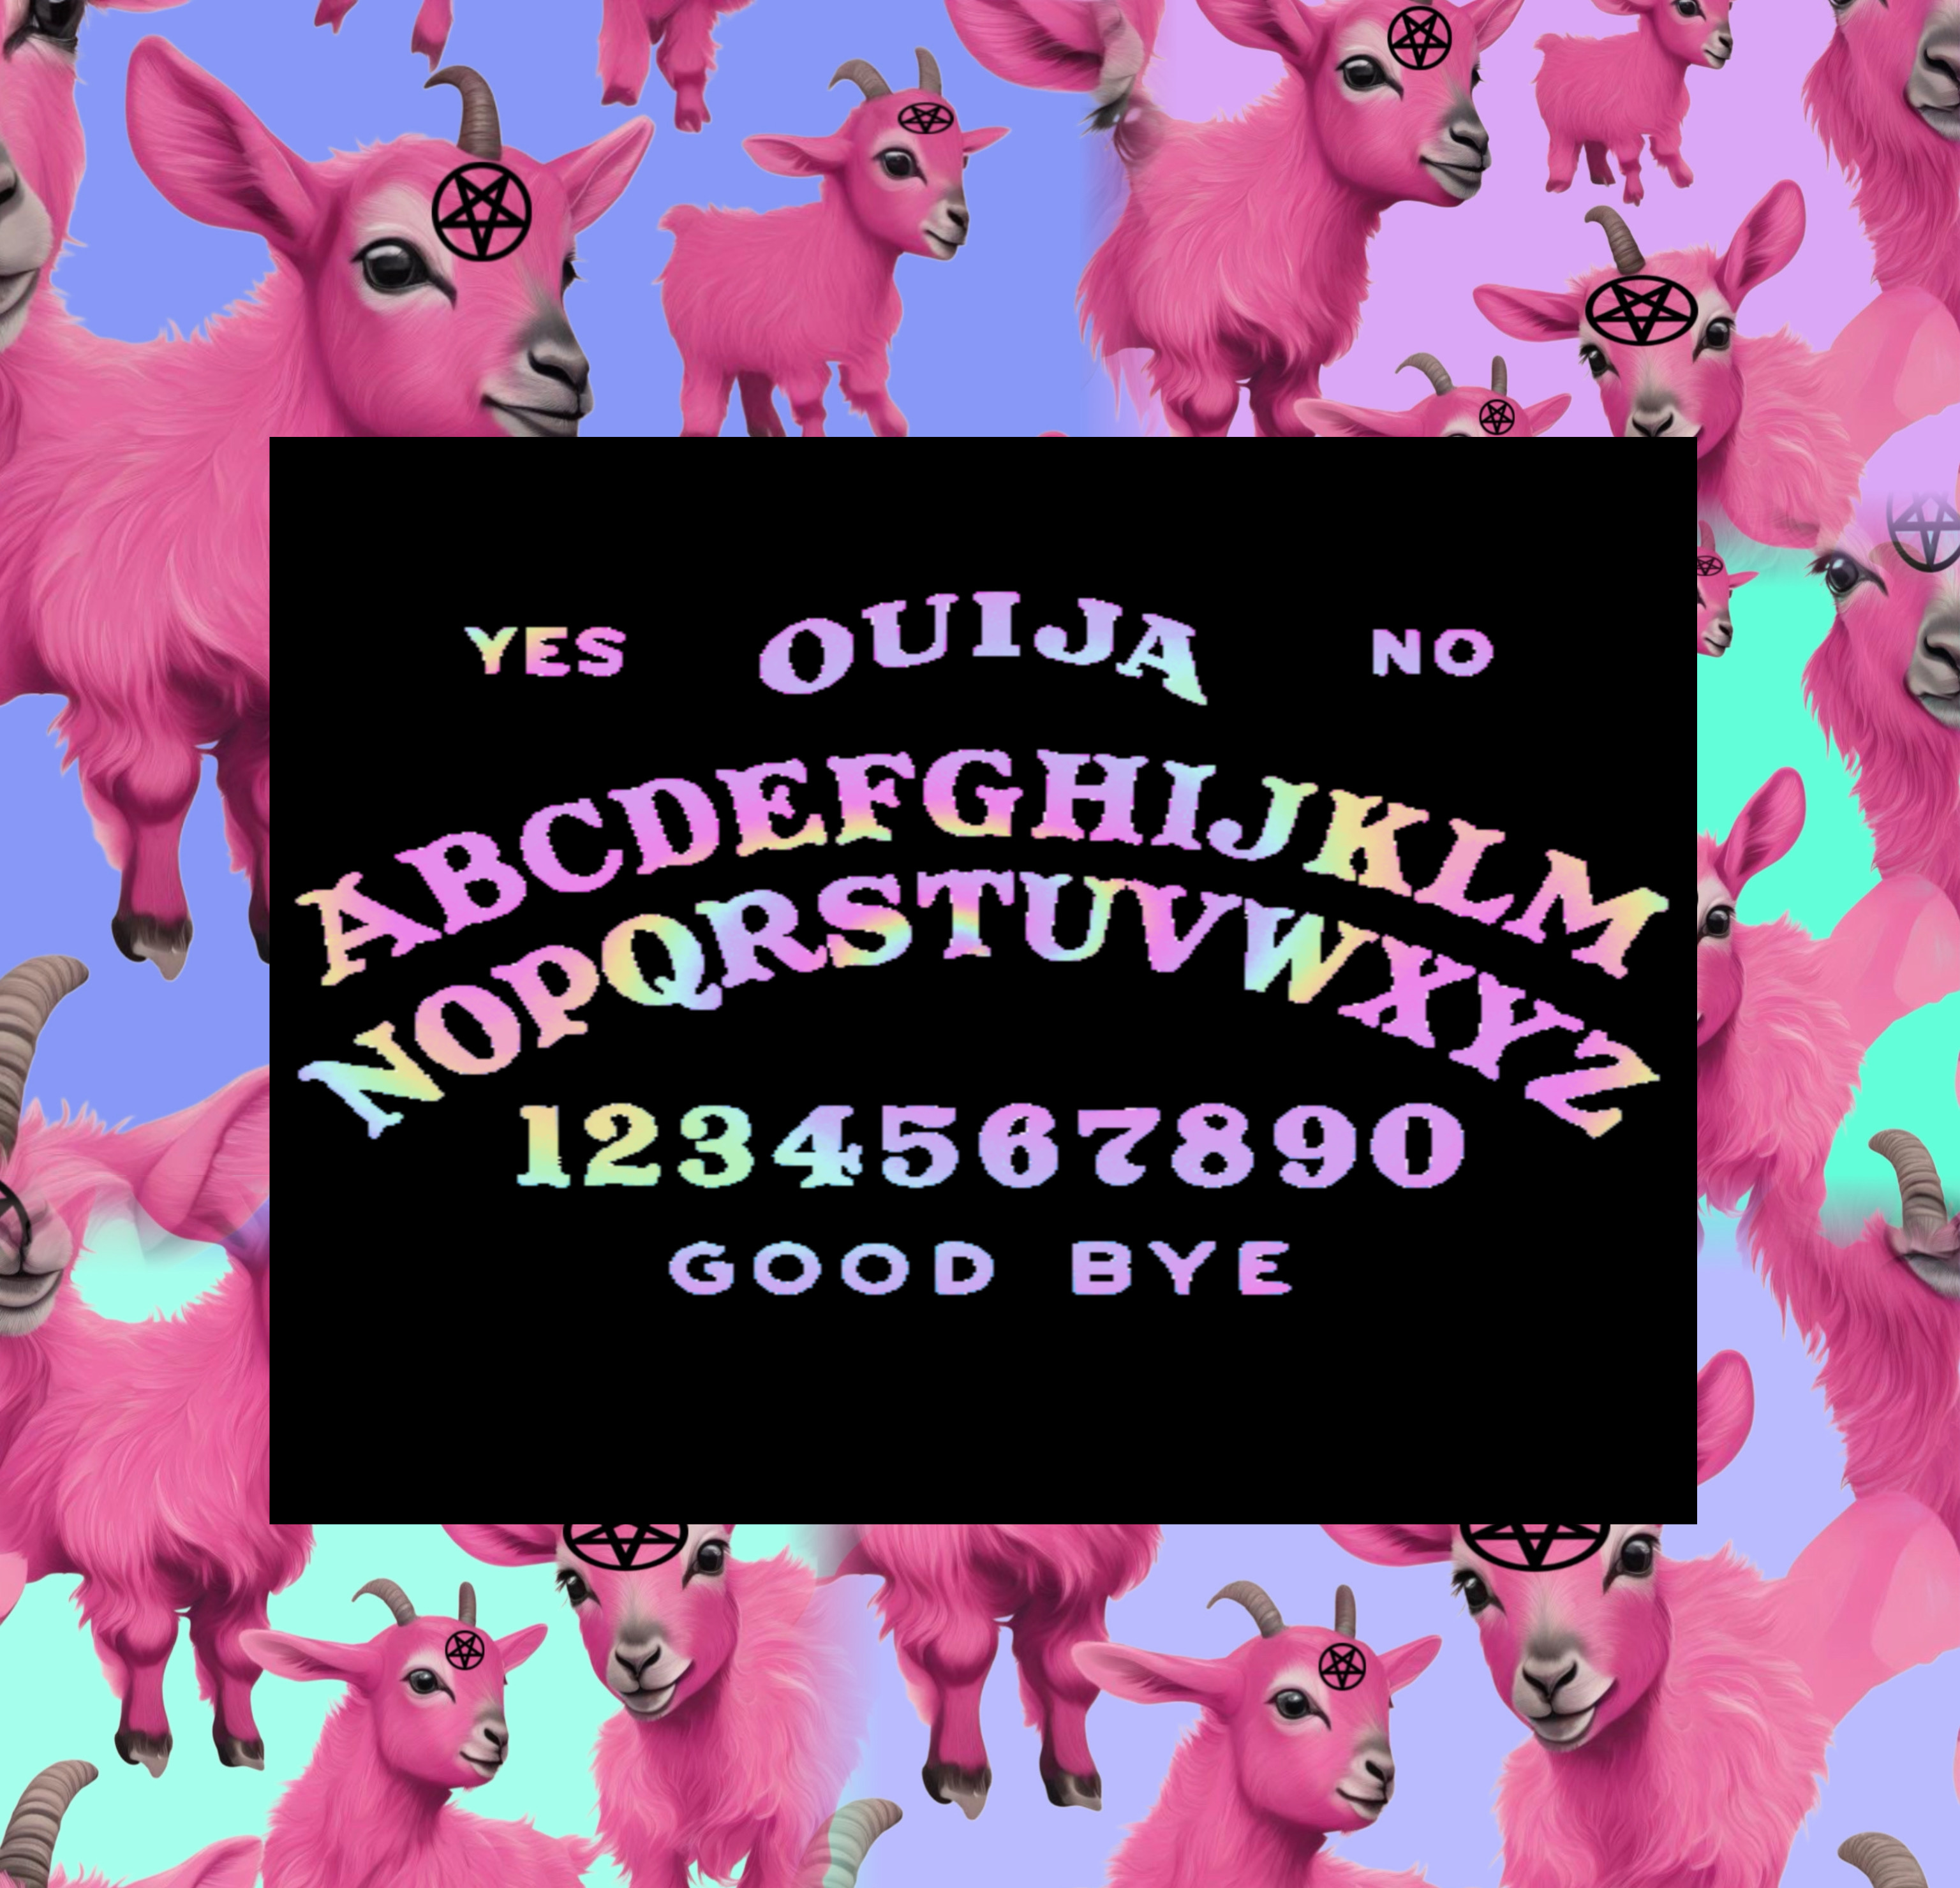
5
I lie down, and my hypnotist asks me, “What is important to you?”
Then he counts backward, and the last thing I hear is “five.”
I arrive at a seance held by the MSBGs; they have an Ouija board that keeps landing on the same letter; when the medium doesn’t move elsewhere, the MSBGs entertain themselves by fire spinning. I have always loved fire; it is essential and enchanting, but also one of the most dangerous things in the world; it can take one thing, such as life or possession, and magically turn it into another thing, ash, which is nothing like whatever it started as.
Then, I began to feel those flames turning me and everything around me into pastel-colored ash.
After, I feel us being scooped up and put in an hourglass; somehow, our grains are still separate even though we are placed together. I don’t like the feeling of the stillness, but it isn’t long before an invisible hand flips the hourglass, and then we all fall in slow motion, which I don’t like much more.
Once we reach the bottom, it is a trap door, and we fall through it. Then, we are sand-like ash on the beach, and it’s so peaceful. I hear the swish of the ocean; the waves sound like, “I miss you.”
When the water hits us, we are like the water-growing toys I had as a child: super absorbent polymers that the water frees; we are restored.
Unfortunately, the MSBGs find the short captivity to be much too long, and they start to peel at the corner of the serene scene like a sticker you are trying to remove, which only aggravates them more.
Once they get the corner up, they all work together and remove it, and underneath is darkness, which is always their stage.
Once on stage, I saw they had taken up heavy metal and Screamo. They are larger than me and significantly angrier. They start a mosh pit and let loose. It’s much too loud, but then it goes silent, only auditorily. It is much more enjoyable on mute.
Then sound starts again, as the little rockstars break their musical equipment and the colorful shrapnel disperses and rearranges, like a kaleidoscope.
Shortly after, everything freezes, and I hear, “I miss you, Sam.”
I want to run toward the voice, but I can’t move, and even though I am screaming, “I miss you too,” as loud as I can, consecutively, there is no sound.
After some time, a piece of debris hits my shoulder, and I hear, “Samantha, you need to come back,” repeated.
It's enough that I open my eyes to my flustered hypnotist; he tells me that he has never seen anyone go that deep before and is alarmed by it. The truth is, I must go deep because the depth of my problem is deeper than any you can have. Unlike the tragic events that brought most people here, love brought me here; it is hard to exorcise that because it means you will lose much of yourself. It is easier to give up the ghost of pain than love; you have more motivation to want to separate yourself. I would never say this to my hypnotist, so I say, “I am sorry; I've been drained.”

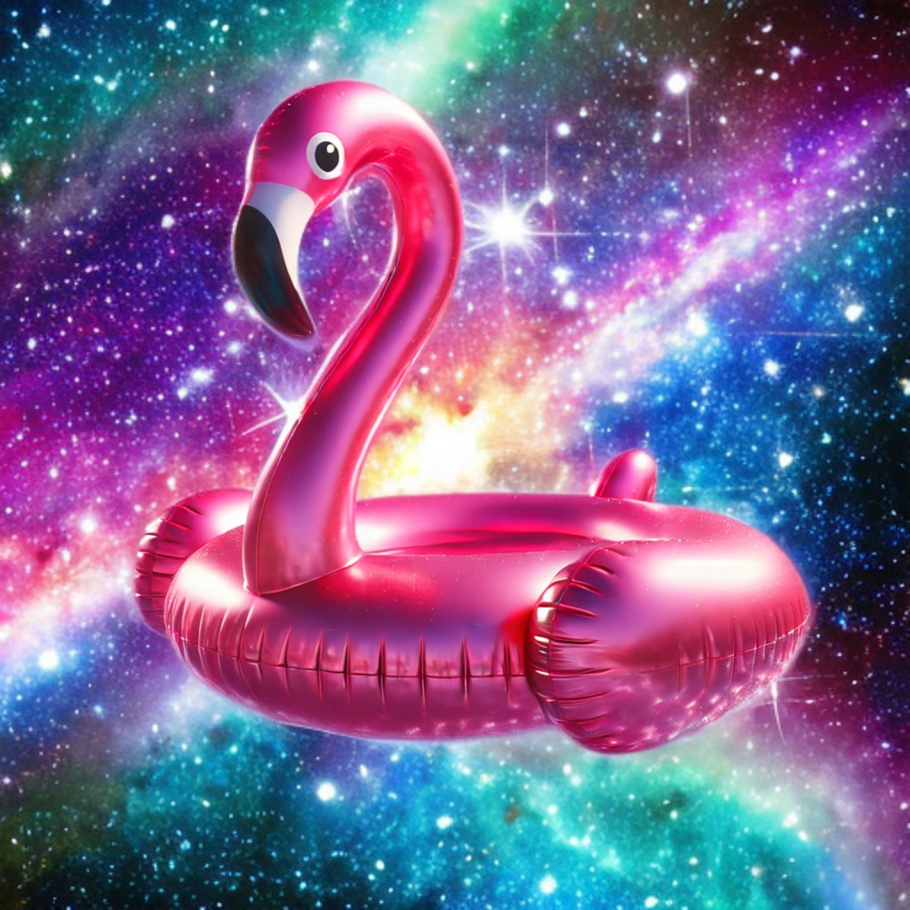
4
As I settle into my session, I notice the hypnotist has hooves; I think those weren’t there before. My insanity may be winning the war, and all the better for me.
My fascination garners the hypnotist's attention, and he asks me if everything is ok. I said, “I am admiring your hooves… I mean your shoes.”
The hypnotist says, “I am fond of these; I got them on a trip to the Baahamas.”
I close my eyes and float gently up and out of his office; the last thing I hear is “four.”
When I hear this, I look down, and the MSBGs wave bon voyage and become smaller until they are the size of ants. I don’t want to go any higher, but I am not in control.
I keep believing I will stop after some time, but the light becomes dark as I enter outer space. Seeing stars and being among them are very different; the majesty eventually overcomes my fear.
I watch the stars twinkle to the beat of My Love and my song, “Silver,” like the wedding rings that turned our fingers green in a way that tattooed them. So even when I stopped wearing my ring due to outside pressure, the ring was still there and much more noticeable than simple jewelry, and it never faded, perhaps because he never did.
It makes me cry to have lived those lyrics, and now that is all we are, sentimental words frozen in time. My tears collect around me as I am the gravity, and then I become entombed in them; I am held in a giant water balloon; it is my womb tomb.
As the song continues, the waves travel through the water and hum like an orgasm, reverberating in grace.
My tears become too heavy; the weight is more than even space can allow, so my sack and I drop. The speed was terrifying and nothing like my gentle ride up. I feel fortunate that below us is a large bucket; when I land, I am just a drop in it. Immersed in the tear-mixed water, I panic because it is a bucket from farther up, but combined with it, it may as well be the ocean.
I try to wade through the water and keep my head above it, but swimming is exhausting. However, I am not left long before a giant flamingo floatation device pops up, and I hoist myself onto it.
Then the MSBGs pop up, and each has a cute floatation device and little drinks in their hands; I am offered one and decline because the drink smells like gasoline. I only realize it is gasoline when the MSBGs start to spit fire. I think, at least, they found a safe place to do that, but the drinks, mixed with my caustic tears, smell like danger; the MSBGs live for danger. So, out of boredom, the MSBGs each pull out a lighter and flambé us; my flamingo bursts, and we go airborne; it is just a lady riding a blow-up flamingo flying above the city. I land on my hypnotist’s office roof and crash through it onto the couch.
I open my eyes, and the hypnotist says, “You must be sleeping more. I didn’t even have to wake you that time.”
I say, “I wish you would have,” and peel pieces of thick pink plastic off of myself as I leave the office.


3
I return for my appointment and step through the hypnotist's doors into Paris, France, which is not confined to the office walls but extends endlessly; the Eiffel Tower is placed perfectly in the distance. I think, well, this is new.
I stay silent until the hypnotist notices I am in a trance and asks me if I like the macaroni art his daughter made. I say, “It is the most realistic artwork I have ever seen.”
He laughs, which is odd.
I stick my hand out in front of my face and scoop up some cooked macaroni; it is delicious. As I chomp away, he laughs, and I think, What is his deal today?
After far too many pleasantries, he begins to count; as he counts down, an invisible string pulls him away. I think the view of Paris from above must be quite lovely.
The last thing I hear is “three,” then I am macaroni, and so is everything else. I smell so good I can’t help but eat my arm, and I think, Feeling like something is missing, really isn’t that new, so I eat my hair, but luckily, the smooshed-up macaroni came back through me and then became a part of me again; it would be nice if everything were so sustainable.
Once I am full of myself, I venture out to see Paris; even as noodles, it is a lovely sight.
When I get closer to the Eiffel Tower, I hear My Love say in my head, “Paris for a honeymoon seems romantic; I wish we could afford it.”
I remember telling him, “Marrying you is all I want; we can get French Fries if you’d like.”
It makes me feel sad to be alone in Paris now.
I start to cry again, even knowing my tears never lead to anything good, such as free-falling from space. Still, I can’t control them, so they fall as they must and start to wash away the macaroni in a reveal: sentimentality dressed as macaroni doesn’t do the justice that undressed as fantasy does.
Then I hear the carousel music and walk towards it, as they have always fascinated me.
After I reach it, I see a familiar tiger and ride for a while; I go round and round, and it never ends. It is lonely until I notice all the other animals are MSBGs masquerading as the other animals, hiding in plain sight.
When they realize I see them, they detach themselves from the ride and pull out firecrackers. I am relieved when they set them off in the sky, and the sparkling explosion of lights reminds me of freedom.
That relief is replaced by terror when they point the firecrackers at each other's heads, and then all mayhem ensues.
Then, the littlest MSBG, dressed like a panda, set the tail of the tiger I was riding on fire. This angered the tiger, who took off at a high speed with me hanging on; I have never gone so fast in my life. We ran everywhere until we burst through the hypnotist's office, where I grabbed the couch as the tiger continued.
I look over, and the hypnotist seems surprised that, yet again, he did not have to get a megaphone to wake me; he is proud of my macaroni art, and I am glad my tiger ride didn’t kill me.

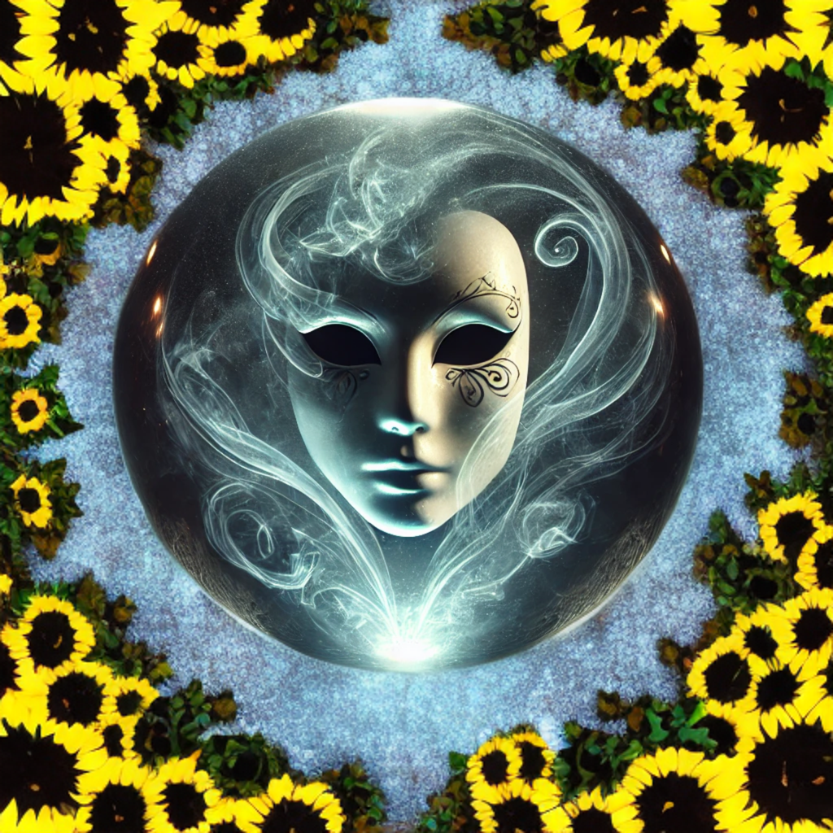
2
When I arrive at my hypnotist's office, I am disappointed that it isn’t Paris. Still, I settle in, and he tells me that some cat, raccoon, or possum entered the office and ate his daughter's macaroni art. I say, “It was likely the tiger.”
He laughs and says, “Oh, yes! The macaroni-eating tiger prowling the streets.”
I hear the tiger roar and think, Well, if there isn’t any macaroni around, you're probably ok.
He says, “I want you to make a wish for yourself, one that can become a reality.” he is always so stuck on reality.
My wish cannot be a reality, so I wish to escape it. The definition of insanity is doing the same thing and expecting different results. The definition of insanity is preaching to an angry goose each sabbath to no avail, but as the evil witch always says, “Both can be true!”
Perhaps love is the only thing that can overpower things it never should: common sense, sanity, truth, etc.
The last thing I hear is “two."
When I arrive at the other place, I am seated at a restaurant table for two; there is a note that says, I will be there soon; wait for me.
I was happy to expect company and someone who didn’t want me to leave.
Then, I realize I am in a crystal ball when a mask peeps in with a fishbowl effect. The masked man starts to spin me, and I hear an invisible chorus sing, “Ash, baashes, they all fall down,” on repeat. I was frightened; I did not want to fall. It felt like all I was doing was falling lately.
I think, think happy thoughts, and realize I am not falling. My thoughts are sunflower seeds; each planted itself in the earth that appears below us, and the sunflowers started to bloom at hyper speed. They grow larger and larger until they break through the crystal, and I am glad it is just hardened sugar water; I ate several pieces while I watched the sunflower squad take over the world.
Then, I pick a small sunflower before it gets so large and impractical, and the memory of the first flower he ever bought me plays; it was unique as a gift but also a living plant; he always did things that revealed himself so effortlessly. No matter how functional or dysfunctional you are, the loss will always be a loss; if it weren’t, it would be a re-gain.
And lost is how I became, as the sunflowers no longer left space for anything more; it is not as if I knew where I was before, but now I certainly didn’t. I wasn’t sure if leaving would help me find my way, but staying assured I wouldn’t, so I started to walk backward, as I once was found and now I am lost.
I walked for some time as the MSBGs discreetly watched from the trees, which all have N+S carved into them.
I see and try to avoid it, but the tree will not let me turn away; its branch keeps tapping me on the shoulder.
Followed by a voice that says, “Samantha, return.”
My hypnotist is confused that I went back to not being quickly brought back, and he asks if I have been sleeping. I say, “Not as much,” as a tiger is running wild.
He said, “I can write you something for that.”
I say, “You’d have to write a novel, and I don’t have the time for that.

1
That week, all the clocks appeared as compasses that bounced from North to South. It is hard to gauge time when time is the direction, and it takes on a new meaning. I was never and always late to everything, but I was also never and always on time.
I lie on the couch, and the hypnotist says, “This is our last session; I want you to focus on resolving your issue.”
Thinking of the person I love as the issue was challenging, but I suppose the problem is that he is gone.
The last thing I hear is “1,” and I am transported to the MSBGs, dressed in pristine white; against the darkness, they look like stars.
Then, my betrothed walks him down the aisle, and he is perfect. Once he reaches me, the colors return ethereally.
I say, "I love you,” and My Love says, “I love you.” It is the moment I have waited for. I know this deep trance will end, so I treasure it.
This is not my first time seeing a hypnotist; I have seen many different hypnotists. I realized the first time I was supposed to see him say “Goodbye” so I could move on with my life, but I couldn’t bring myself to, even knowing that it prevented me from moving on and functioning again. Every time I delay it, I get worse and worse mentally, but I love him in a way that even the delusion of him was worth my proposed eventual happiness and my necessary sanity.
My Love holds me close while the MSBGs throw sequins at us; I am momentarily happy and free. We love each other in the purest, supportive, and encouraging way; he is my soulmate. Love endures during a tornado; fake love fades away on sunnier days.
I try to will myself to stay in this place, as I have many times before, but it is always futile. This time, though, My Love says, “Please let me go, Samantha. I want you to move on. That would make me happiest.”
What I want more than my own happiness is his, and so I know that I must let go.
My hypnotist says, “Wake up.” All the work and build-up for that moment is over now.
Then, my hypnotist asks me if I have solved my problem.
I said, “I can now move on, and with the multi-colored baby satanic goats.” The hypnotist looks confused and says something, but I can’t hear it over the MBSG’s bongos.
Then the MBSGs and I dance out of the office, holding hands, onto a life that isn’t chained to the past or sanity.

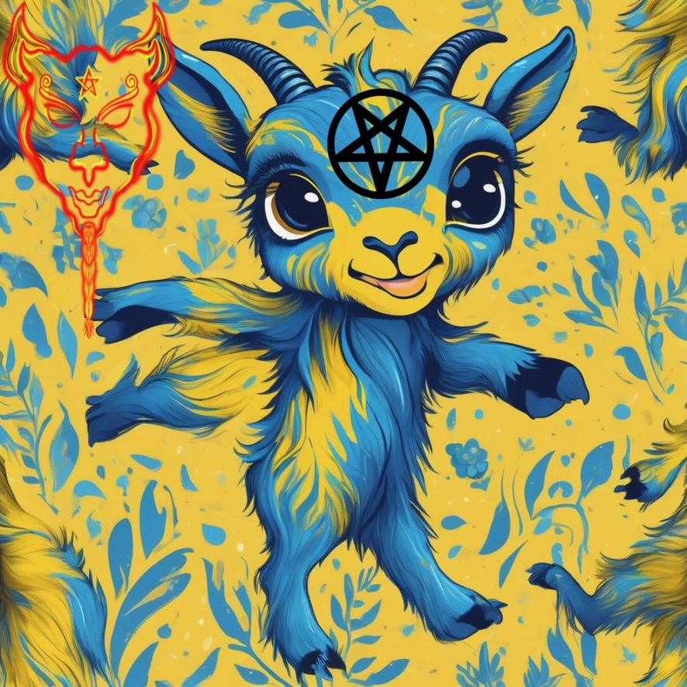
Counting Backward

