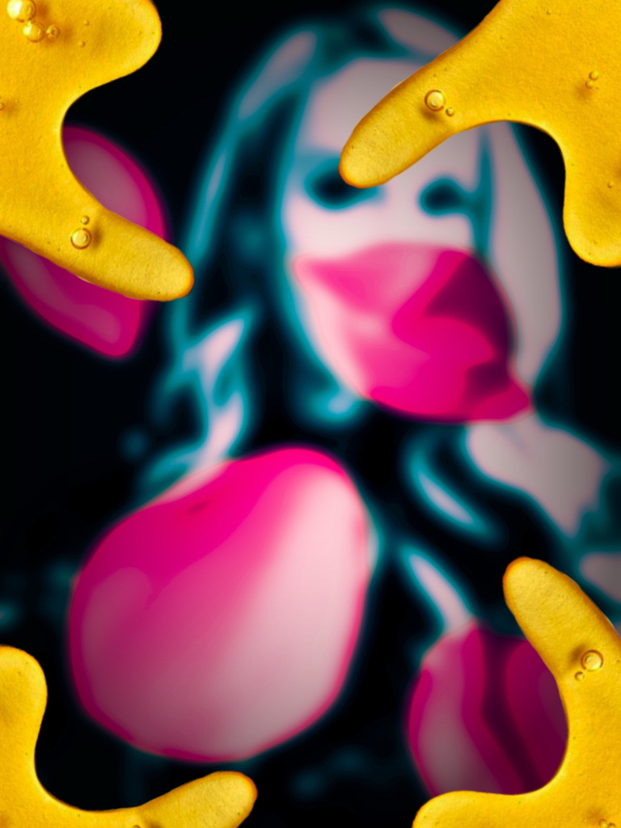
Artificial Roses

Artificial Roses

To the existence of petals through the pain.
Special dedication to Tasha, who inspires me all the time, even when I'm not near her.
If you would like to view or submit art or music inspired by this story or what inspires you, please email artificialrosesstory@yahoo.com or visit www.nancyreaume.com.

To view the Spotify playlist that helped keep the book flowing, please visit Spotify and search for ‘Artificial Roses’ or use the following URL: https://open.spotify.com/playlist/3m6y8nQR3EDuIqclfUeeUD.

Artificial Roses 1
Part One: Rose Petals Sell Possibility 4
Part Two: Love Arose 13
Part Three: Doppelgänger Petals 24
Part Four: Rose to Fall 29
Part Five: Dancing Roses; Dripping Honey 34
Part Six: Bed of Roses 41
Part Seven: Rose Bud 49
Part Seven: A Rose by Any Other Name 52
Part Eight: More Roses; More Honey 55
Part Nine: Despite Thorns 59
Part Ten: A Rose for Our Grave 64


Part One: Rose Petals Sell Possibility
I’m staring down the barrel of his gun. His words are of hatred, but the tears that accompany them reveal something else; I will never believe it’s love, but it’s something. That’s likely because obsession is a close relative of love; it’s love without respect or a power balance. I’m afraid, but I’m so exhausted that an ultimate ending almost feels like a relief.
But it wasn’t always like this.
I began my life in a small mountain town with a clear separation between the upper and lower classes. We were a tourist destination, so we had people rich enough to own more than one mansion, as well as those who served them gratefully or detested them. I fell into the former category, as my first job was at a department store, and it was especially magical to be close to attractive, exceptional people, living my very unexceptional life, and not being attractive myself.
Superstars would come into the department store during their winter vacation and give me a list of a hundred things they wanted. They would try on nothing before paying, without verifying the bill’s correctness. I couldn’t imagine when that was remotely possible for me because I left home at thirteen and had to support myself; still, I was glad to be gone, even if I was poor, because my father was a violent man with a heroin addiction whose fits of rage became as confusing as they were violent.
Although leaving home did not solve all my problems, at least I had an escape, which was my fantasies that were fueled by being near those who were living them. Sometimes, I daydreamed that I was a wealthy Italian heiress with a penchant for orgies and ruby-red dresses. I would sunbathe topless on my yacht with my perfect figure, clear skin, and sip champagne. A whole group of women surrounds me, as the wind blows our hair in a sexy way while the sun drenches us with the magnificence of summer in Capri.
I could leave on demand after a while. Something terrible would happen, and I would suddenly find myself on a stage, singing a sexy melody about falling in love under the stars; the darkness and lighting added drama and flair. The people adore it; they are cheering my name and telling me they love me. Whatever was happening to me outside of this would never reach me here.
The world is often cruel, so I could tell you hundreds of fabulous delusions I’ve lived in, and I started to sketch and color those other fabulous lives; it was my scrapbook of my many lives. In the pages, you would find Chelle, the famous painter who kept 25 multicolored poodles lounging around the pool, or Deborah, the boozy movie star who likes to keep a harem of perfect men around her, waiting for the Greek command.
Although these stories saved me numerous times, they started to get me into trouble at work, so I would actively try not to; yet, self-control can only suppress compulsion, not entirely eliminate it. But my luck was about to change.
My first break came when a large beauty conglomerate advertised looking for a woman to pose for an ad campaign’s “before photo” to show the effectiveness of their makeup and skincare. I was the only person to show up to the open call, likely due to the pride that I lacked, so I won by default. It seemed to be false advertising once I realized that I would not be the after model; instead, they would modify the photograph of another model. Still, I also understood that they were showing a possibility, which is never a bad thing to have, and any mild discomfort I felt dissolved entirely when I learned I would make $50 for the day; my pay at the department store was $1.25 an hour.
Getting that job was the first time I had hope that wasn’t pretend. I have often dreamed of the pool I now dipped my toe in, seemingly insignificant but actually opposite; I could think of nothing else.
On the day of the photo shoot, I arrived at the small studio where they had set up shop. It wasn’t exactly Hollywood glamorous, but that didn’t matter to someone who sees things differently. I walked through the door, and the uninterested assistant suddenly became a suit-clad attendant asking for my designer handbag and offering me a whiskey. Then I’d hear, “Miss! Miss! Are you with me? Please move so we can get a profile shot.” I adjusted, and we are suddenly on Broadway; showgirls with feathered fans, all around.
It took a bit longer than I expected, which I was ecstatic about; I didn’t want to go. I wanted to stay in a world where I wasn’t hungry, but instead, I could eat caviar and be admired, rather than being seen as garbage along the road. I cried on my walk home. That night, I drew the beautiful scenes I had envisioned while at the photo shoot and hid the money well.
It took some time for the ad to run in print. I wasn’t looking forward to that part of the process because I wanted to be known for something extraordinary, not for how much my appearance needed expensive cosmetics and skincare to fix it. Still, I was curious to see how it turned out.
Unfortunately, so much time passed that the spark created by the ad had gone out. My life returned to how it was before: surviving.
It was probably eight months from when I was photographed that my older roommate had his friends over, and they gave me something to drink that incapacitated me, but I was still awake. I was raped for hours as I circled through my stories with a prayer for God to escape this. One moment, I am Crystal, the daughter of a mob boss and a coffee magnate. A mink coat weighs me down, and a cigarette rests on my lips as I plan to meet my much younger lover later. Then, back to a sweaty man over me with anger in his eyes. Then bam, I am Jocier: The Magnificent, the master illusionist who gives her spare time to all the cat charities; then another sweaty man with anger in his eyes on top of me.
The next day, when I could move, I felt like I couldn’t. However, I needed money, so I had to; therefore, I walked to my job. When I got closer to the department store, a man was preaching loudly, “God answers prayers!” Then, he looked at me directly and repeated it. I was distracted enough that I ran hard into a man who dropped his paper in front of me, and before me was the “before” me in the ad. They made some adjustments that enhanced my unattractiveness, and I was glad because it didn’t look exactly like me, so I might not get found out. I could imagine people approaching me saying, “Aren’t you the ‘before girl?’ Why’d you go back to being ugly? Did you stop using the creams? Why would you stop using the creams?”
I picked up and unfolded the paper, and the “after girl” likened to my image was gorgeous. She was exactly who I would be if I could create my appearance: large, doe-like eyes with impeccably applied eyeshadow; smooth, flawless skin; full lips; perfectly coiffed hair; and that indescribable factor that elevates pretty to beautiful.
The man interrupted my thoughts, saying, “Miss, I need my paper back!” I handed it back to him with the “after” side up, and he commented that he would like to take the “after girl” to dinner, while he couldn’t get away from me fast enough.
After I saw that ad, I felt something new coursing through my body, like a phantom from the future; something was coming.
That something ultimately turned out to be the success of those beauty ads. Many people felt that they could be transformed; things could be more like they wanted, and looking the way they wanted was the first step.
I received a call the day after the ads launched from the secretary on behalf of the CEO of Pretty Petals. She said that the CEO wanted to thank me in person, as they were selling out almost everywhere and expected that trend to continue. They arranged for a train and a hotel for me and advised me on where to collect the money for my travel expenses. I couldn’t believe it; I had never left my city, been on a train, received cash like that, or met a CEO.
When I went to pick up the travel funds, I was astonished to find that the amount was more than my monthly budget, so I decided never to return to the house I was staying at again; this was a fresh start.
Later, a courier dropped off my train ticket and hotel information for the following day with a card from the CEO, Masahiki Uotani. The cover of the card was a rose, and as I opened the card, rose petals floated out and surrounded me. Inside the card read: “Here’s to success!” He added nothing but signed his name.
After arriving at my job, I said my mother had passed and I would need to take time off work. The statement was factually correct, but she did not die recently, nor is that the reason I needed time off work.
On my shift, I asked one of the cosmetics ladies if she knew of Masahiki Uotani. She said, of course, as his family started the mega beauty products brand, which has remained in the family and been around the longest, we sold much of it here. She followed by saying he was also handsome and single.
After work, I decided to go to the train station well in advance of my train’s departure. I sat on the train while busy people commuted, until they became costumed participants in my masquerade. We danced in masks as we moved around each other; for a moment, we would connect, then rotate, and another stranger would share a moment in time as the music played. We dance for some time, until a spotlight appears at the center of the concentric circle we have been dancing in.
As it brightens, Masahiki appears in a black mask and tuxedo, holding out a white rose and extending his hand to me, and we dance. As we dance, long-stemmed roses drop from above, until they lose their stems on impact and bounce back as lovely, colored petals, floating as honey pours on us from above. He then dips the rose in the honey, which shockingly drips into puddles of blood on the floor; I am only partially concerned or distracted until the sweet blood starts to drip from his mouth, and then I am terrified. He lets go of my hand and is pulled into the dark as all the honey turns bloody. I try to follow him, but I am sticky, so my motion is impaired. Then the rose petals stick to me and the bloody honey cools like tar, so I am encapsulated alone in a reddish golden tomb adorned by rose petals. Eventually, I clawed my way out and was no longer sticky, but clean in a simple white dress that looked like a nightgown. Everything is dark except for a lit path, so I follow it until it ends at a mirror. I look in it and see someone else; she says, “You’re beautiful now.” I correct her, saying, “No, you’re beautiful now.” She smiles and winks and says, “We’re beautiful now.”
When I wake up, I realize my train stop is nearing; I get off at my stop and head to the hotel. When I entered the hotel, a massive chandelier dominated the space, and the floors were so polished that you could see your reflection. It had an exotic feel, with a waterfall located on the way to the four-star restaurant. It was filled with exciting people, and I was more like one of them, at least for the next two nights.
When I was brought to my room, I got on the bed and turned on the radio. The music that played was lovely, the violin and piano filled the room, and I levitated as I danced about, rose petals under my feet as I spun and moved.
Then, I noticed the note on my table, which stated the time for dinner, along with the restaurant’s name, which stopped my heart. I knew this restaurant from the picture shows my mother and me snuck in to escape my father’s abuse; having had happiness by proxy for those moments that I can still remember clearly; she was still lively before the years of my father’s abuse drained her so much that she was unable to get it together and ultimately took her life.
A sweet memory drifts into my mind of watching a picture with my mother about a wealthy man who falls in love with an alleged murderess. She always loved love stories the best, perhaps because she never got one, or even a chapter of one. Instead, she was an escape artist.
I then remembered the money and decided to treat myself to a dress, because I couldn’t go to an extravagant place in my dingy clothes. I found the nearest thrift store and figured that, with my keen knowledge from the department store, I could find something nice, secondhand. When I found an Alexandrian King dress, in the color of the rose from the card from Masahiki, I had this eerie feeling like so many things were fitting in extreme ways, but then I thought, You have a rose-colored view now; maybe perspective was putting everything in place one petal at a time.
When I returned to my hotel room, a parcel was waiting for me; a note on top said, “Before you come to dinner, please enjoy these.” I opened the hefty parcel and was surprised to find a large assortment of cosmetics, skincare products, and perfumes inside. I decided to use what I needed, and I would sell the rest later. It was odd feeling, like a star for such a strange reason; I was the anti-star.
I was shocked when the first lipstick I opened was called “Miss You, Maude,” which was my mother’s name, and I missed her. I could see her applying these products in the next life while living in one of her treasured romance noir films.
I applied the cosmetics, and the makeup gave me more confidence, but it didn’t make me anywhere near as beautiful as the “after” photograph. However, as I applied the finishing touches, the mirror revealed someone else, not me with makeup on; she smiles until she morphs into a rose. I sketched this until an unexpected knock at the door interrupted me.
After answering the door, I was informed that the escort was there to take me to the restaurant. I hadn’t taken travel time into account, and the courier seemed impatient, so I left immediately, realizing after we had made some progress that I was carrying my heavy sketchbook.
As we silently walked to our destination, the city’s liveness became its own show: people dancing as it rained honey. A man kissed the honey off a woman’s lips, and she shook, spraying the honey over everyone. So, many people were drenched; some stayed erect, and some swam in it.

Part Two: Love Arose
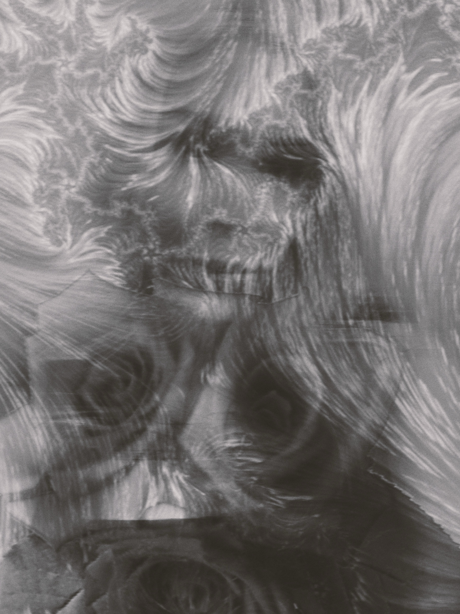
Once we arrived at the restaurant, my escort moved me to the back, where the others would meet. I put my sketch book on the empty seat next to me, and as I sat back, I realized that I was sitting across from the “after” version of myself, and she is enchantingly elegant. She was deep in conversation with a woman in a tweed baby pink pencil skirt and matching jacket, with a very stylish haircut; her grey and brown hair fell perfectly in place. They seem familiar and laugh frequently, perhaps catching up on “beautiful people activities.”
I sit there observing them until a lull in the conversation, and they notice me. The beautiful “after” model says, “Don’t worry, hunny, being before can be great, too. Like getting that hussy out of my house before I shoot her, or take his money before he cheats.” I laugh, but sense that there is some truth to this joke. Perhaps you could be with a woman beautiful enough to be an “after model,” and it still wouldn’t be enough to keep a partner faithful, or you could be the “after” model and still have “before” problems. It was the first time a small crack appeared in my idea that being beautiful would fix everything, although I was certain it could help a great deal; so, I sealed the crack, and it was such a good repair that you would never know it was there.
Then, more people joined the table, and the waiter came around and took our orders. I was surprised that the CEO wasn’t at the dinner, as it was all women, 14 of us. Seeing my hesitation, the model said, “Get whatever you like; these dinners are a business expense for them,” and winked at me. I ordered a steak, which was the only thing I felt I could pronounce correctly, and everything else seemed too fancy to be edible to someone with a palate heavy on beans.
When my dish was served, it was a work of art, topped with ginger that was thinly sliced and shaped like a rose. After we finished eating, I was surprised that there was still no CEO; he was a phantom.
After we finished eating, Masahiki arrived, dressed like my dream, but his mask disintegrated as he neared us, the dust swirling around him, forming a rose and then falling to the floor. He was the most handsome man I had ever seen in my life. His eyes had a look of kindness in them, in addition to being intense and dark. When he smiled, his eyes changed, making his smile seem genuine. He had a beautiful smile that was sweet and sly, the equivalent of an eye winking. His hair was cut and styled at a fancy salon; every hair was perfectly in place. He was not very tall, which I loved, maybe because he was closer to me? Lips closer to lips, eyes closer to eyes, hips closer to hips. I had never felt attracted to a man before; I thought any reward would never be worth the risk; yet, there was something about him that felt safe, and he became the most attractive to me.
The handsome CEO apologized for his lateness, as this campaign had created quite a stir; the demand was so great that the supply issue was now a happy problem needing to be solved. He said, “I want to thank you all for the great success this has been. We are selling hope! Things can change at any time, and then suddenly you’re on the other side of before.” Then he toasted us with champagne topped with a rose petal that was now before us, saying, “To keeping dreams and hope alive.”
It was silly, seeing as the dreams we were selling were somewhat false, yet I understood what he was trying to say: if you believe that things can improve one day, then you haven’t given up; you are still trying, and trying is the only thing that may one day lead to success. I would never disparage false hope entirely, just because it lacks the attractive integrity that hope has, because it fills a void that, if it weren’t filled, could be much worse. So, I raised my glass to faux hope instead of lowering it in despair.
After the toast, everyone chatted around me, and I felt the bubbles inside me until the bubbles escaped from my lips and floated along, carrying the petal with them. The CEO followed the path and made his rounds, greeting and thanking each of us.
When he came to me, he extended his hand and said, “If I were to choose between being before or after, I would choose before. Before means you have a journey ahead of you; you are not finished. After means the journey has ended, which doesn’t usually end in satisfaction, but rather in a feeling of loss; all that buildup, and now it is done - then what? The fun in anything is the journey, is it?”
I put my hand in his, and his warmth radiated into me. Then I said, “I suppose I hadn’t thought of it that way. I’m Maryanne; nice to meet you.”
He held my hand longer than a handshake, looked into my eyes, and said, “I am grateful for your help with this campaign, which has been successful beyond measure. Remember what I said and think of this as a journey; you are still moving forward and not wishing you could go back.”
I agreed while our hands were connected until another woman summoned him over, and he continued on. He did not come back around again before he excused himself, as he had a very early meeting the next day. I was surprised he stayed so long, and I was sad to watch him go. I wanted to feel that warmth again.
After he left, everyone quickly dispersed, and I walked home, watching the stars in the sky form the word “love,” then into a rose, and then return to their original spots.
Upon arrival at the hotel, I found a thank-you note and a bottle of rosé champagne waiting for me. I had never drunk much, but in this setting, I liked it; it felt like my problems floated away with the bubbles. So, I enjoyed the peace of not enduring horrible things or thinking about them. For the first time, I didn’t feel the pull of gravity; instead, I felt full of lightness.
My thoughts turn to honey-filled bubbles that float by, each containing something unique: the CEO in a mask appears in the first, the next is full of rose petals, and then there is one of my beautiful reflection. But not long after they appeared, they started to drip blood into puddles on the floor; so much blood. Then the bubble filled with rose petals popped, and the honey and petals joined the blood on the floor, floating along. I watched this until I heard a knock on the door.
I answered the door and could not believe it; it was Masahiki. I opened the door with my jaw on the floor, joining the blood, honey, and rose river. He handed me my sketchbook and said, “You forgot this. They were unsure who to contact, so they brought it to my door. Your name is on the first page. These are incredible and inspiring. May I come in?”
I invited him in and we both sat down. He then flipped through the album, asking me questions about each of my artworks. I was surprised at how much he cared about my work. I then realized how much my work aligned with his brand’s; these were visual possibilities not so far out of reach, like the stars.
When we finished, one of the most important men in the business world had spent over an hour listening to me; I could reach out and grab a star. He then said he needed to leave because of that early meeting, but he would like to speak with me about turning my sketches into advertisements. He said what they were doing had become monotonous, and we could maintain the current momentum with these. I said nothing because I did not believe I was in reality.
Finally, he smiled and said, “Think it over.” His warm smile and attention did something to me that I had never felt before; I never wanted to let him go.
When I fell asleep, I was back at the masquerade, but this time I was in the center spotlight, along with Masahiki, as we danced carefully. I loved being pulled into him. When he twirled me away from him, all I wanted to do was return quickly. I could feel the passion and love when we looked into each other's eyes.
Then we froze, which was perfect, until armless hands slowly pulled him away from me. They were too strong for him to stay, and I was still frozen, yet aware. He looked so sad to be removed from me, and I was devastated.
Then blood started to pour from his mouth, until he was not in view; then nothing was in view, and I could not move. I woke up gasping for air; rose petals on my eyes blinded me until I removed them. It was very early, but I couldn’t go back to sleep, so I sketched us stepping into the blood-honey river with everything above it being dream-like; bubbles and rose petals everywhere, both in and out of focus.
I was surprised when, an hour later, another knock came at the door; it was Masahiki again. He said, “I didn’t know if this was too early. Let’s get breakfast.”
I agreed, and there he discussed how we could utilize the sketches in their print advertising. He said, “This would show different women living in the success of their lives, which was once but a dream, using our products. I will give you $50 for each sketch. I would also like you to consult on a new project we are working on.”
I said, “I am sorry, but I am worried that this is a game or something else. It is just not believable to me.”
Masahiki smiled and said, “I will have the contracts for you today. You will need to stay here, so the hotel will be paid for the duration of our work.” He always met my defensiveness without anger or irritation, but instead, with comfort, as if to say, “I can help your skepticism with proof.”
I remained silent, even as he left. Things like this don’t happen often, so skepticism is the only emotion I felt; not happy, but skeptical; not hopeful, but skeptical - just straight skeptical. I was even too afraid to daydream about it; what if I dared to dream something so close, and I was let down?
Water surrounds me; I’m submerged now and moving beautifully. Then a rose with a long stem passes me, and then I become it. I float along until a hand grabs my stem and pulls me from the water; the puller is Masahiki. My petals are then invisibly removed one by one and float around him, and never fall, because my will to stay near him bests gravity. He says, “Before is better,” and we freeze, and then we reverse, and my petals return to the rose, and as soon as the rose pieces are together, I am a person; a naked person.
Then, I woke up. I didn’t realize I had fallen asleep. Curiously, I looked over and saw that I had sketched the transformation of the rose. The sketch’s existence showed that only fear kept me from floating, because when I set my mind elsewhere, I sketched the possibility, dreamily. So, I allowed the sketch to take me to possibilities: he and I are a few years later, and we are married; then a few years after, we have twin boys; then, much later, we are older and still together. Love feels like a fast blooming rose; just bursting with beauty, blossoming with potential.
Later, the promised contracts and money arrived. As I counted the money, the currency turned into stemmed roses; I had dozens. The contract offered many more bouquets. It was real, yet I couldn’t believe it.
Then, Masahiki phoned the room to inform me he would travel by train across the country but would be back in two weeks. For those weeks, I lived in possibilities, like petals defying gravity, to the point that I convinced myself my previous life was all a nightmare; it was always roses and honey. Still, the blood always came. I kept thinking that my life was so bad previously that I spent it elsewhere, and my here and now was about to collide with it; I wondered whether I would bounce, break, or merge.
When Masahiki returned, he stopped by my hotel room with work documents. I felt honey oozing from my mouth; he grabbed a rose to catch the overflow, then gently rubbed it against his lips and body.
Masahiki and I worked hard for the next several months to bring my visions to life. He treated me as an equal. We made a perfect pair. Sadly, when I really started to get used to his warmth and beauty, his business would call, and then he would be gone for more extended periods. When he was gone, I withered away.
After he left, I discovered we would be working on a short film version of an ad that would play before a film, known as a commercial; we would be the first in our industry to do so. My visions would then not be limited to a model on set in a photograph, but instead, more real-life in film. I also found out that he put me in charge while he was away. I protested as I had no experience and didn’t want to disappoint Masahiki, yet it was set in stone.
I worked hard on those ads and learned how to lead a team. I was something I never previously saw in myself: capable. My confidence grew immensely as my vision was revered and my direction valued. By the third month, the last before the commercials rolled out, I had become a different person; I had gained confidence.
After my job was done, it was handed over to a team that would perfect and edit it, and then I was lonely. Still, I knew Masahiki would be home soon, and we would be going to the film, where our advertisement would premiere. He becomes giant to me, and I drop rose petals one by one into his large, open mouth; when they meet his tongue, they are dissolved into honey; unfortunately, when they overfill him, blood flows out of his mouth.
The night of the premiere, I expertly applied my makeup, having received an education from shooting the commercials. My newly colored, honey-blond hair was styled in a sexy, polished look. I wore a dress sent over by a designer, composed of many black roses. It wasn’t quite “after photo” magic, but I damn sure wasn’t the “before photo.” I hear a knock, it’s my escort.
When we arrived, my magic man was already there, standing outside. As I approached, Masahiki didn’t initially acknowledge me because he didn’t recognize me, until I got close enough that I could nearly kiss him, and then, he smiled and said, “Is that our Lip and Cheek Creme in ‘Petals and Proposals?’ It looks great on you, better than the real flowers whose petals were used to create it.”
I smiled slyly. I desired to live my own fantasy: the confident, smart, blonde who ends up with an ultra-successful, handsome, mysterious man. So, I decided to overtake the girl I was; not to become a better version but a new one entirely, as if the old me was never there, worse than dead.
As we walk into the premiere, we become a living sketch; he is nude, covered in honey, and my pink-petal lips kiss him, my tongue licking the honey off him until it fills my stomach and comes back as petals flying from my mouth. He is mine, and I am his, and that was all that mattered.
The film commercial turned out perfectly. It starred Jane, the wild cat tamer, and advertised creme eye makeup; it ends with, “Only for those with a wild side.” After the film, we all had drinks and toasted the first of many “living dreams,” and always, “possibilities.” After one drink, Masahiki said he had to go as he had an early meeting, and he was gone so fast. The only bad thing about honey is that while it is intoxicatingly sweet, it sticks to you and isn’t easily removed. I walked home feeling like gravity was pulling me harder than ever; yet I stayed afloat for him, which spoke to more than shallow lust and fascination.
When I returned to the hotel, I ordered some hygiene items to be sent up and put on my robe. A minute later, I heard a knock on the door, but I was still in my robe, so I didn’t answer. They had previously left it at the doorstep when I didn’t answer, so I was surprised when the knocking continued. Finally, I opened the door, and it was Masahiki. He was shocked to see me in a robe, as much as I was to see him at all, considering he excused himself for an early meeting. I blushed and started to close the door when he said, “Don’t be embarrassed; I like it.”
So the new me pulled him into the room and kissed him. The withered rose was set ablaze and transformed into a vibrant rose, rather than ash. Usually, he surprises me, but I surprised him this night.
After the kiss and the momentary shock wore off, he smiled and said, “That’s not in the contract.” I bit my lip and said, “I’ll have an amendment to you by morning.” His white roses now merged with my red roses, and we became lush, pink roses soaking in honey so warm that we slid and never stuck.
In the morning, I left him a new contract written in honey; he smiled.
From then on, the commercials continued to be a big success, and Masahiki wanted to continue our work. This meant he now took me with him, traveling by boat and train to many desirable destinations, so there weren’t long absences. I just loved being around him; it wasn’t just one thing - it was everything.
Later, he took me to the Eiffel Tower for my birthday; we lay in the grass and watched the fireworks in the dark sky. The bright explosions of light appeared as full-bloom roses that, when dispersed further, became flecks of glitter that fell upon us. For the first time, I felt beautiful and thought beautifully.

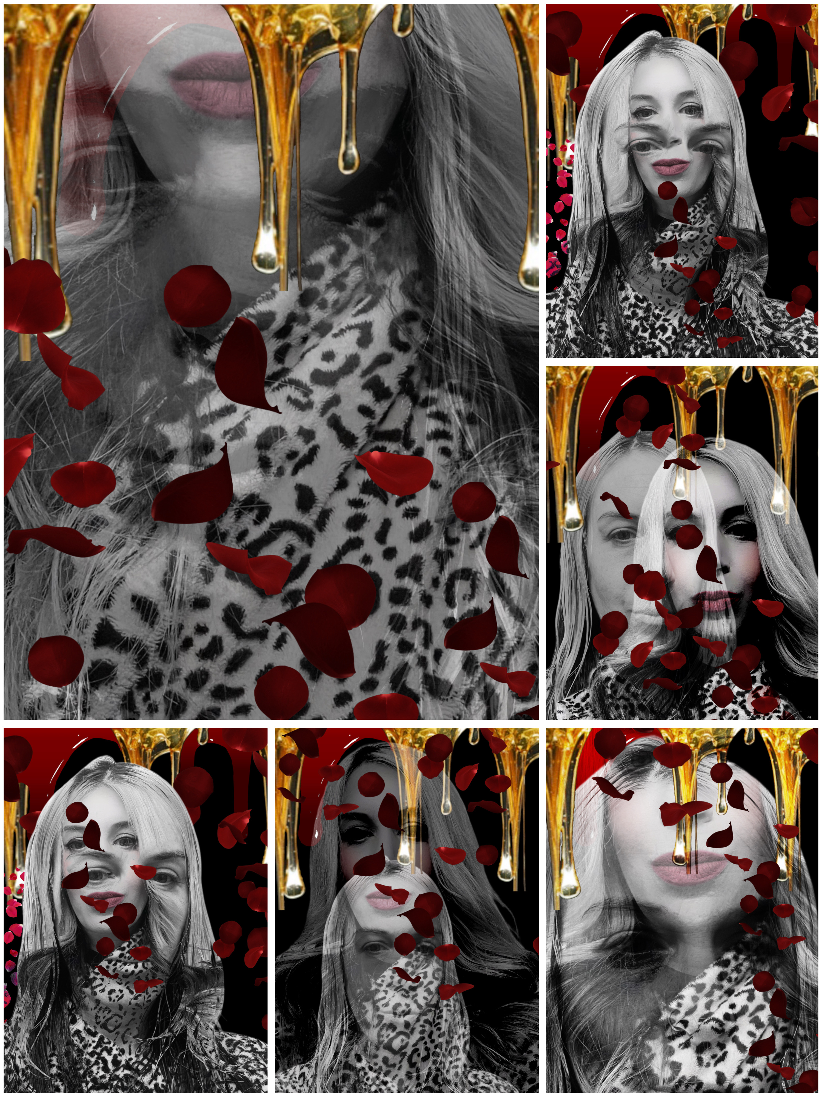
Part Three: Doppelgänger Petals
Masahiki and I decided to keep our relationship private due to our work, so the company would arrange for us to stay in different hotel rooms. Right after we arrived, I’d hear that familiar knock; then he’d grab me up and carry me to the bed. We left a trail of honey-dipped petals everywhere we went. I did not fall in love, but instead, I floated in love with him, as I wanted to always be with him, and never make the ending impact of a fall.
Yet, things weren’t exactly all roses, because while he made me feel secure and was respectful, the many women around him always made me feel insecure. It was hard to deal with, and sometimes I would wish the roles were reversed so he could feel that, because while not meaningfully oblivious, he was nonetheless.
Luckily, my security was bolstered when Masahiki told me that he loved me, some months into the relationship. I replied, “I love you so damn much.” It was a perfect moment.
Then, to my chagrin, he smiled and said, “Great! We will do a company release of this information so we can be together in public. I don’t want to hide anymore.”
I agreed, because I loved him, even knowing the price would be other people’s unsolicited, vulgar opinions being overstated, and needing to accept that without reaction. I now had to prepare myself for something that would hurt, no matter how prepared I was.
Later that week, we attended a party as a couple. As we entered together, the champagne turned to honey, and everyone raised their glass to us, allowing the honey to pour slowly into their mouths. I wondered if some damaged little girl was sketching this scene, trying to escape.
After the honey moment had dissipated, some people were passive-aggressive in their looks and body language, but it wasn’t as bad as it could have been.
However, the next event gave people time to digest this information, spread the word, and organize. The strange thing is that they loved the rush of the possibilities that our love was built upon: a king can love a peasant; it is a beautiful love story; it should have been protected as precious, but instead, they wanted to shred it up. So, people noticeably treated me differently; the women pointed and laughed at me, while the men whispered that I wasn’t the genius behind the company’s successful new direction, because, as it turned out, I was just a plaything. It was a heart-wrenching experience, but the fact that he wanted to be open about our love was the most romantic thing you could dream of, so I remained silent.
After a while, a woman started talking to me about the new rouge campaign, and when we finished speaking, I looked over and saw a horde of women swarming Masahiki. If they had wanted him when he was single and seemingly unobtainable, they really wanted him now, as an obtainable challenge. I was the one to knock off my floating petal-stal.
I wanted to avoid the crowd, so I went the other way and ran right into another crowd. I tried to go around them, but one of the women grabbed me and said, “Hey, everyone! Look, this is the ‘Before Woman.’ You are really an ugly little thing, aren’t you?” The women found this to be hilarious. With my newfound artistry and confidence, I thought I was beautiful enough, but now all my hard work had been replaced by their perceptions of me as before. I was not aware that they would have never known I was the “before” model if the “after” model hadn’t mentioned it when people started asking, “Who is this woman?” Still, the damage was done; I was previously on a journey to the after, and now I was back to before.
Then, another woman asked, “How desperate is he to date her?” And yet another, “Is he not well mentally?” So, I ran to the hotel and cried, honey, bloody tears all the way there.
Once in the room, I looked in the mirror, and I was the same as before; how could that be? I wasn’t. From then on, all the honey was mixed with blood and would often drip steadily from me.
It continued like that, and it was too much, but I endured because I didn’t want to seem weak to him or make him feel like he needed to referee me against society. So I decided to put on a show that everything was pure honey, and it was, just mixed with blood.
One night, I left early to avoid as much shame and pain as possible. Masahiki came in a few hours later, and he said, “Honey, I was looking for you everywhere. Why didn’t you tell me you were leaving?”
My red sticky lies dripped from my mouth, as I said, “I’m sorry, something upset my stomach, and I felt I might get sick. I didn’t want to have that happen at the event.” He grabbed me and said, “I’m sorry to hear that. Let’s lie down then.” We got under the covers, and then we were in a hive, sheltered and loving. What we had was perfect, which was the most challenging part to accept about the situation. My thoughts filled our hive with honey; we suffocated until I woke up, terrified.
As time went on, I couldn’t shake the deep hurt that I had confidence before, but never realized how easily it could be destroyed. Perhaps my new personality was akin to makeup, and the “before” me was now revealed as the “makeup” was wiped off. The resulting pain and insecurity caused me to act noticeably different, so Masahiki kept asking if something was going on; I lied and said there wasn’t. However, later, seeing that this wasn’t getting better and causing issues between us, I figured that if I had a problem, I should solve it. Now that I had money, there were solutions.
So, I made arrangements to travel to Europe for a multitude of procedures to turn me into the person I wanted to look like. I told Masahiki, and he said, “Please don’t, because you don’t need it; you are so damn beautiful already.” I should have felt beautiful because the only person I cared about said I was, yet my scars were coming apart and oozing; I needed to patch them up. This was our only fight, and it was a big one. Still, I set the date and made preparations to leave.

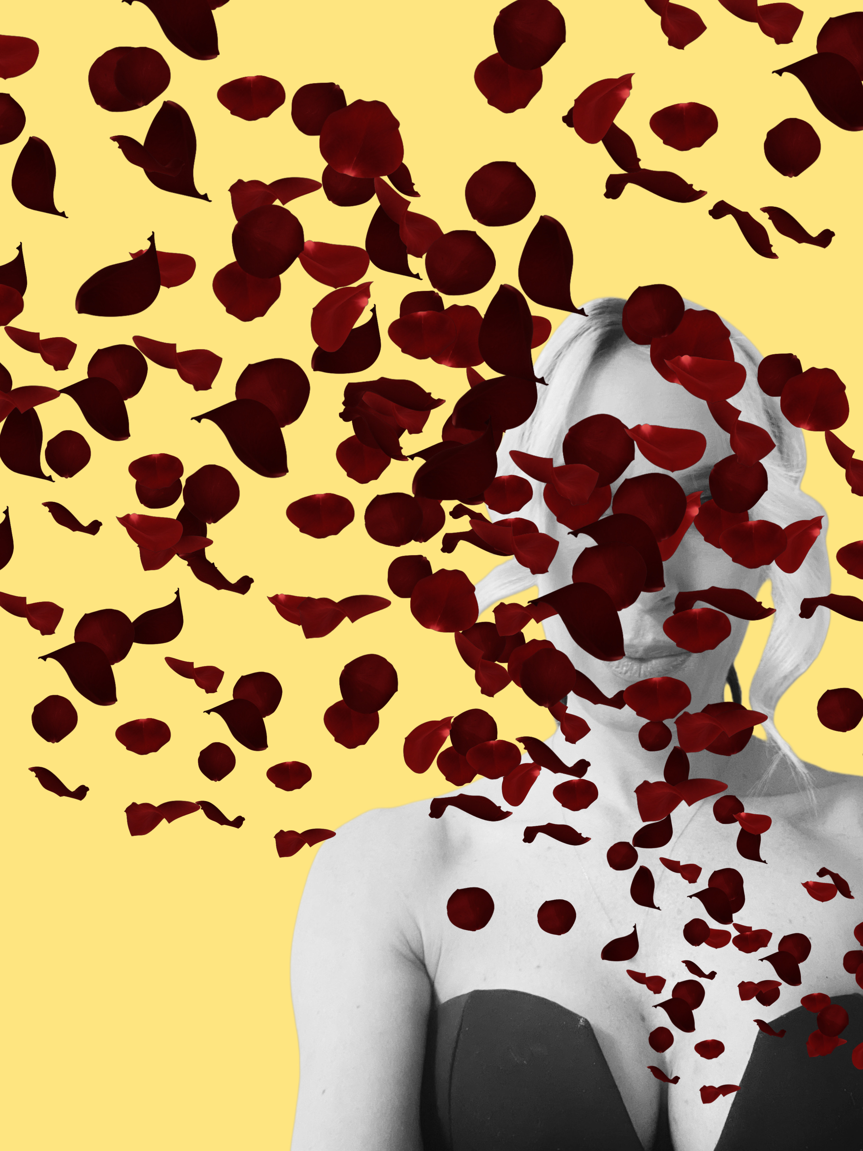
Part Four: Rose to Fall
Days before I left on my extended leave, Masahiki made reservations at the restaurant where we first met, and there he said, “I grew up with my uncle mostly due to my parents’ busy work schedules, and he was a monster. Feeling abandoned by my parents and being broken down by my uncle made me beyond insecure; others may have seen something lovely and worthy, but I never felt that way. Then one day, I committed to pushing out the insecurities that other people had instilled in me and being exactly who I was, not a perception of myself or a judgment of myself. You can do this too; I’ll help you. Please stay and don’t do it.”
I wanted to stay. I could have stayed. I should have stayed. Instead, I said, “Baby, I need to leave. Once I accomplish this, I will be who I want to be, and not be so indeterminate about myself.” Then I kissed him. He didn’t want me to go; I needed to go. That night, we made love, and in the morning, I left.
After many days of travel, I arrived in Switzerland for my procedures. I would have a few, let those heal a bit, then another round, and so forth. My first round was immediately after I arrived, and it went well. My days were spent recovering and sketching; the sketches played out around me as I completed them.
However, I missed Masahiki so much that I began to question my decision to leave. Still, I wanted to keep the spot I had, floating beautifully around him, and I didn’t feel like I could compete without the procedures, so I stayed for them. The more I became the woman I wanted to look like, the more I believed I was making the best long-term decision.
When I had fully recovered, I was the “after” woman, and people noticed me as such. True confidence changes you, and this time, my confidence was solid, so unlike before, a few words could never penetrate it. This gave me strength, which made me feel sexier and be more assertive.
When Masahiki and I finally reunited, it was like all our other reunions: explosions of petals that stuck to everything. However, that isn’t to say things continued as sweet as honey, because the sticky situation began to expose itself over time.
The first friction between us arose at a pool event where I passed by a group of women, and one of them said, “She doesn’t look like that without makeup; who wants to be with someone who takes off a mask before bed?” So, I responded with maturity by placing my towel in the water, wiping my face clean, revealing no makeup on the towel, and the same face, followed by a few special words. Masahiki was embarrassed. He didn’t understand why I let them get under my skin and then react, but he didn’t understand that it didn’t feel avoidable to me, like saying, “Float away; do not be affected by gravity.” I felt like I should protect myself, and he felt like I shouldn’t let it impale me, as it did. It made me feel so insecure, which turned to rage.
No matter the embarrassment, Masahiki was glad to have me back; yet, it was evident that I had undergone another significant mental and physical transformation, and he needed to get acquainted with the changed woman.
Luckily, just when I started to feel the negative emotions that I had promised myself I would never again with my new confidence, Masahiki told me that the head of advertising wanted me as the main model for the company. Although Masahiki informed me of the offer, I don’t believe he wanted me to go because we were used to being together and had just had a long stretch apart. Still, he wanted to see me happy, so he did not betray his emotions.
I could not believe that I was offered an even stronger solution to my original problem; if my new look didn’t keep me at the top with him, then global validation would. I immediately confirmed that I would accept the contract, and he said, “Well, then… We should celebrate.”
Later that week, I had prepared for months of travel, yet I strongly felt I shouldn’t leave. It seems so strange that my fear of him leaving was causing me to literally. My love for him was greater than my fear, if my love hadn’t been perpetuating and provoking it.
The night before I left, Masahiki proposed to me with an extravagant ring and a large bouquet of roses, which he dipped in honey and dripped over me from my hair to my toes. I loved him so much. If I could change anything, I would have never left him.
After I left, my life was productive and chaotic. Eventually, I started to be recognized by my name, rather than my relationship. Women who once snickered now marveled; men who used to intimidate saw an adversary. However, there was a price, and that was a substantial loss more of my privacy. I now had people who followed me, hoping for a story; there was nowhere to hide anymore. More than anything, I missed Masahiki; it was hard to know that my stubbornness was what prevented me from being happy, and yet I felt powerless over it.
It was some months after I left that I received word that Masahiki hadn’t been feeling very well and wanted me to come home immediately. I figured that this was him just being cheeky and missing me, so I told the messenger that I would be home in two weeks and would take great care of him. I couldn’t wait to see him; after my obligations, anyway.
The day before I was set to leave, I received a belated message that Masahiki had been diagnosed with Typhoid Fever and was in a critical condition, so I should leave immediately. I left everything behind and rushed to get to him as quickly as possible.
Sadly, it was not fast enough; he died before I even received the original message. So, when I returned, it was to say goodbye to the corpse of my everything with blood honey dripping from his mouth and my eyes. I left, he died, and we dropped roses on his grave, and that was it. I could not believe it. It couldn’t be over. I couldn’t accept that it was.
The ring on my finger kept reminding me of him, which caused deeply painful emotions, yet I couldn’t take it off. I hoped my will could overpower reality, at the expense of sanity and peace.
From there, I didn’t know how to handle it, so I didn’t and instead tried to escape. I never turned down a party invitation or anything offered to me once I was there. I would walk into the party, knowing I would come up less than I came in, but still, I kept on. Everyone’s champagne now turned to blood honey and dripped animalistically down from their lips.
When I started using honey intravenously, my father’s ghost would speak to me; he would say, “I always knew you were like me,” but his presence is exorcised when the honey reaches my heart, causing rose petals to fly out of my mouth and surround me. At the peak, I feel Masahiki, and I believe he is floating around me, the way I used to with him. Chasing that moment resulted in addiction, which would later claim my job, possessions, reputation, and prospects. However, just before I was to be homeless, I encountered a model with whom I had previously worked who seemed to share the same addiction. She approached me with a proposition, offering me an audition to dance nude in one of the mob-owned underground clubs; she said it pays well and suggested giving it a try, and if I didn’t like it, it would just be an interesting experience or story. I needed money, so I agreed.

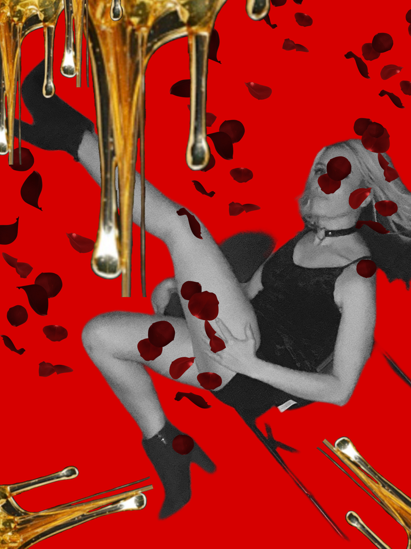
Part Five: Dancing Roses; Dripping Honey
When I arrived at the location for my audition that night, I was confused, as it was a plain factory building, but that was by design. After entering, we descended several steps deep underground, so it was both literally and figuratively. As we went deeper, you could hear the music pulsing intensely, which was nicely offset by the soft, focused lighting being more demure in its seduction.
Once underground, the woman escorting me introduced herself as Margaret and asked to see my body and the outfits I had brought with me. I then modeled the lingerie my almost husband had given me. I had once worn these in complete love, now I would take them off for money in desperation, and the brutal sting of irony was almost too much to bear.
After Margaret examined my body, which, despite my unhealthy choices, still held up, she was pleased. So, I moved on to the next phase, which involved observing the girls dance for a while so that I could later emulate them. She said if I did well, I could have the job. I nodded, and she led me much farther north until we came to an area whose futuristic melodies came pulsing through sexually. I then sat down at the very back and watched.
The first pair I noticed was a very young lady and a husky gentleman. He was seated, and she stood between his legs, facing him, while she slowly lowered herself until they were looking into each other’s eyes, much to his pleasure. You could tell he wanted to touch her, but currently couldn’t afford the separate service, and since breaking any of the rules could get you barred, he kept his hands under his bum.
As she danced, I observed him closely, and he looked at her with adoration, which suggested wanting more than sex, always that, but also that he wished she loved him. I would come to find that fantasies are more varied than I expected, and most unexpectedly, love is one of them.
The dancer fed off the man’s desire for her; she is in control. She continued to look into his eyes as she took off her lacy top. Topless, she rubbed her breasts into his face and then pulled back so she could present the “tip pot.” You can get lost in a fantasy for a song and escape whatever worries or hurts you, but another song has a price. It is our business to make fantasy good enough to live in a harsher reality, to pay for it. And a good fantasy becomes an addiction.
The man decided on another dance, so he put money in the pot. When it hit the bottom, it bounced and came up as rose petals that fell upon them, revealing a man with enough money for a room, but he didn’t need to use it, because the woman loved him as much as she wanted to fuck him.
However, when the next song comes around, he doesn’t have the money in reality, no matter how great the fantasy, and wish for it not to end. Seeing his hesitation, she faced away from him, then she worked her hands down her body slowly, removing her panties along the way, and then, fully bent over, she spread her buttocks for him. This is called a “closing move,” and it differs based on the customer because every man’s fantasy is unique; therefore, it pays to pay attention to your customer and get to know what drives them wild so that the fantasy and money may continue to flow.
However, without payment, the petals stop floating, and she is thoughtlessly and immediately moving on to her next mark, while he is back where he started, but with less money. That is the magic of fantasy; regardless of the truth or result, living in that moment is still worth it.
Next, I watched a very curvy woman with long blonde hair, dressed in leather, spot her quite mature prey from across the room. She summoned him over with her eyes, and he walked in a trance toward her. Once he was in her chair, she didn’t remove any of her clothing, nor did she dance; instead, she tied the man’s hands tightly. I was immensely confused, only to be more so when this woman turned him around and began to flog him vigorously under a red spotlight. I looked over at the man, and he appeared to love it. I came to learn that pleasure is not always overtly so; sometimes it is pain. I knew nothing of fetishes until this place.
The leathered woman eventually stopped her assault and moved to the music while he was still restrained. After the song, she put her tongue in his ear and then whispered something to him, which caused rose petals to burst out of his other ear. Since he couldn’t reach his wallet to pay to continue, he had good reason to pay for a room. With the agreement made, she untied him and then led him further into the bowels of the building while rose petals floated between them.
While watching the couple disappear, I was called over by a stunning dancer. She had shoulder-length brown hair and a complexion as smooth as cream, and wore a silk bra and panties that matched her crimson lipstick. Over loud music, she introduced herself as Faith. She instructed me to observe her working in the private rooms, which offered more privacy than the many chairs scattered across a long general dance floor, so if you were afraid that you or your fetish would be seen, they were available for a higher price. However, the services provided in the bedrooms located deeper in the building would not be permitted in the private rooms.
Moments after we entered the private room, her first customer arrived. He was a handsome man who wore a gaudy wedding ring. You could tell this was one of her regulars because they immediately embraced as though they were meeting again. He then glanced at me, and I was mesmerized by his eyes, which reminded me of a shark’s, focused and deep, like the ocean.
I smiled, and he shrugged, then sat down. Faith danced for him, and I noticed that they touched each other with intense sensuality and familiarity, which looked more like two lovers than a married man and a nude dancer.
When the song ended, he pulled out a ton of money and placed it in the pot. He wanted to ensure the pre-paid petals permitted reality to be pushed farther back, allowing him to enjoy the ride. As she danced for him, it seemed the fantasy was as much her desire as his; the attraction was mutual, which was unexpected, and yet a wedding ring lingered between them; luckily, the petals would cover it for a while.
As they shared this intensity, I wondered why he had placed enough money in the pot for several dances, instead of paying for the bedroom time; that is, until I realized how the petals came out slowly as foreplay; their pleasure was to delay it and be forced to enjoy the moment, not focusing or rushing to the climax. She danced endlessly, moving in ways that tantalized him.
After some time, the time was up, and he exited just as our next customer entered. Faith recognized this man as well, and it appeared that she had loyal repeat customers. Surprisingly, she turned the lights on, which was blinding after being in mostly darkness with some light. She then pulled out a concealed blanket, and I wondered if maybe you could break the rules and allow bedroom service in the private room, but that was cleared up when he began to dress in an adult-sized diaper and an oversized toddler’s onesie. Then she sat up against the wall on the blanket, cradling this man in her arms and mothering him. She whispered words of encouragement while he diligently sucked on her breasts, which were filled with honey that dripped from his lips.
After he left, Faith told me that I would dance for the next client while she observed. I knew it was coming, and yet, I was incredibly nervous and self-conscious. Seeing my nerves, she pulled out a honey kit. She injected the honey into herself first, and then into me.
After that, she turned out the lights, except for the low lighting that would be centered on me. As the honey hits my heart, I see my client enter and sit in the chair facing away from me. I try to advance toward him, but honey fills the floor, and it’s so sticky, it’s hard to move forward, so I struggle to do so in six-inch stilettos.
After much resistance, I finally reach the chair and am shocked to see Masahiki. I immediately jump onto his lap and kiss him passionately while grinding into him. He pulls off my lacy bra and passionately massages my breasts with his hands and mouth. Rose petals fill the room and float.
Unfortunately, moments later, as I come down from the drug, so do the floating petals, and I see the brutish man who was before me, looking at me with intent. I was devastated, and he didn’t notice.
I upsold a room on my first dance, but Faith informed the man that he could pay for the time, but it would be with Bridgette, since I was new. When he accepted this without hesitation,
I learned that those who fulfill a fantasy are often interchangeable. After he left, I danced the rest of the night in a blur among large floating white roses dripping in blood.
Later, I was offered the job and I accepted. I wondered how far this would drag me into the abyss; you hardly ever hear of happily ever afters once you become immersed in this life.
From then on, I kept honey in my veins to keep me going, and it numbed me enough; although I knew I would eventually have to work the bedrooms, and I worried about how I would deal with that, still, I tried to push it to the back of my mind.
Luckily, I excelled very quickly, having been accustomed to selling throughout my career, and I loved selling because it involves clear communication and deep understanding. So, I approached it like a puzzle and figured out and provided the fantasy, and later, I would often wonder about the experiences that resulted in those desires or dysfunctions.
Initially, I told myself this was “just till I got back on my feet;” however, my job fueled my addiction, so after some time, I knew I’d never find my feet on solid ground again. It wasn’t a vicious cycle but a steady decline. I couldn't look at a mirror because all I could see was the bloody before.

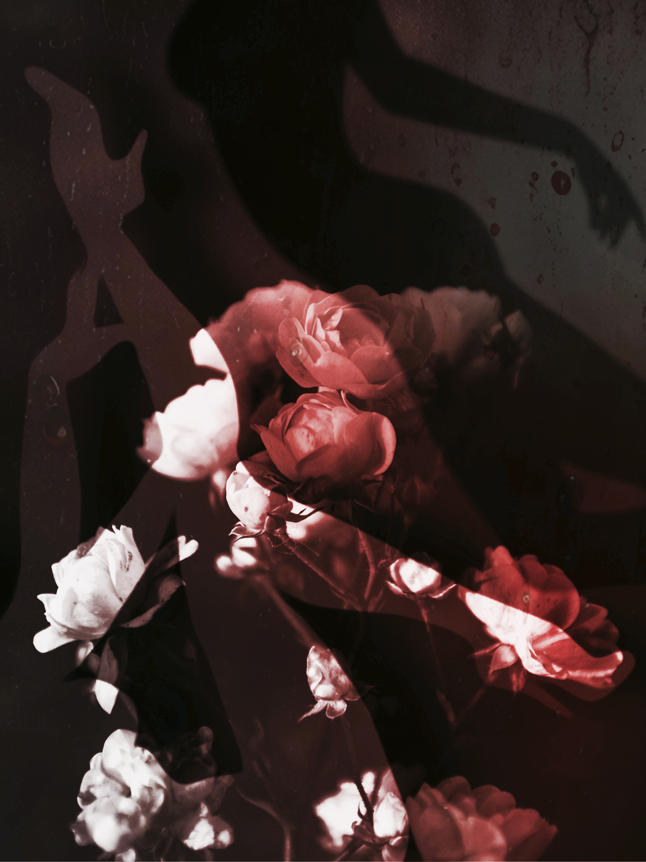
Part Six: Bed of Roses

Fortunately, as my life was descending, I met Tasha, a dancer who was returning from retirement. She was tall, curvy, confident, and commanding. She was the most gorgeous woman I had ever seen, and one of the few legends that reality revealed in the even better lighting.
Tasha had wanted safety and stability more than anything, so she gladly gave up dancing when she met Lindon, a nice man at the club who wanted her to stay home. She loved that he thought she was magnificent and a work of art; few women ever experience a fraction of the adoration he expressed. He also understood that you may have a cheetah in a fenced sanctuary, but not an aquarium tank, and so he didn’t expect her to change herself entirely or require much of her except for her love and loyalty. And Tasha brought plenty to the table; for whatever she lacked in domestic desires, she made up for it by being the intelligent, kind, and beautiful woman who brought excitement into Lindon’s life. The sanctuary they built was a lovely one.
Initially, the marriage seemed destined for eternity, proving that opposites can complement each other; however, the things that Tasha wanted most were warring against her need for excitement and complete freedom; life hadn’t gotten as dark as it would later for her so at the time she didn’t understand the magnitude and value of a secure life with a compassionate and solid man. She also lacked the experience to understand that a strong connection is only the start to being soulmates, because beyond that, there must also be respect, communication, and there cannot be abuse.
Once Tasha got drunk on champagne, and feeling the sting of her repeatedly bad relationships enhanced by the clarity of hindsight, she revealed to me that she was certain that Lindon was her soulmate. Her voice and heart broke as she described how she left him because of this powerful dichotomy within her; there was something about her that wanted certainty, safety, and routine, and yet another stronger part that resented and balked at it. I had never seen her cry prior, and as she shook uncontrollably, her blood-honey tears nearly drowned us.
Unfortunately, later, when Tasha had been through enough storms to need and appreciate the peace of his serenely anchored sailboat, she realized what she had lost. Sadly, by then, Lindon had married and had a family; although he still remembered her birthday and sent her a card every year, which always invited the ghosts with it, as she wondered how her life might have been different.
Tasha was glad to return to dancing because she needed the distraction. I noticed immediately that the dancers were extremely standoffish with her, which was natural given the competitive nature of our job, but this was next level. However, her magnetism drew me in, rather than repelling me, and so I approached her, to her surprise. She was the first friend I had outside of my petal phantom, and we had a strong bond, making an imposing pair. It wasn’t long after we met that we moved in together.
Tasha was so different from me, as she always wanted to be around many people and experience everything; yet, as she dragged me along with her, I always ended up glad I was with her. The days of summer were warm and felt endless, and the nights were equally as warm, as warm honey poured over us, allowing the rose petals to cling to and cover us. I will never forget that glorious time, as a dream juxtaposed against more insidious things.
Unfortunately, life didn’t stay that way, as it shifted towards an unthinkable place, starting when Tasha came home with what she said was exciting news. She said, “I gave the mob boss’s son who moved back home from Illinois a dance, and he is so handsome and powerful. I think I am in love.”
I was speechless because I had never seen Tasha gush over a man before; I had only seen her intimidate and play with them. Plus, this was precisely the type of man she would warn me against, overly entertaining, because falling in love with a mobster is just plain crazy, as they played by their own rules and were often above accountability and reproach. I could hear her saying, “How silly a woman should be to love a mobster and expect a reverend,” only to now be hoping for the holy man. Fantasy is one thing; love is certainly another.
In addition to confusion, I felt jealousy, and so condescendingly remarked, “What about all that stuff about how stupid it would be to trust a mobster with your heart? What about your don’t shit where you eat rule?”
It is challenging to quantify what causes attraction and at what levels, but he was the top for her. He was everything she said she didn’t want, and yet was attracted to beyond reason. She just shrugged this off, and from then on, I had visions of blood honey coming out of her eyes and breasts.
Luckily, the mobster was out of town for work nearly all the time, so Tasha and I still spent time together, and although a bit love-sick, she maintained her effervescence and autonomy. Unfortunately, as time went on, she was not quickly disillusioned, as I had expected, but instead stepped further into an illusion; the longing and distance seemed only to fuel her obsession.
However, I didn’t start to worry deeply until after I first watched her dance for him. While she danced, I observed his eyes turn pitch black, the whites gone entirely, and they were sucking her plentiful petals into his depths. He must have felt my eyes on him because he looked at me with a malevolent smirk on his face. Then he fired the petals he had sucked in through his eyes at me, and I was hit with a wave of sticky blood.
When Tasha came in early in the morning, I hadn’t been to sleep. I told her that this man had something much more unsettling about him than being a mobster, and I wanted her to try to distance herself from him. She staunchly defended him, and we argued about it. This was our only fight, and it seemed clear that if I pushed the issue, it could be our last anything, so I didn’t.
A month later, I performed my first of many dances for Lester. I hadn’t considered I would ever feel love for a man that wasn’t Masahiki, but Lester was shy, sweet, and thoughtful, and saw perfection in me where I saw nothing; his overinflation of me made me feel lighter. He only ever booked me for a private room, and after one dance, just wanted to talk. I believe it was his shyness that led him here more than his penis, as you must be able to speak with a woman to get her naked in most other circumstances. I hadn’t realized how cold my life had become until he warmed me slowly, instead of torching me to get what he needed faster.
I loved talking to Lester because he never pressured me to divulge equally, and he had no shortage of things he liked to discuss with great exuberance and enthusiasm. Often, he spoke of his family’s farm and working in the family business, as well as all his many hopes and dreams.
I knew he didn’t have much money, and I believe he spent it all on me. He hoped that I might date him eventually, but didn’t expect me to.
During the time he courted me, the list of romantic things he did was more extensive than I could ever count, and he only continued to add to it. So, eventually, with incredible fear and bravery, I said “yes” to a date. After we started dating, I grew to love him. Although the concept of love was beautiful in theory, as a practicing dancer, it created a sticky situation. Dancing for strangers while dating Lester was hard enough, but soon I would be forced to work in the bedrooms, and that would be much worse. That thought made me realize that I had worked at the club for what felt like forever and was still not working the bedrooms. Still, I thought maybe life is layered like petals, and these were happier petals, so I should enjoy it. Later, I found out it was Tasha who paid some price to keep me out of them.
Unfortunately, because I hardly saw her, I had not realized how turbulent her waters had become, or that she was taking in extra water for me, while mine were becoming serene. By the time I saw Tasha that December, it had been three months since I had last seen her. She had quit working at the club after her mobster lover pledged his financial support and put her in an apartment, which gave her the support to pursue her many aspirations. I assumed she was not in touch because she was in a love bubble and enjoying early retirement. I wanted it so badly to be a good thing for her, despite my terrible feelings. Sadly, when I saw her, I immediately realized that she hadn’t been around anyone because it was clear she was still healing from what appeared to be a brutal beating. I ran towards her and asked her, “What the hell happened to you?”
She said that a customer was angry that she retired, so he found out where she lived and tried to rape her while she fought him off. As she spoke, I noticed that almost all of her rose petals were trapped below the surface of those bruises; faint ghosts, filtered through darkness. I was shocked, and I hugged her; however, something felt off about this. Still, I figured it was plausible, as our profession is one of the most dangerous. I was so sad when she retired, but then I was relieved. I never considered the perpetrator could be her partner because I watched her stab a few different men, so if she wouldn’t take shit from a stranger, then why would she from anyone else? So, I accepted this explanation, even though I strongly felt that something was wrong.
Then, she rushed out pretty fast, and I yelled after her that I wasn’t waiting no damn three months to see her again. I missed her terribly, but I believed that Tasha would be around much more after she calmed and healed from that attack, and the excitement of new love wore off.
While I waited for Tasha to come around again, I enjoyed my time with Lester. I had eventually divulged my addiction to him, and he said that he was concerned for me and wanted to help me quit. His sincere desire to care for me made me care about myself more, and there was something so impressive about him, as my violent tornadoes of self-doubt and anguish hardly disrupted him. So, I stopped pumping the dark honey in my blood.
The night Lester asked me to marry him was so wonderful at the time, but horrific in hindsight. It was after the proposal that I returned home and ran into Tasha, who did not realize I had taken the extra day off to be with Lester. I had not seen her in a few months, and she was a mix of black, blue, red, yellow, and brown, with swollen areas. She wasn’t recovered; she was much worse than before. Finally recognizing he had gone to far and knowing that I wouldn’t believe another stranger attack story, she told me the truth: she fell in love with a mobster, only to find out he was married shortly after, she had tried to get him to leave his wife or Tasha tried to leave, but he would get more violent. He was a volatile, married mobster —a monster.
Immediately, I wanted to kill this man. I started to prepare. But then she begged me not to do anything, because she said she had left him for good and wouldn’t have to see him again, so why risk anything?
I didn’t want her to stay at our place, so I implored her to let us put her up at Lester’s family farm, as there was plenty of space and his family was incredibly easy to get on with. She asked who Lester was, and I explained my fiancé. She seemed unsure where the time went.
While with Tasha, I could hear these eerie echoes of phantom whispers reverberating through our place. Then, an enormous black rose suddenly dropped onto me, and things went dark until the flood of darkness was pushed below me, revealing the light again. When my eyes adjusted, I saw Tasha with only hollowed-out eye sockets and slightly decomposed. I was about to scream, but another giant black rose fell onto me again, revealing Tasha to be more decomposed and maggot-infested. This repeated and progressed until she was nothing but dust. I didn’t know what to do.
Luckily, Lester came looking for me later; he examined Tasha closely and was concerned, so we cared for her together throughout the night. During this time, she continued to believe Lester was Lindon and called and treated him as such. She would embrace time tightly and say things like, “I cannot believe you are here, Lindy. I have missed you so much.” It was clear that she was very unwell.
That morning, Lester and I wanted to skip work to move her to the farm, but feeling better, she insisted assertively that we go to work. She promised that she would stay locked in and pack until we got home and announced ourselves. She kissed my lips for a long time, and they still tasted like honey; it brought me back to the summer days when we were wrapped up together. I never forgot the taste of her honey-lips, and I never saw her again.

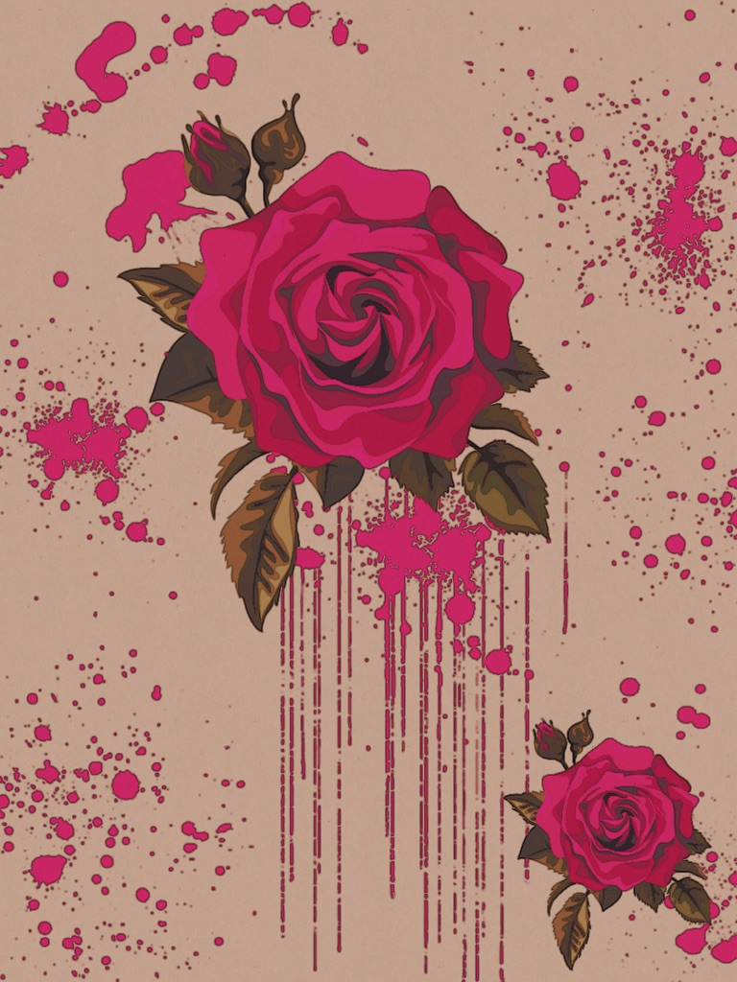
Part Seven: Rose Bud
Later, when Lester and I returned, Tasha was not around. I waited anxiously for her to return. After some time, I began to go through her things, and one of her bags was filled with money, along with a note placed on top, addressed to me. It said that if anything should ever happen to her, to take the money and run because she believed the mobster would kill me on the off chance I knew anything, and could say anything. She must have known that the mobster was coming, and it was unavoidable, but she wanted to take care of me. Realizing I was in danger, I told Lester I was leaving and to stay away; he refused and told me he was coming with me.
With more than enough money for a fresh start, Lester and I headed north. Along the trip, he proposed with a bouquet of cloth roses; when he handed it to me, the faux petals burst from the bouquet and floated around us as we kissed.
We decided to change our names and appearance so we could be new people; I was Alice; he was Lou; we were the Princes. We eventually came to a town that felt right to us, and we got married and started a new life there. I initially worried that I would experience the same dilemma Tasha did previously, and I worried that I could desire routine and security, but later, would those lose their appeal?
While I was worrying, Lou planted these artificial rose bushes everywhere and believed so much that they bloomed; they may not have been real, but they were flawless because they didn’t rely on what living things must. After Lou’s magic yielded, my concern was alleviated, and I was content. Later, when I had my son, my contentment turned to joy, as I had something truly wonderful enough to cast out the gloom I had been living under after losing Tasha.
Unfortunately, after some time, my memories or thoughts of Tasha turned into hallucinations—a realistic memory. At first, she always looks beautiful, full of life, and happy. I want to be near her. But then she starts to decay. It wasn’t long after those visions started that blood honey tears regularly dripped from my husband and son’s eyes. I became consumed with worry.
Then, that December, while walking home from work, a man came up behind me and grabbed me; it was a mobster who addressed me by my former name. I said, “Good sir, I am not the woman you are speaking of, but my husband and I have a little money, and will give it to you.” He didn’t believe I was someone else because, some years ago, I had constructed a memorable face. I was given two choices that night: write a goodbye note where I say that I am leaving my family for a better man, or watch my family be killed. I wrote the note, and when my husband read it, he was heartbroken, as was my son.

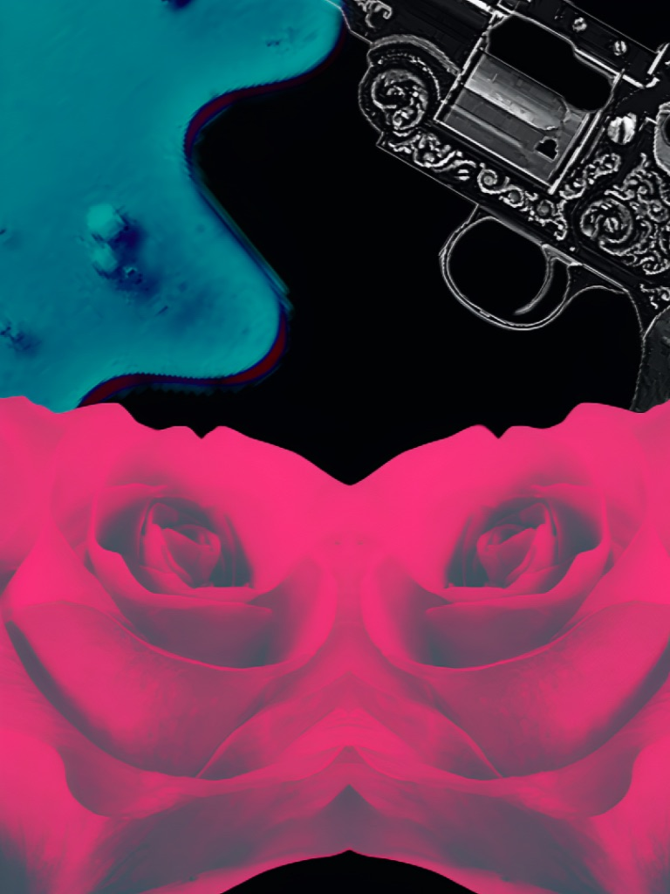
Part Seven: A Rose by Any Other Name
Once I was returned, I found that I would not be killed or dancing in the club, but the private entertainer for the mobster who I believed murdered my best friend. I was in an impossible situation because I hated this man and wanted to leave or end his life, but I was informed that if I did anything, he would have my family murdered.
From the first moment I was presented to him, he demanded my name be Tasha, and that I act, dance, and screw like her; then sent me to get my nails, makeup, and hair to match her’s; I also had to wear her clothes, including her intimate garments.
I believe the mobster missed Tasha because she was a unique person, and they had a genuine connection; I also believe that he killed her to avoid accountability. In her life, she became a beaten-down, hidden possession; after her death, she possessed him powerfully. He often tried to replace her, but found he couldn’t. It was after many attempts that he suddenly thought of me, her former housemate, and how I looked a bit like her and knew her intimately. So, he hunted me down to play the person he killed, and I dearly loved and missed. From then on, I haunted myself; sometimes I appeared as myself in my reflection and felt like me, and sometimes I saw and felt like her, until I wasn’t sure who I was.
As time passed, my situation continued to worsen, as the mobster began beating me. There was a sickness in him that fed on destroying beauty. I became a prisoner who had no more petals.
Then months later, I brought in the paper that I wasn’t permitted to read, and out fell a flyer for Pretty Petals; they were searching for a new “before girl.” The amount it paid caught my eye; it was enough for me to escape with my family again. I looked in the mirror, and I was worse than before. Given Masahiki’s presence in this escape plan, I decided to take the risk.
Later that week, when the mobster was with his family, I snuck out to audition. While there, I mentioned that I modeled in the original ad, but I had stopped using the cosmetics and had forgotten the possibilities, so I returned to before. The fact that my ugliness came from being battered mentally and physically was of no concern; I was not beautiful anymore, and that is all that mattered.
Luckily, my pitch was perfect, and I got offered the job on the spot. I signed a contract with the familiar rose company logo and snuck out later that week to shoot the photographs. I then hid the money away and waited for my jailer’s family vacation later that month to escape.
When the time came, I escaped and headed to my family’s place. It had been a few years since I had seen them, and I missed them so much.
Unfortunately, when I arrived at our house, it was vacant. So I asked around and found that my husband had moved on and they had a happy family. Even though it hurt, I didn’t fault him for it, since he believed I had abandoned him. Yet I hadn’t considered it because all I had to consider was them; they were always the center of everything.
I decided to watch them from a distance, and when I saw how happy they were and remembered the danger that had always followed me, I didn’t approach them, and I never saw them again.

Part Eight: More Roses; More Honey
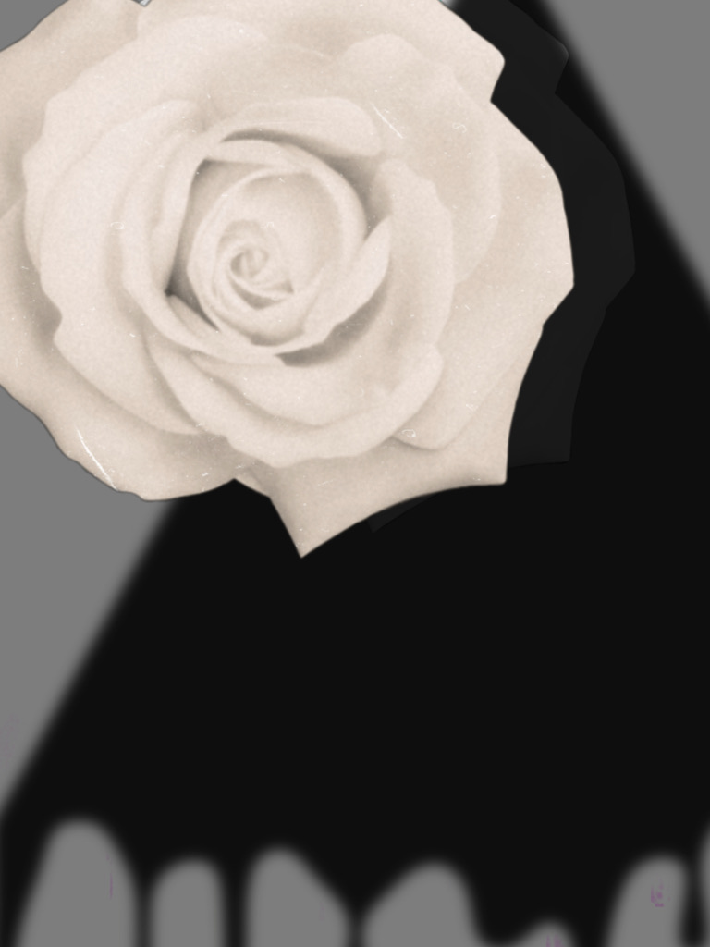
Once I realized that my family had moved on, I moved farther south and eventually ended up in a small town with tropical weather and plenty of geography between me and a few of my ghosts. With the ad money, I got a small place and made it my own. Later on, I got a job as a dancer, where I kept my clothes on, for a traveling band. My dance partner was an experienced and skilled dancer, and the son of the patriarch of the family’s entertainment business. We spent a lot of time together as he trained me to dance. He was shy and immature, but he was sweet, patient, and extremely handsome.
I remember the first time we smoked this herb at his tiny house; he looked at me with these dreamy eyes, and then said overly sticky-sweet things to me, and they were enough to make me want to take a dip. He was always one single rose, but that is all that is necessary.
After that, he wanted to date me, but I kept brushing that off because we didn’t have much of a connection past a friendship. Still, there were plenty of the right feelings, if not deeper ones, and he loved me in the way only younger men do: shallowly, and eager to please. So, with the added pressure from his family, I agreed.
As I expected, the connection never advanced past the phenomenal friendship we shared; he was young, and I was still in love with Masahiki. Still, we enjoyed our time together because we always had such a good time.
Later, when his friend Ricki returned from school abroad, now graduated, I realized that the lack of connection was due to us both being in love with someone else. I recognized the look immediately; I had been both the giver and receiver of it. I would watch the two bathe in honey while petals flew from each of their eyes and mouths, and attach to the other; the feeling was mutual. However, it was illegal to be homosexual, so people were not likely to act on their desires. I then decided that, for all the wonderful things Carlos made me feel about myself, I could help them out. So, I invited them for dinner at my place.
After dinner, we had a few drinks and relaxed. I then shocked them both when I kissed Ricki, and I confused them more when I kissed Carlos next. I then suggested they kiss each other, but they both declined and pretended they didn’t want to, while gauging the others’ reaction. I insisted, though, and pulled them into the bedroom, saying, “I know how to keep a secret.”
That first kiss between them oozed with honey before contact was made; it was the buildup of receiving your fantasy, having had it for many years. Even though I was clearly the extra, it was so lush that I couldn’t help but absorb the excess. The memory of that night still brings the taste of the golden sweetness to my lips.
Carlos and I got married shortly after that encounter. It was a beautiful tropical ceremony that his family insisted we have. His family was prosperous and well-known, so I was introduced to a number of interesting and successful people, who all commented on how beautiful I looked. This was true, but it was strange to hear, considering at times I had been ugly enough to be in an ad for that; yet, I have found that beauty and ugliness have woven in and out of my life and can be altered by circumstances or money, so appearance has never been independent for me; when I looked in the mirror, I wasn’t attached to what I saw.
On our wedding night, Ricki was waiting for us, and we moved him in shortly after, above suspicion. During this time, I directed us, not just because the two were incredibly inexperienced, but also because I was experimenting; I had done it all, but I had done much of it as a job, which is different. Some days, we’d spend twenty-four hours in bed, addicted.
Eventually, I discovered my true fantasy was thinking of Masahiki. With an inventive imagination and smokable herb, I was able to make him appear nearly. Oftentimes, a ghost played by either man was part of our ménage à trois. For a while, it was heaven inside hell.
Later, it appeared that the two were in love, and I was a distraction; I was a bridge that had now been crossed, and now they didn’t need me romantically, although we remained very close friends. I was happy for them.
Eventually, I wanted to give them their space, so I figured they could tell everyone who noticed my absence that I was on a world tour of dancing and would return, allowing them to maintain their nest without whispers. I would never return.

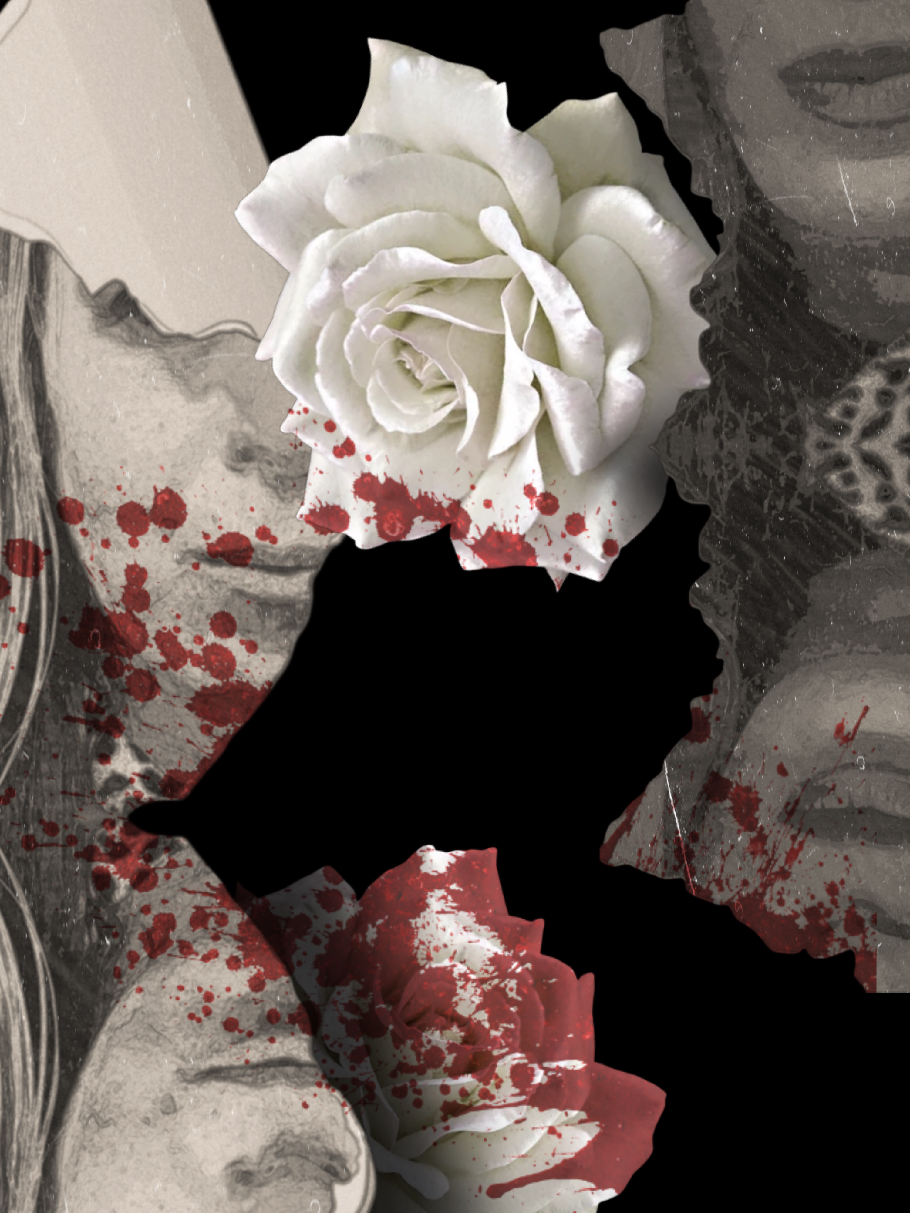
Part Nine: Despite Thorns
Now I had to go back to the drawing board; I would need to change my location, occupation, name, and life. I decided to take a train across the country and get off at some point. Strangely, I decided to stop in the mountain town where I had started my life, because where I once felt like it was a cage holding me in, I now felt like I was being protected by the bars.
Once settled, I secured a job as a supervisor at the department store where I had previously worked. However, I did not dream about the women I serve now because I know things are never as they appear; money and fame can bring evil, and cannot replace love. I was a much wiser woman this time around, hardened by experiences. My days became so similar that many times the only thing that changed was my shade of lipstick and blush. The stillness was a conductor for all of my ghosts to live; I would often see horrible things and then be doused in sweet blood. People who couldn’t see the sticky substance would stare in confusion as I frantically tried to wipe it off.
Then one day, when I was at work, a man approached me and called me Maryanne, which was now not my name, so I said, “Oh, no, I am sorry, honey, my name is Faye. I often get mistaken for other people. I suppose I have one of those faces.”
As he got closer, I remembered this man; his name was George, and he had worked in the restaurant below the department store when I worked here years ago. It was the only time anyone recognized me after my continual transformations. I always liked George; he was older than I by some years, but incredibly handsome and affable. I didn’t know then that years ago, the continual small talk I had with him while accessing the store’s storage was enough for him to care for me and recognize me, regardless of my name or disguise.
George waited for me to agree that I was Maryanne, but I couldn’t. So, he stood there until a customer approached, and then he left, looking confused.
Next, I was confused when he showed up with a single white rose later that week. He asked me to dinner, but I declined, saying truthfully that dating was not something I saw in my cards for the foreseeable future. He looked so disappointed, but did not leave.
After a pause, he asked if he could play the She Loves Me, She Loves Me Not game with the rose, and if it landed on “she loves me,” then I would go on a date with him. He then smiled slyly and said, “You may appear as whoever you want, and I will address you by any name you wish.” I could tell then that he remembered me with certainty; yet, my new identity was not an issue.
I didn’t agree to this, but he started removing petals anyway, and as he did, the rose petals floated into my chest. It was so warm and overwhelmingly good; it had been so long since I had tenderness and attention.
He landed on “he loves me not.” Part of me wanted to take the out because I was afraid, and I felt too damaged even to try for any relationship, but then, the petal transfusion took all my good sense away from me. I felt something after not feeling anything for so long, and it felt addictive to me. I was hooked.
I smiled and said I would go out with him; no games were necessary. I then watched as petals burst from his being. I made someone happy, and someone made me happy, and that was magical.
The first date went perfectly, and then there were several more that were even better. With George, I could be more myself, instead of the darkened, different person I had become or the roles I had to play. He had few distractions being retired, and he was my addiction, so our lives moved forward together in slow motion, sticky and sweet. We had a profound and loving bond, despite his limited knowledge of my life, and we built a beautiful world together, as we took care of each other.
Later, when George’s health started to decline, it was an easy decision to quit my job, as I wanted to be near George at all times. During my time caring for him, I was able to devote much of my time to art again; it had been many years since I had even tried. Since George always loved it when I read to him, I started writing stories to accompany my drawings, or vice versa. As I began to immerse myself in the art, I felt a sense of healing; I had been through far too much to harbor delusions about being new again, yet being less broken was more than I could have hoped for; I was grateful.
Eventually, George asked me for the truth about my life. I don’t believe I would have told anyone else, but there was something about him that made me feel secure and safe enough, so I fought past the fear of reliving pain and my want to run, and I told him everything. He never flinched. He loved me not as an insecure girl, a woman with ghosts, a hunted prize, a mother, a nude dancer, or any other versions of me; instead, he loved them all. I couldn’t help but love him for loving me as the “after” of a lot of dark shit.
George then said he was glad he knew all of me, and now he wanted to marry the whole of me, but he insisted on marrying me as myself. I would have loved to marry George, but I didn’t want to take the risk because the mobster could still be looking for me, so I said I didn’t think it was a good idea. He then put something in my hand, and it was an engagement ring with a Maude-colored gem, which invited my mother’s spirit; I knew that if she could have hand-selected anyone for me, it would have been George, the antithesis of her husband, so I said I would marry him as myself, and kissed him passionately.
Then, he assured me that so much time had passed and we lived so far from the mobster that we should be safe; still, he said we could take extra measures to ensure our safety. He stressed that no matter what, he would always protect me.
We got married a few months later in a small civil ceremony. Ours was a cocoon filled with honey, complete with closeness and maximum lubrication. That was the best day, but it was also one of the biggest mistakes I have ever made.

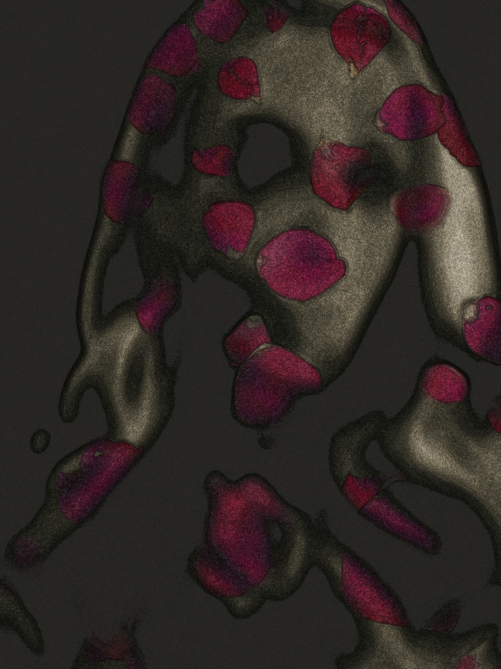
Part Ten: A Rose for Our Grave
Our undoing was the wedding photograph and announcement George posted in the paper; he felt sure of our safety, and he was so proud of our love. Unfortunately, by some act of the devil, this paper ended up in the possession of the mob boss’s driver, who was making the journey across the country and stopped in our beautiful town for the night.
It was a week later that, while returning from the drug store, someone grabbed me from behind and put a rag to my face, and I lost consciousness. Then my body was dragged away.
When I woke up, I was in the mobster’s bed. He had aged considerably since I had last seen him, and his rage had only increased with time. Something was irreparably broken about him now; if he had been a night with a tiny light before, his darkness was now pitch black. He brought me into absolute darkness.
Once he noticed I was awake, the mobster put a collar on me and told me that I was his and if I should ever try leaving him again, he would find me as he did before, but then he would break all of the bones in my body one by one. I was terrified.
My days from then on played out like one long nightmare in which I could never awake. He frequently beat me severely, so that I was covered in wounds, bruises, and scars. When he was heavily under the influence, he would cry out, “Tasha, why did you have to try to leave me?” “Tasha, I miss you.” “Tasha, I just love you so much, I hate you.”
Before the mobster, I had previously thought that people fall into categories: in love, in hate, or indifferent, and that once you truly hate someone, and aren’t just transitioning from love to hate, it is impossible to love them again. However, within him, love and hate coexisted simultaneously, but not in peace. It was incredible to witness the pain that stemmed from his love and the destruction that accompanied his hate. It was an act of sadism on himself, as much as it was on me.
Now, when I looked in the mirror, I saw that no beauty products could help, no matter how falsely; there were no more good possibilities. I couldn’t tell you how long I was there; I lost track of time.
Then, one day, I felt so low and bored that I took a risk and read the paper that I was forbidden to. On the fifth page, I was shocked to see that George had died at the age of 70. The article revealed that he was a much bigger deal in the business realm than my humble husband had ever expressed to me. He was lamented as a legend, visionary, and compassionate man, who received national coverage of his passing.
Sadly, I didn’t appear in the “Survived by” section, because George received the letter I was forced to write, stating that I had changed my mind and was leaving him for a more exciting life, so he had the marriage annulled. I was erased from his life, but I could not let go of him like this, and I knew I must say “Goodbye” to him.
Unfortunately, it was harder to figure out a way to escape since the mobster had added numerous additional measures to ensure I was confined. He was also around much more, as he was not as interested in keeping up his family life appearance as he was feeding his various, nefarious addictions.
Then I remembered how many times I was drugged to gain quick control of me and how easy it was to get hold of his many “medications,” as he often had them hidden in a toiletry kit.
When he briefly left that night, I moved quickly and prepared everything, so when he returned, already drunk, I made him another drink, and then he fell into a deep sleep. As I snuck out, I heard him calling out for Tasha painfully in his nightmare.
I arrived just in time, because the viewing had long been over and they were preparing George for cremation. Alone together, I cried honey, bloody tears, and watched as they dripped from his eyes as well. I then dug inside myself, took my last petals out, and sacrificed them, as I spread them on top of him. George loved me as I was, not the possibility of who I could be, or me sans my past or pain; I cared for him very much, and I didn’t want him to be gone. Now I would leave without any petals and with nothing but perfect memories.
As I went to exit the viewing room, I was shocked to see the mobster master had found me, and this time, he brought a gun. He told me to walk and directed me to the basement, which was dark and housed several bodies that were preparing for cremation.
When the mobster spoke to me, his words slurred, his body swayed, and he was drenched in sweat. I had slipped him medication, and he took additional medication to counteract that so he could get to me without delay, and he was reacting to it. As the drugs coursed through him, he experienced psychosis. He looked at me for a moment, and then I melted away, revealing Tasha. Then, a blackness burst forth, and it was back to me; then I unzipped myself to reveal Tasha again, until a burst of particles, and then it was me again.
Then his vision goes blurry, and when it returns, he sees me as Tasha remains, putrified and horrifying; he was terrified. So he shot her, which was, unfortunately, actually me.
As I lay there dying, he cried tears of deep grief while expressing to Tasha that he was molded to be callous, so that is how he became; still, he had only ever loved her, and he would never love anyone again. Then he put the gun to his head and shot himself.
As we lay there together, we oozed honey from our eyes and wounds, which turned into rose petals; they multiplied until they filled the cellar, and when they cleared with extreme force, there was Masahiki. I have missed him, so I run to him, leaving a trail of honey.

Artificial Flowers
