
Better Half

Better Half
To those who never feel whole without their better half.

If you would like to view or submit art or music inspired by this story or what inspires you, please email BetterHalfStory@yahoo.com or visit www.nancyreaume.com and submit with Better Half in the subject line.

To view the Spotify playlist that helped keep the book flowing, please visit Spotify and search for ‘Better Half’ or use the following URL: https://open.spotify.com/playlist/6wzhS8c1wOneFOEVbDvRCz?si=cgiaLe-oSh2gT_4atdA6iQ

Better Half 1
Part One: Smoke and Mirrors 4
Part Two: Where There’s Smoke There’s Fire 10
Part Three: Smoke Screen 15
Part Four: Smoke Grenade 20
Part Five: Smoke the Monster Out 24
Part Six: Seeing Through the Smoke 31
Part Seven: Rising Smoke 34
Part Eight: Blowing Smoke 36
Part Nine: Escaping the Smoke 40
Part Ten: When the Smoke Clears 43
Part Eleven: The Dance of Smoke 48
Part Twelve: Colored Smoke 52

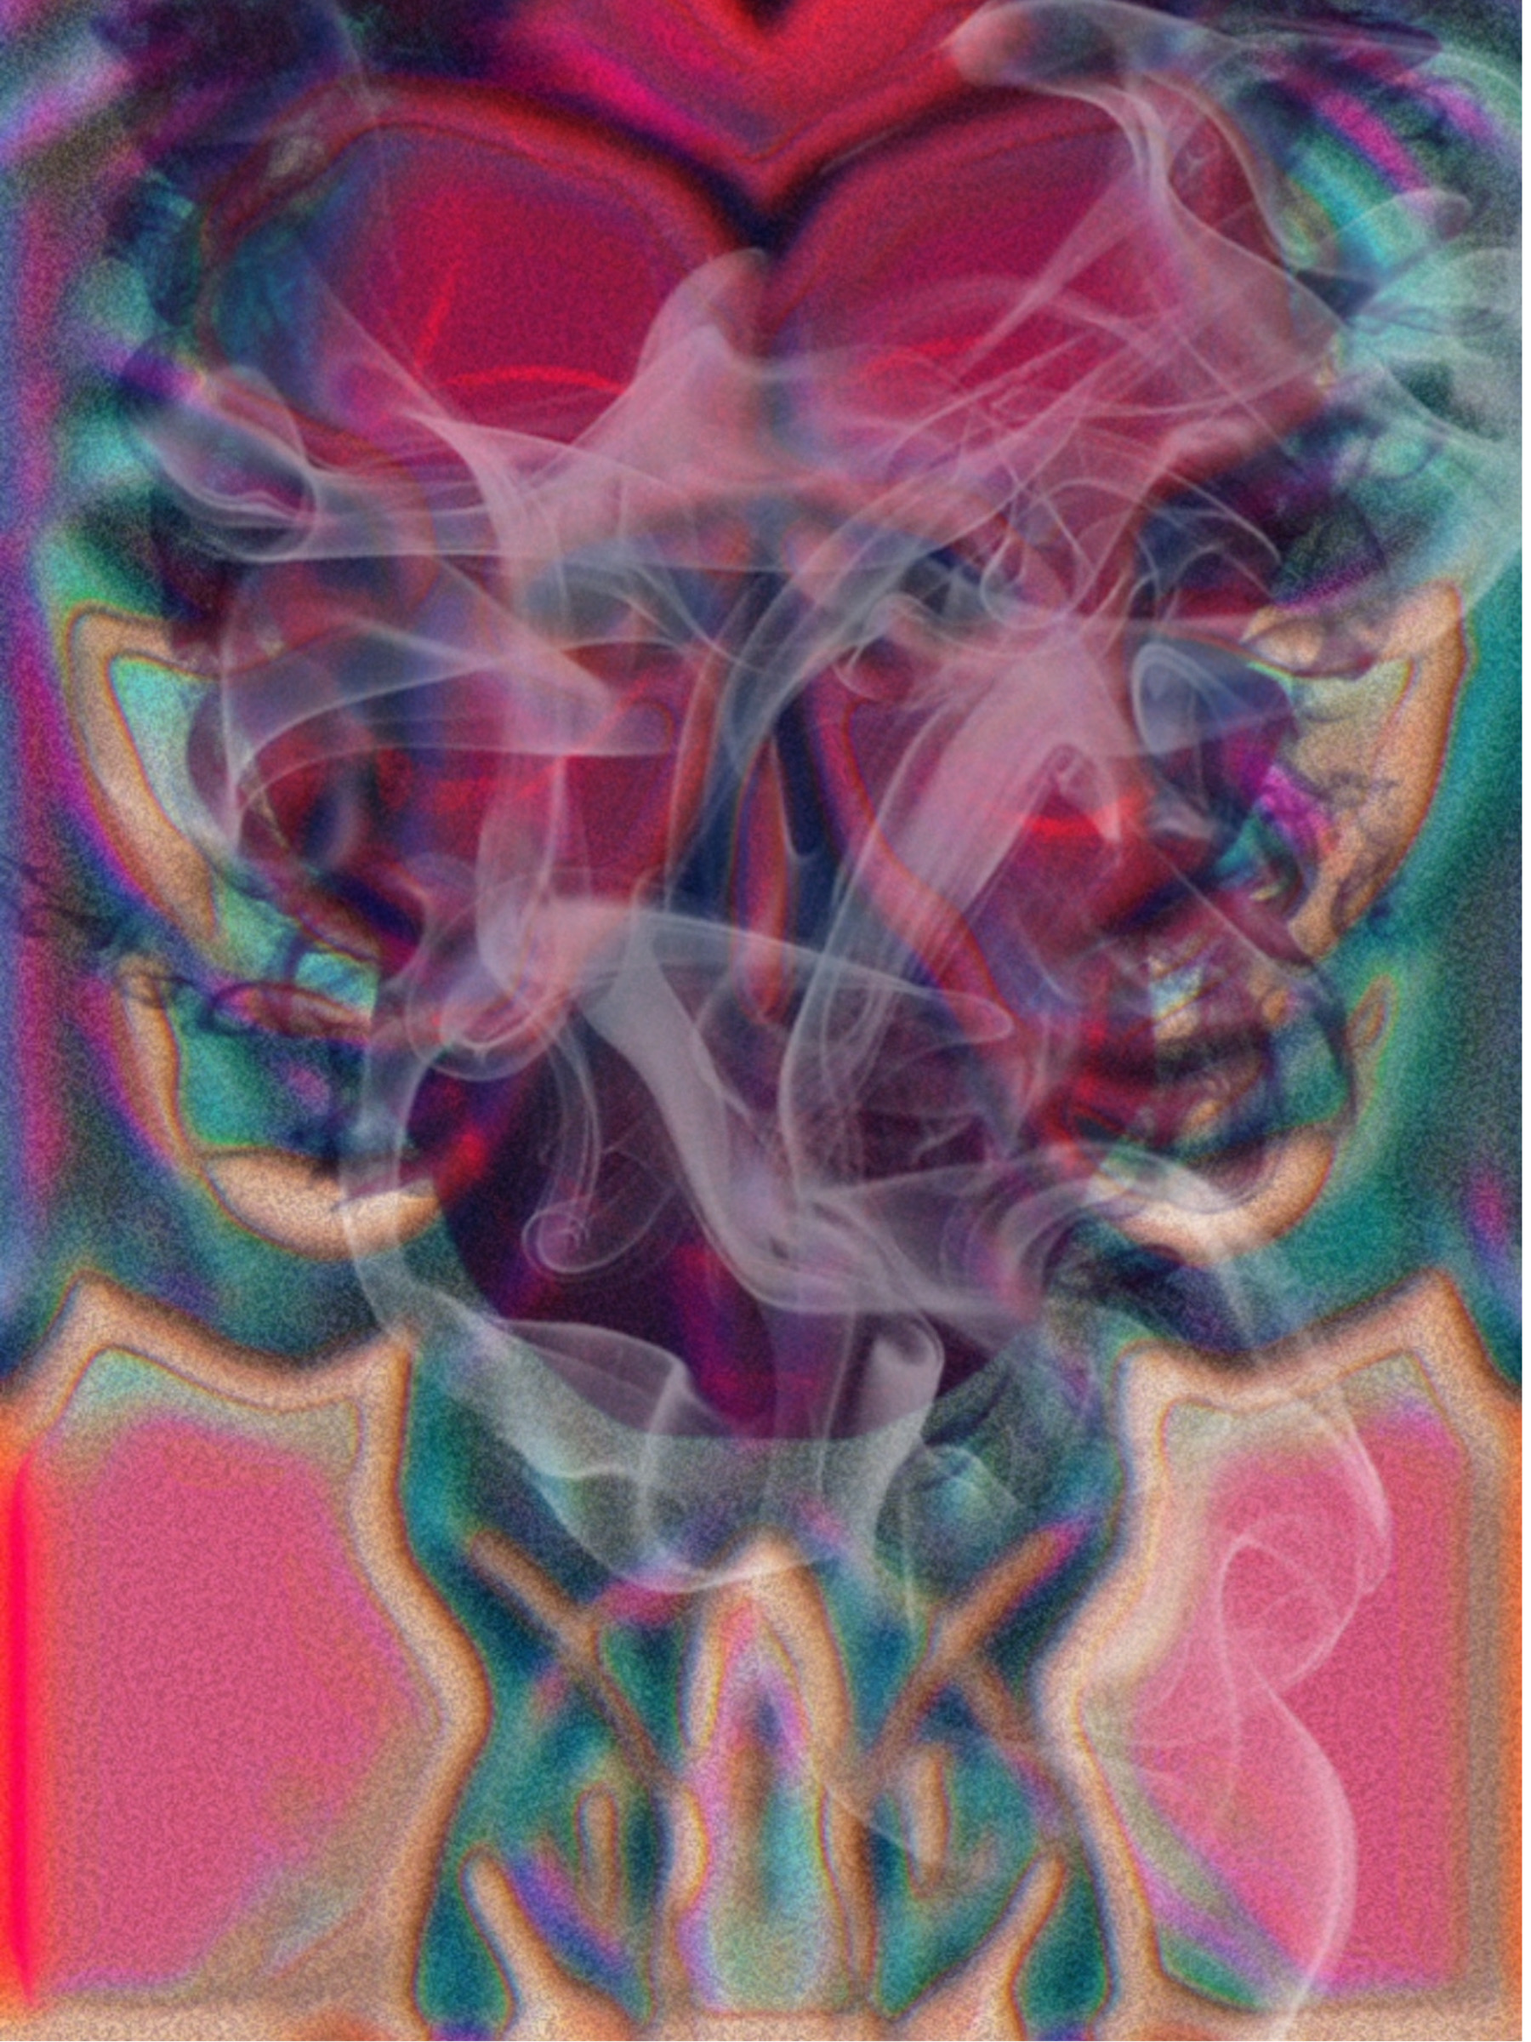
Part One: Smoke and Mirrors
They say you should be lucky if you find one soulmate in your life; I found two. My first love was a conjoined twin, Sara; the left side of the two. She was crazy about me, often serving as my muse in much of my art and photography. Losing her was so painful, yet once I realized that escaping the uninvited guest’s visit is inevitable, I uncomfortably welcomed it.
Sara and her conjoined twin sister, Tara, referred to each other as their better half, and they truly meant it. They were as different as night and day, yet profoundly loved the other. The conjoined twins were born to a mother who was rumored to work in the brothels and was barely surviving herself before the unexpected pregnancy. Their mother purportedly fainted when she was told she had twins, and then, after being roused, fainted again when she was told they were conjoined. When she woke up, she chose to give the children up, as one baby was already too much, two with special care needed was far too much. She believed she was sparing them from the struggling life she lived as she didn’t see a way out, especially with children in tow.
After spending some time in the infirmary, the twins were sent to an orphanage, where they spent the first four years of their lives. They couldn’t remember much of this time, except that Sara said she remembered many other children finding homes while they remained, and that this was the first time she had ever felt flawed or unlovable for being different. It was the start in several events that would lead to crippling fear of abandonment for her.
However, their luck was about to change when a train broke down in their small town with heiress Leia Ravenclaw aboard. Leia was the heiress to a lingerie empire, the first of its kind; it clawed its way through the barriers of a more prude time, one mistress at a time, to become an enormous success. Leia’s father actually got the idea from his mistress, who wished it were easier to find sexier intimate wear and more of a selection; he thought, “Why is that so hard?” and stole the idea and ran with it. Strangely, the mistress disappeared after making some noise on the idea being her own and threatening to out their affair.
Growing up, Leia’s father, Tom, was wealthy, controlling, cold, and uncompromising; she had things, but never his approval or affection. However, Leia felt slightly better when she realized she wasn’t singled out when put on trial for the murder of his mistress he was exclusively described by everyone as such. Her father enjoyed keeping everyone around him off balance because hidden beneath harsher things, he must have been wildly insecure. As far as character witnesses go, he had many; however, they were all against him.
During the trial, the continued confirmation of her father’s rotten character, without him ever having consequence or remorse, made a significant impact on Leia and was the first drastic divergence in her privileged, if painful, life.
When Leia’s father was found not guilty, when he damn sure was, she decided that she would serve justice to him this time, and keep the empire that he signed over to her during the trial in the event he was found guilty or liable monetarily in any way. Her father tried in vain numerous times to get his daughter to return his money; she provided the necessities, but not more, ensuring his life was never too comfortable.
After her father’s exile, Leia ran the company, which had been previously run without any female leadership, despite selling exclusively to them; successful before it now skyrocketed with the female touch. It was also Leia’s influence that allowed it to become became the giant that it is today, as it transitioned from being sold in a few expensive specialty stores to being available in many stores, and offering more affordable options.
Unfortunately, as capable, gifted, and caring as Leia was, she chose men who were much the opposite. She had a string of relationships where she was lied to, cheated on, and scammed, which she always stayed in for much too long. It was baffling to most, but it made sense to those who knew her well because they knew she received less than the minimum from her father; thus, her expectations were disproportionate, and she was conditioned to try to gain the affection of someone incapable, fruitlessly. Still, while she had never met a prince, she had not met Satan until she met the silver-tongued Herb Livone.
Herb was many horrible things underneath, but he had the Adonis shell that would provide a heavy smoke screen to his character. When they first met, Leia was immediately attracted to him, but it was his intelligence that cast a powerful spell upon her as it cleverly concealed who he was and allowed him to became exactly what she desired to draw her into his trap; it was downright dangerous. He asked her out and she eagerly agreed.
On that first date, Herb pulled out all the stops for the wealthy woman, as he cooked expertly, was interested in everything about her, and made love passionately and generously. It was inevitable that she fell under his trance.
After, that date, he continued to pursue her in the way that anyone would dream of, constantly showing up with thoughtful gifts and showering her with attention, affection, and love. She felt so fortunate that after many horrible relationships, she finally found everything in she was looking for.
However, it was not smooth sailing from there, as her closest friend, Taylor, staunchly and vocally did not like or trust Herb. Taylor and Leia were unlikely friends, as Taylor was the daughter of the mistress that her father murdered, but she was not his child. Taylor, ten years Leia’s junior, was a teen during the trial, but matured into a lovely woman. The two became friends when Taylor heard about Leia’s form of justice inflicted upon her father and approached her, thanking her. Leia hugged her, they both cried, and from that day forward, they were inseparable.
Soon after that initial meeting, Leia gifted Taylor part of her company, and the two enjoyed working together so much that they decided to live together. Leia enjoyed the benefits of a relationship that she had been lacking due to the absent and unreliable men she had dated, and Taylor had the stability emotionally and financially that alluded her after the death of her father and subsequently her mother.
Leia always loved Taylor, yet her deep desire to have children led her to look for a man, rather than immediately starting a life with someone who immeasurably loved her, and unconditionally. Yet, Taylor never gave up hope that one day they could be together.
Unfortunately, while Taylor had a significant influence over Leia’s life, she seemed to have none when it came to Leia’s affection of Herb. Leia wrote off the warnings from Taylor believing her to be jealous and believed she would come to accept it with time.
When Herb asked Leia to marry him after only a few months, she accepted, which only increased Taylor’s worry and suspicions. While Leia heard wedding bells, Taylor heard alarm bells. Taylor then tried more fervently to get Leia to slow this hyper-speed relationship, saying that if there wasn’t anything hinky going on, then waiting should be no issue. Taylor also swore that this had nothing to do with her romantic feelings for Leia and everything to do with the deep well of concern she had for her. Still, Leia remained unconvinced; yet, she didn’t want to hurt or lose Taylor, so she devised a plan that would calm Taylor while allowing her to marry Herb, so before the marriage, Leia transferred a significant number of her business shares to Taylor, so if something went wrong with the marriage, she wouldn’t lose her business due to the majority stake. Leia was certain Herb was in it for love, so this was only a formality to keep her dearest friend from worrying.
Soon after that transfer, Leia and Herb were married in a wedding that was opulent, picture-perfect, and appeared in several different publications. Taylor did feel jealous and saddened beyond measure, even if she didn’t allow it to affect her advice; yet, she couldn’t help but see how happy and absolutely in love the two were, and think maybe she was wrong.

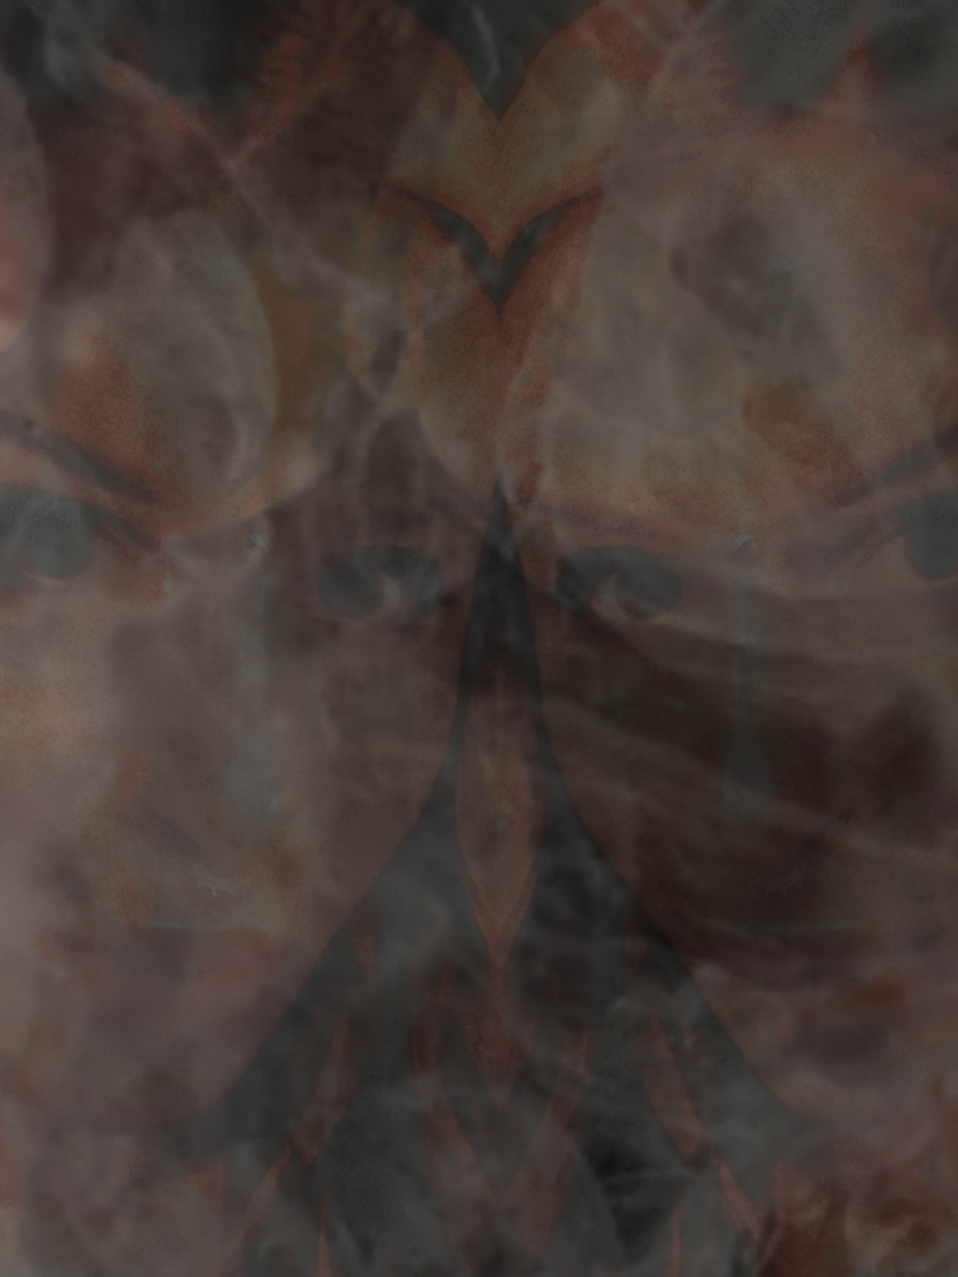
Part Two: Where There’s Smoke There’s Fire
After her honeymoon, Leia moved from the estate she shared with Taylor to a new, grander estate she had purchased, anticipating the arrival of future children. Taylor knew it was coming, but it was devastating nonetheless, and she constantly felt the loss of her constant companion. Still, they saw each other daily for business, and they maintained their friendship, often meeting up.
Sadly, later on, Herb found love letters between Taylor and Leia; he lost his temper, beating Leia and demanding that she separate herself from Taylor. Leia excused the violence as a man so profoundly hurt and betrayed that he lost control, and she complied with his wishes to sever from Taylor; however, the two women were still intertwined by business.
When Leia explained to Taylor that she wanted to maintain only a professional relationship and no longer have a personal one with her, Taylor was distressed. She could understand jealousy because she felt it many times, but Herb should trust Leia and not mandate who she could see.
From then on, the women no longer had a personal relationship, and Herb closely monitored their professional one. Leia was no longer the bubbly, successful, eccentric woman with a heart of gold; instead, she was now a frail, jumpy, fearful, and quiet woman, which didn’t resemble the former at all. It was horrible enough that Taylor went from having everything and all of the time to having nothing and none of the time, but when she started to see significant negative changes in her friend, it consumed her.
When things appeared to be getting worse instead of better with time, Taylor became concerned enough to take more drastic measures and contacted the man who killed her mother, Leia’s father, Tom. You know it must have been love because what else could humble you enough to ask who you believe to be the devil himself for help?

When Taylor showed up at Tom’s residence, he had no idea who Taylor was, as she had become a woman. So, she had to painfully explain that she was the daughter of the woman he murdered and that she had astonishingly befriended his daughter, who was now in trouble. Tom was shocked, and he fell to his knees; then he cried, making guttural sounds that only come from genuine remorse and pain. When he could speak, he profusely apologized to her and, for the first time, admitted he was guilty.
Sometimes, life works in ways that make you believe that life must be part of some divine design, which is a powerful experience. Tom was forced to humble himself and reflect on his life, which allowed him to become a better person. As a result, Taylor met that better man while trying to help his daughter and her dearest friend. Later on, Tom would become like a father to Taylor, who had lost her father years ago.
After that meeting, they devised a plan to help Leia, and the first part of the plan was for Taylor to transfer a small percentage of the company to Tom, which afforded him the ability to participate in the business and its meetings. Then, once that was established, they could take turns distracting Leia’s jailer so that they could speak with her alone. They figured that if they continued to tell Leia she deserved better and would help her get out, she would hopefully one day leave Herb with that in mind. It was an excellent plan if Herb were less controlling, so they were unable to speak with her as they had hoped. Still, they waited and hoped for the opportunity.
Then, one day, Leia announced to the board that she was pregnant, and she was visibly bursting with happiness, resembling herself more than she had since marrying Herb; even Herb seemed happier. Taylor and Tom wanted this so badly to be the thing that changed Herb for the better, the way humility had changed Tom; both were avid believers in redemption, having drawn on their own extraordinary experiences. They only wanted Leia to be happy, so they were optimistic.
However, after that joyful announcement, it was hard to gauge Leia’s happiness because they hardly ever saw her. Herb would always tell everyone that Leia needed her rest, and it seemed believable because her pregnancy was higher risk due to a heart condition. Their plan was now obsolete, since they no longer saw her. All they could do was pray, hope, and wait.
Then, one night, Taylor received a call from the hospital about Leia, who had never updated her emergency contact information. They said she wasn’t doing well and she should come at once. She immediately grabbed Tom, and they rushed to the hospital.
Once at the hospital, the doctor pulled them into an office. The doctor stunned them when he offered his condolences for the child Leia had lost. Then he said that he believed Leia had been beaten, but she said that she had fallen, which was so unlikely that it made the doctor suspect she was being abused. The doctor requested that they try to see if they could get more information and if someone was hurting her, to have her report this to the authorities.
Taylor said nothing but went to run to Leia; however, Herb materialized seemingly from nowhere, like a genie from smoke, and stepped in her way; his omnipresence was sinister and unsettling. Herb smirked and demanded that the two leave; yet, when they didn’t, he called security.
After the security personnel arrived, Taylor explained to the guard that this was Leia’s father and that she was her closest friend and emergency contact, so they should be permitted in the room. The guard was confused, so he figured the best way to make a decision was to ask Leia herself; therefore, he disappeared into her room to speak with her.
When the guard returned, he uncomfortably informed the two that Leia did not want them there and felt harassed. This did not satisfy Tom or Taylor, so they attempted to fight their way past Herb and the guard. However, more security guards intervened, threatening to involve the police, and they had no choice but to leave.
Soon after Leia’s hospital trip, she changed her emergency contact to Herb, and he began selling many of the shares in the company that Leia had still held. He then used the money to transform their estate into a fortress, complete with armed guards, making it impossible for Tom and Taylor to speak with Leia and uncover the truth.
With her emergency contact changed, Leia would be alone when she lost two more babies to Herb’s violence.

Part Three: Smoke Screen
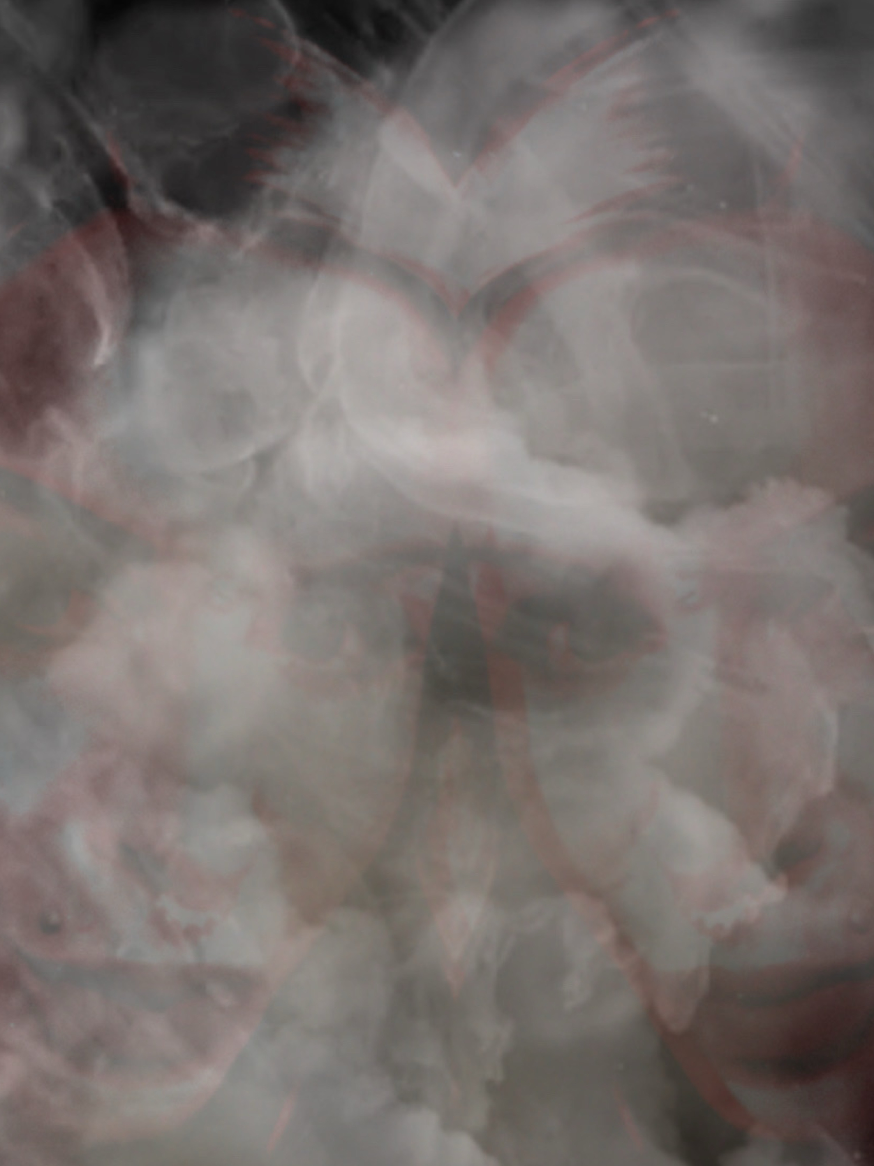
After her third miscarriage, Leia recognized that she had married Herb because she thought he was a good man who could give her children, only to find that he was a cruel man who killed any possible children before they even lived, and now she was told that the beating was so bad that she could not have children naturally any longer. This realization was enough for her to wish to leave him, but she was afraid and didn’t see a way out.
Although soon there was a glimmer of hope because this “accidental fall” was investigated as she was unconscious when they arrived, and Herb’s hands were battered as if from beating something or someone. Once they saw how many “accidental falls” Leia had, the investigators knew, and they arrested Herb.
After Herb went to jail, Leia decided she had had enough and was done with him permanently. She then contacted her father and Taylor, who were mortified at her condition but relieved that she was done with Herb. They were incredible supports to Leia during her astounding five-year-long recovery. On the bright side of bad, now that Leia couldn’t have children, it no longer dissuaded her from being in a relationship with Taylor, and she figured that they could adopt children. The two women had loved each other, but when they fell in love, it was as beautiful as any love story in existence. It eventually felt like the past had all been a bad dream.
Then, life became even better for Leia when her train broke down on her way to visit Tom, who had become the father she had always hoped for. Now, he was a happily married man living in the state below her. Realizing there would be a considerable amount of time until she would be able to get on another train, she started to walk around the town she had never heard of before.

Leia found that the town was a small farming community with little else there beyond the farms, save for a few administrative buildings and an orphanage. Leia decided to go inside the orphanage, and when she entered, she felt an overwhelmingly good feeling, which greatly intensified when she met the twins, who stole her heart, and whose more expensive care was of no issue. She adopted the twins, whose world was about to change so much for the better.
While Leia was finalizing the adoption papers, Tom was worried because Leia had not shown up, so he called Taylor, who was hysterical and ready to call the police. However, as soon as she hung up on Tom, Leia phoned with an update, saying she would be on the train back home instead, with a surprise in tow. She asked Taylor to apologize to Tom for the change of plans and tell him it is a good thing, and he will understand soon.
When Leia showed up with the conjoined twins, surprise was an understatement. Taylor was a little concerned about the impromptu decision, but then became immediately excited to be a mother. It ultimately turned out to be the best decision for everyone.
Luckily, they were adopted just as the twins were becoming severely emotionally detached, except from each other, as previously it was them against the world, instead of within it, which is not healthy. The twins loved their mother and their Pop Pop, Tom, and would have never guessed the complicated history of the trio.
The twins were initially enrolled in school, but kids can be cruel, so they became a sideshow attraction for children to bully and tease. As a result, Taylor began homeschooling them, which they loved. The twins also had every private lesson imaginable, which allowed them to hone their many natural abilities into incredible skill with clever modifications for two people who are one. They never missed being around other children because they had each other and were busy becoming piano prodigies, accomplished dancers, and scholars.
Sadly, the twins lost their Pop Pop Tom, who was a massive presence in their lives, when they were eight. When he passed, Taylor and Leia were there, holding his hands. Eerily, the much older song, “I Love Your Blue Eyes,” came on the radio, which was Taylor’s mother’s and Tom’s favorite song and one she often sang to him. Taylor believed her mother had forgiven a forgivable man, whom she had loved very much, and they could now enjoy an eternity together.
A few months after Tom’s passing, the twins noticed their mothers acting very strangely; they were being very secretive and often having hushed conversations behind locked doors, which had never been locked prior. Their mothers also seemed panicked and frightened all the time. The twins thought this could be grief, but it was actually that Leia had been informed that Herb would be released from prison soon, and he was violent, vindictive, and unpredictable.
When Herb was released from prison, they realized how valid their paranoia had been when he started to stalk the family. So, the pair fortified their palace far beyond even what Herb had done, years prior, to keep Leia hostage. They felt relieved when it seemed like the added guards deterred him, and they stopped seeing him altogether. This gave them a false sense of security, but one that they needed to maintain their sanity.
Then, some months later, they felt assured that Herb had moved on, likely to his next unsuspecting mark, who would later meet the devil. It was a sad thought, and yet they were so relieved he was not around them. Over time, they felt increasingly secure, becoming more complacent in their security practices.

Then, one day, after a business meeting, Leia left Taylor for Herb. Taylor would now only see Leia through the closed window of a locked car as a passenger to Herb. Leia also sold all of her shares to the company, which Taylor had transferred back, with Herb’s exit. Then Leia sent for her things and gave word that she was off to Europe with the love of her life, Herb.
None of this ever added up, and Taylor was very concerned that this was coerced, as well as about the violence Herb was capable of, but what could Taylor do about it? Before, she would have gone to the end of the earth and faced certain danger to save Leia, but now she had two girls who needed to be protected and depended on her. Taylor loved Leia, and she loved those little girls; the twins won out because they were children. Taylor’s suspicions were correct; it was more than an abused woman stuck in the hellish cycle of abuse; Herb threatened to kill Leia’s whole family if she did not leave them and come with him, so she did.
Then one day, Taylor received word that while in Europe, Leia had fallen ill and died. Taylor was despondent. She wanted to be strong for the twins, the way she had been since Leia left, but the finality of it did her in, because she had always believed they would be together again someday, as soulmates always find their way back to each other. The twins were very upset that their mother was gone; yet, they experienced so much loss in their lives, it was more normalized, and because of this, they never had expectations of permanence in anything or one, aside from each other, so they always lived like you could leave or die tomorrow, and so had little regrets when that inevitably happened. They figured they could survive any loss, except for each other.

Part Four: Smoke Grenade
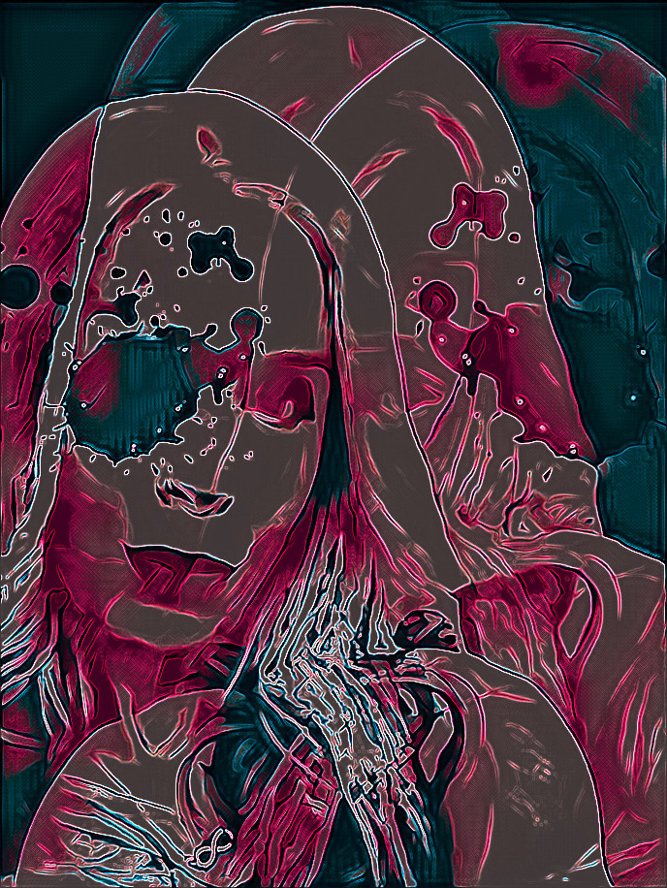

Then, one day, the twins realized that Taylor had not woken them up for their ballet lessons, so they went and found her asleep in her bed, but she appeared to be grey and bluish. The twins tried to rouse her and realized she was so cold and would not wake up, so they rushed to the neighbors, who in turn contacted the police, who realized immediately she was dead on arrival.
After Taylor passed away, the twins had no legal guardian; however, a trust had been set up for their care until they were older and could inherit more. The issue was that a trust did little good without anyone to care for them, and the trust posed a problem of trust, as any time money enters, motivations become murky.
Then, not long after Taylor’s passing and the twins’ eleventh birthday, the neighbors they had run to when Taylor died, offered to care for them. This felt like a perfect solution for a board of members that is extremely cautious of bids to care for children with trust funds from individuals who are not family or designated, for good reason. Additionally, the twins already trusted the neighbors, who had shown them deep affection, making this an easy decision.
While the guardian designation process was ongoing, the neighbors, Dorthy and Larry Clark, were everything a child would wish for; Dorthy cooked delicious meals, Larry played with them, and their private lessons continued. The twins were content. So, after the paperwork was finalized, a year later, everyone who checked on the twins during the process was released, and things started to change for the worse, starting with the couple requesting that the twins sleep in their bed with them.
This is where the twins began to separate drastically, based on where they slept; my wife, Sara, always slept next to the snoring Dorothy, while Tara slept next to the predatory Larry. Even though Sara experienced some of what was happening, she didn’t understand, while Tara knew what was happening and was experiencing it all.
Also, not long after the Clarks became the twins’ official guardians, the private lessons stopped, along with most positive things. Still, the twins had a silver lining in that they had access to endless learning materials for high school and college, as Dorothy was a teacher and later a professor before her retirement; as long as the twins were out of their hair, they could do what they wanted inside the home. So, the two would take turns playing teacher and student, with the twin playing teacher being maternal to the twin playing student; unknowingly, the two were giving each other the maternal love they needed in an alternating manner. The two showed incredible ingenuity in the seesawing of comprehension with two bright minds; if one didn’t understand, the other usually did and could teach the other, so they homeschooled each other exceptionally well.
In addition to educating each other, they also began to write and act in plays, many of which were in French, their shared passion. Education was a necessary distraction, but the plays and compositions were what maintained their sanity and optimism, providing them with a place to escape the horrors and neglect of their reality. Together, they dreamt their way out of tragedy.
Unfortunately, after some time living in their new circumstances, Tara became increasingly and alarmingly distant and angrier as she had to engage while enduring Larry’s sexual abuse to prevent her twin from also going through it, and she didn’t tell Sara to protect her. Experiencing that much pain while having to keep it secret from her better half wore on Tara’s mind, which allowed dangerous pressure to build.
Then, one day, while living under that high pressure, Tara looked over and saw Dorothy return from the bathroom, and clearly witnessed the sexual abuse; Dorothy seemed shocked but only momentarily before she acted as if nothing was happening and went back to bed. It filled Tara with rage.

Part Five: Smoke the Monster Out
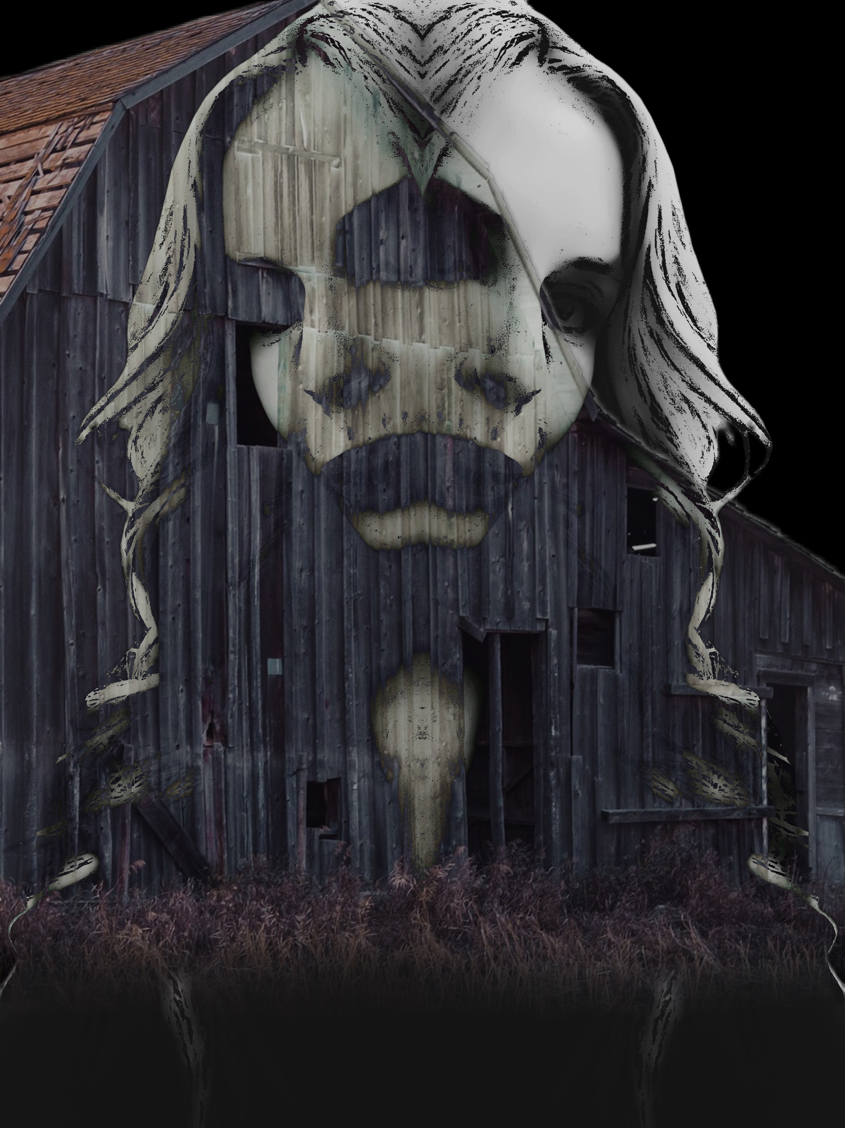
Shockingly, Leia eventually rose from the dead; her death had been nothing more than a ploy by Herb to keep more distance than a continent between Taylor and Leia. Leia stayed with Herb out of fear for her family, but later, Herb died of a heart attack, and she was released. When Leia learned later that Taylor had died, she wondered if it had been Taylor who had been terrorizing Herb from the other side, as Herb had horrible nightmares and suffered from panic attacks until he died; it didn’t sound impossible that not even death could keep Taylor from protecting her family.
While Leia was grief-stricken at the news of the loss of her soulmate, she held it together because she still had the twins, whom she missed terribly. She had quite a bit of red tape to cut through now, though, seeing as people don’t usually come back from the dead, so that would need to be sorted, and the twins had been adopted by Larry and Dorothy.
While hashing out the legalities, Leia was able to locate the twins, who were living in another state with their surrogate family. Everyone was stunned to see her, as people don’t return from the dead. When the shock wore off, the twins were so glad that their mother was there to retrieve them.
Sadly, right shortly after Leia arrived there, she was gone without a word, leaving the twins again; yet, she did not leave of her own accord, instead, she was kidnapped. It seemed astronomical that one woman could be kidnapped as much, until you consider her wealth and the easy access to her person, as she never isolated herself in her wealth. Leia never suspected anything was amiss when the Clarks lured her to the barn to collect her children’s belongings, only to end up chained in their barn.
After chaining up Leia, the couple then became panicked without a plan. They didn’t want to chance losing the twins and decided they should stay ahead of this and run. Yet, Dorothy did not want to give up the property because it had been in her family for many years. So, the psychopaths summoned their daughter, Stacy, who was a young adult, and ordered her to look after the property and the twins’ mother, who was chained in the barn. Stacy was already used to accepting horrible things from these two, as she was a brainwashed victim of their abuse, so she complied.
Then, the twins and their captors headed ironically to Europe, where their mother had just returned from. Once there, the couple decided to capitalize on the twins’ uniqueness and put them into the entertainment industry. They had a few offers, yet finally chose to accept the offer from a production in Eastern Europe, which was a “Freakshow.” However, this was a production rather than a spectacle, so the twins loved it. The twins already had a wealth of material and acts on hand due to their isolation, and they were proud to share their works with the world, which cheered, rather than sneered, like they had experienced before they left school to be homeschooled.
Although more than praise, flowers, or anything else, the twins loved the people they entertained with, who were similar to them, and whom they hadn’t even known existed previously. Being around a group of different individuals made them feel the same and accepted; so, more than ever in their lives, they felt incredibly connected to people outside of each other, which was very positive for them; they may have been enough for each other, but having many more people added was good for them, and there was never a shortage of the strange and unusual, such as acrobats, “Girl-Boy,” the dancing squirrels, clowns, and many more; however, they were closest with Stan, who performed as “The Elephant Enchanter,” and Gazelle, who performed as “The Real Mermaid.”
Stan, “The Elephant Enchanter,” worked with real elephants whom he trained to dance and entertain the crowd; many times, he performed on top of one. He never aspired to this career until, while at college, his brother, who ran the family’s wild animal training and entertainment business, was killed by a gorgeous wild cat who came to them after being severely abused in another show, and was scared and confused. Stan knew then he had to go home to take over, but he decided that elephants may be the way to go, at least until things cooled down about the incident. It was a great choice, as it was a natural pairing, given that they were similar in character: kind and strong. He loved those elephants like children, showering them with affection and admiration, and so they were spared the cruel treatment that can occur in these shows. In return, the elephants merrily put on a good show to impress the kind man they adored.
Gazelle, “The Real Mermaid,” possessed the remarkable ability to remain submerged underwater for extended periods before rising to the surface to breathe. She held the world record for this feat and had competed around the world, proudly displaying the awards she won from various countries. She, however, found that while it is her passion, it wasn’t practical as a career because it was inconsistent. So she worked as a clerk and was miserable until one day she thought about how much she loved mermaids and wondered if she could perform as one. She tried to pitch this idea to the different shows, but the cost of building an aquarium that size was astronomical, and with maintenance, it may never return on the investment. She was despondent, unable to break free from her dull and monotonous life, while missing the water terribly. Still, she later fell in love with a wonderful man and had her time in the sun.
Unfortunately, Gazelle’s husband died in the war, and she became a very young widow, albeit a much wealthier one. She used the money she received from the government to build that gigantic aquarium and work on an act. She proved everyone wrong about it being a bad investment, as many times, people bought tickets solely to see her. The crowd would watch as she swam around gracefully and sensually for so long that when the curtain drops, you believe she is a mermaid, not a woman, who is gasping for air on the other side of the curtain, hidden from view.
Stan and Gazelle had performed in many shows across various production companies, and frequently found themselves starring in the same shows, so they became close friends. It was a perfect pairing because they both lost someone who was a large part of their hearts and the reason they now performed, and who they worked hard to honor. Since they understood each other well, they felt very comfortable and spent a lot of time together.
When the twins joined the show, Stan and Gazelle took the twins under their wings and were naturally paternal with them, which they loved since they hadn’t had that from their adopted family. The four spent a great deal of time together and always had a blast. Despite their dire situation, the twins have a great fondness for this time because of them. The twins had many guardians over the years, and they loved them, but they were also somewhat detached from them, likely due to their minds’ survival instinct. Most people in their lives are viewed like a cast of characters, whom they may love, but may only be around for a few acts, and the play must go on; fewer and weaker attachments make that easier. However, the two often spoke of the mermaid with the depth of attachment that they had never expressed for anyone except for each other; looking at the impact she had, she was the most influential person in their lives. I remember when I first started dating Sara; she and Tara would color their hair in many different colors using dyes they made from natural ingredients, so often it was bizarre. Curious after so many hair color changes, I asked Sara if she was searching for her perfect color, and if there were even any shades left to try.
Sara laughed and said she wasn’t searching for her perfect hair color; she was searching for change. She said that the mermaid had always changed her hair color, and so the twins asked her the same question I had. The mermaid said, “If you don’t like your circumstances, then dye your hair because the first step in changing your circumstances is acknowledging the need for it. A different hair color will remind you of this need, frequently, which will eventually ignite progress.” It seems unbelievable that hair color could change your circumstances, yet it always seemed to work for the twins, likely due to the power of manifestation. The twins have colored their hair every color that exists, and they could even tell you what the event or situation was that caused the desire for change. What the twins never realized was that the mermaid always wore wigs; her hair fried from her own advice.
In addition to the many shades of sage wisdom Gazelle provided, she was always taking them places, doing activities with them, and giving them some normalcy. One of their favorite activities was learning to swim with Gazelle. Sara would tear up when she mentioned that once they were skilled swimmers, the mermaid presented them with a custom-made mermaid tail, like her own, made of silicone and other materials, which was altered to allow for two mermaids who were also one. In that moment, the twins recognized that the complicit, shell of a mother never shared such moments with them; yet, she was their mother? Feeling all of this, Tara, who had softened with Gazelle’s love, said that she wished that Gazelle were their mother. The mermaid loved the little girls, so she told them she would be their mother. That day, the twins gained a mermaid for a mother.
As a result of being finally cared for, the twins’ self-esteem and ability to trust greatly improved. They were no longer recluses, but spry butterflies who got along with everyone who lived in the camp, often talking their ears off. During that time, every single person inspired the twins in a way that was imprinted, like their charm bracelet.

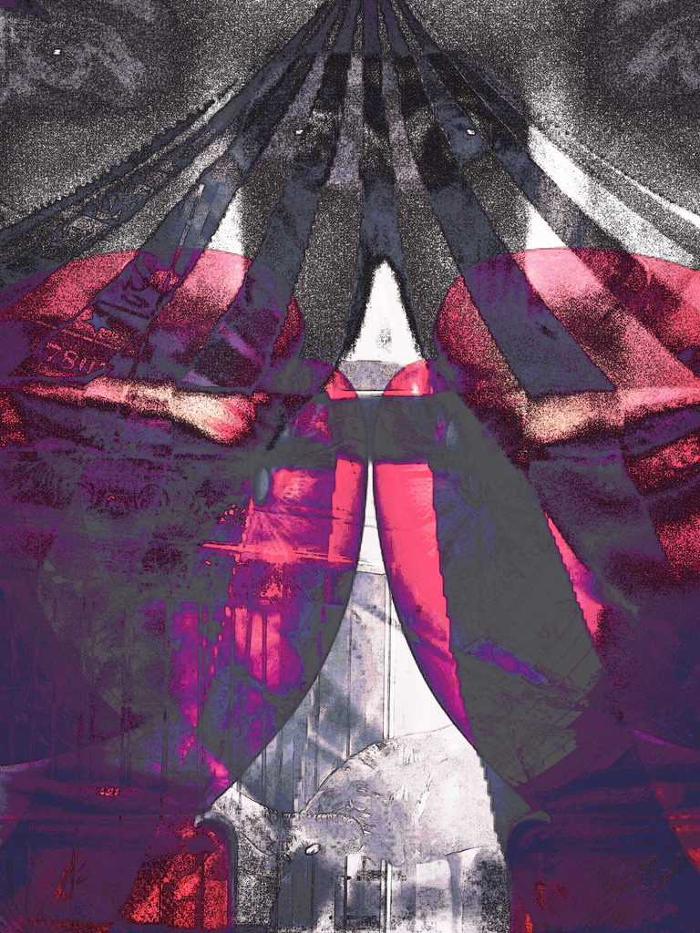
Part Six: Seeing Through the Smoke
Over a year after the twins arrived, Stanley, “The Elephant Enchanter,” brought them to a boxing match when his date stood him up. He had recently become obsessed with the sport and was training as an amateur. The twins had such a good time that the next day they begged him to allow them to join him at his boxing practice. He didn’t see the harm, so he brought them.
Up close, the twins saw that boxing was like a dance—just a violent one, which the twins desperately wanted to try, so they pleaded with Stan to let them practice. He initially declined because he didn’t want them to get hurt, but then he reconsidered, wanting them to be fearless. So, the twins got gloved up and into the ring, and they loved it. Stan could not believe the amount of skill the twins had, especially considering it was their first time boxing.
Seeing the twins so happy and their potential, Stan spoke with the gym owner to see if they could be added to the lessons. The owner raised an eyebrow at the outlandish request; the gym had no female members, much less female children; the owner had no place for them.
Since the twins could not join the class, Stan asked the owner if he could pay for the ring time after everyone left. The owner didn’t see the harm in the twins playing around when everyone was gone, for a fee, of course.
So, Stan began to figure out how to translate and adapt the sport to suit the conjoined twins, who trained hard and became exceptional boxers, likely due to dance being a central part of their lives and hyper-vigilance being a way of life.
Then, one evening, the owner returned to the gym to retrieve the glasses he had left behind, and when he passed by the ring, he was so enthralled that he stayed to watch. He caught himself wanting to cheer or provide adjustments. He left without saying anything, but then kept thinking about the little anomaly boxers.
Eventually, the owner was able to push past old ideals and attitudes and embrace change, which can be exciting and igniting. He decided that he would provide the twins with professional and intensive training while creating a spot for them in the boxing world.
Some time into the twins’ training, the gym owner informed them that he was going to hold an open-call boxing match for girls, with a cash prize. He did not think many boxers or paying customers would show up, but it was a step in a grander picture. However, the owner was incorrect; it had a massive turnout because it was interesting and to some a novelty.
The twins were underestimated because everyone assumed that two people having to be perfectly in sync would be a considerable limitation; however, this was not correct, because when in the zone, they shared a consciousness, enhanced by twice the power.
Wanting to maintain that incredible momentum from the first open-call match, they began holding more events, which were successful. It wasn’t long before the young boxers were paid and had the opportunity to win money if they were successful. Stan, who never trusted the twins’ surrogate parents, put their portion away until they matured.

Part Seven: Rising Smoke


While the twins were finding some happiness somewhere over the rainbow, their mother, Leia, was in a barn, being cared for by Stacy under the direction of her parents.
Initially, Stacy approached the arrangement like a jailer caring for a prisoner; she was emotionally removed from Leia, yet felt it was her duty. Although as time passed, Leia cleverly and subtly got Stacy to talk and interact with her more, which became easier for Stacy when her boyfriend had broken up with her after she said she needed to stay and care for her parents’ house for a while without him; he assumed she had a double life, which she did, just not the cheating kind, and cut ties.
As the women began to speak for longer, Leia humanized herself, naturally, because Leia was a genuinely loving, caring, and compassionate person. Stacy was fascinated by Leia’s true-life story and admired her strength. There were many times when Stacy wished Leia were her mother, rather than the cold woman who had raised her.
As Stacy became increasingly conflicted, she would often think about letting Leia go, but Stacy’s mind wasn’t wired right; she had been programmed to do without question, and she was terrified of her parents.
Leia didn’t blame, hate, or resent Stacy because she understood life well enough not to judge other people, as life’s seldom black and white, and she was always kind and recognized that Stacy was only a more fortunate prisoner.
Slowly, Stacy opened up about the abuse she had suffered at her parents' hands, and Leia became terrified for the girls.

Part Eight: Blowing Smoke

Far away from Leia, the twins were becoming beautiful women, which Larry decided to capitalize on by selling them to the sex trade. He sat the twins down to terrorize and prepare them for their new job. Before he left them in stunned silence, he said, “Sara, I am going to screw you tonight to teach you some things before your paid “date” because Tara is already up to speed.” Both girls were petrified.
After a moment, Sara, who was confused about how Tara could be current on something that she was not, because they were attached, asked Tara, which caused Tara to break down, now realizing that all the sacrifices she made and secrets she kept to protect Sara meant nothing.
When Tara could speak, she explained what Larry had been doing and how it had taken so much of her light. Sara was shocked and saddened that her twin had hidden something from her, which she had never had before. All Tara could think of was preventing Sara from going through what she had. Eventually, Tara devised a plan and made the necessary preparations.
Then, that night, Tom asked his wife to sleep on the other side of the bed, which she did without question, and tried to go to sleep as quickly as possible. Not long after, Dorothy started snoring, Tom began to touch Sara, and while he was distracted, Tara took garden shears and repeatedly plunged them into his head and neck. She nearly decapitated him when the violent act was over.
Dorthy called the police immediately, and the officers were so stunned at the situation that they took an hour to ensure they weren’t still asleep.
When the police questioned the twins, Tara admitted to killing Larry because he was the devil, and said that Sara knew nothing of her plans. This situation was a first for everyone: one body, two people; one guilty and one innocent. What do you do in that situation? Punish an innocent person to ensure you punish the guilty, or let the guilty person go to protect the liberty of the innocent person? It certainly set a precedent. They ultimately decided to arrest them both, as they were attached, until they could figure out what to do.
When I first heard of conjoined twins set to go to trial, as an admitted killer, and her attached, innocent, conjoined twin, like everyone else, I was riveted by this unusual saga. So, when they were looking for artists to bid on sketching what many hailed as “The Trial of the Century,” I bid $1. The price and my credentials were suitable, so I secured the contract.
When I saw the twins for the first time, they were gorgeous, and they didn’t appear to be as the press portrayed them. I caught myself using them as muses in my art during my free time. I hadn’t felt so inspired or created so much before.
The trial was lengthy, and both sides consisted of well-matched professionals. However, regardless of whether you sided with the prosecution or defense of Tara, Sara was in the mix, and no one could prove or believe that Sara was involved. Still, you can’t separate them, so whatever Tara’s fate would also need to be Sara’s.
When the case was turned over to the jury, they deliberated longer than I have ever experienced. During this time, I closely observed the girls over many days of silent waiting and began to sketch them into different realities.
The jury deliberated for nearly a month before they announced they were deadlocked. The prosecution believed any jury would always be deadlocked because of Sara, so they offered the twins five years in an asylum. Tara was consumed with guilt, so Sara made the choice easier, saying they should take it, as it wasn’t that much time, and would just be another one of their adventures.
Back in the United States, the now husbandless Dorthy relieved her daughter, Stacy, who was caring for Leia in the barn. So life got much worse for Leia. Now, without Stacy’s conversations and many sleepovers, Leia started to go insane.

Part Nine: Escaping the Smoke
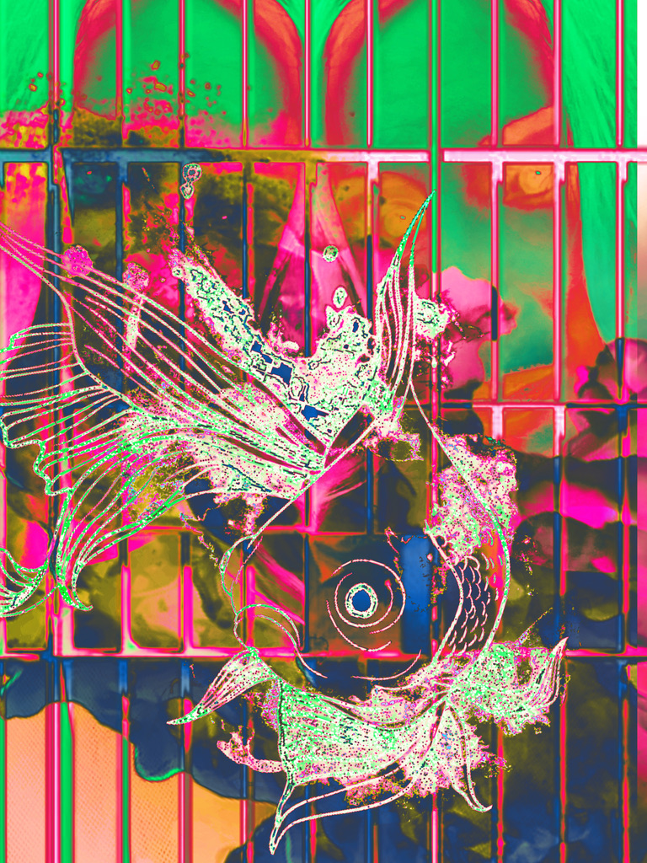
When Tara and Sara first got to their “Asylum Castle,” the twins’ lives were much more restricted, but they were happier because they were safe; safety is a powerful force that most people take for granted.
After some time, the twins opened up to a counselor, which helped Tara become less angry and Sara process everything. Additionally, they found purpose in teaching other patients, as they possessed extensive knowledge and enjoyed the role of teaching. So, they were revered and never treated like freaks.
Things got even better when the twins met a young man named Clayton; he was dark, mysterious, intriguing, and dramatic. Tara was enamored with him. She hadn’t been in love or thought she could be, but then this boy changed all that; the sardonic Tara now uncharacteristically doodled hearts on everything. Clay performed the magic trick, and presto, Tara is the girl Tara should have been protected enough to be.
Sara was initially irritated by Clay’s overly emotional nature; it was exhausting, but later came to understand that Clay felt so much more deeply about everything, and if you could spare some energy, it was something to behold. She also really loved how deeply he loved Tara. Sara didn’t even cause issues when Tara asked if she could be with Clay sexually after months of being in love.
Clay’s dramatic flair also proved to be perfect for starring in the twins’ many plays. He was the obvious muse of much of Tara’s work during this time and a hidden muse in Sara’s.
Their muse, Clayton, spent a year in the hospital with them. It was a happy time and one that yielded an expansive and impressive body of work for both. Their escapism was phenomenal, and the implications were painful to know.
Then it was time for Clayton to leave with a sincere promise to keep the relationship alive. Unfortunately, as time passed and the twins were still unable to go, Clayton stopped writing, and Tara was devastated, crying constantly.
It was a month into mourning that the twins received a letter from me; I sent them a collection of the art that they had inspired. It was Sara who wrote to me; she addressed it, “Dear Probable Murder,” which I later found out was on Tara’s behest, which made sense because Sara is hardly sarcastic, while that’s all Tara speaks. It was that humor that drew me further past the line I had only slightly crossed; I had never been remotely emotionally attached to the subject of my professional work, much less the criminal subjects of the trials that I would sketch, yet here I was feeling smitten.
Yet, it was more than their beauty and charm that drew me in; it was this need for a complete understanding of something complex. Spending so much time in trials, I mastered making very acute and astute reports, and it never took long; however, with the twins, I couldn’t draw conclusions that made sense, or figure them out, and quickly realized that I hadn’t even scratched the surface of things. It might have been a siren’s song, waiting for me to believe until I was dead on the rocks, but I believed in and grew to love them.
As time passed, we wrote to each other more frequently, and I came to look forward to our correspondence. I would send my different art to the twins, which they loved; they saved it all, initially feeling that it was vain, but realizing it made them feel more powerful than beautiful, which felt like a reminder instead of a source of vanity. They were mermaids who didn’t need water.
It wasn’t long before I fell in love with Sara. I suppose the fact that our relationship was an exclusively fantasy, without the inconveniences of reality, in addition to infatuation, sealed my fate. However, since Sara was only 16, I never acted on that feeling.
Later, when I had gained the twins’ trust, they began to send me stories and plays they created, which were inspired by my art. This inevitably led to collaborations between us. Our collaborations were perfect marriages of our minds, and my favorite works.
Then, about a year into our correspondence, I got called on assignment in India. I was on contract, so I couldn’t say no. I still tried to send mail, but it was much harder with the distance and expense. I eventually figured a real relationship was worth more than a phantom pen pal and started dating a beautiful woman who lived near me.

Part Ten: When the Smoke Clears

Leia lived in almost complete solitude after Stacy left, while Stacy was chained to the barn in her mind, finding it impossible not to have nightmares as much awake as asleep. Ultimately, Stacy could not handle the guilt, so a year after she left Leia, she dropped out of school, had a breakdown, and then talked to the police, leading to the arrest of Dorthy and herself, while Leia was liberated.
Once freed, Leia insisted they give immunity to Stacy because she recognized Stacy as a victim, and the two had bonded, even if it was a traumatic one. When the prosecution resisted, Leia said she would not testify about Stacy, so they didn’t have a choice. Stacy was released with the promise to testify against her monster mother, Dorothy, at trial.
When Stacy testified, she opened up about the sexual, mental, and physical abuse she suffered at the hands of her parents. So it was now out in the open, confirming what Tara had said when she was on trial for murder, but she was never believed. Many people previously thought that Dorothy and Larry were innocent, and that Tara was a homicidal maniac willing to fabricate a reason to kill; however, now that they knew the pair had the twins’ mother locked in a barn, no one could believe Larry and Dorothy innocent saints, which made them wonder if the slaying wasn’t justified.
After Dorothy was sentenced to a lengthy term, which ensured she would never get out, Leia was focused on getting her girls out of the state institution to which they were confined. When Leia started raising hell, the state stepped out of the way; they figured it was best to let this fade from memories as quickly as possible.
Since the twins felt abandoned by Clayton and me, they became too scared to let anyone else in for fear of losing them. As a result, the days in the asylum had become identical, and they no longer produced art, so the days became valueless. So, they were ecstatic to be released.
Unfortunately, when you pass the point of no return, there are no happy ending shops, just salvage yards; still, there is beauty in salvaging something that isn’t present elsewhere; to get that beauty takes grit and effort, which fosters appreciation and accomplishment.
Sadly, after their release, the twins watched their mother, Leia, go through abject hell, trying to recover from being chained to a barn, isolated and afraid. Leia would constantly be transported to that barn and scream out in agony, and her nightmares were so terrifying. She also would frequently speak to her dead lover, Taylor. It did not take long to realize Leia had gone mad. Still, the twins did the best they could for Leia, and there were still good times. They loved to entertain Leia and brought the world to her, since she was afraid and ill, and didn’t want to be in the world.
The twins cared for their mother, Leia, as long as they could, but then her condition worsened, and they were afraid for her life, so they had to ask for help, which led to Leia being sent to the facility that the twins had just left. They knew this would be temporary because she would get better and leave as they had. They wrote her daily and hoped she would return better soon.
Later on, oddly enough, included with their mother’s letter was a letter from Clay to Tara; he explained that he wanted to continue to write her before but his mother sent him to another facility closer to her new home for his mental illness, and he couldn’t send letters from one facility to another; it wasn’t permitted. Tara was shocked and relieved that he hadn’t abandoned her by choice. She immediately forgave him, and the two lovers picked up as if no bad feeling had ever entered, or time had passed.
While in the institution, Clay was of great comfort to Leia. He made sure she was cared for and entertained her so she was never bored. It was perfect because, where Clay was way too much for most people, to Leia, who needed more than most, he was everything. This was a relief to the twins.
After the trial of her mother, Stacy was free technically, but not mentally. She could not deal with the guilt she felt, which ironically, her parents, the actual evil, never felt. To deal with the guilt, Stacy began living in the barn and isolating herself as a form of penance.
Once she heard Leia was in an institution, she visited her and begged for her forgiveness. Leia had already forgiven Stacy; she had done so the first time they met, but stated that she would forgive her as long as Stacy forgave herself, lived her life, and stopped the self-punishment.
Stacy felt she had no choice but to grant the wishes of the person she had harmed so terribly, so she forgave herself and moved out of the barn and then set it ablaze; the land, oddly, later became a shelter for women experiencing violence, which was one of the first.
Then Stacy fulfilled her promise to her captor-turned-mother, Leia, and lived the kind of life that wouldn’t waste another precious one, and lived it with openness and grace.
Then, one year after Leia entered the institution, she had a heart attack and died. The twins wanted to fall apart and into a depression, but their mother, Leia, who endured so much, had requested they not, but instead live their lives in honor of her, so they had no choice but to try to respect her wishes and make her proud.
When Leia died, she left everything to charity. She felt that her money had only ever brought her trouble, and she believed it would continue to do so. She had absolute faith that her twins were capable and was relieved they wouldn’t be held back by the nefarious things that often accompany wealth.
While giving the money to charity was the right thing to do, it left the twins without anything, so they started to feel adrift, absolutely aimless. However, they were not in limbo for long, because the announcement of Leia’s death was a sensational worldwide news story, in which the twins’ salacious tale was included, and it would catch the eyes of two people from their past.

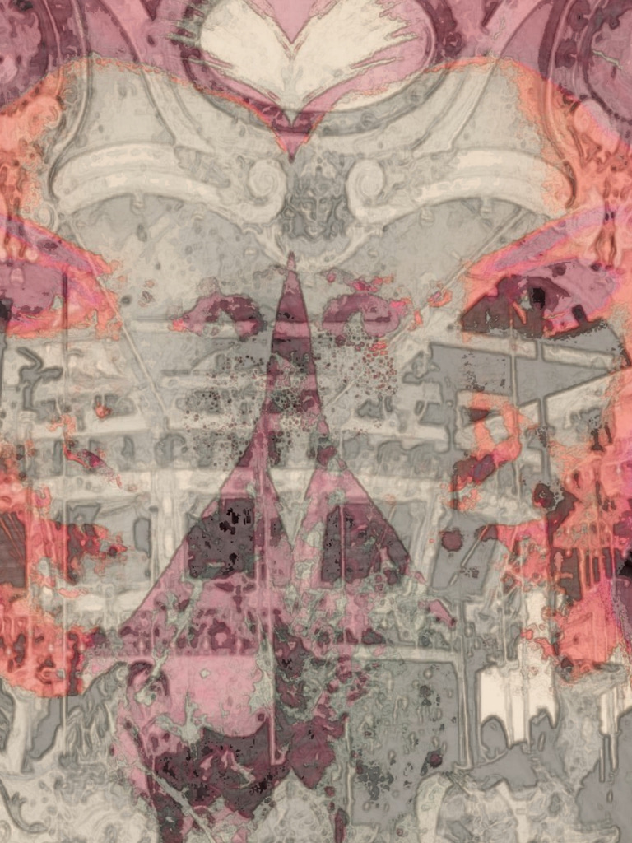
Part Eleven: The Dance of Smoke
Reading about Leia’s death, Stan, “The Elephant Enchanter,” and Gazelle, “The Human Mermaid,” were sickened to discover what the twins had gone through at the hands of their adopted family, and what happened to Leia. The pair had always had a bad feeling about Dorothy and Larry, but never expected the diabolical evil that was there.
After Stan and Gazelle last saw the twins, they fell in love. They had always loved each other, as they were like-minded best friends, but had previously been hesitant to risk their friendship or get hurt. However, after enduring numerous storms together, they realized that they never had to go it alone, and they never left each other’s side, so it was a risk worth taking. They had the type of love that makes people, even cynical ones, believe in it.
Shortly after reading the article, Gazelle and Stan tracked the twins down and offered a place to stay and support while they recovered, which the twins gratefully accepted. So, shortly after the twins turned 18, they headed to Paris, where Gazelle and Stan had set up their production. The twins never joined the show; instead, they participated in behind-the-scenes activities, including choreography and costuming.
Often, Gazelle and the twins would go out in Paris, where they shopped and enjoyed fancy brunches with interesting people. They would also frequently visit the country with Stan, where they would go fishing or hiking. Even though the twins were now adults, they were happy to have parents.
Tara still wrote Clay, who was devastated at the loss of his second mother, Leia. He was unsure of when he would be released from the institution, but Tara had no problem waiting for him.
After some time, the twins would often venture out on their own and travel the countries in Europe; a favorite was Spain, because the two loved the ocean and the heat. It was during a winter holiday that I ended up attending a party in Barcelona, where I was frozen when I saw them and figured, “What are the chances?”
However, Sara wasn’t frozen, and having only seen me in photographs, noticed me immediately, and pulled Tara quickly to me, then kissed me without fear. I loved that. After that long and perfect kiss, Sara explained that the two were living in Paris with the people they considered their parents, seeing as they no longer had any. I explained that I was now single and living in Switzerland, but between things. Sara then asked me to come with them to Paris and see the show. I thought, “How could you not?” And quickly agreed.
Tara gave me a lot of shit initially; still, I liked her dark sense of humor and returned it, which she respected. We became friends.
Our Parisian lifestyle was perfect; it was all fun and shows; worse things stayed outside. We did little else but enjoy life until my savings started to run dry, and I knew I would need to start working again. I wanted to continue collaborating with the twins, as I saw a great deal of potential in them. So, we worked together for a while, which produced some of the best work that any of us had previously done, until Sara lost interest and instead started studying to become a teacher. Yet, Tara and I kept working, and we got along extremely well.
As time passed, the friendship between Tara and me grew much closer because we spent a lot of time working together, while Sara had earplugs in and studied. This eventually led Sara to feel threatened. She and Tara fought so much that they stopped talking, for the first time in their lives.
I could see how miserable they were. I thought about never speaking to Tara again, but she is mandatorily there, so what kind of awkward life would that be? When things only escalated over time, I decided to leave.

Part Twelve: Colored Smoke


After I left, Sara blamed Tara and became obsessed with a surgery that could separate her from the person she used to refer to as her better half. Sara had now replaced Tara as the angry one of the pair; still, Tara felt that when roles were reversed, Sara was patient and understanding, so she should be the same. Tara even stopped talking to Clay because it made Sara angrier.
When the twins spoke with the doctor, all Tara heard were the risks, while all Sara heard were the rewards. Tara ultimately decided against the surgery. So, Sara wanted to drink, dance, and have sex to express her pain, but mostly, she wanted to forget. Tara went along without resistance, although, after some time, Tara started to like it; she liked sex, liquor, and trying to forget.
They found, though, after the thrill of the party had worn off, that they hadn’t solved the problem because while they had many pleasures, they had no purpose, which fuels you and gives you sustainable joy and self-esteem, and time only allowed it to get worse. So, any time there was stillness, it would gnaw at them both, and their souls would ache in pain.
After some time, Sara was unable to outrun her problems, and she became depressed and dangerously so. Tara was unsure what to do; she could bear seeing Sara angry, but not sad. So, Tara had no choice but to sign the papers after being thoroughly informed that this was a highly risky procedure.
The month before the surgery, Sara was noticeably happier, which put Tara at ease. The twins would spend their time merrily working on their projects and dreaming of their lives once they were individuals. The two had continued as if they had never had any difficulties between them, as each other’s better half; being separated brought them together.
Nearing the surgery date, they finished their play, “Poppy,” which they had been working on for most of their lives. It was their best work and seemed to be an autobiographical work veiled as fiction. The play is removed from the audience, as I believe the twins felt in their lives, which made them difficult people, among so many other wonderful things.
Then, the night before the surgery, Sara said, “Tara, I want you to know that you are the better half. You think on your feet. You’re a fighter. You’re so strong.” It made Tara cry; she loved her twin so much.
Then, the day of the surgery, they were given medication and fell asleep looking at each other’s better half. Then they began to dream, wild dreams that seemed to be from a time in the future, as much of it was so foreign.
In Tara’s dream, she was stuck in a maze whose white walls were lined with bright, neon-colored lights, making it a beautiful place to be lost. Tara looked over, expecting to find Sara, but Sara was not there; she was scared because she had never dreamed alone, since she was attached to Sara.
Then, Sara’s voice called to her, and Tara followed it, and as she did, Sara’s things appeared on the floor of the maze: Sara’s baby teeth, Sara’s favorite lilac plush toy cat, and their artwork, while memories from the twins’ interesting lives were projected on the walls.
After wandering through the maze for some time, Tara became more panicked and then sat down and began to cry, as she felt the heaviness of being alone for the first time. Then, after some time, she suddenly felt a tap on her shoulder; it was Sara. She took Tara’s hand in her own and said, “I love you, Tara. Please promise me that you will live your life fully and not regret anything.” This frightened Tara speechless, wondering why Sara would say such a thing.
Sara smiled and said, “I love you. You are my better half.” Then, Sara was suddenly in bandages, which were rapidly oozing blood.
Tara woke up screaming, so the nurse gave her a shot. She then dreamed she was in the first play she and Sara had created, about a cat who was a criminal turned detective. When Tara awoke, she asked how Sara was because she was feeling concerned. Instead of information, they gave her a shot. Tara was not recovered enough to get the bad news, so drugging her was the solution, which would transfer her into one of her and Sara’s artworks or plays; however, Sara, herself, unfortunately, never appeared again in her dreams.
A month later, the doctors thought it was time to tell Tara that Sara was dead; they couldn’t drug her the rest of her life to avoid the truth, and she was stable enough for it. Tara couldn’t believe it; she had never even wanted this. It was Sara’s idea, and now she was dead. Tara had only considered that she, herself, might die, but for some reason had not considered Sara as a similar risk. Tara became so escalated that they became worried for her, so they kept drugging her. They figured that maybe she could escape reality until perhaps she could come to terms with it, which proved to take longer and be more complex than initially anticipated.
Then, one day, Tara woke up to find Clay there. Right after being discharged, he and his mother went in search of Tara. He was both a naughty boy and a mama’s boy.
Tara smiled immediately. Clay felt like a safe haven to Tara; plus, he knew her mother and twin well and loved them both, which made her bond with him even more precious, meaningful, and unique. Clay was so good to her as she recovered. It ultimately evolved into a friendship, but it was a love story nonetheless. When Clay and Tara went their separate ways, Tara was lost.
Since I last saw the twins, I had moved to North America, which reopened the wound, as the first of my belongings to arrive was my chest of our artwork. So, in that empty house, I reviewed everything and felt the loss of the twins more than I expected; it was a gut-wrenching pain. I stayed without moving in that pain until a month later, when the rest of my belongings were delivered. I realized that while I could have stayed that way forever, I couldn’t afford to, so I threw myself into work, met friends, and built a network. However, finding love was a different story. How does one move on from the excitement of dating a conjoined twin whose talents set fire to my own? It was hard to find someone who excited me spiritually, creatively, sexually, and emotionally, the way that Sara had with the addition of Tara, who had been my best friend. Then I kept thinking of my father, who used to say, “Gerard, don’t go down with a sinking ship due to pride.” I believe many times, I should have folded but didn’t and lost it all, but with time, I understood that sometimes things are not a challenge but an impossibility, and thus are a sinking ship, which is a hard thing to conquer, especially when you are so invested or attached to the ship that is sinking. My father was a good man who died much too young. So I did my best to move on, although I still fantasized about what a future with Sara and Tara would be like. I kept their art in the open until I met someone, and I hid it all.
I met Matai at one of the many parties I regularly attended out of loneliness. After striking out with women who were good but too good for my tastes, I went much wilder. Matai was a woman whose negative reputation preceded her, which had isolated her fairly well; however, I remembered how wrong the things I heard about the twins were and how lucky I was to have met them, so I wasn’t going to ever let someone’s perceptions and opinions of someone prevent me from seeing for myself.
I loved what Matai and I had in the beginning. We would party hard, then have sex in every way imaginable, and she was noncommittal and often unreliable, which was enough to keep my attention; her unavailability was a turn-on for me.
We had been casually seeing each other for four months when she became pregnant; although, she was unsure if I was the father. She didn’t want children; she was a champagne and parties, not juice and diapers type of woman; so she decided that she would give them up for adoption. I asked if she would marry me and we could raise the child together; I didn’t care if the child was mine.
She turned me down; she was also not the marrying kind. But she offered that I could adopt the child, and I agreed. When Matai gave birth, I was shocked to find out that she had twin boys. Shortly after giving birth, Matai left, and I never saw her again. Still, I loved my sons; they gave me purpose.
I raised those boys for six years before I met Meghan, who was the mother of a baby girl whose father had left. Meghan was not exciting or highly sexual, but stable and a great mother; I loved her for practical reasons. Meghan and I got married in a grand wedding just a year after we met. I had a beautiful family.
Unfortunately, Meghan died unexpectedly when the boys were ten and her daughter Laura was five. That was a particularly difficult time for me and a significant adjustment. Still, I couldn’t fall apart because I had three children, so I battled through it.
Then, two years after Meghan died, I received a letter from Tara, asking me if she could pay me for the rights to the art I had contributed, as she wanted to release some of it so Sara’s dreams could come true, even if posthumously. She then informed me, in case I wasn’t aware, of the surgery and Sara’s death.
I wrote her back and offered my condolences, saying she could use my work with no payment necessary; it would be my tribute to Sara.
What I didn’t know was the reason for the project, and the rush to finish it was that Tara was losing her mind and didn’t know how much longer she would be sane enough to help share Sara with the world. Tara’s insanity started when she felt her sister’s spirit had conjoined with her own, and she heard Sara speak as clearly as anyone else. They said it was just getting used to the stress of losing part of you.
I wanted to visit with Tara, but I had a family on a different continent, so I couldn’t just take that trip. Still, we became ardent pen pals who collaborated and provided advice on our various projects. Although it wasn’t all business, we became close friends again. I looked forward to writing and receiving her letters. She sent a photograph of how she looked now as a solo individual, which was unusual to see, but she was beautiful. I sent her a family photograph, and she commented on how sweet it was.
Two years later, all of the art collectives were to be released. Tara wasn’t offended when the papers played up her crime to garner interest, as long as there was interest. Headlines read as Half of Conjoined Twin Honors Her Dead Twin Through Their Works, and Convicted Murderess, Formerly Conjoined Twin, Wants to Share Her Twin with the World.
It was an enormous success, which spread to me as a contributor. So, I stayed busy, but I often thought of Tara and frequently wrote to her; I saved every letter. I also created a lot of work with the twins as my muse again.
Then, one day, I heard a knock at my door; it was Tara. She kissed me immediately, and I was surprised and happy. It was strange, however, that it was just one person there, and I was kissing Sara’s twin. I had thought of them both at intimate times later, but never considered Tara romantically, even with the profound friendship.
Once inside, I asked her about the arm mechanism she now used, and she said that Clay, now her friend, had created it, along with many other adaptive contraptions that he had started making for her, and later greatly profited from those patents. Once in my arms, Tara never returned home, because she was already home.
When I loved Sara, I was green, and it was a fluffy fantasy of cotton candy; when I loved Tara, it was gritty reality with depth and dimension. Tara was never a consolation; I loved her with all my heart, and I know she felt the same.
We later married and raised a family. Sara was present everywhere. We continued to work together until we no longer worked at all. I would never be Tara’s better half, but she was always mine.

Better Half
