June 2026 Newsletter

2026-2027 Post 21 Commander

Of the many things that depend on our entire elected leaders’ responsibilities I want thank each of them for their Enthusiastic initial involvement in our future success. Achieving our goal of the monthly newsletter and have set into motion the update to our post website. (www.vetsclub21.org) and email (vetsclub21@gmail.com).

As we applaud your volunteerism; recording of 923.25 hours a dramatic increase; Thank you all. And our staff, Anna, the single-handed cook has feed more than fifty meals during our Friday night’s prime rib dinners. Great job Anna and thank you!!

Based on the visit with the National Commander American Legion Commander Dan K. Wiley, his wife, and staffs’ dinner at our post Monday June 15th we have adjusted our E Board meeting to June 8th the general meeting remaining on the 17th. Please consider your attendance at the general meeting. The continued Legion and community involvement depends on all of us.

Greetings from your Post Service Officer. I trust that you are enjoying this fine Spring weather that we have here in the Pacific Northwest. This is a great time to get out and visit us at Post 21.
Your Post is staying active in assisting veterans in need. We recently were able to provide temporary assistance to two vets that were about to be evicted from their residences. We caught them up on their back rent and hopefully they will be able to handle their rent going forward. We provided them with additional information on the VA rent assistance program. If you know of a vet that needs assistance, please let me know.

Paul Krutsch
Service Officer

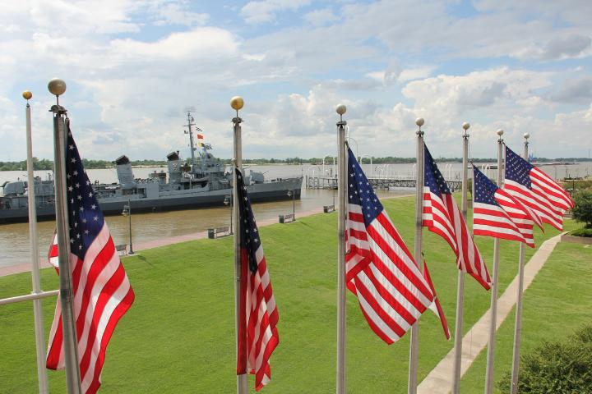
Flag Day June 14, 2026
Chaplain’s Corner:
We had a great time on the (Ride of Honor and Remembrance). Thank the GOOD LORD that it didn't rain till after the service that we had. The Riders did a great job in leading all of us to all the stops that we did. The Sea Cadets did a wonderful job with the flags. Take the time to thank them for to way they helped us out.
We didn't have a lot of people cemeteries but we were there to honor everyone that served so that was very important for all that there.
We had the Legion members for Post21. Post 21 Auxiliary member.
Sons of the American Legion. Post 21 Legion Riders and Sea Cadets- Ironside Division McMinnville.
Most of all the Sea Cadets helped with the playing of Tap.
Back at the post we
And remembered the men of the "USS FRANK E. EVANS [DD-754] who were lost at sea on June 3, 1969. 74 men lost their lives at sea and Post 21 takes the time to remember them each year.
As I close out please take the time to pray for all the ones that are sick and in need of prayer. If you know of anyone that needs prayer or if they are in the hospital please let me know so that I can go pray for them. As your Chaplain I'm always here to pray for you and your family.

May God keep you safe.
Chaplain Thomas Clayton
503-550-8044
armynavy6782@gmail.com
Finance Officer Cheryl Saville-Miller:
Good news! We believe that we approaching the finish line in getting all of our documents to our auditors and hope they everything they need in order to complete the forensic audit we requested in October 2026. It is a lot of information for them to
Finance Officer continued:
wade through, and they will let us know if they have questions or need any other information. If you were a executive committee officer in 2024 and/or 2025, they will likely be reaching out to you via email or phone. Please cooperate with them in whatever information they request, and you can provide.

I am now fully staffed in the office with 2 part-time office managers. Debra Misner has been with us since August 2023 with a break last year and Doug Kuhn has joined our team. Doug is a Navy vet and is learning his duties fast. They are a great team and we are extremely happy to have them here. Please greet them if you see them. You might ask, “why do we have two?” Well, we count money 7 days a week and it isn’t realistic to have someone come 7 days a week and never have a day off. There is lots to do but between the two, they make up a full-time position and do a fantastic job.

Attached to this newsletter is my monthly finance report as reported at the May meeting. These reports are from the last meeting to the current meeting. It has some really good information so please read it.
Finance Committee Meeting, 4th Wednesday at 6:00 pm. Your finance committee is Chaired by me, Cheryl Saville-Miller and I am pleased to say that Steve Randles, Paul Krutsch and Scott Fitkin have volunteered to be on the committee. Thank you gentlemen!

Auxiliary
I hope this note finds you all in good health. Auxiliary is busy planning our annual events. We will start taking donations for our yard sale from May 25th to June 4th. Yard sale will take Place June 6th and 7th. We will not be taking, car seats, electronics, large furniture, highchairs,
Auxiliary Continued:
vacuums, or clothes that are dirty or damaged. We will have auxiliary members ready to take all donations. We have 4 students that were chosen for $1000 scholarships this year. Our monthly veteran’s lunch is still going strong. June 11th is the next one and we will be serving meatloaf, potatoes, gravy, veggies and desserts. Lunch will be served from 11am until 12:30pm.
Debra Godwin
Unit 21 President
2nd Vice Commander
Our 2nd Vice is out for a bit so Debra Godwin has stepped up to run the activities committee. Here is her report on upcoming
events and club news Fathers day June 21, from 8am until 11am. All fathers will eat for free. June 14, Take a soldier fishing. See Bob Berweger for details. June 15-June 17 Our National Commander will be visiting Post 21. Dinner on June 15 will be at 7:00 pm. Please come and greet him and his wife as well as other individuals who will be traveling with him.
July 4th, 250th Birthday celebration, from 11am until 6pm. We will need several volunteers. Set up, clean up, cooking, serving, and helping with yard games. If interested in helping please contact Debra or Cheryl. We are asking for members to bring their favorite side dish or dessert. There will be awards for the best side and dessert.
Think about how small our kitchen is and the amount of food that comes out. We serve over 800 customers a month and more than half are our community members. We should all be proud of our post and the community we serve. Please thank your servers, remember they are volunteers. Our cooks are behind the scenes but need a thank you also.

Debra Godwin, Club Manager
From the Rose Garden:
I am pleased to present to you all, some of the heroes of last Veterans Lunch May 14.
From Left to Right, Sim Sears, Kyle Krutch, Larie Scott, Gale Wilson, Becky Berweger, and Susan Haley. If you have never been, your missing out. Every second Thursday of the month.

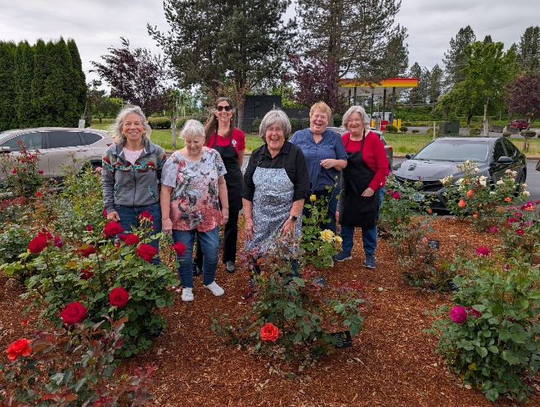

Thank you all for what you do. It seems you enjoy serving.

1st Vice
Greetings Legionnaires,
As we head into June, I would like to provide an update on our membership efforts at American Legion Post 21. Our Membership Committee continues to stay active in recruiting eligible veterans and sharing the mission of The American Legion throughout our community. Currently, the committee consists of Juan Palacios, Nick McClusky, and myself. We are still looking for one additional member to join our team. If you enjoy meeting fellow veterans, talking about the benefits and values of Legion membership, and helping Post 21 grow, we would welcome your participation.
This spring, members of the committee attended the Chemeketa Community College Job Fair, where we had an excellent opportunity to meet and speak with veterans
1st Vice continued:
from a variety of backgrounds. One of the most beneficial aspects of these events is that the first hour is reserved exclusively for veterans, allowing us to have meaningful conversations about military service, camaraderie, and the programs and support offered through The American Legion. We plan to participate in additional job fairs and outreach events as they become available throughout the year.
Membership remains the lifeblood of our Post. Every new member brings new ideas, experiences, and opportunities to strengthen our ability to serve veterans, their families, our youth, and the McMinnville community. Thank you to everyone who continues to recruit, renew, and encourage eligible veterans to become part of our American Legion family. Together, and in keeping with our motto, “For God and Country,” we can continue to build a stronger Post 21 for future generations.
For God and Country,
Randy David
First Vice Commander & Membership Chairman
American Legion Post 21
McMinnville, Oregon

Adjutant Juan Palacios
Hello,
The 2026 American Legion Convention is on June 23-27 at Chinook Winds Casino in Lincoln City. The Post has six (6) Delegates strength. Meaning the Post has six votes on the convention floor for voting. The Post is sending six (6) Delegates and two (2) Alternate Delegates.
The delegates are Post Commander Gale Sears, Post Adjutant Juan Palacios, Post Finance Officer Cheryl Salville Miller, Post Historian Nickolas McCleskey, Post Judge Advocate Robert (Doc) Wilson and Post Member Rich Pimm.
The Alternate Delegates are Post Service Officer Paul Krutsch and Past Post Commander Leroy Brown.
The Post will be voting on New State Officers and Legion issues. Also, in attendance will be Matthew Shuman, the 2nd Leading Candidate for National Commander.

The Post newsletter is advancing with articles. If you have photos, stories or events PLEASE submit them to vetsclub21@gmail.com attention Juan Palacios or Cheryl Miller.
Renewals are coming in; also new members are joining as well. Membership is essential to keeping the Post strong

American Legion Historian:
I am Nick McCleskey, your new post Historian.
My goal this year is to work to upgrade our website with a new opening page and to have a linked page within for each group: Auxiliary; Sons; Riders. I plan for each group to eventually have a dedicated page of their own for, Events. This will allow photos and videos be uploaded specific to each group. Yes other website pages may be considered as needed. I will keep you posted on progress at our general meetings and our monthly newsletters. Please feel free to contact me anytime.

Lemonade stands in McMinnville are most famous during Lemonade Day, an annual youth entrepreneurship event hosted by the McMinnville Area Chamber of Commerce. The next city-wide Lemonade Day is officially scheduled for August 15, 2026, where dozens of local kids will set up shop across town.
local.lemonadeday.org +4
The Main Event: Lemonade Day McMinnville
- Date: Saturday, August 15, 2026
local.lemonadeday.org

Bob Berweger

Post 21 Community
Post 21 wants to provide thanks and gratitude to the Local Iron Side Naval Sea Cadet Corps as they performed with pride and professionalism during our Memorial Day activities at three local grave sites and the American Legion post 21. A special thank you to Angel and Shanna Uscagna for their leadership and support.

The McMinnville Iron Side Naval Sea Cadet Corps (NSCC) is of American youth ages 13-17 who strive to learn about the Navy, Marine Corps, Coast Guard and Merchant Marine involvement and leadership.

Sea Cadets are authorized by the Secretary of the Navy. The objectives of the Sea Cadet program are to introduce youth to naval life, to develop in them a sense of pride, patriotism, courage, self-reliance, and to maintain an environment free of drugs and gangs. The Iron Side division was commissioned in the Yamhill County area in August 2009.

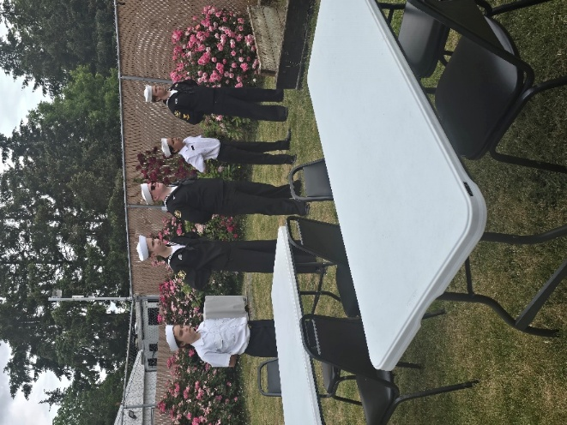

May Financial as Reported to the General Membership

Wednesday May 20, 2026
 | Current Account and cash on hand balances
Current Post Account Balance | $109,230.36 |  | Cash On Hand > |  | $6,118.89
Current Lottery Account Balance | $205,876.37 |  |  | Bar Bags > | $225.00
Facility Maintenance | $28,766.18 |  |  | Bar Lotto Bags > | $5,052.00
Memorial Account | $5,781.00 |  |  | Office/Bar Keno> | $300.00
Total Post Bank Assets = | $349,653.91 |  |  | Office Drawer Lotto | $2,526.00
 |  |  | Total Liquid Assets: |  | $14,221.89
Total assets as of | $349,653.91
Assets as of 4/15/26 | $340,888.58
Asset Growth April to May 2026 | $8,765.33
Member Tax Exempt Spending |  |  | UBI Taxable Income
Jan-26 | $2,542.00 |  | Jan 26 | $46,452.31
Feb-26 | $21,745.00 |  | Feb 26 | $ 28,123.00
Mar-26 | $21,115.00 |  | Mar 26 | $ 20,877.00
Apr-26 | $24,058.00 |  | Apr-26 | $ 30,535.00

June 2026 American Legion Post 21
Activities and Events
S | M | T | W | Th | F | S
 | 1 | 2 | 3  SAL Mtg  6:00 pm | 4 | 5  Friday Night Dinner  KP – Legion  Auxiliary Yard Sale | 6  Cancer Bingo  Canceled  Auxiliary Yard Sale
7  Bingo  Canceled | 8  Exec Committee  6:00 pm  House Committee  5 pm  Activities Mtg  5:00 pm | 9 | 10 | 11  Veterans Lunch  11-12:30 | 12  Friday Night Dinner  KP - Auxiliary | 13
14  Take a soldier fishing – Hagg Lake  Bingo  12-4 pm | 15  Meet and greet/dinner with National Cdr  7pm | 16  Breakfast with National Cdr  8 am  Auxiliary Mtg  6 pm | 17  General Members Mtg  6 pm | 18 | 19  Friday Night Dinner  KP - SAL | 20  ALR Poker Run  Sheridan Days
21  Father’s day breakfast  8-11 am | 22 | 23 | 24  AL Riders Mtg  7pm  OR Dept Convention  Chinook Winds | 25  Convention  Chinook Winds | 26  Friday Night Dinner  KP- Riders  ALR Awards Banquet Chinook Winds  Convention | 27  OALR Teddy Bear Run  Lincoln City  Convention  Chinook Winds
28  Bingo  12-4 pm | 29 | 30

